ISO 20022
Tracking Business Transactions

Message Definition Report Part 1
Approved by the Payments SEG on March 2nd, 2025
This document provides information about the use of the messages for Tracking Business Transactions and includes, for example, business transactions and examples.
March 2025

Table of Contents
Table of Contents 2
1 Introduction 5
1.1 Terms and Definitions 5
1.2 Abbreviations and Acronyms 5
1.3 Document Scope and Objectives 6
1.4 References 7
2 Scope and Functionality 8
2.1 Background 8
2.2 Scope 8
2.3 Groups of MessageDefinitions and Functionality 8
3 BusinessRoles and Participants 9
3.1 Participants and BusinessRoles Definitions 9
3.2 BusinessRoles and Participants 10
4 BusinessProcess Description 11
5 Description of BusinessActivities 14
5.1 Tracker update and reporting 14
6 BusinessTransactions 16
6.1 PaymentStatusTrackerUpdate and PaymentStatusTrackerReport BusinessTransaction 16
6.2 PaymentStatusCustomerTrackerReport 17
7 Business Examples 19
7.1 PaymentStatusTrackerUpdate Message - trck.001.001.04 19
7.2 PaymentStatusTrackerReport Message - trck.002.001.03 25
7.3 PaymentStatusCustomerTrackerReport - trck.004.001.02 33
8 Revision Record 38
Preliminary Note
The Message Definition Report (MDR) is made of three parts:
MDR Part 1
This describes the contextual background required to understand the functionality of the proposed message set. Part 1 is produced by the submitting organization that developed or maintained the message set in line with an MDR Part 1 template provided by the ISO 20022 Registration Authority (RA) on www.iso20022.org.
MDR Part 2
This is the detailed description of each message definition of the message set. Part 2 is produced by the RA using the model developed by the submitting organization.
MDR Part 3
This is an extract if the ISO 20022 Business Model describing the business concepts used in the message set. Part 3 is an Excel document produced by the RA.

Introduction

Terms and Definitions
The following terms are reserved words defined in ISO 20022 Edition 2013 – Part1. When used in this document, the UpperCamelCase notation is followed.
Term | Definition
BusinessRole | Functional role played by a business actor in a particular BusinessProcess or BusinessTransaction.
Participant | Involvement of a BusinessRole in a BusinessTransaction.
BusinessProcess | Definition of the business activities undertaken by BusinessRoles within a BusinessArea whereby each BusinessProcess fulfils one type of business activity and whereby a BusinessProcess may include and extend other BusinessProcesses.
BusinessTransaction | Particular solution that meets the communication requirements and the interaction requirements of a particular BusinessProcess and BusinessArea.
MessageDefinition | Formal description of the structure of a message instance.
When a MessageDefinition or message identifier is specified, it should include the variant and version number. However, in this document (except in the business examples section, if present), variant and version numbers are not included. In order to know the correct variant and version number for a MessageDefinition, the related Message Definition Report Part 2 document should be consulted.

Abbreviations and Acronyms
The following is a list of abbreviations and acronyms used in the document.
Abbreviation/Acronyms | Definition
ACK | Acknowledgement
ACH | Automated Clearing House
AML | Anti-Money Laundering
BIC | Business Identifier Code
B/D | Broker/Dealer
CA | Corporate Actions
CAG | Corporate Advisory Group
CBI | Corporate Banking Interbancario
CCP | Central Counterparty
CNS | Continuous Net Settlement
CSD | Central Securities Depository
CUG | Closed User Group
DD | Direct Debit
EACH | European Association of Central Counterparty Clearing Houses
EnI | Exceptions and Investigations
ESCH | European System of Central Banks
ESCR | Committee of European Securities Regulators
FI | Financial Institution
FIA | Futures Industry Association
FOA | Futures and Options Association
GCM | General Clearing Member
IBAN | International Bank Account Number
ICM | Individual Clearing Member
ICSD | International Central Securities Depository
IDB | Inter-dealer/broker
IFX | Interactive Financial eXchange Forum
ISTH | International Standards Team Harmonisation
ISITC | International Securities Association for Institutional Trade Communication
KYC | Know Your Customer
MCR | Message Change Request
MDR | Message Definition Report
MTF | Multilateral Trading Facility
MRI | Mandate Related Information
NCM | Non-Clearing Member
NAK | Negative acknowledge (reject)
OAGi | Open Application Group
PV | Proxy Voting
RTGS | Real Time Gross Settlement
SBF | Société de Bourse française (now Euronext)
SEG | Standards Evaluation Group
SLA | Service Level Agreement
SMPG | Securities Market Practice Group (www.smpg.info)
TDN | Trade Date Netting
TM | Trading Member
TSU | Trade Services Utility
TWIST | Transaction Workflow Innovation Standards Team
XML | eXtensible Mark-up Language

Document Scope and Objectives
This document is the first part of the Tracking Business Transactions Message Definition Report (MDR) that describes the BusinessTransactions and underlying message set. For the sake of completeness, the document may also describe BusinessActivities that are not in the scope of the business processes covered in this document.
This document describes the following:
- the BusinessProcess scope
- the BusinessRoles involved in these BusinessProcesses
- The main objectives of this document are as follows:
- to provide information about the messages that support the business processes
- to explain the BusinessProcesses and BusinessActivities these messages have addressed
- to give a high level description of BusinessProcesses and the associated BusinessRoles
- to document the BusinessTransactions
- to provide business examples
The messages definitions are specified in Message Definition Report Part 2.

References
Document | Version | Date | Author
ISO 20022 Business Justification 144 – Tracking | 1.0 | 18 Sept 2019 | SWIFT

Scope and Functionality

Background
This Message Definition Report covers a set of three (out of five) Tracking of Business Transactions MessageDefinitions developed by Swift standards in close collaboration with the Swift global payment innovation (gpi) community and submitted for the approval of the Payment Standards Evaluation Group (SEG) in October 2024. These messages are specifically designed to support the tracking of payment transactions.

Scope
These messages are specifically designed to support the Tracking of an underlying business transaction or process, whereby a Tracking facility outside of the business flow can provide and/or receive information on the underlying business transaction or process for providing tracking and transparency.

Groups of MessageDefinitions and Functionality
These messages are to be used with the ISO 20022 Business Application Header (head.001). The schema and more information about the Business Application Header (BAH) can be found on the www.iso20022.org website.
These MessageDefinitions should stay aligned with the CBPR+ “live” messages.

Groups

Tracking Business Transactions

MessageDefinition | Message Identifier
PaymentStatusTrackerUpdate (to Tracker) | trck.001.001.xx
PaymentStatusTrackerReport (from Tracker) | trck.002.001.xx
TrackerAlertNotifcation | trck.003.001.xx*
PaymentStatusCustomerTrackerReport | trck.004.001.xx
TrackerInvestigationStatusNotification | trck.005.001.xx*
* messages are to be registered at a later date given the fact that they are used in projects that are in development

Functionality
See Message Definition Report Part 2 for the message and formats.

BusinessRoles and Participants
A BusinessRole represents an entity (or a class of entities) of the real world, physical or legal, a person, a group of persons, a corporation. Examples of BusinessRoles: “Financial Institution”, “Automated Clearing House”, “Central Securities Depository”.
A Participant is a functional role performed by a BusinessRole in a particular BusinessProcess or BusinessTransaction. Examples of Participants: the “user” of a system, “debtor”, “creditor”, “investor”.
The relationship between BusinessRoles and Participants is many-to-many. One BusinessRole can be involved as different Participants at different moments in time or at the same time. Examples of BusinessRoles: "user", "debtor”, "creditor", "investor". Different BusinessRoles can be involved as the same Participant.
In the context of Tracking Business Transactions the high-level BusinessRoles and typical Participants can be represented as follows:

Participants and BusinessRoles Definitions
Participants
Description | Definition
Debtor | Party that owes an amount of money to the Creditor. In the context of the payment model, the debtor is also the debit account owner.
Creditor | Party to which an amount of money is due. In the context of the payment model, the Creditor is also the credit account owner.
Debtor Agent | Financial institution servicing an account for the Debtor.
Creditor Agent | Financial institution servicing an account for the Creditor.
Intermediary Agent | Agent between the debtor's agent and the creditor's agent. There can be several intermediary agents specified for the execution of a payment.
Financial Market Infrastructure | Infrastructure responsible for providing clearing and settlement of financial transactions.
Instructing Agent | Agent that instructs the next party in the payment chain to carry out the payment/instruction.
Instructed Agent | Agent that executes the instruction upon the request of the previous party in the chain (either an agreement party, or a clearing agent).
Business Roles
Description | Definition
Tracker | End-to-end transaction tracking platform, used to monitor the progress of a business transaction or process and obtain transparency on its status.
Tracker Informing Party | Party who provides information to the Tracker.
Tracker Informed Party | Party who receives information from the Tracker.

BusinessRoles and Participants

BusinessRole | Initiating Party | Forwarding Agent | Debtor | Creditor | Debtor Agent | Creditor Agent | FMI | Instructing Agent | Instructed Agent
Tracker
Tracker Informing Party | X | X | X | X | X | X | X | X | X
Tracker Informed Party | X | X | X | X | X | X | X | X | X

BusinessProcess Description
This diagram represents the high level BusinessProcesses.

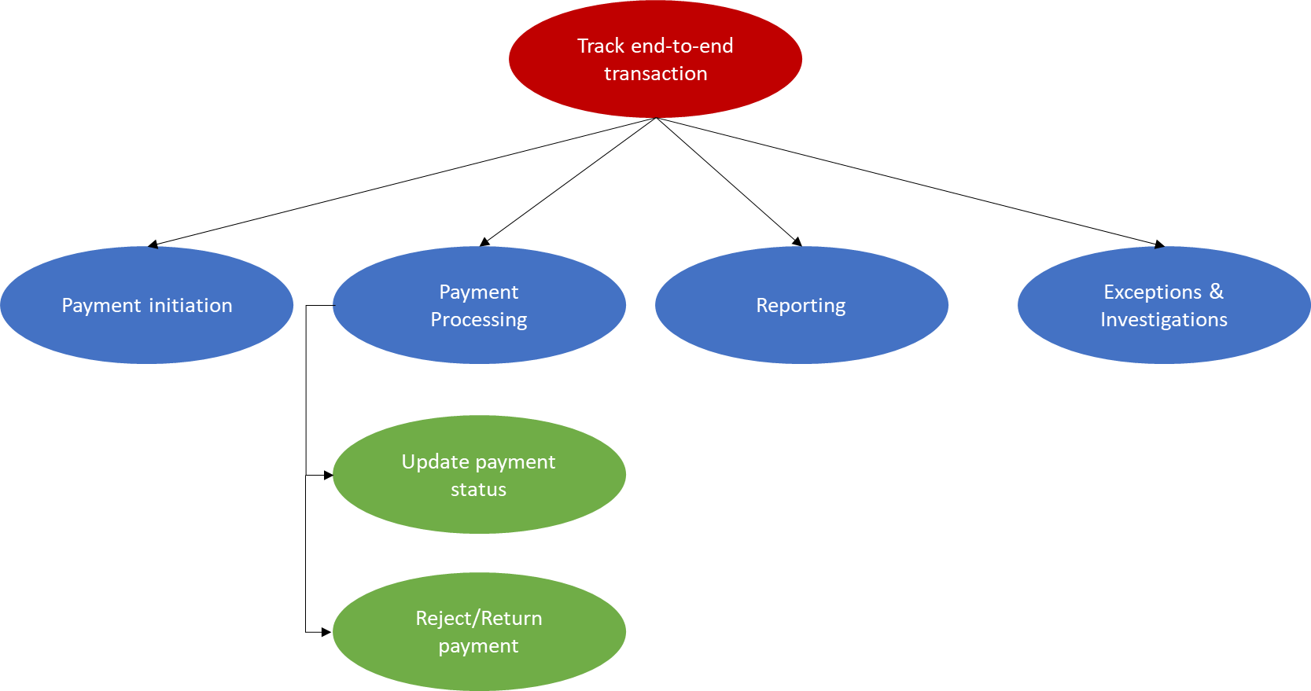

Note: Exceptions & Investigations business process is out of scope for this first set of messages.

Payment Initiation
Item | Description
Definition | An initiating party orders to financial institution (debtor agent or forwarding agent) a payment related instruction. This may refer to an underlying business transaction (for example, an invoice).
Trigger | Decision has been made to make a payment (either by a person or a system).
Pre-conditions | The required (identifying) information is available to make a payment.
Post-conditions | The initiating party sends a CustomerCreditTransferInitiation message to the forwarding agent or debtor agent.
Role | Debtor (initiating party)

Payment Processing
Item | Description
Definition | Instructing agent performs the transfer of cash between the debit party and the credit party.
Trigger | Payment execution date in the payment is reached.
Pre-conditions | Instructed payment is executable (all information is there to process the payment and the payment validity has been checked).
Post-conditions | Transfer of ownership is performed between the debit party and credit party.
Role | Financial institution

Payment Status Update
Item | Description
Definition | The process of an Agent providing an update on the status of a payment clearing and settlement message received and or being processed.
Trigger | Decision being made on a payment (either by a person or a system)
Pre-conditions | Payment has been received, or a change has been made to the processed status.
Post-conditions | A change in status of the payment.
Role | Debtor, Creditor, Debtor Agent, Intermediary Agent, Financial Market Infrastructure, Creditor Agent.

Payment Rejected/Returned
Item | Description
Definition | The process of an Agent either Rejecting or Returning a payment clearing and settlement message received.
Trigger | Decision of a payment that cannot be processed further (either by a person or a system)
Pre-conditions | Payment has been received, or a change has been made to the processing status.
Post-conditions | Payment being either Reject or Returned.
Role | Debtor, Creditor, Debtor Agent, Intermediary Agent, Market Infrastructure or Creditor Agent.

Reporting

Item | Description
Definition | The process includes the financial impact reporting, the reporting on the payment transaction status and the reconciliation process.
Trigger | Payment process is completed.
Pre-conditions | An agreement exists between the reporting party and the reported party to do a specific type of reporting, in order to meet legal requirements and business requirements agreed between the reporting and reported party.
Post-conditions | The payment transaction is reported on.
Role | Account Servicer (debtor agent or creditor agent).

Exceptions and Investigations

Item | Description
Definition | The process includes the handling of any exceptions and investigations related to the payment transaction.
Trigger | An exception or investigation process starts when a problem occurs in the normal execution of a payment transaction.
Pre-conditions | Issue detected in the payment chain.
Post-conditions | The subject of the investigation is handled with could lead to further processing of the payment or cancellation/reject/return of the payment.
Role | Financial institution

Description of BusinessActivities
This section presents the different BusinessActivities within each BusinessProcess. The BusinessActivities of a process are described with activity diagrams.
Legend
Symbol | Name | Definition
 | Start Point | Shows where the lifecycle of the business process commences.
 | End Point | Shows where the lifecycle of the business process may ends.
 | Lozenge (or diamond) | Indicates that a choice between several actions can be made.
 | Bar | Indicates that several actions are initiated in parallel.

Tracker update and reporting

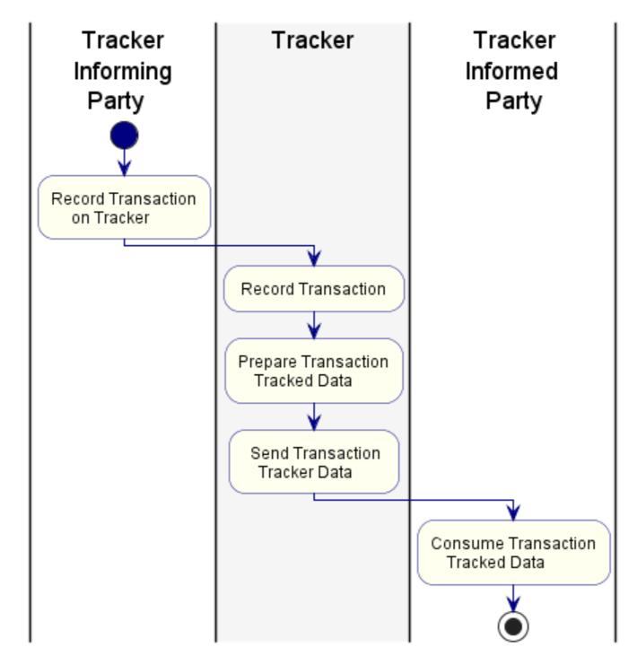

Step | Description | Initiator
Record transaction on tracker | The tracker informing party provides payment status update to the tracker related to underlying transaction | Tracker informing party
Record transaction | Via the payment status update, the tracker can record the transaction in central database | Tracker
Prepare transaction data | The tracker stores relevant status and transactional information related to the underlying transactions and prepares the data to be reported to other parties in the payment chain | Tracker
Send transaction tracker data | The Tracker sends the prepared data to the tracker informed parties (other parties in the chain). | Tracker
Consume transaction tracked data | The tracker informed parties (other parties in the chain) receive the status and transactional information from the tracker. | Tracker informed party

BusinessTransactions
This section describes the message flows based on the activity diagrams documented above. It shows the typical exchanges of information in the context of a BusinessTransaction.
Note: The below business transactions are examples of these flows but other flows are possible including additional agents.

PaymentStatusTrackerUpdate and PaymentStatusTrackerReport BusinessTransaction

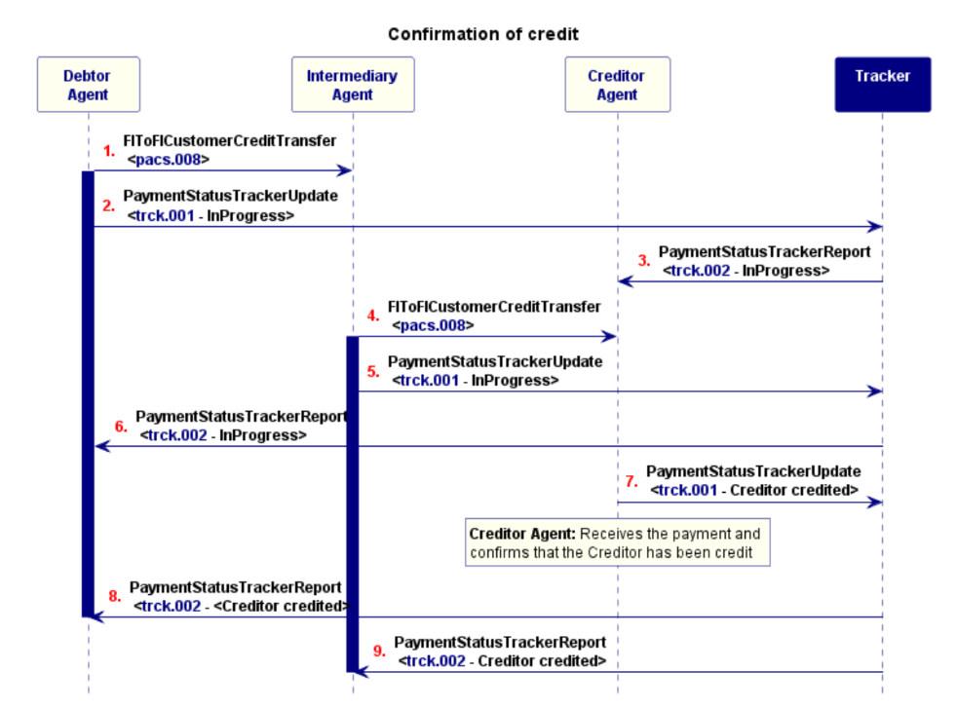

1) The Debtor Agent sends a payment instruction to the Intermediary Agent
2) The Debtor Agent (as Tracker Informing Party) informs the tracker about that payment instruction.
3) The tracker informs the Creditor Agent of the payment instruction between the Debtor Agent and the Intermediary Agent.
4) The Intermediary Agent forwards the payment instruction to the Creditor Agent.
5) The Intermediary Agent (as Tracker Informing Party) informs the tracker about that payment instruction.
6) The Tracker informs the Debtor Agent of the payment instruction between the Intermediary Agent and the Creditor Agent.
7) The Creditor Agent credits the account of its customer and informs the Tracker (ACCC status).
8) The tracker informs the Debtor Agent of the credit.
9) The tracker informs the Intermediary Agent of the credit.

PaymentStatusCustomerTrackerReport

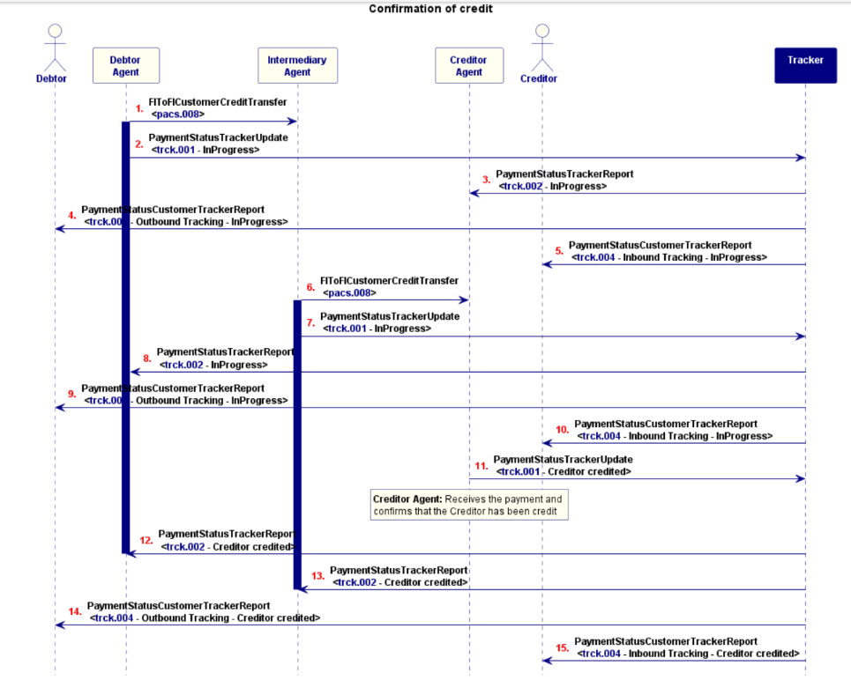

1) The Debtor Agent sends a payment instruction to the Intermediary Agent
2) The Debtor Agent (as Tracker Informing Party) informs the tracker about that payment instruction.
3) The tracker informs the Creditor Agent of the payment instruction between the Debtor Agent and the Intermediary Agent.
4) The tracker informs the debtor of the payment instruction between the Debtor Agent and the Intermediary Agent (outbound tracking view).
5) The tracker informs the creditor of the payment instruction between the Debtor Agent and the Intermediary Agent (inbound tracking view).
6) The Intermediary Agent forwards the payment instruction to the Creditor Agent.
7) The Intermediary Agent (as Tracker Informing Party) informs the tracker about that payment instruction.
8) The Tracker informs the Debtor Agent of the payment instruction between the Intermediary Agent and the Creditor Agent.
9) The tracker informs the debtor of the payment instruction between the Intermediary Agent and the Creditor Agent (outbound tracking view).
10) The tracker informs the creditor of the payment instruction between the Intermediary Agent and the Creditor Agent (inbound tracking view).
11) The Creditor Agent credits the account of its customer and informs the Tracker (ACCC status).
12) The tracker informs the Debtor Agent of the credit.
13) The tracker informs the Intermediary Agent of the credit.
14) The tracker informs the debtor of the credit (outbound tracking view).
15) The tracker informs the creditor of the credit (inbound tracking view).

Business Examples
This section describes business examples of the use of the various MessageDefinitions.

PaymentStatusTrackerUpdate Message - trck.001.001.04

Description
BBBB Bank, New York, has received a payment initiation request from its client ABC Corporation, New York. They initiate a payment clearing and settlement message towards the Creditor Agent using an Intermediary Agent. In parallel to the payment clearing and settlement message, BBBB Bank and subsequent Agents in the payment transaction inform a Tracking facility on the progress of the payment to the Creditor.
These examples cover three Payment Status Tracker Update messages:
· The first sent by BBBB Bank to the Tracking facility confirming the initiation of a payment clearing and settlement message.
· The second by AAAA Bank, London to the Tracking facility confirming the processing of the payment clearing and settlement message onto a Payment Market Infrastructure
· The third by CCCC Bank, London who having received the settlement message via the Payment Market Infrastructure provides confirmation to the Tracking facility that the
Creditor’s account has been credited.

Business Data Example 1
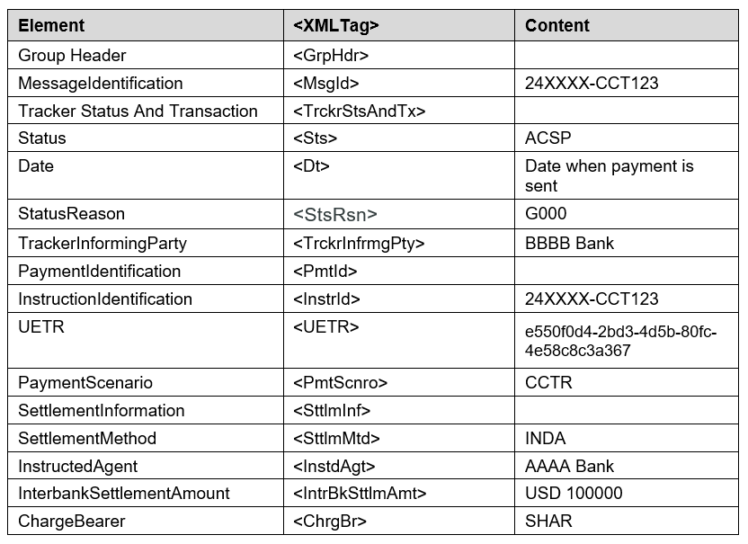

Message Instance Example 1
<AppHdr>
<Fr>
<FIId>
<FinInstnId>
<BICFI>CCCC Bank</BICFI>
</FinInstnId>
</FIId>
</Fr>
<To>
<FIId>
<FinInstnId>
<BICFI>TRCKCHZZXXX</BICFI>
</FinInstnId>
</FIId>
</To>
<BizMsgIdr>24XXXX-CCT126</BizMsgIdr>
<MsgDefIdr>trck.001.001.03</MsgDefIdr>
<BizSvc>swift.gpi.gcct.01</BizSvc>
<CreDt>2025-12-17T10:31:48.000Z</CreDt>
</AppHdr>

<PmtStsTrckrUpd>
<GrpHdr>
<MsgId>24XXXX-CCT126</MsgId>
</GrpHdr>
<TrckrStsAndTx>
<TxSts>
<Sts>ACCC</Sts>
</TxSts>
<Tx>
<TrckrInfrmgPty>
<Id>
<FinInstnId>
<BICFI>ABCDEFGH</BICFI>
</FinInstnId>
</Id>
</TrckrInfrmgPty>
<PmtId>
<InstrId>24XXXX-CCT124</InstrId>
<UETR>e550f0d4-2bd3-4d5b-80fc-4e58c8c3a367</UETR>
</PmtId>
<PmtScnro>
<Cd>CCTR</Cd></PmtScnro>
<TrckrData>
<ConfdDt>
<DtTm>2025-12-17T10:31:48.000Z</DtTm>
</ConfdDt>
<ConfdAmt Ccy="USD">100000</ConfdAmt>
</TrckrData>
</Tx>
</TrckrStsAndTx>
</PmtStsTrckrUpd>
</Document>
Business Data Example 2
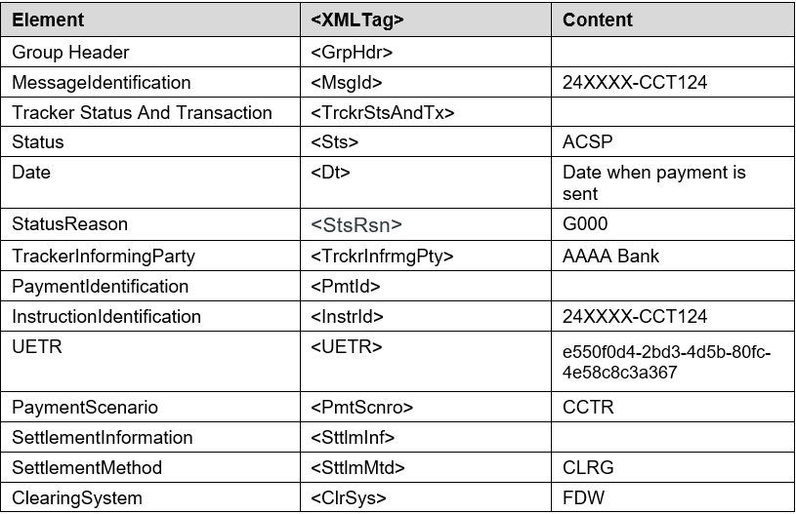
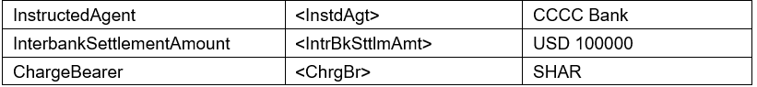

Message Instance Example 2
<AppHdr>
<Fr>
<FIId>
<FinInstnId>
<BICFI>CCCC Bank</BICFI>
</FinInstnId>
</FIId>
</Fr>
<To>
<FIId>
<FinInstnId>
<BICFI>TRCKCHZZXXX</BICFI>
</FinInstnId>
</FIId>
</To>
<BizMsgIdr>24XXXX-CCT126</BizMsgIdr>
<MsgDefIdr>trck.001.001.03</MsgDefIdr>
<BizSvc>swift.gpi.gcct.01</BizSvc>
<CreDt>2025-12-17T10:31:48.000Z</CreDt>
</AppHdr>
<PmtStsTrckrUpd>
<GrpHdr>
<MsgId>24XXXX-CCT126</MsgId>
</GrpHdr>
<TrckrStsAndTx>
<TxSts>
<Sts>ACCC</Sts>
</TxSts>
<Tx>
<TrckrInfrmgPty>
<Id>
<FinInstnId>
<BICFI>CCCCCCCC</BICFI>
</FinInstnId>
</Id>
</TrckrInfrmgPty>
<PmtId>
<InstrId>24XXXX-CCT124</InstrId>
<UETR>e550f0d4-2bd3-4d5b-80fc-4e58c8c3a367</UETR>
</PmtId>
<PmtScnro>
<Cd>CCTR</Cd>
</PmtScnro>
<TrckrData>
<ConfdDt>
<DtTm>2025-12-17T10:31:48.000Z</DtTm>
</ConfdDt>
<ConfdAmt Ccy="USD">100000</ConfdAmt>
</TrckrData>
</Tx>
</TrckrStsAndTx>
</PmtStsTrckrUpd>
</Document>
Business Data Example 3
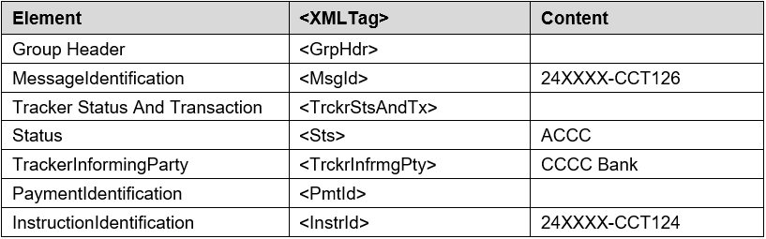
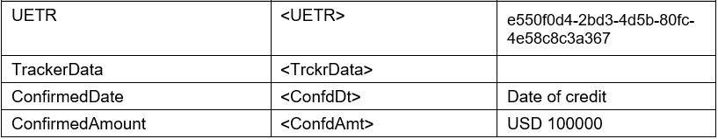

Message Instance Example 3
<AppHdr>
<Fr>
<FIId>
<FinInstnId>
<BICFI>CCCC Bank</BICFI>
</FinInstnId>
</FIId>
</Fr>
<To>
<FIId>
<FinInstnId>
<BICFI>TRCKCHZZXXX</BICFI>
</FinInstnId>
</FIId>
</To>
<BizMsgIdr>24XXXX-CCT126</BizMsgIdr>
<MsgDefIdr>trck.001.001.03</MsgDefIdr>
<BizSvc>swift.gpi.gcct.01</BizSvc>
<CreDt>2025-12-17T10:31:48.000Z</CreDt>
</AppHdr>
<PmtStsTrckrUpd>
<GrpHdr>
<MsgId>24XXXX-CCT126</MsgId>
</GrpHdr>
<TrckrStsAndTx>
<TxSts>
<Sts>ACCC</Sts>
</TxSts>
<Tx>
<TrckrInfrmgPty>
<Id>
<FinInstnId>
<BICFI>ABCDEFGH</BICFI>
</FinInstnId>
</Id>
</TrckrInfrmgPty>
<PmtId>
<InstrId>24XXXX-CCT124</InstrId>
<UETR>e550f0d4-2bd3-4d5b-80fc-4e58c8c3a367</UETR>
</PmtId>
<PmtScnro>
<Cd>CCTR</Cd>
</PmtScnro>
<TrckrData>
<ConfdDt>
<DtTm>2025-12-17T10:31:48.000Z</DtTm>
</ConfdDt>
<ConfdAmt Ccy="USD">100000</ConfdAmt>
</TrckrData>
</Tx>
</TrckrStsAndTx>
</PmtStsTrckrUpd>
</Document>

PaymentStatusTrackerReport Message - trck.002.001.03
Description
BBBB Bank, New York, has received a payment initiation request from its client ABC Corporation, New York. They initiate a payment clearing and settlement message towards the Creditor Agent using an Intermediary Agent. In parallel to the payment clearing and settlement message, BBBB Bank and subsequent Agents in the payment transaction inform a Tracking facility on the progress of the payment to the Creditor.
These examples cover three Payment Status Tracker Report messages that BBBB Bank, New York, receives from the Tracking facility allowing BBBB Bank to follow the progress of the status of the transaction:
The first confirms the initiation of a payment clearing and settlement message by BBBB Bank itself.
The second confirms that AAAA Bank, London has processed the payment clearing and settlement message onto the Payment Market Infrastructure.
The third confirms that CCCC Bank, London has credited the Creditor’s account.

Business Data Example 1
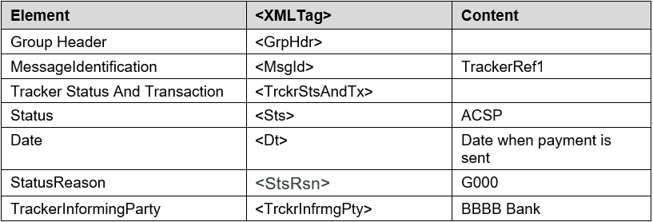
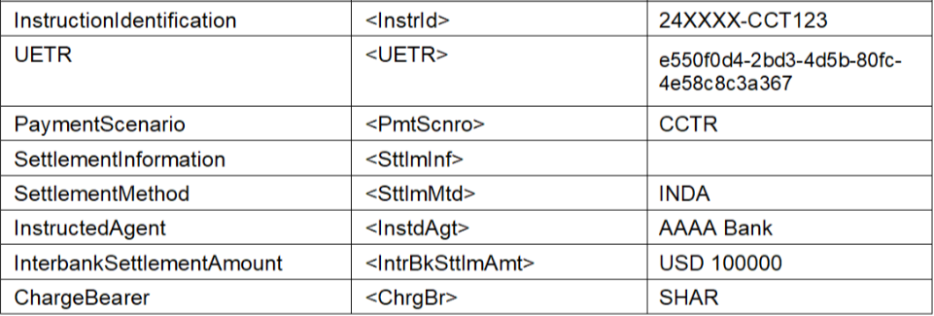

Message Instance Example 1
<AppHdr>
<Fr>
<FIId>
<FinInstnId>
<BICFI>TRCKCHZZXXX</BICFI>
</FinInstnId>
</FIId>
</Fr>
<To>
<FIId>
<FinInstnId>
<BICFI>BBBB Bank</BICFI>
</FinInstnId>
</FIId>
</To>
<BizMsgIdr>TrackerRef1</BizMsgIdr>
<MsgDefIdr>trck.002.001.02</MsgDefIdr>
<BizSvc>swift.gpi.gcct.01</BizSvc>
<CreDt>2025-12-17T09:31:47.000Z</CreDt>
</AppHdr>
<Document>
<PmtStsTrckrRpt>
<GrpHdr>
<MsgId>TrackerRef1</MsgId>
</GrpHdr>
<TrckrStsAndTx>
<TxSts>
<Sts>ACSP</Sts>
<Dt>
<DtTm>2025-12-17T09:31:47.000Z</DtTm>
</Dt>
<StsRsn>
<Rsn>
<Cd>G000</Cd>
</Rsn>
</StsRsn>
</TxSts>
<Tx>
<TrckrInfrmgPty>
<Id>
<FinInstnId>
<BICFI>BBBBBBBB</BICFI>
</FinInstnId>
</Id>
</TrckrInfrmgPty>
<PmtId>
<InstrId>24XXXX-CCT123</InstrId>
<UETR>e550f0d4-2bd3-4d5b-80fc-4e58c8c3a367</UETR>
</PmtId>
<PmtScnro>
<Cd>CCTR</Cd>
</PmtScnro>
<SttlmInf>
<SttlmMtd>INDA</SttlmMtd>
</SttlmInf>
<InstdAgt>
<FinInstnId>
<BICFI>AAAAAAAA</BICFI>
</FinInstnId>
</InstdAgt>
<IntrBkSttlmAmt Ccy="USD">100000</IntrBkSttlmAmt>
<ChrgBr>SHAR</ChrgBr>
<DbtrAgt>
<FinInstnId>
<BICFI>BBBBBBBB</BICFI>
</FinInstnId>
</DbtrAgt>
<CdtrAgt>
<FinInstnId>
<BICFI>CCCCCCCC</BICFI>
</FinInstnId>
</CdtrAgt>
</Tx>
</TrckrStsAndTx>
</PmtStsTrckrRpt>
</Document>
Business Data Example 2
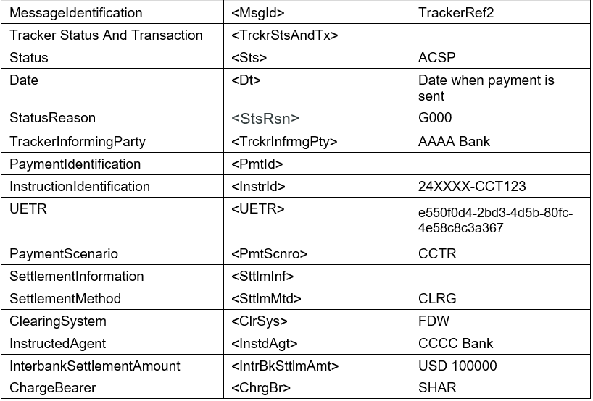

Message Instance Example 2

<AppHdr>
<Fr>
<FIId>
<FinInstnId>
<BICFI>TRCKCHZZXXX</BICFI>
</FinInstnId>
</FIId>
</Fr>
<To>
<FIId>
<FinInstnId>
<BICFI>BBBB Bank</BICFI>
</FinInstnId>
</FIId>
</To>
<BizMsgIdr>TrackerRef2</BizMsgIdr>
<MsgDefIdr>trck.002.001.02</MsgDefIdr>
<BizSvc>swift.gpi.gcct.01</BizSvc>
<CreDt>2025-12-17T10:30:47.000Z </CreDt>
</AppHdr>

<Document>
<PmtStsTrckrRpt>
<GrpHdr>
<MsgId>TrackerRef1</MsgId>
</GrpHdr>
<TrckrStsAndTx>
<TxSts>
<Sts>ACSP</Sts>
<Dt>
<DtTm>2025-12-17T09:31:47.000Z</DtTm>
</Dt>
<StsRsn>
<Rsn>
<Cd>G000</Cd>
</Rsn>
</StsRsn>
</TxSts>
<Tx>
<TrckrInfrmgPty>
<Id>
<FinInstnId>
<BICFI>ABCDEFGH</BICFI>
</FinInstnId>
</Id>
</TrckrInfrmgPty>
<PmtId>
<InstrId>24XXXX-CCT123</InstrId>
<UETR>e550f0d4-2bd3-4d5b-80fc-4e58c8c3a367</UETR>
</PmtId>
<PmtScnro>
<Cd>CCTR</Cd>
</PmtScnro>
<SttlmInf>
<SttlmMtd>INDA</SttlmMtd>
</SttlmInf>
<InstdAgt>
<FinInstnId>
<BICFI>AAAAAAAA</BICFI>
</FinInstnId>
</InstdAgt>
<IntrBkSttlmAmt Ccy="USD">100000</IntrBkSttlmAmt>
<ChrgBr>SHAR</ChrgBr>
<DbtrAgt>
<FinInstnId>
<BICFI>BBBBBBBB</BICFI>
</FinInstnId>
</DbtrAgt>
<CdtrAgt>
<FinInstnId>
<BICFI>CCCCCCCC</BICFI>
</FinInstnId>
</CdtrAgt>
</Tx>
</TrckrStsAndTx>
</PmtStsTrckrRpt>
</Document>

Business Data Example 3
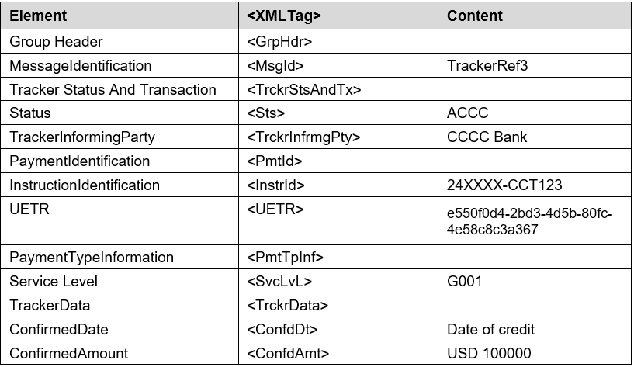

Message Instance Example 3
<AppHdr>
<Fr>
<FIId>
<FinInstnId>
<BICFI>TRCKCHZZXXX</BICFI>
</FinInstnId>
</FIId>
</Fr>
<To>
<FIId>
<FinInstnId>
<BICFI>BBBB Bank</BICFI>
</FinInstnId>
</FIId>
</To>
<BizMsgIdr>TrackerRef3</BizMsgIdr>
<MsgDefIdr>trck.002.001.02</MsgDefIdr>
<BizSvc>swift.gpi.gcct.01</BizSvc>
<CreDt>2025-12-17T10:31:48.000Z</CreDt>
</AppHdr>
<Document>
<PmtStsTrckrRpt>
<GrpHdr>
<MsgId>TrackerRef3</MsgId>
</GrpHdr>
<TrckrStsAndTx>
<TxSts>
<Sts>ACCC</Sts>
</TxSts>
<Tx>
<TrckrInfrmgPty>
<Id>
<FinInstnId>
<BICFI>BANKCUS33XX</BICFI>
</FinInstnId>
</Id>
</TrckrInfrmgPty>
<PmtId>
<InstrId>24XXXX-CCT123</InstrId>
<UETR>e550f0d4-2bd3-4d5b-80fc-4e58c8c3a367</UETR>
</PmtId>
<PmtScnro>
<Cd>CCTR</Cd>
</PmtScnro>
<TrckrData>
<ConfdDt>
<DtTm>2025-12-17T10:31:48.000Z</DtTm>
</ConfdDt>
<ConfdAmt Ccy="USD">100000</ConfdAmt>
</TrckrData>
</Tx>
</TrckrStsAndTx>
</PmtStsTrckrRpt>
</Document>

PaymentStatusCustomerTrackerReport - trck.004.001.03

Description

BBBB Bank, New York, has received a payment initiation request from its client ABC Corporation, New York. They initiate a payment clearing and settlement message towards the Creditor Agent using an Intermediary Agent. In parallel to the payment clearing and settlement message, BBBB Bank and subsequent Agents in the payment transaction inform a Tracking facility on the progress of the payment to the Creditor. BBBB Bank can then keep the Debtor, ABC Corporation, informed and/or CCCC Bank can keep the Creditor, DEF Electronics, informed on the payment’s progress and any unexpected delays or issues with the payment.
This example covers a PaymentStatusCustomerTrackerReport where the Tracker facility provides a notification to the outbound customer (of BBBB Bank, New York) containing status and transactional information. The message is the last one the Tracker facility generates and sends which includes the ACCC status as well as some historical information about previous events (i.e. the first and second legs of the payment transaction).

Business Data Example
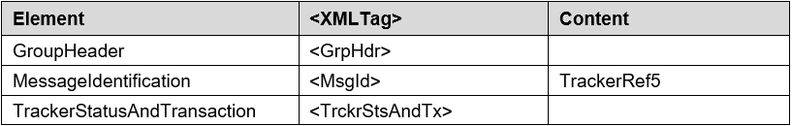
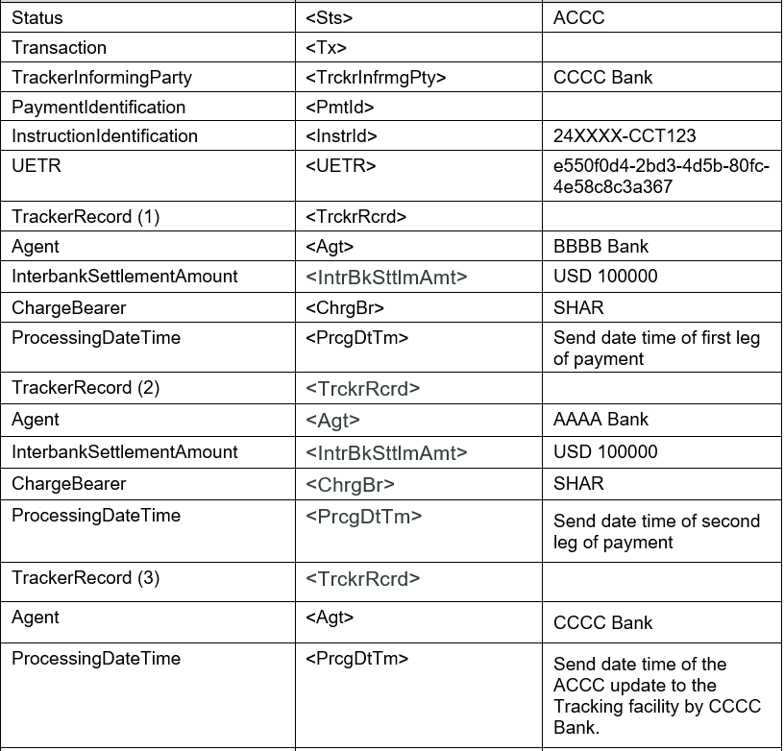
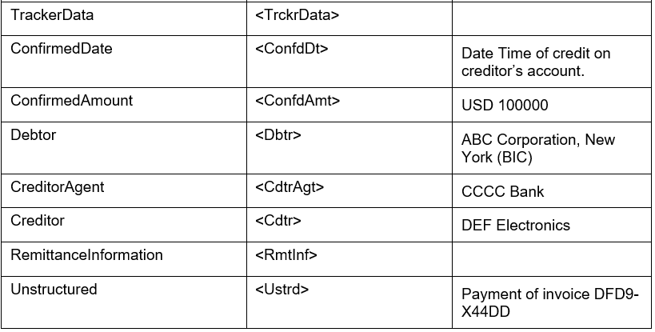

Message Instance Example
<AppHdr>
<Fr>
<FIId>
<FinInstnId>
<BICFI>TRCKCHZZXXX</BICFI>
</FinInstnId>
</FIId>
</Fr>
<To>
<OrgId>
<OrgId>
<AnyBIC>ABC Corporation, New York (BIC)</AnyBIC>
</OrgId>
</OrgId>
</To>
<BizMsgIdr>TrackerRef5</BizMsgIdr>
<MsgDefIdr>trck.004.001.02</MsgDefIdr>
<BizSvc>swift.gpi.g4c.01</BizSvc>
<CreDt>2025-08-12T12:59:26.00Z</CreDt>
</AppHdr>
<Document>
<PmtStsCstmrTrckrRpt>
<GrpHdr>
<MsgId>ABC1234</MsgId>
</GrpHdr>
<TrckrStsAndTx>
<TxSts>
<Sts>ACCC</Sts>
</TxSts>
<Tx>
<TrckrInfrmgPty>
<Id>
<FinInstnId>
<BICFI>CCCCCCCC</BICFI>
</FinInstnId>
</Id>
</TrckrInfrmgPty>
<PmtId>
<UETR>e550f0d4-2bd3-4d5b-80fc-4e58c8c3a367</UETR>
</PmtId>
<IntrBkSttlmDt>2025-08-12</IntrBkSttlmDt>
<InstdAmt Ccy="EUR">100000</InstdAmt>
<TrckrRcrd>
<PtyOrAgtId>
<Id>
<FinInstnId>
<BICFI>BBBBBBBB</BICFI>
</FinInstnId>
</Id>
</PtyOrAgtId>
<IntrBkSttlmAmt Ccy="USD">100000</IntrBkSttlmAmt>
<ChrgBr>SHAR</ChrgBr>
<PrcgDtTm>2025-08-12T12:50:20.00Z </PrcgDtTm>
</TrckrRcrd>
<TrckrRcrd>
<PtyOrAgtId>
<Id>
<FinInstnId>
<BICFI>AAAAAAAA</BICFI>
</FinInstnId>
</Id>
</PtyOrAgtId>
<IntrBkSttlmAmt Ccy="USD">100000</IntrBkSttlmAmt>
<ChrgBr>SHAR</ChrgBr>
<PrcgDtTm>2025-08-12T12:52:20.00Z </PrcgDtTm>
</TrckrRcrd>
<TrckrRcrd>
<PtyOrAgtId>
<Id>
<FinInstnId>
<BICFI>CCCCCCCC</BICFI>
</FinInstnId>
</Id>
</PtyOrAgtId>
<PrcgDtTm>2025-08-12T12:59:26.00Z</PrcgDtTm>
</TrckrRcrd>
<TrckrData>
<ConfdDt>
<DtTm>2025-08-12T12:59:26.00Z</DtTm>
</ConfdDt>
<ConfdAmt Ccy="EUR">100000</ConfdAmt>
</TrckrData>
</Tx>
</TrckrStsAndTx>
</PmtStsCstmrTrckrRpt>
</Document>

Revision Record

Revision | Date | Author | Description | Sections affected

Disclaimer:
Although the Registration Authority has used all reasonable efforts to ensure accuracy of the contents of the iso20022.org website and the information published thereon, the Registration Authority assumes no liability whatsoever for any inadvertent errors or omissions that may appear thereon. Moreover, the information is provided on an "as is" basis. The Registration Authority disclaims all warranties and conditions, either express or implied, including but not limited to implied warranties of merchantability, title, non-infringement and fitness for a particular purpose.
The Registration Authority shall not be liable for any direct, indirect, special or consequential damages arising out of the use of the information published on the iso20022.org website, even if the Registration Authority has been advised of the possibility of such damages.

Intellectual Property Rights:
The ISO 20022 MessageDefinitions described in this document were contributed by Swift. The ISO 20022 IPR policy is available at www.ISO20022.org > About ISO 20022 > Intellectual Property Rights.

