**Hadoop Exercise -7**

**Question) Implement a simple map-reduce code for the wordcount problem using Java. Create the jar files and run the code using HDFS.**

1. The following is the directory structure in my Ubuntu WSL:

/home/hadoop/hadoop/

├── wordcount_java/

├── input.txt/

├── WordCount.java/

├── all the wordcount classes/

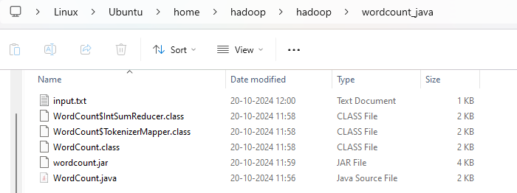

1. The following is the structure in HDFS (or) Browser Directory:

/hadoop/ (user)

├── hadoop/ (parent folder)

├── wordcount_java/

├── input/

├── input.txt/

├── output/

├── _SUCCESS/

├── part-r-00000/

1. Start All Hadoop Daemons

1. Setting up the directory structure

1. Write the WordCount java program



import java.io.IOException;

import org.apache.hadoop.conf.Configuration;

import org.apache.hadoop.fs.Path;

import org.apache.hadoop.io.*;

import org.apache.hadoop.mapreduce.*;

import org.apache.hadoop.mapreduce.lib.input.FileInputFormat;

import org.apache.hadoop.mapreduce.lib.output.FileOutputFormat;

public class WordCount {

public static class TokenizerMapper extends Mapper<LongWritable, Text, Text, IntWritable> {

private final static IntWritable one = new IntWritable(1);

private Text word = new Text();

public void map(LongWritable key, Text value, Context context) throws IOException, InterruptedException {

String[] words = value.toString().split("\\s+");

for (String str : words) {

word.set(str);

context.write(word, one);

}

}

}

public static class IntSumReducer extends Reducer<Text, IntWritable, Text, IntWritable> {

private IntWritable result = new IntWritable();

public void reduce(Text key, Iterable<IntWritable> values, Context context) throws IOException, InterruptedException {

int sum = 0;

for (IntWritable val : values) {

sum += val.get();

}

result.set(sum);

context.write(key, result);

}

}

public static void main(String[] args) throws Exception {

Configuration conf = new Configuration();

Job job = Job.getInstance(conf, "word count");

job.setJarByClass(WordCount.class);

job.setMapperClass(TokenizerMapper.class);

job.setCombinerClass(IntSumReducer.class);

job.setReducerClass(IntSumReducer.class);

job.setOutputKeyClass(Text.class);

job.setOutputValueClass(IntWritable.class);

FileInputFormat.addInputPath(job, new Path(args[0]));

FileOutputFormat.setOutputPath(job, new Path(args[1]));

System.exit(job.waitForCompletion(true) ? 0 : 1);

}

}

1. Compile the Java Code

NOTE: THE BELOW COMMAND GIVES ERROR BECAUSE OF THE APOSTROPHE STYLE



USE THE BELOW COMMAND WITH THE CORRECT APOSTROPHE



1. Create the JAR file



1. Create the input directory in HDFS



1. Run the MapReduce Job

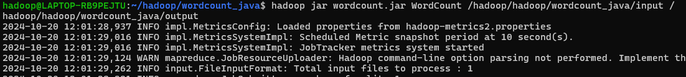

1. View the output



1. Stop all Daemons

