**Indian Institute of Engineering Science & Technology, Shibpur**

**Department of Computer Science & Technology**

**Artificial Intelligence Laboratory 2025 CS 4271**

**ASSIGNMENT – 03**

**NAME - RAKSHA PAHARIYA**

**ENROLLMENT NO - 2021CSB029**

<https://colab.research.google.com/drive/1Nd7RWx_4GvsZwz-wg9vbvxO359VPUUeD?usp=sharing>

**Question 1 :** A disaster has struck a futuristic smart city, and your task is to develop an AI-powered drone navigation system to rescue stranded survivors. The drone must autonomously navigate through the city, avoiding obstacles like collapsed buildings and fire zones while optimizing for the fastest route (equivalent to minimum energy consumption).

Your objective is to implement the A Search Algorithm* to guide the drone from its starting position (S) to rescue multiple survivors (G1, G2, ... , Gn) (intermediate states) and return to base (B) (treated as goal state) while minimizing energy consumption and ensuring safe traversal.

Grid Representation of the City (State Space Representation of the City): The smart city is represented as a 3D grid where each (𝒙,𝒚,𝒛) coordinate defined as: (𝑥,𝑦) in the 2D coordinate and z values is the depth of flying at different levels. Each of the depth ‘𝑧’ is represented by different notations as:

Roads & Open Spaces (0) → The drone can fly here.

Buildings/Collapsed Structures (1) → The drone cannot pass through.

Fire Zones (F) → High-risk zones. Passing through incurs an extra cost.

Survivor Locations (𝐺,𝐺 ,...,𝐺) → The drone must visit and rescue them. • Recharging Stations (R) → The drone can stop and recharge energy if needed.

Base Station (B) → The drone must return here after completing the mission.

Drone’s Start Position (S) → Where the drone begins.

Drone Movement and Cost Considerations:

a) The drone moves in 3D space:

Up (x, y, z+1)

Down (x, y, z-1)

North (x-1, y, z)

South (x+1, y, z),

East (x, y+1, z)

West (x, y-1, z).

Diagonal movements (like flying at an angle) are not allowed for simplicity.

b) Energy Consumption Factor:

Moving through clear space (0) costs 1 energy unit.

Moving through fire zones (F) costs 3 energy units due to turbulence.

Moving upwards (z+1) costs extra 2 energy units, while descending (z-1) costs 1 energy unit.

c) Objective:

The drone must rescue all survivors before returning to base (B).

The optimal path minimizes total energy consumption.

If needed, the drone can recharge at (R), but stopping at a station adds a fixed time penalty.

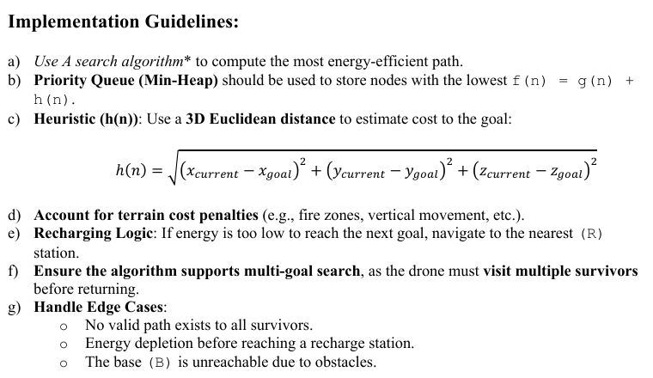

**Solution 1 :**

import heapq

import math

from collections import deque

**OUTPUTS :**