Assignment 2
ML as a Service

Ratnadeep Patra
Student ID: 26294153

2026 SPRING

Github Username | RP28
Github Repos | Experiment Repo: https://github.com/RP28/36120-26SP-AT2-26294153-experiments  Package Repo: https://github.com/RP28/36120-26SP-group13-26294153-package  API Repo: https://github.com/RP28/36120-26SP-AT2-26294153-api
URLs | Render: https://three6120-26sp-at2-26294153-api.onrender.com/docs

36120 - Advanced Machine Learning Application
Master of Data Science and Innovation
University of Technology of Sydney
Table of Contents

1. Executive Summary 2
2. Business Understanding 3
a. Business Use Cases 3
b. Key Objectives 3
3. Data Understanding 4
4. Data Preparation 5
5. Modeling 6
6. Evaluation 7
a. Results and Analysis 7
b. Business Impact and Benefits 8
c. Ethical Considerations 9
7. Deployment Architecture 15
8. Conclusion 10
9. References 11

Executive Summary
This project develops a Sydney weather-intelligence ML service with two outputs. It forecasts Climate Comfort Index, or CCI, for 1, 2 and 3 days ahead and Weather Hazard Category, or WHC, exactly 7 days ahead. The business focus is not only routine weather. Low CCI values can indicate unusually uncomfortable periods that need contingency planning, while high CCI values can identify favourable operating windows. High and Extreme WHC labels are especially important because they are the conditions most likely to require closer operational review.
The design uses only information that can realistically be available before prediction. Daily predictors are lagged by one day because totals, maxima and other full-day aggregates are not complete until the day ends. Historical Open-Meteo data is collected in yearly chunks. A ThreadPool approach was not used to fetch data from Open-metro API because parallel calls produced HTTP 429 rate-limit responses, so the final pipeline fetches chunks sequentially and uses caching, response validation, retries and back-off for reliability.
The deployed CCI model is Experiment 2 Weighted Elastic Net. Test RMSE is 9.4873, 9.8465 and 10.0501 for the 1-day, 2-day and 3-day horizons. MAE is 7.1589, 7.4537 and 7.6371, while R squared is 0.3063, 0.2533 and 0.2220. RMSE improves on the training-mean baseline by 18.72%, 15.67% and 13.93%. Tail MAE remains higher at 13.56, 14.90 and 15.70 points, indicating that the model is comparatively less accurate when forecasting unusually low or high CCI values than under typical conditions.
The deployed WHC model is Experiment 2 Elastic-Net Logistic Regression with proportion-aware SMOTE. Test severity-weighted recall is 0.2077 and macro F1 is 0.2397. Of 37 actual High or Extreme Risk events, 5 are detected, giving 13.51% hazardous-event recall. The model produces 180 High or Extreme alerts, with 2.78% precision and 175 false alerts, so it is only a supplementary escalation signal.
Production monitoring should prioritise the predictors identified as most influential during model evaluation. For CCI, permutation-importance analysis highlighted previous-day CCI, the 3-day and 30-day CCI EWM histories, daylight, and temperature and pressure histories as important predictors across the three forecast horizons. For WHC, individual feature importances were less stable, but WHI history, seasonal context and wind-interaction features provided some of the more informative signals and should therefore be monitored together. Monitoring should also track source-data freshness, CCI tail error, and the frequency and recall of High and Extreme WHC events to detect both input drift and deterioration in model performance.

Business Understanding

Business Use Cases
CCI supports short-term planning for weather-sensitive activities such as outdoor events, tourism, field work and venue operations. It summarises several weather conditions into a single comfort score from 0 to 100. While overall forecast accuracy is important, the extreme ends of the CCI range are particularly relevant for planning. Low CCI values may indicate uncomfortable conditions where schedule changes, shelter or backup arrangements could be considered, whereas high CCI values can indicate favourable conditions for outdoor activities. For this reason, the regression models are evaluated using both overall prediction error and the error specifically observed for low and high CCI values.
WHC serves a different purpose by identifying potentially hazardous weather conditions for transport, outdoor work, events and infrastructure planning. It classifies each forecast as Low, Moderate, High or Extreme Risk. High and Extreme Risk conditions are especially important because these are the situations most likely to require additional safety checks, contingency planning, operational changes or closer review of authoritative weather information. Missing these events could therefore have more serious consequences than misclassifying routine Low or Moderate conditions. For this reason, the evaluation does not rely only on overall classification performance. Hazardous-event recall is used to measure how many actual High and Extreme Risk events are detected, while alert precision measures how often High or Extreme alerts issued by the model are correct.
CCI combines temperature, humidity, wind, cloud and rain into a single comfort measure. WHI combines precipitation, wind gusts, cloud, snow and temperature hazards before mapping the result to WHC. Machine learning forecasts these derived outcomes from prior weather and temporal context. For CCI, the aim is useful numerical accuracy with special attention to unusually low and high comfort conditions. For WHC, the aim is to identify High and Extreme Risk conditions that may require safety checks, contingency planning or operational changes, while separately evaluating both missed hazardous events and false alerts.

Key Objectives
- Produce reproducible and leakage-safe forecasts that improve on simple historical baselines. For CCI, maintain useful overall RMSE and MAE while reducing error in the lower and upper tails. For WHC, increase sensitivity to High and Extreme Risk events while measuring the false alerts created by that sensitivity.
- Operationalise the selected models as reusable pipelines and a date-based API, with training-time preprocessing reproduced at inference. Monitoring should cover constant model evaluation metric checks and monitoring crucial model predictors.

Data Understanding
The project uses Sydney historical weather from the Open-Meteo archive for 1 January 2000 to 31 December 2025. The data layer collects hourly and daily variables and produces 9,497 daily records before supervised-target and temporal-context trimming. Exploratory data analysis (EDA) was used here to understand distributions, seasonality, class imbalance, skew, redundancy and relationships in the observed data before modelling.
CCI is calculated deterministically from daily mean temperature, relative humidity, wind speed and cloud cover plus daily precipitation total. Its weighted components are temperature 35%, humidity 20%, and wind, cloud and rain 15% each. WHI uses precipitation and wind-gust hazards at 30% each, cloud at 20%, and snow and temperature at 10% each. WHC then maps WHI to four ordered classes: <25 Low, 25-<50 Moderate, 50-<75 High and >=75 Extreme Risk.
After exact calendar-date targets and one-day lagging, the CCI task contains 9,493 supervised rows and the WHC task 9,489 rows. CCI has mean 72.60, standard deviation 10.16 and range 28.63-98.89. Its future targets remain centred in the comfortable range but contain meaningful lower and upper tails. WHC is much more imbalanced: 5,239 Low Risk (55.21%), 3,965 Moderate Risk (41.79%), 274 High Risk (2.89%) and only 11 Extreme Risk observations (0.12%). This imbalance is a central modelling difficulty because ordinary accuracy can look strong while severe events are missed.
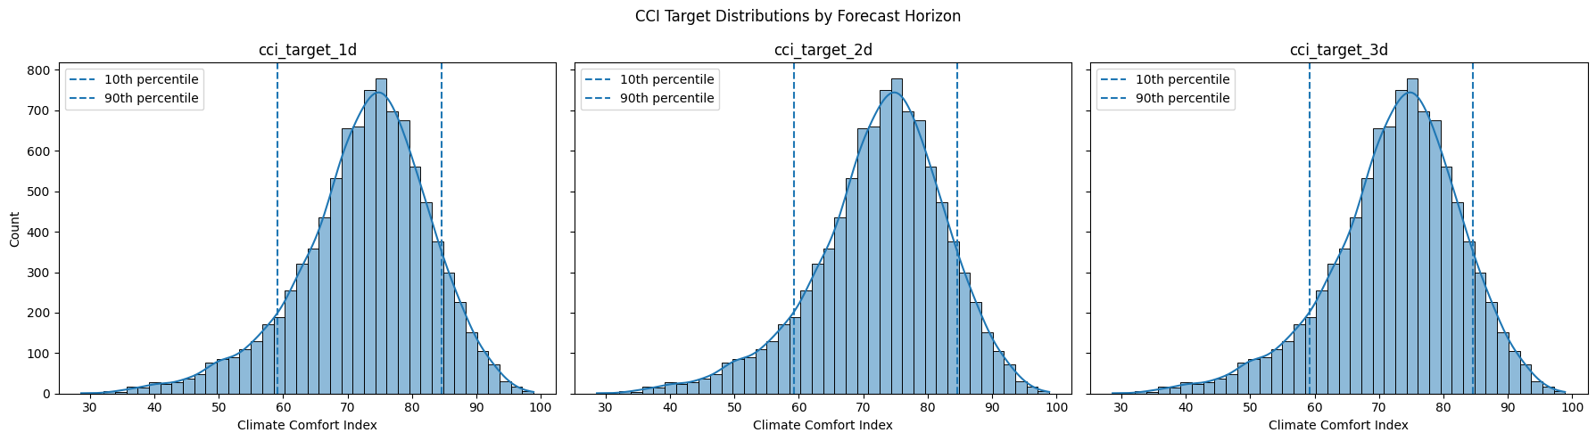
Figure 1. CCI target distributions for the 1-, 2- and 3-day horizons, with lower and upper 10% tails marked (Experiment 1).
EDA showed a strong annual cycle in CCI, substantial day-to-day persistence, and groups of highly correlated weather summaries within temperature, moisture, wind, cloud and pressure families. Precipitation-related variables were strongly right-skewed, while direction variables required circular rather than ordinary linear treatment. For WHC, the dominant data characteristic was severe-class sparsity, together with seasonal changes in class mix. These observations motivated representative feature selection, log transformation of precipitation, cyclic seasonal encoding and historical-context features. Model-derived importance is deliberately evaluated later, after fitting, rather than being treated as EDA evidence.
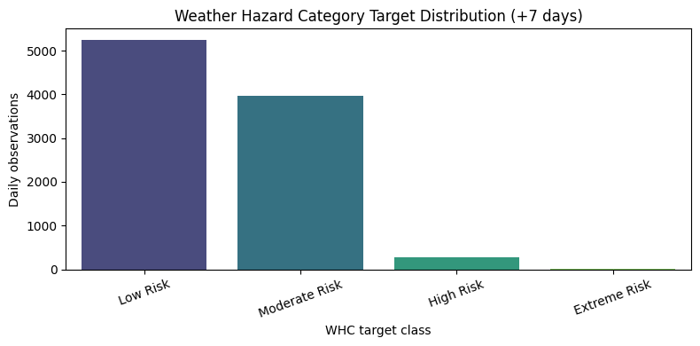
Figure 2. WHC +7-day target distribution, showing the scarcity of High and especially Extreme Risk observations (Experiment 1).

Data Preparation
The reusable data module validates requested dates and collects Open-Meteo data in full-calendar-year chunks for experimentation. A ThreadPool approach was tested, but parallel requests caused HTTP 429 rate-limit responses, so the final implementation retrieves yearly chunks sequentially. Responses are checked for requested dates and variables, valid responses can be cached, and remaining 429 responses use Retry-After when available or increasing back-off before retrying. Duplicate timestamps are removed and records are sorted.
Hourly weather is aggregated to daily statistics using summaries that match the target definitions. All predictors are lagged by one day or more because same-day daily aggregates are not fully known when the forecast is requested. For forecast origin $d$, the latest complete raw weather is therefore $d-1$. Targets remain fixed to future calendar dates, giving CCI predictions for $d+1$, $d+2$ and $d+3$ and WHC for $d+7$. During serving, the API fetches history through $d-1$ and shifts only the row date forward so fitted preprocessing sees the same alignment used in training. This is the main leakage control and keeps offline evaluation consistent with live feature availability.
Skewed precipitation is transformed with $log⁡(1+x)$. Historical index context is represented with exponentially weighted means (EWMs), which smooth a sequence while giving newer observations more influence than older ones. With adjust=False, the recursive form is:
$${EWM}_{t}=a* x_{t}+\left(1-a\right)* {EWM}_{t-1}, a= \frac{2}{span+1}$$
CCI retains 3-day and 30-day EWMs of previous-day CCI to capture short and longer memory, while WHC retains a 30-day EWM of previous-day WHI. Because each series begins from already lagged t-1 values, these summaries remain available at forecast time.
Seasonality is encoded with harmonics rather than raw day-of-year. For angle $Θ=2π\frac{day of year-1}{days in year}$, each harmonic k contributes $sin⁡(kΘ)$ and $cos⁡(kΘ)$, so 31 December and 1 January remain adjacent in feature space. For CCI, one harmonic explains 69.3% of the mean annual profile, two explain 78.8% and three 81.8%. The first two are retained because the third adds comparatively little. WHC retains three annual harmonics because its third harmonic adds more seasonal structure. Dominant wind direction is also circular and is represented by a selected sine-cosine harmonic instead of raw degrees.
Additional CCI features include temperature–radiation interactions to capture how thermal conditions and solar exposure act together, along with smoothed temperature and pressure features that represent recent weather trends rather than isolated daily fluctuations. WHC preprocessing similarly includes historical WHI features to provide context on recent hazard conditions, together with weather-interaction terms that capture combinations of conditions that may be more informative for hazard prediction than individual variables alone.
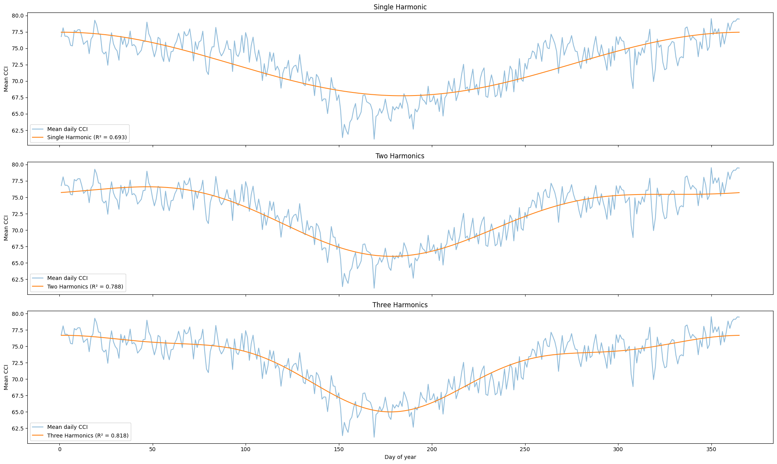
Figure 3. Mean annual CCI profile compared with one-, two- and three-harmonic fits. The two-harmonic representation captures most seasonal structure with lower complexity.
The split is chronological: training ends in 2021, validation covers 2022-2023 and test covers 2024-2025. After final data preparation, CCI has 8,006/730/728 rows and WHC 8,006/730/724. Feature scaling is fitted using training data only. Sample-weighting strategies for CCI and SMOTE configurations for WHC are applied only to the training data, but their hyperparameters are tuned based on validation performance. The validation set therefore guides model and hyperparameter selection without being directly resampled or used to fit preprocessing statistics, while the test set remains untouched until final evaluation.

Modeling
The experiments are intentionally sequential. CCI starts with Elastic Net (Experiment 1), adds target-based weighting to the same linear model (Experiment 2), then tests Random Forest and XGBoost capacity (Experiment 3). WHC starts with Elastic-Net Logistic Regression, then adds proportion-aware SMOTE, and finally tests tree alternatives using the same minority-class treatment. This structure allows each experiment to answer a specific limitation identified in the previous one rather than changing many factors at once.
The custom WeightedRegressor wraps any scikit-learn regressor that accepts sample_weight. For each training target $y_{i}$ it first measures distance from the training median using
$$d_{i}= \frac{|y_{i}-median(y)|}{IQR(y)}$$
Linear weighting uses $w_{i}=min⁡(w_{max}, 1+s* d_{i})$, while quadratic weighting uses $w_{i}=\min\left(w_{max}, 1+s* { d_{i}}^{2}\right)$. The selected weighted Elastic Net therefore minimises a weighted squared-error term plus the usual Elastic-Net L1/L2 penalty. Unusual low and high CCI values contribute more to fitting, but the maximum weight of 3 prevents a small number of tail observations from dominating the model.
The custom SMOTEClassifier applies oversampling only inside fit(). If $n_{c}$ is a class count and $n_{max}$ the majority count, rarity is
$$r_{c}=1- \frac{n_{c}}{n_{max}}$$
and the target count is
$${n_{c}}^{'}=min⁡(ceil\left[n_{c}+ n_{c}\left(m-1\right)r_{c}\right], n_{max})$$
where m is the sampling multiplier. Thus the rarest classes receive close to the requested multiplier while classes already near the majority receive much less oversampling. Standard SMOTE then forms a synthetic point between neighbouring minority samples. Validation, test and inference records are never resampled. The wrapper then fits Elastic-Net Logistic Regression to the resampled training set.
Residual and confusion analyses drive the experiment flow. CCI Experiment 1 residuals are roughly centred but errors are much larger in the lowest and highest target quantiles than in the central 25-75% range, motivating Experiment 2 weighting. After weighting, tail MAE improves, but validation residual means still change systematically across smoothed temperature and pressure ranges, suggesting remaining nonlinear or threshold-dependent structure and motivating Experiment 3.
For WHC, the baseline confusion matrix shows poor severe-class detection. SMOTE in Experiment 2 increases High/Extreme sensitivity, but its confusion matrix and pairwise boundary analysis reveal substantial overlap around the High Risk class, motivating nonlinear trees. Experiment 3 does not improve the severe-event objective because its selected tree model detects no High/Extreme test events.
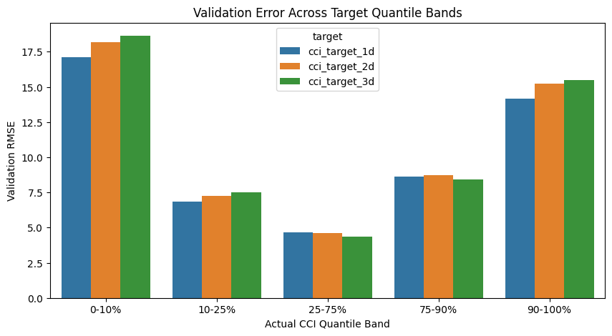
Figure 4. Experiment 1 validation RMSE by CCI target quantile band. The much larger tail errors provide direct evidence for testing target-weighted regression in Experiment 2.
Manual parameter searches narrow sensible regions before Optuna tuning on the validation period. CCI Experiment 2 selects linear weighting for 1 day and quadratic weighting for 2 and 3 days, with strongly L1-dominant Elastic-Net solutions. WHC Experiment 2 selects sampling multiplier 11.3577, k-neighbours 7, C=0.0049 and l1_ratio=0.7712. Final selection is based on validation behaviour and business-specific diagnostics, not whichever model happens to achieve the lowest final test number. The API serves the Experiment 2 CCI and WHC workflows using the same fitted transformations as training.

Evaluation

Results and Analysis
Final CCI model performance is summarised in Table 1. Accuracy gradually weakens as the forecast horizon increases, while the higher tail MAE shows that unusually low and high CCI values remain more difficult to predict than typical conditions.
Table 1. Final Experiment 2 CCI test performance by forecast horizon.
Metric | 1-day | 2-day | 3-day
Test RMSE | 9.4873 | 9.8465 | 10.0501
Test MAE | 7.1589 | 7.4537 | 7.6371
Test R² | 0.3063 | 0.2533 | 0.2220
RMSE improvement vs training-mean baseline | 18.72% | 15.67% | 13.93%
Tail MAE | 13.56 | 14.90 | 15.70

Although Experiment 3 achieves lower final-test RMSE, its validation RMSE is higher than Experiment 2 at each horizon. The pre-defined validation criterion therefore supports the weighted model and avoids selecting a model after observing the test period. This keeps the final choice aligned with the planned evaluation protocol rather than post-hoc test performance.
The predicted-versus-actual plots make the main CCI error pattern visible: predictions occupy a narrower band than the observed values, particularly as the horizon increases. Weighting improves tail error but does not eliminate regression toward the centre. Residual analysis therefore suggests that limited future signal and remaining nonlinear structure still constrain performance.
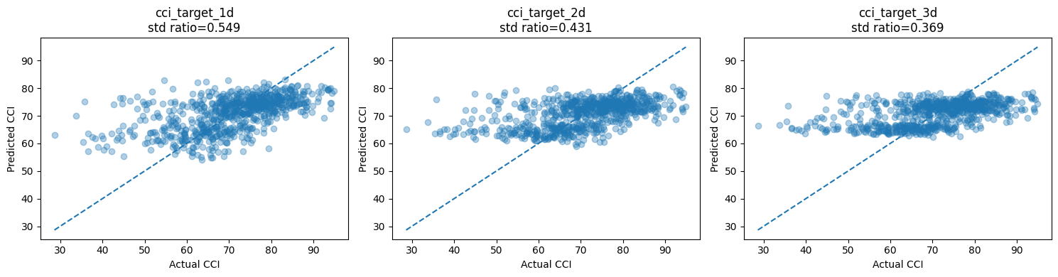
Figure 5. Experiment 2 CCI test predictions versus actual values. The 45-degree line shows ideal predictions; the compressed vertical spread illustrates regression toward the centre.
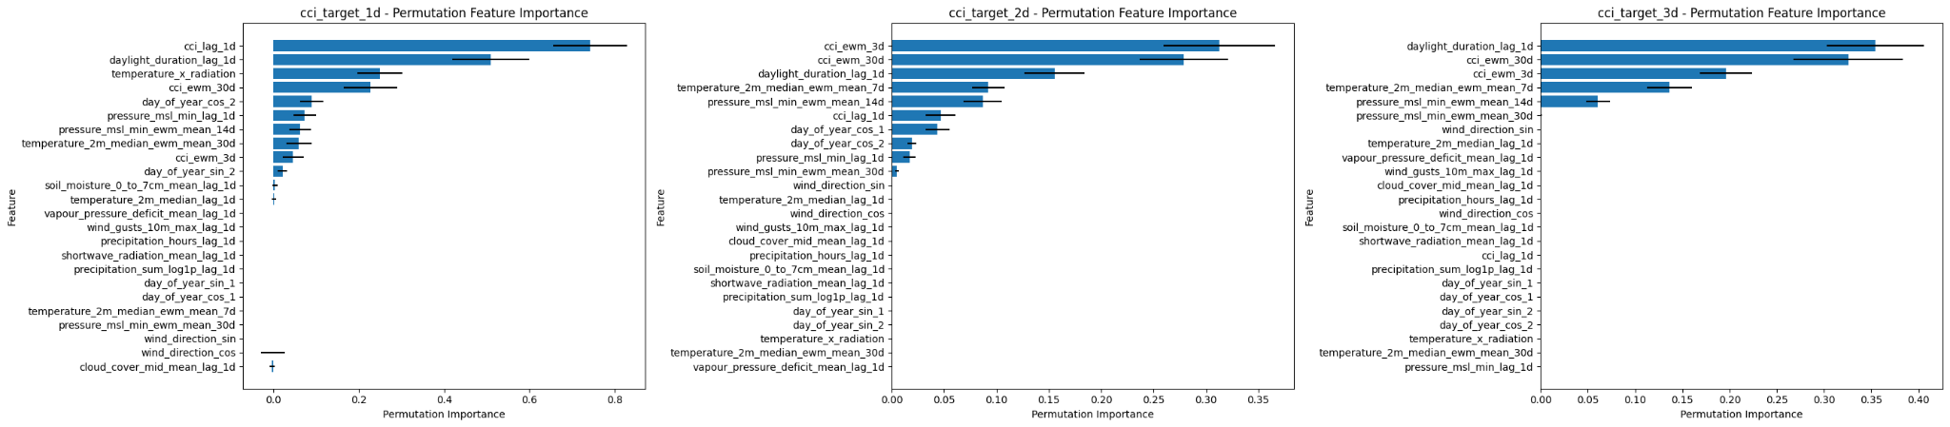
Figure 6. Permutation importance for the served CCI model across the 1-day, 2-day and 3-day forecast horizons. Immediate persistence dominates at 1 day, while smoothed CCI histories become more important at longer horizons.
Permutation importance is used only after fitting as a post-hoc sensitivity diagnostic on held-out test data. Figures 6 and 7 visualise the importance. For the served CCI model, previous-day CCI and daylight are the strongest predictors at the 1-day horizon, while the 3-day and 30-day CCI EWMs become more influential at 2 and 3 days. These patterns show that short-horizon forecasts depend heavily on immediate persistence, whereas longer-horizon forecasts rely more on smoothed historical context and seasonal structure. These values describe how much test score degrades when an input is permuted, so they are useful for monitoring but should not be interpreted as causal effects.
WHC shows a different failure mode. Experiment 1 detects 3 of 37 High or Extreme test events, Experiment 2 detects 5 of 37, and Experiment 3 detects none. Thus Experiment 2 raises hazardous-event recall from 8.11% to 13.51%, but at the cost of 175 false High or Extreme alerts and a precision of only 2.78%. Figure 7 also shows that WHC permutation importances are small and unstable relative to CCI, which is consistent with the difficulty of learning a reliable severe-event boundary from limited predictive signal. The Experiment 2 test confusion matrix explains the trade-off directly: only 5 of 36 High Risk days are correctly labelled High, the single Extreme day is predicted Low, and many Low or Moderate days are promoted to High. Most errors occur between neighbouring or overlapping severity regions, so the model is unsuitable as an autonomous warning system.
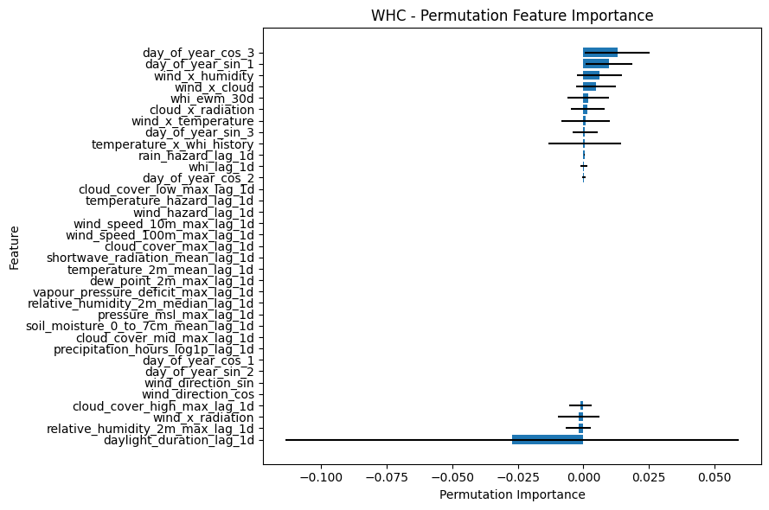
Figure 7. Permutation importance for the served WHC model. The small and unstable values reinforce that no single predictor provides a strong, reliable separation of hazardous classes on the test period.
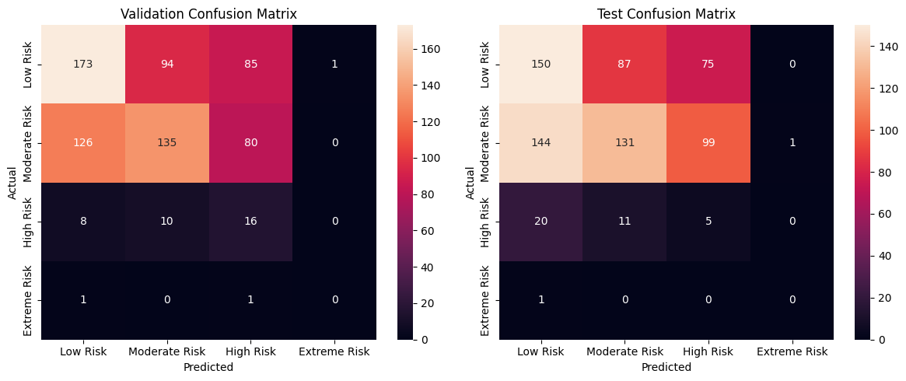
Figure 8. Experiment 2 WHC validation and test confusion matrices. Increased severe-class sensitivity is visible, but so is the large false-alert burden and weak Extreme Risk separation.

Business Impact and Benefits
The final CCI service converts many weather inputs into a directly consumable 1-day to 3-day comfort forecast. On test data, about 60%, 58% and 57% of predictions are within 7 CCI points and 75%, 73% and 73% are within 10 points. The 90th percentile absolute error is 15.10, 15.98 and 17.04 points. Mean signed error is 0.34, 0.18 and 0.47 points, showing little overall directional bias even though larger individual errors remain.
The main business limitation is at the CCI extremes. Tail MAE is 13.56, 14.90 and 15.70 points, around twice the overall MAE. These are the periods most likely to change a decision. Very low comfort may justify contingency actions, while very high comfort may identify a favourable operating window. Because the model pulls some extreme values toward the centre, tail forecasts should be checked against the underlying weather variables and interpreted with wider tolerance rather than as exact scores.
WHC has a more restrictive business role because its rarest labels are also the most important. The test period contains 36 High Risk days and 1 Extreme Risk day. The model issues 180 High or Extreme alerts and catches 5 of 37 actual hazardous events. Hazardous-event recall is 13.51% and alert precision is 2.78%. It misses 32 hazardous events and creates 175 false alerts. A High or Extreme prediction can trigger additional review, but a Low or Moderate prediction cannot be treated as proof of safe conditions.
The main benefit is consistent and reproducible screening. CCI helps compare nearby days and focus planning on unusually uncomfortable or favourable periods. WHC provides one supplementary trigger for checking authoritative forecasts and contingency plans. Production monitoring should combine model metrics with input monitoring, especially previous-day CCI and WHI, CCI EWMs, daylight, temperature and pressure histories, wind interactions, source-data freshness, CCI tail error and High or Extreme WHC event performance.

Ethical Considerations
The service uses general meteorological variables such as temperature, humidity, wind, cloud and precipitation rather than provider-specific identifiers or features tied uniquely to Open-Meteo. Prediction requests are date-based and do not require personal or behavioural data, so direct privacy exposure is low. This design reduces dependence on provider-specific artefacts, although model reliability still depends on the quality and representativeness of the historical observations and on the assumptions embedded in the derived CCI and WHC definitions [9].
The more significant ethical risk is how users interpret and act on the predictions. WHC has limited hazardous-event detection and produces many false severe alerts, so treating it as a definitive safety warning could create false reassurance when hazardous conditions are missed or alert fatigue when warnings are frequent. The API should therefore be presented as decision support rather than an authoritative warning system, with safety-critical decisions confirmed using official weather information and human judgement [9].
The model is trained for a single Sydney location and should not be assumed to represent every local microclimate or every way that communities understand comfort, hazard and Country. No Indigenous personal data is used, but decisions that affect Aboriginal and Torres Strait Islander communities should not treat these outputs as a replacement for local knowledge, community consultation or appropriate Indigenous data-governance principles. The CARE and Maiam nayri Wingara principles provide relevant guidance when data or decisions concern Indigenous peoples and communities [10][11].

Deployment Architecture
The deployed service is a FastAPI application hosted on Render. As shown in Figure 9, a prediction request begins with date validation and then constructs a 30-day serving window ending on the day before the supplied date. Weather records already held in the in-memory cache are reused and only missing date ranges are retrieved through the exported serving-data function. The returned rows are then shifted forward by one day so the fitted preprocessing receives the same temporal alignment used during training [7][8].
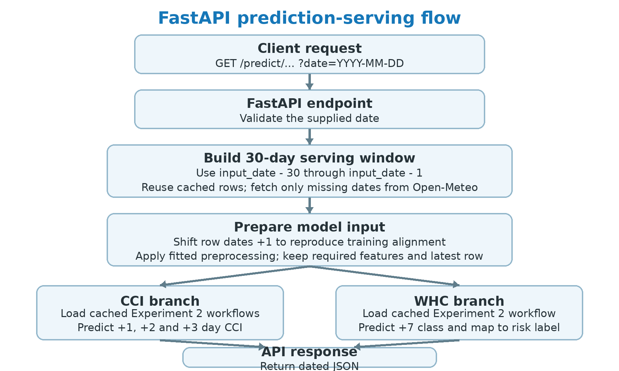
Figure 9. FastAPI serving flow for CCI and WHC prediction requests.

Each saved Experiment 2 workflow contains the fitted preprocessing and model. After transformation, the API keeps the required feature columns and scores only the latest model-ready row. The CCI endpoint calls three fitted workflows to return +1, +2 and +3 day forecasts, while the WHC endpoint calls the classification workflow once for exactly +7 days and maps the predicted class to its risk label. Model objects and metadata are cached after first load, and FastAPI returns the dated outputs as JSON. Invalid dates, insufficient historical context and source-data failures are surfaced through explicit HTTP errors rather than silent fallback behaviour [7][8].

Conclusion
The project produced two end-to-end ML forecasting workflows and deployed them behind a common FastAPI service. CCI demonstrates useful short-horizon signal, while WHC demonstrates the much harder problem of rare hazardous-event prediction.
The final CCI model, Experiment 2 Weighted Elastic Net, provides a planning-oriented forecast with test RMSE of 9.49, 9.85 and 10.05 points and MAE of 7.16, 7.45 and 7.64. It improves baseline RMSE by 18.72%, 15.67% and 13.93%, and reduces tail error relative to Experiment 1, although tail MAE remains 13.56 to 15.70 points. The final WHC Experiment 2 model improves High and Extreme sensitivity over Experiment 1, but its 13.51% hazardous-event recall and 2.78% alert precision are not sufficient for an autonomous warning service.
Future work should focus on stronger predictive signal rather than only increasing model complexity. Useful directions include richer recent-weather or forecast inputs, more hazardous-event observations, probabilistic WHC outputs, threshold analysis tied to operating costs, broader spatial validation and systematic drift monitoring. Monitoring should explicitly include previous-day CCI and WHI, CCI history features, daylight, temperature and pressure histories, wind interactions, CCI tail error, High and Extreme recall, source-data freshness and repeated API rate limiting.
Across all six experiments, the key result is that model choice is only one part of a reliable service. Realistic feature availability, sequential and stable source-data retrieval, temporal validation, rare-event evaluation and faithful serving transformations are equally important. The project retains the weighted linear CCI model because its validation behaviour supports the original selection process, and the SMOTE logistic WHC model because the tree alternatives fail to detect hazardous test events. The deployed service reproduces these pipelines from data retrieval through prediction, with CCI tail uncertainty and WHC rare-event limitations clearly constraining consequential use.

References
Data, software, project artefacts and ethical-governance sources used in the implementation and discussion are listed below.
[1] Open-Meteo. Historical Weather / Archive API, source of Sydney hourly and daily weather observations.
[2] scikit-learn 1.9.1. ElasticNet, LogisticRegression, StandardScaler and Random Forest implementations used by the project.
[3] imbalanced-learn >=0.14.2. SMOTE implementation used by the custom proportion-aware classifier wrapper.
[4] XGBoost. Gradient-boosted tree implementation evaluated in Experiment 3.
[5] Optuna >=5.0. Hyperparameter optimisation used in the experiment workflows.
[6] mlweave 0.1.9. Pipeline construction and experiment tracking used across preprocessing and modelling.
[7] FastAPI 0.139.0 and Uvicorn 0.50.0. Serving framework used by the Weather Intelligence API.
[8] Ratnadeep Patra, project source: six AT2 experiment notebooks, dataset.py, features.py and custom_models.py; API repository: https://github.com/RP28/36120-26SP-AT2-26294153-api.
[9] Australian Government, Department of Industry, Science and Resources. Australia's AI Ethics Principles. https://www.industry.gov.au/publications/australias-ai-ethics-principles (accessed 27 Sep 2026).
[10] Maiam nayri Wingara Indigenous Data Sovereignty Collective. MnW Principles. https://www.maiamnayriwingara.org/mnw-principles (accessed 27 Sep 2026).
[11] Global Indigenous Data Alliance. CARE Principles for Indigenous Data Governance. https://www.gida-global.org/careprinciples (accessed 27 Sep 2026).

