

**A project Report on**

**JUSTDAIL WEBSITE USING AUTOMATION TOOL SELENIUM WEBDRIVER WITH JAVA.**

**By**

**Rathi Preethi .V**

**Batch-EON (2021-5533)**

**Under the Guidance of,**

**Amurta Deore Kachole**

**(Technical Trainer)**

**EduBridge India Pvt. Ltd.**

**Introduction:**

This Project aims to do overall testing like functional testing, GUI testing on justdail website to check quality of application using selenium web driver. It helps to improve quality of website and saves time for manually doing this testing.

In this project our main focus is to test the Shop Online Module . Shop online contains mobile phone,AC,lap tops and books .In order to purchase mobile phone ,first we have to select the brand and choose the price of product then we can see sellers in just dial website.

**Software Requirements:**

Operating System: Windows 10

Browser: Latest version of Google Chrome

Platform: Eclipse IDE

Automation Tool and Language: Selenium WebDriver, Java

Files: JDK, Selenium Jar files, Common IO file

1. **SHOP ONLINE MODULE**

**TC01:** Launch the browser and justdail website

**Selenium WebDriver Test Script:**

System.*setProperty*("webdriver.chrome.driver","C:\\selenium web driver\\chromedriver\\chromedriver.exe");

WebDriver driver=**new** ChromeDriver();

driver.get("https://www.justdial.com/sideMenu");

System.***out***.println("Launching website");

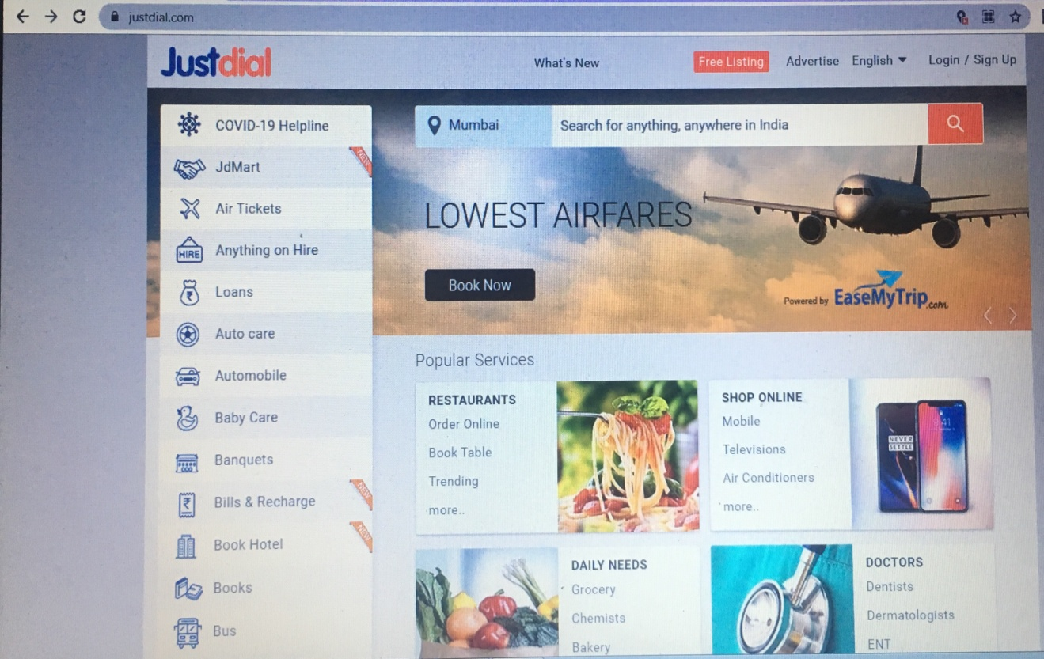

**TC02:** Maximize the window

**Selenium WebDriver Test Script:**

driver.manage().window().maximize();

System.***out***.println("Maximize the window");

**TC03:** To verify and display the Shop online

**Selenium WebDriver TestScript**

Thread.*sleep*(600);

JavascriptExecutor js=(JavascriptExecutor) driver;

js.executeScript("window.scrollBy(0,2000)");

System.***out***.println("shop online");

driver.findElement(By.*xpath*("//span[@id='hotkeys_text_54']")).click();

Thread.*sleep*(600);

js.executeScript("window.scrollBy(0,100)");

**TC04:** To verify and display mobile phones

**Selenium WebDriver Test Script:**

Thread.*sleep*(600);

js.executeScript("window.scrollBy(0,100)");

System.***out***.println("order mobile phone");

driver.findElement(By.*xpath*("//span[contains(text(),'Make your pick from a wide range of smartphones av')]")).click();

js.executeScript("window.scrollBy(0,400)");

**TC05:** To verify and display Samsung mobile phone

**Selenium WebDriver Test Script:**

System.***out***.println("select samsung ");

driver.findElement(By.*xpath*("//*[@id=\"mnintrnlbnr\"]/ul[1]/li[9]/a/span[3]")).click();

Thread.*sleep*(600);

js.executeScript("window.scrollBy(0,200)");

**TC06:** To verify and display the price of mobile phone

**Selenium WebDriver Test Script:**

Thread.*sleep*(600);

js.executeScript("window.scrollBy(0,200)");

System.***out***.println("select phone price from 10,000-20,000");

driver.findElement(By.*xpath*("//li[@id='3']//input[@id='103']")).click();

**TC07:** To verify and display the samsung galaxy M31

**Selenium WebDriver Test Script:**

Thread.*sleep*(600);

js.executeScript("window.scrollBy(0,100)");

System.***out***.println("choosing samsung galaxy M31");

driver.findElement(By.*xpath*("//body/article[1]/section[1]/section[1]/div[2]/div[8]/div[2]/a[1]/div[1]/div[2]")).click();

**TC08:** To verify and display the Sellers

**Selenium WebDriver Test Script:**

Thread.*sleep*(500);

js.executeScript("window.scrollBy(0,500)");

System.***out***.println("select the seller");

driver.findElement(By.*xpath*("//*[@id=\"buy_B07DJCJBBN\"]")).click();