Kitchen Chimney buying guide

Umar Shareef

Kitchen chimney is an appliance that absorb smoke, fumes from kitchen and makes kitchen clean and oil, smoke free. In fact, modern kitchen chimney adds style and decor to your modular kitchen.  
  
We are providing buying guide and tips to buy kitchen chimney to choose best kitchen chimney. In fact, you can use our [kitchen chimney selector](http://www.zelect.in/kitchen-chimney/kitchen-chimney-selector) to choose best kitchen chimney.

Things to consider before buying a chimney

Whatever the kitchen chimney online you are going to buy, must fit in your kitchen, suction power, chimney filter types is comfortable with cooking habits. We are furnishing some of the tips must consider before buying chimney online.

* Chimney filter types
* Types kitchen chimney
* Chimney suction power
* Chimney size
* Chimney design
* Chimney ducting

Types of kitchen chimney filter

Depending on the structure, material and filtering process, chimney filter types are classified into 3 categories.

* Cassette filter
* Baffle filter *(best for Indian food)*
* Carbon filter

Cassette filter

[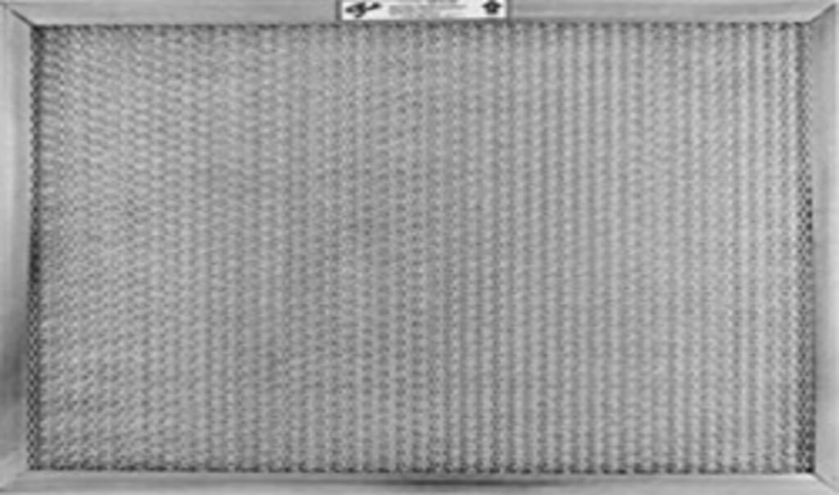](http://www.zelect.in/kitchen-chimney/kitchen-chimney-selector)

Cassette filter is made of aluminum mesh that are stocked on each other. Gap between the mesh allows air through it. Oil, grease particles in air strike to the this mesh aluminum thread.

Slowly these grease, oil particles clogged the mesh and affects the suction power of the chimney. That’s why, cassette filters need to wash, clean once in a week for better performance. To [clean chimney](http://www.zelect.in/kitchen-chimney/how-to-clean-a-kitchen-chimney), immerse cassette filter in a bucket of detergent water for some while, wash with cleaner water. If need you can scrub too.

Baffle filter

[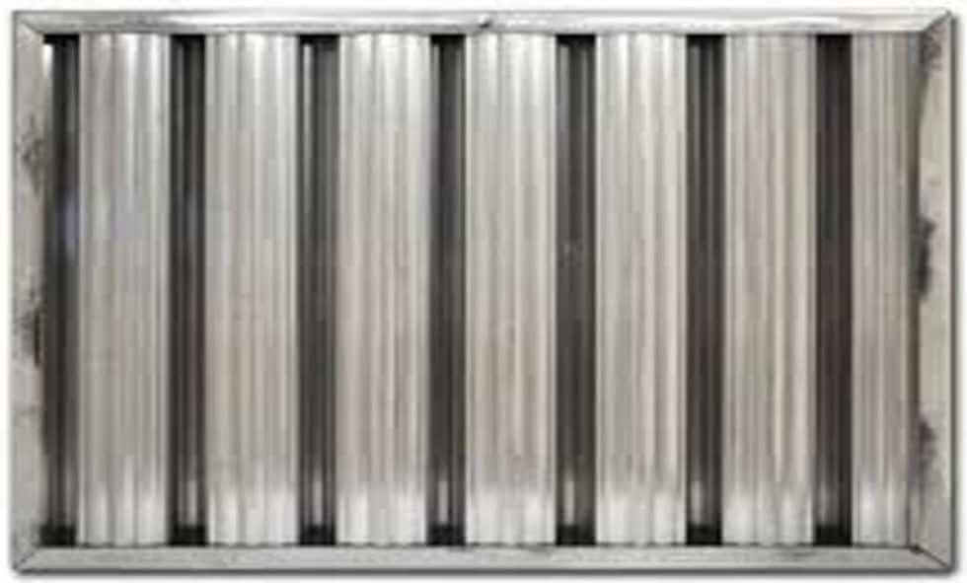](http://www.zelect.in/kitchen-chimney/kitchen-chimney-selector)

The baffle is a flow control panel. Baffle filter is made in multiple curve structure. When cooking air passes through these curve changes the direction of smoke air. During this process heavy grease, smoke particles they are dragged down in baffle filter. Even though, baffle filter is fully filled with grease, oil it hardly affects the chimney suction power.

Baffle filter chimneys are best for Indian food items with Masala food. It is very easy to find baffle chimney, look for the product description and search for baffle. For example[Pigeon Sterling chimney](https://dl.flipkart.com/dl/pigeon-sterling-dlx-60-wall-mounted-chimney/p/itme9gv5hzawez8q?affid=easycards&affExtParam1=zelectsite&affExtParam2=buying_guides) is one of such good baffle filter kitchen chimney. The baffle filter needs very less maintenance. Needs to wash baffle filter once in 3 months. These filters capabilities to run a number of years without replacement.

Carbon filter

[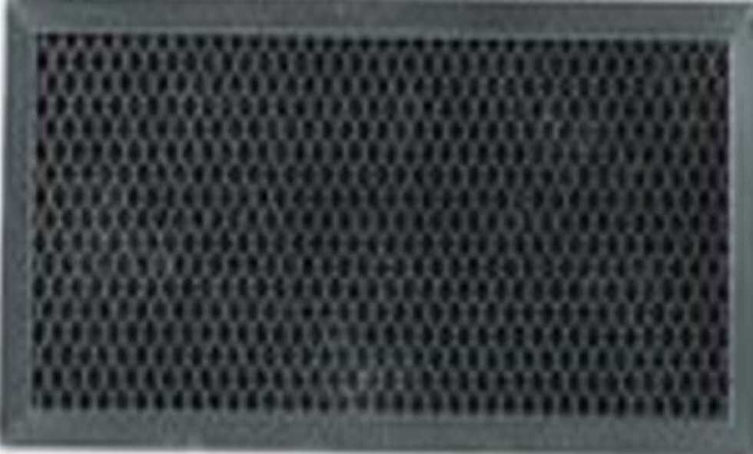](http://www.zelect.in/kitchen-chimney/kitchen-chimney-selector)

Carbon filter, also known as Charcoal filter because it is made up of black charcoal. Carbon filter mainly used for absorbing odor. The carbon filter is an optional one. In case of recycling / without duct, chimney carbon filter used along with the baffle filter or cassette filter.

The oil, smoke particles clogged inside the carbon filter and reduce the suction power of the chimney, so they need to replace once in six months depending the intensity of cooking. For more details about type kitchen chimney do read [different types of chimney filters](http://www.zelect.in/kitchen-chimney/kitchen-chimney-filters)