|  |  |
| --- | --- |
| 1. 1 | Evidence of the system |

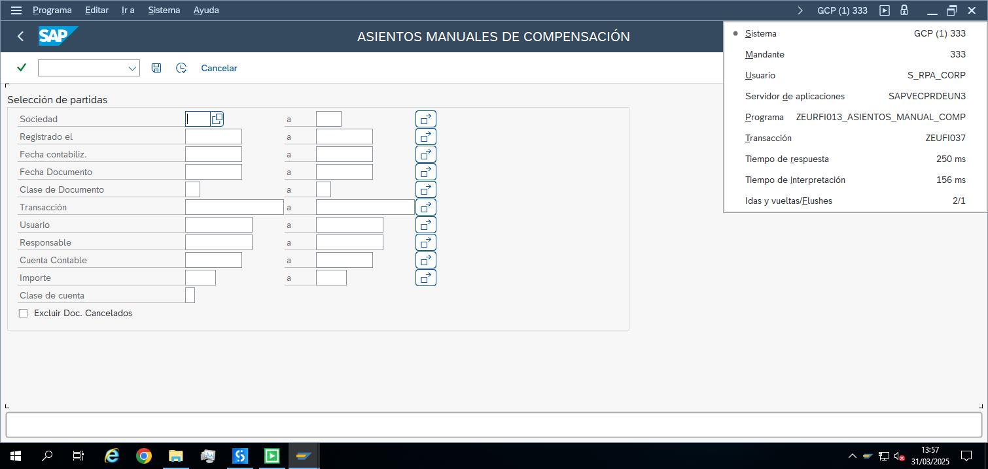

|  |  |
| --- | --- |
| 1. 2 | Companies selected |

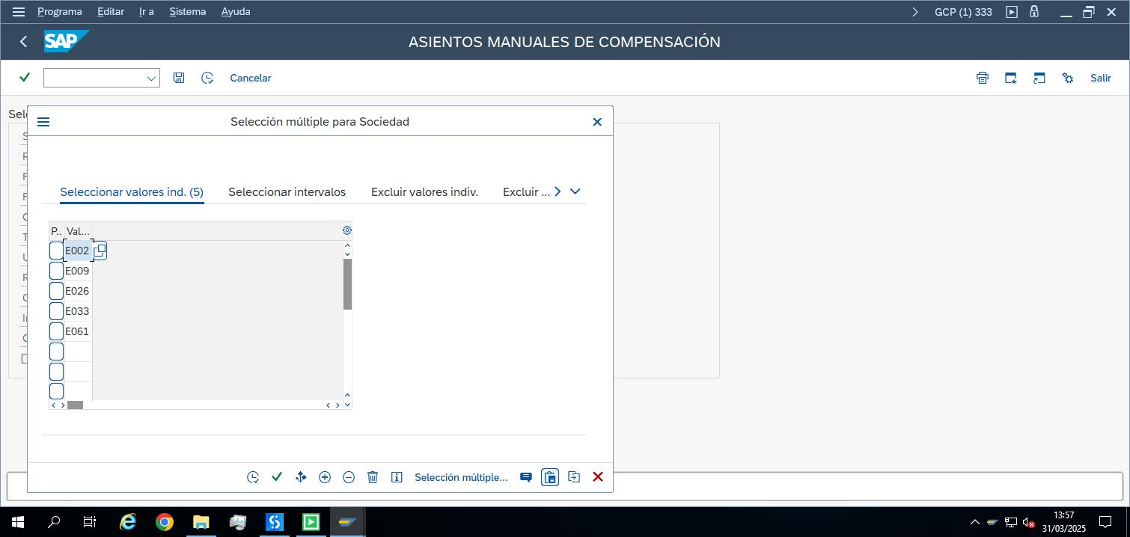

|  |  |
| --- | --- |
| 1. 3 | Included Document Types |

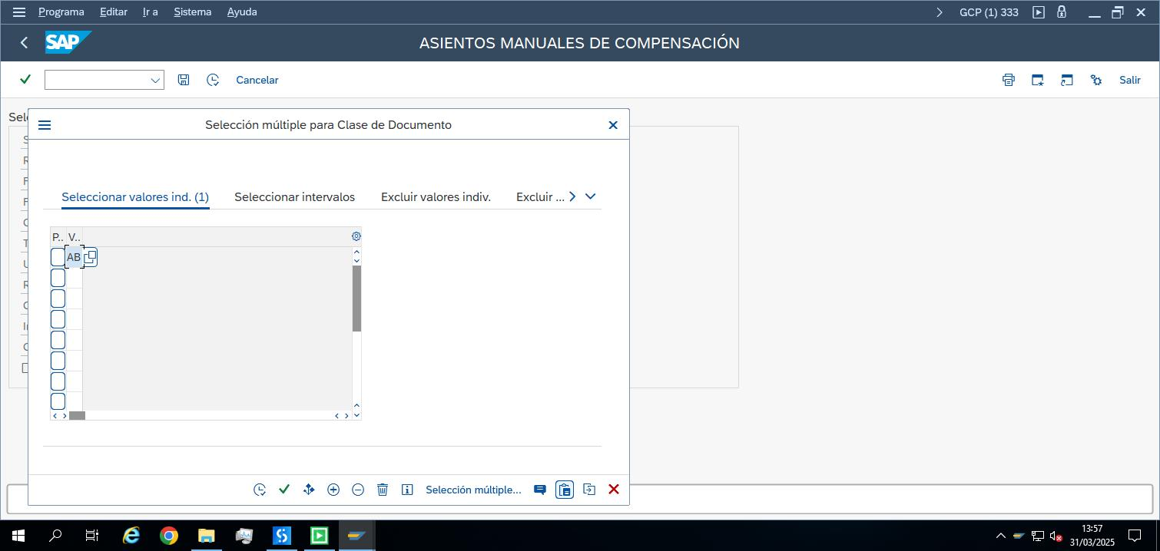

|  |  |
| --- | --- |
| 1. 4 | Other parameters: “Effective Date” & Exclude Reverted documents |

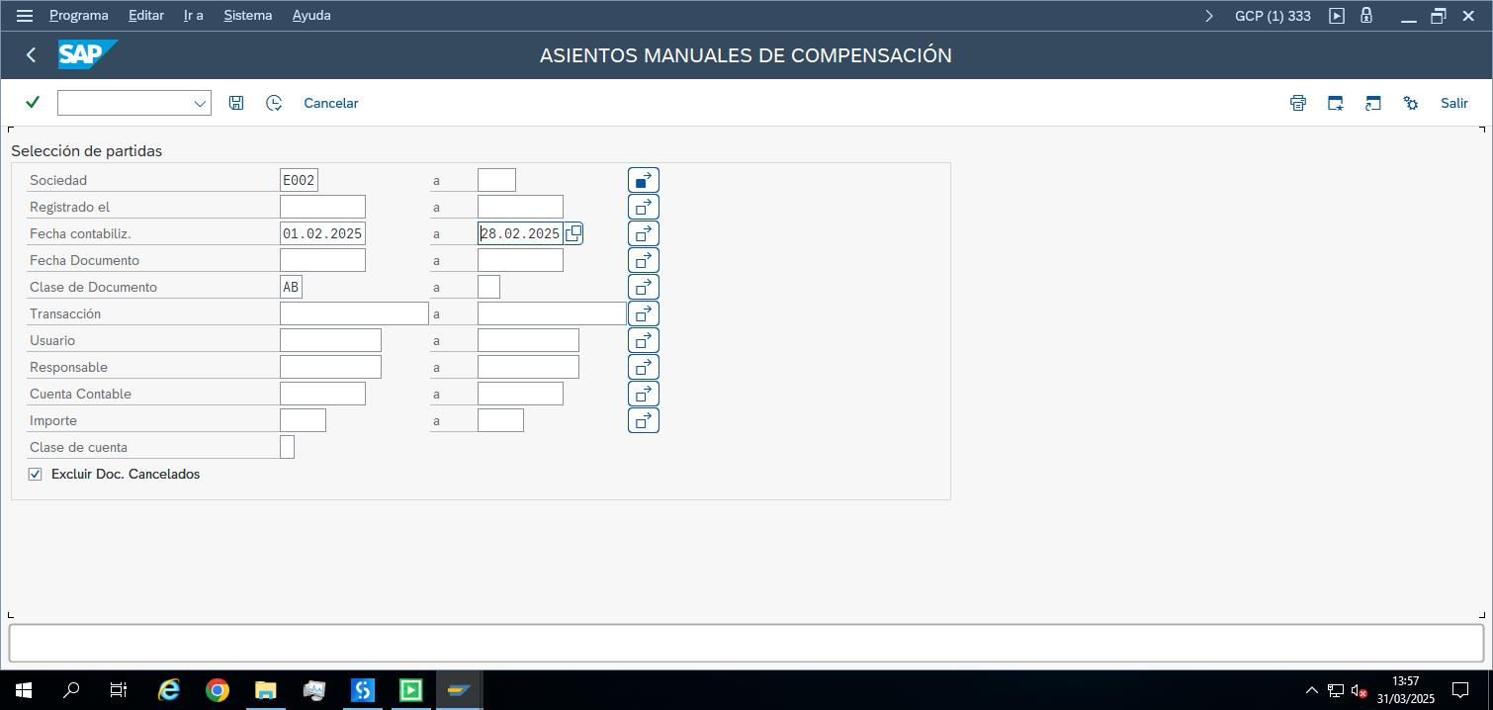

|  |  |
| --- | --- |
| 1. 5 | Result: Start and End with total of “Total Deb./Cred.” |

