Assignment - 6

|  |
| --- |
| Rudra Chinhara, 202117 |

# Write a program for swapping of two numbers using 'call by value' and 'call by reference' strategies.

## Code:

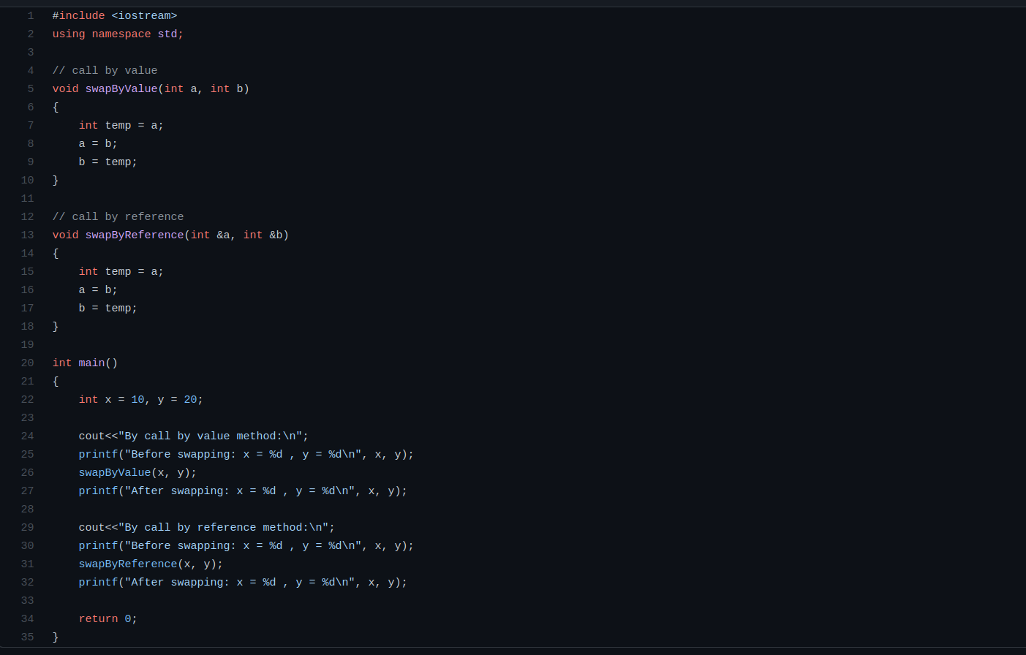

* **Output:**

