Assignment - 7

|  |  |  |
| --- | --- | --- |
| Rudra Chinhara, 202117 |  |  |

# **Write a program to create a linked list & perform operations such as insert, delete, update, reverse in the linked list.**

## **Code:**

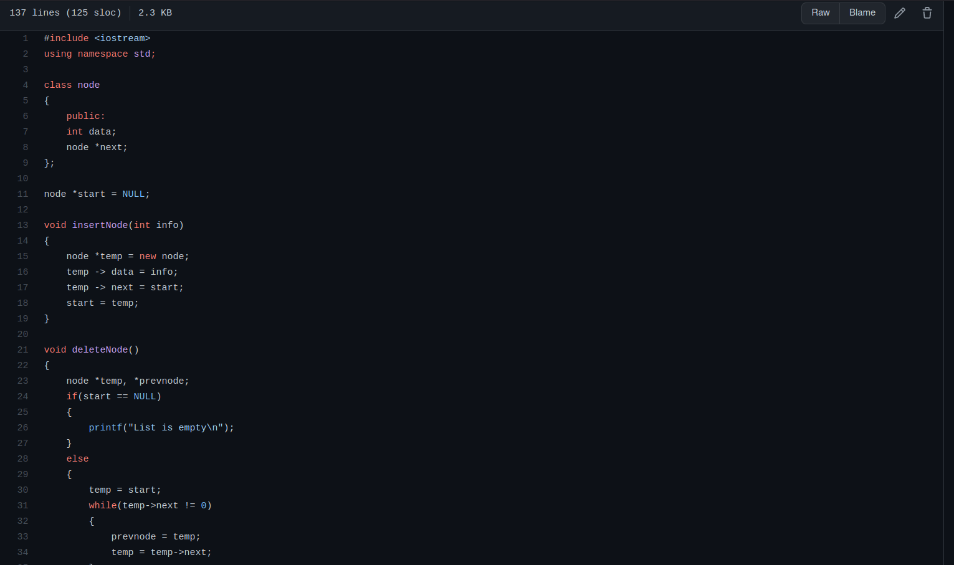

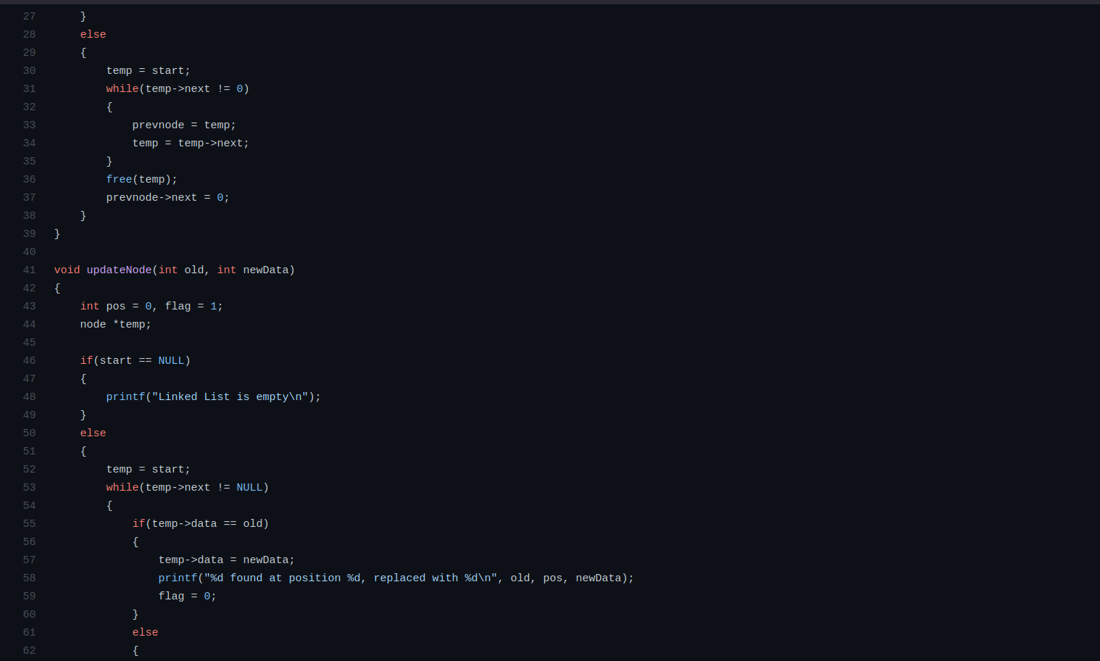

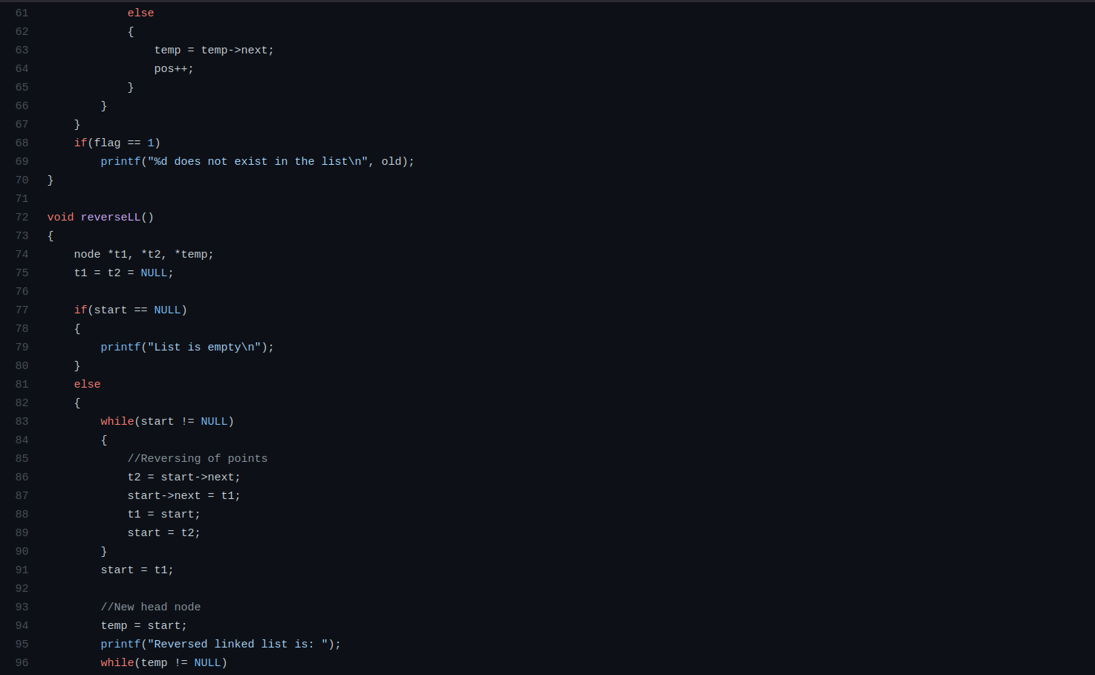

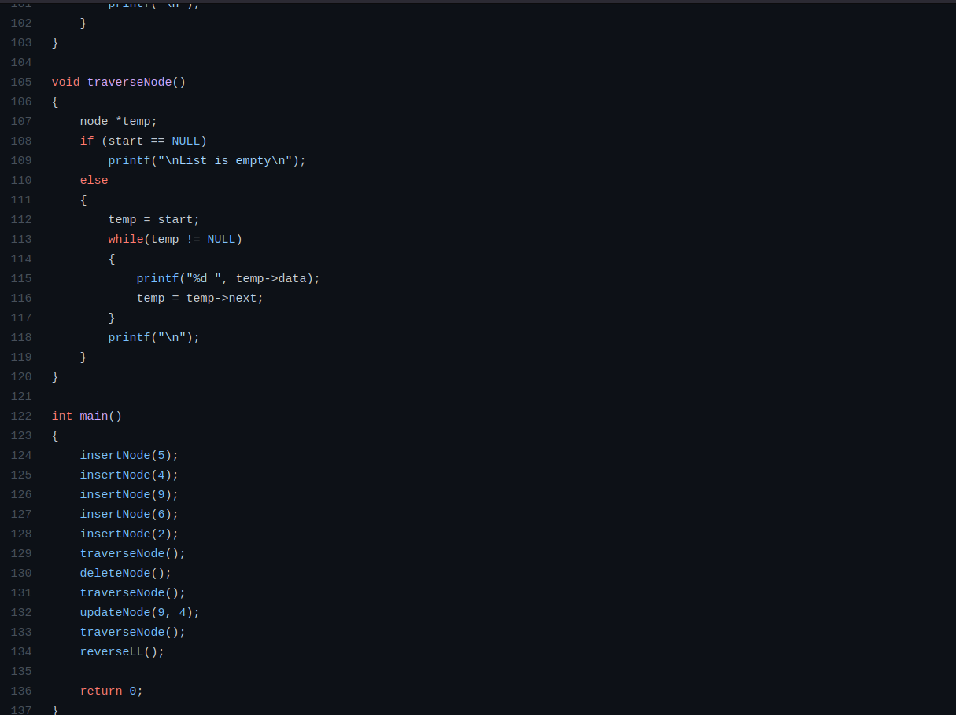

## Output:

