**Assignment - 9**

Write a program to implement all the binary tree traversal methods using classes.

Rudra Chinhara

202117

B. Tech. CSE, 2nd Year

Central University of Haryana

<https://github.com/RPChinhara-202117/DSA_Assignments.git>

**Code:** 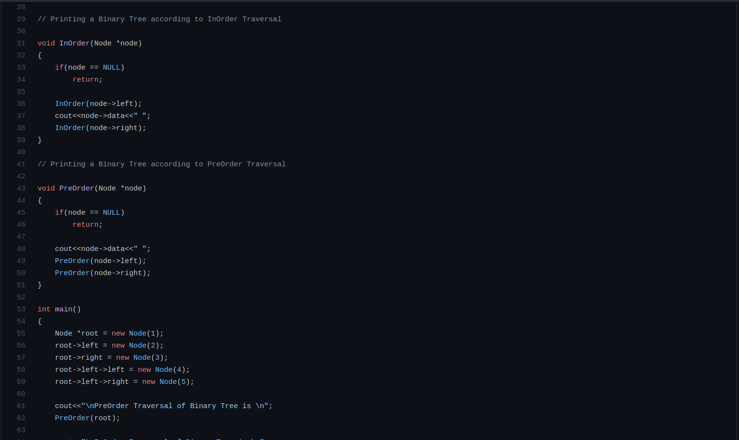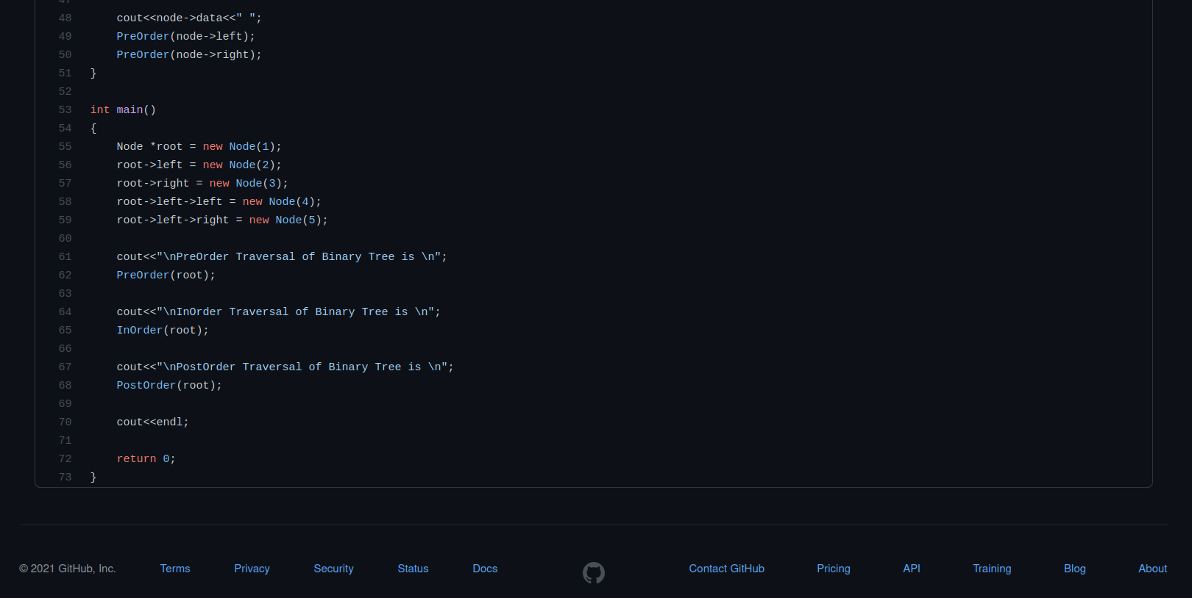

**Terminal Output:**