1. User (Abstract Class)
This is the parent class for all users.

Purpose
Represents any person who can log into the Faculty Management System.

Attributes
Visibility | Attribute | Type
- | userId | String
- | username | String
- | password | String
- | firstName | String
- | lastName | String
- | email | String
- | phoneNumber | String

Methods
Visibility | Method | Return Type
+ | login() | boolean
+ | logout() | void
+ | updateProfile() | void
+ | changePassword() | void
+ | getRole() | String (abstract)

Relationships
User
├── SystemAdmin
├── Lecturer
└── Student

2. SystemAdmin

Purpose
Manages the entire system.

Attributes
No new attributes are needed because it inherits everything from User.

Methods
SystemAdmin
+ manageStudents()
+ manageLecturers()
+ manageFaculties()
+ manageDepartments()
+ manageCourses()
+ assignLecturers()
+ generateTimetable()
SystemAdmin
+ manageStudents()
+ manageLecturers()

3. Student

Purpose
Represents a student in the university.

Attributes
Attribute | Type
studentId | String
registrationNumber | String
semester | int
faculty | Faculty
department | Department

Methods
Method
+ viewCourses()
+ viewTimetable()
+ viewAttendance()
+ viewGrades()

4. Lecturer

Purpose
Represents a lecturer.

Attributes
Attribute | Type
lecturerId | String
employeeNumber | String
specialization | String
department | Department

Methods
Method
+ viewAssignedCourses()
+ markAttendance()
+ enterGrades()
+ viewTimetable()

5. Faculty

Purpose
Represents a faculty such as Computing, Engineering, or Business.

Attributes
Attribute | Type
facultyId | String
facultyName | String
description | String

Methods
Method
addDepartment()
removeDepartment()

6. Department

Purpose
Represents a department within a faculty.

Attributes
Attribute | Type
departmentId | String
departmentName | String
faculty | Faculty

Methods
Method
addCourse()
assignLecturer()

7. Course

Purpose
Represents a course offered by a department.

Attributes
Attribute | Type
courseId | String
courseCode | String
courseName | String
credits | int
department | Department
lecturer | Lecturer

Methods
Method
assignLecturer()
enrollStudent()

8. Enrollment

Purpose
Links students and courses.
Without this class, you can't correctly represent the many-to-many relationship between students and courses.

Attributes
Attribute | Type
enrollmentId | String
student | Student
course | Course
enrollmentDate | LocalDate

Methods
Method
enroll()
dropCourse()

9. Attendance

Purpose
Stores attendance records.

Attributes
Attribute | Type
attendanceId | String
student | Student
course | Course
date | LocalDate
status | String (Present/Absent/Late)

Methods
Method
markAttendance()
updateAttendance()

10. Grade

Purpose
Stores grades awarded to students.

Attributes
Attribute | Type
gradeId | String
student | Student
course | Course
marks | double
letterGrade | String

Methods
Method
calculateLetterGrade()
updateGrade()

11.TIMETABLE
Purpose:
Stores lecture schedules for courses.

Attributes:
timetableId : String
course : Course
lecturer : Lecturer
dayOfWeek : String
startTime : String
endTime : String
room : String
semester : int

Methods:
addSchedule()
updateSchedule()
deleteSchedule()

Correct relationships:
Faculty 1 ─── * Department

Department 1 ─── * Course

Course 1 ─── * Enrollment * ─── 1 Student

Course 1 ─── * Attendance * ─── 1 Student

Course 1 ─── * Grade * ─── 1 Student

Course 1 ─── * Timetable

Lecturer 1 ─── * Course

Lecturer 1 ─── * Timetable

Core Classes
User (Abstract)
SystemAdmin
Student
Lecturer
Faculty
Department
Course
Enrollment
Attendance
Grade
Timetable

UML Diagram
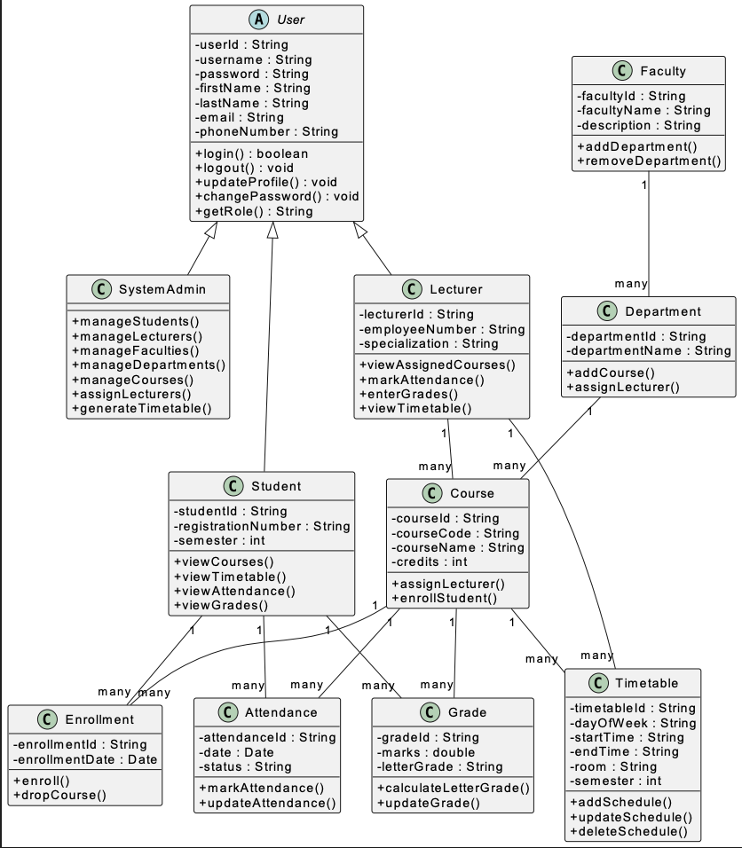

Development Roadmap
Project Setup
↓
Database
↓
Common Package
↓
Authentication
↓
Dashboard
↓
Student Module
↓
Lecturer Module
↓
Faculty & Department
↓
Course
↓
Timetable
↓
Attendance
↓
Grade
↓
Reports
↓
Testing & Integration

