Q1

Alice4D: [[-93.44723347 -7.16843011 -0.87392732 -0.68148247]]

Alice2D: [[-0.62562864 -0.295158 ]]

prediction: 5.354514697523497

Q2

U:

[[-0.33306893 -0.73220483 0.57543613 -0.1476971 ]

[-0.48640367 -0.34110504 -0.56984703 0.56774394]

[-0.79307315 0.44109455 -0.0055891 -0.42004684]

[-0.15333474 0.39109979 0.58661434 0.69239659]]

S:

[1.10528306e+01 9.13748280e-01 5.00674393e-16]

V:

[[-0.41903326 -0.56492763 -0.71082199]

[ 0.81101447 0.11912225 -0.57276996]

[ 0.40824829 -0.81649658 0.40824829]]

A = UDV

Q3

The Rank2 matrix is still too large to display due to one of the sides being 1401

Norm: 7.317532201210154e-13

Q4

Q5

independent vectors of null space

[-2, 7/2, 1, 0]

[-3, 5/2, 0, 1]

Row Echelon form of A:

[1, 0, 2, 3],

[0, 1, -7/2, -5/2],

[0, 0, 0, 0]

Row Echelon form of A transpose:

[1, 0, -1],

[0, 1, 1],

[0, 0, 0],

[0, 0, 0]

Null Space:

[ 0.81786391 -0.14262416]

[-0.41787061 -0.77606481]

[ 0.1438269 -0.48813724]

[-0.3685059 0.37296621]

pseudoinverse:

[ 0.06507304 0.01460823 -0.05046481]

[ 0.03984064 -0.03187251 -0.07171315]

[-0.00929615 0.14077025 0.1500664 ]

[ 0.09561753 0.12350598 0.02788845]

A \* A pseudoinverse which should be like the identity matrix:

[ 0.66666667 0.33333333 -0.33333333]

[ 0.33333333 0.66666667 0.33333333]

[-0.33333333 0.33333333 0.66666667]

Q6

Q7

Red,Green,Blue are values for x=0.8,0.5,0.2

Chart showing Y as MAE and X as Basis Sizes

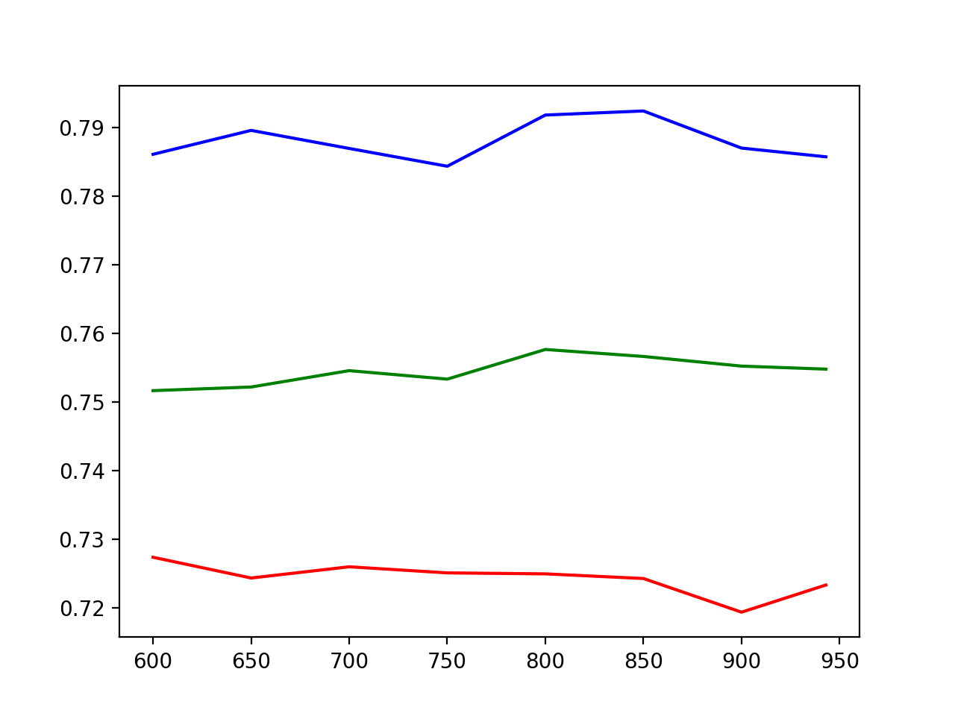

Chart showing Y = predictions per second and X = starting Basis size