Top of Form

|  |  |  |
| --- | --- | --- |
|  | Sinnahn |  |
| http://donjon.bin.sh/scifi/system/stars/G.jpg | **G4 V Yellow Main Sequence** |  |
| http://donjon.bin.sh/scifi/system/worlds/tethys.jpg | **Rock Planet** |  |
| 1 moon |
| http://donjon.bin.sh/scifi/system/worlds/tethys.jpg | **Rock Planet** |  |
| http://donjon.bin.sh/scifi/system/worlds/earth.jpg | Sinnahn **E830342-7** |  |
| 1 moon |
| http://donjon.bin.sh/scifi/system/worlds/tethys.jpg | **Rock Planet** |  |
| http://donjon.bin.sh/scifi/system/worlds/tethys.jpg | **Rock Planet** |  |
| http://donjon.bin.sh/scifi/system/worlds/gaspra.jpg | **Asteroid Belt** |  |
| http://donjon.bin.sh/scifi/system/worlds/neptune.jpg | **Jovian Planet** |  |
| 8 small moons, 1 large moon |
| http://donjon.bin.sh/scifi/system/worlds/neptune.jpg | **Jovian Planet** |  |
| 16 small moons |
|  | | |
|  | Sinnahn **E830342-7** |  |
| Starport: | **E (Frontier)** |  |
| Frontier installation. Essentially a marked spot of bedrock with no fuel, facilities, or bases present. |
| Naval Base: | **No** |  |
| Scout Base: | **Yes** |  |
| Size: | **8 (8000 miles)** |  |
| Atmosphere: | **3 (Very thin)** |  |
| Very thin atmosphere, requires the use of compressors to insure sufficient oxygen to breathe. |
| Hydrography: | **0 (No free standing water)** |  |
| Population: | **3 (Thousands of inhabitants)** |  |
| Government: | **4 (Representative democracy)** |  |
| Government by elected representatives. |
| Law Level: | **2 (Portable energy weapons prohibited)** |  |
| Tech Level: | **7 (circa 1970 to 1980)** |  |

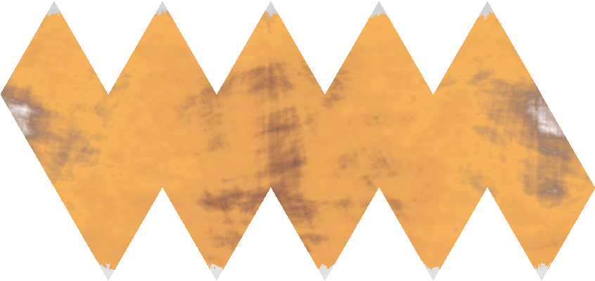

Bottom of Form