The Adventures of Space Protection Force

TITLE Copyright © 2017 by Edward Benditt.

All rights reserved. Printed in the United States of America. No part of this book may be used or reproduced in any manner whatsoever without written permission except in the case of brief quotations em- bodied in critical articles or reviews.

This book is a work of fiction. Names, characters, businesses, organizations, places, events and incidents either are the product of the author’s imagination or are used fictitiously. Any resemblance to actual persons, living or dead, events, or locales is entirely coincidental.

For information contact; address www.edwardbenditt.com

Book and Cover design by <TBA>

ISBN: number

First Edition: <TBA> 2017

10 9 8 7 6 5 4 3 2 1

Contents

Prologue 9

CHAPTER ONE 10

CHAPTER TWO 13

CHAPTER THREE 16

CHAPTER FOUR 21

CHAPTER FIVE 23

Appendix A 26

Characters 26

Appendix B 28

Ships 28

Appendix C 31

Planets and systems 31

Appendix D 34

Organizations 34

Appendix E 35

Technology 35

Appendix F 37

Military Ranks & other stuff 37

Navy Officers 37

Marine Officers 38

NCOs 38

Appendix G 40

Space Station 40

Appendix H 46

Decision making 46

Appendix I 53

Images 53

*Dedicated to my family*

# Prologue

*“Space travel is life-enhancing, and anything that's life-enhancing is worth doing. It makes you want to live forever."*

-RAY BRADBURY

# CHAPTER ONE

*“Since, in the long run, every planetary civilization will be endangered by impacts from space, every surviving civilization is obliged to become spacefaring--not because of exploratory or romantic zeal, but for the most practical reason imaginable: staying alive... If our long-term survival is at stake, we have a basic responsibility to our species to venture to other worlds.”*   
― Carl Sagan

With class just let out and on walking back to her apartment a message indicator flashes on her hud. Urgent message, from grandmother’s, Ailepci, Pegasus. “Go ahead,” said Sidney. The message display read, “Please come to Nu Gama, Nu G, right away. This was problematic as Nu G is some 150 light years away.

Sidney Appledoorn is a 20 year-old spacer on New Titan or big T as the colonist call it. Big T is over 29 years-old but considered one of the newest colonies in the solar system. The space station, High T, is over 40 years-old, but has a top rated educational system. However, it is expensive and the only way Sidney was able to attend college was to join the planetary R.O.T.C.

One advantage of the R.O.T.C. is the implant of the Ailepc as well as its upgrades. If you remember the TI-82 or the ever more recent TI-Nspire, from old earth, then you might understand the functions of the device. That is just a basic concept of the device. An “Ailepci” is an Artificial intelligence life enhancement personal computer interface that is implanted and connected to the user's brain. An Ailepci is a tremendous help with all her courses including accounting, science, engineering, computer sciences, business and history.

A much cheaper and more widely used non-implant unit is a wrist PDA which is available with a lot fewer options and apps. The main difference is that implants can often connect remotely to nearby equipment, allowing users to exchange data and exert control over their surroundings.

Suddenly Sidney mind wondered and remembered the day that she first experience the hum in her head that was “Lotus” her Ailepci.

This was quickly followed by the image of her grandmother telling her that her parents were missing with all hands on the Princess Lola, which almost made her start crying in earnest. She berated herself as there was not time for this and began running again.

Sprinting faster back to her apartment, mind racing to figure out the reason why; what happened, is she hurt; is she sick and in the hospital; or worse could she be dead.

“Lotus call grandma Tabie,” Sidney demands.

Lotus sniffs, “I am already doing that.

The number is currently busy, but I am getting the Ansible Telecommunication Company, ATC, on the Net to request an emergency breakthrough.

Sidney!

We broke through.”

After a pregnant minute, Lotus squeaks, “No answer.”

“Call Pegasus directly then,” Sidney snaps.

A deep baritone voice came through the connection, “Get home now, your grandmother is in the hospital,” Pegasus demands and the connection was dropped.

In a near panic now grabbing and starting to re-pack the go-bag she had in the closet. She crams two weeks of shore cloths along with 3 days of MREs and bottled water. At the same time she activated the self-test on her nanocloth pressure suite she bought from a second-hand store last year for her yachting club activities, and that reported green.

“Lotus, find all ship in port that are going to or is going to a port with a transfer point to Nu G., and submit a medical leave form to school’s Net,” Sidney said out of breath.

While making her way to the docks Lotus reports, “There is only one ship going out system going toward Nu G, Triple 3 LTD’s - Walker, will be departing to Nu G this week. Sidney looked around and found the cargo ship listed on the departure board in section 5 level Alpha dock 3.

# CHAPTER TWO

S

he hurried down to the dockside to find a burly man with a name tag proclaiming him to be Strauss.

"Do you have any space available to Nu G.?"

Without looking up Strauss says, "what do you think we are Moonlight?"

Moonlight Transport is one of the largest transporters with a fairly good reputation for transport, but there was none in system. As Sidney fights the urge to argue, and says instead, "No but I need to get to Nu G, and will do anything to get there as you’re the only ship leave for there this week."

"Oh, well yeah but why are you in such a hurry?" Strauss asks.

"My grandmother is in the hospital and I need to get there as soon as possible."

"Well, why didn't you say so before, I'll go ask the captain I am sure we can use an extra cargo handler for this trip", Strauss stated emphatically.

While waiting, Sidney pondered why he didn’t use his PCI instead of going to ask the Captain in person.

Then she noticed a flashing message in the top corner of her hud that caught her eye. It was a missed notice that concerned pirates reported in the area and caution is recommended. She dismissed it out of hand as not a concern. There has not been a reported pirate attack for almost 20 years.

Strauss came back with a huge grin on his whiskered face and said, “Welcome aboard the Walker! You’re in luck as we are almost at capacity, but the captain is looking for capable and cheap crew members. If you are interested then letting get you and your cargo aboard.”

Sidney picked up her only bag and said, “Point the way.”

Entering through the cargo holds huge doors. Strauss leaned down and said, “Follow Jones’ to the crew quarters.”

Sidney looks up at Strauss and said, “What does he look like and where can I find him?”

“That would be me”, says a tall blonde hair blue eyed bull of a man with a deep baritone voice from behind her.

She spins around and says, “Nice to meet you,” but she is speechless at the sight of him to say anymore.

He puts a huge maul of a hand on her shoulder and says, “Let’s get you stowed away.”

He leads her to the crew quarters and says, “Let’s get to work.” Then thinks better of it and asks, “Have you ever been a cargo handler before?”

“No, but I am willing to learn.”

Jones sighs.

“Why are you aboard my ship?”

“My grandmother is in the hospital and this was the only ship out system to Nu G,” she sniffs.

Jones looks at his hands and sighs, “Sorry.” He looks at her again and says, “okay, enough of that let me show you around and have you fill out some paperwork and get you started.”

They go off on the grand tour of the ship and when she gets to the engine room where she sees a, Kennedy-Armstrong Drive, for the first time. Jones explains, “This baby allows faster-than-light travel across light years, and is based on some advanced space-warping technology, the drive requires copious amounts of energy, while Interplanetary and orbital space travel still uses fusion-power.”

Lotus reminded her of a science article that stated, “This kind of drive can fail resulting from poor drive maintenance or spatial anomalies.” She mentally kicked Lotus for such morbid information.

She is then lead to the communication room where her eyes get very wide as she sees the ATC mark 2300. The one thing her she knows and is familiar with on this whole ship so far.

As she focused back in on Jones, he was saying, “This is the Comm room all communication into and out of the ship goes through here.”

Sidney says, “and that is the ATC 2300 allows for unidirectional broadcasts, but when paired with other ATC 2300’s it can produce simultaneous bidirectional communication. It was based off the Laser Communications Relay Demonstration, LCRD, which allowed the use of laser beams to transfer data between spacecraft and stations at 10 times the speed of light. This method permitted data to and from base stations at speeds of 100 Mbps, which was several times faster than the most advanced connections available 50 years ago. However, they were phased out due to the high price and sparse quantity produced. At least that is what the instructor said.”

Jones just looked at her like she grew a third head and said, “That piece of junk in the corner can do all that?” Sidney looked at his and nodded. “Well it has been sitting there for more years then I have been on this ship and that has been a while.”

Sidney asked if once under way if she could work to fix it if there was time. Jones agreed and they were off to the next place of interest, “Security.” Here Jones introduced her to the millions of forms she needed to complete to work on a cargo ship.

# CHAPTER THREE

*“I*

*n the coming era of manned space exploration by the private sector, market forces will spur development and yield new, low-cost space technologies. If the history of private aviation is any guide, private development efforts will be safer, too."*

-Burt Rutan

The Core planetary systems of stars is the vast emptiness of space. Transition from Nu F will be three systems. Most of them are just rocky planets with a class E Sun much like Tau Ceti. The Sun in Alpha Centauri A however has a class G star and not much else.

Sidney was lead to the cargo hold and put under the watchful eye of Mr. Concert, also called Strauss, the Cargo Master. She was taught how to put cargo into holds and stock the pantries. After the last Pallet of cargo was unstrapped and stacked the bay doors closed, umbilical disconnect, which meant they to stop taking on fresh water and air; waste removal stop neing pumped out; direct communication links were closed; reaction mass was stopped being taken on. All this took hours to complete and now they were on their way to Nu G some 150 light years away, which should take 15 days.

She was issued a ship suite, and identification. She was told to get to her crew quarters and strap in as she felt the ship thrusters started to move the ship out of space dock at a sedate 1 meter per second. She noticed that the only difference between her suite and the newer one is the backpack is smaller and the suite skin is thinner. Her suite only has life support for 30 days, and the newer ones go up to 90 days. The new suite is stronger and made with a denser nanocloth material to support the heaver backpack.

Then after clearing the docks the in-system fusion drive came up and started to move the ship out to warp distance 30 light days from the station, which is standard Galactic law. The only issue was that this ship fusion drive is slower the newer ion-fusion drive on most modern ships. The ship measures 200+ meters long.

The interior of the ship has three levels or decks:

* Bridge / Upper
* Main
* Lower

The bridge/upper deck forward starts with the bridge and then captain’s quarters are on the port side and officers’ quarters are on the starboard side of the ship. This is followed by the Comm shake on the port side. Amidships there is an elevator and stairwells leading down to the main and lower decks of the ship. There is also a long passageway leading to the life support, mechanical, and other restricted areas are at the aft section of the ship.

On the main deck forward is the passenger compartment on both the port and starboard sides and wardroom. Through a passageway there is the crew mess then through another passageway there is the crew quarters on both the port and starboard sides of the ship; and through the last passageway is the galley. Amidships there is an airlock connected to sickbay, which prevents the spread of sickness as it is sealed from the rest of the ship, then another airlock to the catwalk over the cargo area.

Along the lower deck from the forward section of the ship is the sensor compartment and passageway that providing access to the ships’ two short-range shuttlecraft that are located under the ship. Cargo area can be accessed on the port or starboard sides of the ship for easier loading and unloading, and there is engine room access is at the very stern of the ship.

She was wondering the ship when she ran into the life support section. She went in and was taken aback when she saw the amount of or lack there to the equipment. She did get introduced to Marisa, a tall red head with bright green eyes and a fashion for flare that is not of this world, literally she is from Annikka. To here her tell it, “My planet hosts a wide array of indigenous life forms suited for the exotic.”

“How did you end up on this ship,” Sidney asks.

“Well about four years ago I just graduated from college with a degree in biology and applied to a new colonial company. However, I was turned down due to a lack of experience, and so I applied for a job with Triple 3 and was accepted. And here I am the number 2 life support operator on the ship. It was hard the first 2 years working cargo dockside, but I slowly got through that and finally working with what I love plants.”

“Wow, two years as cargo handler, why?” Sidney asked.

“Because you have to learn the layout of the ship, the schedules, and the other little nuances” Marisa says.

“Do you know much about what life support actually does?” she asked.

“No not really can you explain it to me,” said Sidney.

“Sure, my job is to investigate, analyze and resolve any issue with the air and water (A&W) systems on the ship. It is also referred to as the Micro-Ecological Life Support System Alternative (MELiSSA), it was conceived as a micro-organism and higher plants based ecosystem. The A&W systems works through the entire ship as air is needed in order to survive of course, and so does the water system.”

Sidney looked at her confused, “Air is more important than water right?”

“In what sense” Marisa asks?

“In the sense that air is needed or everyone would surely die quickly,” Sidney states.

“Well, yes that is right, but the water acts as a barrier to both radiation and the hydration needs of the crew. Without water in between the haul of this ship and space we would be blasted with solar radiation, of about 1 sievert which is 5.5 percent increase in the risk of getting fatal cancer. The normal daily radiation dose received by the average person living on Earth is 10 micro Sieverts (0.00001 sievert)” Marisa states.

“Moreover, though the A&W system work together in a more symbiotic relationship. The Aeroponic crops, or the hyperactive marine algy as I call them, can produce 93.1 kPa (13.5psi) to 129 kPa (18.8 psi) with an Oxygen content of 21% to 40%. The aerogenic crops are grown from special seeds, instead of being planted and fertilized with chemicals. The aerogenically grown plants actually absorb more minerals and vitamins than ones grown in the ground, making them more nutritious and good for creating oxygen.” Marisa says. “Oh, and you can ray it if thing get desperate enough.”

Sidney looked at her like she just grew a third head.

Sidney wonders over to the last section on the ship the mechanical engineering tech section. Here she was made the acquaintance of Jackson. A tall skinny guy about 6’2”, 210lbs with blue eyes and light brown hair. He looks to be about 30, but he says he is 28.

“So, the usual questions how did you become a member of the crew and what degree brought you here,” Sidney asked.

“I was a dropout from here actually, and I did study electrical and mechanical engineering. I joined Triple 3 because my classes were a joke and I hated all my professors,” Jackson said emphatically.

Anyways off topic, I found out how gravity is made on ships and stations. According to Jackson, “It’s called the Kern effect.

“In the early 21st century a group of scientist carried around a garden gnome and going around the planet and they found that this little plastic gnome weighed more closer to the earths’ core. Since today’s ships use 3.3 cubic millimeters of neutron star material in the ships’ design and rotated by the electromagnetic track that runs around the ship which produces artificial gravity on ships. It also has another affect and this one is very important can you guess what it is,” Jackson asks?

“No, clue tell me,” Sidney states.

“It protects us from solar radiation,” Jackson says with a serious face.

“I thought that the water in between the haul did that,” Sidney said confusedly.

“They both do but the magnetic field that is generated is more like earths,” he said.

“Older ships used just a electro-magnetic field. This lead to the application of using strong magnetic field generators in the keel of the ship or station; this gives them a true sense of where down should be. It is also the reason the keel is so thick, as it has to endure the great forces acting on it as well as be far enough away from the computers to be truly effective. The other disadvantage was the energy used to keep the electro-magnetic field up was very expensive,” Lotus stated matter of factly.

Sidney walked away thinking that most things on the ship serve duel functions as well as most crew.

# CHAPTER FOUR

“T

*he time was fast approaching when Earth, like all mothers, must say farewell to her children."*

-ARTHUR C. CLARKE

The next morning she woke from troubled dreams, and found herself drenched in sweat. She lay on her back, and if she lifted her head a little seeing bear walls for the most part except for the huge display screen of the galaxy that is passing her by. As she was a late addition and crew space was filled she got to stay in a passenger cabins made up of a double suite, with private sleeping areas a shared common room, and central bathroom. The reset of the crew have double bunks a common area and share a one of three central bathrooms.

Sidney walks down to the wardroom and starts to grab a plate for breakfast.

“Put that down right now young lady. Don’t you know that is is for officers?” said a large balding gentleman about 45.

“What! Sorry, I am new first time on a cargo ship.” Sidney said vehemently.

“Okay, well go back there through the passageway to the mess,” he points.

Being all kinds of flustered now she timedly walks through the passageway to find chaos, and jumps right in to grab something before it is all gone. With a big smile on her face now she digs right in.

“Hey new girl the officers yell at you for trying to take their food?” she nodes with a mouth full of food.

“You’ll get used to it there are some places on the ship that you just don’t go unless you are an officer and that is just one of them,” said Jackson.

“I like it here it reminds me of school and getting to the good stuff before it is all gone,” Sidney said.

After that Sidney walked down to the cargo master office to report, but was told by Jones, “No works right now, come back later and jobs will be posted on the wall outside the office. In the meantime why don’t you study for one of the certifications on the ship.”

Sidney went back to her room.

“Lotus, bring up all certification that I can qualify for on this ship.” Sidney said.

“On screen now,” said Lotus

And on the big screen which just seconds ago showed the galaxy now is displayed the four certification she can qualify for in the next 3 months aboard.

* Engineering / Drives
* Life support
* Communication

“Lotus, which one would be more beneficial to me long-term,” Sidney asks.

“That is a person decision,” said Lotus.

“So then what would best suite my current academic credits, talents, and abilities” Sidney asked.

“Well stated that way engineering / drives or communication I would bet are your best choices,” said Lotus.

“Thanks Lotus I will think about it,” said Sidney.

# CHAPTER FIVE

“T

*he time was fast approaching when Earth, like all mothers, must say farewell to her children."*

-ARTHUR C.

Choosing the communication certification explanation link Sidney read, “An Ansible is a means of near instantaneous communication. ATC operates as a sim-monopoly as it only operates all ansible relay stations, but does not operate or maintain them. These stations function as a network of store and forward message routers. Because governments depend on this system, each system is responsible for operating and maintaining the system. Smaller ship mounted ansibles and are part of the military forces pact which allows them to communicate near real-time to each other.”

She continued on, “It all started why NASA tested the Laser Communications Relay Station which allowed the use of laser beams to transfer data between spacecraft and stations on planet at .03 the speeds of light. This has led to the LaserPulse Amplifer (LPA) array stations which serve as the only means of interstellar communication in a single star system,” Sidney paused and was dumb struck by the vastness of the communication system and how it really worked.

She continued reading, “LPAs operate on a similar principal as the jump drive, sending a directional radio transmission instantaneously from one station to another over a distance of up to 5 light years. Though the nature of the technology allows only unidirectional broadcasts, paired LPAs can provide simultaneous bidirectional communication. LPA stations are generally categorized as A, B, C, D, E or F: A stations, located 5 planets away, have high volume capacity and transmit messages regularly, usually every 12 to 24 hours; B stations every 24 to 32 hours, and so on.

Given the demand and expense of Laserpulse communication, messages are frequently bundled into batches of hundreds, and sent simultaneously. While the transmission itself is nearly instantaneous, it may be days, weeks, or months before a message is sent, though one can pay a higher fee for "priority service". A message can reach any station in the Inner System in approximately six months, with transit times of as little as a few days possible at great expense,” now she understood why some message came back fast then others.

She clicked on the history of communication and read, “The first successful Laserpulse broadcast occurred on New Year's Eve, 2230. Over the next 150 years ATC constructed a network of stations that extended Laserpulse communications to numerous worlds throughout all human space. As required by law Earth and all other sovereign planets assumed the maintenance of the stations. Which means ATC is responsible for the operation and software upkeep of the stations.

Though ostensibly neutral, ATC is rumored to have leveraged its communications monopoly for political purposes, occasionally imposing "interdictions" (denials of service) on opposing organizations. No proof has ever been found.”

Choosing the engineering / Drive certification explanation link Sidney read, “Faster-than-light travel across interstellar distances is common and depends on a Jump Drive. Interplanetary and orbital space travel is generally conducted by ion-fusion drives.

The theoretical underpinnings of jump drive is hyperspace fields discovered in the early 22nd century by MIT physicists whose experiments revealed that distortions exposed in space were actually gateways to hyperspace allowing them to jump almost instantaneously between two points. Though originally dismissed, the effect was confirmed in the mid-22nd century and subsequently exploited by the colonization space agency.

To use a jump, one must use a special partial radar collector to find a hyperspace field, this is the first step. Next the ship has to activate the jump drive which envelopes the ship in a “warp bubble.” This allows the hyperspace field to envelope the ship and then pushed it through a hole in normal space called a "jump point." Depending on the distance to be traversed, the ship spends up to 15 seconds in hyperspace before reemerging into normal space through another jump point at the destination. The opening and closing of jump points destroys large numbers of subatomic particles and produces a pulse of electromagnetic energy that can be detected at considerable range.

In addition, jumping requires copious amounts of energy due to the drive using a particle accelerator to rip apart normal space-time by generating a micro black hole.

A jump point is a crack in time-space, and to use the jump points which are normally found far above a solar system's ecliptic, which usually are found where the gravitational influence in the system is most stable; however, some other points exist near local gravitational bodies that have a pull that is stable enough can also be used; though quicker, using such points is more dangerous.

# Appendix A

## Characters

* Sidney Appledoorn — Protagonist of the book
* Bruce Olaf Ionesco – Antagonist of the book
* Geff Appledoorn — Chairman of Steelforce LTD and father of Sidney.
* Aminta Appledoorn —Grandmother and Steelforce LTD retired CIO.
* MacMorris — Master Sergeant of Space Protection Force Academy.
* Adrian Becker – General and current CEO of the Skyguard.
* Cathern Ray – Master Sergeant in the Skyguard
* Garson Tollemache –CEO of the ATC.
* Strauss Concert – Cargo master of the Walker.
* Jon Jones – Security chief on the Walker, Former Staff Sergeant in Space Protection Force.
* Harry Travis – Sidney’s First Officer on the Walker. Has both advanced prosthetic arms allowing him to do more than anyone else could.
* Jim Vladimirescu – A twenty-five year-old valued bodyguard and crew member only after extensive training from Chief John Martin.
* John O’Hara – Founder of the Skyguard,
* Jason Milic –Master Gunner in Commandos of the Obscure’s Company who transferred to the Walker.
* Lee Quincy – Junior pilot on the Walker and later Senior Pilot.
* Robin Lindsay – Chief of Engineering on the Walker with sixty-plus years of experience. Been with Steelforce Transport her entire life.

# Appendix B

## Ships

Steelforce fleet

* Walker — A small, outdated Steelforce merchant ship / merchant with older and slower ion-fusion engines and a jump drive.
* Wasp — A new Steelforce Transport merchant ship with newer ion-fusion engines, and a type FTL, warp, drive and a limited defensive systems.
* Swellbound — Large Steelforce Transport freighter captained by Jose Foreman, and uses an older and slower ion-fusion engines and a jump drive.

Pirates

* Indulgence — In league with the Pirate Space Association, pirate league, and uses a fusion engine with a jump drive.

Merchant / Passanger Liners

* Pure Sterling — A merchant trader, and uses a jump drive. Owned and operated by Steelforce LTD
* Lazy Luck — A smallish merchant trader, and uses a jump drive. Owned and operated by Steller LTD
* Black Pelican — A Large merchant trader, and uses a jump drive. Owned and operated by Triple 3 LTD
* Euphoria — A Large merchant trader, and uses a warp drive. Owned and operated by Steelforce LTD
* Beauty of Bel — A passenger liner operated by Carnival Cruise line, and uses a Warp drive.
* Celine — A passenger liner operated by Celebrity Cruise line, and uses a Warp drive.

Mercenaries

* Britannia — A mercenary Cruiser operated by PMC. Described by a PMC officer as capable of handling anything, and uses a Warp drive.

Privateer

* Lady Hanna — This ship is a Privateer / cargo ship fitted for use as a warship, and uses a jump drive.

Military

* Tolerant - A flagship is a vessel used by the commanding officer of a group of naval ships, reflecting the custom of its commander, characteristically a flag officer, flying a distinguishing flag. Used more loosely, it is the lead ship in a fleet of vessels, typically the first, largest, fastest, most heavily armed, or best known. Under Space Protection Force, military grade warship with fleet control information center (CIC) functions.
* Grey Mist — Analogous to PT boats and gunboats, this craft is usually very small, fragile, and are used as police ships and/or for harassment. Not often a Hero's current ship, but often was his/her first command. Blurs the line between Bombers and Cutters - cheap enough to produce in numbers, and sometimes fast and agile enough to be a threat. A warship formerly part of the Space Protection Force, and uses a FTL drive. But is now run as a training ship.
* Bailey's - a ship with battleship-level armament and cruiser-level armor; typically faster than a battleship because the reduction in armor allowed mounting of heavier propulsion machinery
* Freedom - a fast, independent warship. Traditionally, cruisers were the smallest warships capable of independent action, along with battleships and battlecruisers.

# Appendix C

## Planets and systems

* Annikka – A planet with a wide array of indigenous lifeforms suited for the exotic. Annikka station was later the host of a terrorist attack.
* Anthea – Newly colonized and primarily agricultural, Botanical is widely considered provincial and uncultured. Its people are known for their subdued fashions and distrust of outsiders.
* Apolline – A major manufacturing center with a populace desiring art and culinary additives. Its system falls to large groups of pirates later on.
* Eglao – A prosperous and respectable trading station in a system with three habitable planets. Privateers must submit to a lengthy adjudication process in order to keep 'prizes' brought in here.
* Ciannait – A system that, with the collapse of the ansible network, fell into xenophobia, in-system piracy, and slavery. Populated heavily by bigots who dislike anyone who is not Ciannaitian in addition to humods, and is home to small branch of Army Navy World (ANW) a large and reputable military —supply store.
* Corbett – Near the edge of explored space, Ionus is home to small branch of Army Navy World (ANW), a large and reputable military —supply store.
* Anclichi – Located midway on the route from Botanical to Ionus, it is a developing world that reacts with paranoid fervour to any possible threat, going so far as to close all access to the system and shoot at unarmed traders who came too close at the first sign of problems in the beginning.
* Minka Confederation – One of the biggest and wealthiest systems, and home of the ATC. As such is the communications center for all – or most of – human-occupied space. A central system with three inhabited worlds. The largest, Mercer, is known for its arboriform space station and its strict code of conduct which requires perfect courtesy at all times.
* Thera - A poor system with a nexus of multiple FLT jump points. Also captured by pirates.
* Nu Gaia – A 'live-and-let-live' world where indiscretions that don't interfere with local citizens are ignored and the criminal element has a large presence. On the other hand, "The death penalty is frequently imposed and [they] do not have an appellate court system."
* New Titan – Contains three inhabited planets, Prime, Aslilles, and a mining colony Skeetis. The relations between Prime and Aslilles have not always amicable due to religious differences. Prime is the center for the manufacture of agriculture, mining, firearms and construction equipment for many of the colony worlds in its sector, and is home to small branch of Army Navy World (ANW) a large and reputable military —supply store.
* Udchosie – A wealthy system along lucrative trade routes. Prefer to be oblivious to any outside threats with superior confidence in their ability to be looked over by pirates. It is later attack on a trumped up claim by the pirates as a way of intimidating other systems.
* Nu Genus – Wealthy and technologically advanced, this world is the headquarters of large enterprises and the home world of the store. Genus is known for its clement weather and extensive, island-studded oceans.
* Coet – A prosperous and respectable trading station in a system with three habitable planets.
* Etheria – Newly colonized and primarily agricultural, Botanical is widely considered provincial and uncultured. Its people are known for their subdued fashions and distrust of outsiders.
* Sinnahn - Near the edge of explored space, and is the home to Army Navy World II (ANW II), a smaller store then the original but still reputable military —supply store.
* Space Defense Force Home – The location of the Space Force and Space Defense Force academy’s home system.

# Appendix D

## Organizations

* Steelforce Enterprise – A Transport and Merchant Company, the largest transport company with an excellent reputation. And the second largest merchant company with an excellent reputation.
* Triple 3 LTD - The Merchant Company, The largest merchant company with an fair reputation.
* Steller LTD - The Merchant Company, The third largest merchant company with an fair reputation.
* Moonlight Transport – A Transport Company, the second largest transport companies with an fair reputation.
* Space Rider Transport – A Transport Company, the third largest transport companies with an poor reputation.
* C&S Commercial Bank – Very reputable and secure bank found in most stations and developed planets. The bank of preference for the most major transporters.
* ATC - Ansible Telecommunication Company - Controls and maintains the Ansible system that makes faster-than-light communication between planets possible.
* Private Military Company (PMC) - A mercenary corporation and perhaps the most respected and widely known mercenary force offering everything from consultancy to medical backup and – if the price is right – warships to fight a war.
* Space Pirate Association - The official name of the pirate fleet.
* Space Defense Force - Space navy.

# Appendix E

## Technology

* humod – A human with modification, and in general terms describes anything from a person bearing an module (example: memory, sight, sound, or limb alteration) to a person significantly altered for specific work. Alterations can include but are not limited to limb and sensory, organ replacements and specialized hardware that grants enhanced capabilities.
* CIC – Control Information Center located on a military ship near the bridge.
* Space Station - A space station is a manned satellite designed to remain in low Earth orbit for a long period of time. In general, space stations have the ability for other spacecraft to dock to them.
* Life support - Aeroponic crops would be grown from special seeds suspended in the air in plastic frames, instead of being planted and fertilized with chemicals. Research has shown that aeroponically grown plants actually absorb more minerals and vitamins than ones grown in the ground, making them potentially more nutritious and good for creating oxygen in space craft and stations.
* Food dispensers - Scientists have to come up with a way to provide a good protein source using test-tube meat, grown in strips from stem cells in a laboratory, grown small strips of muscle tissue from a pig's stem cells, which lead to artificial, cruelty-free artificial beef, pork, chicken and lamb.
* Point Defense is a fancy name for all the short ranged weapons and anti-missile missiles used to shoot at incoming enemy missiles. They are analogous to anti-aircraft guns. A low powered weapon would do for defense against nuclear warheads. John Schilling says that nuclear weapons are rather complex and fragile devices, and it doesn't take much to put them out of action. And they do not undergo sympathetic detonation, i.e., they don't go boom just because you hit them real hard. So if your point-defense system can score a solid hit, the nuke is effectively useless
* Identification friend or foe (IFF) systems

# Appendix F

## See Resources

# Appendix G

## Space Station

In his incredibly useful sourcebook for designing science fiction universes A lists some common uses for space stations:

#### Agriculture

Food-producing station

#### Base

A forward base to support spacecraft is sometimes called "staging base" if military. Generally located in a "remote" location, remote being defined as "a long distance from the home base of the supported spacecraft." (e.g., a military base can be "remote" even if it is near a huge metropolitan planet belonging to a hostile nation).

#### Construction

Orbital Shipyard. Closely related is Spacedock, an outer space version of drydock where spacecraft are repaired or refitted.

#### Space Superiority Platform

Armed military station keeping an eye on the planet it is orbiting. If a planet is balkanized, the station will watch military ground units belonging to hostile nations. If the planet is a conquered one, or the government is oppressing the inhabitants, the station will try to maintain government control and deal with revolts. In any case, read about planetary attack

#### Planetary Defense

Armed military station defending its planet from outside attack, orbital fortress. Note that an orbital fortress will be more heavily armed than a warship of the same mass since the fortress design can allocate the mass budget for propulsion in favor of more weapons. These will be in a close orbit to the planet they are defending.

#### Fuel

Orbital propellant depot. Fuel refining and storage facility

#### Habitat

Residential colony

#### Industrial

Orbital factory or smelting plant. They can be near asteroid clusters with rich mineral deposits, or be for industries that would otherwise pollute an inhabitable planet.

#### Meteorology

Weather-monitoring station

#### Observation

Station monitoring the planet below. News media, military spy satellite, tracking global ocean and air traffic, remote listening post, etc.

#### Powersat

Large solar power satellite, beaming energy to clients via microwaves

#### Quarantine

Medical isolation station, research into technologies too dangerous to experiment with on an inhabited planet (medical disease research, nanotechnology, biowarfare agents, etc.), customs quarantine stations for infected incoming passengers.

#### Research

Scientific research. This can be for research that requires microgravity, or the station can be located near an interesting planet or astronomical phenomenon.

#### Spaceport

Orbital spaceport. There are more details about spaceports here

#### Aldrin Cyclers

Cyclers are special stations in Hohmann orbits between pairs of planets. They are used as very cheap but very slow methods of interplanetary transport.

#### Boomtowns

A "gold" strike in an asteroid belt or the establishment of a military base in a remote location may create a "boomtown". The sudden appearance of large numbers of asteroid miners or enlisted people is an economic opportunity to sell them whiskey, adult entertainment, and other hard to find luxuries at inflated prices. Not to mention supplies and tools. Remember, in the California Gold Rush of 1849, it was not the miners who grew rich, instead it was the merchants who sold supplies to the miners. Civilian entrepreneurs may find it expedient to connect their ramshackle spacecraft together to make impromptu space stations. But remember that boomtowns can become ghost towns quite rapidly, if mineral strike dries up or the military base is closed.

#### Hospitals

Can be general hospitals, hospitals specializing in treating victims of spacecraft disasters, and geriatric hospitals using microgravity to prolong the lives of the elderly.

#### Ghost Town

A ghost town is the abandoned skeletal remains of a space station.

#### Hotel

Short or long term living quarters for people. Generally includes restaurants of various quality.

#### Interdiction

This is a military term for the act of delaying, disrupting, or destroying enemy forces or supplies en route.

#### Plantary defense

A sort of combination of Space Superiority Platform and Planetary Defense. The idea is that the station is to prevent anything from entering or leaving the planet it is orbiting. A planet might be invested, meaning that the planet is under siege from whoever owns the space station. The station does not want planetary inhabitants escaping, nor does it want blockade runners entering. A planet might be interdicted because they contain something very dangerous (Xenomorphs, thionite, the City on the Edge of Forever, replicators, or 100% lethal plagues). Or the planet might be interdicted because it has something very valuable and the station owner does not want poachers sneaking in and stealing any.

#### Macrolife

Macrolife is sort of a cross between a huge habitat and a generation star ship. These are traditionally hollowed-out asteroids.

#### Pirate Haven

Space pirates need infrastructure (fences for pirated loot, fuel and reaction mass, ship repairs, R&R for the crew). A hidden space station can act as a Pirate Haven and cater to these needs.

#### Ship Docks

Short or long term storage of spacecraft.

#### Sky Cap also known as Sky Watch

Monitors the entire sky from their location, keeping track of trajectories of known spacecraft and spotting the appearance of unauthorized spacecraft. And other important events, such as unexpected nuclear explosions. Space traffic controllers want to know trajectories of spacecraft. Orbit Guard wants to know about alterations in asteroid orbit both authorized and unauthorized. Military wants to know about enemy battle fleets. Merchant princes want to know about hostile privateers and space pirates. There will be several such stations located in widely separated parts of the solar system, for determining distance by triangulation and to make it harder for spacecraft to hide behind objects.

#### Space Traffic Controllers

Outer space equivalent of terrestrial air traffic controllers. Monitors and controls the flight plans of local spacecraft. Generally only needed in "crowded" areas,such as the orbital space around inhabited planets.

#### Space Tug Services

Groups of space tugs for hire, to move spacecraft, cargo, or other massive objects.

#### Tax Haven / Data Haven

These are shelters used by the wealthy and by corporations. They typically orbit a the planet a corporation is based on, just beyond territorial limits. More details here.

#### CHS

Employment services where spacecraft captains can hire crewmembers.

#### Nexus

A Transport Nexus is a crossroad spaceport for passengers, a port of entry, an orbital warehouses where valuable minerals from asteroid mines are stored and trade goods transshipped, or a "trade-town". Will include related services, such as hotels and stevedore/longshoremen.

Naturally a given space station could have several functions.

Low planetary orbit just above the planet's atmosphere. High planetary orbit at thousands of kilometers. Geosynchronous / Geostationary planetary orbit at an altitude where the orbital period equals one planetary day (useful for communication, observation, powersat, and meteorology). Stellar orbit where the station orbits the local star instead of orbiting a planet. And Trojan orbits where the station occupies a Lagrange point (beloved of L5 colonies)

The size of a station has many terms, none of which are defined. In arbitrary order of size the terms include Beacon (like an interstellar lighthouse), Outpost, Station, Base, and Colony.

# Appendix H

## See resources

# Appendix I

## Images

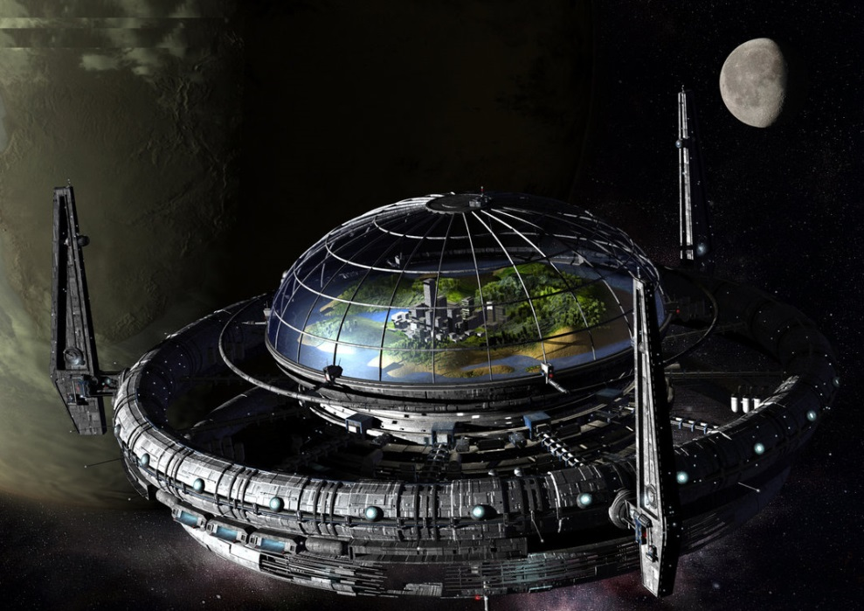

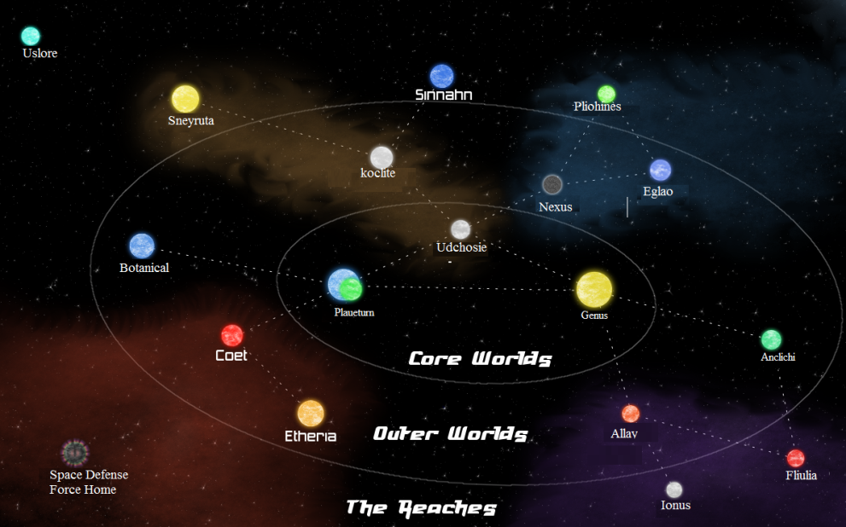

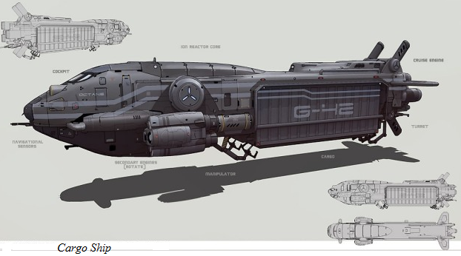

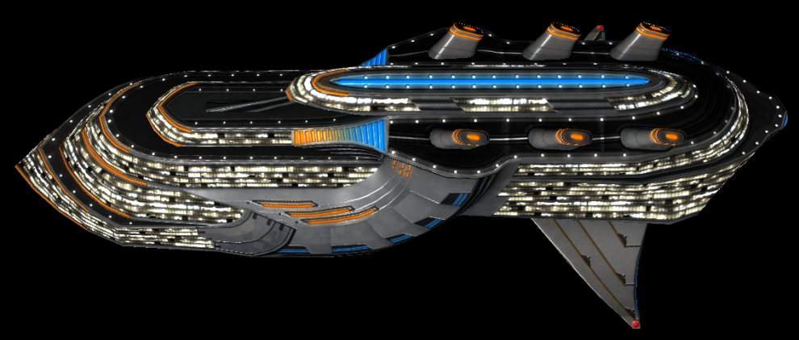

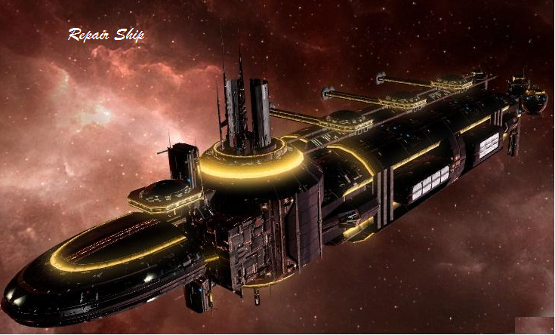

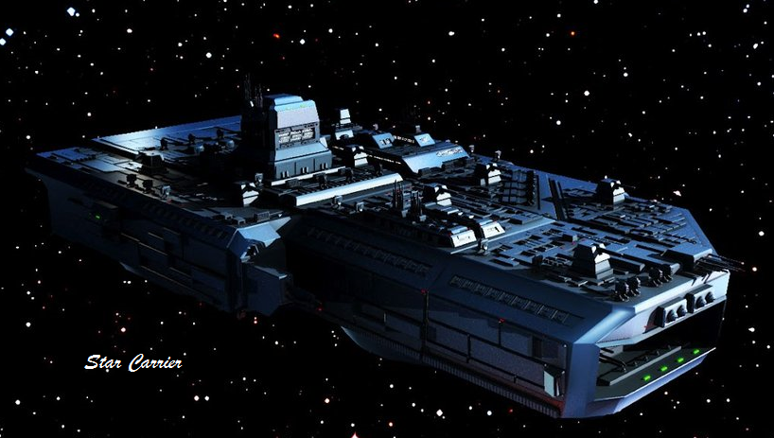

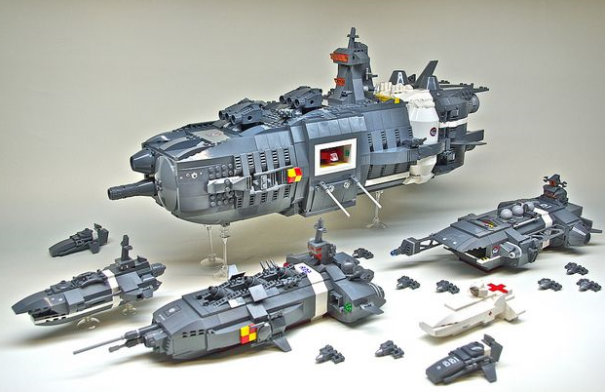

# Appendix J

## See Resources

Appendix K

<https://en.wikipedia.org/wiki/Orbital_mechanics>

<http://www.space.com/22680-nasa-lunar-laser-communications-experiment-infographic.html>