Ros2 Tutorial……………………………..

- Make Packages in Ros2 workspace
- ros2 pkg create my_robot_controller --build-type ament_python --dependencies rclpy

package name – my robot controller
package type – python and ament is build system and Colcon is build tool
depandencies – other packages and functionalities we need to use in this package.
We use RCLPY – python library for Ros2.

Then install VS code editor and use for ros2
- “sudo snap install –classic code” command use for installing VS Code.
- Setup workspace and configure to make nodes.
In the ros2 workspace configure with colcon build.

- Create Ros2 nodes with python and oop.
    - Make python file and make it executable.
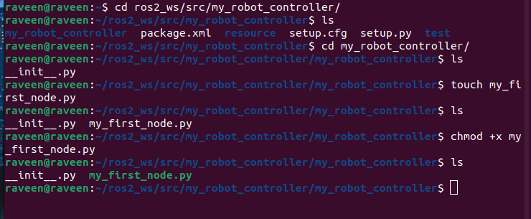

- python code for make my first node
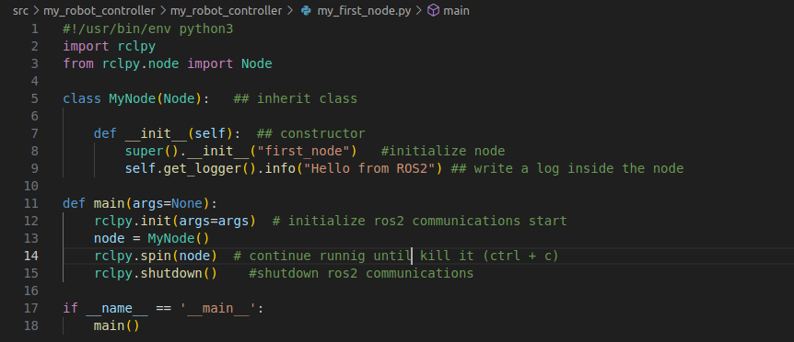

- Inside the my_robot_controller folder make the python file – “my_first_node.py”
- made a node named as “first_node”. And the file name is “my_first_node.py” and the ros2 running name is “test_node” in the “setup.py” file.
- For run as - ros2 run command we need to build file using colcon build command. For that we need to change setup.py file and doing somethings in the command lines.

- Setup file
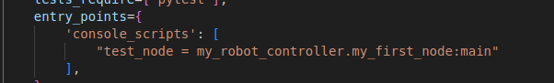

2. In command terminal.

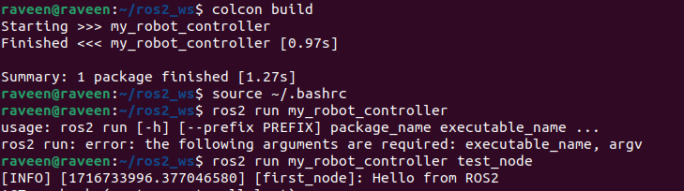

Important - difference between those three.

- When we change the node output we need to again do the colcon build. So we install colcon symlink. “colcon build–symlink-install” in the terminal. Now we don’t need to do colcon build again.
- Also make timer function and counter function to make running code continuously.

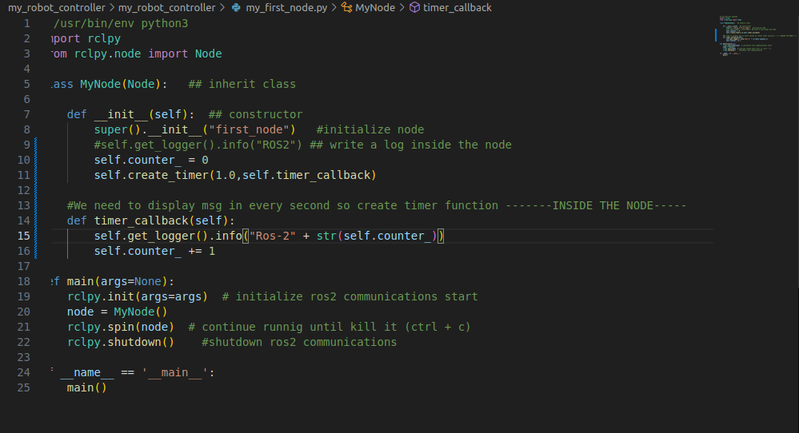

- Topic – topic is a way to communicate with nodes. Ex chatter, nodes- talker and listner, topic is chatter

Talker is publisha the chatter topic and listener is subscribe the chatter topic

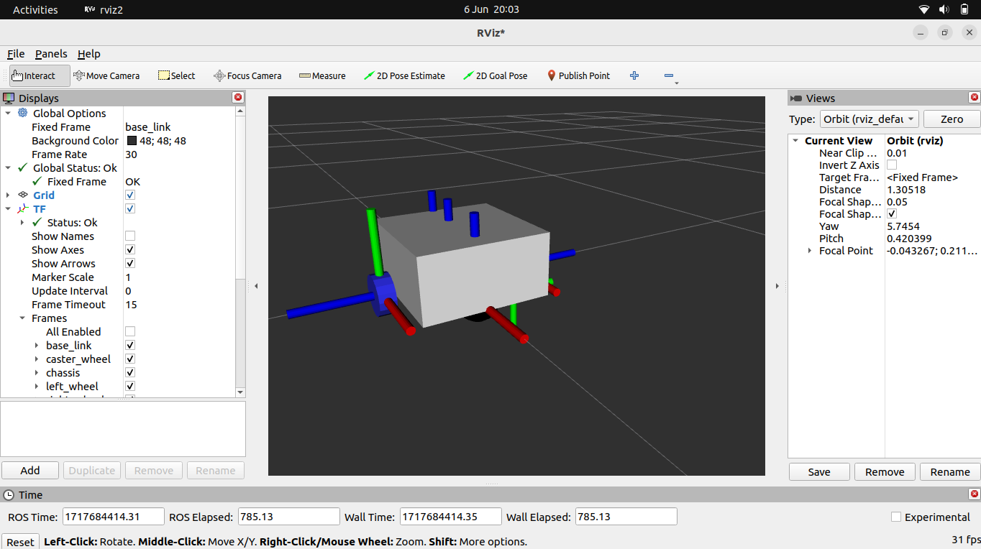

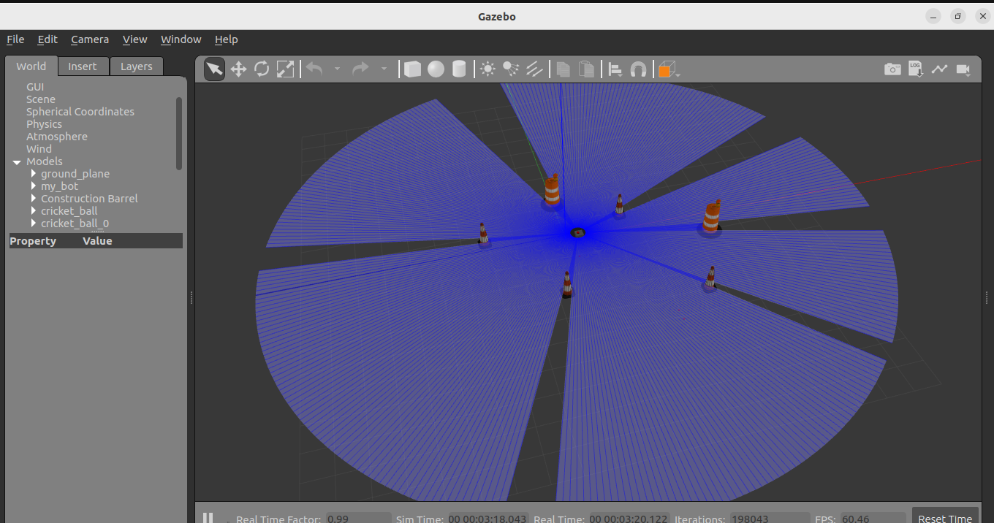

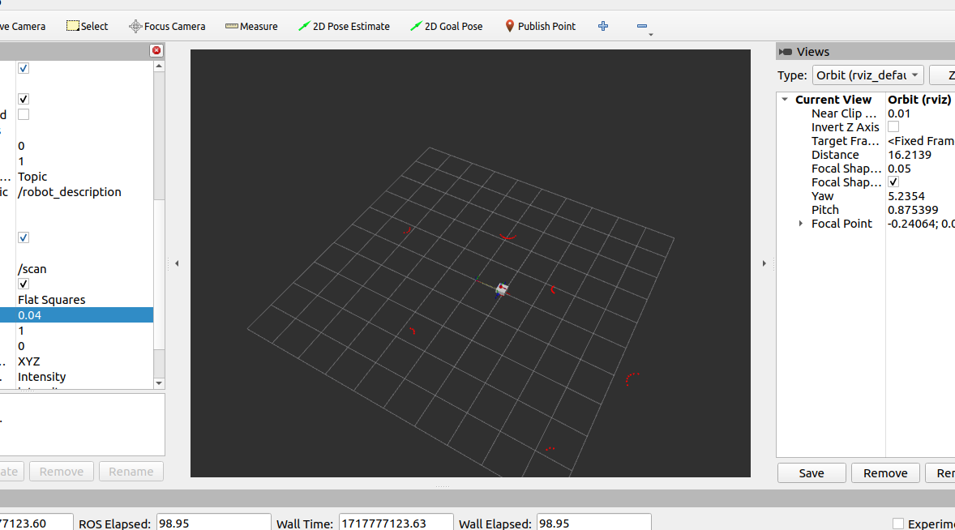
lidar output on Rviz

mapping using SLAM

RVIZ Map

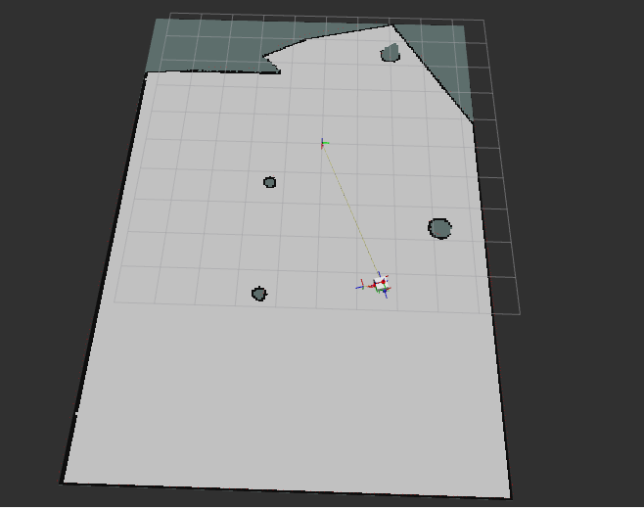

Gazebo World
