ABSTRACT
CleanStreet is a full-stack web-based civic issue reporting and tracking platform designed to digitize and streamline communication between citizens and municipal authorities. The system addresses the inefficiencies of traditional complaint mechanisms, which often suffer from lack of transparency, delayed responses, and poor accountability.
The platform enables authenticated users to report civic issues such as garbage accumulation, potholes, water leakage, and infrastructure damage by submitting geo-tagged complaints with image evidence. Location data is integrated using map-based services, ensuring precise issue identification. Uploaded media is securely stored using cloud-based storage services, while complaint data is managed through a structured NoSQL database architecture.
CleanStreet implements JWT-based authentication and role-based access control to ensure secure user sessions and administrative governance. An administrative dashboard allows authorities to monitor complaints, update statuses (Reported → In Progress → Resolved), and analyze issue trends.
The system follows a modular MERN-stack architecture (MongoDB, Express.js, React.js, Node.js) with RESTful API communication, enabling scalability and maintainability.
By promoting digital accountability, real-time tracking, and data-driven decision-making, CleanStreet contributes toward the development of smarter, cleaner, and more responsive urban ecosystems.

INTRODUCTION
3.1 Background
Urban areas face increasing challenges in managing civic infrastructure due to rapid population growth, unplanned expansion, and limited administrative resources. Common public issues such as garbage overflow, potholes, water leakage, drainage blockages, and broken streetlights directly affect public health, safety, and quality of life.
Traditionally, civic complaints are reported through manual processes, phone calls, or physical visits to municipal offices. These methods often lack structured tracking, transparency, and accountability. As a result, complaints may remain unresolved, mismanaged, or delayed due to inefficient communication channels.
With the rise of digital transformation and smart city initiatives, there is a growing need for technology-driven solutions that enhance civic participation and governance efficiency.

3.2 Need for the System
The absence of a centralized, transparent, and real-time complaint management system creates:
- Delays in issue resolution
- Lack of complaint status visibility
- Poor documentation of recurring problems
- Reduced citizen engagement
- Inefficient allocation of municipal resources
A digital platform can address these limitations by enabling structured reporting, location-based identification, automated tracking, and administrative monitoring.

3.3 Project Motivation
The motivation behind CleanStreet is to build a scalable and secure digital infrastructure that empowers citizens to actively participate in urban maintenance. By integrating modern web technologies, geolocation services, and cloud storage mechanisms, the system aims to create a transparent ecosystem where civic issues are documented, monitored, and resolved efficiently.
CleanStreet aligns with the vision of smart governance by leveraging real-time data, structured workflows, and secure authentication mechanisms to enhance accountability and operational efficiency in municipal services.

PROBLEM STATEMENT
Urban civic management systems in many regions rely on fragmented, manual, or semi-digital processes for reporting and resolving public infrastructure issues. Citizens often report problems such as garbage accumulation, potholes, water leakage, or damaged street infrastructure through phone calls, physical complaints, or informal communication channels.
These traditional mechanisms suffer from multiple limitations:
- Lack of structured documentation
- Absence of real-time complaint tracking
- Limited transparency in resolution progress
- No centralized database for issue analysis
- Weak accountability mechanisms
- Inefficient communication between citizens and authorities
Due to these inefficiencies, complaints may be delayed, overlooked, or poorly managed. Additionally, authorities lack access to consolidated data that could help identify recurring problem areas or optimize resource allocation.
There is a critical need for a secure, scalable, and transparent digital system that enables structured complaint submission, geo-tagged issue identification, real-time tracking, and administrative oversight.
The problem addressed by CleanStreet is the absence of an integrated civic issue reporting and monitoring platform that ensures accountability, improves response time, and supports data-driven urban governance.

OBJECTIVES
The primary objective of CleanStreet is to design and implement a secure, scalable, and transparent digital platform for reporting and managing civic issues. The system aims to enhance communication between citizens and municipal authorities while improving operational efficiency.
5.1 Primary Objectives
- Develop a Centralized Reporting Platform
Create a web-based system that allows citizens to submit structured complaints with image evidence and geo-location data.
- Enable Real-Time Complaint Tracking
Implement a status workflow mechanism (Reported → In Progress → Resolved) to ensure transparency and visibility.
- Ensure Secure Authentication & Role Management
Implement JWT-based authentication and role-based access control for users and administrators.
- Integrate Map-Based Location Identification
Use geospatial mapping tools to precisely capture and display issue locations.
- Design a Scalable Backend Architecture
Build RESTful APIs with modular design using Node.js, Express.js, and MongoDB for efficient data handling.

5.2 Secondary Objectives
- Improve accountability in civic issue resolution.
- Reduce complaint processing delays through digital workflows.
- Maintain structured data for trend analysis and future smart city planning.
- Provide administrators with monitoring tools through a centralized dashboard.
- Ensure cloud-based image storage for optimized performance and reliability.

5.3 Long-Term Objectives
- Integrate analytics for identifying high-frequency problem zones.
- Enable AI-driven issue categorization and prioritization.
- Expand the system to support multi-department governance models.
- Develop a mobile-responsive or native application version for wider accessibility.

SCOPE OF THE PROJECT
The scope of CleanStreet defines the functional boundaries, target users, and operational limitations of the system within its current implementation phase.

6.1 Functional Scope
CleanStreet is designed to support the following core functionalities:
- User Registration and Authentication
Citizens can securely register and log in using JWT-based authentication mechanisms.
- Civic Issue Reporting
Users can:
  - Select issue category
  - Upload image evidence
  - Capture geographic location using map integration
  - Submit structured complaint data
- Complaint Status Tracking
Users can monitor the lifecycle of complaints through defined workflow states:
  - Reported
  - In Progress
  - Resolved
- Administrative Dashboard
Authorized administrators can:
  - View all complaints
  - Update complaint status
  - Manage users
  - Monitor issue trends
- Cloud-Based Media Storage
Uploaded images are securely stored using cloud storage services to optimize performance and scalability.

6.2 Technical Scope
The system is implemented using a MERN-stack architecture:
- Frontend: React.js (Component-based UI)
- Backend: Node.js & Express.js (REST APIs)
- Database: MongoDB (NoSQL Document Store)
- Authentication: JSON Web Tokens (JWT)
- Image Handling: Multer & Cloudinary
- Map Integration: Geospatial location services
The application follows a modular architecture to ensure maintainability and scalability.

6.3 User Scope
The system currently supports:
- Citizens (Complaint Reporting Users)
- Administrators (Issue Management & Monitoring)
Future scope may include multi-department authority roles and analytics access levels.

6.4 Limitations
- The system currently operates as a web application (no native mobile app).
- Integration with official government databases is not yet implemented.
- Automated issue prioritization is not included in the current version.

6.5 Scalability Potential
The architecture allows horizontal scaling, API expansion, and integration with future smart-city infrastructure systems.

LITERATURE REVIEW
7.1 Overview
The concept of digital civic engagement platforms has gained significant importance with the rise of smart city initiatives and e-governance frameworks. Governments and municipalities worldwide are increasingly adopting technology-driven systems to enhance transparency, citizen participation, and administrative efficiency.
Research in e-governance systems highlights the importance of structured data collection, real-time monitoring, and citizen-centric platforms for improving public service delivery.

7.2 Existing Systems
Several countries have implemented digital civic reporting platforms, such as:
- Online municipal grievance portals
- Mobile-based public issue reporting applications
- Smart city dashboards for infrastructure monitoring
These systems generally allow citizens to submit complaints; however, many existing platforms suffer from:
- Poor user interface design
- Lack of real-time tracking transparency
- Limited image-based documentation
- Weak feedback mechanisms
- Limited data analytics integration
Additionally, many systems operate in siloed environments without centralized data structures for long-term urban planning.

7.3 Technical Foundations
Studies in web-based governance platforms emphasize the importance of:
- RESTful API architecture for scalability
- Secure authentication mechanisms (JWT, OAuth)
- Cloud-based storage systems for media handling
- NoSQL databases for flexible data modeling
- Geospatial data integration for precise issue mapping
Modern civic-tech solutions leverage full-stack development frameworks (such as MERN stack) to ensure modular, scalable, and maintainable applications.

7.4 Research Gap Identified
From the analysis of existing civic reporting systems, the following gaps were identified:
- Insufficient transparency in complaint lifecycle management
- Lack of structured geo-tagged issue documentation
- Limited real-time administrative dashboards
- Weak integration between citizens and authorities
- Minimal use of data-driven decision support systems

7.5 Contribution of CleanStreet
CleanStreet addresses these research gaps by:
- Implementing a transparent complaint status workflow
- Integrating map-based geo-tagging for precise location tracking
- Utilizing cloud storage for secure image handling
- Designing a modular MERN-based architecture
- Enabling structured administrative oversight
The system contributes to the growing domain of digital governance and civic technology by providing a scalable, secure, and citizen-centric solution.

PROPOSED SYSTEM
8.1 Overview
The proposed system, CleanStreet, is a full-stack web-based civic issue reporting platform designed to establish a structured, transparent, and scalable communication channel between citizens and municipal authorities.
The system replaces traditional complaint mechanisms with a digital workflow-driven architecture that enables real-time tracking, secure authentication, geo-tagged issue documentation, and centralized administrative monitoring.

8.2 System Workflow
The proposed system follows a structured complaint lifecycle:
- User Registration & Authentication
  - Users register securely.
  - JWT-based authentication ensures session security.
  - Role-based access control distinguishes between citizens and administrators.
- Complaint Submission
  - User selects issue category.
  - Uploads image evidence.
  - Captures geographic location using map integration.
  - Submits structured complaint data to backend APIs.
- Data Processing
  - Backend validates input.
  - Image is uploaded to cloud storage (Cloudinary).
  - Complaint data is stored in MongoDB.
- Administrative Monitoring
  - Admin dashboard displays all complaints.
  - Admin updates complaint status:
    - Reported
    - In Progress
    - Resolved
- Status Tracking
  - Users can monitor complaint progress in real time.
  - Updates are reflected dynamically through API calls.

8.3 System Architecture Model
CleanStreet follows a three-tier architecture:
1️⃣ Presentation Layer (Frontend)
- Built using React.js
- Component-based UI architecture
- Responsive design
- API communication via Axios
2️⃣ Application Layer (Backend)
- Node.js & Express.js
- RESTful API endpoints
- Middleware-based request handling
- JWT authentication
- Role-based authorization
3️⃣ Data Layer
- MongoDB (NoSQL Document Database)
- Mongoose for schema modeling
- Cloudinary for media storage

8.4 Design Principles
The system is designed based on:
- Modularity (separation of frontend, backend, database)
- Scalability (API-based architecture)
- Security (JWT, password hashing with bcrypt)
- Maintainability (clean folder structure)
- Cloud readiness (external media storage)

8.5 Advantages of Proposed System
✔ Transparent complaint lifecycle
✔ Geo-location accuracy
✔ Secure authentication
✔ Scalable architecture
✔ Cloud-based media handling
✔ Improved accountability

8.6 How It Improves Over Existing Systems
Traditional System | CleanStreet
Manual complaints | Digital submission
No tracking | Real-time tracking
Paper-based records | Structured database
Limited transparency | Visible status workflow
No image proof | Image-based evidence
No analytics | Data-ready architecture

SYSTEM ARCHITECTURE
9.1 Overview
CleanStreet follows a three-tier client–server architecture designed for modularity, scalability, and maintainability. The system separates concerns into Presentation Layer, Application Layer, and Data Layer to ensure clean architecture and efficient communication between components.
This layered architecture enhances performance, security, and future scalability.

9.2 Architectural Layers
1️⃣ Presentation Layer (Frontend)
- Built using React.js
- Component-based UI design
- Handles user interaction and rendering
- Communicates with backend using Axios (HTTP requests)
- Integrates map services for geo-location capture
Responsibilities:
- Display forms and dashboards
- Capture user input
- Handle authentication tokens
- Render complaint status updates dynamically

2️⃣ Application Layer (Backend)
- Built using Node.js and Express.js
- Implements RESTful APIs
- Handles business logic
- Manages authentication & authorization
- Processes image uploads
Responsibilities:
- Validate incoming requests
- Authenticate users via JWT
- Store complaint data
- Upload media to Cloudinary
- Update complaint status
- Handle role-based access control

3️⃣ Data Layer
- MongoDB (NoSQL database)
- Mongoose for schema modeling
- Cloudinary for media storage
Responsibilities:
- Store structured complaint documents
- Maintain user records
- Store complaint status history
- Manage image URLs via cloud storage

9.3 System Data Flow
The system operates through the following data flow sequence:
- User submits complaint via React frontend
- Axios sends HTTP request to Express API
- Backend validates request
- Image file processed using Multer
- Image uploaded to Cloudinary
- Complaint data stored in MongoDB
- Response returned to frontend
- Dashboard updates dynamically
This request–response cycle ensures secure and structured communication.

9.4 Architecture Diagram Description
You can draw this diagram in your documentation:
[ User ]
↓
[ React Frontend ]
↓ (HTTP Requests via Axios)
[ Express Server (Node.js) ]
↓
[ MongoDB Database ]
↓
[ Cloudinary (Image Storage) ]
Arrows indicate data flow between components.

9.5 Security Architecture
CleanStreet implements multiple security layers:
- Password hashing using bcrypt
- JWT token-based authentication
- Protected routes middleware
- Role-based access control
- Environment variable-based configuration
This ensures protection against:
- Unauthorized access
- Token tampering
- Direct database exposure

9.6 Scalability Considerations
The architecture supports:
- Horizontal scaling of backend services
- Cloud deployment compatibility
- API extension without affecting frontend
- Microservices expansion in future

TECHNOLOGY STACK
10.1 Overview
CleanStreet is developed using a full-stack JavaScript architecture based on the MERN stack (MongoDB, Express.js, React.js, Node.js). The technology stack was selected to ensure scalability, modularity, performance efficiency, and rapid development.

10.2 Frontend Technologies
🔹 React.js
React.js was chosen for building the user interface due to:
- Component-based architecture
- Reusability of UI components
- Virtual DOM for efficient rendering
- Strong ecosystem support
It enables dynamic rendering of complaint status updates and dashboard elements.

🔹 React Router
Used for:
- Client-side routing
- Seamless navigation between pages
- Protected route handling
Ensures a smooth single-page application experience.

🔹 Axios
Used for:
- Sending HTTP requests to backend APIs
- Handling asynchronous operations
- Managing API response and error handling
Provides structured client-server communication.

🔹 OpenLayers (Map Integration)
Used for:
- Capturing geographic coordinates
- Visualizing issue locations
- Enhancing geo-tagging accuracy
Improves precision in identifying civic problem areas.

10.3 Backend Technologies
🔹 Node.js
Chosen because:
- Event-driven, non-blocking architecture
- High performance for I/O-heavy applications
- JavaScript across both frontend and backend
Ensures consistency in development.

🔹 Express.js
Used as:
- Backend web framework
- Middleware handling
- REST API development
Provides clean routing and modular API structure.

🔹 MongoDB
Chosen due to:
- NoSQL flexible schema
- JSON-like document storage
- Easy scalability
- High performance for structured complaint data
Allows dynamic storage of complaint and user documents.

🔹 Mongoose
Used for:
- Schema modeling
- Data validation
- Structured database interaction
Improves reliability and maintainability.

10.4 Security Technologies
🔹 JSON Web Token (JWT)
Used for:
- Stateless authentication
- Secure session management
- Token-based authorization
Ensures protected route access and role control.

🔹 Bcrypt
Used for:
- Password hashing
- Secure credential storage
Prevents plain-text password storage vulnerabilities.

10.5 Media & Communication Technologies
🔹 Multer
Used for handling multipart/form-data during image upload.

🔹 Cloudinary
Chosen for:
- Cloud-based image storage
- CDN optimization
- Scalable media management
Prevents server overload due to large media files.

🔹 Nodemailer
Used for:
- Email notifications
- OTP verification
- Complaint updates
Enhances user communication workflow.

10.6 Development & Deployment Tools
- Visual Studio Code (IDE)
- Git & GitHub (Version Control)
- Postman (API Testing)
- Environment Variables (.env) for secure configuration

10.7 Why MERN Stack Was Selected
The MERN stack enables:
✔ Full JavaScript development environment
✔ Faster development cycle
✔ Strong community support
✔ Scalable architecture
✔ Cloud compatibility
It ensures maintainability and future extensibility of the system.

SYSTEM MODULES
11.1 Overview
CleanStreet is designed using a modular architecture where each core functionality is implemented as an independent yet interconnected module. This modular design improves maintainability, scalability, and system clarity.
The system consists of the following major modules:
- User Module
- Authentication Module
- Complaint Management Module
- Admin Module
- Notification Module
- Map Integration Module
- Media Handling Module

11.2 User Module
Description
The User Module manages citizen interactions with the platform.
Functionalities
- User registration
- User login/logout
- View personal dashboard
- Submit complaints
- Track complaint status
Technical Implementation
- React-based UI forms
- Axios-based API communication
- JWT token stored securely for session handling
- MongoDB document for user profile storage

11.3 Authentication Module
Description
Handles secure user access and session validation.
Functionalities
- Secure login verification
- Password hashing using bcrypt
- JWT token generation
- Protected route middleware
- Role-based authorization
Security Measures
- Password encryption
- Token expiry handling
- Middleware-based access control
- Environment variable secret storage

11.4 Complaint Management Module
Description
Core module responsible for issue reporting and tracking.
Functionalities
- Issue category selection
- Image upload
- Geo-location capture
- Complaint data storage
- Status update workflow
Complaint Lifecycle
- Reported
- In Progress
- Resolved
Technical Flow
- User submits complaint
- Backend validates data
- Image uploaded to Cloudinary
- MongoDB stores complaint document
- Admin updates status

11.5 Admin Module
Description
Administrative control system for monitoring and managing complaints.
Functionalities
- View all complaints
- Filter complaints by status
- Update complaint status
- Monitor user activity
- Maintain issue transparency
Technical Implementation
- Role-based access control
- Protected admin routes
- Dashboard analytics structure

11.6 Notification Module
Description
Handles communication and system alerts.
Functionalities
- OTP verification emails
- Complaint submission confirmation
- Status update notifications
Tools Used
- Nodemailer
- SMTP configuration
- Backend-triggered mail services

11.7 Map Integration Module
Description
Responsible for capturing and displaying geographic issue locations.
Functionalities
- Location pin selection
- Coordinate extraction
- Map rendering
- Geo-tagged complaint storage
Technology Used
- OpenLayers
- Latitude & Longitude storage in MongoDB
This ensures accurate identification of civic problem zones.

11.8 Media Handling Module
Description
Handles image upload and storage.
Functionalities
- File validation
- Upload handling using Multer
- Cloud storage integration
Benefits
- Reduced server load
- CDN-based image delivery
- Scalable storage management

11.9 Modular Design Advantages
✔ Independent module development
✔ Easier debugging
✔ Better maintainability
✔ Scalability for future enhancements
✔ Clear separation of concerns

DATABASE DESIGN
12.1 Overview
CleanStreet uses MongoDB, a NoSQL document-based database, for storing application data. The database is designed using Mongoose schemas to ensure structured validation, indexing, and relationship modeling.
The system consists of four primary collections:
- Users
- Issues
- Comments
- OTP
The database is designed to support scalability, relational referencing, and performance optimization.

12.2 User Collection
Defined in the User schema
user
Fields:
- name (String, required)
- username (String, unique)
- email (String, unique)
- phone (String)
- location (String, required)
- postalCode (String)
- password (Hashed using bcrypt)
- role (Default: "user")
- status (ACTIVE / BLOCKED)
- memberSince (Date)
- lastActive (Date)
Purpose:
- Stores citizen and admin accounts
- Supports role-based access
- Ensures secure credential management

12.3 Issue Collection
Defined in Issue schema
Issue
Fields:
- title (String, required)
- issueType (String)
- priority (low / medium / high)
- address (String, required)
- latitude (Number)
- longitude (Number)
- postalCode (String)
- landmark (String)
- description (String, required)
- imageUrls (Array of Strings – Cloudinary URLs)
- reportedBy (Reference to User)
- status (reported / in progress / resolved / rejected)
- resolvedAt (Date)
- createdAt (Date)
- commentsCount (Number)
- latestComment (Embedded object)
- upvotes (Array of User references)
- downvotes (Array of User references)
Design Highlights:
- Supports multi-image uploads
- Maintains vote tracking
- Tracks complaint lifecycle
- Stores geo-coordinates
- Optimized for quick comment count retrieval

12.4 Comment Collection
Defined in Comment schema
Comment
Fields:
- issueId (Reference to Issue)
- userId (Reference to User)
- text (String, max 2000 characters)
- parentCommentId (For threaded replies)
- likes (Array of User references)
- createdAt (Date)
Special Design Feature:
A post-remove hook automatically updates:
- commentsCount in Issue
- latestComment reference
This ensures consistency and performance optimization.
Indexes implemented:
- issueId + createdAt
- userId
Improves query performance.

12.5 OTP Collection
Defined in OTP schema
OTP
Fields:
- email (Unique)
- otp (String)
- createdAt (Auto-expiring after 600 seconds)
Key Feature:
TTL Index automatically deletes OTP after 10 minutes, enhancing security.

12.6 Entity Relationship Overview
Relationship Structure:
- One User → Many Issues
- One Issue → Many Comments
- One User → Many Comments
- One User → Many Upvotes / Downvotes
ER Flow:
User
↓
Issue
↓
Comment
Relational references are handled using ObjectId references.

12.7 Database Design Advantages
✔ NoSQL flexible schema
✔ Efficient relational referencing
✔ Performance indexing
✔ TTL security for OTP
✔ Cloud media storage integration
✔ Optimized comment tracking

API DOCUMENTATION
13.1 Overview
CleanStreet implements a RESTful API architecture using Express.js. The backend exposes secured and public endpoints to handle authentication, issue reporting, comment management, administrative control, and analytics.
All protected routes use JWT-based middleware authentication.

13.2 Authentication APIs
Defined in auth routes
authRoutes
🔹 Register User
POST /api/auth/register
Description: Create new user account
Input:
{
"name": "John Doe",
"username": "john123",
"email": "john@email.com",
"password": "Password@123"
}

🔹 Login User
POST /api/auth/login
Output:
- JWT Token
- User details

🔹 Send OTP
POST /api/auth/send-otp
Used for password reset.

🔹 Verify OTP
POST /api/auth/verify-otp

🔹 Reset Password
POST /api/auth/reset-password

🔹 Get Dashboard Data
GET /api/auth/dashboard
(Protected Route)

13.3 Issue Management APIs
Defined in issue routes
issueRoutes
🔹 Report Issue
POST /api/issues/
(Protected)
Supports:
- Multi-image upload (Max 3 images, 5MB each)
- Geo-location data
- Priority selection

🔹 Get All Issues
GET /api/issues/
(Protected)

🔹 Public Issues
GET /api/issues/public
(No authentication required)

🔹 Vote on Issue
POST /api/issues/:id/vote/:type
(Protected)
Types:
- upvote
- downvote

🔹 Update Issue Status (Admin)
PATCH /api/issues/admin/issues/:issueId/status
(Protected)

🔹 Delete Issue (Admin)
DELETE /api/issues/admin/issues/:issueId
(Protected)

13.4 Comment APIs
Defined in comment routes
commentRoutes
🔹 Add Comment
POST /api/issues/:issueId/comments
(Protected)

🔹 Get Comments by Issue
GET /api/issues/:issueId/comments

🔹 Delete Comment
DELETE /api/issues/:issueId/comments/:commentId
(Protected)

🔹 Like Comment
POST /api/comments/:id/like
(Protected)

13.5 Admin User Management APIs
Defined in admin user routes
adminUserRoutes
🔹 Get All Users
GET /api/admin/users
(Admin only)

🔹 Block / Unblock User
PUT /api/admin/block/:id
(Admin only)

🔹 Change User Role
PUT /api/admin/role/:id
(Global Admin only)

🔹 Delete User
DELETE /api/admin/:id
(Admin only)

13.6 Admin Issue Control APIs
Defined in admin issue routes
adminIssueRoutes
🔹 Update Issue Status
PATCH /:issueId/status

🔹 Delete Issue
DELETE /:issueId

13.7 Admin Analytics & Reports API
Defined in admin reports
adminReports
🔹 Get System Analytics
GET /api/admin/reports?range=month
Supports:
- Total users
- New users (range-based)
- Complaint trends
- Resolution rate
- Issue status counts
- Priority distribution
- Average response time
- User satisfaction score
- Active sessions
This endpoint performs aggregation queries and dynamic time-based filtering.

13.8 Geolocation Utility APIs
Defined in utils routes
utilsRoutes
🔹 Reverse Geocoding
GET /api/utils/reverse?lat=..&lon=..
Converts coordinates → readable address

🔹 Forward Geocoding
GET /api/utils/forward?q=address
Converts address → coordinates

13.9 Security in API Layer
- JWT middleware protection
- Role-based access control (admin / globaladmin)
- File upload size limitation
- Rate-controlled OTP system
- Protected admin analytics endpoints

13.10 API Design Advantages
✔ RESTful structure
✔ Modular route separation
✔ Secure middleware implementation
✔ Scalable architecture
✔ Analytics-enabled endpoints
✔ Geospatial support

IMPLEMENTATION DETAILS & TECHNICAL DECISIONS

14.1 Frontend Architecture (React + Modular Design)
CleanStreet frontend is built using a modular React architecture where each major system module is separated into independent components.
🔹 Admin Dashboard Implementation
Implemented in:
AdminDashboard
Technical Highlights:
- Uses useEffect for dynamic data loading.
- Role-based logic (globaladmin vs regional admin).
- Dynamic statistics calculation (Pending, In Progress, Resolved).
- OpenLayers map integration with:
  - Vector layers
  - Custom marker icons (priority-based color coding)
  - Reverse geolocation center logic
- Map modal rendering with optimized cleanup (setTarget(null)).
Engineering Decision:
OpenLayers was chosen instead of Google Maps to avoid API billing costs and enable full open-source flexibility.

14.2 Advanced Complaint Management System
Implemented in:
AdminManageComplaints
Features:
- Server-side pagination
- Infinite scrolling (optimized with requestAnimationFrame)
- Deduplication using Set-based ID tracking
- Role-based status update restriction
- SweetAlert2 confirmation flows
- Optimistic UI updates
- Local state synchronization after backend response
Smart Sorting Algorithm:
Supports:
- Priority-based weighted sorting
- Status normalization
- Comment activity ranking
- Time-based sorting
Technical Depth:
- Efficient filtering + sorting pipeline
- Controlled state updates to prevent UI race conditions
- Pagination fallback if backend does not return totalPages

14.3 Advanced Analytics Engine (Admin Reports)
Implemented in:
AdminReports
Core Features:
- Axios interceptor for automatic JWT injection
- Dynamic time-range filtering (week/month/quarter/year)
- Resolution rate calculation
- User engagement percentage logic
- Donut chart generation using CSS conic-gradient
- Dynamic percentage calculations
PDF Export Engine:
- jsPDF + autoTable
- Multi-page generation
- Dynamic metrics table
- Styled headers and footers
- Automatic page numbering
Export Formats:
- PDF
- JSON
- CSV
Engineering Depth:
- Data mapping + sanitization
- Aggregation normalization
- Auto file naming with timestamp
This module demonstrates production-grade reporting capability.

14.4 User Management System
Implemented in:
AdminUsers
Key Engineering Features:
- Infinite scroll user loading
- Debounced search (500ms delay)
- Role-based filtering (Global Admin vs Regional Admin)
- Optimistic UI block/unblock updates
- Secure role promotion
- Soft-delete implementation
Security Model:
- Global admin can promote/demote
- Regional admin limited to their postal code
- Token-based API protection

14.5 Public Landing + Live Statistics Engine
Implemented in:
Home
Technical Highlights:
- Public endpoints (no authentication)
- Unique issue filtering via Set
- Recently resolved issues extraction
- Live statistics aggregation
Performance Decision:
Client-side deduplication to ensure UI integrity even if backend sends redundant entries.

14.6 Authentication & OTP Security Layer
Implemented in:
Login
Advanced Features:
- Dual-mode login (Password / OTP)
- loginWithToken state injection
- SweetAlert secure UX flows
- Location auto-detection during registration
- Reverse geocoding for address accuracy
Security Model:
- JWT stored securely
- Authorization header auto-injected
- OTP-based password reset

14.7 User Profile + Security Module
Implemented in:
Profile
Engineering Highlights:
- Inline editable fields using contentEditable
- Controlled blur-based state sync
- Reverse geolocation integration
- OTP-based password update inside profile
- SweetAlert secure confirmation patterns

14.8 Civic Issue Reporting Engine (Core Feature)
Implemented in:
ReportIssue
Advanced Features:
- Multi-image upload (Max 3)
- Real-time upload progress bar
- OpenLayers interactive map
- Reverse geocoding on click
- FormData multipart submission
- Upload timeout control (120 seconds)
Engineering Decisions:
- Client-side preview with URL.createObjectURL
- Memory cleanup via revokeObjectURL
- Validation before submission
- Progressive UX feedback
This module demonstrates:
✔ File handling
✔ Geospatial interaction
✔ Async upload control
✔ UI state management

14.9 Community Engagement System
Implemented in:
ViewComplaints
Features:
- Upvote / Downvote toggle logic
- Comment pagination
- Infinite scroll in modal
- Optimistic vote update
- Modal lifecycle management
- Google Maps integration for location view
Advanced Voting Logic:
- Uses Set-based vote detection
- Prevents duplicate votes
- Removes opposite vote automatically

14.10 State Management Strategy
CleanStreet uses:
- React Hooks (useState, useEffect, useRef)
- Context API for Authentication
- Local state normalization
- Optimistic UI patterns
- Controlled component architecture
Why not Redux?
The project scale was optimized using Context + local modular state to reduce complexity.

14.11 Performance Optimization Techniques
✔ Infinite scroll instead of large data load
✔ Deduplication using Set
✔ Conditional rendering
✔ useCallback for heavy functions
✔ Cleanup of map targets
✔ Upload progress tracking
✔ Lazy rendering of modals

14.12 Security Engineering
✔ JWT middleware protection
✔ Role-based authorization
✔ OTP verification flow
✔ Admin privilege restriction
✔ Backend validation
✔ Protected analytics endpoints
✔ Token-based API calls

14.13 Engineering-Level Summary
CleanStreet is not just a UI project.
It demonstrates:
- Geospatial system integration
- Role-based enterprise architecture
- Analytics & reporting engine
- Secure authentication workflow
- Optimized rendering strategies
- Scalable modular React design
- Backend-connected real-time data system

TESTING & VALIDATION

16.1 Overview
Testing was conducted to ensure the reliability, security, performance, and correctness of the CleanStreet platform. Both frontend and backend components were validated using manual testing, API testing tools, and edge-case simulation.
The system was tested under multiple user roles and data scenarios to ensure stability.

16.2 Testing Methodology
The following testing approaches were applied:
- Functional Testing
- Integration Testing
- API Testing
- Role-Based Access Testing
- Boundary & Edge Case Testing
- Performance Testing
- Security Testing

16.3 Functional Testing
Each module was tested independently.
Module | Test Scenario | Expected Result | Status
User Registration | Valid data input | Account created | ✅ Passed
Login | Correct credentials | Token generated | ✅ Passed
Login | Incorrect password | Error message | ✅ Passed
Report Issue | All fields valid | Issue stored in DB | ✅ Passed
Map Selection | Click on map | Address auto-filled | ✅ Passed
Vote System | Upvote toggle | Vote updated | ✅ Passed
Comment System | Add comment | Comment stored | ✅ Passed
Admin Status Update | Change status | Status updated | ✅ Passed

16.4 API Testing
APIs were tested using Postman.
Tested Scenarios:
- Authentication token validation
- Expired token rejection
- Missing required fields
- Invalid issue ID
- Unauthorized admin access
- File upload size limit
All endpoints returned proper HTTP status codes:
- 200 → Success
- 400 → Bad Request
- 401 → Unauthorized
- 403 → Forbidden
- 500 → Server Error

16.5 Role-Based Access Testing
Role | Allowed Actions | Restricted Actions
User | Report issue, comment, vote | Cannot update issue status
Admin | Update issue status (region) | Cannot promote admin
Global Admin | Manage all users & issues | —
Result: Role restrictions functioned correctly via middleware and UI control.

16.6 Performance Testing
Test Cases:
- Uploading 3 high-resolution images
- Loading 100+ complaints
- Infinite scroll pagination
- Analytics dashboard data rendering
Observations:
- No significant UI lag
- Upload progress tracked correctly
- Pagination reduced initial load time

16.7 Security Testing
Security validation included:
✔ Password hashing verification
✔ JWT token protection
✔ Unauthorized API access rejection
✔ OTP expiration (10-minute TTL)
✔ Role-based middleware enforcement
✔ Protected admin analytics endpoint
Tested manually by attempting:
- Accessing protected routes without token
- Modifying token manually
- Using admin endpoints as regular user
All attempts were successfully blocked.

16.8 Edge Case Testing
Tested scenarios:
- Submitting issue without location
- Submitting empty description
- Uploading more than 3 images
- Deleting comment as non-author
- Double voting on same issue
- Network disconnection during upload
System handled all cases gracefully with proper error messages.

16.9 Validation Results
The CleanStreet system demonstrated:
- High functional correctness
- Secure authentication flow
- Stable performance under moderate load
- Proper authorization enforcement
- Reliable state synchronization

RESULTS & SYSTEM OUTPUT

17.1 Overview
The CleanStreet system was successfully developed and deployed as a full-stack web application. The implementation demonstrates secure authentication, real-time complaint tracking, geo-location integration, and analytics-based administrative control.
The following subsections describe the major system outputs with corresponding screenshots.

17.2 Landing Page (Public Interface)
Description:
The landing page provides an overview of the platform, live system statistics, and recently resolved issues. It dynamically fetches public data without requiring authentication.
Key Highlights:
- Live total users count
- Total reported issues
- Postal zones coverage
- Recently resolved complaints
- Call-to-action buttons
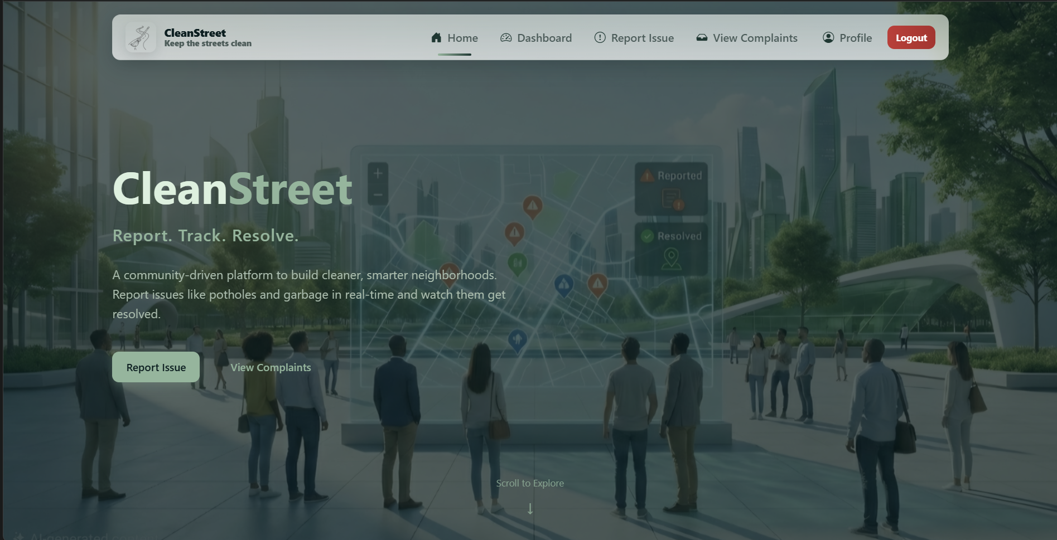
17.3 User Registration & Login System
Description:
The system supports secure login using password authentication and OTP-based verification.
Key Features:
- JWT-based login
- OTP verification
- Role-based redirection
- Geolocation-based address autofill
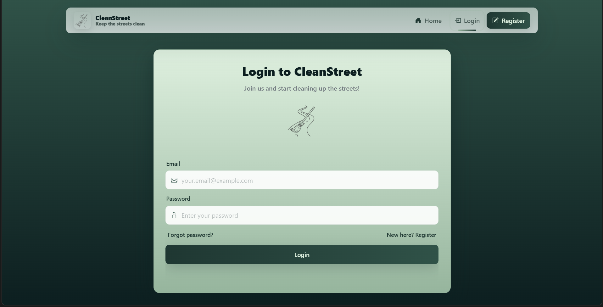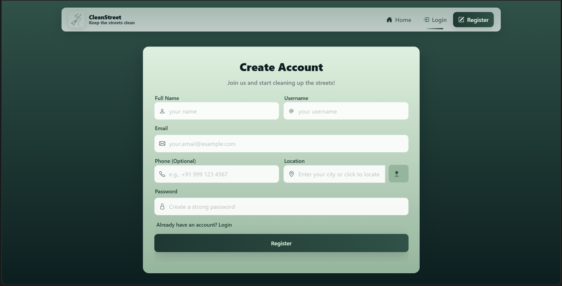

17.4 Dashboard (User View)
Description:
The dashboard provides a summary of complaint statistics and recent activities in the user’s region.
Key Highlights:
- Total Issues
- Pending Issues
- In Progress
- Resolved
- Map visualization
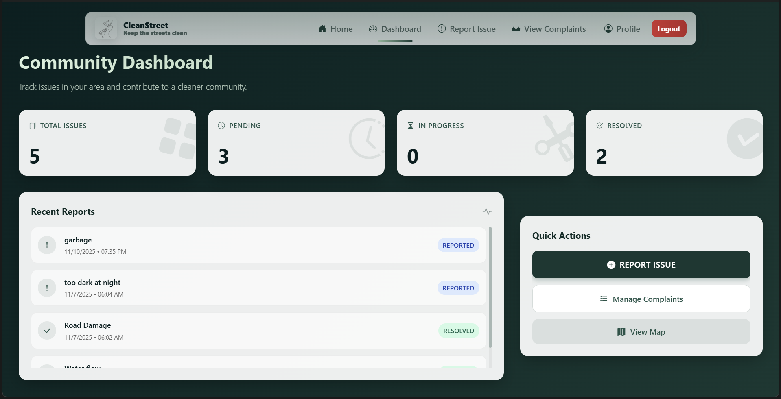
17.5 Issue Reporting Interface
Description:
Users can submit civic issues using a structured form integrated with an interactive map.
Key Features:
- Title & description
- Priority selection
- Multi-image upload (Max 3)
- Real-time upload progress bar
- Click-to-select map location
- Auto-filled address using reverse geocoding
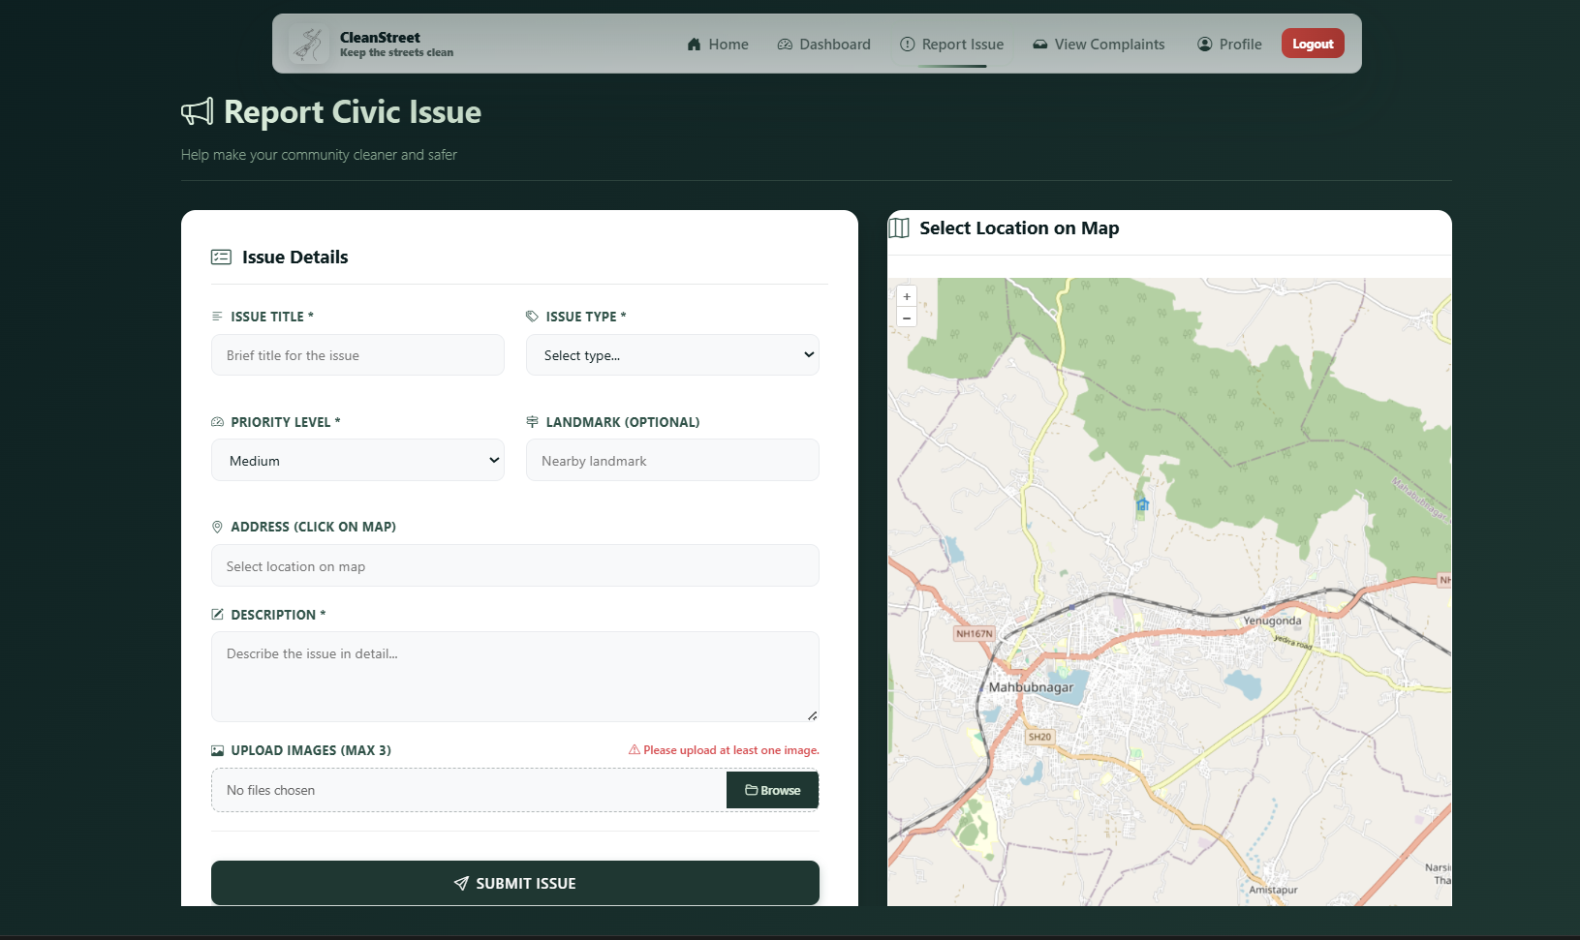
17.6 Complaint Listing & Engagement
Description:
All complaints are displayed with sorting, filtering, and interaction capabilities.
Key Features:
- Infinite scroll pagination
- Priority badges
- Status indicators
- Upvote / Downvote system
- Comment discussion modal
- View location in Google Maps
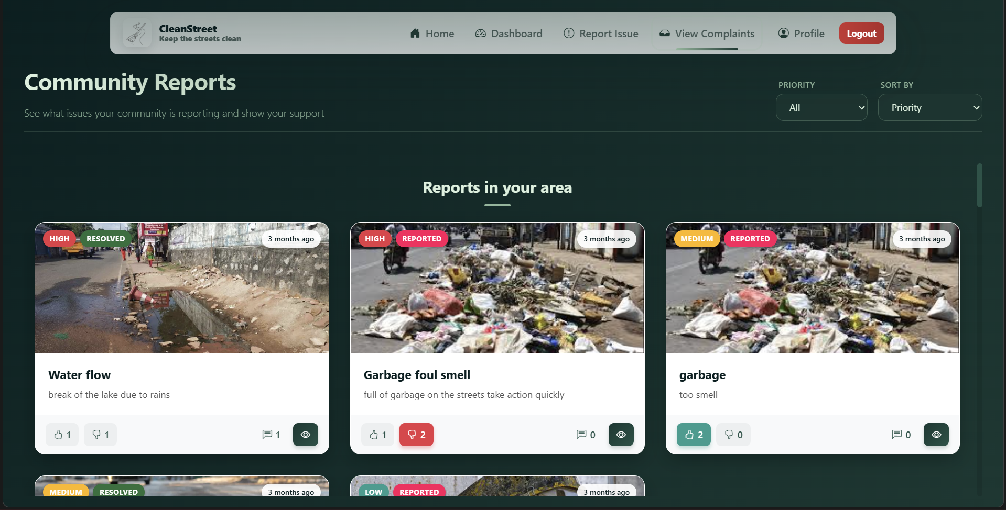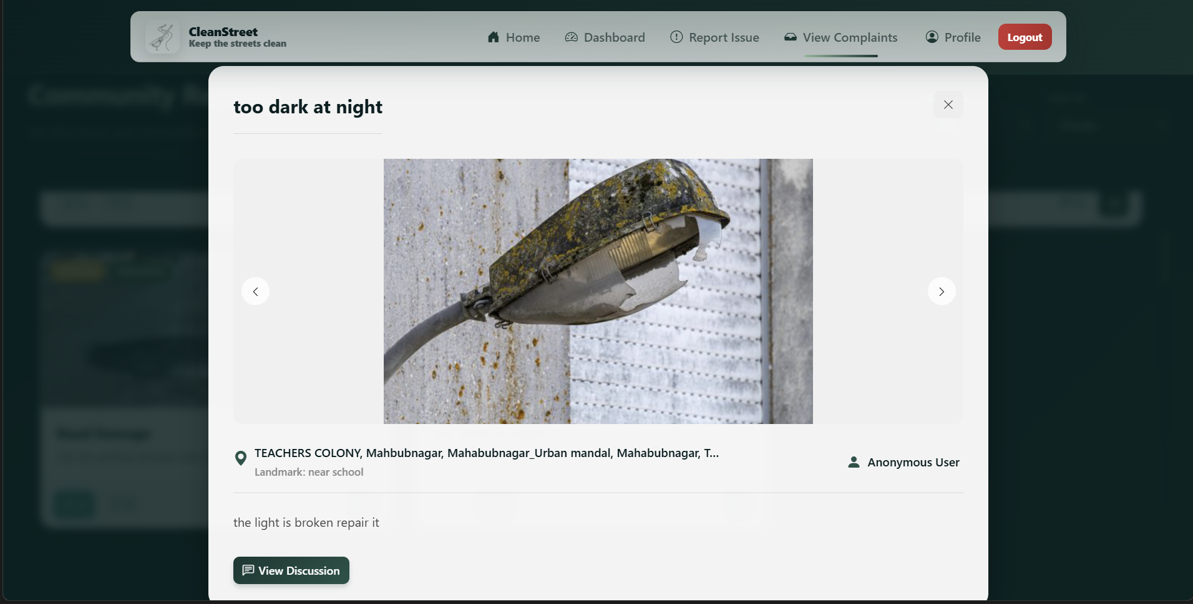
17.7 Admin Dashboard
Description:
Administrators can monitor and manage complaints within their region.
Key Features:
- Region-based filtering
- Complaint status updates
- Issue statistics
- Interactive issue map
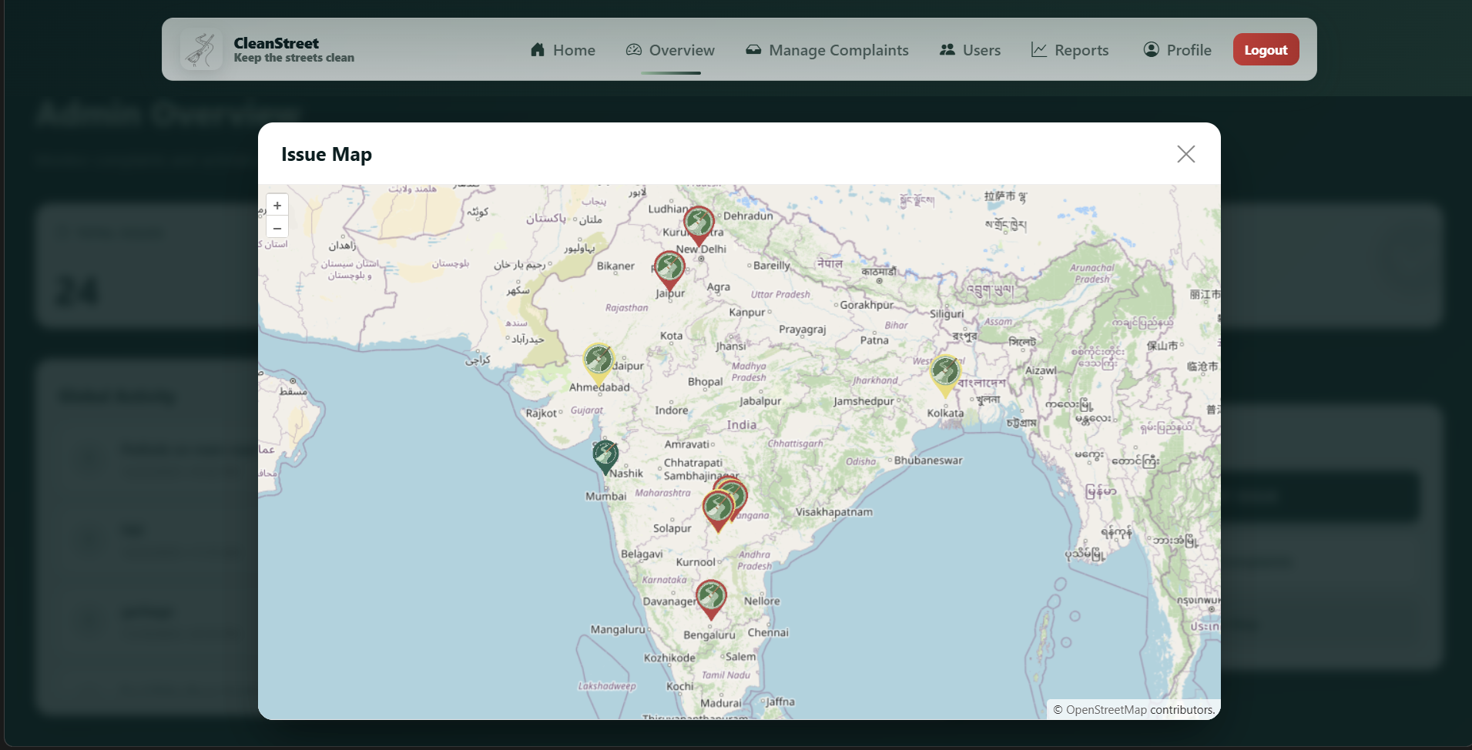
17.8 User Management (Admin Control)
Description:
Global administrators can manage users across the platform.
Key Features:
- Infinite scroll user listing
- Search functionality
- Block / Unblock user
- Promote / Demote admin
- Role-based access control
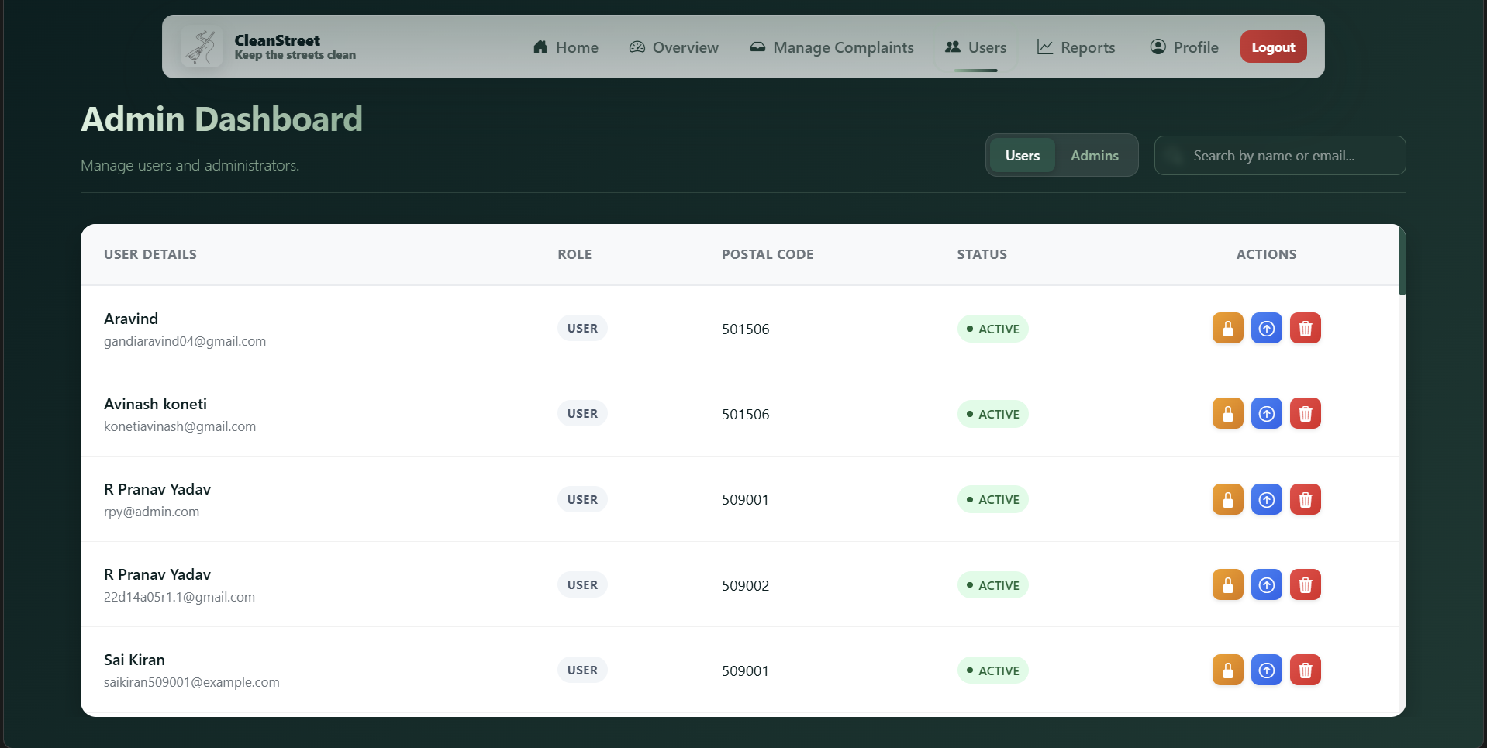

17.9 Analytics & Reporting Module
Description:
The analytics module provides data-driven insights for governance monitoring.
Key Features:
- Resolution rate calculation
- User engagement metrics
- Priority distribution
- Complaint status distribution
- User growth trends
- PDF / CSV / JSON export
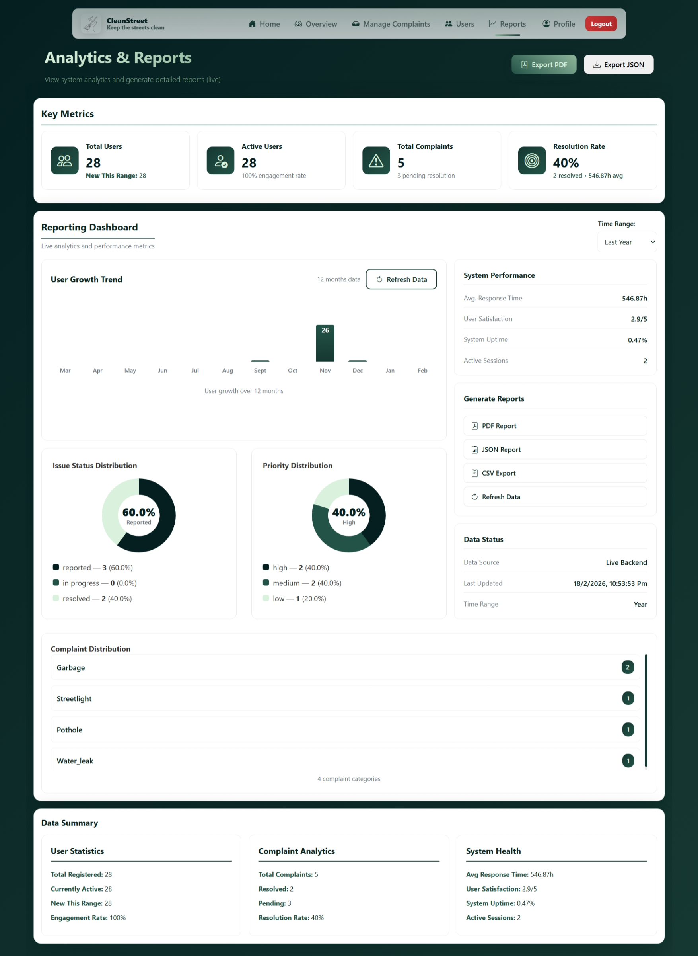
17.10 Security Validation Output
The system successfully enforces:
- Token-based authentication
- Protected routes
- Role-based authorization
- OTP expiration
- Admin privilege restriction
Unauthorized access attempts resulted in proper error responses.

17.11 Deployment Result
The application is deployed and accessible via cloud hosting services, ensuring:
✔ Public availability
✔ Environment variable configuration
✔ Secure production build
✔ Optimized performance
Live Deployment URL:
https://cleanstreet09.vercel.app

17.12 Result Summary
The CleanStreet platform successfully demonstrates:
- End-to-end complaint lifecycle management
- Secure and scalable system architecture
- Geo-location-enabled reporting
- Real-time interaction capabilities
- Administrative analytics and reporting
- Cloud-based deployment readiness
The system meets its defined objectives and validates the feasibility of a digital civic issue management solution.

