Estimating temporary populations: a systematic review of the empirical literature

**Radoslaw Panczak1**

**Elin Charles-Edwards1**

**Jonathan Corcoran1**

1 Queensland Centre for Population Research, School of Earth and Environmental Sciences, The University of Queensland, Brisbane, Australia 4072

# Abstract

**BACKGROUND**

The estimation of temporary populations is a well-established field, but despite growing interest they are yet to form part of the standard suite of official population statistics.

**OBJECTIVES**

This systematic review seeks to review the empirical literature on temporary population estimation and identify the contemporary “state of the art”.

**RESULTS**

We identify a total of 96 studies that attempt to estimate or describe a method of estimation. Our findings reveal strong growth in the number of studies in recent decades that in part has been driven by the rise in both the type and availability of new sources of information, including mobile phone data. What emerges from this systematic review is the lack of any “gold standard” data source or methodology for temporary population estimation.

**CONCLUSIONS**

The review points to a number of important challenges that remain for estimating temporary populations, both conceptually and practically. What remains is the need for clear definitions along with identification of appropriate data and methods that are able to robustly capture and measure the diverse array of spatial behaviours that drive temporary population dynamics.

**CONTRIBUTION**

To our knowledge, this a first review on this topic that brings together literature from various disciplines and collects methods used for estimation.

**Keywords:** temporary populations, daytime populations, service populations, seasonal populations, real-time census, social sensing, systematic review

# Background

Conventional population estimates capture a population at a single point in time. In doing so, such estimates ignore the short-term dynamism of populations that are caused by temporary population mobility, a territorial movement that does not result in a permanent change of usual residence (Bell and Ward 2000). Temporary population movements are defined as moves of one or more night’s duration but can be broadened to also include diurnal movements such as daily commuting (Smith 1989). Temporary population mobility can exert substantive impacts on both the size and composition of populations at the small-area level (Charles-Edwards and Panczak 2018) impacting traffic, housing, retail sales, medical services and emergency preparedness to name a select few (Smith 1989; Smith and House 2007). As a consequence of these impacts, there exists a growing interest and need for temporary population estimates across a broad range of purposes including the planning and delivery of goods and services (Markham, Bath, and Taylor 2013), fiscal equalisation (Graebert, Wyckoff, and Bretz 2014), retail analysis (Soundararaj, Cheshire, and Longley 2019), transport demand (Toole et al. 2015), emergency preparedness (Gao et al. 2014), and as better denominators for crime and epidemiological models (Charles-Edwards et al. n.d.).

Scholarship concerned with developing a conceptual basis for temporary populations estimates is longstanding with early work appearing in the United States in the 1950s (Foley 1954; Schmitt 1956). This early work proposed building on approaches previously used for the estimation of resident populations to generate temporary population estimates. Schmitt (1956) was the first to recognise the value of symptomatic data as a source for such estimates. Several decades later, it was Smith (1987, 1989) that proposed a set of metrics (visitor-days and visitor-years) to capture measures of temporary populations as well as highlighting the difficulty of validating temporary population estimates. More recently, Bell (2000, 2004) argued that estimates of temporary populations are contingent on developing a rigorous understanding of temporary population mobility. Here he drew attention to four dimensions of temporary mobility (movement intensity, duration, seasonality and spatial impact) which he argued drive change in the stock of temporary visitors at both the origin and at the destination.

Despite growing interest in temporary population statistics, they are not yet part of the standard suite of official population statistics. Historically, this been due to a lack of data capturing temporary populations, but also nascent conceptualisation of temporary populations along with a lack of standard methodologies for their production. Indeed, Smith (1989), in his seminal paper on the estimation of temporary populations, noted that the development of a methodology applicable across a wide range of populations and contexts was ‘most likely impossible’ (p.430). At the time of writing he could not have predicted the proliferation of geo-located data from mobile phones and other emergent technologies that have arisen in the 21st Century with potential for the sensing of temporary populations across large geographic areas and in widely differing contexts. The current study assesses progress in the field of temporary population statistics. To this end, we conduct a systematic review of the international literature on the estimation of temporary populations to identify the contemporary state of the art. We seek to understand the volume, geography, population coverage along with the data and methods used to generate temporary population estimates.

The remainder of the paper is structured as follows. In Section 2, we detail the study methods including information sources and search terms, eligibility criteria and data extraction. In Section 3, we report the results of the review across a number of themes including: publication time frame, sources and reasons for estimates; data types; estimation methods; the geography of estimates; the temporal units of estimates; estimated population size and composition; and reproducibility. In the final sections of the paper we summarise the current start of the art in the field.

# Methods: Protocol and capture

The review was conducted using the principles of the PRISMA Statement for Reporting Systematic Reviews (Moher et al. 2009) (*Appendix 1*). In order to deal with complexity and lack of standardization in the field and to account for theory-building character of this work we additionally adopted “mixed-method review” methodology (Gough 2015). This approach allowed us to combine methods of a systematic review (e.g. selection of keywords and sources, eligibility criteria) with the openness and flexibility of traditional reviews. No review protocol was used in this study.

The articles that constituted the review were captured via a search of four databases; (1) Web of Science; (2) Scopus; (3) Google Scholar; and, (4) arXiv. A set of keywords that collectively encompass the breadth of synonyms for temporary populations were used. More specifically, we employed a suite of terms derived from the authors’ knowledge of the field, as well as key words that emerged during early stages of the review process. Terms included: “temporary population”, “working population”, “daytime population”, “mobile population”, “service population”, “floating population”, “elusive population”, “ambient population”, “seasonal population”, “non-resident population”, “real-time census”, “social sensing” and “spatiotemporal population”. We additionally scrutinised the reference lists of included studies to ensure full coverage of articles. Final searches were conducted on the 24 November, 2017. In order to enhance the currency and coverage of the articles captured principles of living systematic review methodology were adopted (Elliott et al. 2014). To this end updates from three databases covering all original queries were configured along with periodic manual searches on the fourth database to ensure any new articles following the final search were included in the review. The final inclusion of studies into the review was conducted on 22 October 2019. Appendix 2 contains details of the full search strategy.

To supplement the key search terms listed above, inclusion and exclusion criteria were developed. These were:

* Studies were included if they produced estimates or forecasts of temporary populations.
* Studies were required to detail their methodology for at least one geographical region and capture non-resident populations.
* Studies were excluded if they focused their analyses on certain population bases (for instance, social media or mobile phone users) without any extrapolation to the total population of a region.
* Studies examining tourist and crowds behaviours were excluded as this is a distinct and voluminous literature deemed extraneous to the core motivation of this study.
* Book reviews and magazines were excluded.
* Only studies published in English were included.

Each of the above criteria were designed to capture studies that offered an in-depth empirical analysis of temporary population estimation. Beyond the criteria mentioned above, there were no restrictions on publication date, or publication status (for example, a published article versus an unpublished thesis). In cases where the same or similar methodology was used across several studies, one representative article was selected for inclusion in the review and used to collect additional references in the supplementary materials.

We developed a data extraction template that was iteratively revised during the extraction process to ensure applicability across all included studies. One author (RP) extracted data from each of the studies that was split into two major groups:

1. Publication details: Publication metadata included: author(s), title, source, year and publication type. We classified studies according to the primary source of data: mobile phones, remote sensing, social media, transport (e.g. cordon counts, traffic and smart card data), official statistics (e.g. national censuses, large scale or national demographic surveys and population registers), surveys (e.g. time use surveys, holiday accommodation occupancy surveys), Wi-Fi and data from utility providers (e.g. electricity consumption). Studies could belong to more than one category.
2. Estimation: characteristics of the estimates reported in the study including whether estimates captured daytime or overnight populations, the country and region for which estimates were made, data sources, methods and software employed, data and population size, number and characteristics of the spatial and temporal units, estimate validation and the purpose for which the estimates were produced.

# Results and Discussion: Estimating temporary populations

## Publications time frame, sources and reasons for estimates

Collectively, our initial search strategy initially identified around 22,900 documents (Figure 1). After removing duplicates, titles and abstracts were screened for eligibility resulting in a reduction to 122 articles. The final stage involved a screening of full texts resulting in the removal of a further 68 articles. A further 26 articles were identified from other sources, while 16 were identified by scanning updates of the search results. A total of 96 studies were selected for analysis (Appendix 3).

**Figure 1.** Flowchart of study selection.

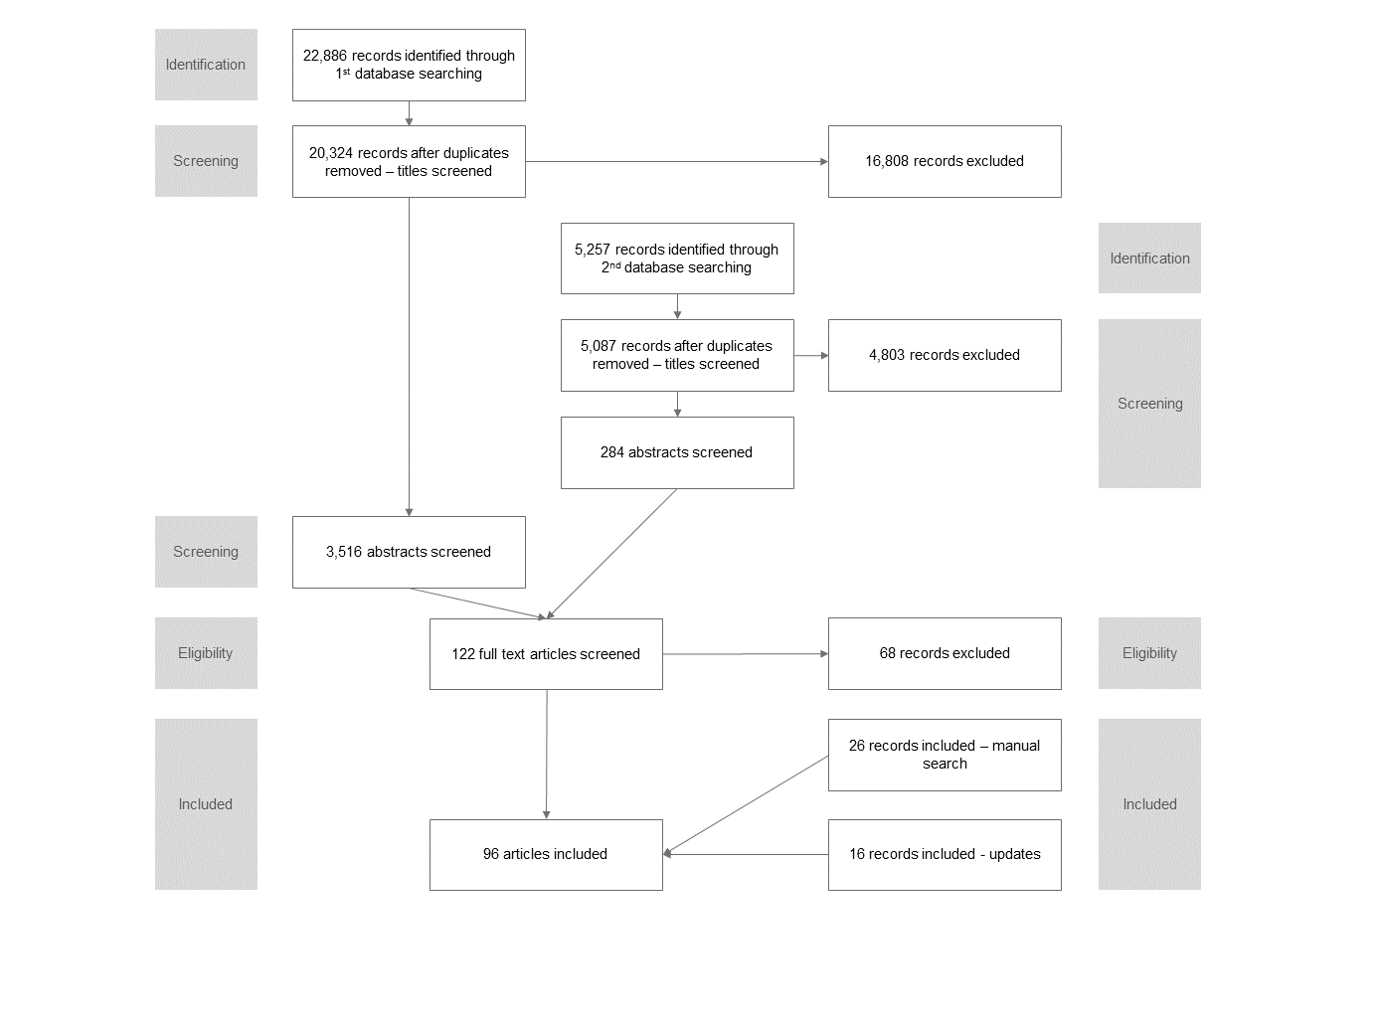

The 96 studies were published between 1925 and 2019 (median publication year 2011) (Table 1; *Appendix 4*). There has been exponential growth in the number of studies since the first publication in 1925, with more than third of the studies (35.4%) published since 2015. A total of 55.2% of studies were published as articles followed by 21.9% as reports and 12.5% as conference proceedings or presentations. Taken together articles focused on various aspects of temporary population estimation, including emergency planning (n=22), understanding service populations (n=8), epidemiology (n=4) and commuting (n=3).

## Data types

Official statistics, defined as large scale data collected by national statistical agencies (such as censuses, population surveys, administrative records or registers), formed the basis, or were an important component of, the largest number of studies (Figure 2). The first recorded report used data on place of work collected at the 1921 Census data from England and Wales to estimate daytime populations (Census of England and Wales 1921 1925). Similar work was undertaken by the US Census Bureau in the 1950s (Bureau of the Census 1956), and such estimates continue to be produced in many countries around the world. A more recent innovation are workday population estimates, which combine estimates of working populations with night-time usual resident counts. These estimates were produced for England and Wales using data from the 2011 Census [Office for National Statistics (2013); see also related work in *Appendix 5*]. In a similar vein, the US Census Bureau has constructed commuter-adjusted population estimates using data from the American Community Survey (McKenzie et al. 2013).

**Figure 2.** Cumulative distribution of year of publication across data types

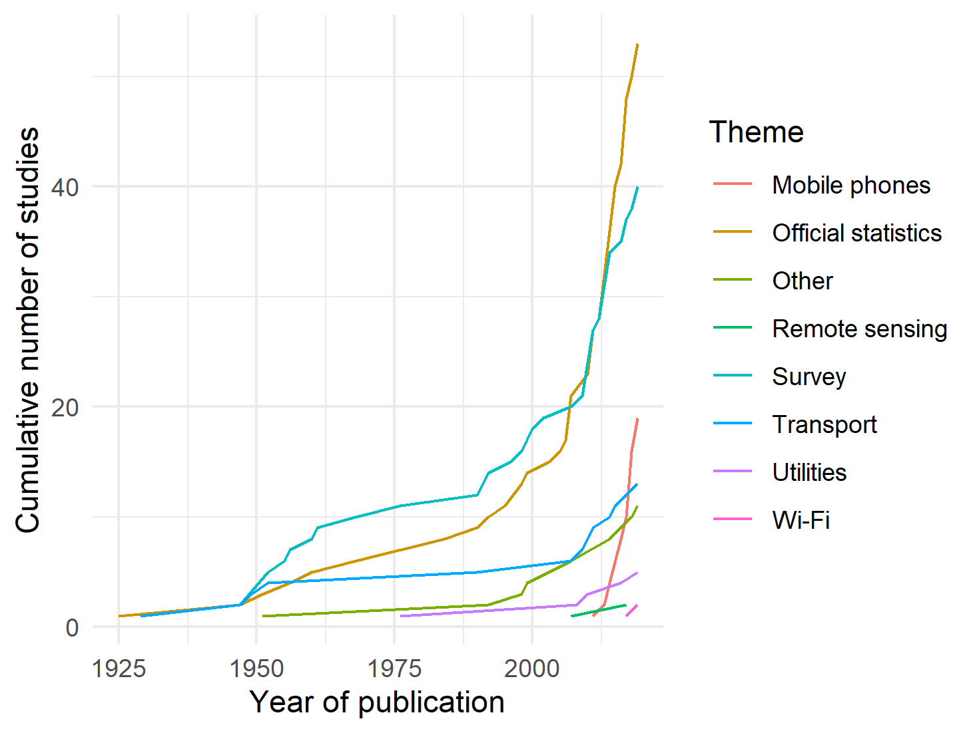

*Note:* Studies can belong to more than one category; ‘Social Media’ category has been excluded as it only has one member.

Census data have served as an input into a host of other population estimates. Census-based studies from the United States include the work from the Seattle City Planning Commission (1951), Fulton (1984), Gober and Mings (1984), Nelson and Nicholas (1992), McPherson and Brown (2003), Kobayashi, Medina, and Cova (2011), Swanson and Tayman (2011), Hodur and Bangsund (2015), Kim and Ahn (2017), Boeing (2018) and Esri (2018). These papers used a range of methods to adjust Census estimates at a variety of temporal and spatial scales, often accompanied by other data source including place of work, transportation models or payroll data that helps to determine size and location of daytime or seasonal populations. Census data from the United Kingdom have formed a key input into the recent work of Smith and colleagues (2005) and Martin, Cockings, and Leung (2015).

Census data has also been used for the estimation and analysis of temporary populations in a number of other countries. Taking advantage of the availability of the place of residence and place of enumeration data, Bell and Ward [(1998); see also subsequent work in *Appendix 5*] looked at the one-day snapshot of the mobility of Australians across multiple census years and spatial scales. Similarly, Taylor (1998) used census data to estimate the mobility of indigenous Australians. Gao and colleagues (2014) and Qi and colleagues (2015) employed Chinese census data adjusted with information for tourists, school and patient populations extended with land use models to calculate daytime population. The main advantage of the census is that it provides close to full enumeration of the population; however, it captures only a snapshot of temporary populations on one day or night, every five or ten years. Many forms of temporary population mobility are highly seasonal, thus census data will not reflect the population present at other times of the year. To address this deficit a number of studies have drawn upon large scale administrative datasets such as health service utilisation records (Markham, Bath, and Taylor 2013), building (Greger 2015) or second home registries (Adamiak, Pitkänen, and Lehtonen 2017), however, these studies tend to target specific population groups or geographical regions, and may not directly capture the mobility of visitors. Notwithstanding these limitations, official statistics remain a crucial component of many temporary population estimates.

The second most common group of studies drew on survey data. Surveys vary widely with respect to the target population, spatial coverage and sample size and include urban travel surveys, destination surveys (Erickson 1961; Happel and Hogan 2002) and large-scale household surveys (Charles-Edwards 2011; Collins and Greaves 2007; Himoto and Kimata 2014; Horanont and Shibasaki 2010; Kashiyama, Pang, and Sekimoto 2017; Kavanaugh 1990; Lau 2009; Roddis 1996; Sekimoto et al. 2011; Stutz, Parrott, and Kavanaugh 1992; Wurtele and Wellisch 1968). Surveys have the singular advantage of being able to collect detailed information on the spatial and temporal dynamics of mobility, including the timing and duration of visits, as well as the characteristics of movers. They can be used to target transient populations such as seasonal snowbirds (Happel and Hogan 2002) or indigenous Australians (Warchivker, Tjapangati, and Wakerman 2000) not captured in official statistics. The major disadvantage of surveys are related to capturing rare events through random sampling. Even in large scale origin-based surveys, sampling error can limit the utility of survey data for estimating temporary populations in small areas and over short time periods. Purposive surveys of accommodation providers or particular target populations fair better, but are usually limited with respect to both population and geographic coverage.

The third largest category of studies, and one that experienced the fastest growth in recent years, is work based on mobile phone data. Some of the early attempts to use this source of data in tracking large scale population distribution changes came from the SENSEable City Laboratory with their work in Milan (Ratti et al. 2006) and Rome (Reades et al. 2007). This was followed by seminal work on seasonal residents in Estonia (Silm and Ahas 2010). However these analyses did not attempt to expand the mobile phone user base to the whole population and the earliest such application identified was in response to the Haiti earthquake (Bengtsson et al. 2011). That was quickly followed by large-scale estimates for Japan (Terada, Nagata, and Kobayashi 2013) and analyses of temporary populations in France and Portugal (Deville et al. 2014). The spatial coverage of mobile phone based studies often reflects availability and accessibility of data. For instance, Italy and in particular Milan, have been the foci for a number of studies given that local telecom providers have offered access to the aggregated and anonymised call records (Khodabandelou et al. 2016). Mobile phone data are also used in parallel with other sources and methods for instance in dasymetric interpolation (Järv, Tenkanen, and Toivonen 2017) or transport survey data (Lwin, Sugiura, and Zettsu 2016). While mobile phone data provide detailed information on short-term change in population numbers at fine spatial resolutions they provide limited information on the characteristics of movers. Finally, as a commercially collected data set, they can be difficult and costly to access.

Transportation data, collected via cordon count, or more recently by smart cards, are an important source of information, particularly for diurnal population estimates. Early work from the United States can be traced back to Thornthwaite who estimated the daytime population of a Central Business District using data from a traffic survey (1929; cited in Wheeler and Brunn 2002). Others followed including Breese (1947), Sharp (1955) and Weir (1960). The New York Regional Plan Association (1949), Seattle City Planning Commission (1951) and Institute for Research in Social Science at the University of North Carolina (1952) employed various transportation surveys and cordon counts to estimate the number of people in central business districts. Similar work from the United Kingdom was undertaken by Menzler (1952). Recent years has seen that the advent of public transport smart card data (Ma et al. 2017) along with technologies such as number plate recognition (Fehr & Peers 2014) as new sources of transportation data for temporary population estimation. These studies have the advantage of longer collection periods, but tend to be limited to relatively narrowly defined geographic regions, usually cities, and tend to be employed for diurnal rather than seasonal population estimates (see Fehr & Peers (2014) for an exception).

Less common, yet still significant, are studies based on a range of symptomatic indicators including utilities data (Edmondson and Nantucket Data Platform team 2019; Goldschmidt and Dahl 1976; McKenzie and Canterford 2016; Monmouth County Planning Board 2008; Rigall-I-Torrent 2010), remote sensing data (Stathakis and Baltas 2018; Taubenböck, Roth, and Dech 2007) and Wi-Fi (Crols and Malleson 2019; Kontokosta and Johnson 2017). At their most basic, these studies assume a constant relationship between a region’s de facto population (including residents, diurnal and overnight visitors) and a single symptomatic indictor. Symptomatic variables theoretically enable the generation of continuous estimates of visitor populations in both a timely and cost effective manner, but are contingent on understanding the relationship between the symptomatic indicator and populations, which may vary across space and time. In addition, it can be difficult to identify appropriate symptomatic indicators when estimates are sought for a large number of regions. For example, a scoping study undertaken by the Australian Bureau of Statistics was unable to identify any symptomatic indicators that could be used to estimate visitor populations across five Local Government Areas in Australia (Lee 1999). Contrary to our expectations, social media data were only used in one study (Lwin, Sugiura, and Zettsu 2016). Here geotagged Twitter data were used together with mobile phone records to predict scaled counts from large person trip survey.

Slightly more than third of studies (38.5%) drew on multiple data sets. Census data was employed as a starting point, for the calibration of models, or as a source of validation. For instance, the seminal work of LandScan - capturing the ambient population (average over 24 hours) at a 1 kilometre resolution - (Bhaduri et al. 2007) used census data as one of the main inputs and Ma et al. (2017) used smart card transportation data to redistribute census (night-time) counts of population across city. Studies also draw on multiple data sources to estimate the components of temporary populations in particular regions (Edmondson and Nantucket Data Platform team 2019), while Rigall-I-Torrent (Rigall-I-Torrent 2010) combined multiple symptomatic indicators with survey data to establish the relationship between household size, type and period of the year to produce population estimates. What emerges from this systematic review is the lack of any “gold standard” data source for temporary population estimation.

## Estimation methods

Smith (1989) in his original study of temporary populations identified two approaches for the estimation of temporary populations: the direct approach which draws on information collected directly from temporary residents via censuses and surveys and the indirect which draws upon symptomatic variables that reflect changes in temporary populations. This distinction is increasingly fuzzy due to the emergence of new data sources such as mobile phone and Wi-Fi data which can be both treated as either direct or indirect sources depending on the methodology employed. In addition, a number of studies combine both direct and indirect sources to generate estimates for individual regions (Rigall-I-Torrent 2010) or to apportion temporary visitors across geographic areas (Lwin, Sugiura, and Zettsu 2016). Moreover studies are increasingly drawing on sophisticated simulation and modelling approaches to produce temporary population estimates (see Crols and Malleson 2019 for an example).

The earliest method of deriving temporary population statistics was to use direct estimates, either from the Census (Census of England and Wales 1921 1925), survey data (Thornthwaite 1929) or by combining multiple formerly disparate sources of data (Breese 1947). These studies often took advantage of availability of information about workplaces of individuals (Office for National Statistics 2013), their status of residence (Gober and Mings 1984) or place of enumeration (Bell and Ward 1998) to distinguish between two or more states of population distribution such as nighttime and daytime populations, or visitors and usual residents. An allied approach involves the scaling of population counts from one or more sources to the whole population based on expansion factors. This approach was used by both early survey based studies (Foley 1952; New York Regional Plan Association 1949) and more contemporary analyses based on mobile phone or Wi-Fi data. In the latter case, various strategies of deriving factors were adopted, some based on the penetration rate of mobile data providers (Bengtsson et al. 2011), night-time Census populations (Deville et al. 2014) or ancillary survey data (Kontokosta and Johnson 2017). Studies either used a single factor for an entire region (Thomas et al. 2017) or multiple factors, varying each geographically (Batran et al. 2018) or over population subgroups (Picornell et al. 2018).

Temporary populations have also been estimated using population accounts or component based approaches. These methods used generic or area-specific equations to derive counts of temporary residents from usual residents by subtracting departures and adding arrivals to a spatial unit in given time (Yong li 1998). For instance Journey-to-Work data (from the Census) has been used to estimate the working population (McKenzie et al. 2013), second home users and usage could be used to capture seasonal populations in specific areas (Adamiak, Pitkänen, and Lehtonen 2017) or sales tax data could be used to derive equivalent residents (Thakur 2018). Additionally, separate estimates have been derived for subgroups of the population (Swanson and Tayman 2011).

As discussed previously, symptomatic data such as electricity usage have been used to track seasonal variation in populations across specific regions (see Goldschmidt and Dahl 1976). An allied strand of research draws on symptomatic data to redistribute temporary populations from larger to smaller spatial units. These include dasymetric techniques commonly used for mapping small area resident populations. The LandScan model (Bhaduri et al. 2007) for instance has the largest spatial coverage providing gridded population estimates of the nighttime and daytime population for the United States. Martin et al.’s (2015) model for Southampton on the other hand is an example of a more spatially and temporally detailed approach that can be adapted to various grid sizes and temporal resolutions. This model has also been implemented in other locations and settings (*Appendix 5*). The redistribution approach usually uses ancillary data such as land use (Batista e Silva et al. 2017) or building type (Greger 2015) as well as data from Censuses, surveys, mobile phones (Järv, Tenkanen, and Toivonen 2017), transportation (Ma et al. 2017) and social media data (Lwin, Sugiura, and Zettsu 2016) as input.

Finally, a number of studies employ some form of modelling or simulation approach using a range of data. These include agent based simulation (Crols and Malleson 2019; Kashiyama, Pang, and Sekimoto 2017; Walker and Barros 2012), cellular automaton models (Khakpour and Rød 2016), and the use of neural networks (Chen et al. 2018; Liu et al. 2018).

## The geography of estimates

Only 17.7% of studies generated estimates for all geographic units within an entire country (Figure 3). The United States was the best represented with a total of five studies, followed by Australia (n=3) and England and Wales (n=2). Only one developing country, Nepal, (Wilson et al. 2016) was represented and one study reported estimates from two countries (Deville et al. 2014). Studies covering a part of the country were again most frequent in the United States (n=32). This was followed by China, Australia, Japan and the United Kingdom as well as a handful of developing nations (namely, Haiti, Bangladesh, Mozambique, Myanmar and Vietnam). A little more than half (54.2%) of the studies focused on a single city.

**Figure 3.** Country of temporary population estimates and national coverage.

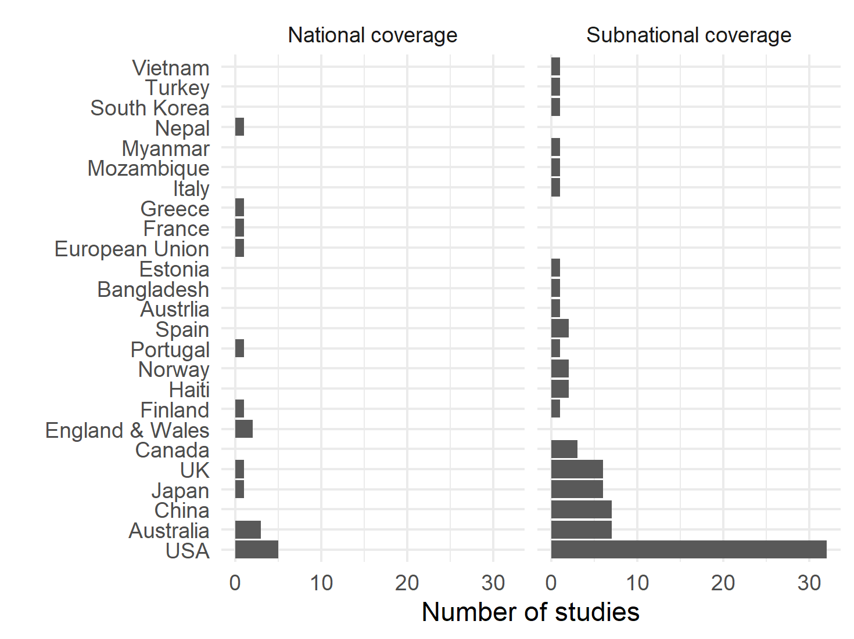

*Note:* Study of (Deville et al. 2014) describes two countries.

Two types of spatial unit for the estimates dominated; 57.3% of studies used some form of administrative unit (for example, a statistical division, a county, a township or metropolitan region) and 29.2% used grids of varying sizes. Other types of spatial unit included points, buildings, or some custom units such as Voronoi polygons. A number of studies 11 reported estimates for more than one type of spatial unit.

There was a large variation in the number of spatial units used to produce estimates ranging from 1 to 52,000 with a median value of 34. 10 studies reported on a single spatial unit including islands (Edmondson and Nantucket Data Platform team 2019), a single administrative region (eg. Fehr & Peers 2014), a city (eg. Goldschmidt and Dahl 1976) and a university campus (Charles-Edwards and Bell 2013). Studies reporting estimates for larger numbers of units provided estimates at the building level (Ara 2014), high resolution grids (Adamiak, Pitkänen, and Lehtonen 2017) or administrative areas (eg. McKenzie et al. 2013), and were often alongside national or large sub-national area coverages. Half of the studies 47 did not report the exact number of spatial units for which estimates are produced.

## Temporal units of estimates

None of the studies revealed an effort to produce and maintain ongoing series of estimates, particularly ones integrated with official statistics. In contrast to majority of studies presenting ad hoc analyses with opportunistic data sources only few analyses and estimates get any sort of updates. Examples of these include Esri Daytime Population (Esri 2018) and analyses of Australian Census from 1991 (Bell and Ward 1998) to 2018 (Charles-Edwards and Panczak 2018).

The majority of studies (77.1%) report on daytime (or both daytime and seasonal) populations and this reflected in the choice of the temporal units used in the estimates. A total of 36.5% of studies used minutes or hours as their temporal unit, with the second most common unit was split between daytime and night-time estimates (21.9%) or daytime only (14.6%) (Figure 4).

**Figure 4.** Temporal units used for estimates.

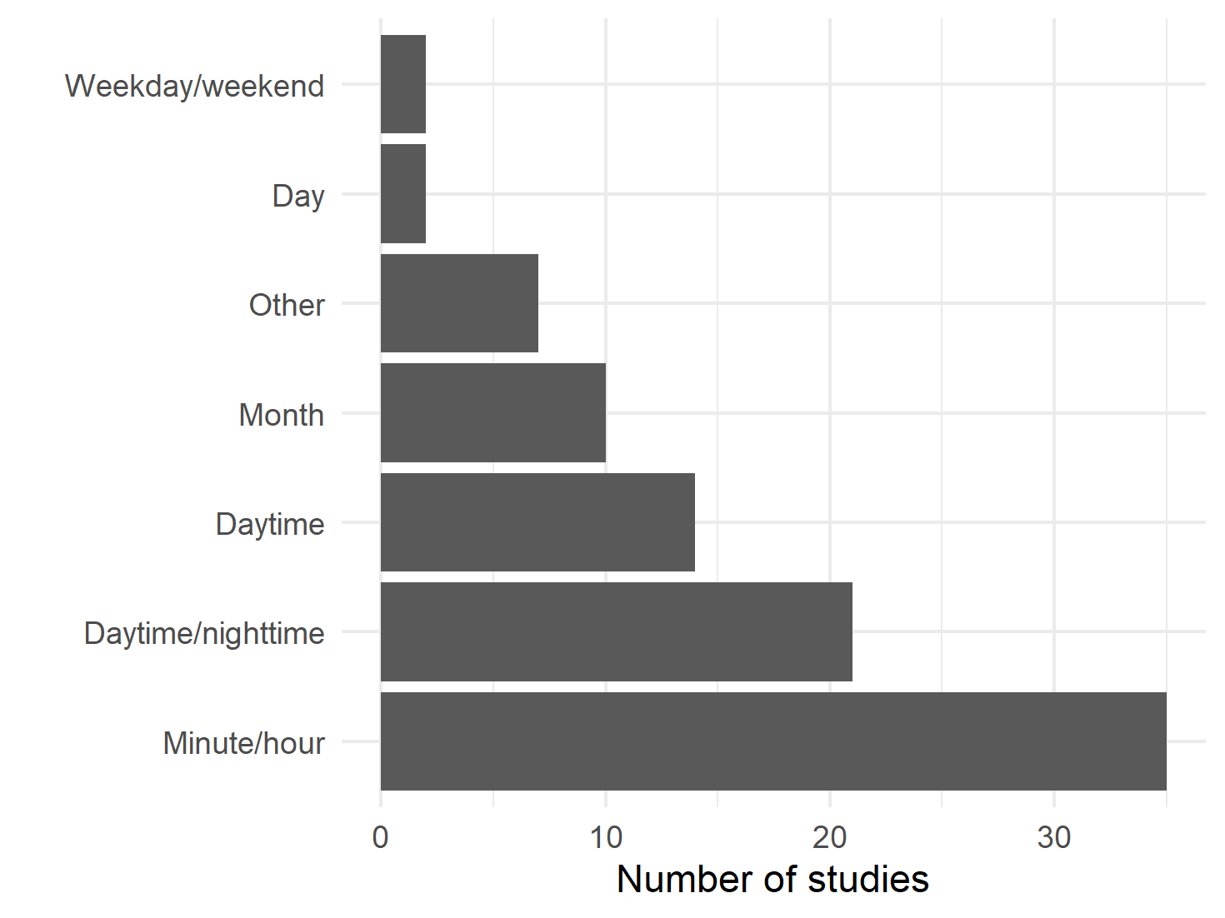

## Estimated population size and composition

There was a large variation in the sizes of estimated populations, ranging from 1 868 to 53,349,074 with median value of 355,100. The size of dataset used for estimation ranged from 422 to 55,963,096 with median value of 722,000. Combining the size of the dataset and the size of estimated populations, largest populations were used or estimated when mobile phone data were employed, followed by smaller amount of transport-based studies (Figure 5). Other large studies used monthly sales tax data of North Carolina counties to derive “equivalent residents” surplus to permanent population.

**Figure 5.** Size of population by theme.

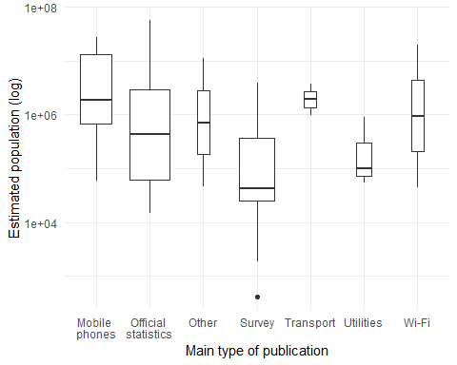

*Note:* The first category used. Box width is proportional to the total number of studies. Studies that did not report on an estimated population size using the size of dataset whenever possible.

In terms of composition, the majority of studies focused on total populations present or working populations. For those studies concerned with population estimates of summer resort towns the total population was extended to include temporary or seasonal visitors (Erickson 1961; Goldschmidt and Dahl 1976).

Majority of studies (70.8%) did not report on any characteristics of estimated populations. This was often driven not by the theoretical or practical considerations but rather by data availability. For instance, many studies drawing on mobile phone data do not have access to any individual-level information (such as, age, sex, reason for visitation, etc.). Some studies sought to capture specific groups of temporary movers including retired individuals undertaking seasonal movements (Happel and Hogan 2002; Rose and Kingma 1989), pupils (Campbell 2010), second home users (Adamiak, Pitkänen, and Lehtonen 2017), indigenous population (Warchivker, Tjapangati, and Wakerman 2000), or on functional area such as university campus (Charles-Edwards and Bell 2013).

## Reproducibility

61.5% of studies did not report estimates nor indicate where they could be obtained. Similarly, 94.8% of studies did not report on the type of software and/or code used to produce the estimates. In some cases, particularly when relatively simple methods were used (for example, equation based), this does not limit reproducibility or replicability of the studies or possibility to implement them across various situational contexts. However, for remaining studies, particularly those based on proprietary data, the prospects of generating estimates across different areas allied with their validation are limited. More particularly, validation of the estimates was not common practice with only 36.5% reporting some attempt at validation with lack of suitable data often quoted as a main reason for not undertaking the task.

# Conclusions

This study sought to systematically review the empirical literature on temporary population estimation to identify the contemporary state of the art. To this end we revealed an interest and demand for temporary population estimates that is approaching 100 years in the making. However it has been over the past two decades where there has been strong growth in the number of studies that is in part driven through the rise in both the type and availability of emerging sources of ICT data. Despite the rise in the number of studies using emergent sources of information, there remains no single source of data for the estimation of temporary populations. Rather traditional sources of information including the census and survey data remain an important backbone through which temporary population estimates are founded.

Notwithstanding the growing prevalence of temporary population studies, a disconnect currently exists with the lack of availability of such estimates through national statistical agencies. To this end the translation of temporary population studies into standardised products appears yet to occur in lieu of rising demand for such information that reflect the so far unresolved conceptual and methodological challenges. Often, in the absence of official estimates, cities and regions generate their own estimates (Edmondson and Nantucket Data Platform team 2019; Fehr & Peers 2014; Harris et al. 2019; Hodur and Bangsund 2015; Lamb 1999; Monmouth County Planning Board 2008). However, it would appear that this situation is likely to change with the recent emergence of major coordinated programs of research focused on temporary population estimates to include ENhancing ACTivity and population mapping (ENACT) (Batista e Silva et al. 2017) and the Population 24/7 (Martin, Cockings, and Leung 2015) projects (see also the subsequent work inAppendix 5). It is likely that through these programs the conceptual and methodological challenges will be systematically addressed and resolved.

It is important to highlight two interrelated limitations of the current study. The first pertains to the fragmented nature of the temporary population literature and its presence across multiple academic domains. For instance 28.1% of studies included in this review were found outside of the literature searches. Both the range and number of keywords (13 individual key words) used to capture studies of temporary populations reviewed here underscore this issue with the result of generating a large amount of false positive findings during literature search. Second, there is a relatively large volume of grey literature represented. To this end, 27.1% of studies included in this study were published as reports. As such, this makes it difficult to systematically capture, classify as well as monitor the development in this field.

In sum, there is little doubt that the field of temporary population estimation will continue to grow however there remains a number of important challenges. Conceptually there is need for the research community and national statistical agencies to develop and agree on clear definitions that enable temporary populations to be classified in order to differentiate them from permanent residents. Practically, there remains much work to complete that comprehensively captures and measures the diverse array of spatial behaviours that involve different spatial circuits and are undertaken for a myriad of different purposes. Coordinated efforts that address both of these remaining challenges will ensure that we progress towards a more robust conceptual and empirical framework for the estimation of temporary populations.

# Acknowledgments

The authors wish to thank the Australian Bureau of Statistics (ABS), in particular - Denise Carlton, Andrew Howe, Anthony Grubb, Glen West, Beidar Cho and Karen Ecclestone of ABS for their input on various aspects of the paper. However, the interpretations of the analysis are solely those of the authors and do not necessarily reflect the views and opinions of the ABS or any of their employees.

We would like to also thank the authors that responded to queries about details of their work: Christoph Aubrecht, Filipe Batista e Silva, Andrew Collins, Donald G. Janelle, Nik Lomax, David Martin, Chris Needham, Andy Newing, Paola Pucci, Stanley Smith and Martijn Tennekes.

# Funding

This research was funded by the Australian Government through the Australian Research Council Linkage project scheme, LP160100305.

# Tables

**Table 1.** Selected characteristics of included studies. Note: * indicates that study can belong to more than one category.

|  |  |  |  |
| --- | --- | --- | --- |
| Characteristic | Value | n / median | % / min; max |
| Year of publication |  | 2011 | 1925; 2019 |
| Search method | Systematic | 54 | 56.25 |
|  | Manual | 26 | 27.08 |
|  | Update | 16 | 16.67 |
| Type of publication | Article | 53 | 55.21 |
|  | Report | 21 | 21.88 |
|  | Conference | 12 | 12.50 |
|  | Thesis | 7 | 7.29 |
|  | Book chapter | 3 | 3.12 |
| Purpose of publication* | Emergency planning | 22 | 22.92 |
|  | Other | 9 | 9.38 |
|  | Service population | 8 | 8.34 |
|  | Epidemiology | 4 | 4.16 |
|  | Commuting | 3 | 3.12 |
| Main type of data* | Official statistics | 53 | 55.20 |
|  | Survey | 40 | 41.68 |
|  | Mobile phones | 19 | 19.8 |
|  | Transport | 13 | 13.56 |
|  | Other | 11 | 11.44 |
|  | Utilities | 5 | 5.20 |
|  | Remote sensing | 2 | 2.08 |
|  | Wi-Fi | 2 | 2.08 |
|  | Social media | 1 | 1.04 |
| Study region | Single city | 52 | 54.17 |
|  | Country | 17 | 17.71 |
|  | Administrative region | 14 | 14.58 |
|  | Multiple cities | 10 | 10.42 |
| Regions for estimates* | Administrative | 55 | 57.3 |
|  | Grid | 28 | 29.16 |
|  | Custom | 8 | 8.34 |
|  | Points | 7 | 7.30 |
|  | Building | 3 | 3.12 |
|  | Voronoi | 2 | 2.08 |
| Number of regions for estimates |  | 34 | 1; 52,000 |
| Temporal unit of estimates | Minute/hour | 35 | 36.46 |
|  | Daytime/nighttime | 21 | 21.88 |
|  | Daytime | 14 | 14.58 |
|  | Month | 10 | 10.42 |
|  | Other | 7 | 7.29 |
|  | Day | 2 | 2.08 |
|  | Weekday/weekend | 2 | 2.08 |
| Size of estimated population |  | 355,100 | 1,868; 53,349,074 |
| Size of dataset |  | 722,000 | 422; 55,963,096 |

# References

Adamiak, C., Pitkänen, K., and Lehtonen, O. (2017). Seasonal residence and counterurbanization: The role of second homes in population redistribution in Finland. ***GeoJournal*** 82:1035–1050. doi:[10.1007/s10708-016-9727-x Seasonal](https://doi.org/10.1007/s10708-016-9727-x%20Seasonal).

Ara, S. (2014). Impact of Temporal Population Distribution on Earthquake Loss Estimation: A Case Study on Sylhet, Bangladesh. ***International Journal of Disaster Risk Science*** 5(4):296–312. doi:[10.1007/s13753-014-0033-2](https://doi.org/10.1007/s13753-014-0033-2).

Batista e Silva, F., Rosina, K., Schiavina Marcello, M., Marin, M., Freire, S., Craglia, M., and Lavalle, C. (2017). ***Spatiotemporal mapping of population in Europe: The ‘ENACT’ project in a nutshell***. ***57th European Regional Science Association (ERSA) Congress***.

Batran, M., Mejia, M., Kanasugi, H., Sekimoto, Y., Shibasaki, R., Batran, M., Mejia, M.G., Kanasugi, H., Sekimoto, Y., and Shibasaki, R. (2018). Inferencing Human Spatiotemporal Mobility in Greater Maputo via Mobile Phone Big Data Mining. ***ISPRS International Journal of Geo-Information*** 7(7):259. doi:[10.3390/ijgi7070259](https://doi.org/10.3390/ijgi7070259).

Bell, M. (2000). ***Data, theory, method: Understanding circulation in Austrália***. ***10th Biennial Conference of the Australian Population Association***.

Bell, M. (2004). Measuring Temporary Mobility: Dimensions And Issues. (Discussion Paper 2004/01).

Bell, M. and Ward, G. (1998). Patterns of Temporary Mobility in Australia: Evidence from the 1991 Census. ***Australian Geographical Studies*** 36(1):58–81. doi:[10.1111/1467-8470.00039](https://doi.org/10.1111/1467-8470.00039).

Bell, M. and Ward, G. (2000). Comparing temporary mobility with permanent migration. ***Tourism Geographies*** 2(1):87–107. doi:[10.1080/146166800363466](https://doi.org/10.1080/146166800363466).

Bengtsson, L., Lu, X., Thorson, A., Garfield, R., and Schreeb, J. von (2011). Improved Response to Disasters and Outbreaks by Tracking Population Movements with Mobile Phone Network Data: A Post-Earthquake Geospatial Study in Haiti. ***PLOS Medicine*** 8(8):e1001083. doi:[10.1371/journal.pmed.1001083](https://doi.org/10.1371/journal.pmed.1001083).

Bhaduri, B., Bright, E., Coleman, P., and Urban, M.L. (2007). LandScan USA: A high-resolution geospatial and temporal modeling approach for population distribution and dynamics. ***GeoJournal*** 69(1-2):103–117. doi:[10.1007/s10708-007-9105-9](https://doi.org/10.1007/s10708-007-9105-9).

Boeing, G. (2018). Estimating local daytime population density from census and payroll data. ***Regional Studies, Regional Science*** 5(1):179–182. doi:[10.1080/21681376.2018.1455535](https://doi.org/10.1080/21681376.2018.1455535).

Breese, G.W. (1947). ***Daytime Population of the Central Business District of Chicago with Particular Reference to the Factor of Transportation***. University of Chicago.

Campbell, N. (2010). *Developing an extensible solution for modelling daytime population movement*. [MSc Thesis]. Southampton: University of Southampton.

Census of England and Wales 1921 (1925). **Workplaces**.

Charles-Edwards, E. (2011). *Modelling flux: Towards the estimation of small area temporary populations in Australia*. [PhD Thesis]. The University of Queensland.

Charles-Edwards, E. and Bell, M. (2013). Estimating the Service Population of a Large Metropolitan University Campus. ***Applied Spatial Analysis and Policy*** 6(3):209–228. doi:[10.1007/s12061-012-9079-y](https://doi.org/10.1007/s12061-012-9079-y).

Charles-Edwards, E. and Panczak, R. (2018). Elsewhere in Australia: A snapshot of temporary mobility on the night of the 2016 Census. ***Australian Population Studies*** 2(1):14–25.

Charles-Edwards, E., Panczak, R., Corcoran, J., and Bell, M. (n.d.). A Framework for Official Temporary Population Statistics. ***Journal of Official Statistics***.

Chen, J., Pei, T., Shaw, S.-L., Lu, F., Li, M., Cheng, S., Liu, X., and Zhang, H. (2018). Fine-grained prediction of urban population using mobile phone location data. ***International Journal of Geographical Information Science*** 32(9):1770–1786. doi:[10.1080/13658816.2018.1460753](https://doi.org/10.1080/13658816.2018.1460753).

Collins, A. and Greaves, S. (2007). Daytime population tracking for planning and pollution exposure assessment. ***Road and Transport Research Journal*** 16(1):55–68.

Crols, T. and Malleson, N. (2019). Quantifying the ambient population using hourly population footfall data and an agent-based model of daily mobility. ***GeoInformatica*** 23(2):201–220. doi:[10.1007/s10707-019-00346-1](https://doi.org/10.1007/s10707-019-00346-1).

Deville, P., Linard, C., Martin, S., Gilbert, M., Stevens, F.R., Gaughan, A.E., Blondel, V.D., and Tatem, A.J. (2014). Dynamic population mapping using mobile phone data. ***Proceedings of the National Academy of Sciences*** 111(45):15888–15893. doi:[10.1073/pnas.1408439111](https://doi.org/10.1073/pnas.1408439111).

Edmondson, B. and Nantucket Data Platform team (2019). Making It Count. A Data-Driven Look at Nantucket’s Dynamic Population.

Elliott, J.H., Turner, T., Clavisi, O., Thomas, J., Higgins, J.P.T., Mavergames, C., and Gruen, R.L. (2014). Living Systematic Reviews: An Emerging Opportunity to Narrow the Evidence-Practice Gap. ***PLoS Medicine*** 11(2):1–6. doi:[10.1371/journal.pmed.1001603](https://doi.org/10.1371/journal.pmed.1001603).

Erickson, R.B. (1961). Measuring resort population increases. ***The Professional Geographer*** 13(4):16–19. doi:[10.1111/j.0033-0124.1961.134_16.x](https://doi.org/10.1111/j.0033-0124.1961.134_16.x).

Esri (2018). Methodology Statement: 2018 Esri Daytime Population. (J10291).

Fehr & Peers (2014). Napa County Travel Behavior Study.

Foley, D.L. (1952). The daily movement of population into central business districts. ***American Sociological Review*** 17(5):538–543.

Foley, D.L. (1954). Urban daytime population: A field for demographic-ecological analysis. ***Social Forces*** 32(4):323–330. doi:[10.2307/2574113](https://doi.org/10.2307/2574113).

Fulton, P.N. (1984). Estimating the daytime population with the urban transportation planning package. ***Transportation Research Record*** 981:25–27.

Gao, X., Yuan, H., Qi, W., and Liu, S. (2014). Assessing the Social and Economic Vulnerability of Urban Areas to Disasters: A case study in Beijing, China. ***International Review for Spatial Planning and Sustainable Development*** 2(1):42–62. doi:[10.14246/irspsd.2.1_42](https://doi.org/10.14246/irspsd.2.1_42).

Gober, P. and Mings, R.C. (1984). A Geography of Nonpermanent Residence in the U.S. ***Professional Geographer*** 36(2):164–173. doi:[10.1111/j.0033-0124.1984.00164.x](https://doi.org/10.1111/j.0033-0124.1984.00164.x).

Goldschmidt, P.G. and Dahl, A.W. (1976). Demoflush Estimating Population in Seasonal Resort Communities. ***Growth and Change*** 7(2):44–48. doi:[10.1111/j.1468-2257.1976.tb00305.x](https://doi.org/10.1111/j.1468-2257.1976.tb00305.x).

Gough, D. (2015). Qualitative and mixed methods in systematic reviews. ***Systematic Reviews*** 4(1):181. doi:[10.1186/s13643-015-0151-y](https://doi.org/10.1186/s13643-015-0151-y).

Graebert, M.B., Wyckoff, M., and Bretz, L. (2014). Northwest Michigan Seasonal Population Analysis.

Greger, K. (2015). Spatio-Temporal Building Population Estimation for Highly Urbanized Areas Using GIS. ***Transactions in GIS*** 19(1):129–150. doi:[10.1111/tgis.12086](https://doi.org/10.1111/tgis.12086).

Happel, S.K. and Hogan, T.D. (2002). Counting snowbirds: The importance of and the problems with estimating seasonal populations. ***Population Research and Policy Review*** 21(3):227–240. doi:[10.1023/A:1019560405310](https://doi.org/10.1023/A:1019560405310).

Harris, E., Leaver, J., Young, N., and Perlich, P.S. (2019). Washington County Temporary Resident Population Estimates, 2017.

Himoto, K. and Kimata, J. (2014). A Model for the Spatio-temporal Distribution of Population using Country-Wide Statistical Data and Its Application to the Estimation of Human Exposure to Disasters. In: ***Improving Disaster Resilience and Mitigation - IT Means and Tools***. Springer, Dordrecht: 73–87. doi:[10.1007/978-94-017-9136-6_5](https://doi.org/10.1007/978-94-017-9136-6_5).

Hodur, N.M. and Bangsund (2015). Service Population Estimates for City of Williston. (742).

Horanont, T. and Shibasaki, R. (2010). ***Estimate ambient population density: Discovering the current flow of the city***..

Institute for Research in Social Science University of North Carolina (1952). ***Population Distribution, Spatial and Temporala Study of Daytime -Nighttime Differentials in the Proportional Distribution of the Total Population of Selected Urban Areas***. Chapel Hill.

Järv, O., Tenkanen, H., and Toivonen, T. (2017). Enhancing spatial accuracy of mobile phone data using multi-temporal dasymetric interpolation. ***International Journal of Geographical Information Science*** 31(8):1630–1651. doi:[10.1080/13658816.2017.1287369](https://doi.org/10.1080/13658816.2017.1287369).

Kashiyama, T., Pang, Y., and Sekimoto, Y. (2017). Open PFLOW: Creation and evaluation of an open dataset for typical people mass movement in urban areas. ***Transportation Research Part C: Emerging Technologies*** 85:249–267. doi:[10.1016/j.trc.2017.09.016](https://doi.org/10.1016/j.trc.2017.09.016).

Kavanaugh, P. (1990). ***A method for estimating daytime population by small area geography***. ***Proceedings of the 1990 Urban and Regional Information Systems Association Conference***:150–164.

Khakpour, M. and Rød, J.K. (2016). An attraction-based cellular automaton model for generating spatiotemporal population maps in urban areas. ***Environment and Planning B: Planning and Design*** 43(2):297–319. doi:[10.1177/0265813515604262](https://doi.org/10.1177/0265813515604262).

Khodabandelou, G., Gauthier, V., El-Yacoubi, M., and Fiore, M. (2016). ***Population estimation from mobile network traffic metadata***. ***2016 IEEE 17th International Symposium on A World of Wireless, Mobile and Multimedia Networks (WoWMoM)***:1–9. doi:[10.1109/WoWMoM.2016.7523554](https://doi.org/10.1109/WoWMoM.2016.7523554).

Kim, H. and Ahn, J.-S.(. (2017). Modelling Daytime Population Distribution for Emergency Response and Social Vulnerability Assessment. ***Journal of Korean Geographical Society*** 51(3):335–346.

Kobayashi, T., Medina, R.M., and Cova, T.J. (2011). Visualizing Diurnal Population Change in Urban Areas for Emergency Management. ***The Professional Geographer*** 63(1):113–130. doi:[10.1080/00330124.2010.533565](https://doi.org/10.1080/00330124.2010.533565).

Kontokosta, C.E. and Johnson, N. (2017). Urban phenology: Toward a real-time census of the city using Wi-Fi data. ***Computers, Environment and Urban Systems*** 64:144–153. doi:[10.1016/j.compenvurbsys.2017.01.011](https://doi.org/10.1016/j.compenvurbsys.2017.01.011).

Lamb, G. (1999). Estimating the Seasonal Population of Door County.

Lau, K.H. (2009). A GIS-based Stochastic Approach to Generating Daytime Population Distributions for Vehicle Route Planning. ***Transactions in GIS*** 13(5-6):481–502. doi:[10.1111/j.1467-9671.2009.01175.x](https://doi.org/10.1111/j.1467-9671.2009.01175.x).

Lee, S. (1999). Service Population Pilot Study: An Investigation to Assess the Feasibility of Producing Service Population Estimates for Selected LGAs. (1999/3).

Liu, Z., Ma, T., Du, Y., Pei, T., Yi, J., and Peng, H. (2018). Mapping hourly dynamics of urban population using trajectories reconstructed from mobile phone records. ***Transactions in GIS***:1–20. doi:[10.1111/tgis.12323](https://doi.org/10.1111/tgis.12323).

Lwin, K.K., Sugiura, K., and Zettsu, K. (2016). SpaceTime multiple regression model for grid-based population estimation in urban areas. ***International Journal of Geographical Information Science*** 30(8):1579–1593. doi:[10.1080/13658816.2016.1143099](https://doi.org/10.1080/13658816.2016.1143099).

Ma, Y.J., Xu, W., Zhao, X.J., and Li, Y. (2017). Modeling the Hourly Distribution of Population at a High Spatiotemporal Resolution Using Subway Smart Card Data: A Case Study in the Central Area of Beijing. ***ISPRS International Journal of Geo-Information*** 6(5). doi:[10.3390/ijgi6050128](https://doi.org/10.3390/ijgi6050128).

Markham, F., Bath, J., and Taylor, J. (2013). New directions in Indigenous service population estimation.

Martin, D., Cockings, S., and Leung, S. (2015). Developing a Flexible Framework for Spatiotemporal Population Modeling. ***Annals of the Association of American Geographers*** 105(4):754–772. doi:[10.1080/00045608.2015.1022089](https://doi.org/10.1080/00045608.2015.1022089).

McKenzie, B., Koerber, W., Fields, A., Benetsky, M., and Rapino, M. (2013). ***Commuter-Adjusted Population Estimates: ACS 2006-10***. Journey to Work and Migration Statistics Branch, U.S. Census Bureau.

McKenzie, F. and Canterford, S. (2016). Demographics for fire risk analysis regional Victoria and peri-urban Melbourne.

McPherson, T. and Brown, M. (2003). U.S. Day and Night Population Database (Revision 2.0) - Description of Methodology. (LA-UR-03-8389).

Menzler, F.A.A. (1952). An estimate of the day-time population of London. ***Journal of the Town Planning Institute*** 38(5):116–120.

Moher, D., Liberati, A., Tetzlaff, J., Altman, D.G., Altman, D., Antes, G., Atkins, D., Barbour, V., Barrowman, N., Berlin, J.A., Clark, J., Clarke, M., Cook, D., D’Amico, R., Deeks, J.J., Devereaux, P.J., Dickersin, K., Egger, M., Ernst, E., Gøtzsche, P.C., Grimshaw, J., Guyatt, G., Higgins, J., Ioannidis, J.P., Kleijnen, J., Lang, T., Magrini, N., McNamee, D., Moja, L., Mulrow, C., Napoli, M., Oxman, A., Pham, B., Rennie, D., Sampson, M., Schulz, K.F., Shekelle, P.G., Tovey, D., and Tugwell, P. (2009). Preferred reporting items for systematic reviews and meta-analyses: The PRISMA statement. ***PLoS Medicine*** 6(7). doi:[10.1371/journal.pmed.1000097](https://doi.org/10.1371/journal.pmed.1000097).

Monmouth County Planning Board (2008). Summer coastal population study.

Nelson, A.C. and Nicholas, J.C. (1992). Estimating functional population for facility planning. ***Journal of Urban Planning and Development*** 118(2):45–58.

New York Regional Plan Association (1949). Persons and Vehicles Entering Manhattan South of 61st Street, 1924-1948. ***Regional Plan Bulletin*** 74:1–6.

Office for National Statistics (2013). 2011 Census: The workday population of England and Wales - An alternative 2011 Census output base.

Picornell, M., Ruiz, T., Borge, R., García-Albertos, P., Paz, D. de la, and Lumbreras, J. (2018). Population dynamics based on mobile phone data to improve air pollution exposure assessments. ***Journal of Exposure Science & Environmental Epidemiology*** 29:278–291. doi:[10.1038/s41370-018-0058-5](https://doi.org/10.1038/s41370-018-0058-5).

Qi, W., Liu, S., Gao, X., and Zhao, M. (2015). Modeling the spatial distribution of urban population during the daytime and at night based on land use: A case study in Beijing, China. ***Journal of Geographical Sciences*** 25(6):756–768. doi:[10.1007/s11442-015-1200-0](https://doi.org/10.1007/s11442-015-1200-0).

Ratti, C., Frenchman, D., Pulselli, R.M., and Williams, S. (2006). Mobile Landscapes: Using Location Data from Cell Phones for Urban Analysis. ***Environment and Planning B: Planning and Design*** 33(5):727–748. doi:[10.1068/b32047](https://doi.org/10.1068/b32047).

Reades, J., Calabrese, F., Sevtsuk, A., and Ratti, C. (2007). Cellular Census: Explorations in Urban Data Collection. ***Pervasive computing*** 6(3):30–38. doi:[10.1109/MPRV.2007.53](https://doi.org/10.1109/MPRV.2007.53).

Rigall-I-Torrent, R. (2010). Estimating overnight de facto population by forecasting symptomatic variables: An integrated framework. ***Journal of Forecasting*** 29(7):635–654. doi:[10.1002/for.1166](https://doi.org/10.1002/for.1166).

Roddis, S. (1996). ***Metropolitan Activity Profiles - A New Perspective on Demand***. ***20th Australasian Transport Research Forum Conference***.

Rose, L.S. and Kingma, H.L. (1989). Seasonal Migration of Retired Persons: Estimating Its Extent and Its Implications for the State of Florida. ***Journal of Economic and Social Measurement*** 15(1):91–104. doi:[10.3233/JEM-1989-15106](https://doi.org/10.3233/JEM-1989-15106).

Schmitt, R.C. (1956). Estimating Daytime Populations. ***Journal of the American Planning Association*** 22(2):83–85. doi:[10.1080/01944365608979227](https://doi.org/10.1080/01944365608979227).

Seattle City Planning Commission (1951). Daytime and Night-time Population Distribution in Metropolitan Seattle: April, 1950. (6).

Sekimoto, Y., Shibasaki, R., Kanasugi, H., Usui, T., and Shimazaki, Y. (2011). PFlow: Reconstructing People Flow Recycling Large-Scale Social Survey Data. ***IEEE Pervasive Computing*** 10(4):27–35. doi:[10.1109/MPRV.2011.43](https://doi.org/10.1109/MPRV.2011.43).

Sharp, H. (1955). The Non-Residential Population of the Central Business District. ***Land Economics*** 31(4):378–381. doi:[10.2307/3159307](https://doi.org/10.2307/3159307).

Silm, S. and Ahas, R. (2010). The seasonal variability of population in Estonian municipalities. ***Environment and Planning A*** 42(10):2527–2546. doi:[10.1068/a43139](https://doi.org/10.1068/a43139).

Smith, G., Arnot, C., Fairburn, J., and Walker, G. (2005). A National Population Data Base for Major Accident Hazard Modelling.

Smith, S.K. (1987). How to tally temporary populations. ***American Demographics*** 9(7):44–5.

Smith, S.K. (1989). Toward a methodology for estimating temporary residents. ***Journal of the American Statistical Association*** 84(406):430–436.

Smith, S.K. and House, M. (2007). Temporary Migration: A Case Study of Florida. ***Population Research and Policy Review*** 26(4):437–454.

Soundararaj, B., Cheshire, J., and Longley, P. (2019). Estimating real-time high-street footfall from Wi-Fi probe requests. ***International Journal of Geographical Information Science*** 0(0):1–19. doi:[10.1080/13658816.2019.1587616](https://doi.org/10.1080/13658816.2019.1587616).

Stathakis, D. and Baltas, P. (2018). Seasonal population estimates based on night-time lights. ***Computers, Environment and Urban Systems*** 68:133–141. doi:[10.1016/j.compenvurbsys.2017.12.001](https://doi.org/10.1016/j.compenvurbsys.2017.12.001).

Stutz, F.P., Parrott, R., and Kavanaugh, P. (1992). Charting urban space-time population shifts with trip generation models. ***Urban Geography*** 13(5):468–474. doi:[10.2747/0272-3638.13.5.468](https://doi.org/10.2747/0272-3638.13.5.468).

Swanson, D.A. and Tayman, J. (2011). On estimating a de facto population and its components. ***Review of Economics & Finance*** 1.

Taubenböck, H., Roth, A., and Dech, S. (2007). ***Linking structural urban characteristics derived from high resolution satellite data to population distribution***. ***Urban and Regional Data Management: UDMS 2007 Annual Conference***:35–46.

Taylor, J. (1998). Measuring short-term population mobility among indigenous Australians: Options and implications. ***Australian Geographer*** 29(1):125–137. doi:[10.1080/00049189808703207](https://doi.org/10.1080/00049189808703207).

Terada, M., Nagata, T., and Kobayashi, M. (2013). Population Estimation Technology for Mobile Spatial Statistics. ***NTT DOCOMO Technical journal*** 14(3):10–15.

Thakur, R. (2018). *A Methodology to Account for Seasonal Population Shifts in North Carolina*. [MSc Thesis]. United States – North Carolina: The University of North Carolina at Charlotte.

Thomas, K.V., Amador, A., Baz-Lomba, J.A., and Reid, M. (2017). Use of Mobile Device Data To Better Estimate Dynamic Population Size for Wastewater-Based Epidemiology. ***Environmental Science & Technology*** 51(19):11363–11370. doi:[10.1021/acs.est.7b02538](https://doi.org/10.1021/acs.est.7b02538).

Thornthwaite, C. (1929). *Louisville, Kentucky: A study in urban geography*. [PhD Thesis]. Berkeley: Department of Geography, University of California.

Toole, J.L., Colak, S., Sturt, B., Alexander, L.P., Evsukoff, A., and González, M.C. (2015). The path most traveled: Travel demand estimation using big data resources. ***Transportation Research Part C: Emerging Technologies*** 58:162–177. doi:[10.1016/j.trc.2015.04.022](https://doi.org/10.1016/j.trc.2015.04.022).

Walker, L. and Barros, J. (2012). ***An agent-based population model for Wolverhampton, UK: A spatio-temporal activity based approach to population modelling***. ***GISRUK***.

Warchivker, I., Tjapangati, T., and Wakerman, J. (2000). The turmoil of Aboriginal enumeration: Mobility and service population analysis in a Central Australian community. ***Australian and New Zealand Journal of Public Health*** 24(4):444–449. doi:[10.1111/j.1467-842X.2000.tb01610.x](https://doi.org/10.1111/j.1467-842X.2000.tb01610.x).

Weir, T.R. (1960). A Survey of the Daytime Population of Winnipeg. ***Queen’s Quarterly*** 67:654–664.

Wheeler, J.O. and Brunn, S.D. (2002). An urban geographer before his time: C. Warren Thornthwaite’s 1930 doctoral dissertation. ***Progress in Human Geography*** 26(4):463–486. doi:[10.1191/0309132502ph381ra](https://doi.org/10.1191/0309132502ph381ra).

Wilson, R., zu Erbach-Schoenberg, E., Albert, M., Power, D., Tudge, S., Gonzalez, M., Guthrie, S., Chamberlain, H., Brooks, C., Hughes, C., Pitonakova, L., Buckee, C., Lu, X., Wetter, E., Tatem, A., and Bengtsson, L. (2016). Rapid and Near Real-Time Assessments of Population Displacement Using Mobile Phone Data Following Disasters: The 2015 Nepal Earthquake. ***PLOS Currents Disasters*** Feb 24(Edition 1). doi:[10.1371/currents.dis.d073fbece328e4c39087bc086d694b5c](https://doi.org/10.1371/currents.dis.d073fbece328e4c39087bc086d694b5c).

Wurtele, Z.S. and Wellisch, J.B. (1968). Population dynamics: Final report. (TM-L-4146).

Yong li, M. (1998). Research in statistical models for mobile population (SMMP). ***Cartographic Journal*** 35(2):155–164. doi:[10.1179/caj.1998.35.2.155](https://doi.org/10.1179/caj.1998.35.2.155).