Estimating temporary populations: a systematic review of the empirical literature

Radoslaw Panczak, Elin Charles-Edwards, Jonathan Corcoran

# Background

Conventional population estimates capture a population at a single point in time. Such estimates ignore the short-term dynamism of many populations caused by temporary population mobility, territorial movement which does not result in a permanent change of usual residence (Bell and Ward 2000). Temporary population movements are defined as moves of one or more night’s duration, but can be broadened to include diurnal movements such as daily commuting (Smith 1989). Temporary mobility can have a large impact on the size and composition of small area populations (Charles-Edwards and Panczak 2018) impacting traffic, housing, retail sales, medical services and emergency preparedness to name a select few (Smith 1989; Smith and House 2007). As a consequence, there is growing interest and need for temporary population estimates across a broad range of purposes including the planning and delivery of goods and services, fiscal equalisation (Graebert, Wyckoff, and Bretz 2014), retail analysis, transport demand, emergency preparedness, and as better denominators for crime and epidemiological models (Charles-Edwards et al. n.d.).

Scholarship concerned with developing the conceptual aspects of temporary populations has seen a longstanding interest with early work appearing in the Unites States in the 1950s (Foley 1954; Schmitt 1956). This early work proposed building on traditional demographic approaches to generate temporary population estimates and was first to recognise the potential value of symptomatic data as a source for such statistics. Several decades later it was Smith (1987, 1989) that proposed set of metrics (visitor-days and visitor-years) to capture measures of population present as well as highlighting the difficulty of validating estimates of temporary populations. More recently, Bell (2000, 2004) argued that estimates of temporary populations are contingent on developing a rigorous understanding of temporary population mobility. Here he drew attention to four dimensions (movement intensity, duration, seasonality and spatial impact) which he argued are associated with temporary mobility and that drive the change in stock of temporary visitors at both the origin and at the destination.

Despite growing interest in temporary population statistics, they still do not form part of the standard suite of any official population statistics. Historically, this been due to a lack of data capturing temporary populations, but also nascent conceptualisation of temporary populations and lack of standard methodologies for their production. Indeed, Smith (1989), in his seminal paper on the estimation of temporary populations, noted that the development of a methodology applicable across a wide range of population and scenarios was ‘most likely impossible’. He could not have predicted the proliferation of geo-located data from mobile phones and other technologies in the 21st Century with potential for the sensing of temporary populations across large geographic areas and in widely differing contexts. The current study assesses progress in the field of temporary population statistics. To this end, we conduct a systematic review of the international literature on the estimation of temporary populations to identify the contemporary state of the art. To this end the study seeks to understand the volume, geography, population coverage along with the data and methods used to generate temporary population estimates, and investigate how such estimates might be reconciled alongside traditional population statistics.

The remainder of the paper is structured as follows: In Section 2 we detail the adopted methods including information sources and search terms, eligibility criteria and data extraction. In Section 3, we report results of the review examining both theoretical and applied work. In the final sections of the paper we summarise the current start of the art and make a series of recommendations for the production of temporary population statistics.

# Methods: Protocol and capture

The review was conducted using the principles of the PRISMA Statement for Reporting Systematic Reviews (Moher et al. 2009) (*Appendix 1*). In order to deal with complexity and lack of standarization in the field and to account for theory-building character of this work we additionally adopted “mixed-method review” methodology (Gough 2015). That allowed us to combine methods of a systematic review (selection of keywords and sources, eligibility criteria, etc.) with the openness and flexibility of traditional reviews. The study was conducted without a review protocol.

Articles that form the basis of the review were captured via search of four databases; (1) Web of Science; (2) Scopus; (3) Google Scholar; and, (4) arXiv. All databases were searched using a set of keywords that collectively encompass the breadth of synonyms for temporary populations. More specifically we employed a suite of terms that were derived from the authors existing knowledge of the field, as well as key terms that emerged during early stages of the review process. Terms included: “temporary population”, “working population”, “daytime population”, “mobile population”, “service population”, “floating population”, “elusive population”, “ambient population”, “seasonal population”, “non-resident population”, “real-time census”, “social sensing” and “spatiotemporal population”. We additionally scrutinised the reference lists of included studies to ensure full coverage of articles. Last searches were conducted on the 24 November 2017. In order to to enhance the currency and coverage of the articles captured we adopted some of the principles of living systematic review methodology (Elliott et al. 2014). We set up and reviewed updates from three of the databases covering all queries, and manually searched the fourth one. The final inclusion of studies into the review was conducted on 11 July 2019. *Appendix 2* contains details of the search strategy.

To supplement the key search terms listed above, inclusion and exclusion criteria were developed. These included:

* Studies were included if they produced estimates or forecasts of temporary populations.
* Studies were required to detail their methodology for at least one geographical region and capture non-resident populations.
* Studies were excluded if they focused their analyses on certain population bases (for instance, social media or mobile phone users) without any extrapolation to the total population of a region.
* Studies estimating tourist arrivals and crowds were also excluded given that our interest here is on studies aiming to establish more complete and stable populations in the areas in contrast to subgroups (such as tourists) or highly transient populations (such as crowds or pedestrians).
* Book reviews and magazines were excluded.
* Only studies published in English were included.

These criteria were designed to capture studies that offered in-depth empirical analysis of temporary population estimation rather than either theoretic development/debate or studies that presented descriptive analyses. Beyond the aforementioned criteria, there were no restrictions based on publication date, or publication status (for example, a published article versus an unpublished thesis). In cases where the same or similar methodology was used in several studies we selected one representative article to present in the review and collected further references in supplementary materials.

We developed data extraction sheet and revised it iteratively during the extraction process until it was applicable to all studies. One author (RP) extracted data independently. Information extracted from the studies was split into two major groups and included:

1. Publication details: Publication metadata included: authors, title, source, year and publication type. We classified studies according to the primary source of data: mobile phones (MP), remote sensing (RS), social media (SM), transport (e.g. cordon counts, traffic and smart card data), administrative data (e.g. national censuses, health care records or various registries such as a registry of second homes), surveys (e.g. time use survey, holiday accommodation occupancy surveys), Wi-Fi and data from utility providers (e.g. electricity consumption). Studies could belong to more than one category.
2. Estimation: characteristics of estimates in the study including whether estimates captured daytime or overnight populations, the country and region for which estimates were made, data sources, methods and software, data and population size, number of spatial and temporal units, validation of estimates and the purpose for which they were produced.

# Results and Discussion: Estimating temporary populations

## Publications time frame, sources and reasons for estimates

Collectively, our initial search strategy initially identified around 22.9 thousands documents (Figure 1). After removing duplicates, titles and abstracts were screen for eligibility resulting in the set of 122 articles. The final stage involved a screening of full texts resulting in the removal of a further 68 articles. Additional 27 articles were identified from other sources and 15 - captured by scaning updates of the search results. A total of 96 studies were taken forward to form part of the analysis (*Appendix 3*).

The 96 studies were published between 1925 and 2019 (median publication year 2011) and focused on various aspects of temporary population estimation, including the production of temporary population statistics (Table 1; *Appendix 4*). There has been exponential growth in the number of studies since the first publication in 1925, with more than third of the studies (34.4%) published since 2015. A total of 56.2% of studies were published as articles followed by 21.9% as reports and 11.5% as conference proceedings or presentations.

The following discussion draws on the content of the included papers that are cited throughout the text as required. Emergency planning (n=22) was the most frequently quoted as reason for producing temporary population estimates followed by understanding service populations (n=8), epidemiology (n=4) and commuting (n=3), many studies directly discussing a domain of application. We next discuss the papers under 6 broad domains; (1) data; (2) methods; (3) the geography of estimates; (4) temporal units; (5) population size and composition; and, (6) reproducibility.

## Data types

Administrative data, defined as large scale data collected by official agencies (such as censuses or registries), formed the basis or were the strong component of the largest number of studies (Figure 2). First report was based on the 1921 Census data from England and Wales and used data on place of work to estimate daytime population (Census of England and Wales 1921 1925). These estimates continue to be delivered with the latest Census also offering workday population estimates for England and Wales [Office for National Statistics (2013); see also related work in *Appendix 5*]. Census data from the United Kingdom were also extensively used as a part of methodologies developed by more recent work of (Smith et al. 2005) and (Martin, Cockings, and Leung 2015).

The equivalent of this work in the United States employ commuter-adjusted population estimates using the American Community Survey to adjust night-time population counts (McKenzie et al. 2013). Other primarily Census-based studies from the United States include the work from the Seattle City Planning Commission (1951) and Bureau of the Census (1956), Fulton (1984), Gober and Mings (1984), Nelson and Nicholas (1992), McPherson and Brown (2003), Kobayashi, Medina, and Cova (2011), Swanson and Tayman (2011), Hodur and Bangsund (2015), Kim and Ahn (2017), Boeing (2018) and Esri (2018). Each used a wide selection of methods to adjust Census estimates on variety of scales, often accompanied by other data sources. This for example includes, location of work, transportation models or payroll data that helps to determine size and location of daytime or seasonal population.

Census data were also used for estimation and analyses of temporary populations in Australia. Taking advantage of the availability of the place of residence and place of enumeration Bell and Ward (1998) (see also subsequent work in *Appendix 5*) looked at the one day snapshot of mobility of Australians across different years and scales whereas Taylor (1998) used Census for the estimation of mobility of indigenous people. Finally Gao et al. (2014) used Chinese Census data adjusted with figures for tourists, school and patient populations and Qi et al. (2015) extended it with land use models.

Census main advantage is that it provides close to full enumeration of the population, however it also provides only a snapshot of temporary populations on one day or night, every five or ten years. Many form of temporary population mobility are highly seasonal, thus census data will not reflect the population present at other times of the year. Finally, other forms of administrative data such as health service utilization records (Markham, Bath, and Taylor 2013), building (Greger 2015) or second home registries (Adamiak, Pitkänen, and Lehtonen 2017) often complement census providing another data source for methods estimating temporary populations.

The second most frequent group of studies was based on data coming from wide array of surveys. The early work from United States can be traced back to the work of Thornthwaite who estimated daytime population of a Central Business District using trafic survey (1929; cited in Wheeler and Brunn 2002). Others followed including Breese (1947), Sharp (1955) and Weir (1960). The New York Regional Plan Association (1949), Seattle City Planning Commission (1951) and Institute for Research in Social Science at the University of North Carolina (1952) employed various sources of transportation surveys and cordon counts to estimate number of people in central business districts. Similar work from UK was done by Menzler (1952). All these early effort relied on relatively simple methods and working with various survey data, often transport related (cordon counts, traffic surveys) but sometimes surveying whole resort town (Erickson 1961) or areas with significant concentrations of temporary residents (Happel and Hogan 2002). Many of these conceptual approaches have been updated and developed further with various other types of surveys including travel surveys in multiple locations (Charles-Edwards 2011; Collins and Greaves 2007; Himoto and Kimata 2014; Horanont and Shibasaki 2010; Kashiyama, Pang, and Sekimoto 2017; Kavanaugh 1990; Lau 2009; Roddis 1996; Sekimoto et al. 2011; Stutz, Parrott, and Kavanaugh 1992; Wurtele and Wellisch 1968) as well as more traditional, telephone surveys (Galvez and McLarty 1996) or specific surveys such as counts of indigenous population (Warchivker, Tjapangati, and Wakerman 2000), all complimenting data sources for estimation of temporary populations.

Although censuses and surveys tend to lose their position as primary source of data, they still remain crucial part of many estimation attempts. There is a shift from using them as primary sources and into providing more complimentary role, for instance serving as starting points for estimation (–for example, serving as ‘night time population’), delivering time use profiles used to redistribute other data or calibrate models or as a source of validation. For instance, seminal work of LandScan (Bhaduri et al. 2007) used Census as one of the main inputs and Ma et al. (2017) used smart card data to redistribute census (night-time) counts of population across city.

Third largest category of studies, and one that experienced the fastest growth in recent years, is work based on mobile phone (MP) data. The earliest identified application of MP data to estimate temporary populations was done in response to Haiti earthquake (Bengtsson et al. 2011). That was quickly followed by large scale estimates for Japan (Terada, Nagata, and Kobayashi 2013) and analyses of temporary populations in France and Portugal (Deville et al. 2014). Spatial coverage of MP based studies often reflects availability and accessibility of data. For instance, Italy and in particular Milan, are the subject of a number of studies due to the fact that local providers offer access to the aggregated and anonymized call detail records (CDR) (Khodabandelou et al. 2016). MP data are also used in parallel with other sources and methods for instance in dasymetric interpolation (Järv, Tenkanen, and Toivonen 2017) or together with transport survey data (Lwin, Sugiura, and Zettsu 2016).

Less common, yet still significant are studies were based on utilities data (Edmondson and Nantucket Data Platform team 2019; Goldschmidt and Dahl 1976; McKenzie and Canterford 2016; Monmouth County Planning Board 2008; Rigall-I-Torrent 2010), remote sensing (Stathakis and Baltas 2018; Taubenböck, Roth, and Dech 2007) and Wi-Fi (Crols and Malleson 2019; Kontokosta and Johnson 2017). Contrary to our expectations, social media (SM) data were only used by one study (Lwin, Sugiura, and Zettsu 2016). Recognition of complexity of providing estimates together with growing availability of data also led to attempts combining multiple sources of data (Edmondson and Nantucket Data Platform team 2019; Fehr & Peers 2014).

## Estimation methods

The earliest method of deriving temporary population statistics was to use direct estimates, either from the Census (Census of England and Wales 1921 1925), survey (Thornthwaite 1929) or by combining multiple formerly disparate sources of data (Breese 1947). These studies took advantage of availability of information about workplaces of individuals (Office for National Statistics 2013), their status of residence (Gober and Mings 1984) or place of enumeration (Bell and Ward 1998) to distinguish between two or more states of population distribution such as night- and daytime.

Alternative approaches used some form of scaling of population counts from one or more sources to the whole population either by using expansion factors. Such approaches were used by both early surveys (Foley 1952; New York Regional Plan Association 1949) and more contemporary analyses based on MP or Wi-Fi data. In the latter case, various strategies of deriving factors were adopted, some based on penetration rate of MP data provider (Bengtsson et al. 2011), night-time Census population (Deville et al. 2014) or ancillary survey data (Kontokosta and Johnson 2017). Studies either used a single factor for entire region (Thomas et al. 2017) or multiple ones, varying them geographically (Batran et al. 2018) or over subgroups of population (Picornell et al. 2018).

A separate strand of research focused on various methods to redistribute temporary populations in larger spatial units to smaller ones. A range of methods are used including dasymetric approaches widely used for mapping small area resident populations. LandScan USA model (Bhaduri et al. 2007) for instance has the largest spatial coverage providing gridded population estimates of the nightime and daytime population for the United States. Martin et al. (2015) model for Southampton on the other hand is an example of more spatially and temporally detailed approach that can be adapted to various grid sizes and temporal resolutions and has been implemented in other locations and settings (*Appendix 5*). The redistribution approach usually uses ancillary data such as land use (Batista e Silva et al. 2017) or building type (Greger 2015) and apart from Census or surveys could also use MP (Järv, Tenkanen, and Toivonen 2017) or transportation data (Ma et al. 2017) as input.

Temporary populations were also estimated using various equation-based population accounts. These methods used generic or area-specific equation to derive counts of temporary residents from usual residents, subtracting departures and adding arrivals to a spatial unit in given time (Yong li 1998). For instance Journey-to-Work data is used to estimate the working population (McKenzie et al. 2013), second home users and usage could be used to capture seasonal populations in specific areas (Adamiak, Pitkänen, and Lehtonen 2017) or sales tax data could be used to derive equivalent residents (Thakur 2018). Additionally, separate estimates could be derived for subgroups of population (Swanson and Tayman 2011) or for temporal units using seasonal coefficient derived from night-time satellite imagery (Stathakis and Baltas 2018).

Finally, large number of modelling and simulation approaches were tested more recently with various forms of data inputs. That ranged from agent based simulation (Crols and Malleson 2019; Kashiyama, Pang, and Sekimoto 2017; Walker and Barros 2012), cellular automaton model (Khakpour and Rød 2016), to the use of neural networks (Chen et al. 2018; Liu et al. 2018).

## The geography of estimates

Only 17.7% of studies reported on estimates created for the whole country (Figure 3). The United States was the most represented with a total of five studies, followed by Australia and England and Wales. Only one developing country, Nepal, (Wilson et al. 2016) was represented and one study reported on two countries (Deville et al. 2014). Studies covering a part of the country were again most frequent in the United States. This was followed by China, Australia, Japan and the United Kingdom. A handful of developing nations [Haiti, Bangladesh, Mozambique, Myanmar and Vietnam] were included as well. A little more than half (53.1%) of the studies were focused on a single city.

Two types of spatial unit for the estimates dominated; 58.3% of studies used some form of administrative units (for example, statistical division, county, township or entire city) and 28.1% used grids of varying sizes. Other types of spatial unit included points, buildings Vornoi polygons or custom units. A number of studies 11 reported estimates for more than one type of spatial unit.

There was a large variation in the number of spatial units used to produce estimates ranging from 1 to 52,000 with median value of 32. 10 studies reported on a single spatial unit ranging in size including islands (Edmondson and Nantucket Data Platform team 2019), a single administrative region (Fehr & Peers 2014), a city (eg. Goldschmidt and Dahl 1976) and a university campus (Charles-Edwards and Bell 2013). Studies reporting estimates for larger numbers of units provided estimates at the building level (Ara 2014), used high resolution grids (Adamiak, Pitkänen, and Lehtonen 2017) or administrative areas (McKenzie et al. 2013), often alongside national or large sub-national area coverage. A total of 46 studies did not report the exact number of spatial units for which estimates are produced.

## Temporal units of estimates

The majority of studies (76.0%) report on daytime populations (or both daytime and seasonal) and is reflected in the choice of the temporal units used in the estimates. A total of 34.4% of studies used minutes or hours as their temporal scale, with the second most common unit was split between daytime and night-time estimates (21.9%) or daytime only (14.6%) (Figure 4).

## Estimated population size and composition

There was a large variation in the sizes of estimated populations, ranging from 1 868 to 53,349,074 with median value of 343,956. When the size of dataset was taken into account these figures ranged from 422 to 55,963,096 with median value of 722,000. Combining these two sources of information, largest populations were used or estimated when MP data were used, followed by smaller amount of transport-based studies. Other large studies used various forms of tax data (Figure 5).

In terms of composition, the majority of studies focused on general populations, either total populations present or working populations. That was sometimes extended to capture temporary or seasonal visitors in studies focusing on estimates fo summer resort towns (Erickson 1961; Goldschmidt and Dahl 1976). The general lack of information on the characteristics of users was often driven not by the theoretical or practical considerations but rather by data availability. For instance many studies based on MP data do not have access to any information on the users (e.g. age, sex, reason for visitation). Some studies sought to capture specific groups of temporary movers including retired individuals undertaken seasonal movements (Happel and Hogan 2002; Rose and Kingma 1989), pupils (Campbell 2010), , second home users (Adamiak, Pitkänen, and Lehtonen 2017) or indigenous population (Warchivker, Tjapangati, and Wakerman 2000), or a on functional area such as university campus (Charles-Edwards and Bell 2013).

## Reproducibility

60.4% of studies did not report estimates nor indicate where they could be obtained. Similarly, 94.8% of studies did not report on type of software and/or code used to produce them. In some cases, particularly when relatively simple methods were used (for example, equation based), this does not limit reproducibility or replicability of the studies or possibility to implement them in different settings. However, for many studies, particularly those based on proprietary data, the prospects of generating estimates across different areas allied with their validation are limited. More particularly, validation of the results was not common practice with only 36.5% reporting some attempt at validation with lack of data was often quoted as a main reason for not undertaking the task.

# Conclusions

The principal aim of this study was to review empirical literature and survey methods of temporary population estimation. We found a strong growth in the number of studies during the last two decades, particularly among studies using data derived from various mobile phone usage statistics. Despite the rise in the amount of studies using novel data and methods, there was a recognition of importance of good quality of census and survey data as a basis for other methods. A small fraction of studies provided actual estimates, and even smaller - sufficently described software and code used for analyses.

To our knowledge this is the first and only systematic review of literature on this topic. Adopting methods of ‘live systematic review’ we provided up to date results systematizing state of the art in the field. Collecting the diverse literature might offer guidance towards future work helping to unify terminology and link efforts from multiple disciplines that are involved in the empirical work.

There exists a longstanding interest and demand for temporary population estimates with a growing number of empirical studies that have sought to develop a suite of methods to generate such outputs. However a disconnect arguably exists between the growing prevalence of such studies and the availability of such estimates through statistical agencies wherein their translation into standardised products appears yet to occur. Often, in the absence of official estimates cities and regions attempt their own calculations (Edmondson and Nantucket Data Platform team 2019; Fehr & Peers 2014; Harris et al. 2019; Hodur and Bangsund 2015; Lamb 1999; Monmouth County Planning Board 2008). It would seem that this situation may begin to change in the coming years with the emergence of major programs of research focussed on temporary population estimates to include ENhancing ACTivity and population mapping (ENACT) (Batista e Silva et al. 2017) and *Population 24/7* project (Martin, Cockings, and Leung 2015) (see also the subsequent work in *Appendix 5*).

There is also a large body of literature that have potential overlap with techniques for estimation. Research themes whose methodologies could provide insights estimates of temporary populations inlude:

* estimation of gridded populations (ex. WorldPop (Tatem 2017));
* analyses of populations derived from various big data sources without expanding results to overall populations (ex. based on mobile phone data (Calabrese et al. 2006; Silm and Ahas 2010), Twitter (Brogueira, Batista, and Carvalho 2016), Snapchat (Juhász and Hochmair 2018) or search engine data (Li et al. 2019));
* analyses of tourism data such as tourist arrivals at transportation terminals (Jochem et al. 2013) or forecasting tourist volume with search engine data (Li et al. 2018), Google Analytics (Gunter and Önder 2016) or Google Trends (Önder 2017);
* various methodologies of crowd estimation and event monitoring such as classic approaches to demonstration population counts (Yip et al. 2010), agent-based modelling (Chow 2018) approaches based on social media (Botta, Moat, and Preis 2019; Sims et al. 2017) or mobile phone (Mamei and Colonna 2016) data, bluetooth device monitoring (Versichele et al. 2012);
* analyses of pedestrian movements and mobility, for instance based on positioning data (Mizzi et al. 2018) or using Wi-Fi & Bluetooth tracking (Böhm, Ryeng, and Haugen 2016);
* tracking buildings occupancy (Stewart et al. 2017);
* or even the concepts of animal ecology studies, such as analyses of abundance (Melville and Welsh 2009) or movement (Miller et al. 2019).

Many of these studies never move from the analyses of their user bases and an effort would be reqired to extend the results of such approaches to derive estimates of overal population.

It is important to point that the study has several limitations. The work on estimating temporary populations is very fragmented across various domains. It lacks standards and definitions, which makes it difficult to search and synthesize; for instance 28.1% of studies included in the review were found outside of the literature searches. The plethora of just the definitions of keywords for defining temporary populations and identifying relevant work. Additionally, some of the keywords overlap with terms used commonly in other disciplines (such as ‘working population’ used in health and epidemiology or ‘seasonal population’ used in ecology and related fields) resulting in large amount of false positive findings during literature search. Lastly, there is a large amount of grey literature, for instance 21.9% of studies included were in form of various reports. All in all, considering these we might have missed or misclassified some of the studies and further effort will be needed to monitor the development of the field.

Temporal trends in the number of identified publications indicate that the field is accelerating. 15.6% of studies included were found by monitoring search engine updates after the main literature search was conducted. That points to even more urgent need for standardizing and systematizing work in the field, perhaps even the development of guidelines for systematic reporting of temporary population estimates, encourage more open approaches to sharing data and methodology in more detail, preferably with access to software tools and code used.

# Contribution

TBA

# Acknowledgments

We would like to thank the authors that responded to queries about details of their work: Christoph Aubrecht, Filipe Batista e Silva, Andrew Collins, Donald G. Janelle, Nik Lomax, David Martin, Chris Needham, Andy Newing, Paola Pucci, Stanley Smith and Martijn Tennekes.

# Funding

This research was supported through funding from Australian Research Council Linkage Project, LP160100305, Estimating Temporary Populations (TEMPO project). The funders had no role in study design, data collection and analysis, decision to publish, or preparation of the manuscript.

# Figures

**Figure 1.** Flowchart of study selection.

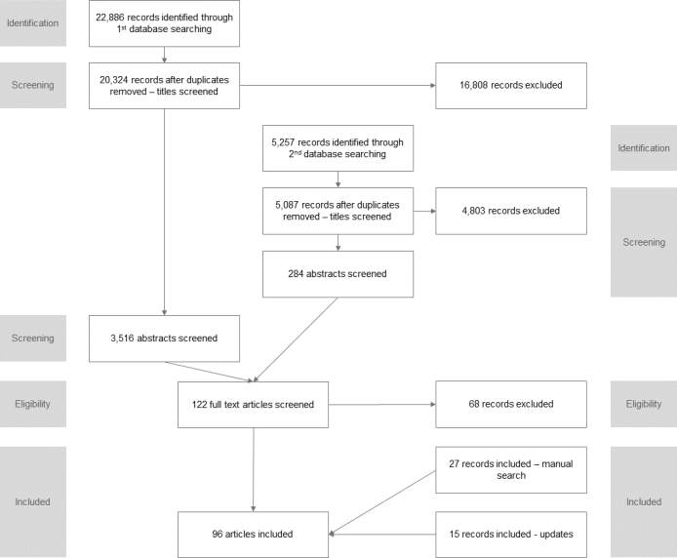

**Figure 2.** Cumulative distribution of year of publication across main themes. Note: Studies can belong to more than one category. ‘Social Media (SM)’ category has been excluded as it only has one member.

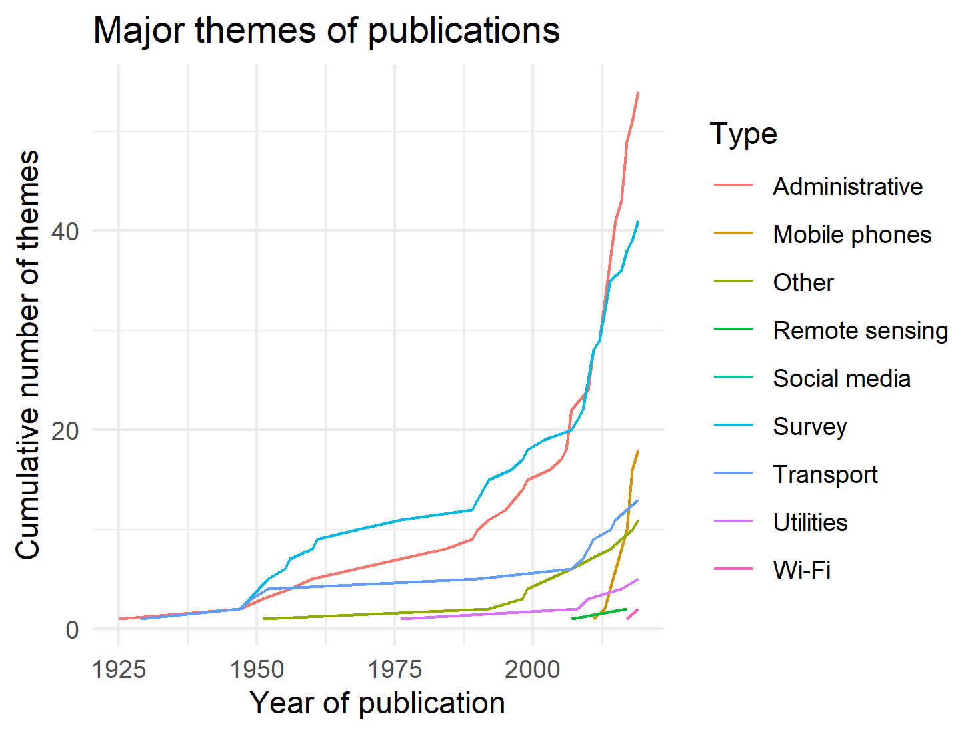

**Figure 3.** Country of temporary population estimates and national coverage. Note: one study describes more than one country.

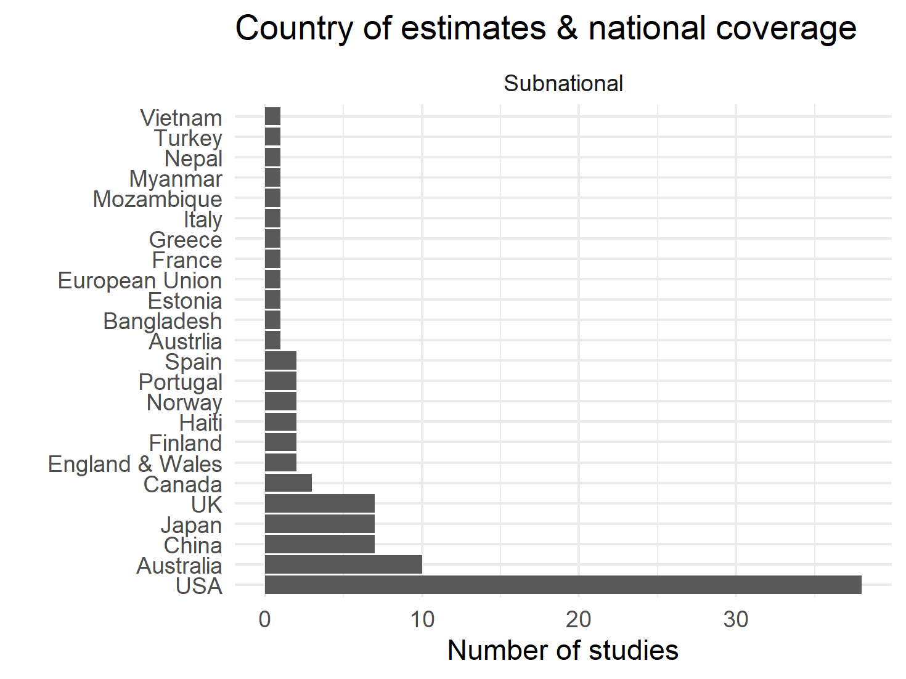

**Figure 4.** Temporal units used for estimates.

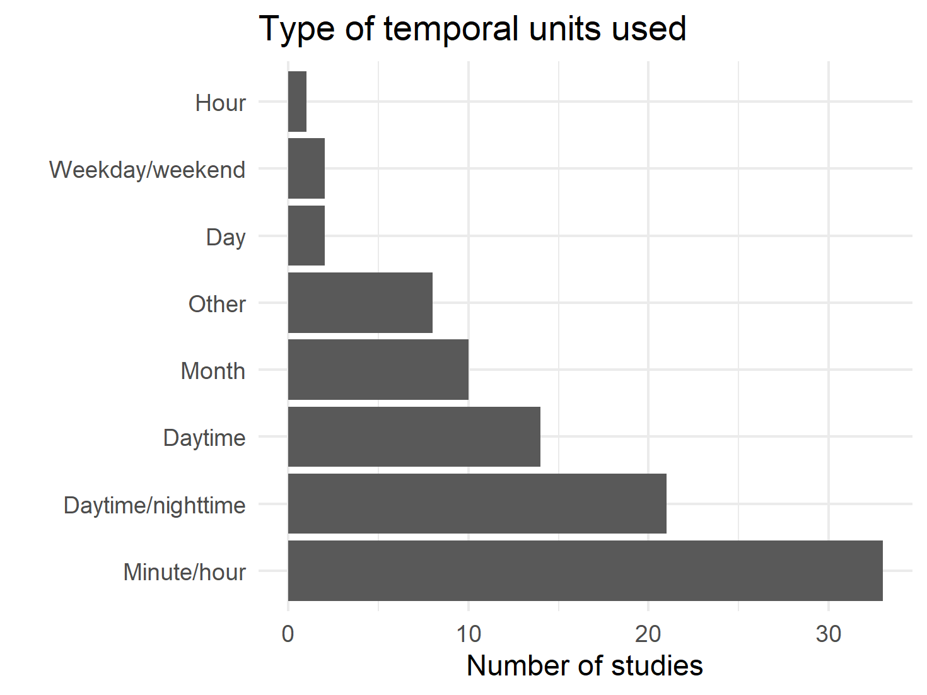

**Figure 4.** Size of population by theme. Note: The Main category used. Box width is proportional to the total number of studies. Studies that did not report on an estimated population size using the size of dataset whenever possible.

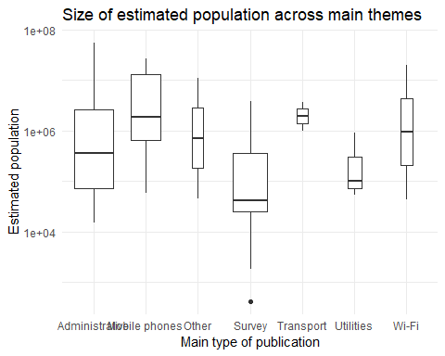

# Tables

**Table 1.** Selected characteristics of included studies. Note: * indicates that study can belong to more than one category.

|  |  |  |  |
| --- | --- | --- | --- |
| Characteristic | Value | n / median | % / min; max |
| Year of publication |  | 2011 | 1925; 2019 |
| Search method | Systematic | 54 | 56.25 |
|  | Manual | 27 | 28.12 |
|  | Update | 15 | 15.62 |
| Type of publication | Article | 54 | 56.25 |
|  | Report | 21 | 21.88 |
|  | Conference | 11 | 11.46 |
|  | Thesis | 7 | 7.29 |
|  | Book chapter | 3 | 3.12 |
| Purpose of publication* | Emergency planning | 22 | 22.92 |
|  | Service population | 8 | 8.34 |
|  | Other | 7 | 7.3 |
|  | Epidemiology | 4 | 4.16 |
|  | Commuting | 3 | 3.12 |
| Main type of data* | Administrative | 54 | 56.24 |
|  | Survey | 41 | 42.72 |
|  | Mobile phones | 18 | 18.76 |
|  | Transport | 13 | 13.56 |
|  | Other | 11 | 11.44 |
|  | Utilities | 5 | 5.2 |
|  | Remote sensing | 2 | 2.08 |
|  | Wi-Fi | 2 | 2.08 |
|  | Social media | 1 | 1.04 |
| Study region | Single city | 51 | 53.12 |
|  | Country | 17 | 17.71 |
|  | Administrative region | 15 | 15.62 |
|  | Multiple cities | 10 | 10.42 |
| Regions for estimates* | Administrative | 56 | 58.34 |
|  | Grid | 27 | 28.12 |
|  | Custom | 8 | 8.34 |
|  | Points | 7 | 7.3 |
|  | Building | 3 | 3.12 |
|  | Voronoi | 2 | 2.08 |
| Number of regions for estimates |  | 32 | 1; 52,000 |
| Temporal unit of estimates | Minute/hour | 33 | 34.38 |
|  | Daytime/nighttime | 21 | 21.88 |
|  | Daytime | 14 | 14.58 |
|  | Month | 10 | 10.42 |
|  | Other | 8 | 8.33 |
|  | Day | 2 | 2.08 |
|  | Weekday/weekend | 2 | 2.08 |
|  | Hour | 1 | 1.04 |
| Size of estimated population |  | 343,956 | 1,868; 53,349,074 |
| Size of dataset |  | 722,000 | 422; 55,963,096 |

# Bibliography

Adamiak, C., Pitkänen, K., and Lehtonen, O. (2017). Seasonal residence and counterurbanization: The role of second homes in population redistribution in Finland. *GeoJournal* 82:1035–1050. doi:[10.1007/s10708-016-9727-x Seasonal](https://doi.org/10.1007/s10708-016-9727-x%20Seasonal).

Ara, S. (2014). Impact of Temporal Population Distribution on Earthquake Loss Estimation: A Case Study on Sylhet, Bangladesh. *International Journal of Disaster Risk Science* 5(4):296–312. doi:[10.1007/s13753-014-0033-2](https://doi.org/10.1007/s13753-014-0033-2).

Batista e Silva, F., Rosina, K., Schiavina Marcello, M., Marin, M., Freire, S., Craglia, M., and Lavalle, C. (2017). Spatiotemporal mapping of population in Europe: The ‘ENACT’ project in a nutshell. *57th European Regional Science Association (ERSA) Congress*.

Batran, M., Mejia, M., Kanasugi, H., Sekimoto, Y., Shibasaki, R., Batran, M., Mejia, M.G., Kanasugi, H., Sekimoto, Y., and Shibasaki, R. (2018). Inferencing Human Spatiotemporal Mobility in Greater Maputo via Mobile Phone Big Data Mining. *ISPRS International Journal of Geo-Information* 7(7):259. doi:[10.3390/ijgi7070259](https://doi.org/10.3390/ijgi7070259).

Bell, M. (2000). Data, theory, method: Understanding circulation in Austrália. *10th Biennial Conference of the Australian Population Association*.

Bell, M. (2004). *Measuring Temporary Mobility: Dimensions and Issues*. Queensland Centre for Population Research School of Geography, Planning and Architecture, The University of Queensland.: pages.

Bell, M. and Ward, G. (1998). Patterns of Temporary Mobility in Australia: Evidence from the 1991 Census. *Australian Geographical Studies* 36(1):58–81. doi:[10.1111/1467-8470.00039](https://doi.org/10.1111/1467-8470.00039).

Bell, M. and Ward, G. (2000). Comparing temporary mobility with permanent migration. *Tourism Geographies* 2(1):87–107. doi:[10.1080/146166800363466](https://doi.org/10.1080/146166800363466).

Bengtsson, L., Lu, X., Thorson, A., Garfield, R., and Schreeb, J. von (2011). Improved Response to Disasters and Outbreaks by Tracking Population Movements with Mobile Phone Network Data: A Post-Earthquake Geospatial Study in Haiti. *PLOS Medicine* 8(8):e1001083. doi:[10.1371/journal.pmed.1001083](https://doi.org/10.1371/journal.pmed.1001083).

Bhaduri, B., Bright, E., Coleman, P., and Urban, M.L. (2007). LandScan USA: A high-resolution geospatial and temporal modeling approach for population distribution and dynamics. *GeoJournal* 69(1-2):103–117. doi:[10.1007/s10708-007-9105-9](https://doi.org/10.1007/s10708-007-9105-9).

Boeing, G. (2018). Estimating local daytime population density from census and payroll data. *Regional Studies, Regional Science* 5(1):179–182. doi:[10.1080/21681376.2018.1455535](https://doi.org/10.1080/21681376.2018.1455535).

Botta, F., Moat, H.S., and Preis, T. (2019). Measuring the size of a crowd using Instagram. *Environment and Planning B: Urban Analytics and City Science*:2399808319841615. doi:[10.1177/2399808319841615](https://doi.org/10.1177/2399808319841615).

Böhm, M.F., Ryeng, E.O., and Haugen, T. (2016). Evaluating the usage of Wi-Fi and Bluetooth based sensors for pedestrian counting in urban areas. *European Transport Conference 2016*:24.

Breese, G.W. (1947). *Daytime Population of the Central Business District of Chicago with Particular Reference to the Factor of Transportation*. University of Chicago.

Brogueira, G., Batista, F., and Carvalho, J.P. (2016). Using geolocated tweets for characterization of Twitter in Portugal and the Portuguese administrative regions. *Social Network Analysis and Mining* 6(1):37. doi:[10.1007/s13278-016-0347-8](https://doi.org/10.1007/s13278-016-0347-8).

Bureau of the Census (1956). *Population Estimates for Survival Planing*. Washington, D.C.: Department of Commerce.: pages.

Calabrese, F., Ratti, C., Calabrese, F., and Ratti, C. (2006). Real Time Rome. *Networks and Communication Studies*:3–4.

Campbell, N. (2010). *Developing an extensible solution for modelling daytime population movement*. [PhD thesis].

Census of England and Wales 1921 (1925). *Workplaces*. London: HMSO.: pages.

Charles-Edwards, E. (2011). *Modelling flux: Towards the estimation of small area temporary populations in Australia*. [PhD]. The University of Queensland.

Charles-Edwards, E. and Bell, M. (2013). Estimating the Service Population of a Large Metropolitan University Campus. *Applied Spatial Analysis and Policy* 6(3):209–228. doi:[10.1007/s12061-012-9079-y](https://doi.org/10.1007/s12061-012-9079-y).

Charles-Edwards, E. and Panczak, R. (2018). Elsewhere in Australia: A snapshot of temporary mobility on the night of the 2016 Census. *Australian Population Studies* 2(1):14–25.

Charles-Edwards, E., Panczak, R., Corcoran, J., and Bell, M. (n.d.). A framework for official temporary population statistics. *Journal of Official Statistics*.

Chen, J., Pei, T., Shaw, S.-L., Lu, F., Li, M., Cheng, S., Liu, X., and Zhang, H. (2018). Fine-grained prediction of urban population using mobile phone location data. *International Journal of Geographical Information Science* 0(0):1–17. doi:[10.1080/13658816.2018.1460753](https://doi.org/10.1080/13658816.2018.1460753).

Chow, T.E. (2018). A crowdsourcingGeocomputational framework of mobile crowd simulation and estimation. *Cartography and Geographic Information Science* 0(0):1–19. doi:[10.1080/15230406.2018.1524314](https://doi.org/10.1080/15230406.2018.1524314).

Collins, A. and Greaves, S. (2007). Daytime population tracking for planning and pollution exposure assessment. *Road and Transport Research Journal* 16(1):55–68.

Crols, T. and Malleson, N. (2019). Quantifying the ambient population using hourly population footfall data and an agent-based model of daily mobility. *GeoInformatica* 23(2):201–220. doi:[10.1007/s10707-019-00346-1](https://doi.org/10.1007/s10707-019-00346-1).

Deville, P., Linard, C., Martin, S., Gilbert, M., Stevens, F.R., Gaughan, A.E., Blondel, V.D., and Tatem, A.J. (2014). Dynamic population mapping using mobile phone data. *Proceedings of the National Academy of Sciences* 111(45):15888–15893. doi:[10.1073/pnas.1408439111](https://doi.org/10.1073/pnas.1408439111).

Edmondson, B. and Nantucket Data Platform team (2019). *Making It Count. A Data-Driven Look at Nantucket’s Dynamic Population*. Nantucket Data Platform.: pages.

Elliott, J.H., Turner, T., Clavisi, O., Thomas, J., Higgins, J.P.T., Mavergames, C., and Gruen, R.L. (2014). Living Systematic Reviews: An Emerging Opportunity to Narrow the Evidence-Practice Gap. *PLoS Medicine* 11(2):1–6. doi:[10.1371/journal.pmed.1001603](https://doi.org/10.1371/journal.pmed.1001603).

Erickson, R.B. (1961). Measuring resort population increases. *The Professional Geographer* 13(4):16–19. doi:[10.1111/j.0033-0124.1961.134_16.x](https://doi.org/10.1111/j.0033-0124.1961.134_16.x).

Esri (2018). *Methodology Statement: 2018 Esri Daytime Population*. Redlands.: pages.

Fehr & Peers (2014). *Napa County Travel Behavior Study*.: pages.

Foley, D.L. (1952). The daily movement of population into central business districts. *American Sociological Review* 17(5):538–543.

Foley, D.L. (1954). Urban daytime population: A field for demographic-ecological analysis. *Social Forces* 32(4):323–330. doi:[10.2307/2574113](https://doi.org/10.2307/2574113).

Fulton, P.N. (1984). Estimating the daytime population with the urban transportation planning package. *Transportation Research Record* 981:25–27.

Galvez, J. and McLarty, C. (1996). Measurement of Florida temporary residents using a telephone survey. *Journal of Economic and Social Measurement* 22(1):25–42. doi:[10.3233/JEM-1996-22102](https://doi.org/10.3233/JEM-1996-22102).

Gao, X., Yuan, H., Qi, W., and Liu, S. (2014). Assessing the Social and Economic Vulnerability of Urban Areas to Disasters: A case study in Beijing, China. *International Review for Spatial Planning and Sustainable Development* 2(1):42–62. doi:[10.14246/irspsd.2.1_42](https://doi.org/10.14246/irspsd.2.1_42).

Gober, P. and Mings, R.C. (1984). A Geography of Nonpermanent Residence in the U.S. *Professional Geographer* 36(2):164–173. doi:[10.1111/j.0033-0124.1984.00164.x](https://doi.org/10.1111/j.0033-0124.1984.00164.x).

Goldschmidt, P.G. and Dahl, A.W. (1976). Demoflush Estimating Population in Seasonal Resort Communities. *Growth and Change* 7(2):44–48. doi:[10.1111/j.1468-2257.1976.tb00305.x](https://doi.org/10.1111/j.1468-2257.1976.tb00305.x).

Gough, D. (2015). Qualitative and mixed methods in systematic reviews. *Systematic Reviews* 4(1):181. doi:[10.1186/s13643-015-0151-y](https://doi.org/10.1186/s13643-015-0151-y).

Graebert, M.B., Wyckoff, M., and Bretz, L. (2014). *Northwest Michigan Seasonal Population Analysis*. Michigan State University Land Policy Institute.: pages.

Greger, K. (2015). Spatio-Temporal Building Population Estimation for Highly Urbanized Areas Using GIS. *Transactions in GIS* 19(1):129–150. doi:[10.1111/tgis.12086](https://doi.org/10.1111/tgis.12086).

Gunter, U. and Önder, I. (2016). Forecasting city arrivals with Google Analytics. *Annals of Tourism Research* 61:199–212. doi:[10.1016/j.annals.2016.10.007](https://doi.org/10.1016/j.annals.2016.10.007).

Happel, S.K. and Hogan, T.D. (2002). Counting snowbirds: The importance of and the problems with estimating seasonal populations. *Population Research and Policy Review* 21(3):227–240. doi:[10.1023/A:1019560405310](https://doi.org/10.1023/A:1019560405310).

Harris, E., Leaver, J., Young, N., and Perlich, P.S. (2019). *Washington County Temporary Resident Population Estimates, 2017*. Salt Lake City: Kem C. Gardner Policy Institute.: pages.

Himoto, K. and Kimata, J. (2014). A Model for the Spatio-temporal Distribution of Population using Country-Wide Statistical Data and Its Application to the Estimation of Human Exposure to Disasters. In: *Improving Disaster Resilience and Mitigation - IT Means and Tools*. Springer, Dordrecht: 73–87. doi:[10.1007/978-94-017-9136-6_5](https://doi.org/10.1007/978-94-017-9136-6_5).

Hodur, N.M. and Bangsund (2015). *Service Population Estimates for City of Williston*. Fargo: North Dakota State University.: pages.

Horanont, T. and Shibasaki, R. (2010). Estimate ambient population density: Discovering the current flow of the city..

Institute for Research in Social Science University of North Carolina (1952). *Population Distribution, Spatial and Temporal;a Study of Daytime -Nighttime Differentials in the Proportional Distribution of the Total Population of Selected Urban Areas*. Chapel Hill.

Järv, O., Tenkanen, H., and Toivonen, T. (2017). Enhancing spatial accuracy of mobile phone data using multi-temporal dasymetric interpolation. *International Journal of Geographical Information Science* 31(8):1630–1651. doi:[10.1080/13658816.2017.1287369](https://doi.org/10.1080/13658816.2017.1287369).

Jochem, W.C., Sims, K., Bright, E.A., Urban, M.L., Rose, A.N., Coleman, P.R., and Bhaduri, B.L. (2013). Estimating traveler populations at airport and cruise terminals for population distribution and dynamics. *Natural Hazards* 68(3):1325–1342. doi:[10.1007/s11069-012-0441-9](https://doi.org/10.1007/s11069-012-0441-9).

Juhász, L. and Hochmair, H.H. (2018). Analyzing the spatio the spatio-temporal dynamics of Snapchat. *AGILE 2018 Workshop: VGI-ALIVE - AnaLysis, Integration, Vision, Engagement*.

Kashiyama, T., Pang, Y., and Sekimoto, Y. (2017). Open PFLOW: Creation and evaluation of an open dataset for typical people mass movement in urban areas. *Transportation Research Part C: Emerging Technologies* 85:249–267. doi:[10.1016/j.trc.2017.09.016](https://doi.org/10.1016/j.trc.2017.09.016).

Kavanaugh, P. (1990). A method for estimating daytime population by small area geography. *Proceedings of the 1990 Urban and Regional Information Systems Association Conference*:150–164.

Khakpour, M. and Rød, J.K. (2016). An attraction-based cellular automaton model for generating spatiotemporal population maps in urban areas. *Environment and Planning B: Planning and Design* 43(2):297–319. doi:[10.1177/0265813515604262](https://doi.org/10.1177/0265813515604262).

Khodabandelou, G., Gauthier, V., El-Yacoubi, M., and Fiore, M. (2016). Population estimation from mobile network traffic metadata. *2016 IEEE 17th International Symposium on A World of Wireless, Mobile and Multimedia Networks (WoWMoM)*:1–9. doi:[10.1109/WoWMoM.2016.7523554](https://doi.org/10.1109/WoWMoM.2016.7523554).

Kim, H. and Ahn, J.-S.(. (2017). Modelling Daytime Population Distribution for Emergency Response and Social Vulnerability Assessment. *Journal of Korean Geographical Society* 51(3):335–346.

Kobayashi, T., Medina, R.M., and Cova, T.J. (2011). Visualizing Diurnal Population Change in Urban Areas for Emergency Management. *The Professional Geographer* 63(1):113–130. doi:[10.1080/00330124.2010.533565](https://doi.org/10.1080/00330124.2010.533565).

Kontokosta, C.E. and Johnson, N. (2017). Urban phenology: Toward a real-time census of the city using Wi-Fi data. *Computers, Environment and Urban Systems* 64:144–153. doi:[10.1016/j.compenvurbsys.2017.01.011](https://doi.org/10.1016/j.compenvurbsys.2017.01.011).

Lamb, G. (1999). *Estimating the Seasonal Population of Door County*.: pages.

Lau, K.H. (2009). A GIS-based Stochastic Approach to Generating Daytime Population Distributions for Vehicle Route Planning. *Transactions in GIS* 13(5-6):481–502. doi:[10.1111/j.1467-9671.2009.01175.x](https://doi.org/10.1111/j.1467-9671.2009.01175.x).

Li, J., Li, J., Yuan, Y., and Li, G. (2019). Spatiotemporal distribution characteristics and mechanism analysis of urban population density: A case of Xi’an, Shaanxi, China. *Cities* 86:62–70. doi:[10.1016/j.cities.2018.12.008](https://doi.org/10.1016/j.cities.2018.12.008).

Li, S., Chen, T., Wang, L., and Ming, C. (2018). Effective tourist volume forecasting supported by PCA and improved BPNN using Baidu index. *Tourism Management* 68:116–126. doi:[10.1016/j.tourman.2018.03.006](https://doi.org/10.1016/j.tourman.2018.03.006).

Liu, Z., Ma, T., Du, Y., Pei, T., Yi, J., and Peng, H. (2018). Mapping hourly dynamics of urban population using trajectories reconstructed from mobile phone records. *Transactions in GIS*:1–20. doi:[10.1111/tgis.12323](https://doi.org/10.1111/tgis.12323).

Lwin, K.K., Sugiura, K., and Zettsu, K. (2016). SpaceTime multiple regression model for grid-based population estimation in urban areas. *International Journal of Geographical Information Science* 30(8):1579–1593. doi:[10.1080/13658816.2016.1143099](https://doi.org/10.1080/13658816.2016.1143099).

Ma, Y.J., Xu, W., Zhao, X.J., and Li, Y. (2017). Modeling the Hourly Distribution of Population at a High Spatiotemporal Resolution Using Subway Smart Card Data: A Case Study in the Central Area of Beijing. *ISPRS International Journal of Geo-Information* 6(5). doi:[10.3390/ijgi6050128](https://doi.org/10.3390/ijgi6050128).

Mamei, M. and Colonna, M. (2016). Estimating attendance from cellular network data. *International Journal of Geographical Information Science* 30(7):1281–1301. doi:[10.1080/13658816.2015.1127378](https://doi.org/10.1080/13658816.2015.1127378).

Markham, F., Bath, J., and Taylor, J. (2013). *New Directions in Indigenous Service Population Estimation*. Centre for Aboriginal Economic Policy Research, The Australian National University.: pages.

Martin, D., Cockings, S., and Leung, S. (2015). Developing a Flexible Framework for Spatiotemporal Population Modeling. *Annals of the Association of American Geographers* 105(4):754–772. doi:[10.1080/00045608.2015.1022089](https://doi.org/10.1080/00045608.2015.1022089).

McKenzie, B., Koerber, W., Fields, A., Benetsky, M., and Rapino, M. (2013). *Commuter-Adjusted Population Estimates: ACS 2006-10*. Journey to Work and Migration Statistics Branch, U.S. Census Bureau.

McKenzie, F. and Canterford, S. (2016). *Demographics for Fire Risk Analysis Regional Victoria and Peri-Urban Melbourne*. Melbourne, Austrlia: Department of Environment, Land, Water and Planning.: pages.

McPherson, T. and Brown, M. (2003). *U.S. Day and Night Population Database (Revision 2.0) - Description of Methodology*. Los Alamos National Laboratory.: pages.

Melville, G. and Welsh, A. (2009). Estimating Species Abundance. In: Wilson, S. R. and Burden, C. (eds.). *Biometrics - Volume I*. Oxford, UK: EOLSS Publishers.

Menzler, F.A.A. (1952). An estimate of the day-time population of London. *Journal of the Town Planning Institute* 38(5):116–120.

Miller, H.J., Dodge, S., Miller, J., and Bohrer, G. (2019). Towards an integrated science of movement: Converging research on animal movement ecology and human mobility science. *International Journal of Geographical Information Science* 0(0):1–22. doi:[10.1080/13658816.2018.1564317](https://doi.org/10.1080/13658816.2018.1564317).

Mizzi, C., Fabbri, A., Rambaldi, S., Bertini, F., Curti, N., Sinigardi, S., Luzi, R., Venturi, G., Davide, M., Muratore, G., Vannelli, A., and Bazzani, A. (2018). Unraveling pedestrian mobility on a road network using ICTs data during great tourist events. *EPJ Data Science* 7(1):44. doi:[10.1140/epjds/s13688-018-0168-2](https://doi.org/10.1140/epjds/s13688-018-0168-2).

Moher, D., Liberati, A., Tetzlaff, J., Altman, D.G., Altman, D., Antes, G., Atkins, D., Barbour, V., Barrowman, N., Berlin, J.A., Clark, J., Clarke, M., Cook, D., D’Amico, R., Deeks, J.J., Devereaux, P.J., Dickersin, K., Egger, M., Ernst, E., Gøtzsche, P.C., Grimshaw, J., Guyatt, G., Higgins, J., Ioannidis, J.P., Kleijnen, J., Lang, T., Magrini, N., McNamee, D., Moja, L., Mulrow, C., Napoli, M., Oxman, A., Pham, B., Rennie, D., Sampson, M., Schulz, K.F., Shekelle, P.G., Tovey, D., and Tugwell, P. (2009). Preferred reporting items for systematic reviews and meta-analyses: The PRISMA statement. *PLoS Medicine* 6(7). doi:[10.1371/journal.pmed.1000097](https://doi.org/10.1371/journal.pmed.1000097).

Monmouth County Planning Board (2008). *Summer Coastal Population Study*.: pages.

Nelson, A.C. and Nicholas, J.C. (1992). Estimating functional population for facility planning. *Journal of Urban Planning and Development* 118(2).

New York Regional Plan Association (1949). Persons and Vehicles Entering Manhattan South of 61st Street, 1924-1948. *Regional Plan Bulletin* 74:1–6.

Office for National Statistics (2013). *2011 Census: The Workday Population of England and Wales - an Alternative 2011 Census Output Base*. Office for National Statistics.: pages.

Önder, I. (2017). Forecasting tourism demand with Google trends: Accuracy comparison of countries versus cities. *International Journal of Tourism Research* 19(6):648–660. doi:[10.1002/jtr.2137](https://doi.org/10.1002/jtr.2137).

Picornell, M., Ruiz, T., Borge, R., García-Albertos, P., Paz, D. de la, and Lumbreras, J. (2018). Population dynamics based on mobile phone data to improve air pollution exposure assessments. *Journal of Exposure Science & Environmental Epidemiology*:1. doi:[10.1038/s41370-018-0058-5](https://doi.org/10.1038/s41370-018-0058-5).

Qi, W., Liu, S., Gao, X., and Zhao, M. (2015). Modeling the spatial distribution of urban population during the daytime and at night based on land use: A case study in Beijing, China. *Journal of Geographical Sciences* 25(6).

Rigall-I-Torrent, R. (2010). Estimating overnight de facto population by forecasting symptomatic variables: An integrated framework. *Journal of Forecasting* 29(7):635–654. doi:[10.1002/for.1166](https://doi.org/10.1002/for.1166).

Roddis, S. (1996). Metropolitan Activity Profiles - A New Perspective on Demand. *20th Australasian Transport Research Forum Conference*.

Rose, L.S. and Kingma, H.L. (1989). Seasonal Migration of Retired Persons: Estimating Its Extent and Its Implications for the State of Florida. *Journal of Economic and Social Measurement* 15(1):91–104. doi:[10.3233/JEM-1989-15106](https://doi.org/10.3233/JEM-1989-15106).

Schmitt, R.C. (1956). Estimating Daytime Populations. *Journal of the American Planning Association* 22(2):83–85. doi:[10.1080/01944365608979227](https://doi.org/10.1080/01944365608979227).

Seattle City Planning Commission (1951). *Daytime and Night-Time Population Distribution in Metropolitan Seattle: April, 1950*.: pages.

Sekimoto, Y., Shibasaki, R., Kanasugi, H., Usui, T., and Shimazaki, Y. (2011). PFlow: Reconstructing People Flow Recycling Large-Scale Social Survey Data. *IEEE Pervasive Computing* 10(4):27–35. doi:[10.1109/MPRV.2011.43](https://doi.org/10.1109/MPRV.2011.43).

Sharp, H. (1955). The Non-Residential Population of the Central Business District. *Land Economics* 31(4):378–381. doi:[10.2307/3159307](https://doi.org/10.2307/3159307).

Silm, S. and Ahas, R. (2010). The seasonal variability of population in Estonian municipalities. *Environment and Planning A* 42(10):2527–2546. doi:[10.1068/a43139](https://doi.org/10.1068/a43139).

Sims, K.M., Weber, E.M., Bhaduri, B.L., Thakur, G.S., and Resseguie, D.R. (2017). Application of Social Media Data to High-Resolution Mapping of a Special Event Population. In: *Advances in Geocomputation*. Springer, Cham: 67–74. doi:[10.1007/978-3-319-22786-3_7](https://doi.org/10.1007/978-3-319-22786-3_7).

Smith, G., Arnot, C., Fairburn, J., and Walker, G. (2005). *A National Population Data Base for Major Accident Hazard Modelling*. Health and Safety Executive.: pages.

Smith, S.K. (1987). How to tally temporary populations. *American Demographics* 9(7):44–5.

Smith, S.K. (1989). Toward a methodology for estimating temporary residents. *Journal of the American Statistical Association*.

Smith, S.K. and House, M. (2007). Temporary Migration: A Case Study of Florida. *Population Research and Policy Review* 26(4):437–454.

Stathakis, D. and Baltas, P. (2018). Seasonal population estimates based on night-time lights. *Computers, Environment and Urban Systems* 68:133–141. doi:[10.1016/j.compenvurbsys.2017.12.001](https://doi.org/10.1016/j.compenvurbsys.2017.12.001).

Stewart, R., Piburn, J., Weber, E., Urban, M., Morton, A., Thakur, G., and Bhaduri, B. (2017). Can Social Media Play a Role in the Development of Building Occupancy Curves? *Advances in Geocomputation*:59–66.

Stutz, F.P., Parrott, R., and Kavanaugh, P. (1992). Charting urban space-time population shifts with trip generation models. *Urban Geography* 13(5):468–474. doi:[10.2747/0272-3638.13.5.468](https://doi.org/10.2747/0272-3638.13.5.468).

Swanson, D.A. and Tayman, J. (2011). On estimating a de facto population and its components. *Review of Economics & Finance* 1.

Tatem, A.J. (2017). WorldPop, open data for spatial demography. *Scientific Data* 4:170004.

Taubenböck, H., Roth, A., and Dech, S. (2007). Linking structural urban characteristics derived from high resolution satellite data to population distribution. *Urban and Regional Data Management: UDMS 2007 Annual*.

Taylor, J. (1998). Measuring short-term population mobility among indigenous Australians: Options and implications. *Australian Geographer* 29(1):125–137. doi:[10.1080/00049189808703207](https://doi.org/10.1080/00049189808703207).

Terada, M., Nagata, T., and Kobayashi, M. (2013). Population Estimation Technology for Mobile Spatial Statistics. *NTT DOCOMO Technical journal* 14(3):10–15.

Thakur, R. (2018). *A Methodology to Account for Seasonal Population Shifts in North Carolina*. [M.S.]. United States – North Carolina: The University of North Carolina at Charlotte.

Thomas, K.V., Amador, A., Baz-Lomba, J.A., and Reid, M. (2017). Use of Mobile Device Data To Better Estimate Dynamic Population Size for Wastewater-Based Epidemiology. *Environmental Science & Technology* 51(19):11363–11370. doi:[10.1021/acs.est.7b02538](https://doi.org/10.1021/acs.est.7b02538).

Thornthwaite, C. (1929). *Louisville, Kentucky: A study in urban geography*. [PhD thesis]. Berkeley: Department of Geography, University of California.

Versichele, M., Neutens, T., Delafontaine, M., and Van de Weghe, N. (2012). The use of Bluetooth for analysing spatiotemporal dynamics of human movement at mass events: A case study of the Ghent Festivities. *Applied Geography* 32(2):208–220. doi:[10.1016/j.apgeog.2011.05.011](https://doi.org/10.1016/j.apgeog.2011.05.011).

Walker, L. and Barros, J. (2012). An agent-based population model for Wolverhampton, UK: A spatio-temporal activity based approach to population modelling. *GISRUK*.

Warchivker, I., Tjapangati, T., and Wakerman, J. (2000). The turmoil of Aboriginal enumeration: Mobility and service population analysis in a Central Australian community. *Australian and New Zealand Journal of Public Health* 24(4):444–449. doi:[10.1111/j.1467-842X.2000.tb01610.x](https://doi.org/10.1111/j.1467-842X.2000.tb01610.x).

Weir, T.R. (1960). A Survey of the Daytime Population of Winnipeg. *Queen’s Quarterly; Kingston, Ont.* 67:654–664.

Wheeler, J.O. and Brunn, S.D. (2002). An urban geographer before his time: C. Warren Thornthwaite’s 1930 doctoral dissertation. *Progress in Human Geography* 26(4):463–486. doi:[10.1191/0309132502ph381ra](https://doi.org/10.1191/0309132502ph381ra).

Wilson, R., zu Erbach-Schoenberg, E., Albert, M., Power, D., Tudge, S., Gonzalez, M., Guthrie, S., Chamberlain, H., Brooks, C., Hughes, C., Pitonakova, L., Buckee, C., Lu, X., Wetter, E., Tatem, A., and Bengtsson, L. (2016). Rapid and Near Real-Time Assessments of Population Displacement Using Mobile Phone Data Following Disasters: The 2015 Nepal Earthquake. *PLOS Currents Disasters* Feb 24(Edition 1). doi:[10.1371/currents.dis.d073fbece328e4c39087bc086d694b5c](https://doi.org/10.1371/currents.dis.d073fbece328e4c39087bc086d694b5c).

Wurtele, Z.S. and Wellisch, J.B. (1968). *Population Dynamics: Final Report*. Santa Monica, California: System Development Corporation.: pages.

Yip, P.S.F., Watson, R., Chan, K.S., Lau, E.H.Y., Chen, F., Xu, Y., Xi, L., Cheung, D.Y.T., Ip, B.Y.T., and Liu, D. (2010). Estimation of the Number of People in a Demonstration. *Australian & New Zealand Journal of Statistics* 52(1):17–26. doi:[10.1111/j.1467-842X.2009.00562.x](https://doi.org/10.1111/j.1467-842X.2009.00562.x).

Yong li, M. (1998). Research in statistical models for mobile population (SMMP). *Cartographic Journal* 35(2):155–164. doi:[10.1179/caj.1998.35.2.155](https://doi.org/10.1179/caj.1998.35.2.155).