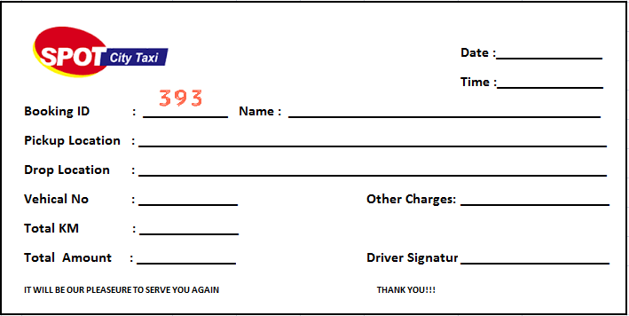

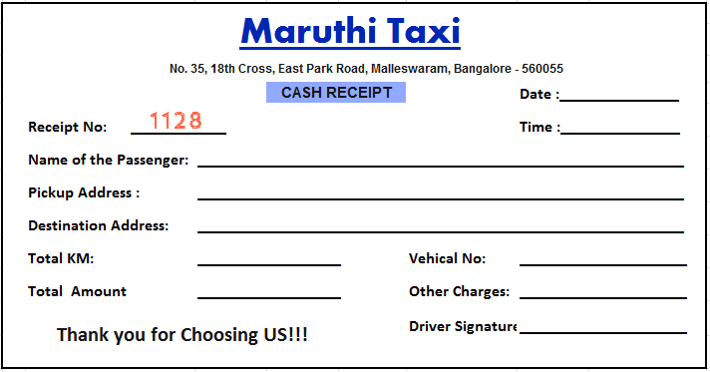

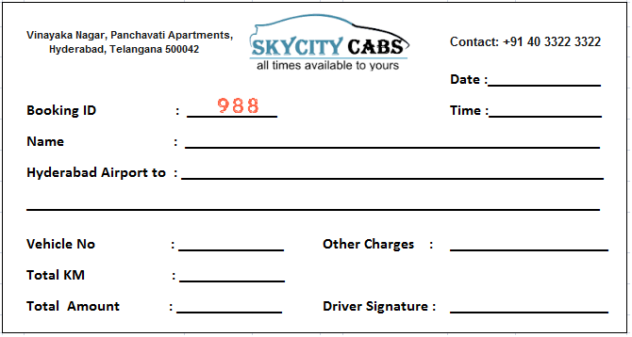

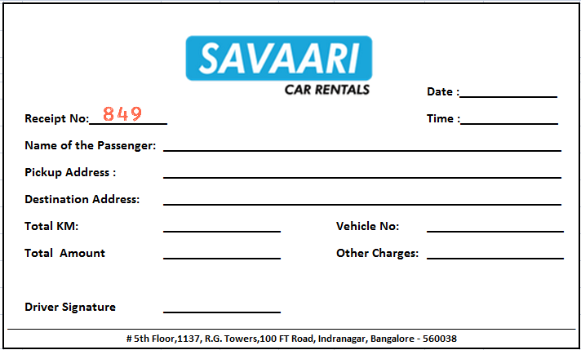

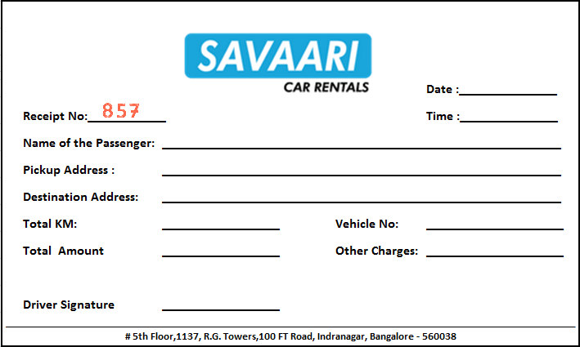

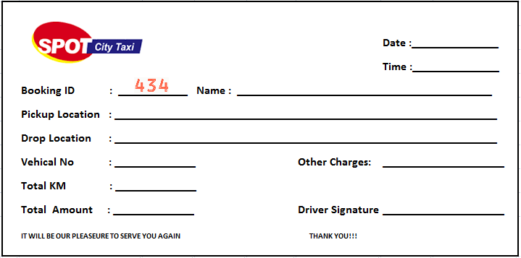

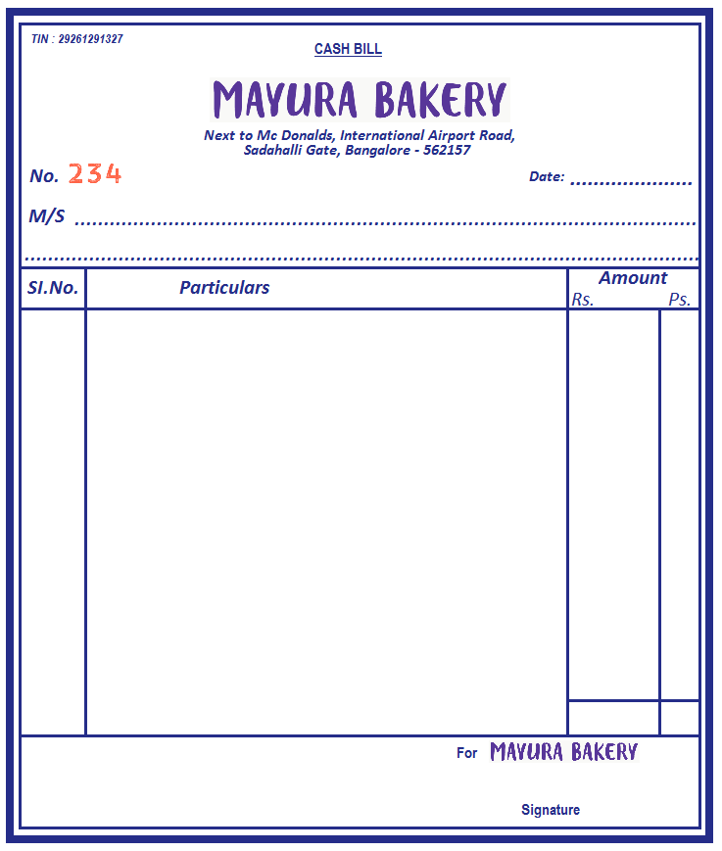

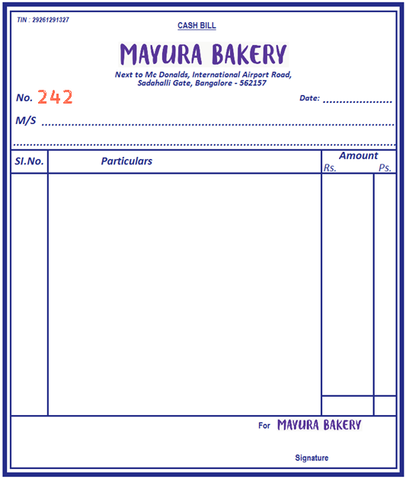

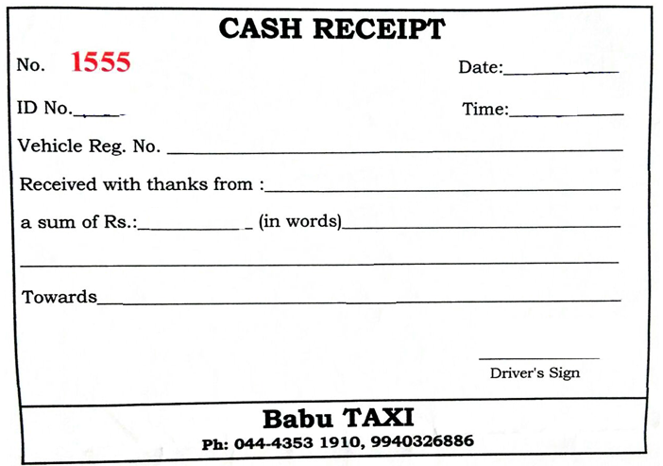

|  |  |  |  |  |  |  |  |  |  |  |
| --- | --- | --- | --- | --- | --- | --- | --- | --- | --- | --- |
|  | **EASY CABS** | | |  |  |  | **MR CABS** | | |  |
|  | **# 80. MADHAPURA** | | |  |  |  | **House No 12-2-823/158/1/A, Mehdipatnam, Hyderabad - 500028,** | | |  |
|  | **HYDERABAD - 81** | | |  |  |  |  |
|  | **TS 09 AJ- 2201** | | |  |  |  | **\*\*\* WELCOM \*\*\*** | | |  |
| **------------------------** | | | | |  |  | **TAXI NO** | **:** | **TS 10 M 4029** |  |
|  | **BILL NO** | **:** | **00020837** |  |  |  | **METER NO** | **:** | **0004160** |  |
|  | **DATE** | **:** | **12-Feb-17** |  |  |  | **RECP. #** | **:** | **1045** |  |
|  | **START TIME** | **:** | **18:07:13** |  |  |  | **DATE** | **:** | **11-Feb-17** |  |
|  | **END TIME** | **:** | **18:52:56** |  |  |  | **START TIME** | **:** | **23:18:13** |  |
|  | **KM** | **:** | **37.00** |  |  |  | **END TIME** | **:** | **00:22:56** |  |
|  | **WT. TIME** | **:** | **00.00** |  |  |  | **KM** | **:** | **40.00** |  |
|  | **FARE** | **:** | **1200.00** |  |  |  | **WT. TIME** | **:** | **15.00** |  |
| **------------------------** | | | | |  |  | **FARE** | **:** | **1250.00** |  |
|  | **CALL - 43434343** | | |  |  |  |  |  |  |  |
|  | **IT WILL BE OUR PLEASEURE TO SERVE YOU AGAIN** | | |  |  |  | **\*\*\* THANK YOU FOR CHOOSING US \*\*\*** | | |  |
|  | **THANK YOU** | | |  |  |  |  | | |  |
|  | **\*\*\*\*\*\*\*\*\*\*** | | |  |  |  |  | | |  |

