Software Design Documents

Version 1.0
Sistema Bibliotecario
Pastorino Riccardo
Progetto di Software Engineering

Table of Contents
1 Introduction 2
2 System Overview 2
3 Models 2
3.1 Static Models 2
3.1.1 Use Cases Diagram 2
3.1.2 Class Diagram 2
3.1.3 Object Diagram 2
3.2 Dynamic Models 2
3.2.1 Sequence Diagrams 2
3.2.2 Activity Diagrams 2
3.2.3 State Machine Diagrams 2
4.0 Vincoli 2

1 Introduction

2 System Overview

3 Models

3.1 Static Models

3.1.1 Use Cases Diagram
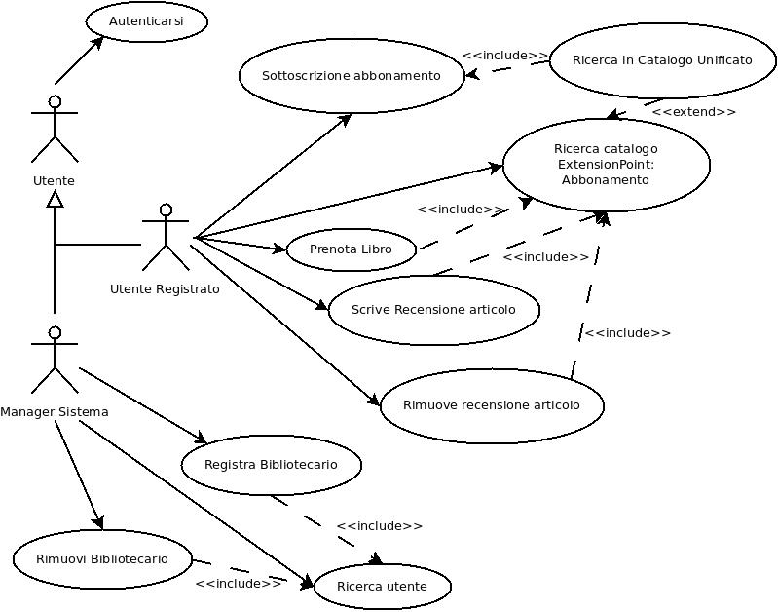

3.1.2 Class Diagram

3.1.3 Object Diagram

3.2 Dynamic Models

3.2.1 Sequence Diagrams

3.2.2 Activity Diagrams

3.2.3 State Machine Diagrams

4.0 Vincoli

