**In-Class Exercise 3 – Advanced SQL**

Question 1 (5pts)

SELECT soh.[SalesPersonID],

p.[FirstName] + ' ' + COALESCE (p.[MiddleName], '') + ' ' + p.[LastName] AS [FullName],

e.[JobTitle],

st.[Name] AS [SalesTerritory],

soh.[SubTotal],

YEAR(DATEADD(m, 6, soh.[OrderDate])) AS [FiscalYear]

FROM [Sales].[SalesPerson] sp INNER JOIN

[Sales].[SalesOrderHeader] soh ON sp.[BusinessEntityID] = soh.[SalesPersonID]

INNER JOIN [Sales].[SalesTerritory] st ON sp.[TerritoryID] = st.[TerritoryID]

INNER JOIN [HumanResources].[Employee] e ON soh.[SalesPersonID] = e.[BusinessEntityID]

INNER JOIN [Person].[Person] p ON p.[BusinessEntityID] = sp.[BusinessEntityID]

1. Using the sql statement above, please create a CTE query and select all columns in the result (2pts) [paste your query below]

WITH ICE3_CTE

AS

(

SELECT soh.[SalesPersonID],

p.[FirstName] + ' ' + COALESCE (p.[MiddleName], '') + ' ' + p.[LastName] AS [FullName],

e.[JobTitle],

st.[Name] AS [SalesTerritory],

soh.[SubTotal],

YEAR(DATEADD(m, 6, soh.[OrderDate])) AS [FiscalYear]

FROM [Sales].[SalesPerson] sp

INNER JOIN [Sales].[SalesOrderHeader] soh ON sp.[BusinessEntityID] = soh.[SalesPersonID]

INNER JOIN [Sales].[SalesTerritory] st ON sp.[TerritoryID] = st.[TerritoryID]

INNER JOIN [HumanResources].[Employee] e ON soh.[SalesPersonID] = e.[BusinessEntityID]

INNER JOIN [Person].[Person] p ON p.[BusinessEntityID] = sp.[BusinessEntityID]

)

SELECT * FROM ICE3_CTE;

1. What is the purpose of the COALESCE in the “COALESCE (p.[MiddleName], '')” part of the sql statement ? (1pt)
   1. The purpose is to return empty / space ('') if middle name is NULL, avoiding NULL to be returned.
2. Why does the “YEAR(DATEADD(m, 6, soh.[OrderDate])) AS [FiscalYear]” convert to a Fiscal Year? (2pt) Please provide the expected result for 1-Aug-2019 and 1-Mar-2019
   1. Because it adds 6 months to the date given
   2. 2020
   3. 2019

Question 2 (10pts)

Using the CTE query created in your answer to Question 1a please create a pivot table of Avg Sales by SalesPerson (Years: 2012, 2013, 2014). Please provide the sql below. Your output should be as follows:

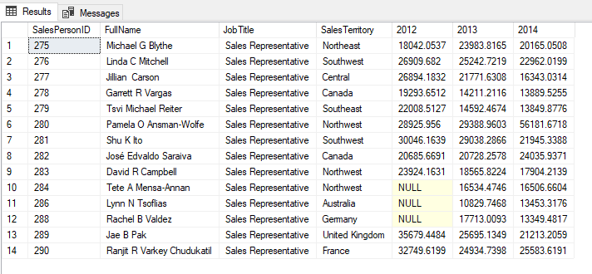

ANSWER:

WITH ICE3_CTE

AS

(

SELECT soh.[SalesPersonID],

p.[FirstName] + ' ' + COALESCE (p.[MiddleName], '') + ' ' + p.[LastName] AS [FullName],

e.[JobTitle],

st.[Name] AS [SalesTerritory],

soh.[SubTotal],

YEAR(DATEADD(m, 6, soh.[OrderDate])) AS [FiscalYear]

FROM [Sales].[SalesPerson] sp

INNER JOIN [Sales].[SalesOrderHeader] soh ON sp.[BusinessEntityID] = soh.[SalesPersonID]

INNER JOIN [Sales].[SalesTerritory] st ON sp.[TerritoryID] = st.[TerritoryID]

INNER JOIN [HumanResources].[Employee] e ON soh.[SalesPersonID] = e.[BusinessEntityID]

INNER JOIN [Person].[Person] p ON p.[BusinessEntityID] = sp.[BusinessEntityID]

)

--SELECT * FROM ICE3_CTE;

SELECT pvt.[SalesPersonID], pvt.[FullName], pvt.[JobTitle], pvt.[SalesTerritory], pvt.[2012], pvt.[2013], pvt.[2014]

FROM (SELECT * FROM ICE3_CTE PIVOT (AVG ([SubTotal]) FOR [FiscalYear] IN ([2012], [2013], [2014])) AS PivotTable) AS pvt;

Please submit your answer via BrightSpace by midnight Thurs, 10th March.