


Functional Safety Concept Lane Assistance
Document Version: [Version]
Template Version 1.0, Released on 2017-06-21



Document history
[Instructions: Fill in the date, version and description fields. You can fill out the Editor field with your name if you want to do so. Keep track of your editing as if this were a real world project.

For example, if this were your first draft or first submission, you might say version 1.0. If this is a second submission attempt, then you'd add a second line with a new date and version 2.0]

Date | Version | Editor | Description
2018-09-28 | 1.0 | Rob Poyck

Table of Contents
[Instructions: We have provided a table of contents. If you change the document structure, please update the table of contents accordingly. The table of contents should show each section of the document and page numbers or links. Most word processors can do this for you. In Google Docs, you can use headings for each section and then go to Insert > Table of Contents. Microsoft Word has similar capabilities]

Document history 1
Table of Contents 2
Purpose of the Functional Safety Concept 2
Inputs to the Functional Safety Concept 2
Safety goals from the Hazard Analysis and Risk Assessment 2
Preliminary Architecture 3
Description of architecture elements 3
Functional Safety Concept 3
Functional Safety Analysis 4
Functional Safety Requirements 4
Refinement of the System Architecture 6
Allocation of Functional Safety Requirements to Architecture Elements 6
Warning and Degradation Concept 6

Purpose of the Functional Safety Concept

[Instructions: Answer what is the purpose of a functional safety concept?]
The functional safety concept looks at the general high level functionality of the item:
- First it needs to be defined which subsystems contain high levels of risk and what needs to be done to prevent accidents.
- Determine which subsystems and elements can be used to meet safety goals.
- Further refine these goals into functional safety requirements.
- Allocate each functional safety requirement to its appropriate place in the item architecture.
- The subsystems which have new requirements allocated to them might need to be refined, i.e. subdivided and defined in detail.
- Subsystems inherit the ASIL of the requirements and they then might be decomposed to make sure that only the safety critical elements have to be fully analysed according to its higher ASIL level.
- Instructionas are provided on the verification and validation of the requirements.

Inputs to the Functional Safety Concept

Safety goals from the Hazard Analysis and Risk Assessment

[Instructions:
REQUIRED:
Provide the lane departure warning and lane keeping assistance safety goals as discussed in the lessons and derived in the hazard analysis and risk assessment.

OPTIONAL:
If you expanded the hazard analysis and risk assessment to include other safety goals, include them here.
]

ID | Safety Goal
Safety_Goal_01 | The oscillating steering torque from the lane departure warning function shall be limited
Safety_Goal_02 | The lane keeping assistance function shall be time limited and the additional steering torque shall end after a given time interval so that the driver cannot misuse the system for autonomous driving.
Safety_Goal_03 | The torque exerted by the driver shall always be measured correctly within a defined accuracy.

Preliminary Architecture
[Instructions: Provide a preliminary architecture for the lane assistance item. Hint: See Lesson 3: Item Definition]
The preliminary architecture can be seen in the folowing diagram:
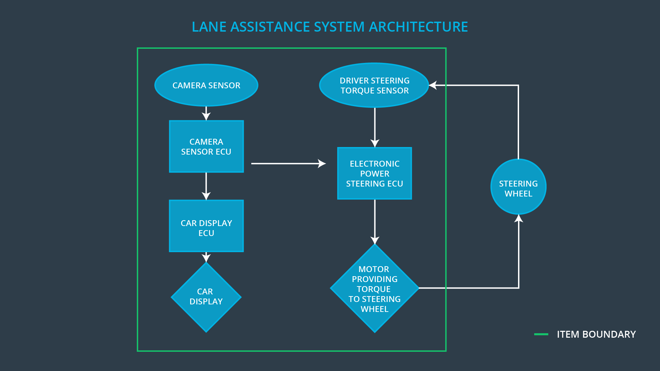

Description of architecture elements
[Instructions: Provide a description for each of the item elements; what is each element's purpose in the lane assistance item? ]

Element | Description
Camera Sensor | Provides the camera images for analyses by the camera sensor.
Camera Sensor ECU | Processes the images from the camera sensor in order to determine the position of the vehicle w.r.t. the lane lines. Using this information actuation requests might be sent to the power steering system and the car display when the vehicle leaves the lane unintendedly.
Car Display | Indicate information and warnings/errors to the driver.
Car Display ECU | Processes and stores the requests by the system to show indications and warnings/errors to the driver.
Driver Steering Torque Sensor | Detects the torque already exerted on the steering wheel by the driver.
Electronic Power Steering (EPS) ECU | Takes torque requests from the camera ECU and matches this torque on the steering wheel by requesting the motor to apply the difference between the required torque and the torque already exerted by the driver.
Motor | Applies the torque requested from the EPS ECU to the steering wheel.

Functional Safety Concept
The functional safety concept consists of:
- Functional safety analysis
- Functional safety requirements
- Functional safety architecture
- Warning and degradation concept

Functional Safety Analysis

[Instructions: Fill in the functional safety analysis table below.]

Malfunction ID | Main Function of the Item Related to Safety Goal Violations | Guidewords (NO, WRONG, EARLY, LATE, MORE, LESS) | Resulting Malfunction
Malfunction_01 | Lane Departure Warning (LDW) function shall apply an oscillating steering torque to provide the driver a haptic feedback | MORE | The oscilating torque applied by the lane departure warning system has a torque amplitude above the defined limit.
Malfunction_02 | Lane Departure Warning (LDW) function shall apply an oscillating steering torque to provide the driver a haptic feedback | MORE | The oscilating torque applied by the lane departure warning system has a torque frequency above the defined limit.
Malfunction_03 | Lane Keeping Assistance (LKA) function shall apply the steering torque when active in order to stay in ego lane | NO | The lane keeping assistance function is not limited in time duration which leads to misuse as an autonomous driving function.
Malfunction_04 | Lane Keeping Assistance (LKA) function shall apply the steering torque when active in order to stay in ego lane (only adding the difference between the required torque and the torque already applied by the driver) | MORE | The torque exerted by the driver is not detected and therefore the system overcompensates

Functional Safety Requirements
[Instructions: Fill in the functional safety requirements for the lane departure warning ]

Lane Departure Warning (LDW) Requirements:

ID | Functional Safety Requirement | ASIL | Fault Tolerant Time Interval | Safe State
Functional  Safety  Requirement  01-01 | The lane keeping item shall ensure that the lane departure oscillating torque amplitude is below mas_torque_amplitude. | C | 50 [ms] | Lane assistant system turned off.
Functional  Safety  Requirement  01-02 | The lane keeping item shall ensure that the lane departure oscillating torque frequency is below max_torque_frequency. | C | 50 [ms] | Lane assistant system turned off.

Lane Departure Warning (LDW) Verification and Validation Acceptance Criteria:

ID | Validation Acceptance  Criteria and Method | Verification Acceptance  Criteria and Method
Functional  Safety  Requirement  01-01 | Validate the setting of the maximum torque by gathering the experiences of users with the system to see if the torque amplitude is an an acceptable level. | Verify that the output torque amplitude of the system never exceeds the specified max_torque_amplitude.
Functional  Safety  Requirement  01-02 | Validate the setting of the maximum torque by gathering the experiences of users with the system to see if the torque frequency is an an acceptable level. | Verify that the output torque frequency of the system never exceeds the specified max_torque_frequency.

[Instructions: Fill in the functional safety requirements for the lane keeping assistance]

Lane Keeping Assistance (LKA) Requirements:

ID | Functional Safety Requirement | ASIL | Fault Tolerant Time Interval | Safe State
Functional  Safety  Requirement  02-01 | The electronic power steering ECU shall ensure that the lane keeping assistance torque is applied for only Max_Duration. | B | 500 [ms] | Lane assistant system turned off.
Functional  Safety  Requirement  02-02 | The system shall only be active when the torque exerted by the driver is propertly detected by the power steering system torque sensor. | D | 50 [ms] | Lane assistant system turned off.

Lane Keeping Assistance (LKA) Verification and Validation Acceptance Criteria:

ID | Validation Acceptance  Criteria and Method | Verification Acceptance  Criteria and Method
Functional  Safety  Requirement  02-01 | Validate the setting of the duration by gathering the experiences of users with the system to see if the system is then not misused as an autonomous system. | Verify if the the system is turned off after every operational time of the specified max_duration.
Functional  Safety  Requirement  02-02 | Validate that the system remains active when the normal amount of torque is exerted by the driver, and it turns off when this is not the case. | Verify if the system is indeed automatically turned off when driver torque signals are no longer correctly received.

Refinement of the System Architecture
[Instructions: Include the refined system architecture. Hint: The refined system architecture should include the system architecture from the end of the functional safety lesson including all of the ASIL labels.]

The refined system architecture, not include the architecture needed satisfy the self-defined additional requirement of making sure that driver input torque is sensed, is shown in the image below.
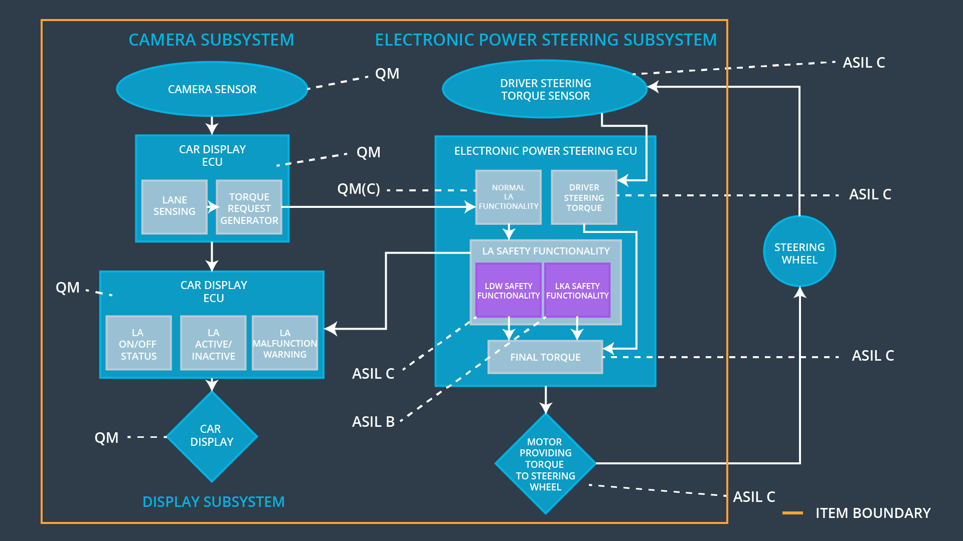

Allocation of Functional Safety Requirements to Architecture Elements
[Instructions: Mark which element or elements are responsible for meeting the functional safety requirement. Hint: Only one ECU is responsible for meeting all of the requirements.]

ID | Functional Safety Requirement | Electronic Power Steering ECU | Camera ECU | Car Display ECU
Functional  Safety  Requirement  01-01 | The lane keeping item shall ensure that the lane departure oscillating torque amplitude is below mas_torque_amplitude. | x
Functional  Safety  Requirement  01-02 | The lane keeping item shall ensure that the lane departure oscillating torque frequency is below max_torque_frequency. | x
Functional  Safety  Requirement  02-01 | The electronic power steering ECU shall ensure that the lane keeping assistance torque is applied for only Max_Duration. | x
Functional  Safety  Requirement  02-02 | Validate that the system remains active when the normal amount of torque is exerted by the driver, and it turns off when this is not the case. | x

Warning and Degradation Concept
[Instructions: Fill in the warning and degradation concept.]

ID | Degradation Mode | Trigger for Degradation Mode | Safe State invoked? | Driver Warning
WDC-01 | Lane assistant system turned off. | Malfunction_01, Malfunction_02, Malfunction_03, Malfunction_04 | Yes | A lane assistant system malfunction light on the dashboard

