Mubanga Nsofu, July 7th 2024
mnsofu@learner.nexford.org
Abstract
A brief description of how to use the python notebook to generate payment slip file for Highridge Construction Company
Readme file for Python Payslip Script Generator

Contents
1.0 Overview 2
Key Features of the Script Include: 2
2.0 Requirements 2
3.0 Installation and loading of relevant modules and libraries 3
4.0 Directory Setup 4
5.0 Specify your file name within the output directory 4
6.0 Initialize Faker and Define Attributes 5
7.0 Generate Synthetic Data and create data frame 5
8.0 Save to CSV 6
9.0 Usage 7
10.0 Troubleshooting 7
11.0 Contact 7

1.0 Overview
The assignment question for module one is solved using Python code. The approach relies on generating synthetic data for employee payslips. The generated data includes employee ID, name, gender, age, address, salary, overtime hours, leave days, and employee level. If required, the data is saved in a CSV file for further analysis or use by Highridge Construction Company. The code was written using Positron, a new IDE built on VS Code from Posit PBC.
The solution utilises the powerful Faker library to enable the Python script to create diverse employee records with attributes such as name, gender, address, age, salary, overtime hours, leave days, and employee level.

Key Features of the Script Include:
- Gender-specific Name Generation: Ensures that names correspond appropriately to the specified gender.
- Salary-based Employee Level Assignment: Dynamically assigns employee levels based on salary ranges and gender.
- Error Handling: Robust error handling to ensure smooth execution and data integrity.
- CSV Export: Exports the generated dataset to a CSV file for further use in data analysis or testing scenarios.

2.0 Requirements

To run this notebook, users(you) need to have the following libraries installed:
- faker: For generating fake data.
- pandas: For creating and manipulating data frames.
- random: For generating random values.
- os: For file and directory handling.

Positron IDE details are shown below:
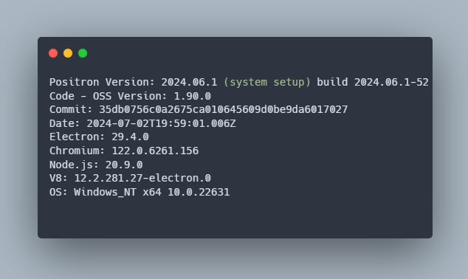
Figure 1 Showing Positron IDE version used

3.0 Installation and loading of relevant modules and libraries

To install the required libraries and modules, use the following commands:

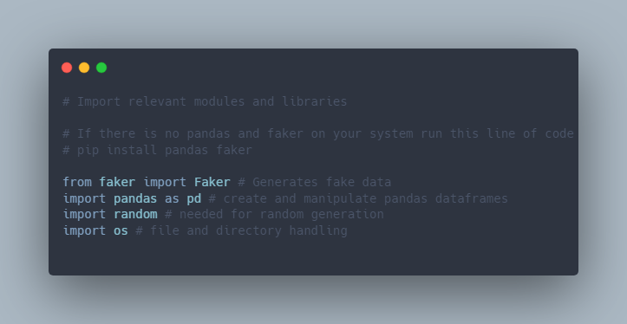
Figure 2 Code snippet showing how to load libraries and modules in Python.

4.0 Directory Setup
Specify the directory where you have write permissions. Replace "your/favored/location/" with your preferred directory path. See how I set up my location below.
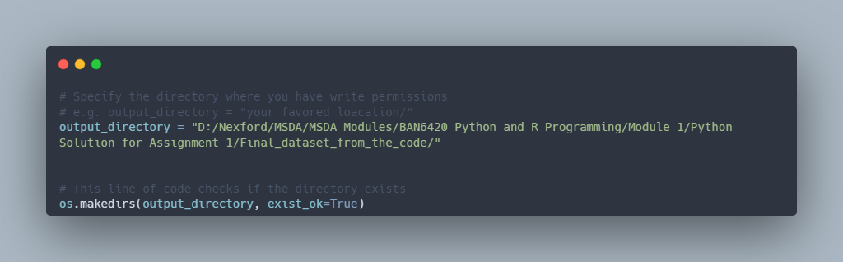
Figure 3 Code snippet showing directory setup

5.0 Specify your file name within the output directory
The code snippet below shows how to specify your file name within the output directory.
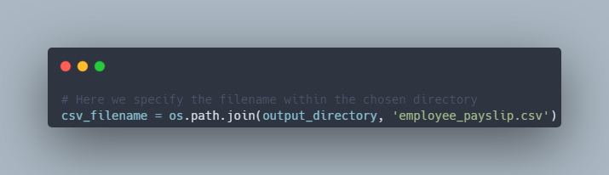
Figure 4 Code snippet showing how to specify the output file

6.0 Initialize Faker and Define Attributes
Create and initialise the faker generator and define possible values for attributes:
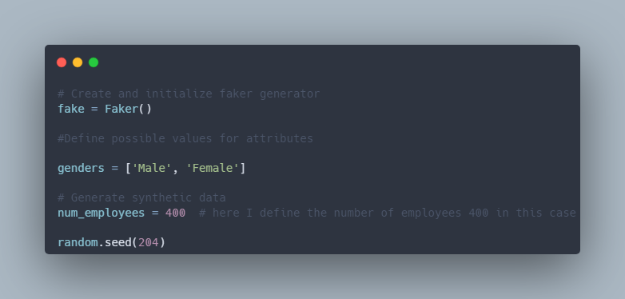
Figure 5 Code snippet initializing a class instance of faker

7.0 Generate Synthetic Data and create data frame

After initialising a class for faker, you can now generate data for the specified number of employees, as shown in the snippet below, and subsequently it in memory as a data frame:

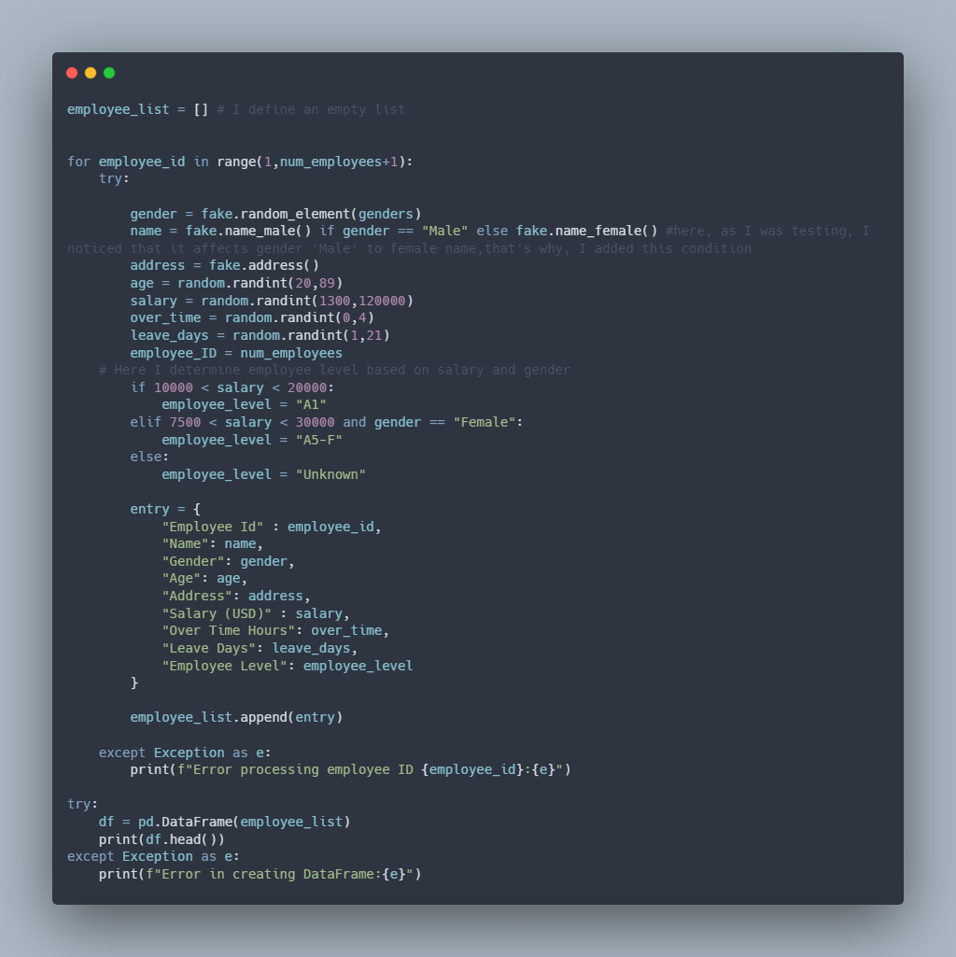
Figure 6 Code snippet showing how to generate the data.
It is worth noting that we have also applied code to handle exceptions, as indicated by the try block statements. In this regard, the code will notify the user or the employee if there is an error when processing or creating the data frame.

8.0 Save to CSV

Save the created data frame to a CSV file:
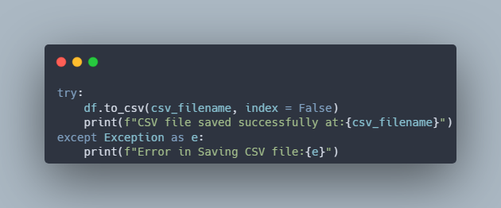
Figure 7 Code snippet showing how to save the data frame into a file.
It is worth noting that exception handling has been applied to ensure that the user is notified of an error during the process should it arise.

9.0 Usage
- Ensure the necessary libraries are installed.
- Specify the output directory path in the code.
- Run the Python script to generate the synthetic data.
- The generated data will be saved as a CSV file in the specified directory.

10.0 Troubleshooting

If you encounter any issues, please check the following:
- Ensure the specified output directory path exists or can be created.
- Verify that the necessary libraries (faker, pandas, random, os) are installed and correctly imported.
For any further issues, please get in touch with me using the details in the contact section.

11.0 Contact

For any questions or issues, please get in touch with me at mnsofu@learner.nexford.org

