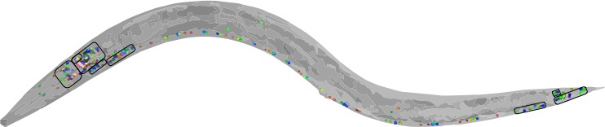

**About the NeuroPAL ID Software (Version 1)**

The NeuroPAL ID software was written to perform (semi-) automated identification of neurons in images of NeuroPAL strains. Please read and cite the following publication (<https://www.biorxiv.org/content/10.1101/676312v1>):

**NeuroPAL: A Neuronal Polychromatic Atlas of Landmarks for Whole-Brain Imaging in *C. elegans***

Eviatar Yemini, Albert Lin, Amin Nejatbakhsh, Erdem Varol, Ruoxi Sun, Gonzalo E. Mena, Aravinthan D.T. Samuel, Liam Paninski, Vivek Venkatachalam, Oliver Hobert

**Author Contributions**

The NeuroPAL ID software was developed jointly by the Liam Paniniski and Oliver Hobert labs at Columbia University and is distributed under the MIT license. Amin Nejatbakhsh lead the effort, designing and coding both the front-end GUI and many of the back-end statistical techniques. Ruoxi Sun (with Amin) designed and coded the neural detection algorithms. Erdem Varol (with Amin) designed and coded the neural identification algorithms. Gonzalo Mena (with Amin and Erdem) designed and coded the algorithms to compute neural identification uncertainty. Eviatar Yemini (with Amin) designed and coded the front-end GUI in addition to back-end saving of illustration and quantification. Molly Reilly and Ibnul Rafi (with Eviatar) annotated the training data for statistical modeling and performed user testing. The NeuroPAL ID software was inspired by prototype software from Vivek Venkatachalam while working in Aravinthan Samuel’s lab at Harvard University.

**Questions, Comments, Bug Reports**

Please contact Amin Nejatbakhsh or Eviatar Yemini.