Department of Computer Science and Engineering
Lab Report
Lab Report No | : | 01
Lab Report Name | : | Missionaries and Cannibals Problem using DFS
Course Title | : | Artificial Intelligence Sessional
Course Code | : | CSE 422
Name | : | MD Rakibul Hassan
ID | : | 0822220105101024
Level | : | 4 | Term | : | 2 | Section | : | A | Group | : | G1
Date of Submission | : | 19/04/2026 | Semester | : | Spring | Year | : | 2026

Marking Rubric
Problem Understanding & Report Clarity (3) | Implementation (4) | Results, Analysis & Presentation (3) | Total (10)

Key Learnings:
- Learned about the BFS and DFS algorithms with hands-on experience.
- Understand the working of the deque library and the append function.

Code Implementation:
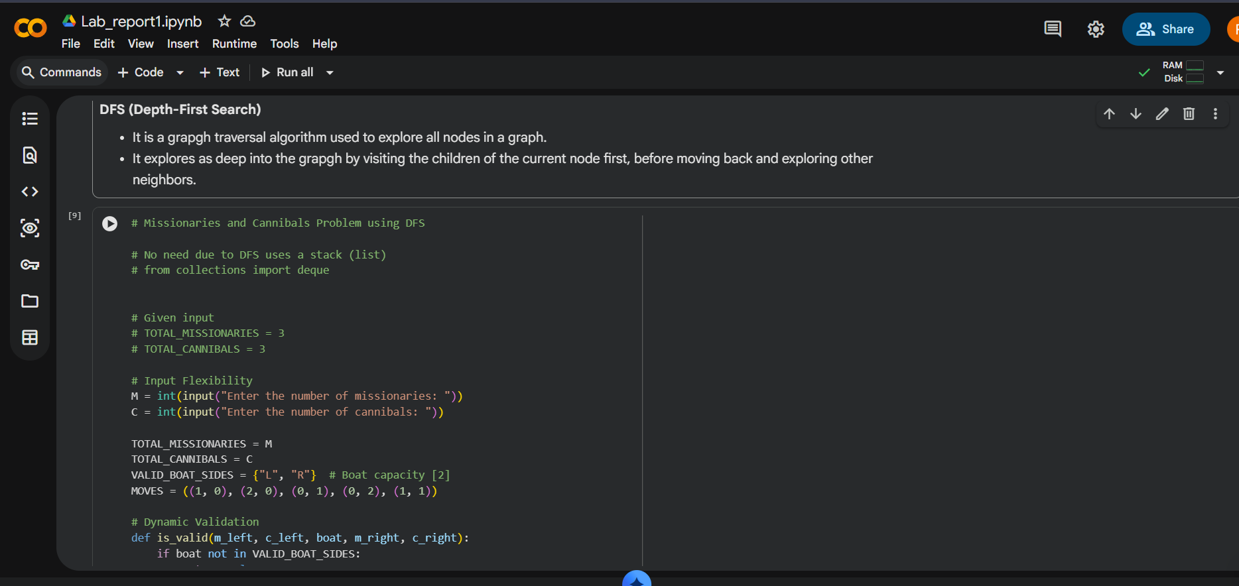
Figure No: 01
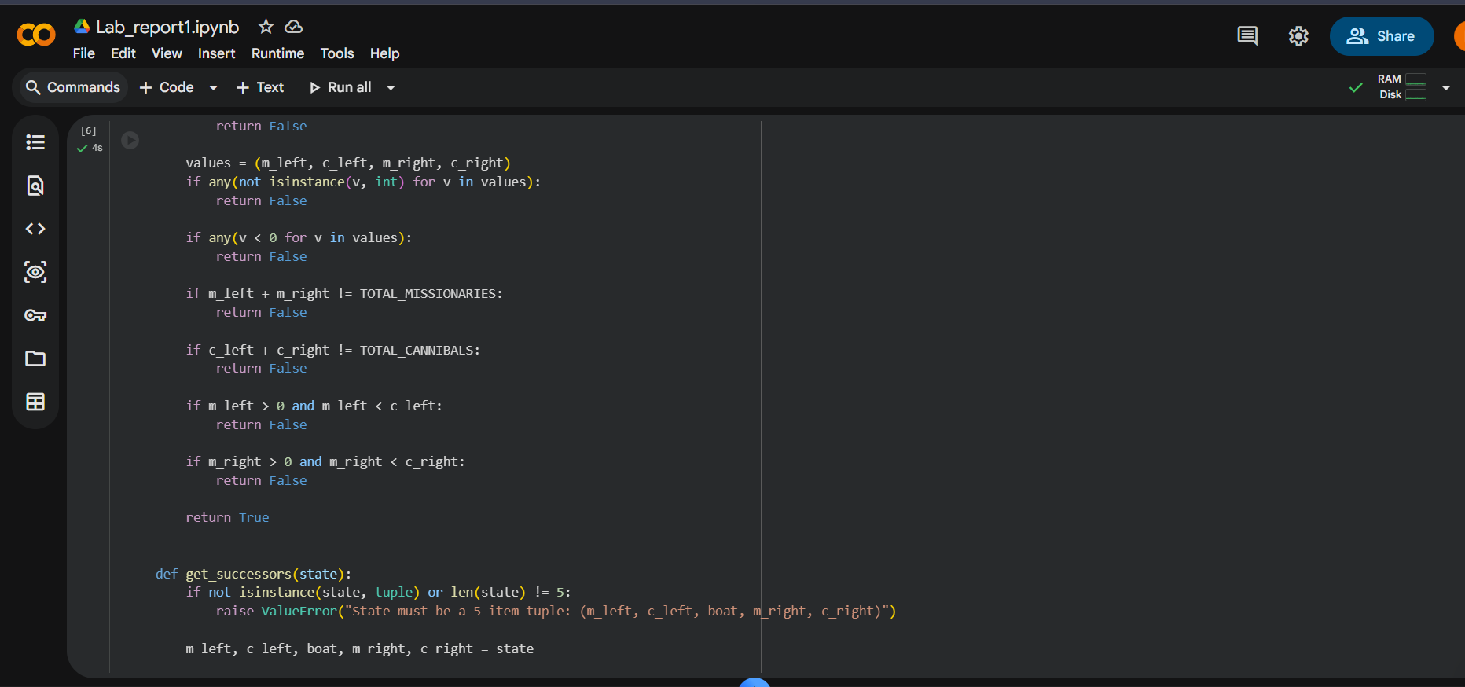
Figure No: 02
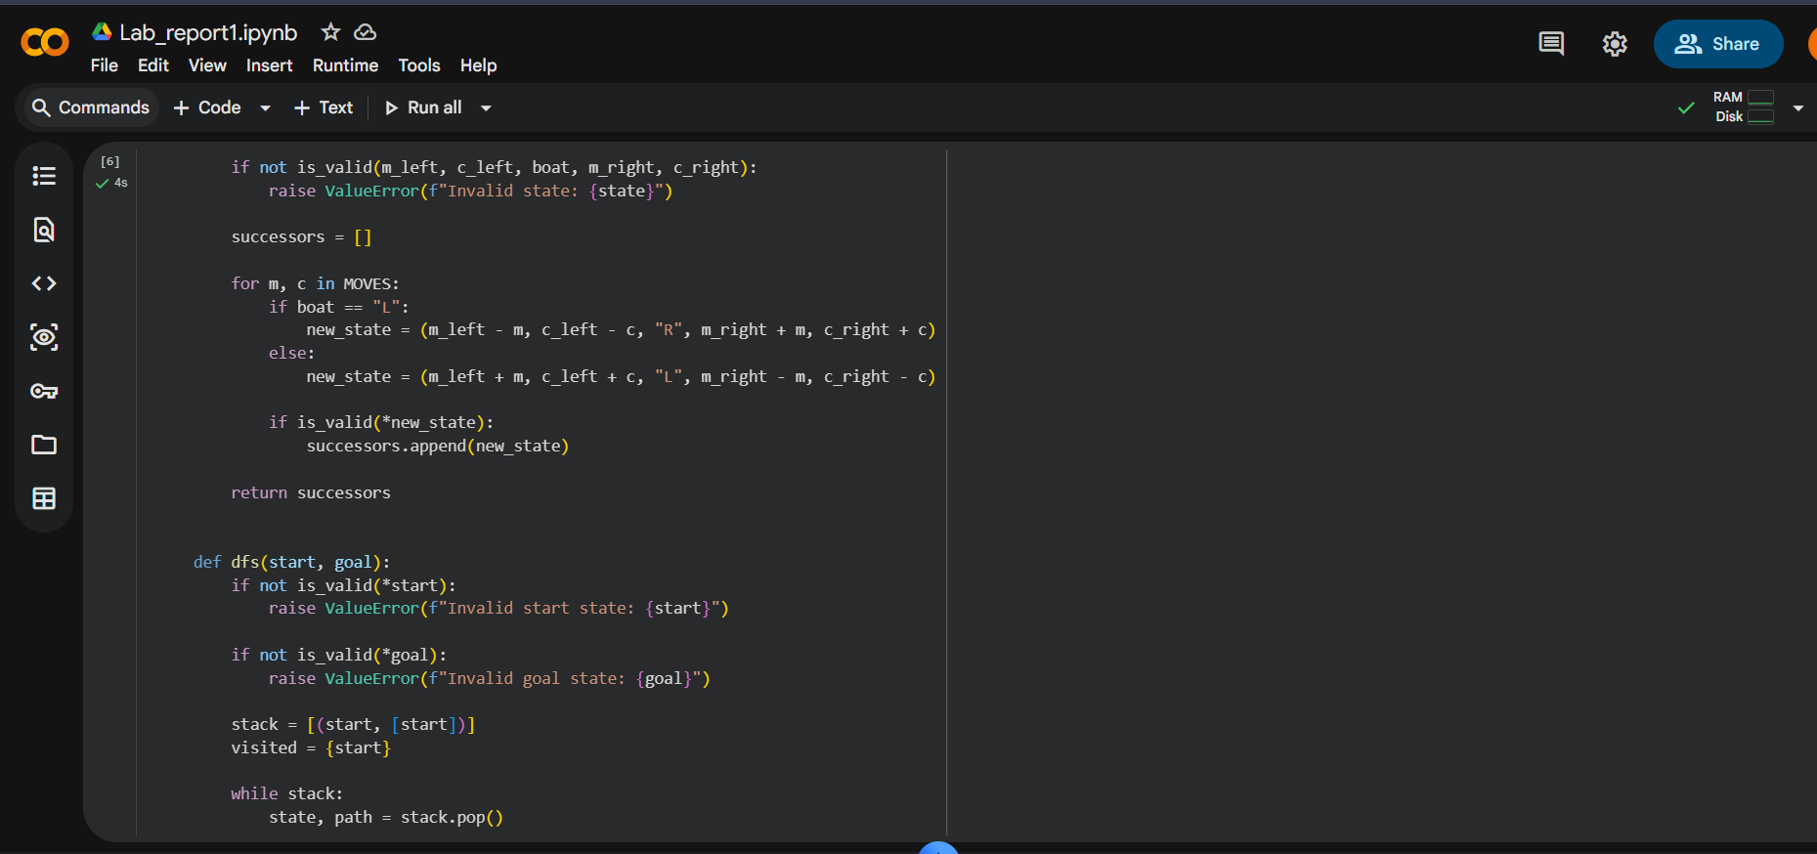
Figure No: 03
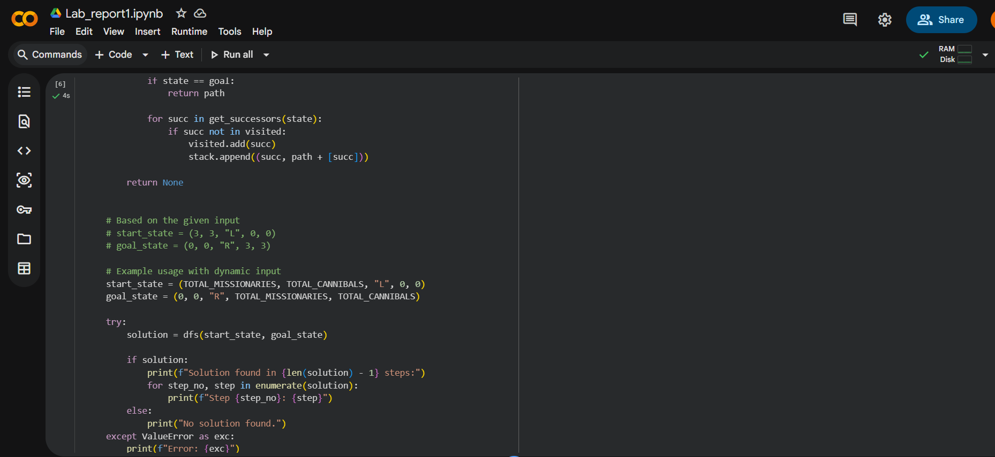
Figure No: 04
Sample Input, Output, and Result Analysis:
Input Sample:
Enter the number of missionaries: 4
Enter the number of cannibals: 3
Output Sample:
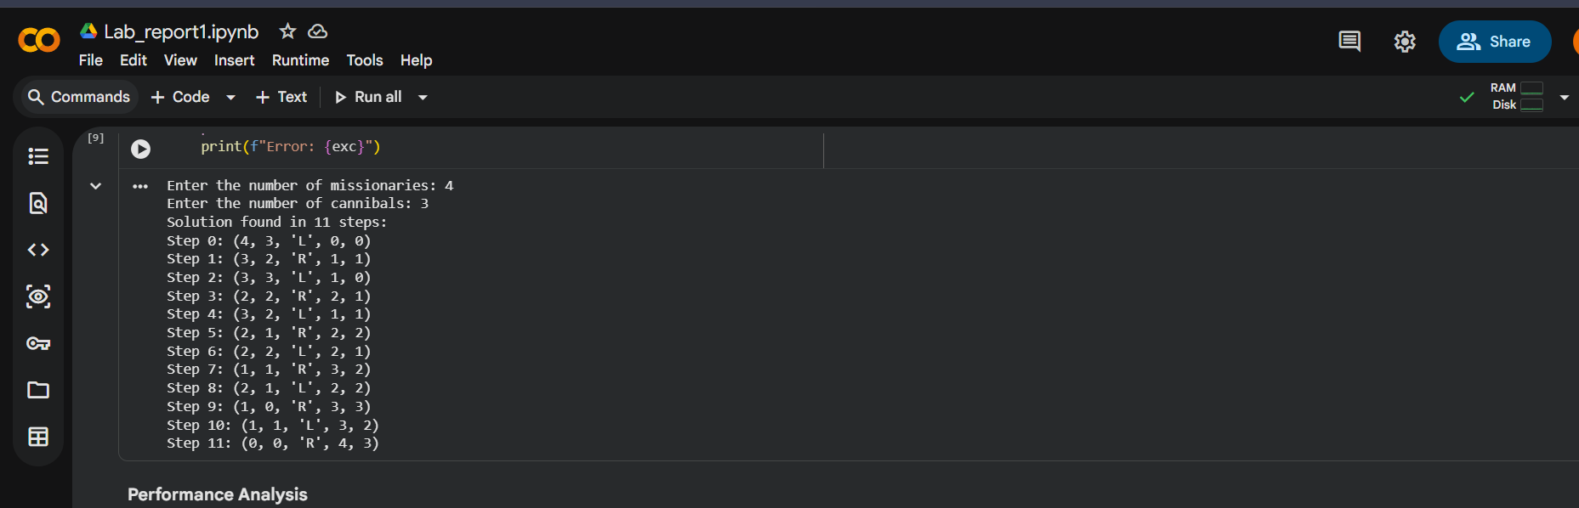
Figure No: 05
Result Analysis
- While DFS can solve the problem, BFS offers a more optimal solution for it.
- The total of 11 moves is needed for transferring all missionaries and cannibals to the right bank.
- DFS uses a stack or recursion.
- Follows all rules:
  - Boat position valid.
  - Non-negative values and totals remain constant.
  - Missionaries must outnumber or equal cannibals on both sides.

