Department of Computer Science and Engineering
Lab Report
Lab Report No | : | 05
Lab Report Name | : | Concise Comparison of Supervised Machine Learning Models for Stroke Prediction
Course Title | : | Artificial Intelligence Sessional
Course Code | : | CSE 422
Name | : | MD Rakibul Hassan
ID | : | 0822220105101024
Level | : | 4 | Term | : | 2 | Section | : | A | Group | : | G1
Date of Submission | : | 05/07/2026 | Semester | : | Spring | Year | : | 2026

Marking Rubric
Problem Understanding & Report Clarity (3) | Implementation (4) | Results, Analysis & Presentation (3) | Total (10)

Key Learnings:
- Learned to clean real-world healthcare datasets by handling missing values, converting categorical features into numerical values, and applying feature scaling, which is especially important for logistic regression and SVM.
- Understood how imbalanced classes affect model performance and learned that oversampling improves learning by giving the minority class adequate representation during training.
- Gained experience splitting data into training and testing sets, then implementing four supervised machine learning algorithms to build predictive models.
- Learned to evaluate models using accuracy, precision, recall, and F1-score and understood how a confusion matrix helps assess the correctness of predictions.
- Learned how to objectively compare multiple models using both numerical tables and visualizations to identify the best-performing approach.
Sample Output:
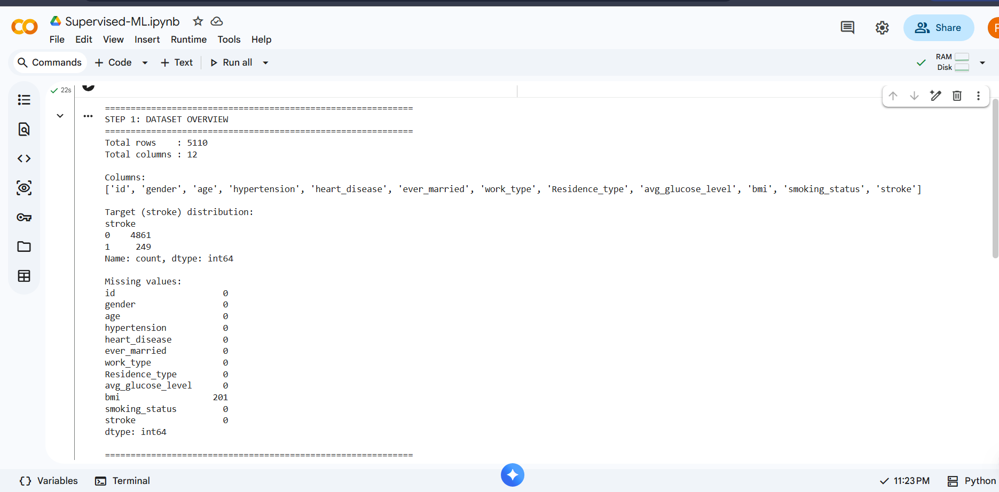
Figure No: 01
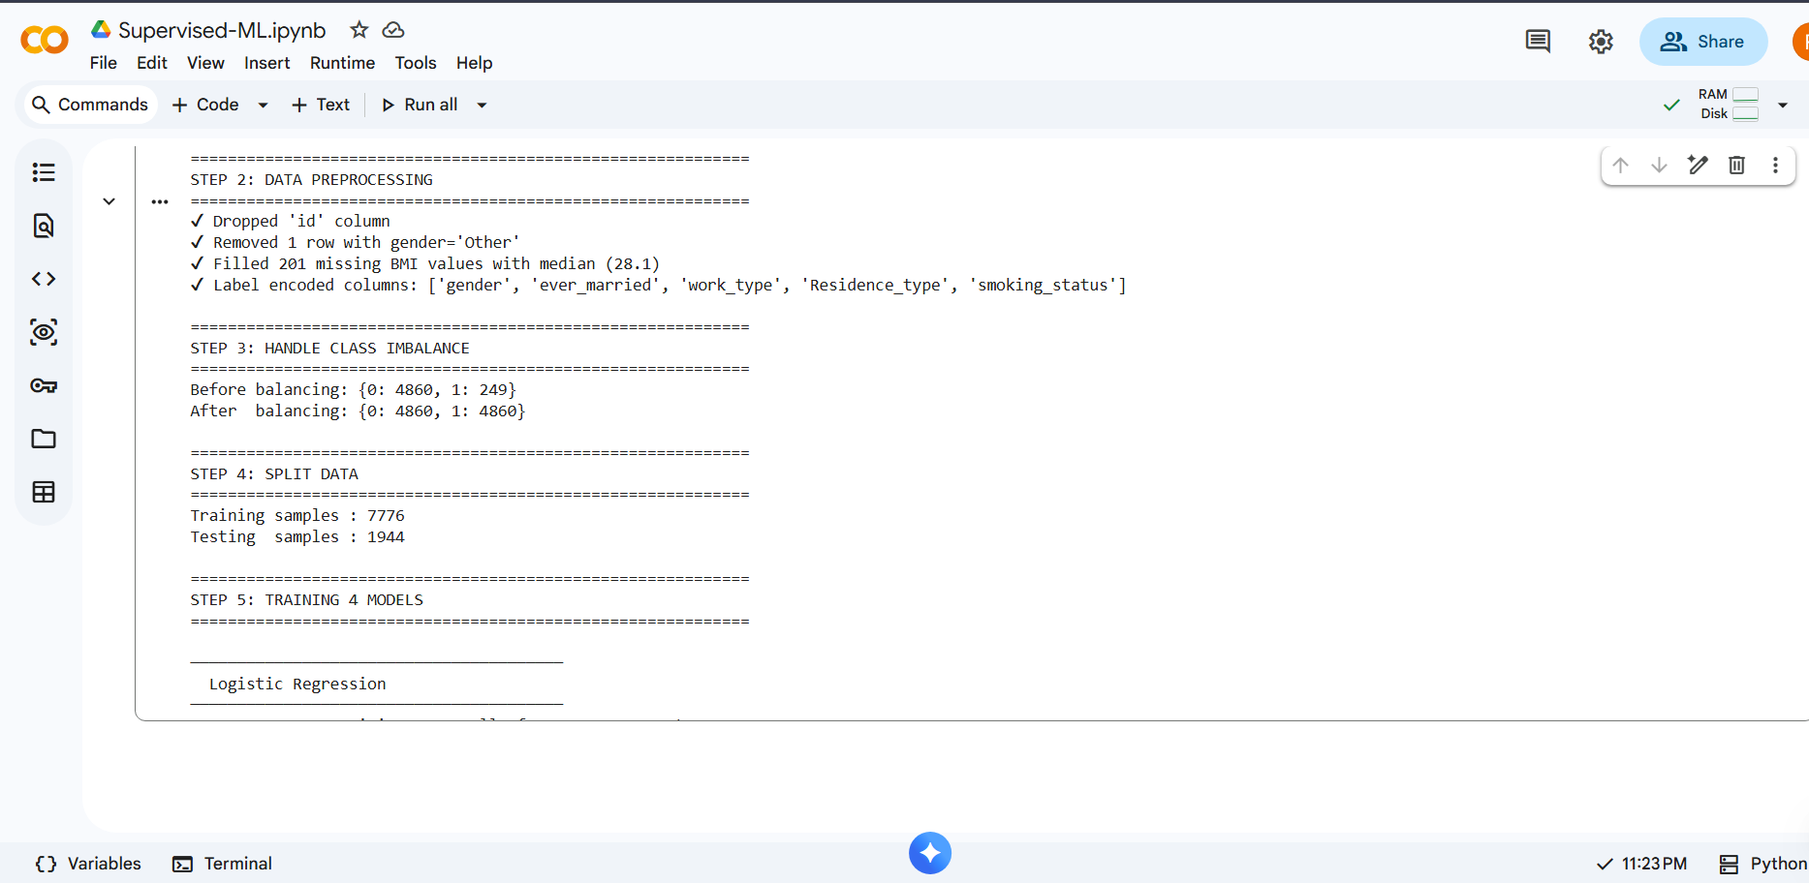
Figure No: 02

Figure No: 03
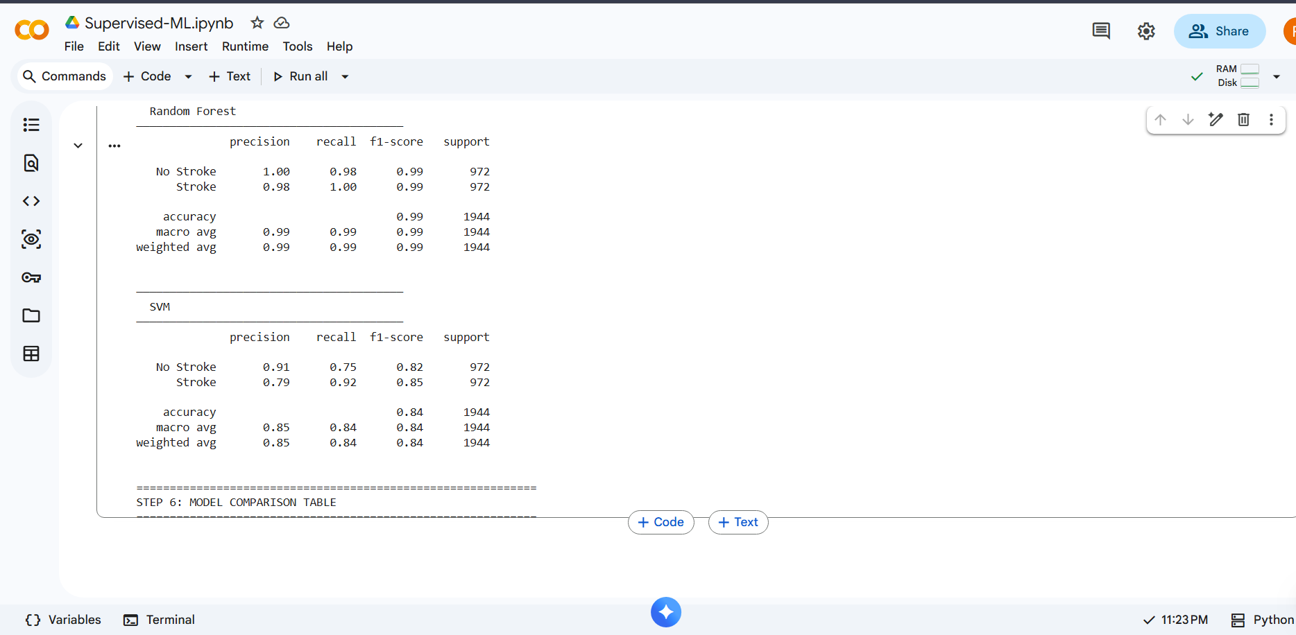
Figure No: 04
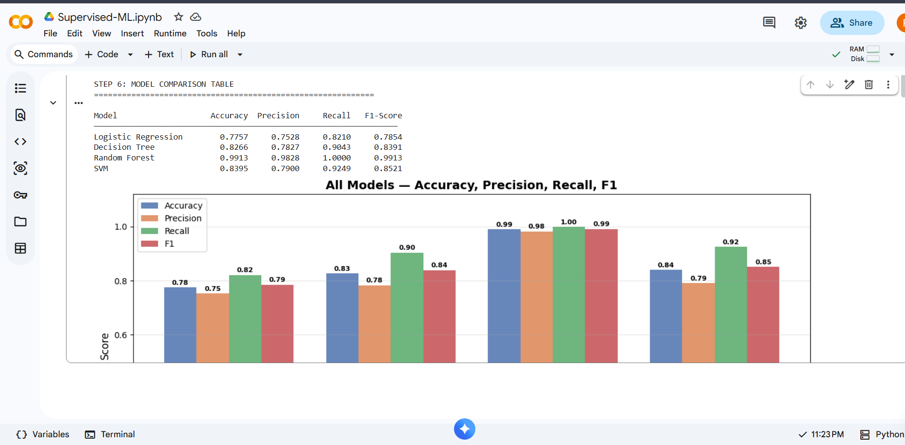
Figure No: 05
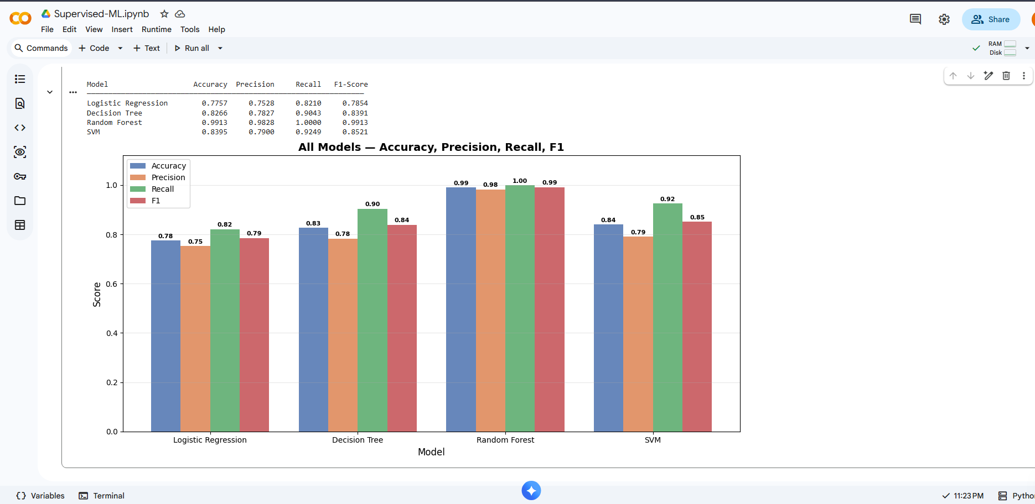
Figure No: 06
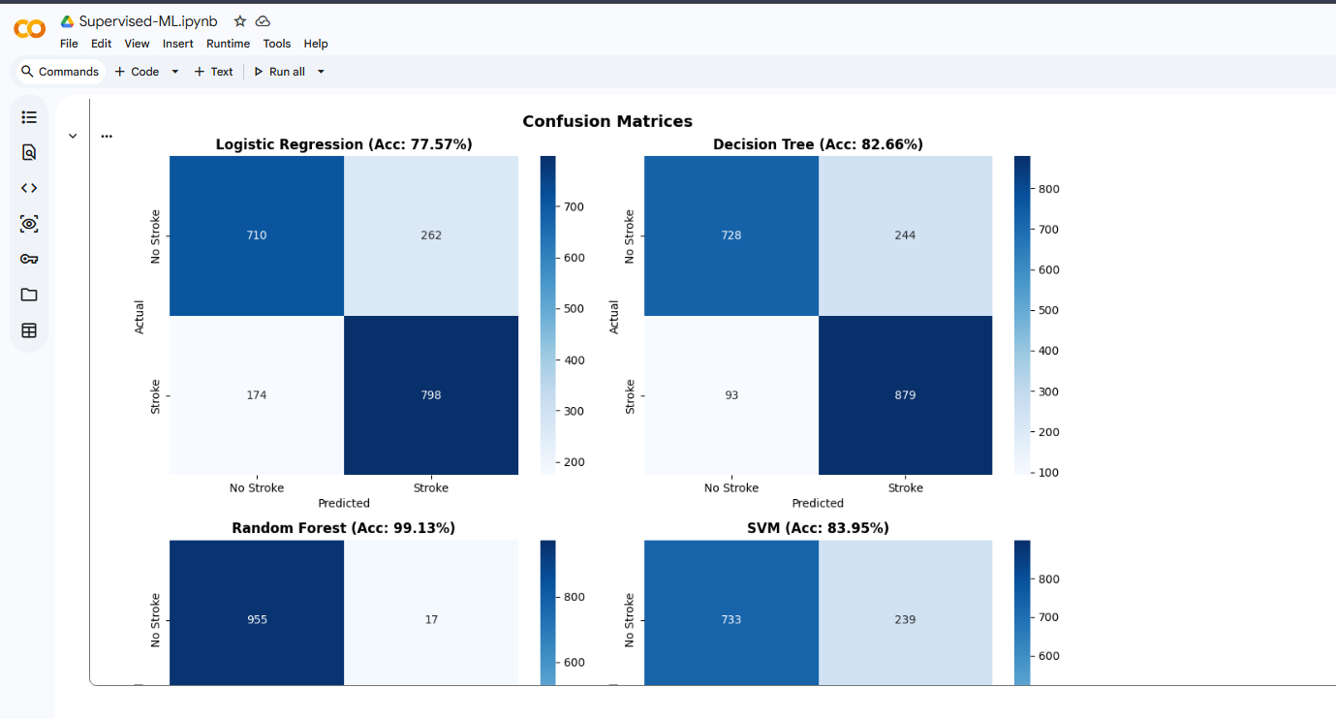
Figure No: 07
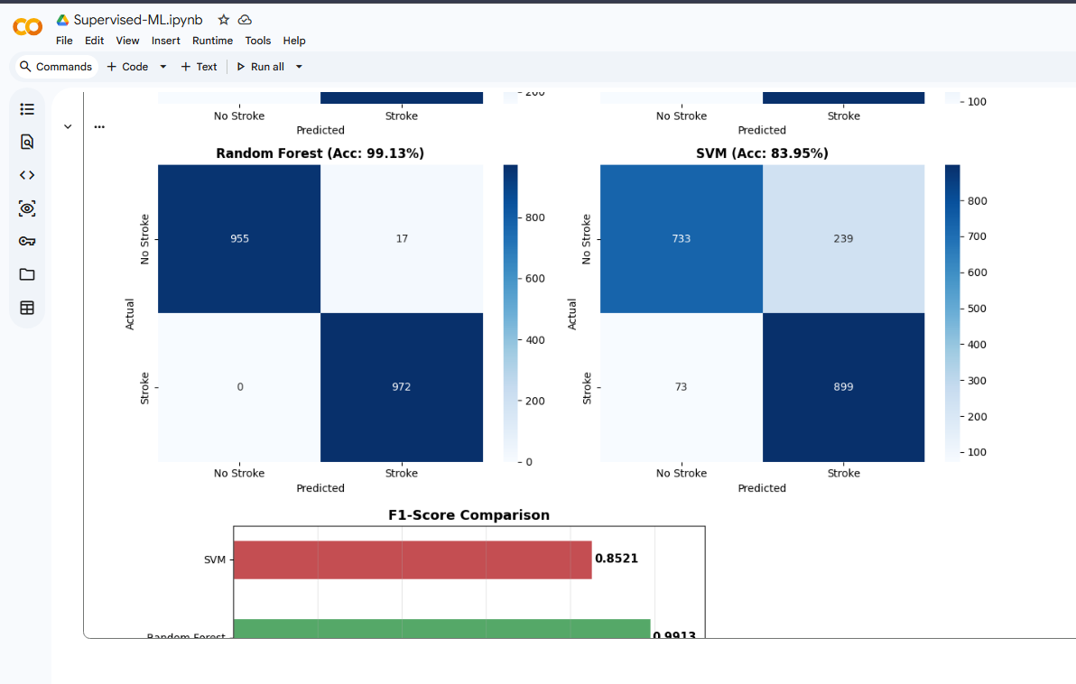
Figure No: 08
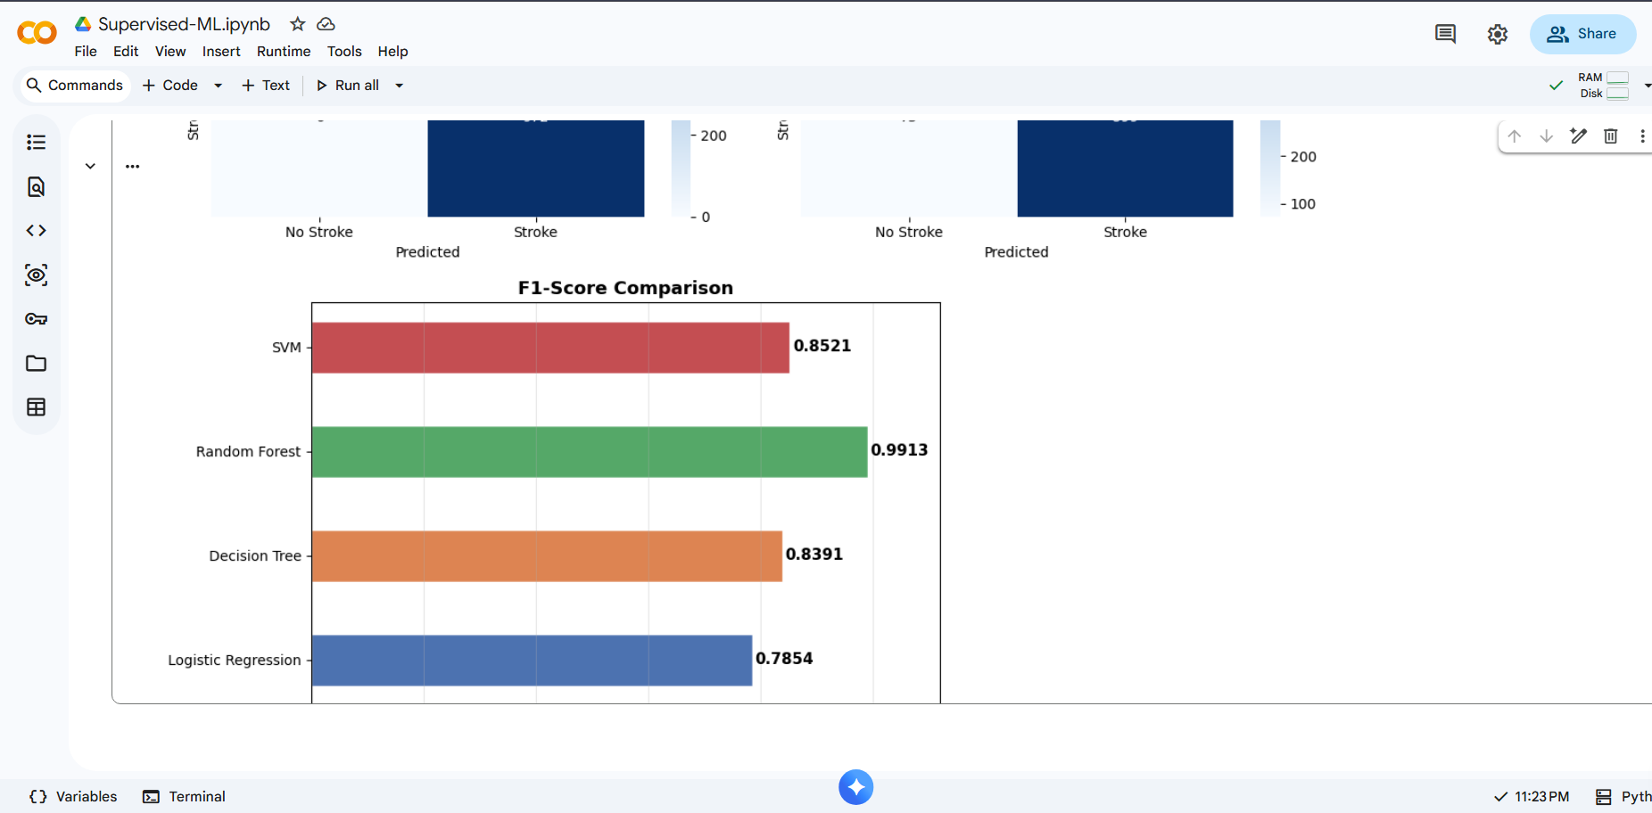
Figure No: 09
Conclusion:
This project successfully applied four supervised machine learning algorithms to predict stroke using a healthcare dataset. After preprocessing and balancing the data, all models were evaluated using standard performance metrics. Among them, Random Forest achieved the best results with the highest accuracy and F1-score. Overall, the project demonstrates that proper data preprocessing and model selection play a crucial role in building accurate machine learning prediction systems.

