Department of Computer Science and Engineering
Lab Report
Lab Report No | : | 7
Lab Report Name | : | Unsupervised learning algorithms (K-Means, Hierarchical Clustering, and DBSCAN) using customer segmentation dataset
Course Title | : | Artificial Intelligence Sessional
Course Code | : | CSE 422
Name | : | Md. Rakibul Hassan
ID | : | 0822220105101024
Level | : | 4 | Term | : | 2 | Section | : | A | Group | : | G1
Date of Submission | : | 19.07.2026 | Semester | : | Spring | Year | : | 2026

Marking Rubric
Problem Understanding & Report Clarity (3) | Implementation (4) | Results, Analysis & Presentation (3) | Total (10)

Key Learnings:
- I learned how to implement and compare K-Means, Hierarchical Clustering, and DBSCAN for customer segmentation.
- I learned how to use the Elbow Method to determine the optimal number of clusters for K-Means.
- I learned how to evaluate clustering performance using the Silhouette Score and Davies–Bouldin Index.
- I learned that K-Means provided the best clustering performance for the Mall Customer dataset.
Code Implementation:
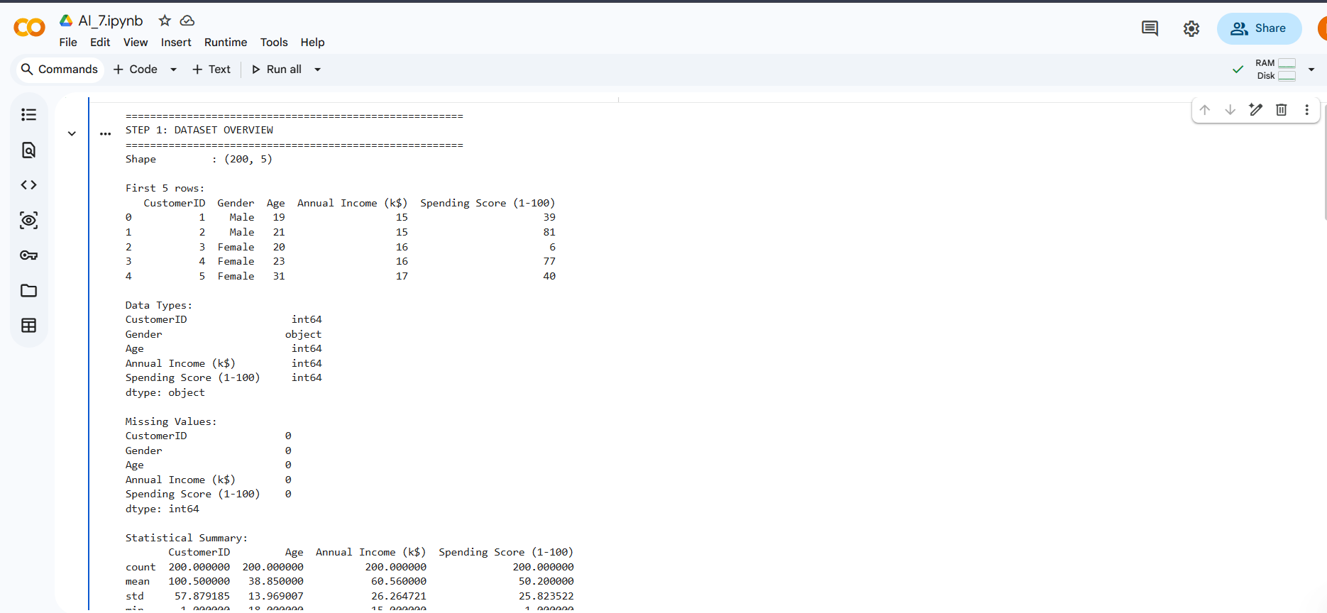
Figure No: 01
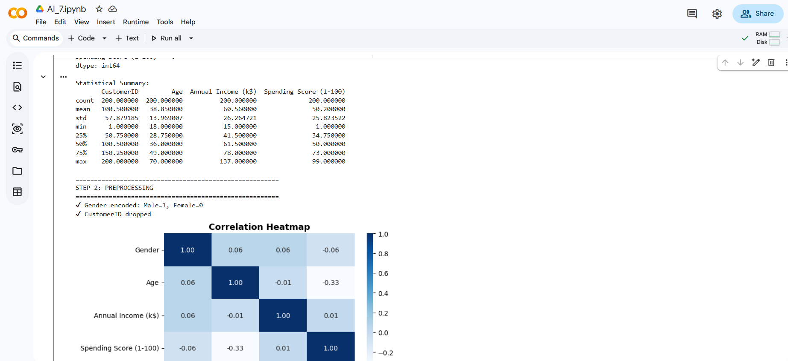
Figure No: 02
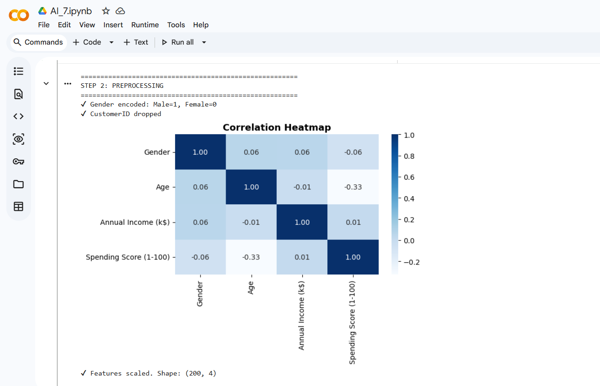
Figure No: 03
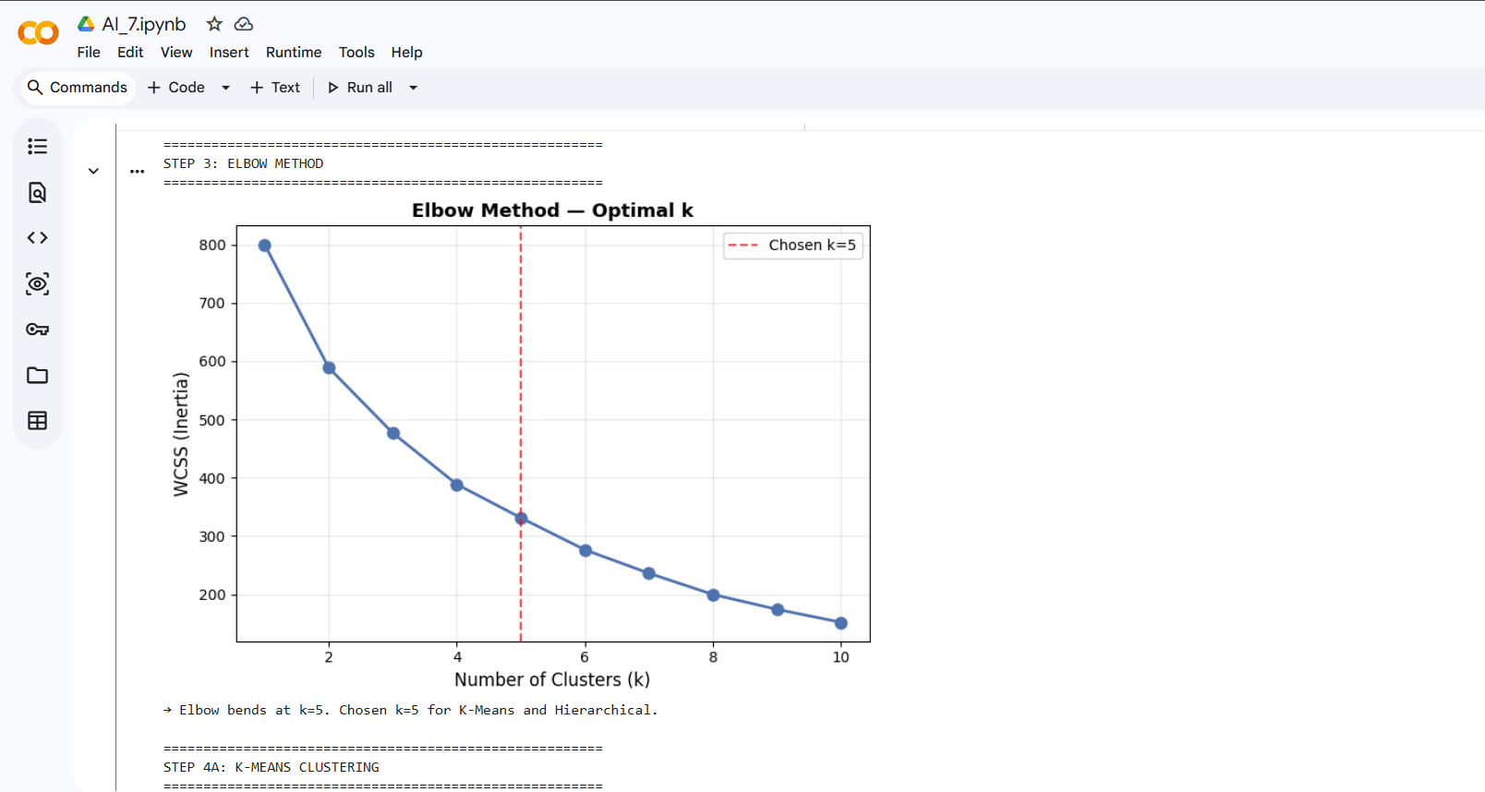
Figure No: 04
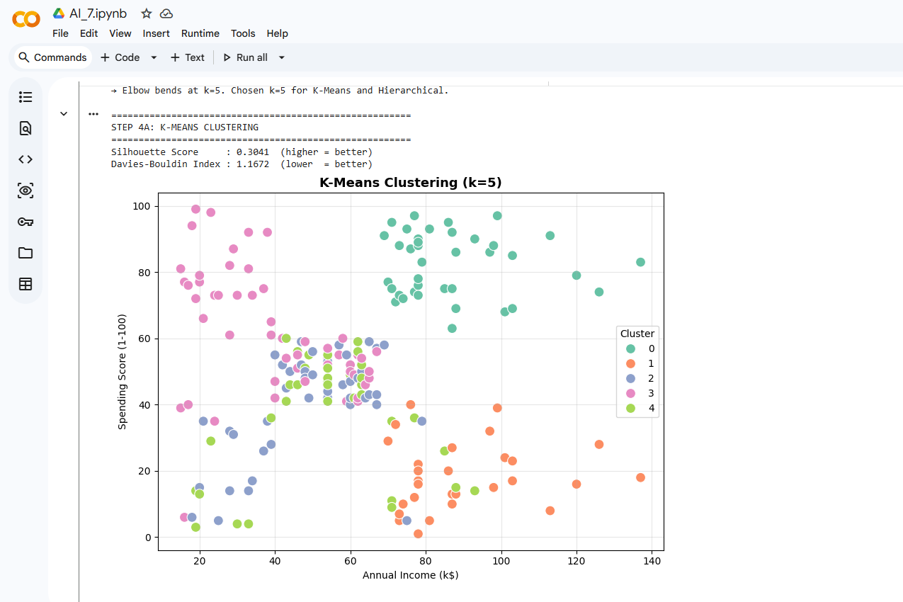
Figure No: 05
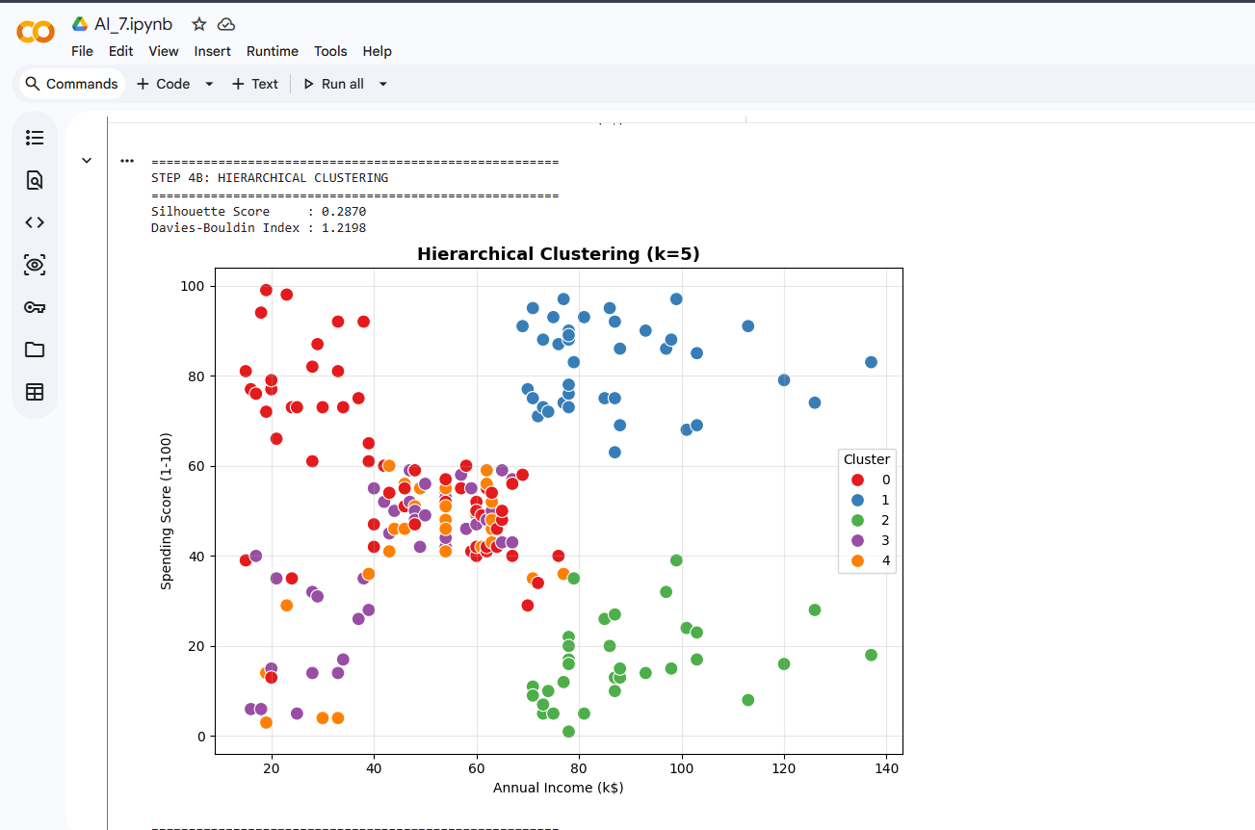
Figure No: 06
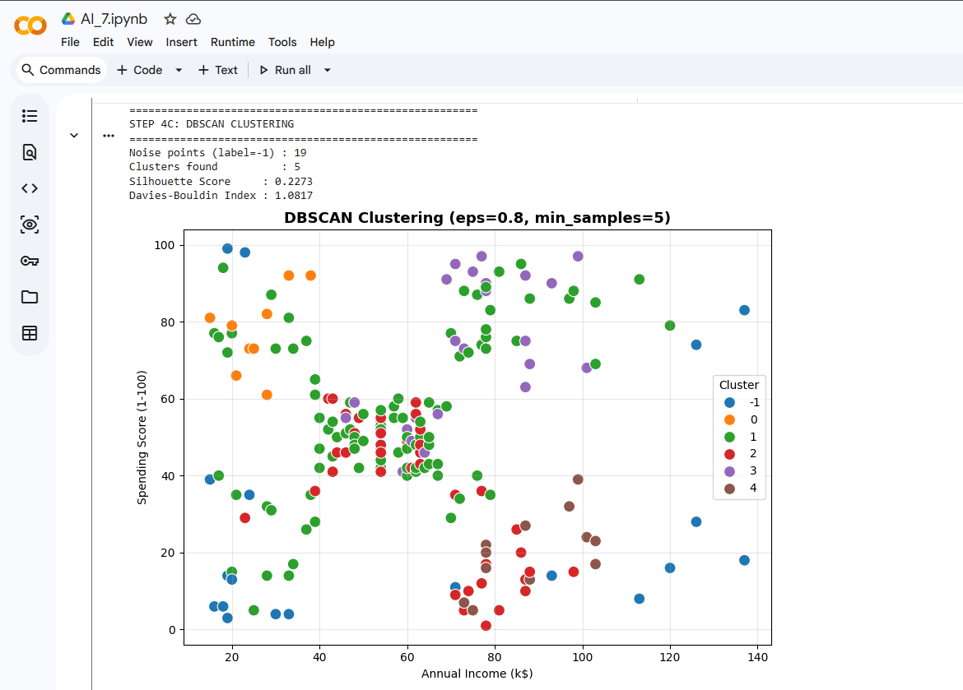
Figure No: 07
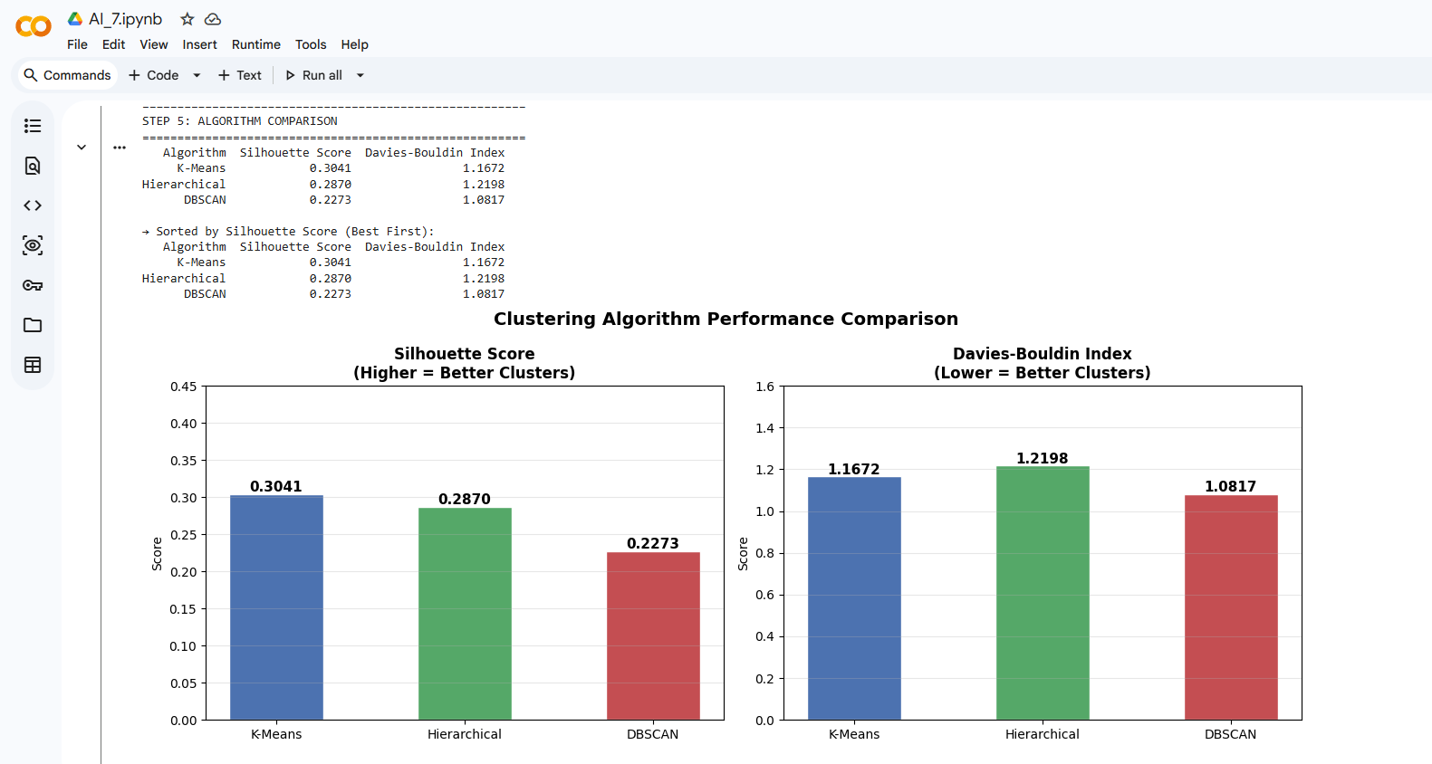
Figure No: 08
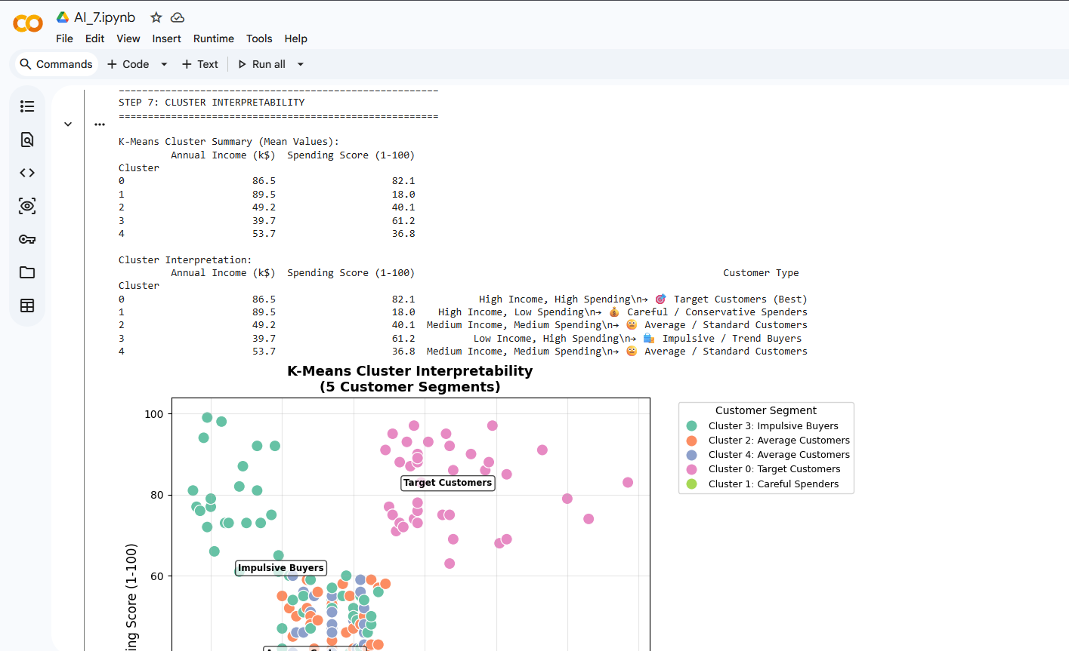
Figure No: 09
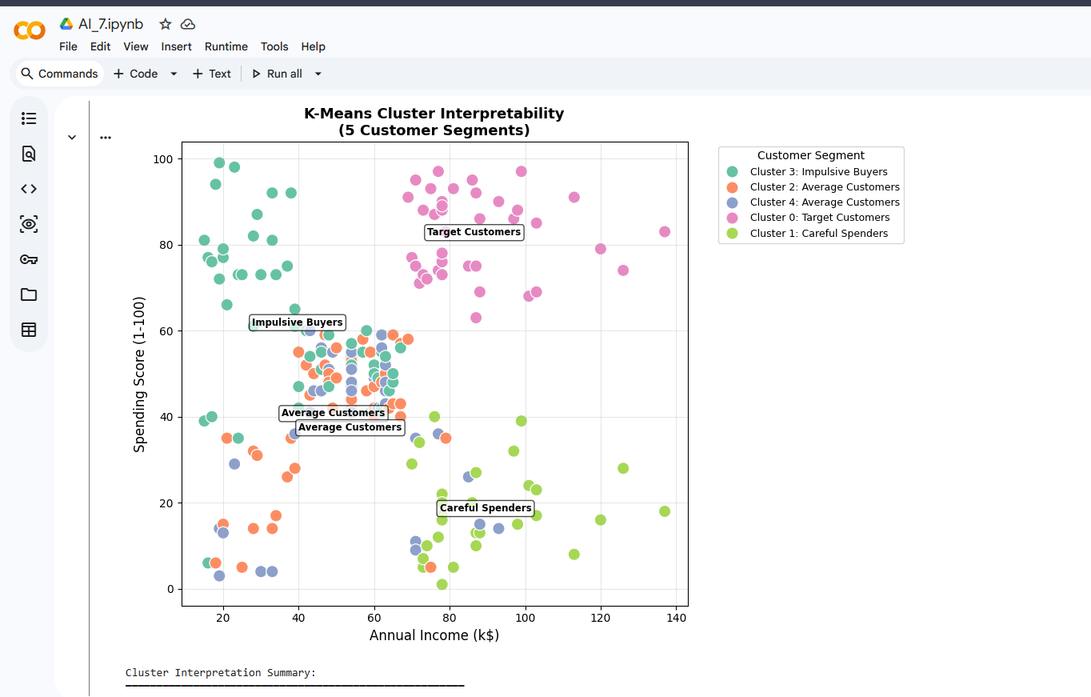
Figure No: 10

Cluster Interpretation Summary:

- Target Customers—High Income + High Spending
→ Best marketing priority. Offer premium deals.

- Careful Spenders—High Income + Low Spending
→ Potential high-value customers. Need incentives.

- Impulsive Buyers—Low Income + High Spending
→ Respond well to flash sales & trendy products.

- Budget Customers—Low Income + Low Spending
→ Price-sensitive. Attract with discounts.

- Average Customers—Medium Income + Medium Spending
→ General audience. Standard promotions work.

Result Analysis
- K-Means produced the BEST Silhouette Score (0.3041) and the second-lowest Davies-Bouldin Index (1.1672).
  - Clear, compact, well-separated clusters.
- Hierarchical clustering performed slightly lower than K-means on both metrics. Still reasonable but not optimal here.
- DBSCAN labeled 19 points as noise and scored the lowest silhouette score. This dataset has compact spherical clusters.
  - Not suited for density-based separation.
- Cluster interpretability confirmed 5 meaningful business segments: Target Customers, Careful Spenders, Impulsive Buyers, Budget Customers, and Average Customers.
- So that we can say, K-Means is the best algorithm for mall customer segmentation based on metrics, visual separation, and cluster interpretability.

