Department of Computer Science and Engineering
Lab Report
Lab Report No | : | 02
Lab Report Name | : | Solution of 8-Puzzle Problem using DFS, DLS and IDS
Course Title | : | Artificial Intelligence Sessional
Course Code | : | CSE 422
Name | : | MD Rakibul Hassan
ID | : | 0822220105101024
Level | : | 4 | Term | : | 2 | Section | : | A | Group | : | G1
Date of Submission | : | 10/05/2026 | Semester | : | Spring | Year | : | 2026

Marking Rubric
Problem Understanding & Report Clarity (3) | Implementation (4) | Results, Analysis & Presentation (3) | Total (10)

Key Learnings:
- Learned about the DFS, DLS and IDS algorithms with hands-on experience.
- Understand the working of the usage limit and the repeatedly applying DLS by increasing the depth limit step by step until the goal is not found.
Code Implementation:
Using DFS
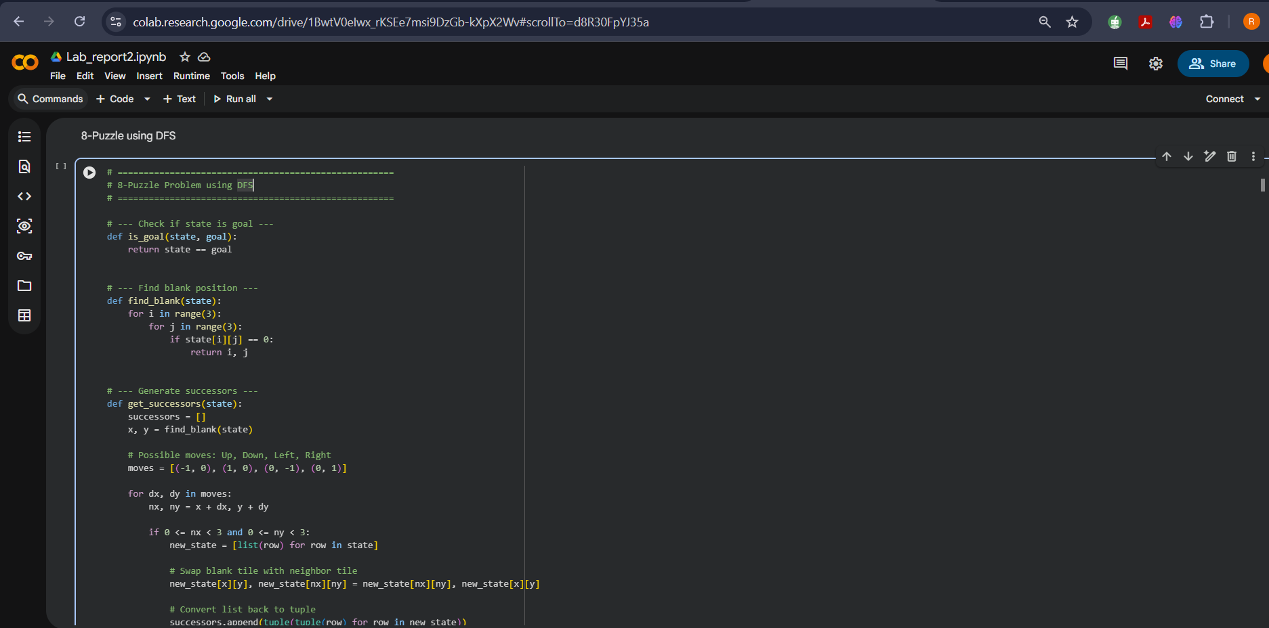
Figure No: 01
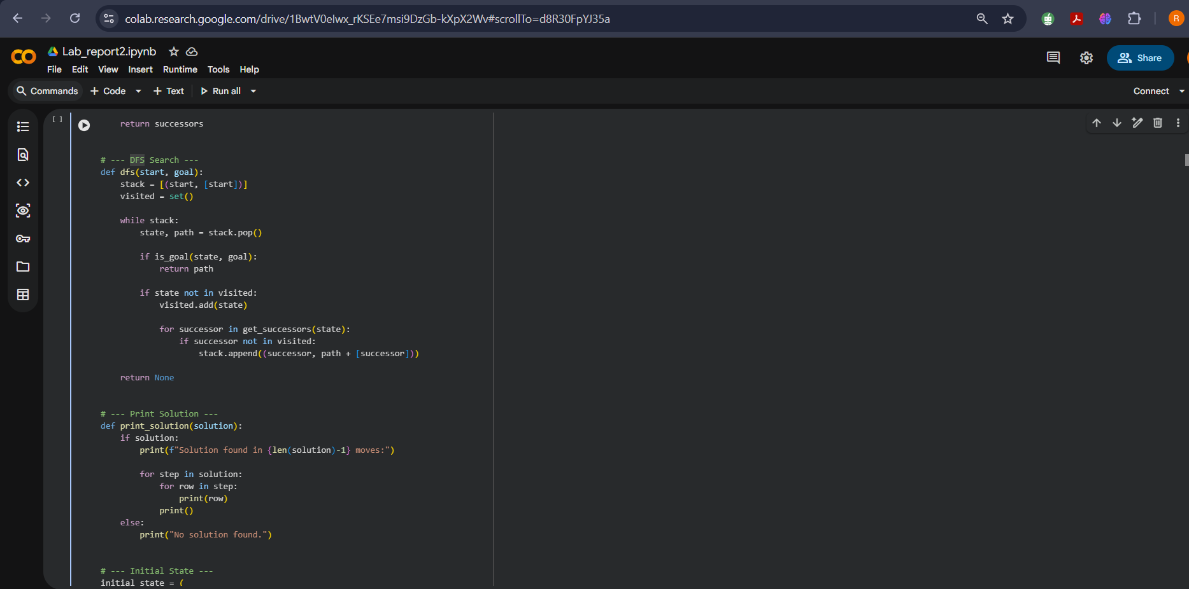
Figure No: 02
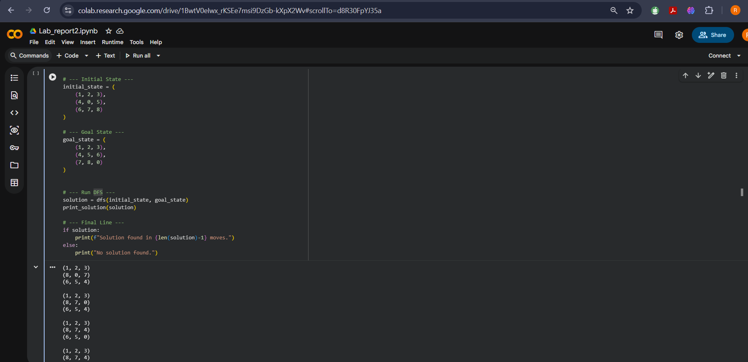
Figure No: 03
Sample Input, Output, and Result Analysis:
Input Sample:
initial_state = ((1, 2, 3), (4, 0, 5), (6, 7, 8))
goal_state = ((1, 2, 3), (4, 5, 6), (7, 8, 0))
Output Sample:
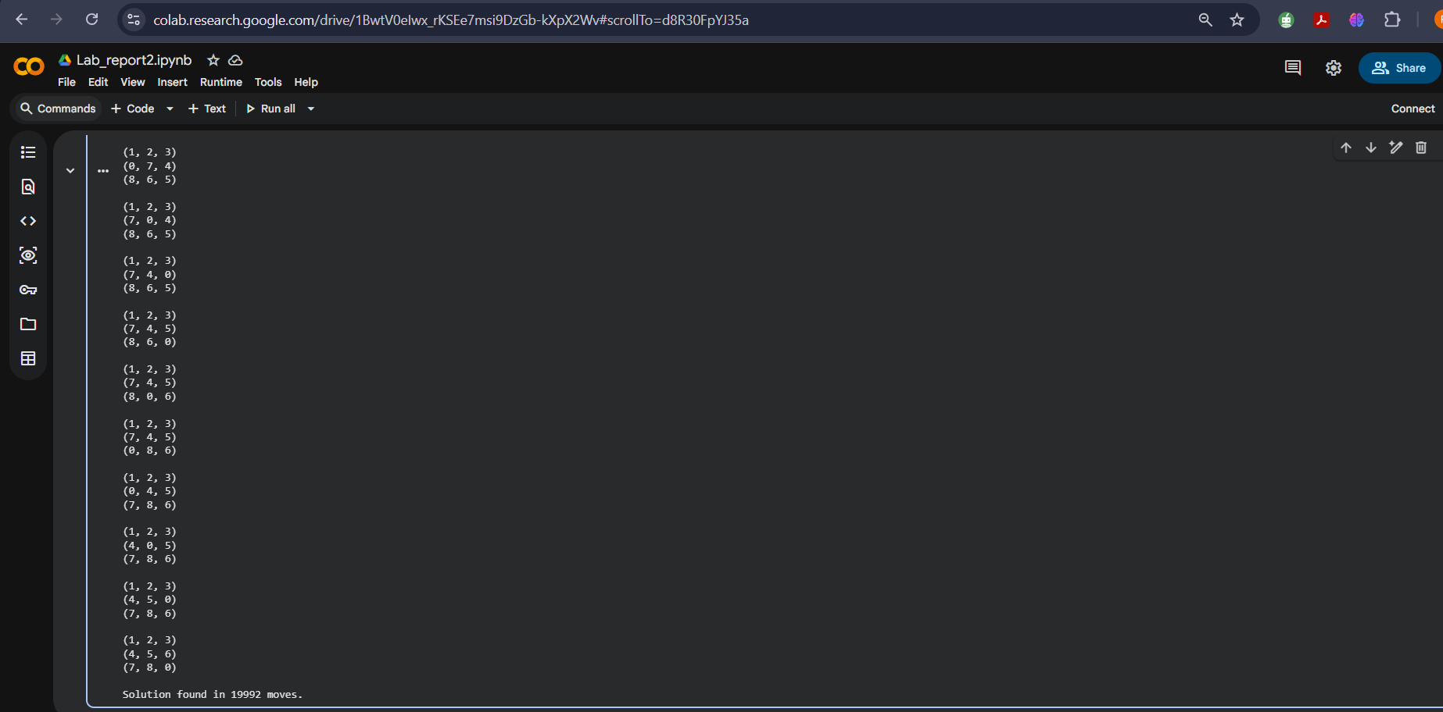
Figure No: 04
Using DLS
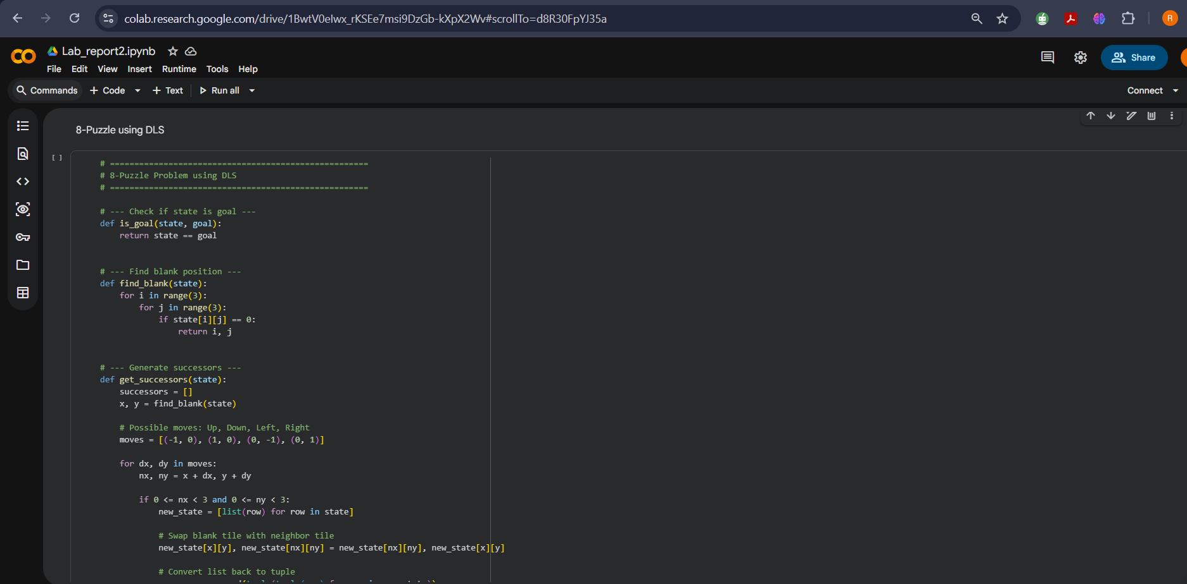
Figure No: 05
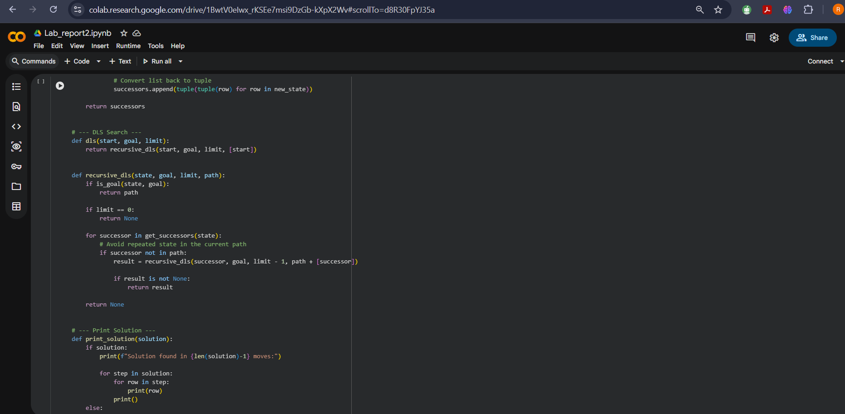
Figure No: 06
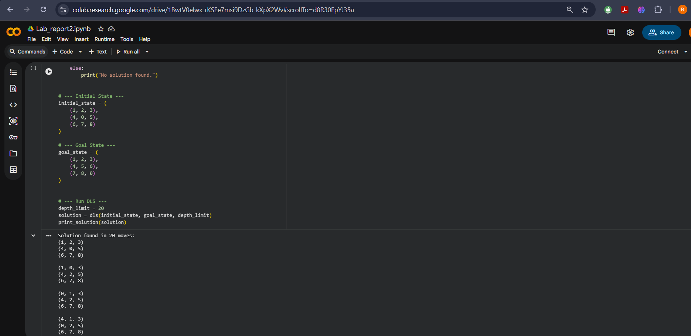
Figure No: 07
Sample Input, Output, and Result Analysis:
Input Sample:
initial_state = ((1, 2, 3), (4, 0, 5), (6, 7, 8))
goal_state = ((1, 2, 3), (4, 5, 6), (7, 8, 0))
Output Sample:
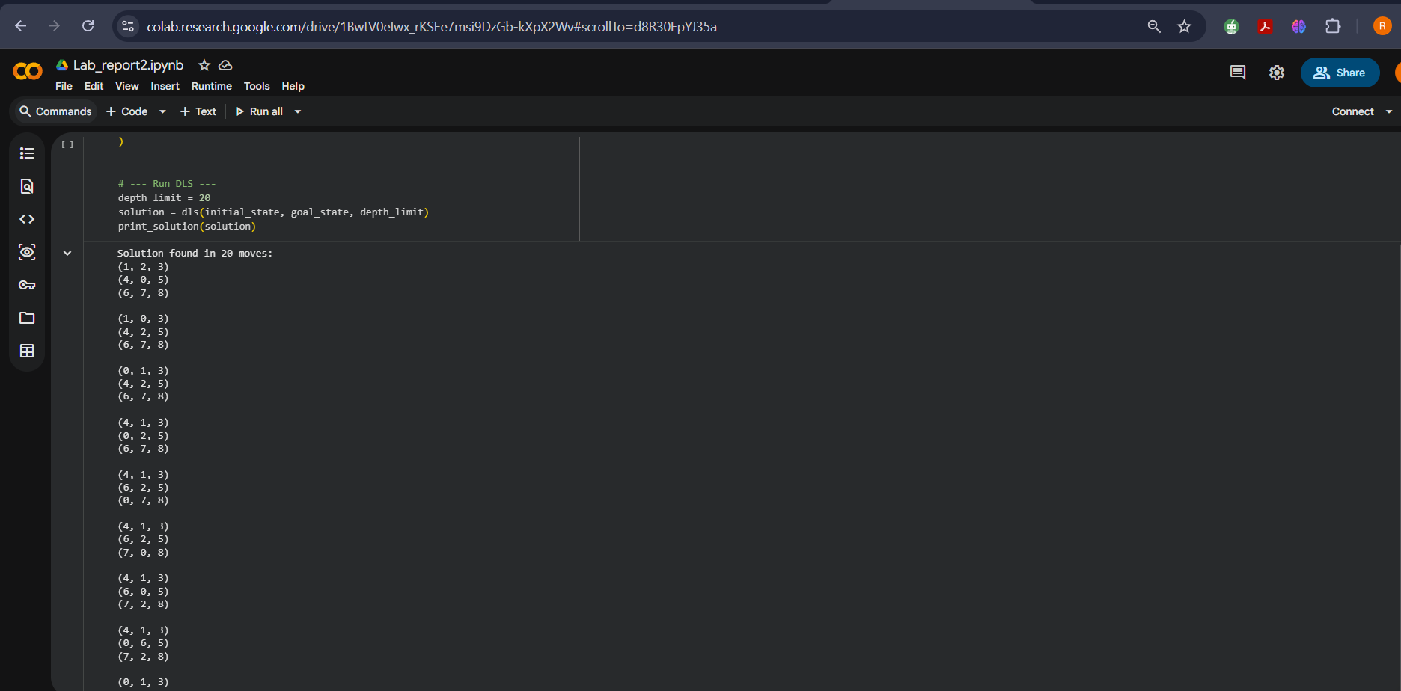
Figure No: 08
Using IDS
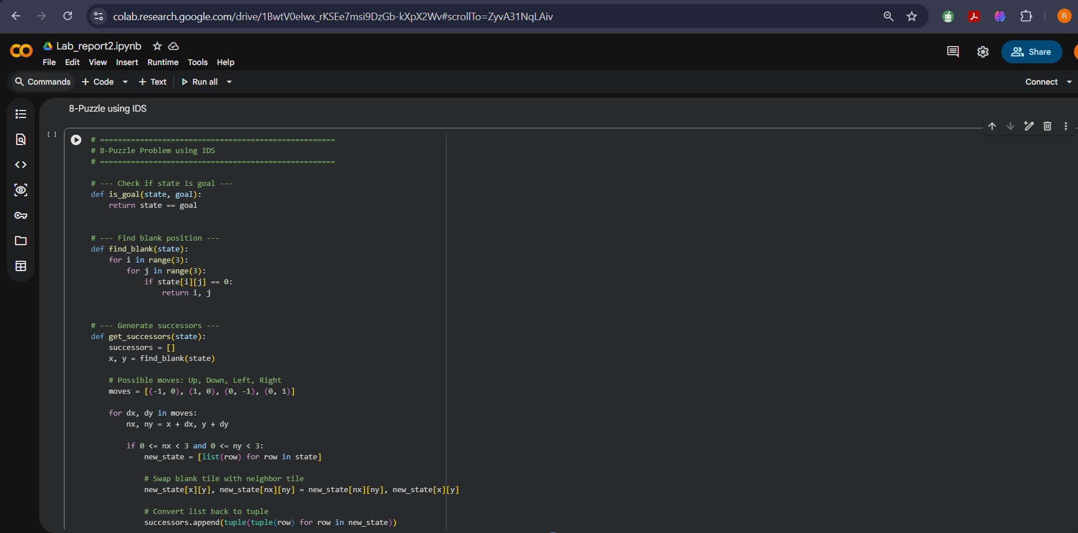
Figure No: 09
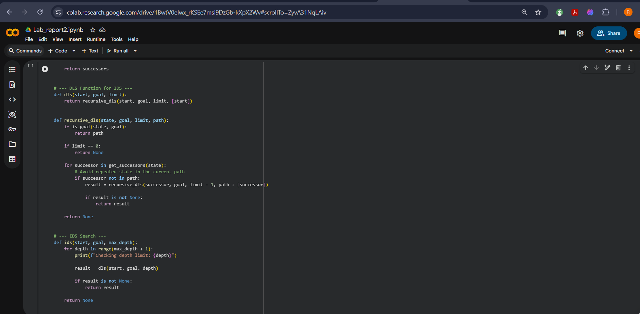
Figure No: 10
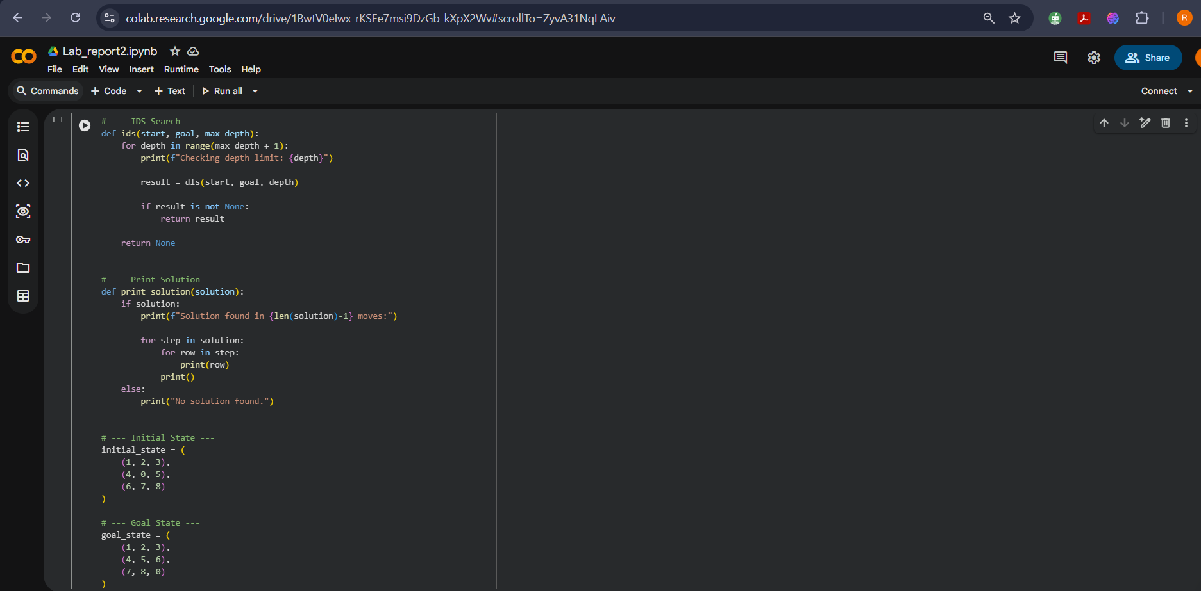
Figure No: 11
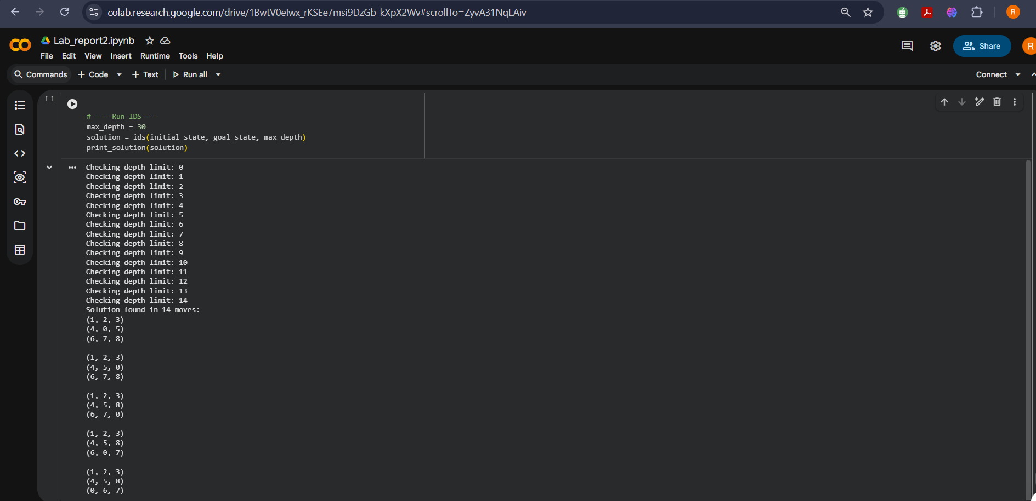
Figure No: 12
Sample Input, Output, and Result Analysis:
Input Sample:
initial_state = ((1, 2, 3), (4, 0, 5), (6, 7, 8))
goal_state = ((1, 2, 3), (4, 5, 6), (7, 8, 0))
Output Sample:
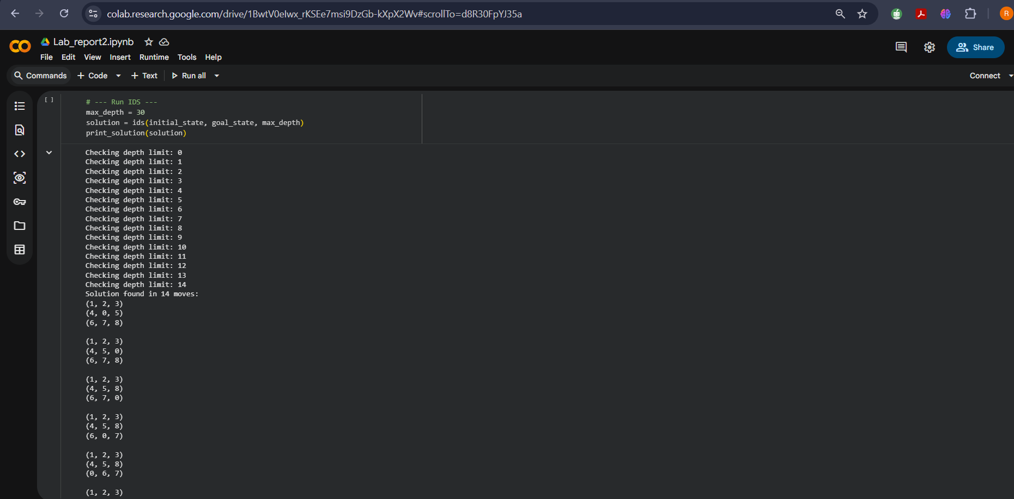
Figure No: 13
Result Analysis
- While DFS can solve the problem, BFS offers a more optimal solution for it.
- A total of 19,992 moves using DFS, 20 moves using DLS and 14 moves in IDS are needed for solving the 8-puzzle problem.
- DFS uses a stack or recursion.
- DLS also uses a stack or recursion but stops exploration once it reaches a pre-defined depth limit.
- IDS repeatedly uses a stack or recursion to perform DLS at increasingly deeper limits until the goal is found.

