Department of Computer Science and Engineering
Lab Report
Lab Report No | : | 6
Lab Report Name | : | Adversarial Search: Minimax Algorithm (Tic-Tac-Toe), Alpha-Beta Pruning Algorithm (Tic-Tac-Toe)
Course Title | : | Artificial Intelligence Sessional
Course Code | : | CSE 422
Name | : | Md. Rakibul Hassan
ID | : | 0822220105101024
Level | : | 4 | Term | : | 2 | Section | : | A | Group | : | G1
Date of Submission | : | 19.07.2026 | Semester | : | Spring | Year | : | 2026

Marking Rubric
Problem Understanding & Report Clarity (3) | Implementation (4) | Results, Analysis & Presentation (3) | Total (10)

Adversarial Search: Minimax Algorithm (Tic-Tac-Toe):
Key Learnings:
- Learned that Minimax guarantees the optimal move when both players play perfectly.
- Learned that the algorithm explores every possible future game state, making it suitable for small games like Tic-Tac-Toe.
- Learned that the evaluation score propagates back through the recursion to determine the best current move.

Code Implementation:
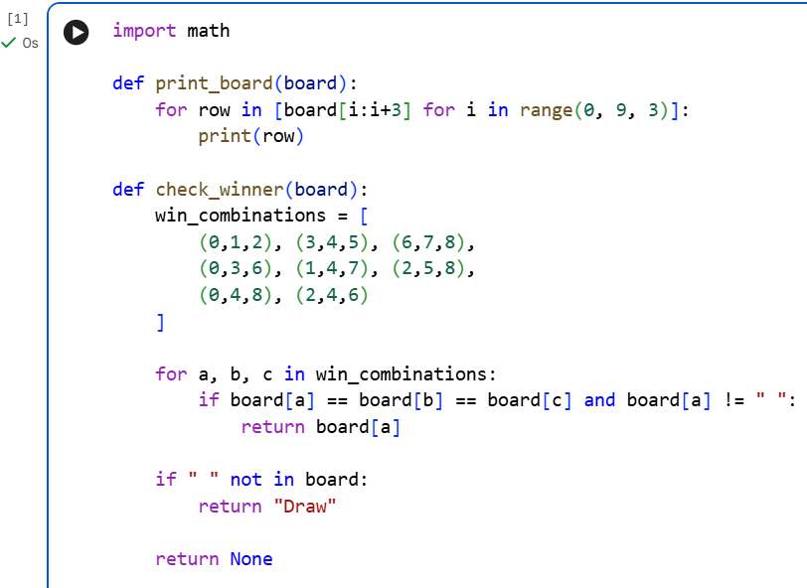
Figure 1: Helper functions for board display and winner detection

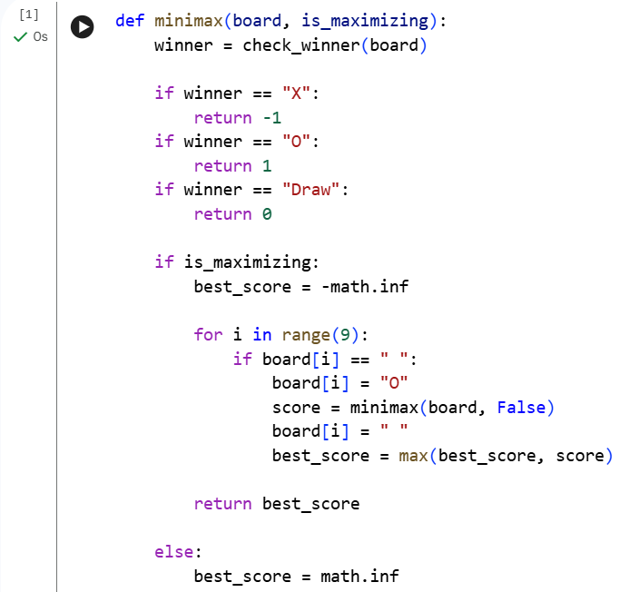
Figure 2: Implementation of the Minimax algorithm for evaluating optimal game moves. (First-Half)

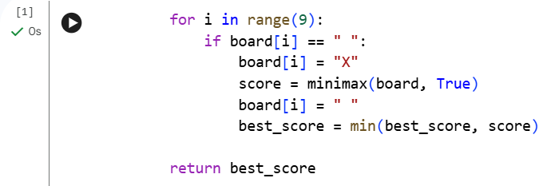
Figure 3: Implementation of the Minimax algorithm for evaluating optimal game moves.

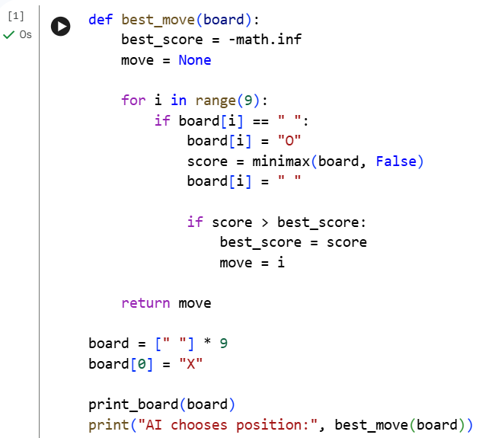
Figure 4: AI move selection using the Minimax algorithm and program execution.

Input-Output:
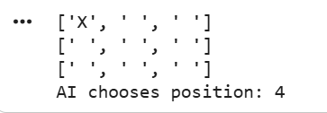
Figure 5: Sample Input-Output
Result Analysis:
- The Minimax algorithm successfully selected the optimal move for the AI by evaluating all possible future game states.
- The AI guaranteed the best possible outcome, assuming both players made optimal decisions.
- The recursive search correctly identified winning, losing, and draw situations before selecting a move.
- Although the algorithm produced the correct result, it explored every possible game state, making it computationally expensive.

Adversarial Search: Minimax Algorithm (Tic-Tac-Toe):
Key Learnings:
- Learned that Alpha-Beta Pruning reduces the number of nodes explored without affecting the final decision.
- Learned that pruning occurs when beta ≤ alpha, allowing the algorithm to skip branches that cannot improve the outcome.
- Learned that Alpha-Beta Pruning is more efficient than Minimax, especially for games with large search trees, because it saves both computation time and memory.

Code Implementation:
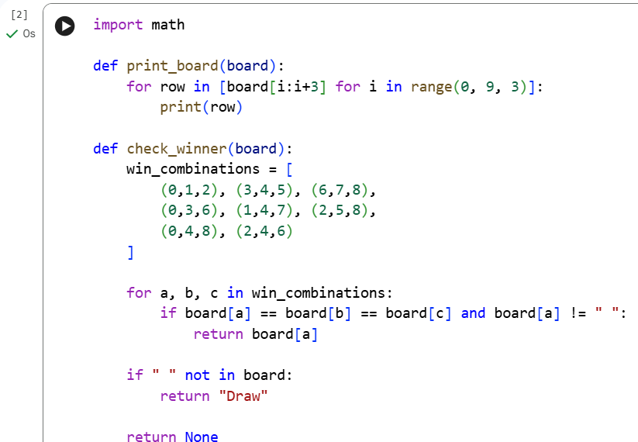
Figure 1: Helper functions for board display and winner detection
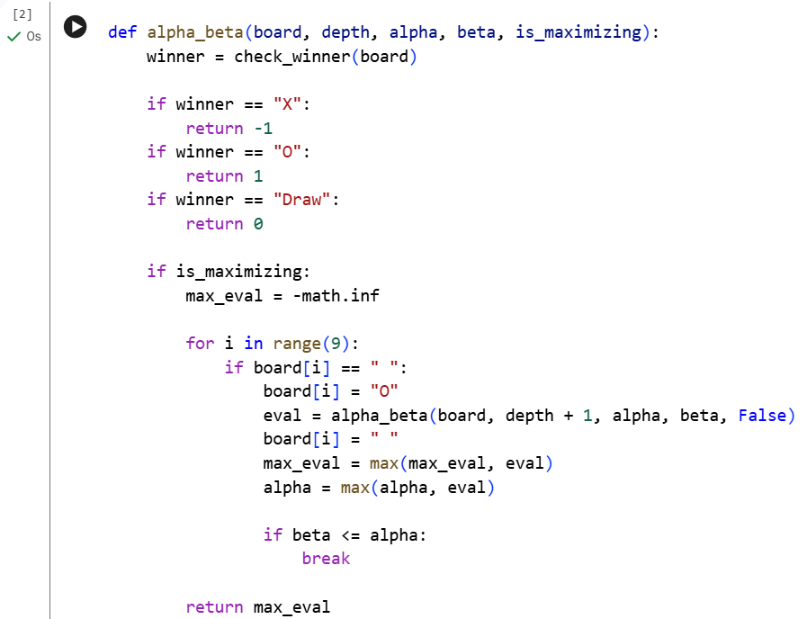
Figure 2: Optimizing game tree search in alpha_beta() function (First Half)
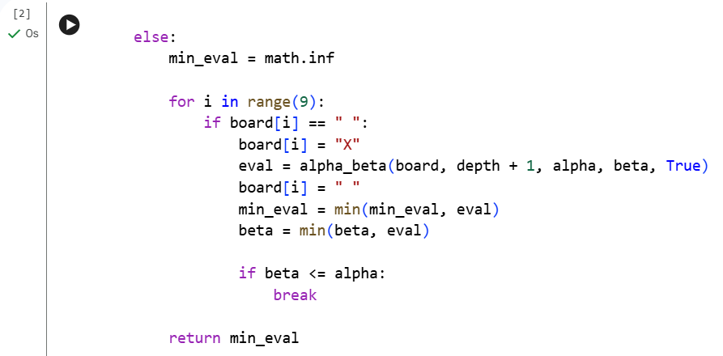
Figure 3: Optimizing game tree search in alpha_beta() function (Second Half)
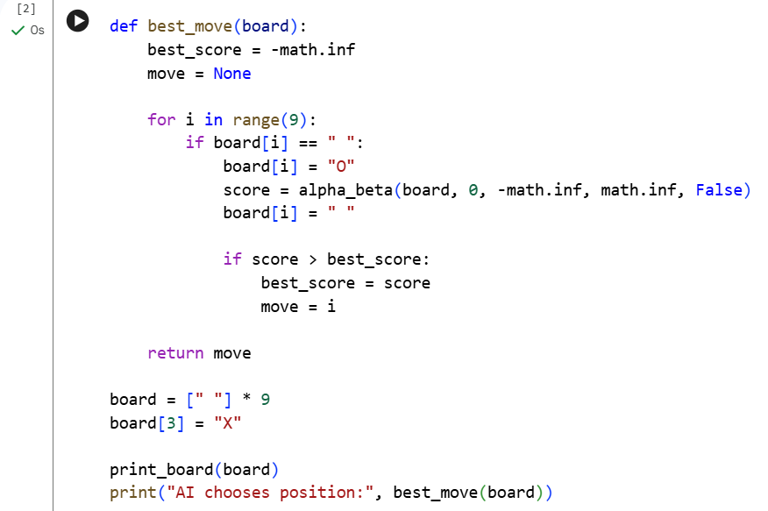
Figure 4: AI move selection using Alpha-Beta Pruning and program execution.
Input-Output:
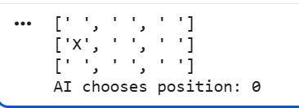
Figure 5: Sample Input-Output
Result Analysis:
- The alpha-beta pruning algorithm selected the same optimal move as the minimax algorithm.
- It reduced the number of game states explored by pruning unnecessary branches using the alpha and beta values.
- The pruning process improved execution efficiency without affecting the correctness of the final decision.
- Compared to Minimax, Alpha-Beta Pruning required fewer computations, making it more suitable for larger game search problems.

