Department of Computer Science and Engineering
Lab Report
Lab Report No | : | 03
Lab Report Name | : | A* Search Algorithm (Romania Road Map Problem)
Course Title | : | Artificial Intelligence Sessional
Course Code | : | CSE 422
Name | : | MD Rakibul Hassan
ID | : | 0822220105101024
Level | : | 4 | Term | : | 2 | Section | : | A | Group | : | G1
Date of Submission | : | 17/05/2026 | Semester | : | Spring | Year | : | 2026

Marking Rubric
Problem Understanding & Report Clarity (3) | Implementation (4) | Results, Analysis & Presentation (3) | Total (10)

Key Learnings:
- Learned about the A* search algorithm with hands-on experience.
- Understand the working process of the A* search algorithm, how it combines actual and heuristic values to reach the goal quickly.
Code Implementation & Sample Input/Output:
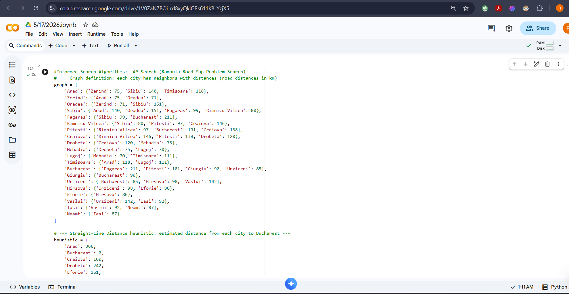
Figure No: 01
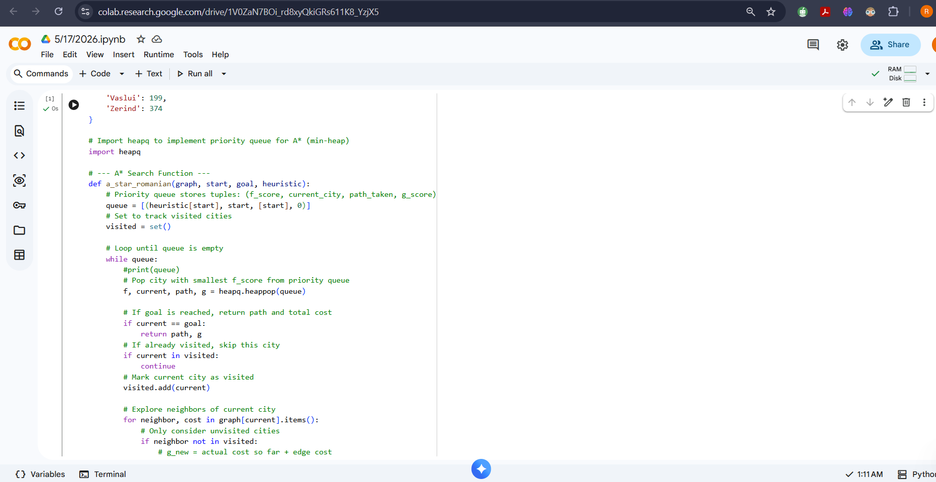
Figure No: 02
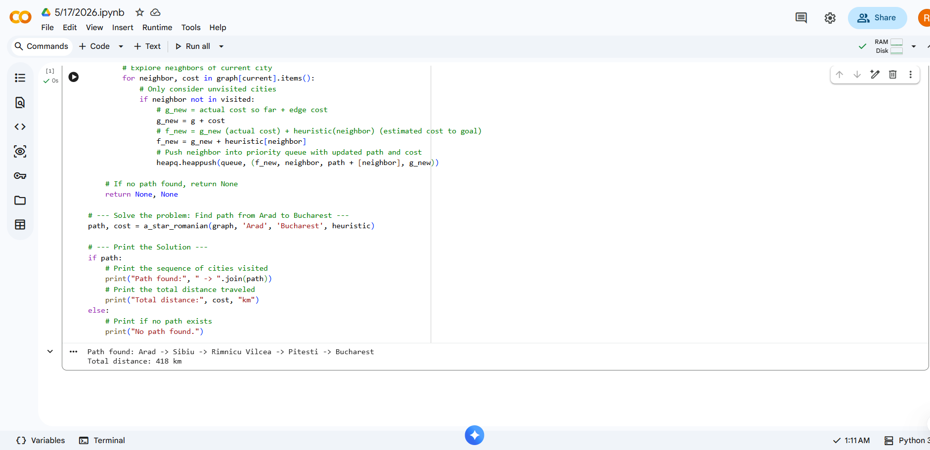
Figure No: 03
Result Analysis
- The A* search algorithm is one of the popular techniques that are used for path-finding and graph traversal.
- A* search is an informed search algorithm that ignores the visited track to avoid the same search repeatedly.
- A* search successfully gets the shortest path from Arad to Bucharest, which is optimal.

