Operating System
CPU Scheduling Simulator

A Case Study Presented to
The Faculty of the Bachelor of Science in Computer Science
College of Computer Studies

In Partial Fulfilment of the
Requirements for the Course
Operating Systems

Submitted to:
Jo Anne G. Cura
Instructor

Pilar, Renz Russel Angelo G.
BSCS-3A
Due: May 15, 2026

1. Introduction
CPU scheduling is the process by which the OS determines which process runs on the CPU at any given time. It directly affects system performance, responsiveness, and fairness. Scheduling algorithms are classified as preemptive (OS can interrupt a running process) or non-preemptive (a process runs until it finishes or blocks).^{[1][2][3]}
This case study implements six CPU scheduling algorithms in a Python/Tkinter simulator. Users supply process parameters and the program outputs Gantt charts, waiting times, and turnaround times for each algorithm.^{[4]}

Objectives:
- Correctly implement FCFS, SJF, SRT, Round Robin, Priority, and Priority+RR.
- Accept dynamic inputs: arrival time, burst time, priority, and time quantum.
- Generate a Gantt chart and compute WT and TAT per process and on average.
- Provide a clean GUI with clear, readable output for all six algorithms.

2. Body
The same two test cases are used across all algorithms for consistency.

TC | Process | Arrival | Burst | Priority | Quantum
1 | P1, P2, P3 | 0, 1, 2 | 5, 3, 8 | 2, 1, 3 | 2
2 | P1, P2, P3, P4 | 0, 1, 2, 4 | 6, 2, 4, 1 | 3, 1, 2, 4 | 2

2.1. First-Come, First-Served (FCFS)
Processes execute in arrival order. Simple FIFO queue — no preemption.^{[1][3]}
Type: Non-Preemptive

Advantages  - Simple to implement  - No starvation | Limitations  - Convoy effect — long process blocks short ones  - High average wait when burst times vary

Test Case 1
Process | Arrival | Burst | Priority
P1 | 0 | 5 | 2
P2 | 1 | 3 | 1
P3 | 2 | 8 | 3

Gantt Chart:
P1 | P2 | P3
0 | 5 | 8 16

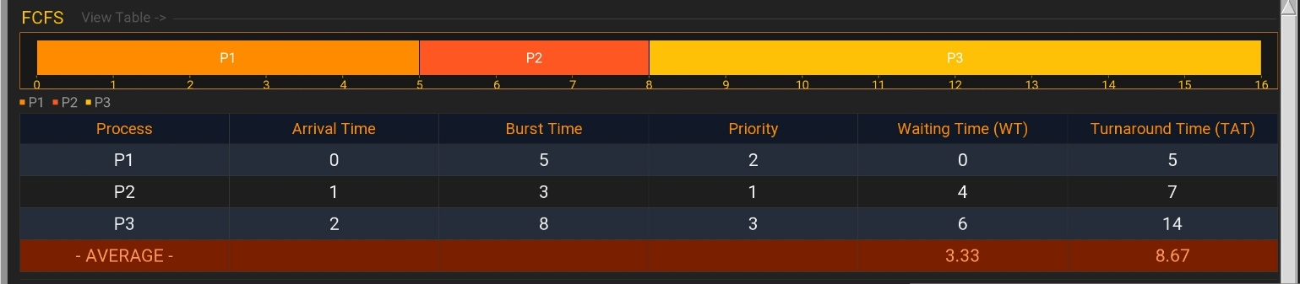

Test Case 2
Process | Arrival | Burst | Priority
P1 | 0 | 6 | 3
P2 | 1 | 2 | 1
P3 | 2 | 4 | 2
P4 | 4 | 1 | 4

Gantt Chart:
P1 | P2 | P3 | P4
0 | 6 | 8 | 12 13

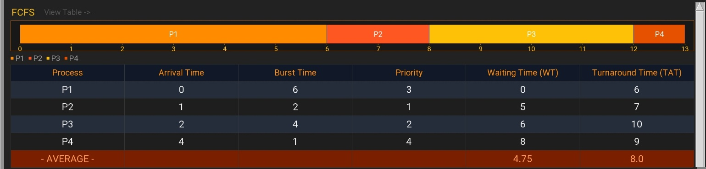

2.2. Shortest Job First (SJF) — Non-Preemptive
Picks the process with the smallest burst time from those currently available. Runs it to completion before selecting again.^{[1][3]}
Type: Non-Preemptive

Advantages  - Minimizes average waiting time (provably optimal for non-preemptive)  - Efficient for batch workloads | Limitations  - Starvation for long processes  - Burst times are often unknown in practice

Test Case 1
Process | Arrival | Burst | Priority
P1 | 0 | 5 | 2
P2 | 1 | 3 | 1
P3 | 2 | 8 | 3

Gantt Chart:
P1 | P2 | P3
0 | 5 | 8 16

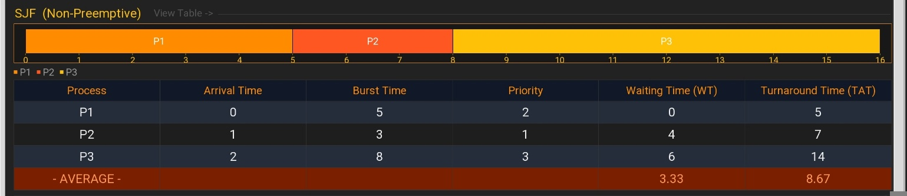

Test Case 2
Process | Arrival | Burst | Priority
P1 | 0 | 6 | 3
P2 | 1 | 2 | 1
P3 | 2 | 4 | 2
P4 | 4 | 1 | 4

Gantt Chart:
P1 | P4 | P2 | P3
0 | 6 | 7 | 9 13
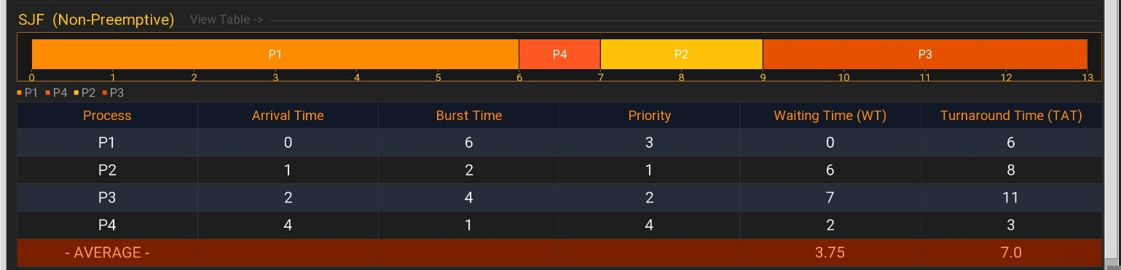

2.3. Shortest Remaining Time (SRT) — Preemptive
Preemptive version of SJF. At every tick, the process with the least remaining burst time runs. A newly arrived shorter process immediately preempts the current one.^{[1][2]}
Type: Preemptive

Advantages  - Optimal average waiting time among all algorithms  - Highly responsive to short arrivals | Limitations  - High context-switch overhead  - Starvation risk for long processes

Test Case 1
Process | Arrival | Burst | Priority
P1 | 0 | 5 | 2
P2 | 1 | 3 | 1
P3 | 2 | 8 | 3

Gantt Chart:
P1 | P2 | P1 | P3
0 | 1 | 4 | 8 16

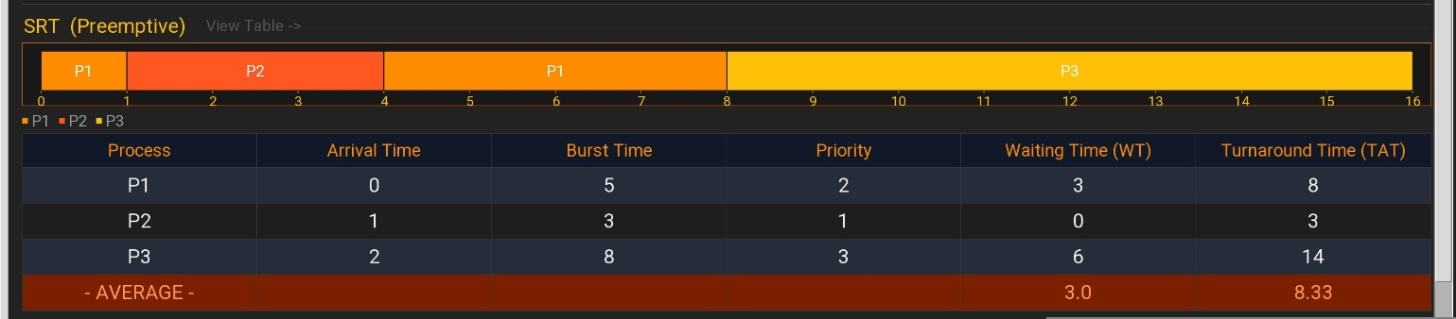

Test Case 2
Process | Arrival | Burst | Priority
P1 | 0 | 6 | 3
P2 | 1 | 2 | 1
P3 | 2 | 4 | 2
P4 | 4 | 1 | 4

Gantt Chart:
P1 | P2 | P3 | P4 | P3 | P1
0 | 1 | 3 | 4 | 5 | 8 13
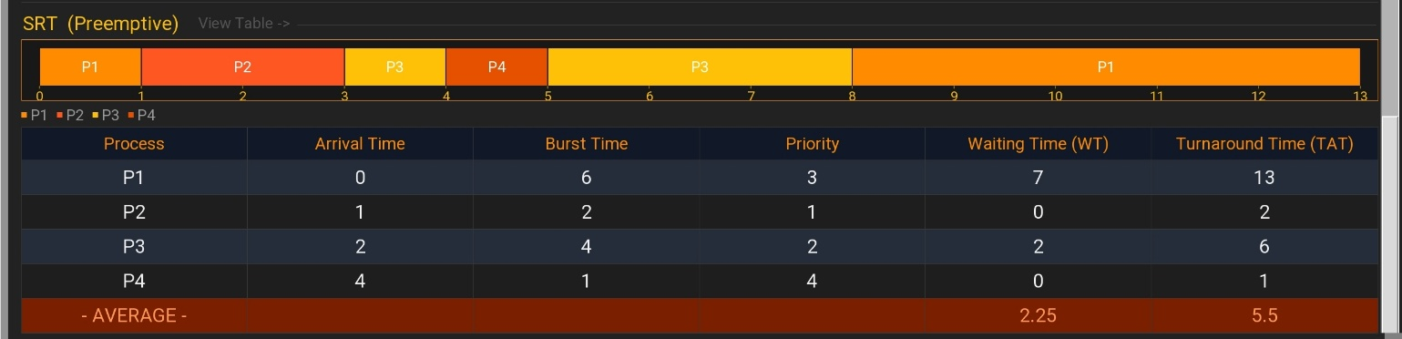

2.4. Round Robin (RR) — Quantum = 2
Each process gets a fixed time quantum in rotation. A process that does not finish within its quantum is preempted and placed at the back of the ready queue.^{[1][2][3]}
Type: Preemptive

Advantages  - Fair — equal CPU time slices  - No starvation | Limitations  - Higher average WT/TAT than SJF  - Performance sensitive to quantum size

Test Case 1
Process | Arrival | Burst | Priority
P1 | 0 | 5 | 2
P2 | 1 | 3 | 1
P3 | 2 | 8 | 3

Gantt Chart:
P1 | P2 | P3 | P1 | P2 | P3 | P1 | P3
0 | 2 | 4 | 6 | 8 | 9 | 11 | 12 16

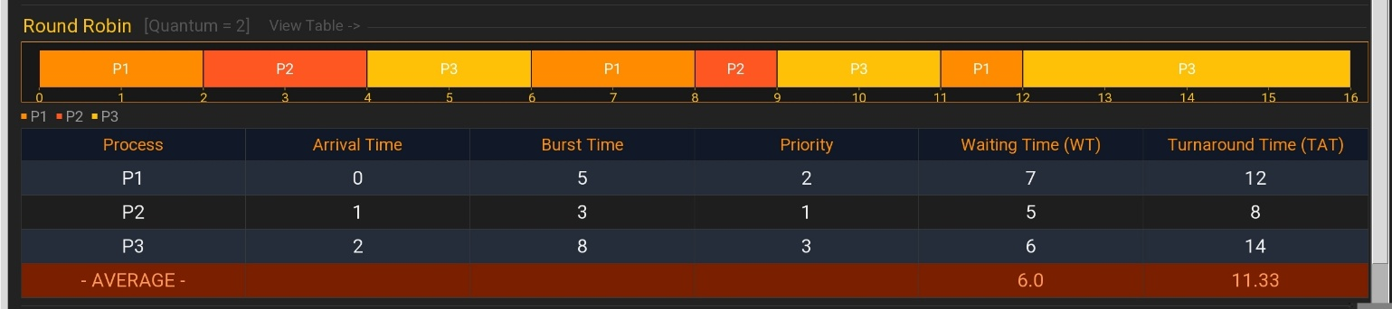
Test Case 2
Process | Arrival | Burst | Priority
P1 | 0 | 6 | 3
P2 | 1 | 2 | 1
P3 | 2 | 4 | 2
P4 | 4 | 1 | 4

Gantt Chart:
P1 | P2 | P3 | P1 | P4 | P3 | P1
0 | 2 | 4 | 6 | 8 | 9 | 11 13
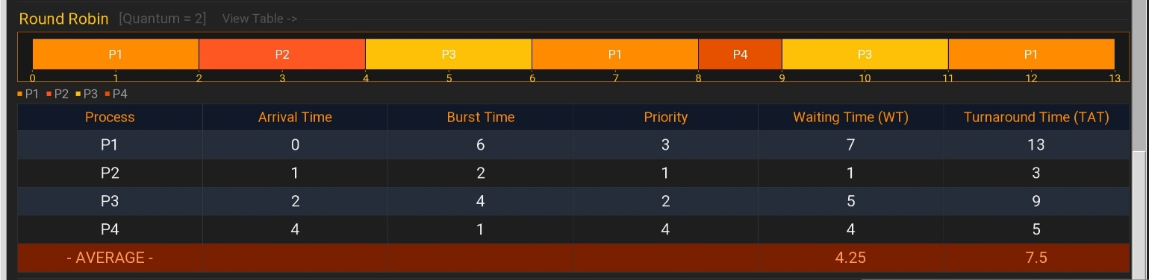

2.5. Priority Scheduling (Non-Preemptive) — Lower # = Higher Priority
Selects the highest-priority available process and runs it to completion. Ties broken by arrival time. Priority direction is configurable in the program.^{[1][2]}
Type: Non-Preemptive

Advantages  - Critical processes execute first  - Flexible — priority direction is user-selectable | Limitations  - Starvation for low-priority processes  - Priority assignment is subjective

Test Case 1
Process | Arrival | Burst | Priority
P1 | 0 | 5 | 2
P2 | 1 | 3 | 1
P3 | 2 | 8 | 3

Gantt Chart:
P1 | P2 | P3
0 | 5 | 8 16

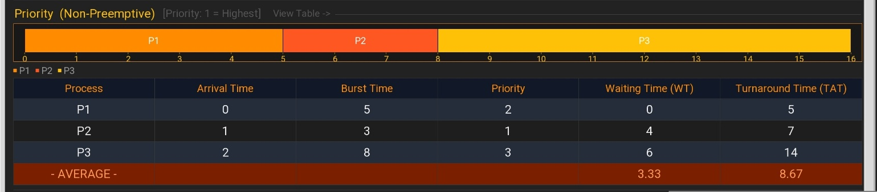

Test Case 2
Process | Arrival | Burst | Priority
P1 | 0 | 6 | 3
P2 | 1 | 2 | 1
P3 | 2 | 4 | 2
P4 | 4 | 1 | 4

Gantt Chart:
P1 | P2 | P3 | P4
0 | 6 | 8 | 12 13

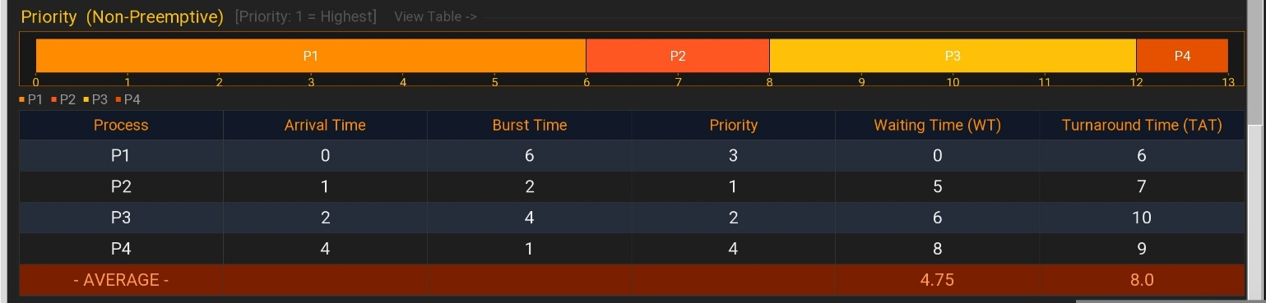

2.6. Priority Scheduling (Preemptive) — Lower # = Higher Priority
Re-evaluates priority at every clock tick. A newly arrived higher-priority process immediately preempts the running one. Ties are broken by arrival time.^{[1][2]}
Type: Preemptive

Advantages  - Immediately responds to higher-priority arrivals  - Better average waiting time than non-preemptive priority | Limitations  - High context-switch overhead  - Starvation risk for low-priority processes

Test Case 1
Process | Arrival | Burst | Priority
P1 | 0 | 5 | 2
P2 | 1 | 3 | 1
P3 | 2 | 8 | 3
Gantt Chart:
P1 | P2 | P1 | P3
0 | 1 | 4 | 8 16

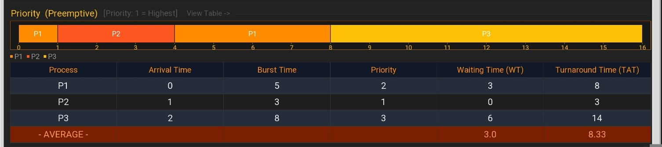

Test Case 2
Process | Arrival | Burst | Priority
P1 | 0 | 6 | 3
P2 | 1 | 2 | 1
P3 | 2 | 4 | 2
P4 | 4 | 1 | 4
Gantt Chart:
P1 | P2 | P3 | P1 | P4
0 | 1 | 3 | 7 | 12 13

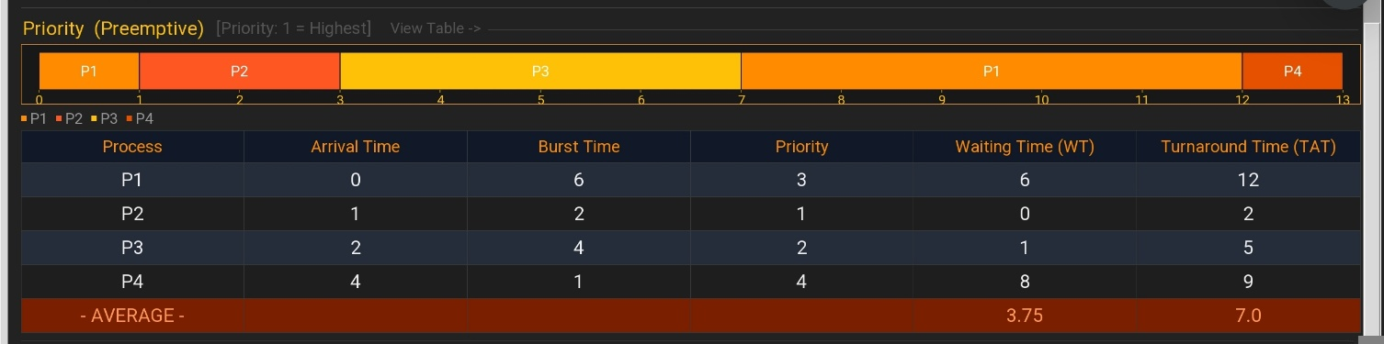

2.7. Priority Scheduling with Round Robin — Lower # = Higher Priority, Quantum = 2
Hybrid: the highest-priority process in the ready queue is selected each dispatch and given one time quantum. If it doesn't finish, it returns to the queue and priority selection repeats.^{[1][2]}
Type: Preemptive (quantum-based)

Advantages  - Combines priority ordering with time-sharing fairness  - High-priority processes are served first without monopolizing CPU | Limitations  - More complex logic than either pure Priority or pure RR  - Low-priority processes still risk long waits

Test Case 1
Process | Arrival | Burst | Priority
P1 | 0 | 5 | 2
P2 | 1 | 3 | 1
P3 | 2 | 8 | 3

Gantt Chart:
P1 | P2 | P1 | P3
0 | 2 | 5 | 8 16

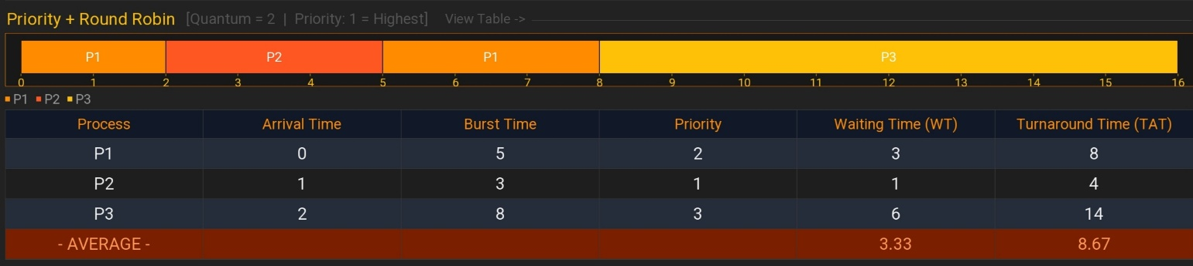
Test Case 2
Process | Arrival | Burst | Priority
P1 | 0 | 6 | 3
P2 | 1 | 2 | 1
P3 | 2 | 4 | 2
P4 | 4 | 1 | 4

Gantt Chart:
P1 | P2 | P3 | P3 | P1 | P1 | P4
0 | 2 | 4 | 6 | 8 | 10 | 12 13
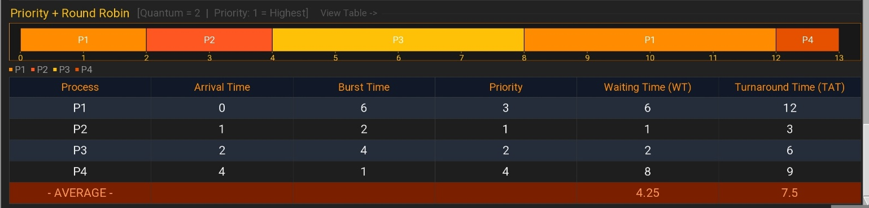

2.7 Algorithm Comparison
Results on Test Case 1 (3 processes):

Algorithm | Avg WT | Avg TAT | Preemptive | Starvation Risk
FCFS | 3.33 | 8.67 | No | None
SJF | 3.33 | 8.67 | No | Yes
SRT | 3.00 | 8.33 | Yes | Yes
Round Robin | 6.00 | 11.33 | Yes | None
Priority | 3.33 | 8.67 | No | Yes
Priority + RR | 4.00 | 9.33 | Yes | Low

Key observation: SRT achieves the lowest average WT. Round Robin is fairest but produces the highest WT. Non-preemptive algorithms are simpler but vulnerable to starvation.^{[1][3]}

3. Summary / Takeaways
Key Insights
- Preemptive algorithms (SRT, RR, Priority+RR) require a tick-by-tick loop and are more complex to implement but more responsive.^{[1][2]}
- SJF and SRT minimize average waiting time but require known burst times, which are rarely available in real systems.^{[1][2]}
- Round Robin is the most equitable — every process gets CPU time at regular intervals — but this comes at the cost of higher average TAT.^{[1][3]}
- Priority Scheduling risks indefinite postponement (starvation) for low-priority processes; Priority+RR mitigates this by enforcing time slices.^{[1][2]}

Performance Observations
- Efficiency (Avg WT): SRT < SJF = FCFS = Priority < Priority+RR < RR (for TC1)
- Fairness: RR and Priority+RR are most equitable; FCFS and Priority are least fair when burst times vary.
- Response time: RR and Priority+RR best suit interactive workloads.

Practical Relevance
Modern OSes combine these principles. Linux CFS uses weighted fair-share scheduling; Windows uses preemptive multilevel priority queues; real-time OSes rely on strict priority preemption. Understanding the fundamentals is essential because all advanced schedulers extend them.^{[1][2]}

Challenges & Solutions
- Preemptive simulation: solved by maintaining a remaining-burst-time map updated each clock tick.
- Round Robin queue ordering: newly arrived processes are enqueued after the current slice ends, not at the tick they arrive.
- Priority+RR dispatch: replaced FIFO dequeue with a priority search over the queue on each dispatch.
- Average row visibility: moved from a separate bottom frame into the treeview as a tagged row to prevent clipping on small screens.

4. References
Silberschatz, A., Galvin, P. B., & Gagne, G. (2018). Operating system concepts (10th ed.). Wiley.
Tanenbaum, A. S., & Bos, H. (2015). Modern operating systems (4th ed.). Pearson.
GeeksforGeeks. (2023). CPU scheduling in operating systems. https://www.geeksforgeeks.org/cpu-scheduling-in-operating-systems/
Python Software Foundation. (2024). tkinter — Python interface to Tcl/Tk. https://docs.python.org/3/library/tkinter.html

5. Repository Link
The repository contains the video demonstration, source code, executable (if applicable), and run instructions.

Repository URL: _________________________________________________

6. Source Code
Python 3 · Tkinter GUI · File:
import tkinter as tk
from tkinter import ttk, messagebox

# ── Result helpers ────────────────────────────────────────────

def calculate_results(processes, timeline):
"""Compute Waiting Time (WT) and Turnaround Time (TAT) for each process."""

# Walk the timeline and record the last end time per process
# (a process may appear in multiple segments, e.g. Round Robin)
finish = {}
for name, start, end in timeline:
if name not in finish or end > finish[name]:
finish[name] = end # keep the latest finish time only

# TAT = Finish Time − Arrival Time
# WT = TAT − Burst Time (time spent waiting, not executing)
results = []
for p in processes:
tat = finish[p["name"]] - p["arrival"]
wt = tat - p["burst"]
results.append({"name": p["name"], "tat": tat, "wt": wt})
return results

def merge_timeline(tl):
"""Collapse adjacent segments of the same process into one block.

Example: [P1,0,2], [P1,2,4] -> [P1,0,4]
This keeps the Gantt chart clean when a process runs back-to-back.
"""
if not tl:
return []
out = [list(tl[0])] # start with the first segment as a mutable list
for seg in tl[1:]:
# Merge if: same process AND this segment starts where the last one ended
if seg[0] == out[-1][0] and seg[1] == out[-1][2]:
out[-1][2] = seg[2] # just extend the end time
else:
out.append(list(seg))
return out

# ── Scheduling Algorithms ─────────────────────────────────────

def run_fcfs(processes):
"""First-Come, First-Served — non-preemptive, ordered by arrival time."""
# Tie-break by name so results are deterministic when arrivals are equal
ordered = sorted(processes, key=lambda p: (p["arrival"], p["name"]))
tl, t = [], 0
for p in ordered:
if t < p["arrival"]:
t = p["arrival"] # CPU idle — jump to when this process arrives
tl.append([p["name"], t, t + p["burst"]])
t += p["burst"]
return tl, calculate_results(processes, tl)

def run_sjf(processes):
"""Shortest Job First — non-preemptive, picks shortest burst from ready queue."""
rem = [dict(p) for p in processes] # copy so originals stay intact
tl, t = [], 0

while rem:
# Collect every process that has already arrived
avail = [p for p in rem if p["arrival"] <= t]

if not avail:
# Nothing ready yet — skip CPU time to the next arrival
t = min(p["arrival"] for p in rem)
continue

# Pick the process with the shortest burst; tie-break by earlier arrival
best = avail[0]
for p in avail[1:]:
if p["burst"] < best["burst"]:
best = p
elif p["burst"] == best["burst"] and p["arrival"] < best["arrival"]:
best = p

tl.append([best["name"], t, t + best["burst"]])
t += best["burst"]
rem.remove(best) # process is finished, remove from remaining list

return tl, calculate_results(processes, tl)

def run_srt(processes):
"""Shortest Remaining Time — preemptive SJF, re-evaluates every tick."""
# Build per-process lookup tables for remaining burst and arrival time
rem = {p["name"]: p["burst"] for p in processes}
arr = {p["name"]: p["arrival"] for p in processes}

tl = []
done = [] # names of completed processes
cur = None # currently running process name
seg_s = 0 # start time of the current unbroken segment
t = 0 # current clock tick

while len(done) < len(processes):
# Build the ready queue: arrived and not yet finished
avail = [p["name"] for p in processes
if p["name"] not in done and arr[p["name"]] <= t]

if not avail:
t += 1 # no process ready — advance time by one tick
continue

# Choose the process with the least remaining burst; tie-break by arrival
chosen = avail[0]
for name in avail[1:]:
if rem[name] < rem[chosen]:
chosen = name
elif rem[name] == rem[chosen] and arr[name] < arr[chosen]:
chosen = name

# If the running process changed, save the completed segment
if chosen != cur:
if cur:
tl.append([cur, seg_s, t]) # flush previous segment before switching
cur, seg_s = chosen, t # start a new segment for the new process

rem[chosen] -= 1 # consume one tick of burst
t += 1

if rem[chosen] == 0:
# Process finished — save its final segment and free the CPU
tl.append([chosen, seg_s, t])
done.append(chosen)
cur = None

return tl, calculate_results(processes, tl)

def run_round_robin(processes, quantum):
"""Round Robin — each process gets at most `quantum` ticks before yielding."""
rem = {p["name"]: p["burst"] for p in processes} # remaining burst per process
ordered = sorted(processes, key=lambda p: (p["arrival"], p["name"]))
tl, queue, in_q, done, t = [], [], [], [], 0

def enqueue_arrived():
"""Add any newly arrived processes to the ready queue (no duplicates)."""
for p in ordered:
if p["arrival"] <= t and p["name"] not in in_q and p["name"] not in done:
queue.append(p["name"])
in_q.append(p["name"]) # in_q prevents the same process being added twice

enqueue_arrived() # seed the queue with processes available at t=0

while len(done) < len(processes):
if not queue:
# Queue empty — jump forward to the next unscheduled arrival
next_arr = [p["arrival"] for p in ordered
if p["name"] not in done and p["name"] not in in_q]
if not next_arr:
break
t = min(next_arr)
enqueue_arrived()
continue

name = queue.pop(0) # take the front of the FIFO queue
run = min(quantum, rem[name]) # run for a full quantum or until done
tl.append([name, t, t + run])
rem[name] -= run
t += run
enqueue_arrived() # admit any processes that arrived during this slice

if rem[name] == 0:
done.append(name) # process fully complete
else:
queue.append(name) # still has work — re-enter at the back of the queue

return tl, calculate_results(processes, tl)

def run_priority(processes, higher_is_better):
"""Priority Scheduling — non-preemptive; picks the best-priority ready process.

higher_is_better=True -> larger number wins
higher_is_better=False -> smaller number wins (1 = Highest mode)
"""
rem = [dict(p) for p in processes]
tl, t = [], 0

while rem:
avail = [p for p in rem if p["arrival"] <= t]
if not avail:
t = min(p["arrival"] for p in rem) # idle until the next process arrives
continue

# Select the process with the best priority value
best = avail[0]
for p in avail[1:]:
if higher_is_better and p["priority"] > best["priority"]:
best = p
elif not higher_is_better and p["priority"] < best["priority"]:
best = p

tl.append([best["name"], t, t + best["burst"]])
t += best["burst"]
rem.remove(best)

return tl, calculate_results(processes, tl)

def run_priority_preemptive(processes, higher_is_better):
"""Priority Scheduling — preemptive; re-evaluates priority every tick."""
rem = {p["name"]: p["burst"] for p in processes}
arr = {p["name"]: p["arrival"] for p in processes}
pri = {p["name"]: p["priority"] for p in processes}

tl, done, cur, seg_s, t = [], [], None, 0, 0

while len(done) < len(processes):
avail = [p["name"] for p in processes
if p["name"] not in done and arr[p["name"]] <= t]
if not avail:
t += 1
continue

chosen = avail[0]
for name in avail[1:]:
if higher_is_better and pri[name] > pri[chosen]:
chosen = name
elif not higher_is_better and pri[name] < pri[chosen]:
chosen = name

if chosen != cur:
if cur:
tl.append([cur, seg_s, t])
cur, seg_s = chosen, t

rem[chosen] -= 1
t += 1

if rem[chosen] == 0:
tl.append([chosen, seg_s, t])
done.append(chosen)
cur = None

return tl, calculate_results(processes, tl)

def run_priority_rr(processes, quantum, higher_is_better):
"""Priority + Round Robin — Round Robin but the queue is priority-ordered.

Each round the highest-priority ready process runs for up to `quantum` ticks.
"""
rem = {p["name"]: p["burst"] for p in processes}
arr = {p["name"]: p["arrival"] for p in processes}
pri = {p["name"]: p["priority"] for p in processes}

ordered = sorted(processes, key=lambda p: p["arrival"])
tl, queue, in_q, done, t = [], [], [], [], 0

def enqueue_arrived():
"""Admit newly arrived processes into the ready queue."""
for p in ordered:
if arr[p["name"]] <= t and p["name"] not in in_q and p["name"] not in done:
queue.append(p["name"])
in_q.append(p["name"])

enqueue_arrived()

while len(done) < len(processes):
if not queue:
# Jump forward to the next unscheduled arrival
next_arr = [arr[p["name"]] for p in ordered
if p["name"] not in done and p["name"] not in in_q]
if not next_arr:
break
t = min(next_arr)
enqueue_arrived()
continue

# From the entire ready queue, pick the single highest-priority process
chosen = queue[0]
for name in queue[1:]:
if higher_is_better and pri[name] > pri[chosen]:
chosen = name
elif not higher_is_better and pri[name] < pri[chosen]:
chosen = name

queue.remove(chosen) # temporarily remove while it runs its slice
run = min(quantum, rem[chosen])
tl.append([chosen, t, t + run])
rem[chosen] -= run
t += run
enqueue_arrived() # admit any processes that arrived during this slice

if rem[chosen] == 0:
done.append(chosen) # finished
else:
queue.append(chosen) # not done — re-enter at the back of the queue

return tl, calculate_results(processes, tl)

# ── Colour Palette ────────────────────────────────────────────

BG_MAIN = "#222222" # main window background
BG_PANEL = "#2C2C2C" # slightly lighter panel surfaces
BG_ALT = "#353535" # alternating table row background
BG_ENTRY = "#181818" # dark entry field / canvas background
BG_HEADER = "#111111" # top header bar
BG_BTN = "#3A3A3A" # default button background
BG_BTN_RUN = "#E64A19" # run button — deep orange accent
FG_DARK = "#F0F0F0" # primary text on dark backgrounds
FG_MID = "#999999" # secondary / dimmed text
FG_LIGHT = "#555555" # subtle hint / decorative text
FG_WHITE = "#FFFFFF" # pure white for high-contrast labels
ACCENT = "#FF8C00" # primary accent — warm orange
ACCENT2 = "#FFC107" # secondary accent — amber (Gantt axis labels)
BORDER = "#404040" # separator lines and borders

# Colours assigned to processes in Gantt charts; cycled when there are more than 10
GANTT_COLORS = [
"#FF8C00","#FF5722","#FFC107","#E65100","#F57C00",
"#FF7043","#FFB300","#D84315","#FF6D00","#FFCA28"
]

# Display names for each algorithm — order must match the runners list in _run()
ALGORITHMS = [
"FCFS",
"SJF (Non-Preemptive)",
"SRT (Preemptive)",
"Round Robin",
"Priority (Non-Preemptive)",
"Priority (Preemptive)",
"Priority + Round Robin",
]

# Dropdown choices for the priority direction setting
PRIORITY_OPTIONS = ["1 = Highest", "Higher # = Higher"]

# ── Shared UI Helpers ─────────────────────────────────────────

def apply_style():
"""Configure ttk widget themes to match the dark colour palette."""
s = ttk.Style()
s.theme_use("clam") # 'clam' is the only built-in theme that exposes field/arrow colours

# Style the Combobox dropdown to blend with the dark theme
s.configure("TCombobox",
fieldbackground=BG_ENTRY, background=BG_BTN,
foreground=FG_DARK, selectbackground=BG_ALT,
selectforeground=FG_DARK, arrowcolor=ACCENT, padding=4)
s.map("TCombobox", fieldbackground=[("readonly", BG_ENTRY)])

# Treeview is not actively used but styled for consistency if needed later
s.configure("Treeview",
background=BG_PANEL, foreground=FG_DARK,
fieldbackground=BG_PANEL, rowheight=32,
font=("Segoe UI", 11))
s.configure("Treeview.Heading",
background=BG_ALT, foreground=ACCENT,
font=("Segoe UI", 10, "bold"), relief="flat")
s.map("Treeview", background=[("selected", "#E64A19")])

def build_header(window):
"""Render the shared top header bar (title + subtitle) for any window."""
f = tk.Frame(window, bg=BG_HEADER, height=58)
f.pack(fill="x")
f.pack_propagate(False) # lock the frame to exactly 58 px — ignore child size
tk.Label(f, text=" CPU Scheduling Simulator",
font=("Segoe UI", 14, "bold"), bg=BG_HEADER, fg=FG_WHITE
).pack(side="left", padx=20, pady=10)
tk.Label(f, text="Operating Systems | Case Study",
font=("Segoe UI", 8), bg=BG_HEADER, fg=FG_LIGHT
).pack(side="right", padx=20, pady=10)

# ── Input Window ──────────────────────────────────────────────

class InputWindow:
"""Main entry screen — lets the user configure processes and launch the simulation."""

def __init__(self, window):
self.window = window
self.window.title("CPU Scheduling Simulator")
self.window.configure(bg=BG_MAIN)
self.window.resizable(True, True)

# Open maximised to the full screen dimensions
self.window.update_idletasks()
sw = self.window.winfo_screenwidth()
sh = self.window.winfo_screenheight()
self.window.geometry(f"{sw}x{sh}+0+0")

# Each entry: [name_var, arrival_var, burst_var, priority_var, widget_list]
self.process_rows = []

apply_style()
build_header(self.window)
self._build_controls() # Time Quantum + Priority Direction bar
self._build_process_table() # editable process input table
self._build_buttons() # action buttons row at the bottom

def _build_controls(self):
"""Build the settings bar: Time Quantum entry and Priority Direction dropdown."""
panel = tk.Frame(self.window, bg=BG_PANEL)
panel.pack(fill="x", padx=20, pady=(12, 0))
f = tk.Frame(panel, bg=BG_PANEL, pady=14)
f.pack(fill="x", padx=16)

# Reusable helper for consistently styled column label text
def lbl(text):
return tk.Label(f, text=text, font=("Segoe UI", 9, "bold"),
bg=BG_PANEL, fg=ACCENT2)

entry_kw = dict(font=("Segoe UI", 11), bg=BG_ENTRY, fg=FG_DARK,
insertbackground=ACCENT, relief="flat", bd=6)

# Time Quantum — used by Round Robin and Priority + Round Robin
lbl("Time Quantum").grid(row=0, column=0, padx=(0, 8), sticky="w")
self.quantum_var = tk.StringVar(value="2")
tk.Entry(f, textvariable=self.quantum_var, width=6,
**entry_kw).grid(row=0, column=1, padx=(0, 24))

# Thin vertical divider between the two settings groups
tk.Frame(f, bg=BORDER, width=1, height=34
).grid(row=0, column=2, padx=(0, 24), sticky="ns")

# Priority Direction — determines whether 1 = highest or highest number wins
lbl("Priority Direction").grid(row=0, column=3, padx=(0, 8), sticky="w")
self.priority_var = tk.StringVar(value=PRIORITY_OPTIONS[0])
ttk.Combobox(f, textvariable=self.priority_var, values=PRIORITY_OPTIONS,
state="readonly", width=18, font=("Segoe UI", 10)
).grid(row=0, column=4)

# Clarifying note — shows which algorithms respect this setting
tk.Label(f, text=" <- applied to Priority and Priority + Round Robin",
font=("Segoe UI", 8), bg=BG_PANEL, fg=FG_LIGHT
).grid(row=0, column=5, padx=(16, 0), sticky="w")

def _build_process_table(self):
"""Build the process input table with header + editable rows in one shared grid.

Using a single tk.Frame for both headers and data rows ensures all columns
share the same pixel geometry — no misalignment when the window is resized.
"""
outer = tk.Frame(self.window, bg=BORDER, padx=1, pady=1)
outer.pack(fill="x", padx=20, pady=(10, 0))
inner = tk.Frame(outer, bg=BG_PANEL)
inner.pack(fill="x")

# One shared grid frame — headers and data rows live in the same grid,
# so column widths are always pixel-identical at any window size.
self._tbl_grid = tk.Frame(inner, bg=BG_PANEL)
self._tbl_grid.pack(fill="x", padx=10, pady=(10, 6))

COL_HEADERS = ["#", "Process Name", "Arrival Time", "Burst Time", "Priority"]
COL_WEIGHTS = [1, 4, 3, 3, 3]

# 'uniform' ties all columns to the same base unit, weights set relative sizes
for ci, wt in enumerate(COL_WEIGHTS):
self._tbl_grid.grid_columnconfigure(ci, weight=wt, uniform="tbl")

# Row 0 — header labels (share the exact same columns as data entries below)
for ci, txt in enumerate(COL_HEADERS):
tk.Label(self._tbl_grid, text=txt,
font=("Segoe UI", 9, "bold"),
bg=BG_PANEL, fg=ACCENT,
padx=10, pady=8, anchor="w"
).grid(row=0, column=ci, sticky="ew")

# Row 1 — full-width separator between header and data rows
tk.Frame(self._tbl_grid, bg=BORDER, height=1
).grid(row=1, column=0, columnspan=5, sticky="ew", pady=(0, 2))

self._tbl_next_row = 2 # row 0 = headers, row 1 = separator, row 2+ = data
for i in range(4):
self._add_row(default_index=i) # pre-populate with 4 default processes

def _build_buttons(self):
"""Build the action buttons row below the process table."""
f = tk.Frame(self.window, bg=BG_MAIN, pady=16)
f.pack()

# Each tuple: (label, command, bg_colour, fg_colour, font_size, x_padding)
btns = [
("+ Add Process", self._add_row, BG_BTN, FG_DARK, 10, 16),
("- Remove Last", self._remove_row, BG_BTN, FG_MID, 10, 16),
("> Run Simulation", self._run, BG_BTN_RUN, FG_WHITE, 11, 26),
("o Reset", self._reset, BG_BTN, FG_MID, 10, 16),
("x Close Program", self._close_program, "#3A1A1A", "#FF6B6B", 10, 16),
]
for col, (txt, cmd, bg, fg, fs, px) in enumerate(btns):
# Each button style gets its own hover (active) colour
abg = "#BF360C" if bg == BG_BTN_RUN else "#5C2020" if bg == "#3A1A1A" else BORDER
tk.Button(f, text=txt, command=cmd,
font=("Segoe UI", fs, "bold"), bg=bg, fg=fg,
activebackground=abg, activeforeground=FG_WHITE,
relief="flat", bd=0, padx=px, pady=9, cursor="hand2"
).grid(row=0, column=col, padx=6)

def _add_row(self, default_index=None):
"""Append a new editable process row directly into the shared table grid.

default_index is used at startup to pre-fill rows; after that, the length
of process_rows determines the correct sequential row number.
"""
idx = default_index if default_index is not None else len(self.process_rows)
row_bg = BG_PANEL if idx % 2 == 0 else BG_ALT # alternating row tint
vars_ = [tk.StringVar(value=v) for v in (f"P{idx+1}", "0", "4", "1")]

ri = self._tbl_next_row # place this row at the next available grid row index
self._tbl_next_row += 1

# Common visual style applied to all four input entry fields
estyle = dict(bg=BG_ENTRY, fg=FG_DARK, insertbackground=ACCENT,
font=("Segoe UI", 10), relief="flat", bd=6,
highlightthickness=1, highlightbackground="#1A1A1A",
highlightcolor=ACCENT)

# Row number label in column 0 — lives in the same grid as the headers
num_lbl = tk.Label(self._tbl_grid, text=f"{idx+1}.",
font=("Segoe UI", 9), bg=row_bg, fg=FG_LIGHT,
padx=10, pady=6, anchor="w")
num_lbl.grid(row=ri, column=0, sticky="nsew")

# Entry cells for columns 1-4; each wrapped in a frame to show row background
cells = [num_lbl] # include label so all row widgets can be destroyed together
for col, var in enumerate(vars_, start=1):
wrapper = tk.Frame(self._tbl_grid, bg=row_bg, padx=4, pady=3)
wrapper.grid(row=ri, column=col, sticky="nsew")
tk.Entry(wrapper, textvariable=var, **estyle).pack(fill="x")
cells.append(wrapper)

# Store: row[0-3] = StringVars for reading input, row[4] = all widgets for cleanup
self.process_rows.append([*vars_, cells])

def _remove_row(self):
"""Remove the last process row, enforcing a minimum of 3 processes."""
if len(self.process_rows) <= 3:
messagebox.showwarning("Minimum Processes",
"A minimum of 3 processes is required.")
return
# Destroy every widget in the last row (label + entry wrappers)
for w in self.process_rows.pop()[4]:
w.destroy()
self._tbl_next_row -= 1 # free the grid row index for future use

def _reset(self):
"""Destroy all process rows and rebuild the default 4-row table."""
for row in self.process_rows:
for w in row[4]:
w.destroy() # remove all widgets from the grid
self.process_rows = []
self._tbl_next_row = 2 # reset back to the first data row (after header + separator)
for i in range(4):
self._add_row(default_index=i)

def _close_program(self):
"""Destroy the root window, ending the application."""
self.window.destroy()

def _get_processes(self):
"""Read and validate all process rows. Returns a list of dicts, or None on error."""
processes = []
seen = [] # track names to detect duplicates

for row in self.process_rows:
name = row[0].get().strip()
try:
arrival = int(row[1].get())
burst = int(row[2].get())
priority = int(row[3].get())
except ValueError:
messagebox.showerror("Input Error",
f"All fields for '{name}' must be whole numbers.")
return None

if burst <= 0:
messagebox.showerror("Input Error",
f"Burst time for '{name}' must be greater than 0.")
return None
if arrival < 0:
messagebox.showerror("Input Error",
f"Arrival time for '{name}' cannot be negative.")
return None
if name in seen:
messagebox.showerror("Input Error",
f"Duplicate process name: '{name}'.")
return None

seen.append(name)
processes.append({"name": name, "arrival": arrival,
"burst": burst, "priority": priority})
return processes

def _run(self):
"""Validate input, run all six algorithms, then open the Results window."""
procs = self._get_processes()
if procs is None:
return # validation already showed an error dialog

higher = self.priority_var.get() == "Higher # = Higher" # bool for algorithm calls
priority_label = self.priority_var.get() # human-readable string for display

try:
quantum = int(self.quantum_var.get())
if quantum <= 0:
raise ValueError
except ValueError:
messagebox.showerror("Input Error",
"Time Quantum must be a positive whole number.")
return

# Pair each algorithm name with a zero-arg lambda that calls the right function
runners = [
(ALGORITHMS[0], lambda: run_fcfs(procs)),
(ALGORITHMS[1], lambda: run_sjf(procs)),
(ALGORITHMS[2], lambda: run_srt(procs)),
(ALGORITHMS[3], lambda: run_round_robin(procs, quantum)),
(ALGORITHMS[4], lambda: run_priority(procs, higher)),
(ALGORITHMS[5], lambda: run_priority_preemptive(procs, higher)),
(ALGORITHMS[6], lambda: run_priority_rr(procs, quantum, higher)),
]

# Run every algorithm; merge consecutive same-process segments for cleaner charts
all_timelines = {}
for name, fn in runners:
tl, res = fn()
all_timelines[name] = (merge_timeline(tl), res)

# Hide the input window and open the results in a new Toplevel
self.window.withdraw()
ResultsWindow(tk.Toplevel(), all_timelines, procs,
quantum, priority_label, self.window)

# ── Results Window ────────────────────────────────────────────

class ResultsWindow:
"""Displays all six Gantt charts with expandable inline results tables."""

def __init__(self, window, all_timelines, procs,
quantum, priority_label, input_window):
self.window = window
self.all_timelines = all_timelines # {algo_name: (timeline, results)}
self.procs = procs # original process list (for table display)
self.quantum = quantum # stored for the settings tag label
self.priority_label = priority_label # stored for the settings tag label
self.input_window = input_window # reference used to restore it on Back
self._gantt_slots = [] # list of (canvas, tl, legend, border, tbl_container)

self.window.title("CPU Scheduling Simulator - Results")
self.window.configure(bg=BG_MAIN)
self.window.resizable(True, True)
# Closing the results window acts the same as pressing Back
self.window.protocol("WM_DELETE_WINDOW", self._go_back_to_input)

# Open maximised
self.window.update_idletasks()
sw = self.window.winfo_screenwidth()
sh = self.window.winfo_screenheight()
self.window.geometry(f"{sw}x{sh}+0+0")

build_header(self.window)
self._build_topbar()
tk.Frame(self.window, bg=BORDER, height=1).pack(fill="x", padx=20) # divider under topbar
self._build_charts_panel()
self._show_charts()

def _build_topbar(self):
"""Build the navigation bar: Back button, hint label, and Close Program button."""
bar = tk.Frame(self.window, bg=BG_MAIN, pady=10)
bar.pack(fill="x", padx=20)

tk.Button(bar, text="<- Back",
command=self._go_back_to_input,
font=("Segoe UI", 10, "bold"),
bg=BG_BTN, fg=FG_MID,
activebackground=BORDER, activeforeground=FG_DARK,
relief="flat", bd=0, padx=14, pady=7, cursor="hand2"
).pack(side="left")

tk.Button(bar, text="x Close Program",
command=self._close_program,
font=("Segoe UI", 10, "bold"),
bg="#3A1A1A", fg="#FF6B6B",
activebackground="#5C2020", activeforeground=FG_WHITE,
relief="flat", bd=0, padx=14, pady=7, cursor="hand2"
).pack(side="right")

# Hint label — tells the user how to reveal the inline results table
tk.Label(bar, text="Click any chart to expand its results table",
font=("Segoe UI", 9), bg=BG_MAIN, fg=FG_LIGHT
).pack(side="right", padx=(0, 20))

def _build_charts_panel(self):
"""Build the vertically scrollable panel that holds all six Gantt charts."""
self.charts_panel = tk.Frame(self.window, bg=BG_MAIN)

# Section heading above the chart list
hdr = tk.Frame(self.charts_panel, bg=BG_MAIN)
hdr.pack(fill="x", padx=20, pady=(12, 8))
tk.Label(hdr, text="Gantt Charts",
font=("Segoe UI", 12, "bold"), bg=BG_MAIN, fg=ACCENT
).pack(side="left")
tk.Label(hdr, text="- All Algorithms (click to view results table)",
font=("Segoe UI", 10), bg=BG_MAIN, fg=FG_MID
).pack(side="left", padx=(8, 0))

# Outer frame holds the scrollable canvas and its scrollbar side-by-side
outer = tk.Frame(self.charts_panel, bg=BG_MAIN)
outer.pack(fill="both", expand=True, padx=20, pady=(0, 10))

# Canvas is the scrollable viewport; _inner is the real content frame inside it
self._sc = tk.Canvas(outer, bg=BG_MAIN, highlightthickness=0)
sb = tk.Scrollbar(outer, orient="vertical", command=self._sc.yview)
self._sc.configure(yscrollcommand=sb.set)
sb.pack(side="right", fill="y")
self._sc.pack(side="left", fill="both", expand=True)

# Placing _inner as a canvas window is the standard tkinter scrollable frame pattern
self._inner = tk.Frame(self._sc, bg=BG_MAIN)
self._win_id = self._sc.create_window((0, 0), window=self._inner, anchor="nw")

# Recalculate scroll region whenever _inner's total height changes (e.g. table expands)
self._inner.bind("<Configure>",
lambda e: self._sc.configure(scrollregion=self._sc.bbox("all")))
# Lock the inner frame width to match the canvas whenever the window is resized
self._sc.bind("<Configure>",
lambda e: self._sc.itemconfig(self._win_id, width=e.width))

# Enable mouse-wheel scrolling on the canvas and its content frame
self._bind_scroll(self._sc)
self._bind_scroll(self._inner)

self._gantt_slots = []
for i, (algo_name, (tl, _)) in enumerate(self.all_timelines.items()):

# Separator line between chart blocks; skip before the very first one
if i > 0:
tk.Frame(self._inner, bg=BORDER, height=1
).pack(fill="x", padx=4, pady=(4, 0))

# ── Algorithm name header row ──────────────────────
name_row = tk.Frame(self._inner, bg=BG_MAIN, cursor="hand2")
name_row.pack(fill="x", padx=4, pady=(14, 5))

tk.Label(name_row, text=algo_name.strip(),
font=("Segoe UI", 10, "bold"), bg=BG_MAIN, fg=ACCENT2,
cursor="hand2").pack(side="left")

# Settings tag (e.g. "[Quantum = 2]") shown next to relevant algorithms
sub = self._settings_tag(algo_name)
if sub:
tk.Label(name_row, text=f" [{sub}]",
font=("Segoe UI", 9), bg=BG_MAIN, fg=FG_LIGHT,
cursor="hand2").pack(side="left")

# Clickable affordance hint
tk.Label(name_row, text=" View Table ->",
font=("Segoe UI", 8), bg=BG_MAIN, fg=FG_LIGHT,
cursor="hand2").pack(side="left", padx=(8, 0))

# Decorative horizontal rule stretching to the right edge of the heading
tk.Frame(name_row, bg=BORDER, height=1
).pack(side="left", fill="x", expand=True,
padx=(10, 4), pady=(6, 0))

# ── Gantt chart canvas ─────────────────────────────
border = tk.Frame(self._inner, bg=BORDER, padx=1, pady=1, cursor="hand2")
border.pack(fill="x", padx=4, pady=(0, 4))
c = tk.Canvas(border, height=110, bg=BG_ENTRY,
highlightthickness=0, cursor="hand2")
c.pack(fill="x")

# ── Colour legend row below the chart ──────────────
legend = tk.Frame(self._inner, bg=BG_MAIN)
legend.pack(anchor="w", padx=4, pady=(3, 0))

# Forward scroll events from chart widgets to the outer canvas
for w in (name_row, border, c):
self._bind_scroll(w)
self._bind_scroll(legend)

# Factory functions avoid the lambda late-binding trap in loops
def make_click(name, cont, bd, leg):
return lambda e: self._toggle_inline_table(name, cont, bd, leg)
def make_enter(b, cont):
# Only highlight when the table is closed (no double-highlight)
return lambda e: b.config(bg=ACCENT) if not cont.winfo_ismapped() else None
def make_leave(b, cont):
return lambda e: b.config(bg=BORDER) if not cont.winfo_ismapped() else None

# ── Inline table container ─────────────────────────
# Created in the correct pack order now, then hidden until the chart is clicked
tbl_container = tk.Frame(self._inner, bg=BG_MAIN)
tbl_container.pack(fill="x", padx=4, pady=(0, 6))
tbl_container.pack_forget() # hidden by default

click_fn = make_click(algo_name, tbl_container, border, legend)
enter_fn = make_enter(border, tbl_container)
leave_fn = make_leave(border, tbl_container)

# Bind interaction events to the name row, border frame, and chart canvas
for w in (name_row, border, c):
w.bind("<Button-1>", click_fn)
w.bind("<Enter>", enter_fn)
w.bind("<Leave>", leave_fn)

# Store all per-slot references for later use by draw and toggle methods
self._gantt_slots.append((c, tl, legend, border, tbl_container))

# ── Inline Table Constants ────────────────────────────────
# The 1-px gap between cells (bg=TBL_BORDER peeking through) acts as grid lines.
TBL_BORDER = "#3A3A3A" # cell gap / grid line colour
TBL_EVEN = "#252D3A" # even row — subtle blue tint
TBL_ODD = "#1E1E1E" # odd row — slightly darker
TBL_HDR = "#111827" # header row background
TBL_AVG = "#7A1F00" # average row — dark red accent
TBL_COLS = ("Process", "Arrival Time", "Burst Time",
"Priority", "Waiting Time (WT)", "Turnaround Time (TAT)")

def _show_charts(self):
"""Pack the charts panel and trigger the initial Gantt draw pass."""
self.charts_panel.pack(fill="both", expand=True)
self.window.update_idletasks() # flush geometry so canvas widths are resolved before drawing
self._draw_all_gantts()

def _build_inline_table(self, container, algo_name):
"""Build the results grid directly inside container — no internal scrollbar.

The outer scroll canvas handles all vertical scrolling.
The TBL_BORDER background peeks through the 1-px cell gaps to form grid lines.
"""
_, results = self.all_timelines[algo_name]

# Outer frame's background colour shows through as the cell gap (grid lines)
outer = tk.Frame(container, bg=self.TBL_BORDER, padx=1, pady=1)
outer.pack(fill="x")
grid = tk.Frame(outer, bg=self.TBL_BORDER)
grid.pack(fill="x")

ncols = len(self.TBL_COLS)
# Equal-width columns; 'uniform' ensures all share the same base unit
for ci in range(ncols):
grid.grid_columnconfigure(ci, weight=1, uniform="icol")

# ── Header row (grid row 0) ────────────────────────────
for ci, col_name in enumerate(self.TBL_COLS):
cell = tk.Frame(grid, bg=self.TBL_HDR)
# padx=(0,1) on all but the last column creates the visible vertical gap
cell.grid(row=0, column=ci, sticky="nsew",
padx=(0, 1) if ci < ncols - 1 else (0, 0), pady=(0, 1))
tk.Label(cell, text=col_name,
font=("Segoe UI", 9, "bold"),
bg=self.TBL_HDR, fg=ACCENT,
padx=12, pady=10, anchor="center"
).pack(fill="both", expand=True)

# ── Data rows (grid rows 1 to n) ──────────────────────
pmap = {p["name"]: p for p in self.procs} # name -> process dict for fast lookup
total_wt = total_tat = 0

for idx, r in enumerate(results):
p = pmap[r["name"]]
values = (r["name"], p["arrival"], p["burst"],
p["priority"], r["wt"], r["tat"])
bg = self.TBL_EVEN if idx % 2 == 0 else self.TBL_ODD # alternating row colour
ri = idx + 1 # offset by 1 to leave row 0 for the header

for ci, val in enumerate(values):
cell = tk.Frame(grid, bg=bg)
cell.grid(row=ri, column=ci, sticky="nsew",
padx=(0, 1) if ci < ncols - 1 else (0, 0), pady=(0, 1))
tk.Label(cell, text=str(val),
font=("Segoe UI", 10),
bg=bg, fg=FG_DARK,
padx=12, pady=9, anchor="center"
).pack(fill="both", expand=True)

total_wt += r["wt"]
total_tat += r["tat"]

# ── Average row (last grid row) ────────────────────────
n = len(results)
avg_wt = round(total_wt / n, 2)
avg_tat = round(total_tat / n, 2)
# Blank strings for columns that are not averaged (arrival, burst, priority)
avg_vals = ("- AVERAGE -", "", "", "", avg_wt, avg_tat)
ri = n + 1

for ci, val in enumerate(avg_vals):
cell = tk.Frame(grid, bg=self.TBL_AVG)
cell.grid(row=ri, column=ci, sticky="nsew",
padx=(0, 1) if ci < ncols - 1 else (0, 0), pady=(0, 1))
tk.Label(cell, text=str(val),
font=("Segoe UI", 10, "bold"),
bg=self.TBL_AVG, fg="#FF9858",
padx=12, pady=9, anchor="center"
).pack(fill="both", expand=True)

def _toggle_inline_table(self, algo_name, container, border_frame, after_widget):
"""Show or hide the inline results table directly below the clicked Gantt chart.

Accordion behaviour: opening one table auto-collapses any other open table.
Table content is built lazily on first click, then cached in widget children.
"""
if container.winfo_ismapped():
# Table is currently visible — collapse it
container.pack_forget()
border_frame.config(bg=BORDER) # restore normal border colour
self._refresh_scroll()
return

# Collapse any other currently open table before expanding this one
for _, _, _, bd, tc in self._gantt_slots:
if tc is not container and tc.winfo_ismapped():
tc.pack_forget()
bd.config(bg=BORDER)

# Build content only once; winfo_children() is empty on first open
if not container.winfo_children():
self._build_inline_table(container, algo_name)

# pack(after=legend) places the table right below the chart regardless of pack order
container.pack(after=after_widget, fill="x", padx=4, pady=(2, 10))
border_frame.config(bg=ACCENT) # highlight border to show open state
self._refresh_scroll()

def _refresh_scroll(self):
"""Recalculate the outer canvas scroll region after any layout change.

Must be called whenever _inner's total height grows or shrinks,
e.g. after showing or hiding an inline table.
"""
self.window.update_idletasks() # force geometry flush before measuring
self._sc.configure(scrollregion=self._sc.bbox("all"))

def _settings_tag(self, algo_name):
"""Return a short settings summary for algorithms that use quantum or priority.

Returns an empty string for algorithms that need no extra context (FCFS, SJF, SRT).
"""
parts = []
if "Round Robin" in algo_name:
parts.append(f"Quantum = {self.quantum}")
if "Priority" in algo_name:
parts.append(f"Priority: {self.priority_label}")
return " | ".join(parts)

def _draw_all_gantts(self):
"""Redraw every Gantt chart — called once after layout is fully resolved."""
self.window.update_idletasks() # ensure canvas widths are known before drawing
for canvas, tl, legend, _, _tbl in self._gantt_slots:
self._draw_single_gantt(canvas, tl, legend)

def _draw_single_gantt(self, canvas, tl, legend):
"""Draw one Gantt chart: coloured process blocks, time axis ticks, and legend."""
canvas.delete("all") # clear any previous drawing
for w in legend.winfo_children():
w.destroy() # clear the previous legend items

if not tl:
canvas.create_text(80, 55, text="No data",
fill=FG_LIGHT, font=("Segoe UI", 9))
return

total = tl[-1][2] # total duration = last segment's end time
cw = canvas.winfo_width() or 1000 # fallback if canvas not yet rendered
lm, rm = 32, 32 # left / right margin in pixels
dw = cw - lm - rm # drawable width between the margins
bt, bb = 14, 84 # block top / bottom Y coordinates
mid_y = (bt + bb) / 2 # vertical centre of blocks (for text)
tick_y = bb + 5 # tick mark length below blocks
time_y = bb + 18 # Y position for time labels

# Collect unique process names in order of first appearance in the timeline
names = []
for seg in tl:
if seg[0] not in names:
names.append(seg[0])

# Assign one Gantt colour per unique process; cycle if more than 10 processes
colors = {}
for i, name in enumerate(names):
colors[name] = GANTT_COLORS[i % len(GANTT_COLORS)]

# ── Process blocks ─────────────────────────────────────
for name, s, e in tl:
x1 = lm + (s / total) * dw # scale start time to a pixel x-position
x2 = lm + (e / total) * dw # scale end time to a pixel x-position
canvas.create_rectangle(x1, bt, x2, bb,
fill=colors[name], outline=BG_ENTRY, width=2)
# Only draw the process label if the block is wide enough to fit text
if x2 - x1 > 16:
canvas.create_text((x1 + x2) / 2, mid_y, text=name,
fill=FG_WHITE, font=("Segoe UI", 8, "bold"))

# ── Time axis ──────────────────────────────────────────
# Tick density adapts to total duration to avoid label crowding
if total <= 20:
step = 1
elif total <= 50:
step = 5
elif total <= 100:
step = 10
else:
step = 20

ticks = list(range(0, total, step))
if total not in ticks:
ticks.append(total) # always include the final end time on the axis

for t in ticks:
x = lm + (t / total) * dw
canvas.create_line(x, bb, x, tick_y, fill=ACCENT2, width=1) # tick mark
canvas.create_text(x, time_y, text=str(t),
fill=ACCENT2, font=("Segoe UI", 7))

# ── Colour legend ──────────────────────────────────────
for name in names:
item = tk.Frame(legend, bg=BG_MAIN)
item.pack(side="left", padx=(0, 12))
self._bind_scroll(item) # keep scrolling working even when hovering the legend
tk.Frame(item, bg=colors[name], width=10, height=10
).pack(side="left", padx=(0, 4)) # small colour swatch
tk.Label(item, text=name, font=("Segoe UI", 8),
bg=BG_MAIN, fg=FG_MID).pack(side="left")

def _bind_scroll(self, widget):
"""Attach mouse-wheel scroll events to a widget, forwarding them to the outer canvas.

Covers Windows/macOS (<MouseWheel>) and Linux scroll button events (<Button-4/5>).
"""
widget.bind("<MouseWheel>",
lambda e: self._sc.yview_scroll(int(-1 * (e.delta / 120)), "units"))
widget.bind("<Button-4>",
lambda e: self._sc.yview_scroll(-1, "units")) # Linux scroll up
widget.bind("<Button-5>",
lambda e: self._sc.yview_scroll(1, "units")) # Linux scroll down

def _close_program(self):
"""Close both the results and input windows, ending the application."""
self.input_window.destroy()
self.window.destroy()

def _go_back_to_input(self):
"""Close the results window and restore the input window."""
self.window.destroy()
self.input_window.deiconify() # un-hide (un-withdraw) the input window

# ── Entry Point ───────────────────────────────────────────────

if __name__ == "__main__":
root = tk.Tk()
InputWindow(root)
root.mainloop() # start the tkinter event loop; blocks until the window is closed

