# Write a Command to check django is installed on our computer or not

django-admin --version

1. **How to Create a environment for installation of django**

**Pip install virtualenvwrapper-win**

**mkvirtualenv nameof venv**

**Eg. Mkvirtualenv batchone**

In order to work on any previously created envs ==è workon name of env

1. Write Command to create project in Django

Django-admin startproject name of project

e.g.

djangi-admin startproject project1

1. List files created in project folder

--init---

Asgi

Settings

Urls

wsgi

manage.py

1. Write command to create application in django

Python manage.py startapp name of app

By Default files

--init—

Admin

Apps

Models

Test

Views

1. How to run server

Python manage.py runserver

1. Write uses of Manage.py

Manage.py created by default during the django project creation

It will help us for managing different things in django project

We can run server using manage.py

We create new app using manage.py

1. Write answers for the following case study

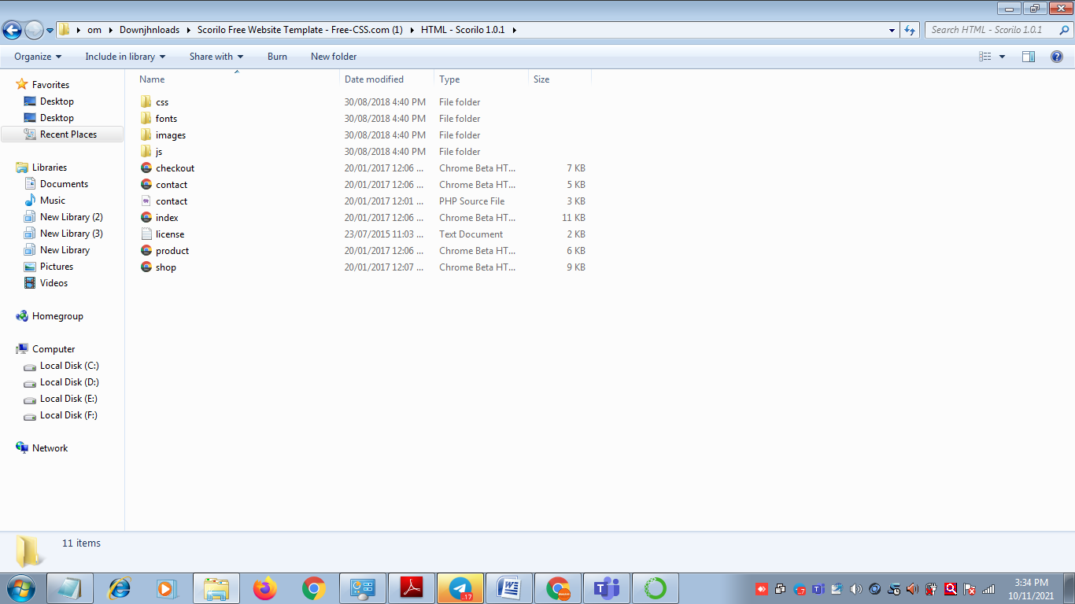

1. Which files you moved to template folder

All the html files are copied to templates

e.g.

index.html

shop.html

contact.html

product.html

checkout.html

1. Write Settings for the template folder

Create one directory with name *templates* in default path

‘DIRS’=[ os.path.join(BASE_DIR,’*templates*’) ]

1. Which files you moved to static folder

All the css js images file folder we move to static folder

1. Write settings for the static folder

Create one folder with name static

Copy all folders having js CSS image into static

STATIC_ROOT=os.path.join(BASE_DIR,’assets’)

STATICFILE_DIRS=[ os.path.join(BASE_DIR,’static’) ]

1. How to manage css and js files path.

In order to manage paths for css and js file we write static and path as it is.

e.g.

<link href="css/bootstrap.min.css" rel="stylesheet">

<link href={% static "css/bootstrap.min.css" %} rel="stylesheet">

1. Which statement we write at the start of every html file to include static folder.

{% load static %}

1. How we collect static files.

Python manage.py collectstatic

1. How we run the app as home page.

Create urls.py in apps

Urls.py contains following

from django.urls import path

from . import views

urlpatterns = [

path('',views.home_page,name="home page"),

] Code in views.py

def home_page(request):

return HttpResponse("Hi Web")

from django.contrib import admin

from django.urls import path,include

urlpatterns = [

path('',include('newapp.urls')),

path('admin/', admin.site.urls),

]