JOB PORTAL SYSTEM

Introduction

A job portal is a website where people who need jobs can find jobs and companies looking for job seekers can find the perfect employees. It serves as a medium where job seekers can create profiles, upload resumes, and search for job openings across various industries and locations.

Purpose

The purpose of this document is to provide a detailed description of the Job Portal System. The system aims to connect employers and job seekers in a seamless online platform where job listings, job applications, and recruitment processes are facilitated.

Scope

This system will provide the following features:

* Job seekers can create profiles, search for jobs, apply for jobs, and manage their applications.
* Employers can post job listings, view applications, and manage job listings.
* Admins can monitor the overall platform, approve/reject jobs, and manage user accounts.

**Definitions, Acronyms, and Abbreviations**

* Job Seeker: An individual searching for employment.
* Employer: A company or individual posting job vacancies.
* Admin: A person responsible for managing the platform and overseeing its operations.

Objective

The objective of this project is to develop a career networking website with a recruitment site, which is a modern way for the employers to advertise the latest job openings in their organization over the internet. This project also facilitates the jobseekers to iterate and follow with their professional network, search jobs and apply for these jobs online. This project will provide the employers with low budget cost effective resume search and job posting options for the companies to best fit their job requirements. Hiring and Firing of the candidates are not in the scope of this project. The administrator of the site can delete any existing User, can delete any existing Job, and manages the website. The administrator can also Backups and Restores the database.

What a jobseeker has to do? He has the facility for viewing the jobs online with optimal details a jobseeker would require, view employers information, uploads, copy and paste or build a resume online to be able to get in a search results of employer.

What an employer has to do? He has the facility for viewing the resumes of the jobseekers online with optimal details, can post a job, can edit a job or he can delete a job he has posted for the jobseeker.

The main objective of this project is to facilitate the jobseeker and employer to make online job searching and resume searching from any location, by using the internet and have no need to go to the offices or to get connected with hiring companies.

**Features**

**User Registration** & **Authentication**: Users can register and log in as job seekers, employers, or admins.

**Profile Management**: Users can create and edit profiles with personal information, skills, experience, and qualifications.

**Job Search & Application**: Job seekers can search and apply for jobs.

**Job Posting & Management**: Employers can post new job listings and manage their existing job posts.

**Admin Dashboard**: Admin can manage users, monitor the site activity, approve/reject job posts, and handle complaints.

**Characteristics**

**Job Seekers:** Users who want to find employment. They need features like job search, applying for jobs, and creating a personal profile.

**Employers:** Companies looking to post job listings and receive applications. They need to manage listings and candidates**.**

**Admin:** Responsible for managing user activities, job postings, and overseeing the platform's integrity.

**Functional Requirements**

The functional requirements of an online job portal system include user registration and authentication for job seekers and employers, allowing them to create and manage profiles. Job seekers should be able to search for jobs based on filters such as location, salary, and industry, while employers can post job vacancies and view applicant resumes. The system should support resume uploading, application tracking, and communication between job seekers and employers. Additionally, it should offer features like job alerts, a rating/review system, and integration with email notifications for updates on application status or new job postings.

**Primary actors of the System**

The primary actors of a job portal system include job seekers, employers, and administrators. Job seekers are individuals looking for employment opportunities; they create profiles, upload resumes, and apply for jobs. Employers are companies or recruiters who post job openings, review applications, and select candidates. Administrators manage the platform, ensuring smooth operation, overseeing user activities, moderating content, and handling technical issues. These actors interact with each other to facilitate job searching and recruitment processes.

**User Story**

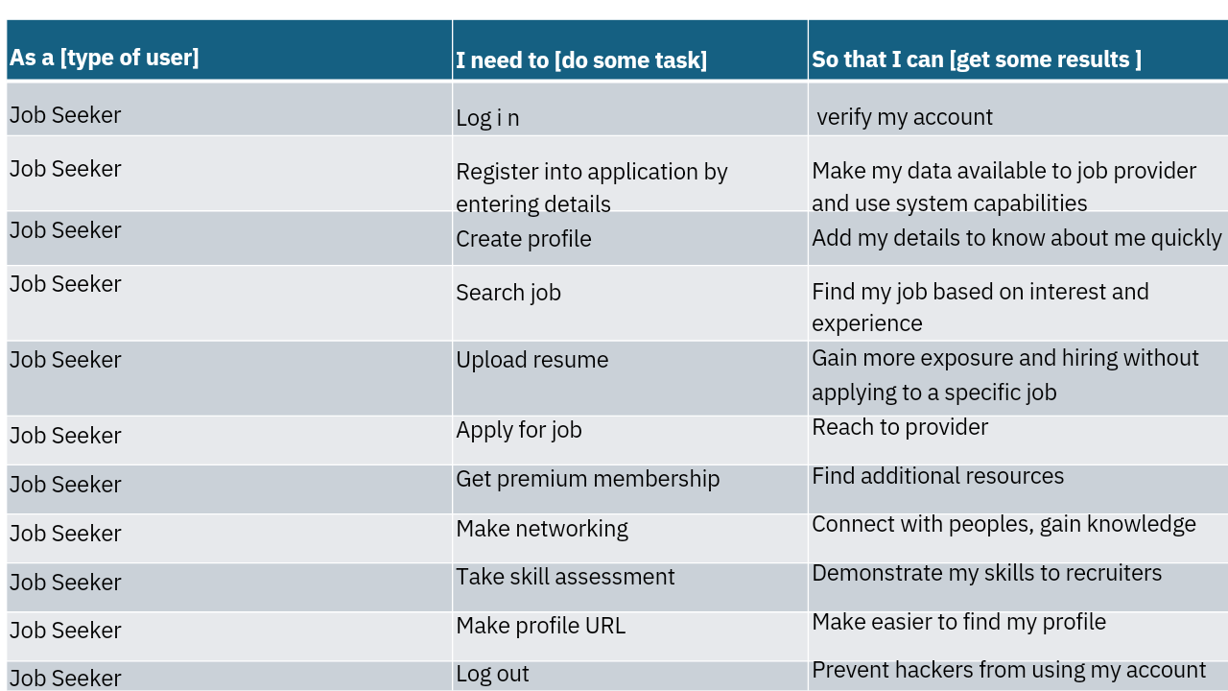

|  |  |  |  |
| --- | --- | --- | --- |
| **As a (type of user)** | | **I need to (Do Some Task)** | **So that I can (Get so result)** |
| Platform Admin | | Login | To enter |
| Platform Admin | | Provider account management | To review the account |
| Platform Admin | | Seeker account Management | To review the account |
| Platform Admin | | Content Management | Tracking the application that published |
| Platform Admin | | Interview Schedule | How much interview scheduled |
| Platform Admin | | Application tracking | To help the seeker when their application is not full fill by sending mail |
| Platform Admin | | Data analysis | That help the provider by providing how much sent |
| Platform Admin | | Subscription | To helping premium members |
| Platform Admin | | Generating reports | It shows statistical knowledge of application |
| Platform Admin | | Help and query management | Helping provider and seeker by solving |
|  |  | | | |

|  |  |  |
| --- | --- | --- |
| As a [type of user] | I need to [do some task] | So that I can [get some result] |
| Job Provider | Register into the app by entering details. | Make my data available to job seeker and use the system capabilities reserved for registered users. |
| Job Provider | After registration, I need to  Login into app by giving user name and password. | Job provider get into his login page. |
| Job Provider | Post company details on the portal. | Candidate can know about the company. |
| Job Provider | Post a job on the job portal. | Advertise job openings and attract potential candidates. |
| Job Provider | View applicant’s details. | Short list candidates for the interview. |
| Job Provider | Send emails to the shortlisted candidates for the interview. | Candidates will be intimated about the scheduled interview. |
| Job Provider | Show shortlisted candidate info in the job portal. | Candidate can view their interview status. |
| Job Provider | I need to call the candidate for the final HR round interview. | Pass the info that the candidate must be available for the final round of interview. |
| Job Provider | I need to list selected candidates in the portal. | Selected candidate info will be available to top level managers in the company. |
| Job Provider | I need to add new employee into the system. | The new employee details will be stored into the system. |
| Job Provider | Log out from the app. | Exit the application. |

Use case Diagrams

Actor

Register

Login

Upload

Resume

Apply Job

Make

Networking

Take skill

Assessment

Create

Profile

URL

Create

Profile

Search

Job

Get

Premium

Membership

Logout

**Job Provider**

Register

Login

Company

Profile

Post Job

Schedule Interview

Add

Selected

Candidates

Logout

Actor

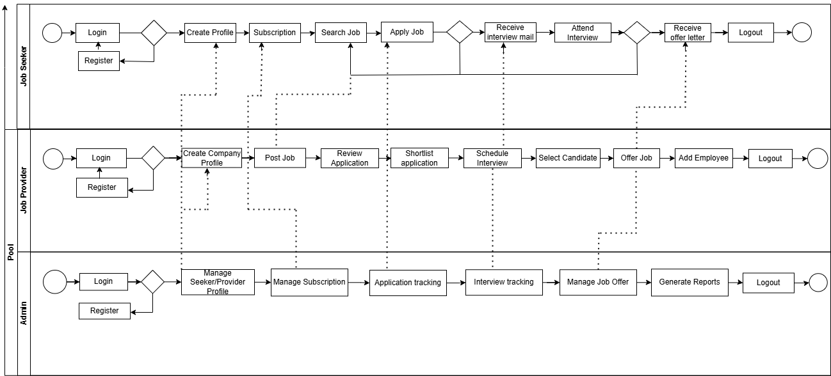V

View

Applicants

Shortlist applicants

Offer

Job

**Admin**

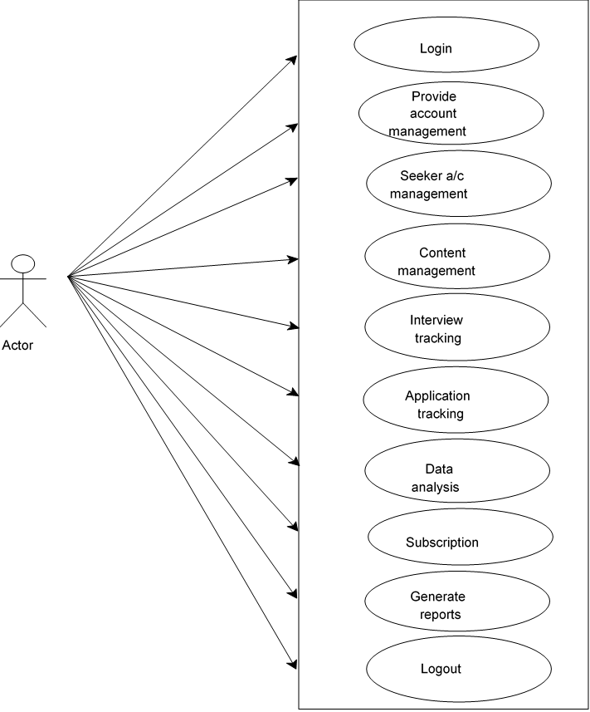

**Business Process Diagram**



Non-Functional Requirements

* The system must be available 99.9% of the time, excluding planned maintenance.
* The system must support at least 10,000 simultaneous users.
* The response time for any user action should be under 3 seconds.
* The system must comply with data protection regulations such as GDPR.

Technical Requirements

A job portal system requires several key technical components to function effectively. It should include a user-friendly interface for job seekers and employers, allowing job posting, search, and application management. The system needs a secure user authentication process, data storage for job listings, resumes, and user profiles, as well as an advanced search algorithm for filtering job opportunities based on various criteria. Integration with email notifications, a responsive design for mobile and desktop, and robust backend systems for handling traffic and data processing are also crucial. Security protocols, such as encryption and data privacy compliance (GDPR), must be implemented to protect sensitive information.

Conclusion

This SRS document for a Job Portal System provides a detailed outline of its key features, system requirements, and specifications. It ensures that the development team, stakeholders, and clients are aligned on what the system will deliver and the expected performance.