Component Naming Convention for Solar Projects
Introduction: The purpose of this section is to standardize the equipment naming across RRC’s ETAP studies. This added consistency will reduce mistakes and contribute to higher client satisfaction. The below names should be used as the default naming conventions, with exceptions being made where necessary.
The first block should be built (block 01) according to the below naming conventions, while entering as much data possible that is known at the time. Even if the protective devices are not known, it is much easier to enter that information later, than it is to add a component to every block. When a component is copied/pasted, the component number 1 higher will be in the dumpster. You must right click and select “Remove from Dumpster” to bring it into the oneline. When there is a leading zero (ex: GSU 01), the component “GSU 1” will be in the dumpster, and “GSU 2” will appear on the oneline. In this case, it is best to leave the components in the dumpster, paste all the blocks that are needed, and add the leading zeros once all blocks are pasted.

AC Model
Point of Interconnection - POI
Main Power Transformer - MPT 1
- MPT Primary Bus - MPT 1 HV
- MPT Secondary Bus - MPT 1 LV
- MV Substation Bus - 34.5 kV MPT 1
- Static Load - No Load Losses - MPT 1 NLL
Generator Step Up Transformer - GSU 01 (Or 001 if project has 100 or more power blocks)
- GSU Primary Bus - GSU HV 01 (If the primary of the GSU is not accessible and there is a MV switchgear, the bus should be named MV SWGR 01)
- GSU Secondary Bus - GSU LV 01
- Inverter Output - INV AC 01
- Static Load Losses - GSU NLL 01
- GSU Fuses (This depends on the inverter manufacturer, some GSUs have a MV relay and Breaker)
  - Expulsion Fuse - EXP 01
  - Current Limiting Fuse - CLF 01
- MV Breaker - CB 01
- Current Transformer - CT 01
- MV Relay - RELAY 01 (Or name according to drawings followed by 01)
Auxiliary Transformer - AUX XFMR 01
- Aux transformer primary bus - AUX XFMR HV 01 (The drawings should be examined to see if this has a different name)
- Aux transformer secondary bus - AUX XFMR LV 01 (The drawings should be examined to see if this has a different name)
- Aux transformer protective devices
  - Auxiliary Transformer Fuse - AUX FUSE 01
  - Auxiliary Transformer Circuit Breaker - AUX CB 01
Inverter - INV 01
DC Bus - DC 01
PV Array - PV 01
MV Cables - These names are generated in the IO sheet and can be found in the Circuit ID column in the MV Circuits tab
Junction Box - JB 01 (Or name accordingly to the Single Line Drawing)
Substation Devices
- HV & MV Breakers - CB 1 (Name after the feeder number, or name according to substation oneline drawing if available)
- MV Relay - RELAY 1 (Name after the feeder number, or name according to substation oneline drawing or .RDB file if available)
- Current Transformer - CT 1
- Capacitor Bank - CAP 1
For BESS components, either add “BESS” to the beginning of each component name, or name according to the project drawings.

MPT Example from Big Star Solar:
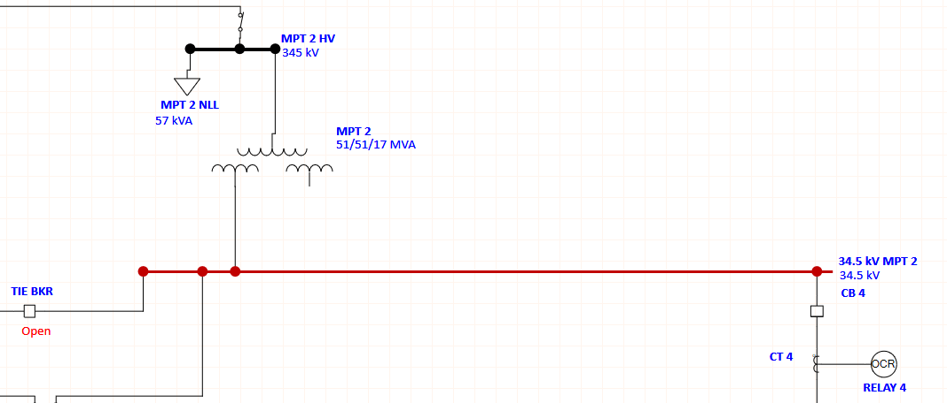

Power Block Example from Big Star Solar:
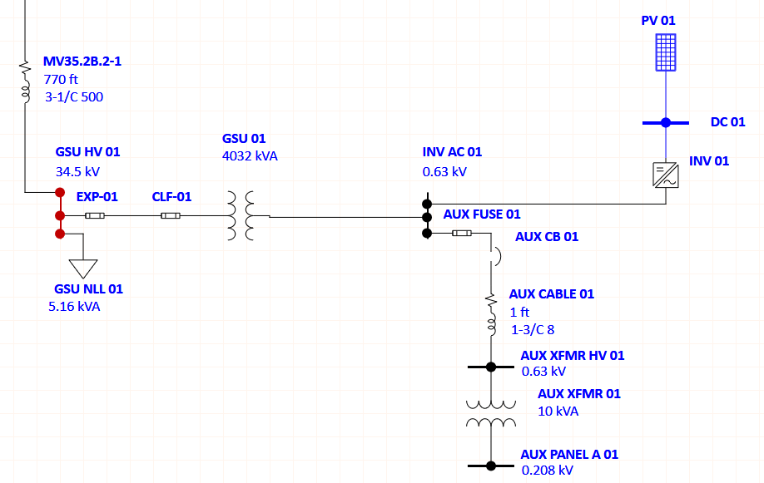

HV & MV breaker Example from Maplewood
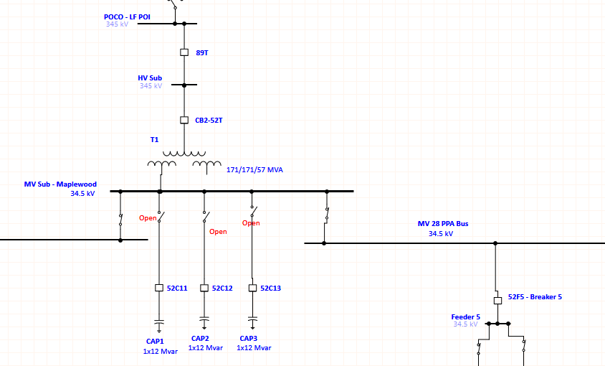

DC Model
The DC system is modeled only for the worst-case block in ETAP. Generic names can be used, as shown below. The DC Recombiner name may need to be customized depending on client preference.

Shoals BLA DC Example - Slate
