Tunisian Red Crescent
an android app by RRDL

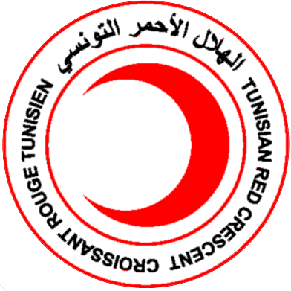
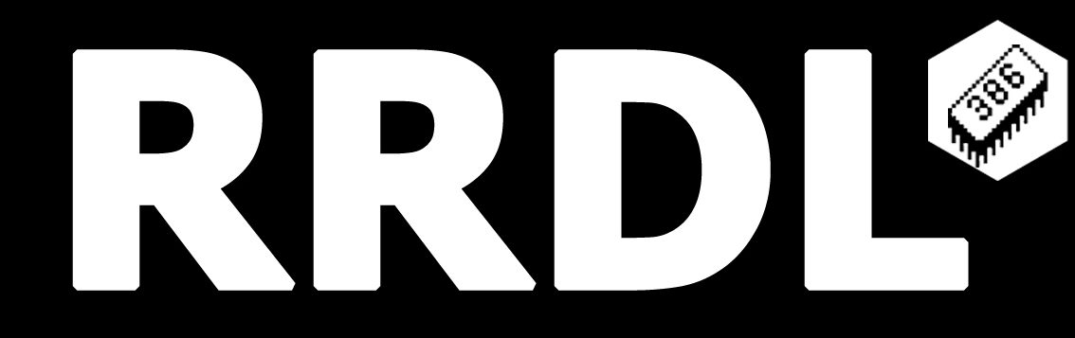

1.RRDL
RRDL is a name we chose to represent our team.
We are a group of senior computer-science students , and we believe that we must use our acquired knowledge to give back to Tunisia and the rest of the World.
We also believe that all of our projects must be open-source as we learned so much from other people who shared their code online.
We strive to make free software ideology mainstream , as it’s beneficial to everyone involved.

-RRDL team
2.How it came to be?
We all witnessed the horrible wildfire that struck ain-drahem.
We were moved by the action of our heroes : firemen , medics , volunteers.
After some research we noticed that the volunteer scene in Tunisia is limited and the volunteer-ism culture is pretty much unheard of.
And this is what motivated our team to develop Tunisian red crescent app.

2.What can it do ?

- View First aid instructions off-line(Localized in French , English and Arabic).
-Get notified about cases that you may make a difference in by helping
-View map that will guide you to the nearest Red Crescent centers.
- Live chat with other volunteers to ease communication between Red Crescent members and good Samaritans.

3.How it works ?

3.1 – Interface :
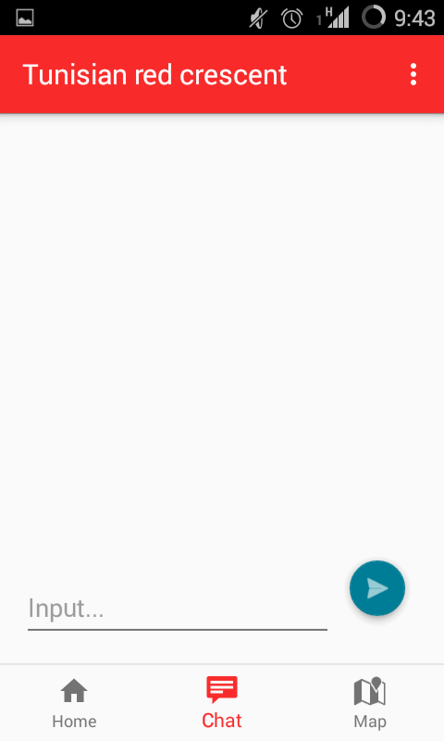
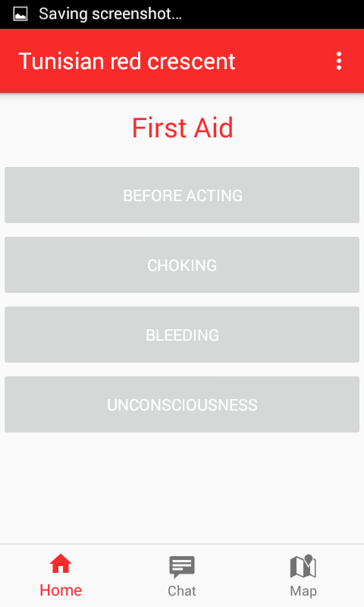
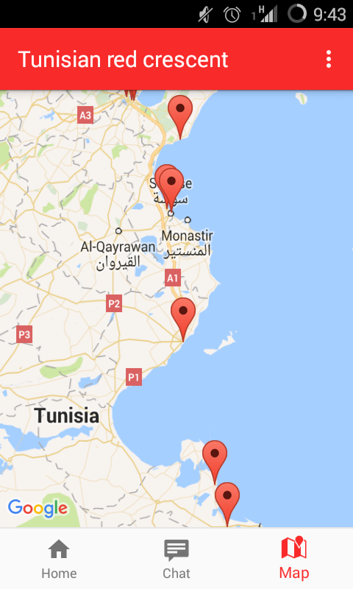

The layout as you can see is pretty intuitive and simple to use
On the left: Home page :
gives you access to first aid instructions

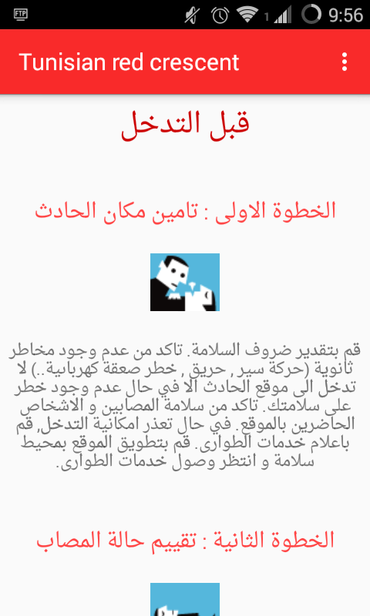

On the Middle: Chat page
On the Far right : Map that contains Tunisian red crescent locals

3.2 – Classes and files
you can further investigate code , assets and contributers on github/rrdl
The project is under an MIT license and everyone is welcome to contribute.

4 – Future and other projects:
You can explore further features that we are currently working on , on RRDL’s github.

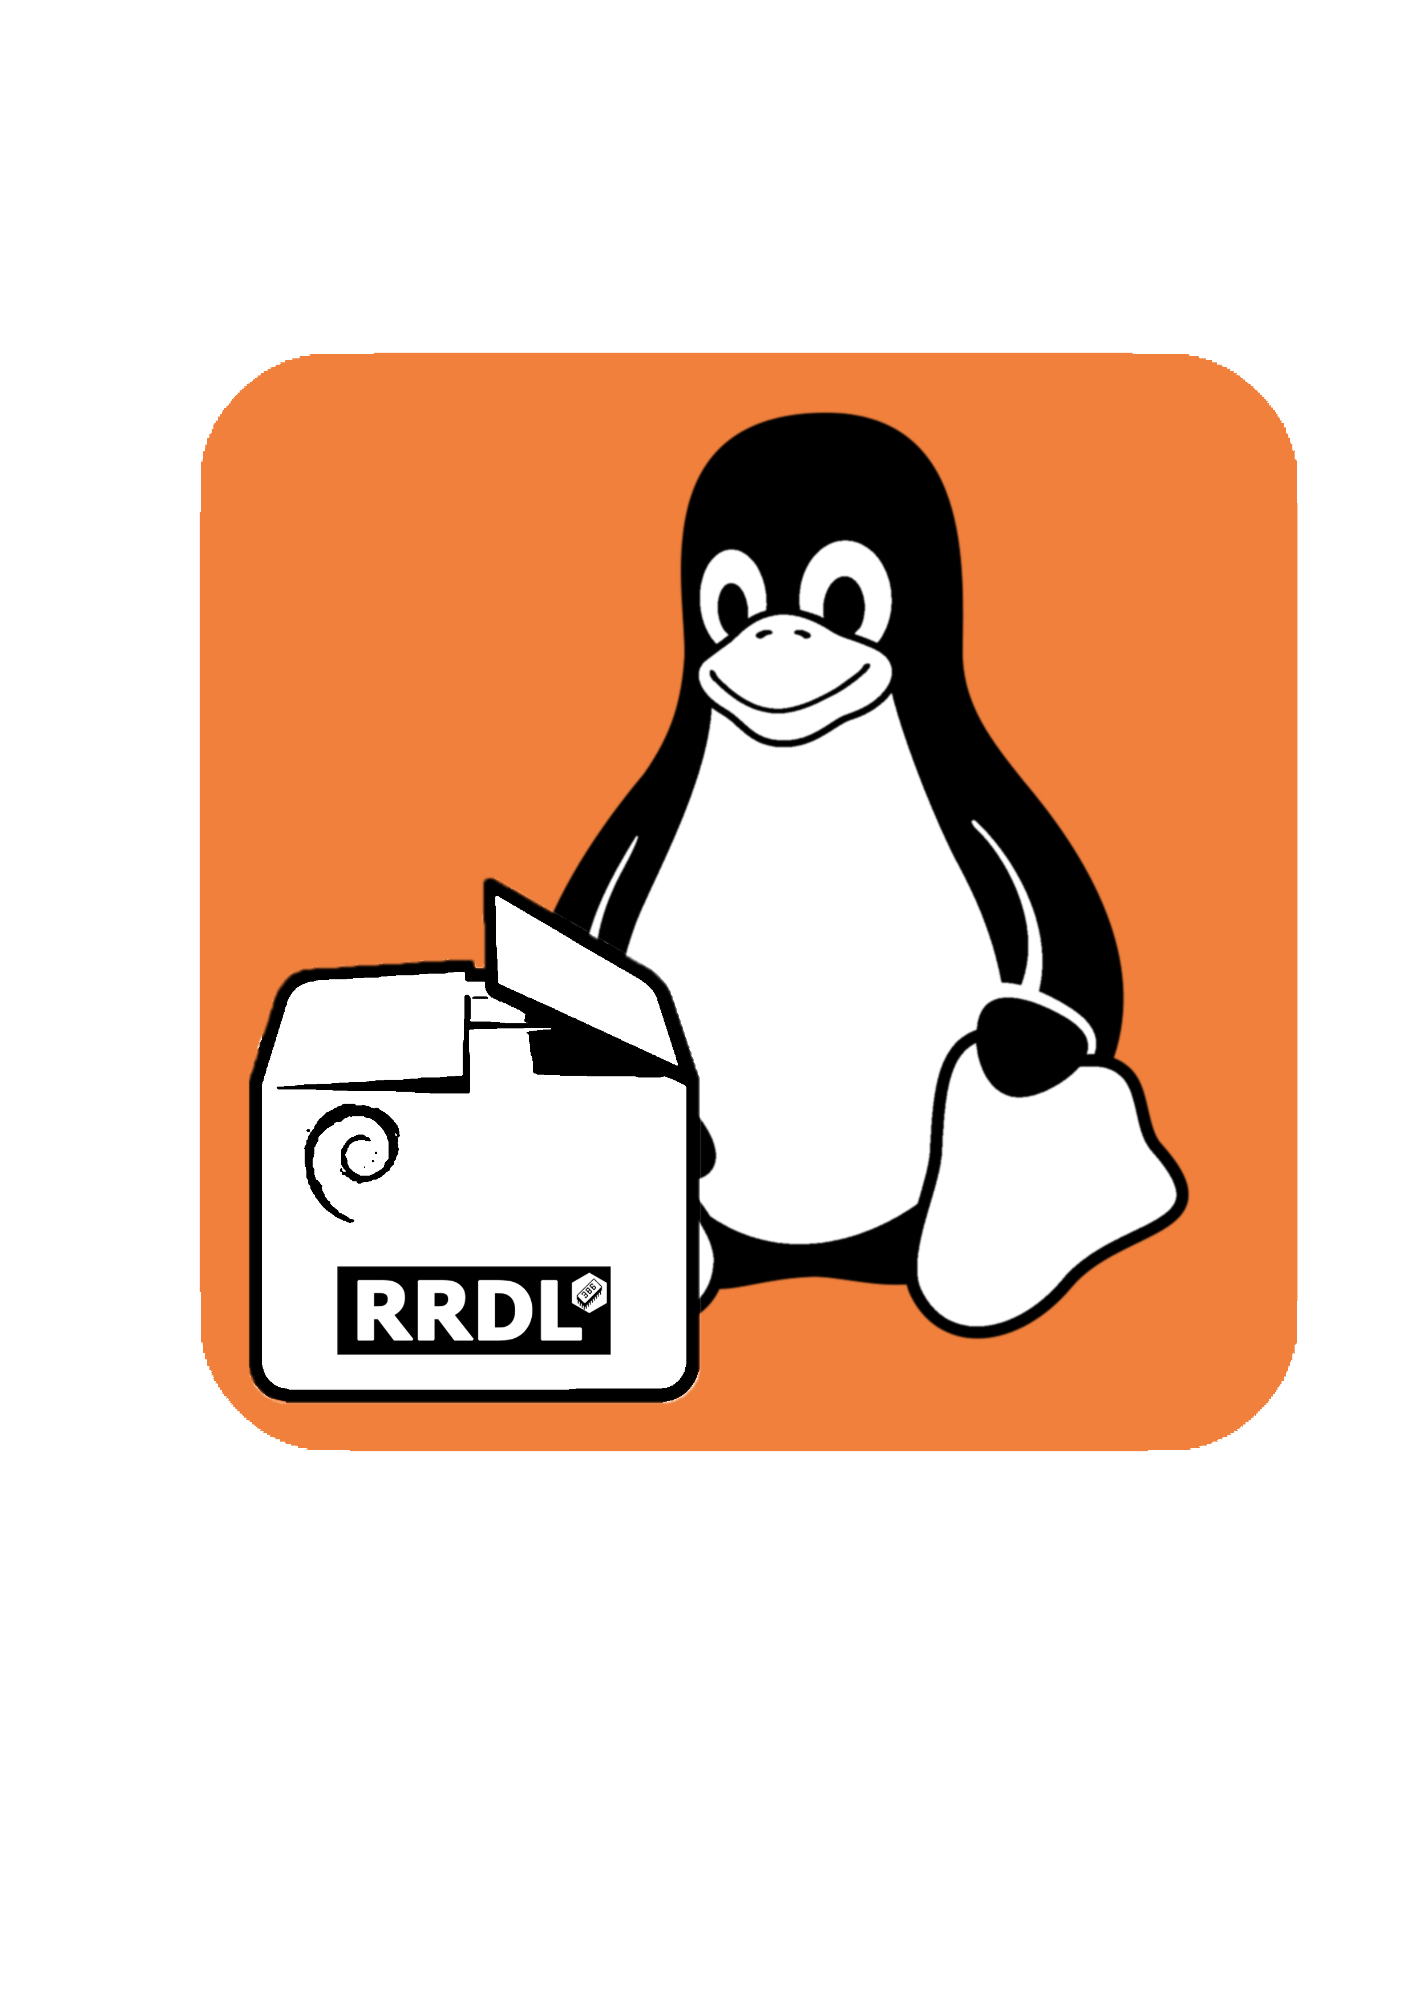
You also can explore other projects and tools that are being worked on (example : Linux Package finder)

