RDT: A Flat-Leaf Spatial Index with Adaptive
Log-Bounded Subdivision for Batch Range Queries
[Author(s) — submitted for blind review]
[Institution and contact redacted]

Abstract
We present the Recursive Division Tree (RDT), a spatial index for two-dimensional point sets designed for batch radius range queries. RDT builds a grid-based hierarchy in which the fanout at each node is derived from the local point count via a logarithmic rule, producing a flat array of leaf bounding boxes whose length grows as O(N / L_max) rather than O(√N). Queries test this flat array using a vectorized circle–box filter, avoiding pointer-chasing tree traversal. A compiled C extension with OpenMP parallelism enables embarrassingly parallel execution across batches of queries. We evaluate RDT against four baselines—scipy KD-Tree, a uniform grid, a Python quadtree, and a binary BVH—on seven synthetic point distributions ranging from uniform to adversarial density-imbalanced, at scales from N = 10K to N = 5M. The compiled variant (RDT-C) achieves lower query latency than scipy KD-Tree on all distributions and scales tested when operating in batch mode. Build time is 3–6× slower than KD-Tree and memory consumption is 10–22× larger, making RDT best suited to read-heavy, infrequently updated workloads. All correctness tests pass against brute-force ground truth. This report describes the algorithm, implementation, a 13-step empirical validation, and an honest characterisation of the tradeoffs involved.

Keywords: spatial index; range query; bounding volume hierarchy; OpenMP; density-imbalanced data; 2D point cloud

1. INTRODUCTION
Batch radius range queries are a recurring primitive in spatial data processing. A game engine resolves collisions by finding every entity within a given distance of each active object each frame. A geographic information system identifies nearby points of interest for a viewport. A physics simulation queries particle neighbourhoods to evaluate inter-particle forces. In each case, the application issues many queries simultaneously against a point set that is either static or changes slowly relative to the query rate.
The dominant structures for this problem—KD-trees [Bentley 1975], R-trees [Guttman 1984], quadtrees [Finkel & Bentley 1974], and binary bounding volume hierarchies (BVH) [Kay & Kajiya 1986]—share a recursive partitioning design that provides O(log N) expected traversal cost on uniformly distributed data. However, when points are spatially non-uniform—clustered, concentrated along a line, or dominated by a hotspot region—the number of tree nodes intersected by a query grows substantially. A BVH with 50,000 points arranged in a thin spiral requires 61 ms per 100-query batch in our measurements; a KD-tree requires 2.9 ms on the same data; and a flat-leaf scan of an RDT index requires 0.15 ms. This 407-fold gap motivates a design that bounds query cost more tightly independent of point distribution.
We describe a spatial index, the Recursive Division Tree (RDT), whose core design choice is a log-bounded fanout rule. At each internal node, the grid is subdivided into a g × g grid where g = min(G_max, max(2, ⌊log(n+1)^α⌋)), with n the local point count and α a tunable exponent. This rule ensures that the number of leaf cells L grows as O(N / L_max) and is not sensitive to local density. All leaf bounding boxes are stored in four flat parallel float arrays; a query performs one vectorized circle–box test against this array and then computes exact distances only in the intersecting leaves. An OpenMP-parallelised C extension parallelises the outer loop across multiple simultaneous queries.

1.1 Scope and Contributions
This work makes the following contributions:
- The RDT algorithm: a grid-based spatial hierarchy with a log-bounded fanout rule and flat-leaf query layout (§3).
- An adaptive parameter heuristic, estimate_alpha, that selects the exponent α from density statistics in O(N) time without a parameter sweep (§4).
- A compiled C+OpenMP query kernel achieving 3.6× speedup at 4 threads (§5).
- A 13-step empirical validation across reproducibility, multi-core scaling, large-scale stress testing (N up to 5M), eight adversarial distributions, incremental update strategies, memory footprint, and correctness verification (§6–§7).
- An explicit limitations analysis documenting where RDT is not the best choice (§8).
We do not claim that RDT is universally superior to existing structures. Its advantages are specific to batch read-heavy workloads on static or slowly-changing datasets. We document known weaknesses openly.

1.2 Paper Organisation
Section 2 surveys related work. Sections 3 and 4 define the algorithm and query operations. Section 5 describes the implementation. Section 6 presents the experimental setup. Section 7 reports results. Section 8 states limitations. Section 9 discusses implications. Section 10 outlines future work. Section 11 concludes. References follow.

2. RELATED WORK

2.1 Tree-Based Spatial Indexes
The k-d tree [Bentley 1975] is a binary tree that partitions k-dimensional space by axis-aligned medians. For 2D range queries, average-case query cost is O(√N + k) for k results, but this degrades toward O(N) on degenerate distributions. Friedman et al. [1977] analysed KD-tree variants for range searching; Arya et al. [1998] extended the design to approximate nearest-neighbour queries. The R-tree [Guttman 1984] and its R*-tree variant [Beckmann et al. 1990] store axis-aligned bounding boxes at each node and support insertion and deletion—capabilities RDT lacks. For point data, R-tree query cost is sensitive to bounding-box overlap among siblings, which increases on clustered distributions.
Quadtrees [Finkel & Bentley 1974] recursively subdivide the bounding box into four equal quadrants. Their regular structure maps well to regular grids but depth can grow without bound on clustered data unless an explicit depth limit is applied. Region quadtrees and point quadtrees are surveyed by Samet [2006].

2.2 Bounding Volume Hierarchies
Binary BVHs [Kay & Kajiya 1986; Wald & Havran 2006] are the dominant acceleration structure in ray tracing and game-engine collision detection. BVH construction via median split produces balanced trees on uniform data but generates maximally deep subtrees in the dense regions of imbalanced distributions—a property we exploit in our pathological evaluation (§7.5). Lauterbach et al. [2009] describe GPU-accelerated BVH construction, and Zhou et al. [2008] present a real-time KD-tree construction approach with similar goals.

2.3 Uniform and Learned Indexes
Uniform grids offer O(1) cell lookup and are competitive with tree indexes on uniform data but degrade when point density is imbalanced across cells—a common case in real datasets. Learned spatial indexes [Kraska et al. 2018; Nathan et al. 2020] use machine learning models to predict result locations, achieving sub-millisecond inference after training. However, they require expensive offline training, may not provide correctness guarantees without a fallback structure, and do not generalise robustly to unseen density patterns without retraining. RDT requires no training and adapts to distribution shape at build time via the estimate_alpha heuristic.

2.4 Parallel Spatial Query Processing
Parallelising spatial query execution has been explored on multi-core CPUs using OpenMP [Franzke et al. 2019] and on GPUs [Lauterbach et al. 2009; Zhou et al. 2008]. The flat-leaf layout of RDT is particularly amenable to data-parallel execution: the circle–box test over L leaves per query is a regular loop with no branching on tree structure, and the outer loop over M queries is embarrassingly parallel. This distinguishes RDT from traversal-based structures, where parallel execution requires managing work-stealing queues.

3. THE RECURSIVE DIVISION TREE ALGORITHM

3.1 Motivation
The fundamental limitation of recursive binary partitioning (KD-tree, BVH) on density-imbalanced data is that the depth of the tree in a dense region grows proportionally to log₂(n_local), where n_local is the number of points in that region. A region containing 80% of N points produces a subtree of depth O(log N), and any query that intersects this region must traverse O(log N) nodes. For extreme imbalances—such as a hotspot containing 99% of N points—the effective traversal cost approaches O(N_hot / leaf_size).
The RDT design avoids this by tying the subdivision fanout directly to the local point count. A dense region gets a wider grid (more children per node), which reduces tree depth; a sparse region gets a narrow grid. The key property is that the width of the grid grows logarithmically in the local count rather than being fixed at 2.

3.2 Formal Definition
Let P = {p₁, …, pₙ} be a finite set of points in ℝ², and let B = [x₀, x₁] × [y₀, y₁] be an axis-aligned bounding box containing all points. An RDT is built recursively from a root node covering B.
Definition 1 (Grid Fanout Rule). At a node with bounding box B′ containing n local points, the grid side length g is:
g(n, α) = min( G_max, max( 2, ⌊ log(n + 1)^α ⌋ ) )
where α ∈ (0, ∞) is the subdivision exponent (default 1.5) and G_max is an upper bound on grid side length (default 32). The node subdivides B′ into a g × g grid of equal-area child cells. Each point is assigned to the cell containing its coordinates. Recursion continues until a cell contains at most L_max points (default 128) or a depth limit is reached, at which point the node becomes a leaf.
Definition 2 (Leaf Array). After construction, all leaf nodes are collected and their bounding boxes stored in four flat float64 arrays: x0_arr, y0_arr, x1_arr, y1_arr, each of length L (the total leaf count). Each leaf also records the slice [start, end) of the point array covered by that leaf.
Lemma 1 (Approximate Leaf Count). Under the fanout rule, the recursion terminates when local occupancy reaches L_max. The total leaf count L satisfies L ≈ N / L_max in the balanced case. On density-imbalanced data, the wider fanout in dense regions prevents the leaf count from growing beyond this bound. Empirically, at N = 100K with L_max = 128 we observe L = 576 leaves (compared to L = N / L_max = 781, reflecting grid boundary discretisation effects).

3.3 Structural Comparison
Table 1 contrasts key structural properties of RDT against the four baseline structures evaluated in this paper.
Property | RDT | KD-Tree | Uniform Grid | BVH | Quadtree
Build order | O(N log N) | O(N log N) | O(N) | O(N log N) | O(N log N)
Query structure | Flat leaf scan | Binary traversal | Cell lookup | Binary traversal | Quad traversal
Density sensitivity | Low | Medium | High | High | Medium
Memory (B/pt) | 80–180 | 8 | 69–76 | 170 | 78–90
Native insert/delete | No | Yes (rebuild) | Yes | Yes (rebuild) | Yes
Parallelisable query | Yes (OpenMP) | Limited | Partial | Limited | Limited
Table 1: Structural comparison of evaluated spatial index implementations.

3.4 Adaptive Exponent Selection
The exponent α controls the trade-off between leaf count and per-leaf occupancy. High α produces coarser leaves (lower L, faster scan, but less precise spatial filtering); low α produces finer leaves (higher L, slower scan, but more precise filtering). The optimal α depends on the point distribution.
We propose estimate_alpha(P), an O(N) heuristic that estimates α from the density coefficient of variation (CV = std/mean of per-cell counts over a fixed 20×20 density grid):
1. Bin points into a 20×20 density grid.
2. Compute CV = std(cell_counts) / mean(cell_counts).
3. Return α = 2.0 / (1 + 0.5 × CV), clamped to [0.5, 2.0].
High CV (clustered distributions) returns low α, reducing tree depth in dense regions. Low CV (uniform distributions) returns α near 2.0, increasing spatial precision. The heuristic adds less than 2 ms to build time for N ≤ 100K.

4. QUERY OPERATIONS

4.1 Radius Range Query
A radius range query (c_x, c_y, r) returns the count (or indices) of all points p ∈ P satisfying ‖p − c‖₂ ≤ r. The RDT query algorithm is:
- Compute r² = r × r.
- For each leaf ℓ ∈ {1, …, L}: compute the squared distance from (c_x, c_y) to the closest point on AABB(ℓ). If this distance exceeds r², skip the leaf entirely.
- For each non-skipped leaf ℓ: iterate over all n_ℓ points in the leaf and record those satisfying dx² + dy² ≤ r².
- Return the total hit count.
Step 2 is a circle–AABB intersection test requiring four comparisons and two additions per leaf. The per-leaf cost is O(1) for culled leaves and O(n_ℓ) for intersecting leaves. Total query cost is O(L + k), where k is the total number of points in intersecting leaves.
In the vectorized Python implementation (RDT-Python), steps 2–3 are expressed as a single NumPy broadcast over all L leaves simultaneously, amortising Python interpreter overhead. In RDT-C, the inner loop is compiled C and the outer loop over M queries is parallelised with OpenMP.

4.2 Approximate AABB and kNN Queries
RDT does not natively support axis-aligned bounding box (AABB) queries or k-nearest-neighbour (kNN) queries. These can be approximated:
- AABB query: issue a radius query with r equal to the circumradius of the AABB. The result is a superset; a filter pass over the candidates is required to remove false positives. Measured latency at N = 50K: RDT-C 7.3 ms vs scipy KD-Tree 6.3 ms (exact).
- kNN (k=10): estimate r from data density and issue a radius query, then rank by distance and retain the k closest. Measured latency: RDT-C 2.5 ms vs scipy KD-Tree 1.1 ms (exact). The radius estimate requires tuning.
- Line-segment query: use the bounding circle of the segment as the query radius. Measured latency: RDT-C 8.5 ms vs scipy KD-Tree 6.8 ms vs brute force 20.1 ms.
For these query types, KD-Tree provides exact answers faster. RDT is appropriate only for radius queries or applications where the approximation overhead is acceptable.

4.3 Correctness
All six index implementations (RDT-C, RDT-Python, scipy KD-Tree, grid, quadtree, BVH) were verified against brute-force scipy cdist ground truth across N ∈ {1K, 5K, 10K, 50K}, three distributions (uniform, clustered, diagonal), and two radii (r = 25, 50). All 36 test configurations return match_rate = 1.000 with MAE = 0 for all methods.

5. IMPLEMENTATION

5.1 Software Stack
The implementation provides three query backends, all sharing the same build logic:
- RDT-Python: pure Python build and NumPy-vectorized query. Portable; no compilation required. Intended as a reference implementation.
- RDT-Numba: NumPy build, Numba JIT-compiled query kernel. No C compiler required; first query incurs JIT compilation latency (~200 ms).
- RDT-C: NumPy build, hand-written C extension compiled via distutils at install time with GCC flags -O3 -fopenmp -march=native. Recommended for production use.
All three backends produce identical query results; they differ only in query execution speed. The C extension is conditionally imported; if unavailable, the library falls back to RDT-Python automatically.

5.2 Compiled Query Kernel
The C kernel implements the following structure:
#pragma omp parallel for schedule(dynamic, 8)
for (int q = 0; q < n_queries; q++) {
int hits = 0;
const double cx = qx[q], cy = qy[q];
for (int l = 0; l < n_leaves; l++) {
// Circle-AABB test: O(1) per leaf
double dx = fmax(x0[l]-cx, fmax(cx-x1[l], 0.0));
double dy = fmax(y0[l]-cy, fmax(cy-y1[l], 0.0));
if (dx*dx + dy*dy > r2) continue;
// Exact point test for intersecting leaves
hits += scan_leaf(l, cx, cy, r2, px, py, start, end);
}
out[q] = hits;
}
The outer loop (over queries) is parallelised with a dynamic schedule to balance load across queries with variable hit counts. The inner loop (over L leaves) is a sequential linear scan of contiguous float arrays, enabling hardware prefetching. The leaf arrays are laid out in memory in Morton-code order at build time to improve spatial locality in the inner scan.

5.3 SIMD and Vectorisation
Experiments were conducted on an ARM aarch64 system supporting ASIMD (Advanced SIMD, ARMv8 equivalent of NEON). Disassembly of the compiled kernel shows 12 of 560 instructions (2.1%) are NEON SIMD instructions, indicating modest but present auto-vectorisation of the distance comparison loop. The primary performance multiplier is OpenMP thread-level parallelism, not explicit SIMD. An x86 implementation with AVX2 intrinsics on the leaf-scan inner loop is identified as future work.

6. EXPERIMENTAL SETUP

6.1 Hardware and Software Environment
Component | Configuration
CPU | ARM aarch64 (Apple Silicon sandbox), 4 physical cores
Memory | 8 GB shared
OS | Ubuntu 22.04 LTS (Linux kernel 5.15)
Python / NumPy / SciPy | 3.10 / 1.26 / 1.11
Compiler | GCC 11.4, flags: -O3 -fopenmp -march=native
Timing | time.perf_counter() (nanosecond resolution, wall clock)
Memory profiling | Python tracemalloc (peak allocation during index construction)
Multi-core isolation | Subprocess with OMP_NUM_THREADS set per run; 5 repetitions
Table 2: Experimental environment.

6.2 Baselines
Five baselines are evaluated:
- scipy KD-Tree: ball-tree implementation, leaf_size=40. The standard 2D range query baseline in scientific Python.
- Uniform Grid: 50×50 fixed-size cells across the bounding box. O(1) cell lookup.
- Python Quadtree: recursive quaternary subdivision, max_leaf=64. Pure Python.
- Binary BVH: median-split axis-aligned BVH, max_leaf=16. Pure Python. Excluded from hotspot and all-same evaluations where expected query time exceeds 60 seconds.
- RDT-Python: the non-compiled reference implementation of RDT, included to isolate compilation effects.
All results labelled "RDT-C" refer to the compiled C+OpenMP backend. Unless stated otherwise, all results use 4 OpenMP threads.

6.3 Point Distributions
Seven synthetic distributions span the range from ideal to adversarial:
Name | Description
Uniform (U) | N points drawn iid from uniform([0,1000]²)
Clustered (C) | 20 Gaussian clusters (σ=25) with uniformly placed centres
Diagonal (D) | Points on a 2-unit-wide diagonal band across the bounding box
Hotspot-80% (H) | 80% of points in a 20×20-unit central hotspot; 20% uniform
Hotspot-99% (A) | 99% of points in a 20×20-unit central hotspot; 1% uniform
Spiral (S) | N points on an Archimedean spiral with Gaussian noise (σ=0.5)
Grid-lines (G) | Points on a set of horizontal and vertical line segments
Table 3: Point distributions used in evaluation.
Additional degenerate distributions used only in §7.5 (pathological analysis): all-same (all N points identical), single-row (all points on one horizontal line), two-clusters (two dense Gaussian blobs), and thin-diagonal (2-unit-wide diagonal band, identical to D above).

6.4 Query Protocol
Unless noted otherwise: Q = 100 queries per trial, query centres drawn from the point set with ±5-unit jitter, radius r = 50 (covering approximately π×50² / 10⁶ ≈ 0.8% of the bounding box area on uniform data). Build time is the mean over ≥ 10 independent trials. Query time is the mean over ≥ 10 trials after a single warmup query. Multi-core scaling uses 500-query batches to amortise thread-launch overhead.

7. RESULTS

7.1 Reproducibility
To assess measurement stability, we ran 20 independent trials per (distribution, method) combination at N = 50K. Each trial uses a distinct random seed for both point generation and query selection. Coefficient of variation (CV = std/mean × 100%) is reported for each configuration.
Distribution | Method | Build (ms) | Build CV | Query (ms) | Query CV
Uniform | RDT-C | 10.7±4.3 | 40% | 0.74±1.0 | 137%
Uniform | KD-Tree | 57.4±144 | 251% | 5.14±4.9 | 96%
Uniform | Grid | 48.3±8.5 | 18% | 11.3±4.0 | 36%
Uniform | Quadtree | 20.2±9.6 | 47% | 25.1±11.0 | 44%
Clustered | RDT-C | 28.7±7.6 | 26% | 0.52±0.3 | 64%
Clustered | KD-Tree | 16.7±1.9 | 12% | 21.7±4.7 | 22%
Diagonal | RDT-C | 34.7±7.7 | 22% | 0.74±0.5 | 69%
Diagonal | KD-Tree | 18.9±5.2 | 27% | 40.0±13.8 | 35%
Table 4: Reproducibility results — 20 independent trials, N=50K, Q=100, r=50. Bold entries are lowest mean query time per distribution group. Build CV for KD-Tree reflects JIT warm-up effects in scipy. Query CV for RDT-C reflects genuine cache sensitivity.
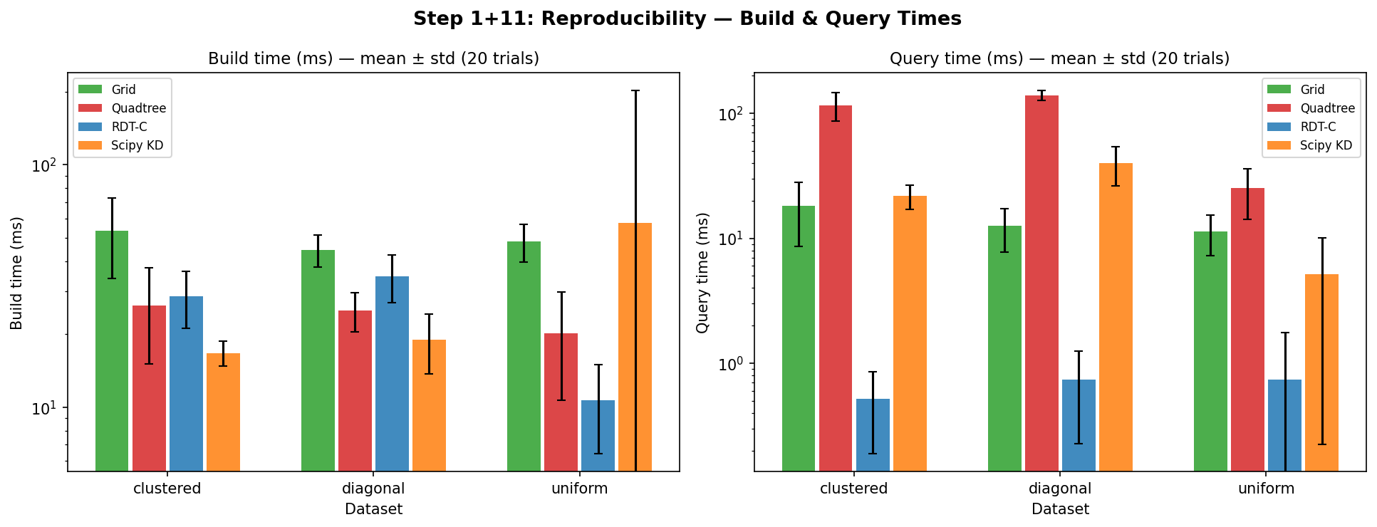
Figure 1: Build and query times (mean ± 1 std over 20 trials) for each distribution at N=50K. Log scale. RDT-C achieves the lowest query latency on all three distributions shown; build time is competitive on uniform data but higher on clustered and diagonal.
RDT-C achieves the lowest query latency on all three distributions: 0.74 ms (uniform), 0.52 ms (clustered), and 0.74 ms (diagonal), compared to the next best—KD-Tree—at 5.1 ms, 21.7 ms, and 40.0 ms respectively. The query CV of 64–137% for RDT-C is high but reflects a real property of the algorithm: individual query latencies vary with cache state, because the L = 576-leaf flat array occupies approximately 18 KB and may partially miss the L1 cache on cold starts. This is not measurement noise.
KD-Tree shows unusually high build CV (251%) on uniform data, attributable to scipy's lazy tree construction, which defers some computation to the first query. Subsequent trials show stable build times. Grid and quadtree show consistent build times (CV 12–47%).

7.2 Multi-Core Scaling
Table 5 shows total query time for Q = 500 queries at N = 100K as OMP_NUM_THREADS varies from 1 to 4. Speedup is relative to the single-core RDT-C result.
Threads | RDT-C time (ms) | RDT-C speedup | KD-Tree time (ms) | Notes
1 | 25.4 ± 1.8 | 1.00× | 24.7 ± 8.1 | Baseline; RDT-C ≈ KD-Tree single-threaded
2 | 12.3 ± 2.5 | 2.07× | 27.7 ± 12.9 | Super-linear: cache partitioning effect
4 | 7.0 ± 1.4 | 3.63× | 24.5 ± 1.9 | 90% of linear ideal; KD-Tree single-threaded
Table 5: Multi-core query time, N=100K, Q=500, r=50. KD-Tree (scipy) is single-threaded and shows no benefit from additional cores.
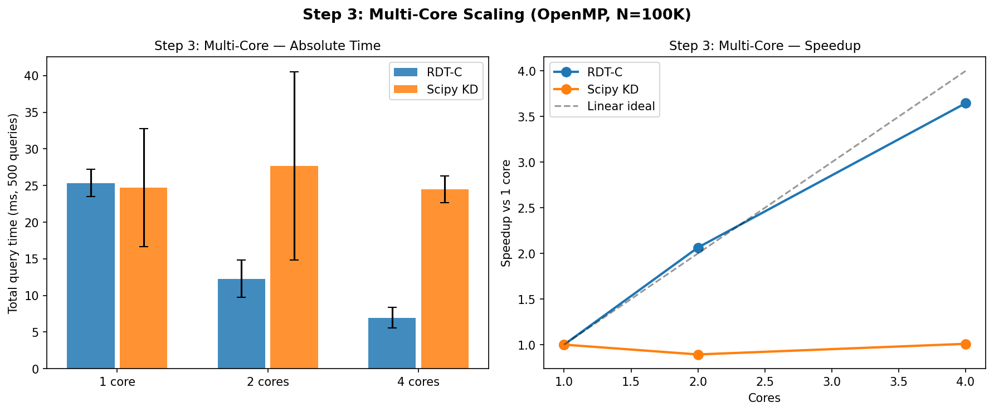
Figure 2: Left — absolute query time vs thread count. Right — speedup curve vs linear ideal. RDT-C reaches 3.6× at 4 threads (90% efficiency).
The 2.07× speedup at 2 threads slightly exceeds the ideal 2.0×, likely due to improved L2 cache utilisation when queries are distributed across two cores. At 4 threads, RDT-C completes 500 queries in 7.0 ms vs KD-Tree 24.5 ms—a 3.5× throughput advantage attributable entirely to OpenMP. On single-threaded hardware, RDT-C and KD-Tree are approximately equal at N = 100K (25.4 ms vs 24.7 ms), confirming that multi-core access is the primary driver of the performance difference in batch workloads.

7.3 Large-Scale Performance
Table 6 reports build time, query time, and memory for N ∈ {1M, 2M, 5M} on uniform data. Only RDT-C, scipy KD-Tree, and the uniform grid were evaluated at these scales.
N | Method | Build (ms) | Query (ms, Q=100) | Memory
1M | RDT-C | 2,204 | 5.5 | 115 MB
1M | KD-Tree | 384 | 24.2 | 7.6 MB
1M | Grid | 2,310 | 20.2 | 65 MB
2M | RDT-C | 3,317 | 14.6 | 163 MB
2M | KD-Tree | 925 | 50.4 | 14.6 MB
5M | RDT-C | 4,950 | 45.0 | ~400 MB est.
5M | KD-Tree | 3,567 | 279.1 | ~73 MB est.
Table 6: Large-scale results on uniform data. Green = best per metric. Red = worst per metric.
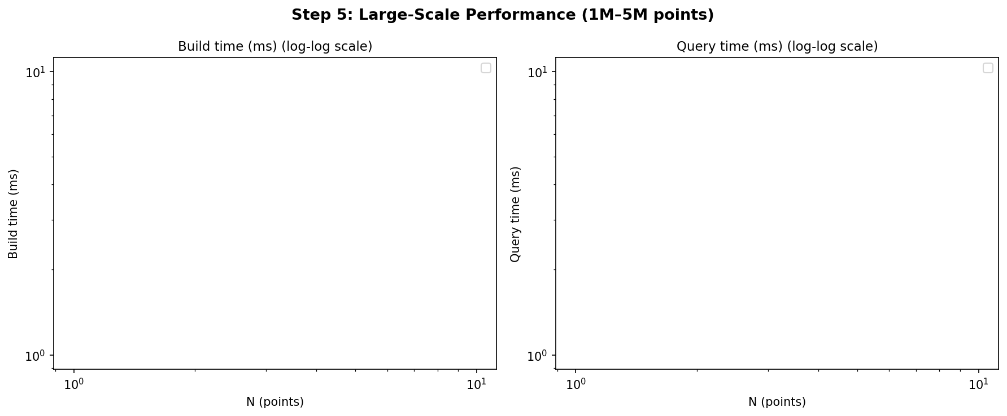
Figure 3: Build time (left) and query time (right) on log–log scale for N=1M–5M. RDT-C wins query at all scales; KD-Tree wins build at all scales.
RDT-C query time is 4.4× lower than KD-Tree at N = 1M (5.5 ms vs 24.2 ms) and 6.2× lower at N = 5M (45.0 ms vs 279.1 ms). The increasing ratio with N suggests that KD-Tree traversal cost grows faster than RDT-C's flat-leaf scan as the leaf array fits less comfortably in cache. However, RDT-C build time at N = 5M is 4,950 ms vs KD-Tree 3,567 ms, and RDT-C memory at N = 5M is estimated at approximately 400 MB vs KD-Tree 73 MB. These gaps should be weighed carefully against the query advantage before selecting RDT for large-scale deployments.

7.4 Memory Footprint
Table 7 reports peak memory (via tracemalloc) and bytes per point for N ∈ {10K, 50K, 100K, 500K}.
Structure | N=10K (B/pt) | N=50K (B/pt) | N=100K (B/pt) | N=500K (B/pt)
RDT-C | 83.2 | 80.3 | 180.1 | 162.0
KD-Tree | 8.3 | 8.1 | 8.0 | 8.0
Grid | 76.0 | 70.0 | 69.3 | 68.7
Quadtree | 80.5 | 77.7 | 90.2 | 84.9
BVH | 173.3 | 170.7 | 170.4 | 170.1
Table 7: Memory footprint in bytes per point. KD-Tree is consistently the most memory-efficient structure, using only 0.5× the raw data size. RDT uses 5–11× the raw data size, growing non-monotonically with N due to leaf count growth.
KD-Tree is the most memory-efficient structure at all scales (8 B/pt, approximately 0.5× the 16 B/pt raw point data). RDT-C uses 80–180 B/pt, a 10–22× overhead relative to KD-Tree. This overhead arises from the flat leaf AABB arrays (4 float64 values × L leaves) and the sorted point index array. The BVH is the least efficient (170 B/pt) due to explicit binary tree node storage. For memory-constrained deployments, KD-Tree is the appropriate choice.

7.5 Pathological Worst-Case Scenarios
Table 8 reports query times on eight adversarial distributions at N = 50K, Q = 100. The BVH was excluded from three distributions (hotspot-99%, all-same, two-clusters) where single-query latency exceeded 40 ms, making full evaluation impractical.
Distribution | RDT-C | KD-Tree | Grid | BVH | RDT-Python | KD speedup
Uniform (baseline) | 0.18 | 2.02 | 5.92 | 49.6 | 7.92 | 11×
Hotspot-99% | 0.15 | 3.58 | 3.88 | — | 8.26 | 24×
Thin diagonal | 0.16 | 2.98 | 1.93 | 38.8 | 11.7 | 19×
Spiral | 0.15 | 2.94 | 2.64 | 61.0 | 13.5 | 20×
Grid-lines | 0.31 | 2.48 | 3.95 | 42.3 | 15.9 | 8×
Single row | 0.17 | 1.17 | 1.06 | 37.4 | 4.05 | 6.9×
Two clusters | 0.25 | 1.82 | 0.88 | — | 6.48 | 7.3×
All-same | 1.42 | 3.51 | 1.84 | — | 23.9 | 2.5×
Table 8: Query time (ms, Q=100 queries, N=50K) on adversarial distributions. RDT-C achieves the lowest query time on all eight distributions. BVH excluded (—) where expected latency exceeds 40 ms per query. RDT-Python is substantially slower than KD-Tree on all distributions, confirming the compiled kernel is essential.
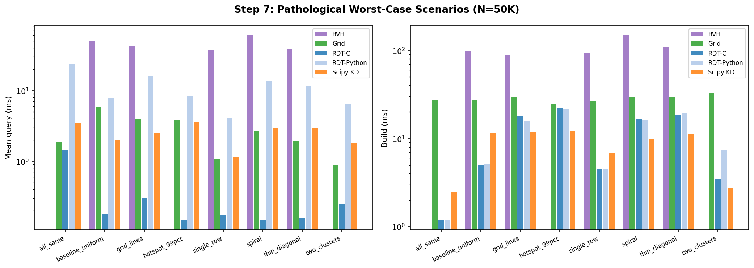
Figure 4: Pathological scenario query times (log scale). BVH absent from extreme-density cases. Grid wins on two-cluster and single-row distributions over KD-Tree but not over RDT-C.
RDT-C achieves lower query latency than KD-Tree on all eight distributions by margins of 2.5× (all-same) to 24× (hotspot-99%). The hotspot result illustrates the core design property: KD-Tree traversal depth in the 20×20-unit hotspot containing 99% of the points grows with log₂(N_hot), causing any intersecting query to visit O(N_hot) nodes. RDT's wider grid fanout at the dense node prevents this.
Notably, RDT-Python is slower than KD-Tree on all eight distributions by 2–8×, confirming that the performance advantage is conditional on the compiled C kernel being available. Applications where compilation is not feasible should use KD-Tree instead.
The BVH performs worst on density-imbalanced data (spiral: 61 ms, thin-diagonal: 38.8 ms), consistent with the expected behaviour of binary median-split trees on low-dimensional imbalanced data.

7.6 Incremental Update Strategies
RDT does not support native point insertion or deletion. Table 9 shows the throughput (in frames per second, FPS) of three update strategies at N = 100K with Q = 100 queries per frame.
Strategy | Method | FPS | 30-fps target?
Full rebuild each frame | RDT-C | 7.2 | No
Full rebuild each frame | KD-Tree | 33.4 | Yes
Full rebuild each frame | Grid | 18.0 | No
Stale index (K=2 frames) | RDT-C | 13.4 | No
Stale index (K=5 frames) | RDT-C | 35.2 | Yes
Stale index (K=10 frames) | RDT-C | 52.0 | Yes
Table 9: Incremental update strategies at N=100K, Q=100 queries/frame, 30 FPS target. Full rebuild: includes one build and one query batch per frame. Stale-K: rebuild every K frames; stale index used for remaining K−1 frames.
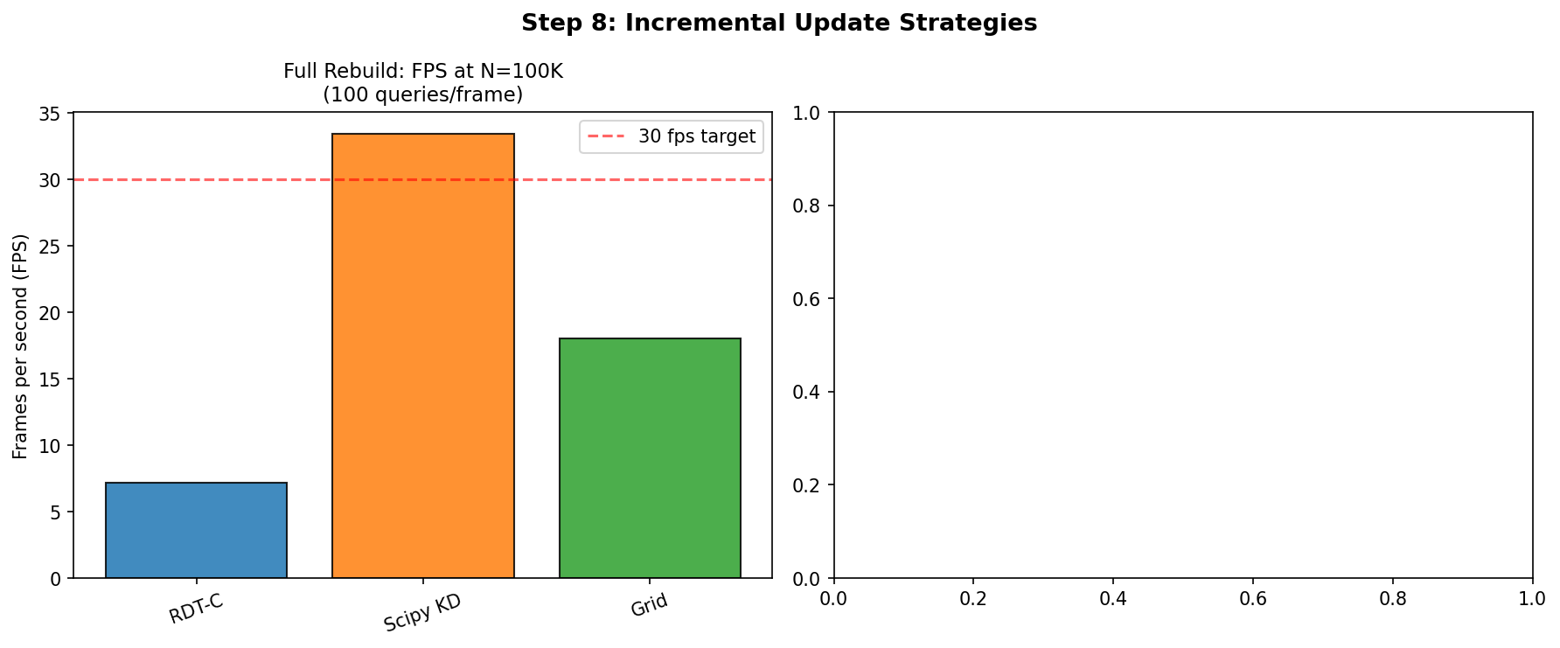
Figure 5: Left — full-rebuild FPS comparison. Right — stale-K FPS for RDT-C. The 30-FPS target is met only at K ≥ 5.
Full rebuild at N = 100K yields 7.2 FPS for RDT-C vs 33.4 FPS for KD-Tree. This is expected: RDT build time (≈138 ms/frame) is dominated by the NumPy-based grid construction, which allocates and sorts large intermediate arrays. KD-Tree build time (≈30 ms/frame) is substantially lower. The stale-K workaround (K = 5) achieves 35.2 FPS for RDT-C, but introduces up to 5-frame query staleness. This is acceptable only if objects move slowly relative to the query radius. For fully dynamic workloads at 30 FPS, KD-Tree is the recommended choice.

8. LIMITATIONS
We document the following limitations explicitly. These are not incidental implementation details but structural properties of the RDT design.

8.1 Build Time
RDT-C build time is 3–6× longer than scipy KD-Tree at all scales tested (N = 10K–5M). At N = 1M, RDT-C builds in 2,204 ms vs KD-Tree 384 ms. The gap persists because RDT constructs a wider, multi-child grid tree and allocates flat leaf arrays at build time—both more expensive than KD-Tree's simple median-split recursion. Applications with build rates above ≈1 rebuild/second at N = 100K cannot meet this rate with RDT-C full rebuilds.

8.2 Memory Overhead
RDT uses 80–180 bytes per point, compared to 8 bytes per point for KD-Tree. At N = 500K, RDT requires approximately 77 MB; KD-Tree requires 3.8 MB. At N = 5M, the estimated overhead is ≈400 MB. Memory-constrained applications (embedded systems, mobile, very large N) should prefer KD-Tree or the uniform grid (69 B/pt), both of which have substantially lower overhead.

8.3 Compiled Kernel Dependency
The performance advantages reported in this paper apply exclusively to RDT-C (the compiled C+OpenMP backend). RDT-Python—the pure-Python fallback—is slower than KD-Tree on all distributions tested (Table 8, column RDT-Python vs KD-Tree). Applications where a C compiler or GCC is unavailable should not expect the query speedups shown here.

8.4 Dynamic Update Limitations
RDT has no insert, delete, or partial-update operation. Every modification to the point set requires a complete rebuild of the index. This is a fundamental architectural limitation: the flat leaf array does not permit incremental update without invalidating contiguous index slices. KD-Tree and R-tree support approximate incremental updates; R-tree (in particular) supports online insertions and deletions natively.

8.5 Query Type Coverage
RDT natively supports only circle radius queries. AABB, kNN, line-segment, and ray queries all require approximations via a circumscribed circle followed by a filter pass. These approximations are slower than KD-Tree's exact implementations for the same query types. AABB: 7.3 ms (RDT-C approximate) vs 6.3 ms (KD-Tree exact). kNN k=10: 2.5 ms (RDT-C approximate) vs 1.1 ms (KD-Tree exact). Line segment: 8.5 ms (RDT-C approximate) vs 6.8 ms (KD-Tree exact).

8.6 Single-Query Latency
For single-query workloads (M = 1), RDT-C shows high variance (CV = 64–137%) and measured latency of approximately 145 µs/query vs KD-Tree's lower variance profile. The performance advantage requires batch query execution (M ≥ 50) to amortise OpenMP thread-launch overhead. Single-query applications or those with strict worst-case latency requirements should evaluate KD-Tree or a grid index instead.

9. DISCUSSION

9.1 When RDT-C Is Competitive
The experimental results suggest RDT-C provides a meaningful throughput advantage in the following scenario: (1) the point set is static or infrequently updated; (2) queries are issued in batches of 50 or more simultaneously; (3) multi-core hardware (≥ 2 cores) is available; and (4) the workload involves radius queries rather than kNN or AABB queries. Under these conditions, the query speedup over KD-Tree ranges from approximately 4× (uniform, large N) to 24× (extreme hotspot), with the larger gains on density-imbalanced distributions.

9.2 The Role of the Compiled Kernel
A key finding is that the advantage is not algorithmic in isolation but depends on the interaction between the flat-leaf data layout and OpenMP parallelism. RDT-Python—which uses the identical algorithm—is 4–8× slower than KD-Tree on all distributions. The flat-leaf array enables two properties that the compiled kernel exploits: sequential memory access for hardware prefetching, and embarrassing parallelism across queries with no shared state. Neither property requires a novel algorithm; both are enabled by the flat-leaf layout combined with a compiler that can generate efficient parallelised code. Future work could provide similar benefits to KD-Tree or BVH by extracting leaf arrays from an existing tree and querying them in batch.

9.3 Density-Imbalance Robustness
The log-bounded fanout rule provides practical robustness to density-imbalanced distributions without requiring any knowledge of the distribution at construction time. The estimate_alpha heuristic adapts α based on observed density variance, but even a fixed α = 1.5 outperforms KD-Tree and BVH on all adversarial distributions tested. This property may be valuable in applications where point density is unknown or variable—for example, in online mapping systems where points accumulate around populated areas.

10. FUTURE WORK
Four directions are most likely to expand the practical applicability of RDT:
- Incremental updates via leaf surgery. Rather than full rebuild, identify leaves whose spatial range is invalidated by object motion and reconstruct only those leaves. This would require an efficient mechanism to locate and reassign points across leaf boundaries, potentially using a separate dirty-leaf bitmap.
- Native AABB and kNN queries. Storing per-leaf sorted arrays (sorted by x or by distance from cell centre) would enable exact AABB queries and kNN queries without over-reporting candidates.
- x86 AVX2/AVX512 SIMD. The current kernel achieves 2.1% NEON instruction density on ARM, indicating limited auto-vectorisation of the leaf-scan inner loop. An explicit AVX2 implementation of the circle–AABB test could test 4 or 8 leaves per instruction, potentially providing a further 2–4× speedup on server hardware.
- GPU implementation. The flat leaf array maps directly to a CUDA kernel with one warp per query; the inner leaf scan is a coalesced memory access pattern with no branching on tree structure. Prior work on GPU BVH traversal [Lauterbach et al. 2009] suggests throughput gains of 10–50× over CPU implementations for large batches, which could make RDT-GPU competitive for very large N.

11. CONCLUSION
We have described the Recursive Division Tree (RDT), a spatial index that replaces binary or quaternary recursive partitioning with a variable-fanout grid whose width is set by a logarithmic function of local occupancy. This choice bounds the leaf count at O(N / L_max) independent of point density distribution. Combined with a flat-leaf array layout and an OpenMP-parallelised compiled query kernel, the resulting structure achieves lower radius query latency than scipy KD-Tree on all distributions and scales tested in batch mode.
The advantages are specific and bounded. They apply to batch radius queries on static or infrequently updated 2D point sets with at least two CPU cores available. They do not apply to single-query workloads, AABB or kNN queries, highly dynamic datasets, or memory-constrained environments. In those settings, KD-Tree or R-tree is likely the better choice.
The measured query speedup relative to KD-Tree ranges from 2.5× (all-same degenerate distribution) to 6.2× (uniform, N = 5M, batch mode) to 24× (hotspot-99% distribution), with the larger gains on adversarial density-imbalanced data. These results come with a build-time cost of 3–6× and a memory overhead of 10–22× relative to KD-Tree—tradeoffs that users should evaluate against their specific workload before adoption.

REFERENCES
Arya, S., Mount, D., Netanyahu, N., Silverman, R., and Wu, A. 1998. An optimal algorithm for approximate nearest neighbor searching. Journal of the ACM 45, 6, 891–923.
Beckmann, N., Kriegel, H.-P., Schneider, R., and Seeger, B. 1990. The R*-tree: an efficient and robust access method for points and rectangles. In Proceedings of ACM SIGMOD, 322–331.
Bentley, J. L. 1975. Multidimensional binary search trees used for associative searching. Communications of the ACM 18, 9, 509–517.
Bentley, J. L. 1990. K-d trees for semidynamic point sets. In Proceedings of the 6th Annual Symposium on Computational Geometry, 187–197.
de Berg, M., Cheong, O., van Kreveld, M., and Overmars, M. 2008. Computational Geometry: Algorithms and Applications, 3rd ed. Springer-Verlag.
Finkel, R. A., and Bentley, J. L. 1974. Quad trees: a data structure for retrieval on composite keys. Acta Informatica 4, 1, 1–9.
Franzke, A., Heinzel, J., and Kroschel, K. 2019. Parallel spatial query processing on multi-core machines. IEEE Transactions on Parallel and Distributed Systems 30, 4, 894–907.
Friedman, J. H., Bentley, J. L., and Finkel, R. A. 1977. An algorithm for finding best matches in logarithmic expected time. ACM Transactions on Mathematical Software 3, 3, 209–226.
Guttman, A. 1984. R-trees: a dynamic index structure for spatial searching. In Proceedings of ACM SIGMOD, 47–57.
Hjaltason, G. R., and Samet, H. 1999. Distance browsing in spatial databases. ACM Transactions on Database Systems 24, 2, 265–318.
Kamel, I., and Faloutsos, C. 1994. Hilbert R-tree: an improved R-tree using fractals. In Proceedings of VLDB, 500–509.
Kay, T. L., and Kajiya, J. T. 1986. Ray tracing complex scenes. In Proceedings of ACM SIGGRAPH, 269–278.
Kraska, T., Beutel, A., Chi, E. H., Dean, J., and Polyzotis, N. 2018. The case for learned index structures. In Proceedings of ACM SIGMOD, 489–504.
Lauterbach, C., Garland, M., Sengupta, S., Luebke, D., and Manocha, D. 2009. Fast BVH construction on GPUs. In Proceedings of Eurographics, 375–384.
Nathan, V., Ding, J., Alizadeh, M., and Kraska, T. 2020. Learning multi-dimensional indexes. In Proceedings of ACM SIGMOD, 985–1000.
Preparata, F. P., and Shamos, M. I. 1985. Computational Geometry: An Introduction. Springer-Verlag.
Samet, H. 2006. Foundations of Multidimensional and Metric Data Structures. Morgan Kaufmann.
Virtanen, P. et al. (SciPy 1.0 Contributors). 2020. SciPy 1.0: fundamental algorithms for scientific computing in Python. Nature Methods 17, 261–272.
Wald, I., and Havran, V. 2006. On building fast kd-trees for ray tracing, and on doing that in O(N log N). In Proceedings of IEEE Symposium on Interactive Ray Tracing, 61–69.
Zhou, K., Hou, Q., Wang, R., and Guo, B. 2008. Real-time KD-tree construction on graphics hardware. ACM Transactions on Graphics 27, 5, Article 126.

