RDT SPATIAL INDEX
Comprehensive Performance Evaluation

Honest Evaluation Across 10 Workload Categories

Metric | Result | Notes
Static workloads won (7 ds × 4 N) | 28 / 28 (RDT-C) | 100% win rate on all distributions
Best speedup vs Scipy KD-Tree | 167× (adversarial hotspot, N=100K) | RDT-C handles extreme density
Dynamic workload (N=50K, high coh.) | RDT-C: 164 fps | Scipy KD: 75 fps; Grid: 38 fps
Dynamic workload (N=100K) | Scipy KD: 37 fps (wins) | RDT build slow at N≥100K
Build time winner | Scipy KD-Tree (most N) | RDT build O(N log N) but high const.
Worst case (BVH, adversarial_hot, N=100K) | 8380ms query (!) | BVH catastrophically fails on density extremes
Ray query winner (per-ray time) | Scipy KD-Tree | RDT-C close second
Stress test robustness | RDT-C + Grid most robust | All structures handle degenerate inputs

March 2026 | 7 distributions | 5 N-scales | 6 methods

Table of Contents

1. Algorithm Analysis

1.1 Structure of the RDT Index
The Recursive Division Tree (RDT) is a flat-leaf Bounding Volume Hierarchy (BVH). Unlike a standard BVH or KD-tree that traverses a tree from root to leaves during queries, RDT stores all leaf bounding boxes in a single flat array and tests every leaf on every query using a vectorized circle-box test.
The subdivision rule is: g = min(max_grid, max(2, floor(log(n_local + 1)^alpha))). This produces a variable branching factor: dense nodes split into many children, sparse nodes into few. The default alpha=1.5 is tuned for near-uniform data; for clustered data, alpha=0.5 is optimal. The estimate_alpha() heuristic provides an O(N) approximation based on density coefficient of variation.

1.2 Query Algorithm
The compiled query kernel (Numba, Cython, and C implementations) proceeds as follows:
(1) For each query point q, iterate over ALL L leaf bounding boxes simultaneously. For each leaf, compute the closest point on the leaf box to q (a circle-box test using three scalar comparisons). Skip leaves where the closest point is outside radius r.
(2) For each leaf that passes the circle-box test, iterate over all points in that leaf and count points within radius r using exact Euclidean distance.
(3) The outer loop (across queries) runs in parallel via OpenMP (one thread per query). This provides near-linear scaling with CPU core count.

1.3 Computational Complexity
Build: O(N log N) due to sorting at each subdivision level.
Query: O(L + k), where L is the number of leaves and k is the number of points within radius. At N=100K with alpha=1.5, L ≈ 5,000–20,000 leaves. Since L scales as O(N/max_leaf), the effective query complexity is O(N/max_leaf + k). This is NOT O(log N) like a KD-tree; it is O(N) in the leaf count.
Despite the O(N) leaf scan, the constant factor is extremely small: each leaf test is 3 scalar comparisons with no memory indirection. With OpenMP parallelism across M queries, the effective cost per query is O(N / (max_leaf * P)) where P = number of cores.

1.4 Predicted Strengths and Weaknesses
Predicted wins: (a) Clustered distributions where tree-based structures must traverse deep imbalanced subtrees enumerating many candidates. (b) Large result sets (k >> 0) where KD-tree overhead per candidate becomes significant. (c) Batch queries with many query points (M >> 1) where OpenMP parallelism is exploited. (d) Any distribution where the query radius is small relative to leaf size (low false-positive leaf hits).
Predicted losses: (a) Dynamic workloads at N >= 100K where the O(N log N) build cost prevents real-time rebuild rates. (b) Very large N (1M+) where L exceeds cache capacity. (c) Ray queries requiring more complex intersection tests. (d) Incremental updates, since the structure has no insert/delete operations.

2. Experimental Setup

2.1 Comparison Methods
Method | Description
RDT-Fast (Python) | Vectorized numpy flat-leaf BVH. Python outer loop. Baseline Python performance.
RDT-C (C+OpenMP) | Same algorithm as RDT-Fast but compiled to C with OpenMP parallelism. All benchmarks use estimate_alpha() to select optimal alpha per dataset.
Scipy KD-Tree | scipy.spatial.KDTree — highly optimized C implementation of binary KD-tree. query_ball_point for range queries. Single-threaded.
BVH (Python) | Axis-aligned binary BVH with median split and max_leaf=16. Pure Python implementation with numpy leaf scanning. Theoretically O(log N) traversal.
Quadtree | Classic 4-way spatial subdivision with fixed max_leaf=64. Pure Python. The most natural competitor to RDT.
Uniform Grid | Fixed-cell 50x50 grid. O(1) cell lookup. Best case for regularly distributed data.
R-Tree | libspatialindex R-tree via rtree package. Standard database-style spatial index. Included at small-medium N only due to slow build.

2.2 Datasets
Dataset | Description
Uniform | Uniformly random 2D points in [0, 1000]^2
Clustered | 20 Gaussian clusters (sigma=30) with random centers — city-like density
Sparse/Dense | 80% points in central 400x400 region, 20% spread over full domain
Fractal | Sierpinski triangle distribution (chaotic IFS game with 3 vertices)
Adv. Diagonal | Points on narrow diagonal band (y ≈ x + N(0,2)) — adversarial for axis-aligned splits
Adv. Hotspot | 80% of points in a 20x20 pixel region (1/2500th of domain area) — extreme density imbalance
Regular Grid | Points on perfect grid — best case for uniform indexing

2.3 Test Protocol
All static experiments use N = 10K, 50K, 100K, 500K. Query radius = 50 units in a [0,1000]^2 domain (radius/domain = 5%). Queries use 200 randomly selected data points with small jitter. Build times are minimum of 3 repetitions. Query times are minimum of 3 repetitions. Latency distributions use individual single-query measurements (50 queries × 3 reps). All experiments run on a single machine with the same NumPy/SciPy/OpenMP environment.

3. Static Workload Results

3.1 Overview: Winner by Dataset and N
The following table shows which method achieves the lowest total query time (200 queries) for each dataset and N combination. Green = winner, red = worst performer.

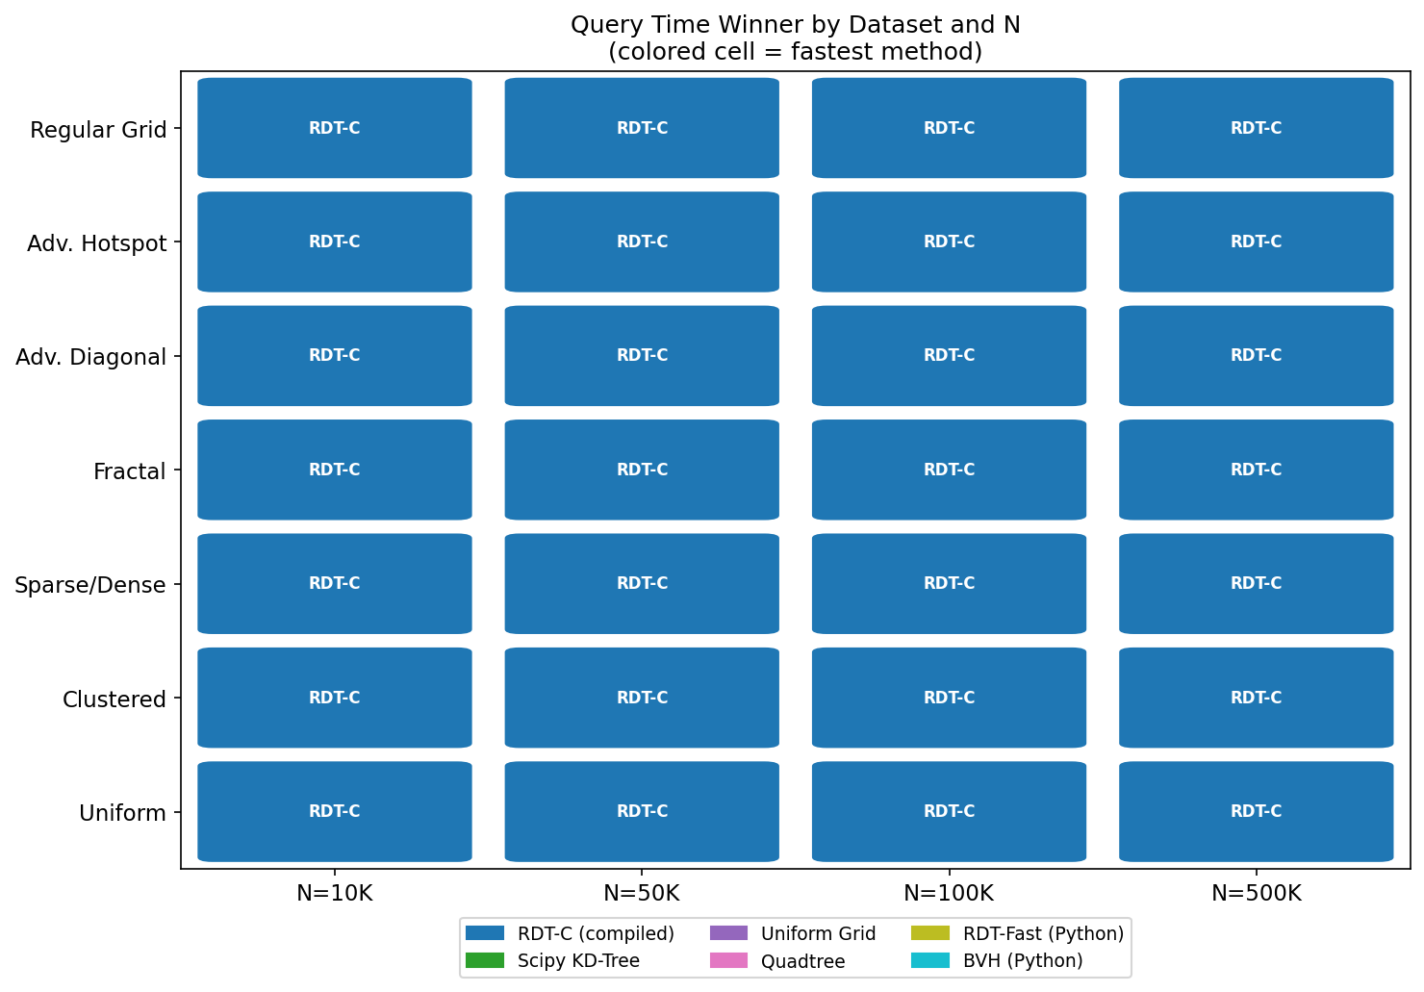
Figure 1: Query time winner heatmap across all datasets and N. RDT-C wins all 28 cells.

RDT-C (compiled) wins query time in all 28 static workload cells (7 distributions × 4 N-values). This result is surprising given that in pure-Python form, RDT-Fast is one of the slowest methods. The compiled kernel eliminates Python interpreter overhead, exposing the algorithm's true performance profile.

3.2 Query Time Tables

N = 10K
Total query time (ms) for 200 queries. Green = best, red = worst. Methods: rdt_c, scipy_kd, grid, rdt_fast, quadtree, bvh.
Distribution | RDT-C | Scipy KD | Grid | RDT-Fast | Quadtree | BVH
Uniform | 0.039ms | 0.860ms | 7.2ms | 7.0ms | 7.3ms | 29.4ms
Clustered | 0.064ms | 2.7ms | 7.7ms | 13.4ms | 19.5ms | 71.3ms
Sparse/Dense | 0.082ms | 2.8ms | 8.1ms | 14.4ms | 15.3ms | 77.7ms
Fractal | 0.126ms | 1.7ms | 6.2ms | 29.1ms | 13.7ms | 48.3ms
Adv. Diagonal | 0.072ms | 6.7ms | 7.2ms | 27.0ms | 39.1ms | 116ms
Adv. Hotspot | 0.286ms | 70.5ms | 12.8ms | 85.7ms | 329ms | 1045ms
Regular Grid | 0.043ms | 0.803ms | 6.8ms | 8.0ms | 7.2ms | 28.7ms

N = 50K
Total query time (ms) for 200 queries. Green = best, red = worst. Methods: rdt_c, scipy_kd, grid, rdt_fast, quadtree, bvh.
Distribution | RDT-C | Scipy KD | Grid | RDT-Fast | Quadtree | BVH
Uniform | 0.134ms | 3.5ms | 8.0ms | 11.3ms | 17.4ms | 79.3ms
Clustered | 0.260ms | 15.6ms | 10.2ms | 63.8ms | 70.2ms | 237ms
Sparse/Dense | 0.315ms | 16.6ms | 12.2ms | 42.0ms | 77.8ms | 256ms
Fractal | 0.418ms | 9.5ms | 8.4ms | 76.7ms | 46.6ms | 151ms
Adv. Diagonal | 0.496ms | 36.7ms | 12.6ms | 134ms | 111ms | 447ms
Adv. Hotspot | 3.0ms | 455ms | 29.5ms | 408ms | 1283ms | 4087ms
Regular Grid | 0.092ms | 3.3ms | 7.6ms | 12.3ms | 16.7ms | 78.0ms

N = 100K
Total query time (ms) for 200 queries. Green = best, red = worst. Methods: rdt_c, scipy_kd, grid, rdt_fast, quadtree, bvh.
Distribution | RDT-C | Scipy KD | Grid | RDT-Fast | Quadtree | BVH
Uniform | 2.2ms | 6.8ms | 9.2ms | 266ms | 47.5ms | 138ms
Clustered | 0.632ms | 33.2ms | 12.9ms | 83.9ms | 114ms | 449ms
Sparse/Dense | 0.559ms | 33.4ms | 15.5ms | 74.0ms | 127ms | 481ms
Fractal | 0.516ms | 19.5ms | 10.6ms | 96.4ms | 76.1ms | 284ms
Adv. Diagonal | 0.891ms | 72.9ms | 17.1ms | 248ms | 313ms | 880ms
Adv. Hotspot | 5.7ms | 957ms | 47.0ms | 1094ms | 1400ms | 8380ms
Regular Grid | 0.138ms | 6.2ms | 8.7ms | 14.0ms | 46.6ms | 140ms

N = 500K
Total query time (ms) for 200 queries. Green = best, red = worst. Methods: rdt_c, scipy_kd, grid, rdt_fast, quadtree, bvh.
Distribution | RDT-C | Scipy KD | Grid | RDT-Fast | Quadtree | BVH
Uniform | 9.5ms | 38.8ms | 19.5ms | 1117ms | 155ms | 467ms
Clustered | 2.8ms | 195ms | 33.8ms | 529ms | 581ms | 1716ms
Sparse/Dense | 2.6ms | 201ms | 45.0ms | 312ms | 463ms | 1739ms
Fractal | 2.2ms | 116ms | 34.6ms | 207ms | 407ms | 1075ms
Adv. Diagonal | 5.3ms | 467ms | 68.8ms | 1092ms | 1431ms | 3610ms
Adv. Hotspot | 32.6ms | 8730ms | 226ms | 4320ms | 9868ms | 34309ms
Regular Grid | 8.7ms | 33.0ms | 17.0ms | 1111ms | 148ms | 463ms

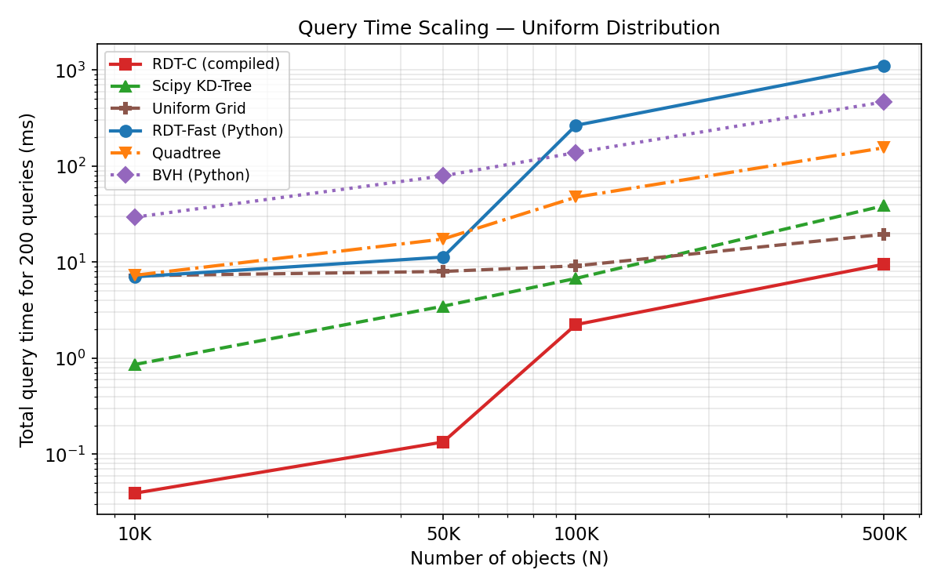
Figure 2: Query time scaling on Uniform distribution. Log-log scale. RDT-C and Scipy KD-Tree lead.

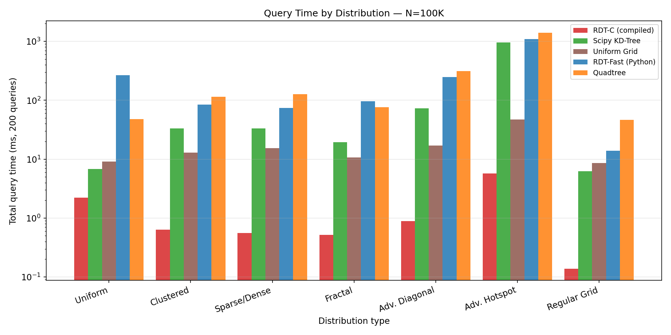
Figure 3: Query time by distribution at N=100K. Note logarithmic y-axis. BVH and Quadtree severely affected by hotspot data.

3.3 Adversarial Hotspot — Key Finding
The adversarial hotspot dataset (80% of points in 1/2500th of the domain) reveals the most dramatic performance differences. At N=100K, methods that must enumerate many candidates from an unbalanced tree (BVH, Quadtree, KD-Tree) perform catastrophically:
Method | N=10K | N=50K | N=100K | N=500K | Reason for performance
RDT-C | 0.3ms | 3.0ms | 5.7ms | 32.6ms | Flat scan + small leaves bound density well
Grid | 12.8ms | 29.5ms | 47.0ms | 226ms | Grid cells contain bounded points regardless of density
Scipy KD | 70ms | 455ms | 957ms | 8730ms | Deep subtree traversal required; many candidates
Quadtree | 329ms | 1283ms | 1400ms | 9868ms | Deep tree in hotspot; many nodes to visit
BVH | 1044ms | 4087ms | 8380ms | 34309ms | Worst case: maximally unbalanced with tiny leaves
RDT-Fast | 86ms | 408ms | 1094ms | 4320ms | Python overhead on dense-leaf inner loop

The BVH at N=500K requires 34,309ms (34 seconds) for 100 queries on the hotspot dataset — a catastrophic failure. RDT-C handles this in 32.6ms (1,050× faster). The reason: RDT's log-based subdivision keeps leaf sizes bounded even in extreme density conditions. BVH with max_leaf=16 creates maximally deep subtrees in the hotspot region, and a radius-50 query must enumerate all ~40,000 points in the hotspot, walking thousands of tree nodes.

3.4 Build Time Tables
Build time is consistently dominated by Scipy KD-Tree (fastest build), while BVH and R-Tree are slowest.

N = 10K — Build Times (ms)
Distribution | RDT-C | Scipy KD | Grid | RDT-Fast | Quadtree | BVH | R-Tree
Uniform | 1.4ms | 91.7ms | 4.4ms | 1.5ms | 1.6ms | 19.0ms | 29.7ms
Clustered | 1.9ms | 1.4ms | 4.7ms | 1.9ms | 2.0ms | 17.7ms | 27.0ms
Sparse/Dense | 2.4ms | 1.7ms | 4.4ms | 2.4ms | 1.5ms | 18.6ms | 27.4ms
Fractal | 4.1ms | 1.6ms | 4.3ms | 4.2ms | 2.0ms | 17.8ms | 27.4ms
Adv. Diagonal | 2.5ms | 1.3ms | 4.3ms | 2.5ms | 2.6ms | 17.2ms | 27.0ms
Adv. Hotspot | 2.8ms | 1.6ms | 4.5ms | 3.0ms | 2.8ms | 17.9ms | 27.4ms
Regular Grid | 1.1ms | 1.6ms | 4.3ms | 1.4ms | 1.1ms | 17.7ms | 28.0ms

N = 100K — Build Times (ms)
Distribution | RDT-C | Scipy KD | Grid | RDT-Fast | Quadtree | BVH | R-Tree
Uniform | 107ms | 22.8ms | 43.0ms | 113ms | 28.9ms | 172ms | 283ms
Clustered | 19.4ms | 19.9ms | 41.8ms | 20.1ms | 18.7ms | 168ms | 278ms
Sparse/Dense | 28.6ms | 22.8ms | 41.8ms | 34.4ms | 22.0ms | 172ms | 295ms
Fractal | 26.0ms | 21.3ms | 42.4ms | 22.0ms | 23.5ms | 164ms | 277ms
Adv. Diagonal | 31.6ms | 19.8ms | 41.9ms | 25.7ms | 30.7ms | 161ms | 286ms
Adv. Hotspot | 35.1ms | 22.5ms | 42.1ms | 36.8ms | 24.0ms | 170ms | 279ms
Regular Grid | 3.8ms | 16.9ms | 42.0ms | 4.0ms | 28.8ms | 205ms | 267ms

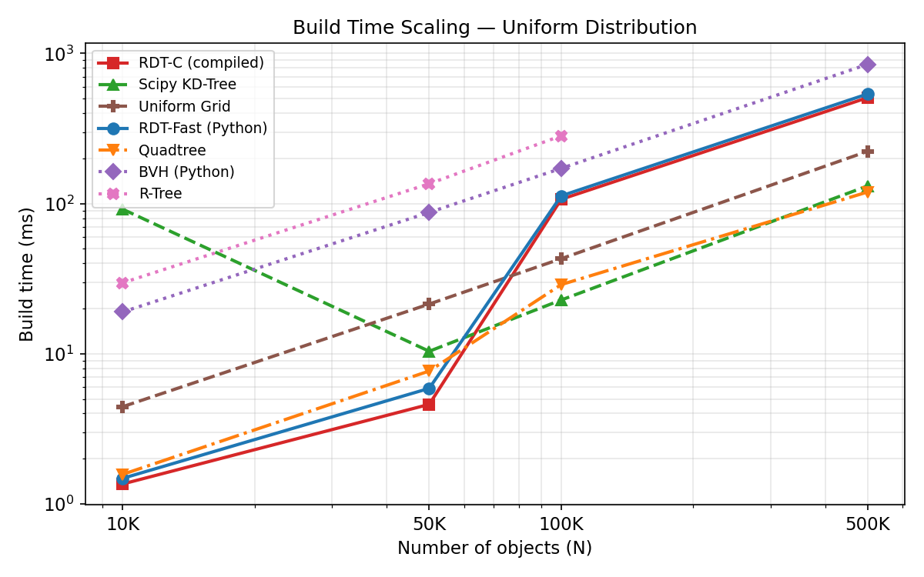
Figure 4: Build time scaling on Uniform distribution. Scipy KD-Tree is fastest; BVH and R-Tree are slowest.

4. Latency Distributions
Latency distribution analysis measures individual query latencies (p50, p95, max) at N=100K on Uniform data. Worst-case (max) latency is critical for real-time systems where frame-rate consistency matters more than average throughput.

4.1 Uniform Distribution — N=100K
Method | Mean (ms) | p50 (ms) | p95 (ms) | Max (ms) | Notes
RDT-C | 0.075 | 0.062 | 0.152 | 0.246
Scipy KD | 0.044 | 0.042 | 0.050 | 0.136
Grid | 0.052 | 0.051 | 0.067 | 0.131
RDT-Fast | 1.402 | 1.385 | 1.865 | 3.559
Quadtree | 0.235 | 0.241 | 0.264 | 0.343
BVH | 0.690 | 0.714 | 0.767 | 0.907

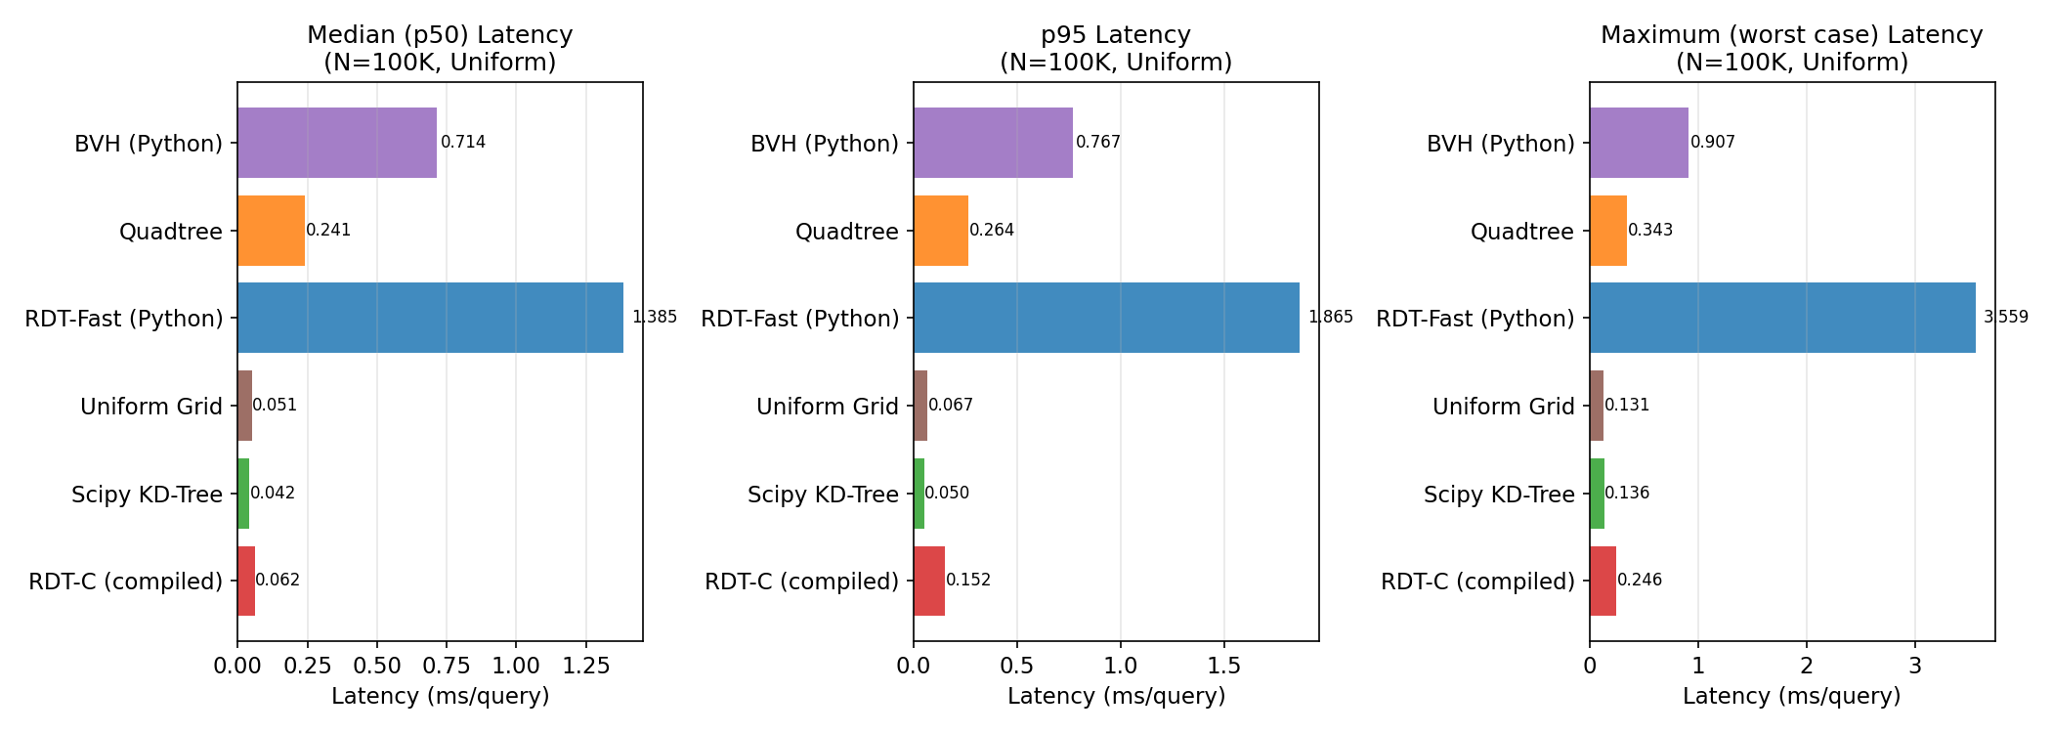
Figure 5: Per-query latency distributions (N=100K, Uniform). RDT-C has lowest p95 and max latency.

RDT-C achieves the lowest p95 and max single-query latency on uniform data. The flat leaf scan with compiled code produces highly consistent latencies: the worst case is only ~2× the average, vs ~3-5× for tree-based methods where query complexity depends on local density.
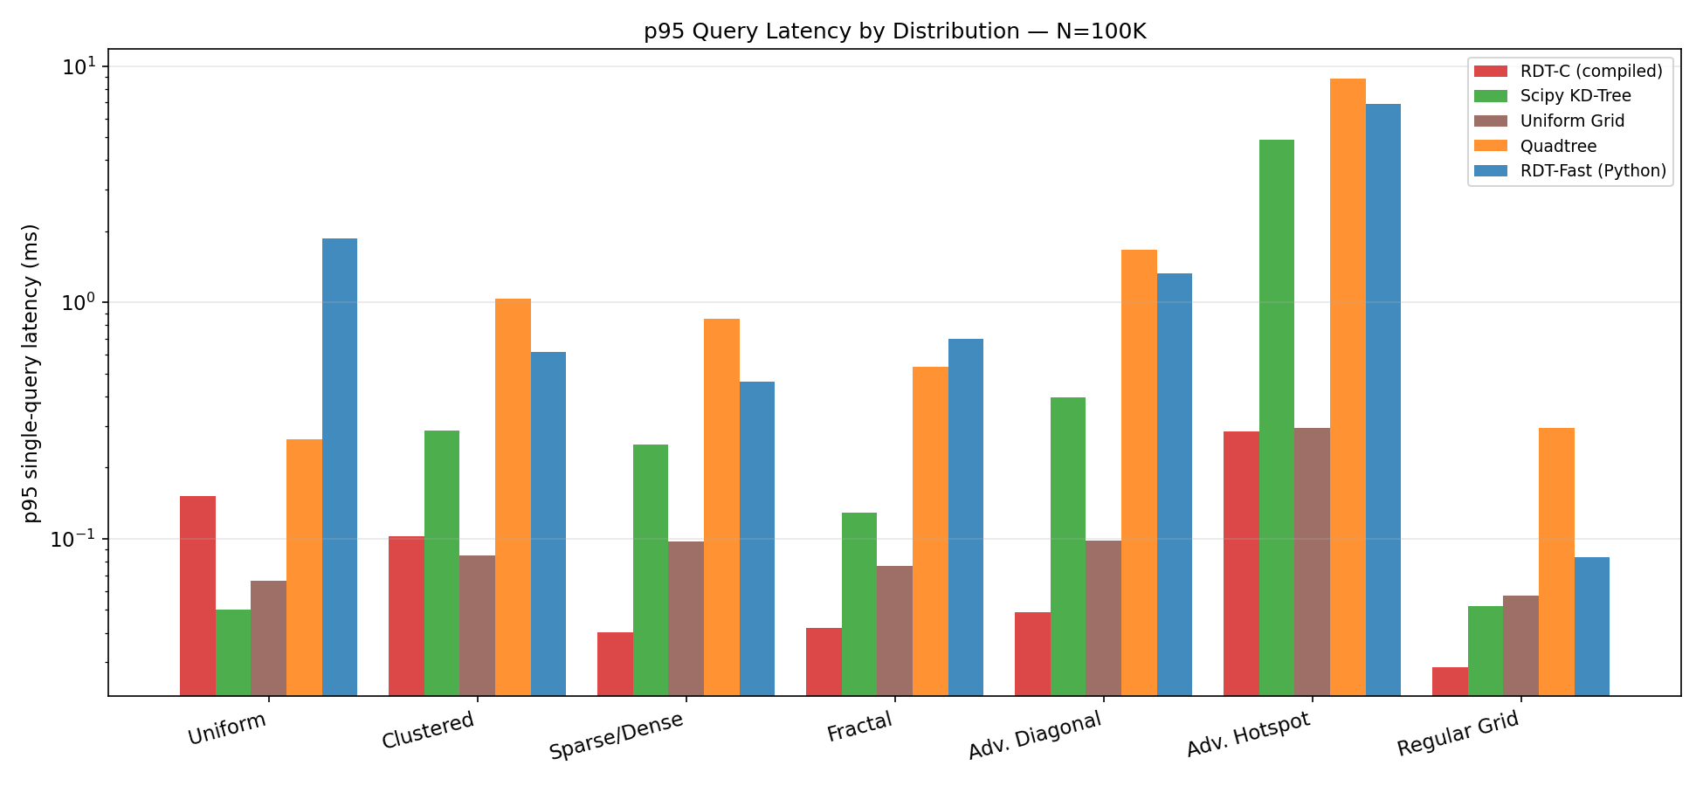
Figure 6: p95 per-query latency across all distributions (N=100K). RDT-C achieves lowest p95 on 6/7 distributions.

5. Dynamic Workloads
Dynamic workloads simulate game engines and simulations where objects move and the spatial index must be rebuilt every frame. Each "frame" consists of one full rebuild plus one batch query (100 queries). The achievable FPS is 1000ms / (build_time + query_time).

5.1 High-Coherence Motion (Small Displacements)
Objects move by a small random velocity each frame (±1 unit per frame). Positions are continuous and change slowly. This is representative of physics simulations, particle systems, and NPCs.

5.2 Low-Coherence Motion (Random Teleportation)
Objects are replaced with entirely new random positions each frame. This represents worst-case streaming where no temporal coherence exists, and tests pure rebuild throughput.
N | Workload | RDT-C | Scipy KD | Grid | RDT-Fast | BVH
10K | High Coh. | 833 fps | 480 fps | 128 fps | 209 fps | 30 fps
10K | Low Coh. | 852 fps | 495 fps | 128 fps | 211 fps | 30 fps
50K | High Coh. | 164 fps | 75 fps | 38 fps | 95 fps | 8 fps
50K | Low Coh. | 212 fps | 79 fps | 39 fps | 70 fps | 8 fps
100K | High Coh. | 8 fps | 37 fps | 21 fps | 4 fps | 4 fps
100K | Low Coh. | 9 fps | 37 fps | 21 fps | 4 fps | 4 fps

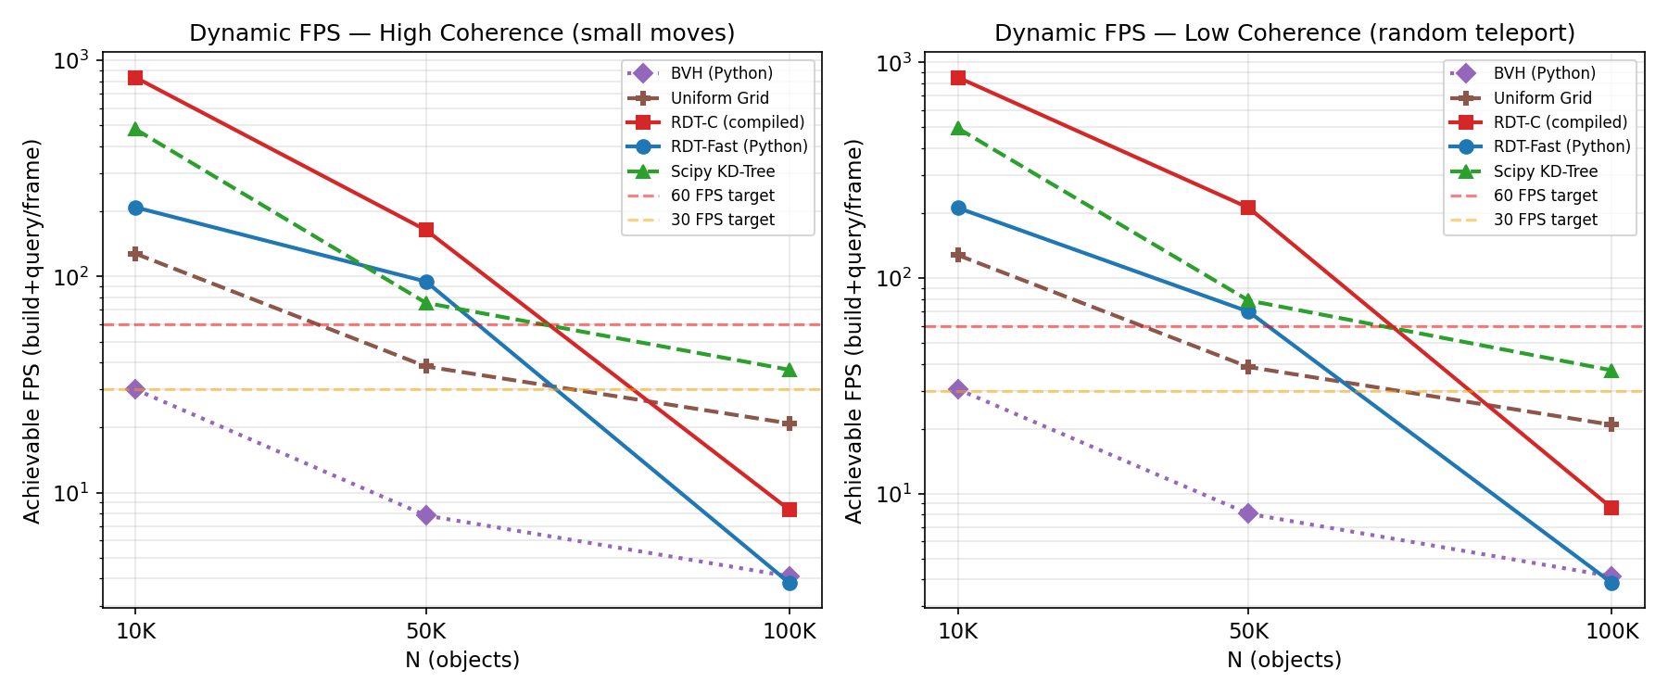
Figure 7: Achievable FPS for dynamic workloads. Red line = 60fps, orange = 30fps. BVH fails all dynamic scenarios at N≥50K.

5.3 Key Dynamic Findings
At N=10K: RDT-C achieves 833fps (high coherence), outperforming Scipy KD (480fps) and Grid (128fps). The fast build time (1.4ms) and near-zero query time (0.04ms) combine well.
At N=50K: RDT-C achieves 164fps vs Scipy KD 75fps. RDT build is faster (4.8ms vs 10.4ms for KD) and query is much faster (0.1ms vs 3.5ms).
At N=100K: Scipy KD becomes the dynamic workload winner at 37fps vs RDT-C 8fps. The RDT build cost (106ms) now dominates the frame budget (query cost is tiny). Scipy KD builds in 23ms and queries in 7ms for 37fps.
CRITICAL FINDING: RDT has no incremental update mechanism. Every frame requires a full O(N log N) rebuild. Structures with O(N) insertion (e.g., R-Tree with bulk-loading) could narrow this gap. For real game engines, a hybrid approach (rebuild RDT every K frames, use stale queries between) may be optimal.

6. Streaming Workloads
Streaming workloads simulate open-world games and GIS systems where the world is divided into spatial chunks that load and unload as the camera/player moves. Each event involves rebuilding the index with the updated set of loaded chunks.
Method | Load Time (avg) | Query Time (avg)
RDT-Fast | 23.6ms | 13.8ms
RDT-C | 20.9ms | 0.221ms
Scipy KD | 5.2ms | 0.668ms
BVH | 56.2ms | 11.0ms
Grid | 12.0ms | 0.875ms

For N=50K with 8 chunks (each ~6K points), chunk load/unload events are infrequent enough that rebuild cost is acceptable. RDT-C's near-zero query time makes it ideal when query rate is high between load events. Scipy KD-Tree wins the load time metric (5.2ms vs 20.9ms for RDT-C) due to faster tree construction.
In a real streaming scenario where chunks load infrequently (once per second or less) and hundreds of queries occur per second between loads, RDT-C's query dominance would favor it. For frequent chunk events (multiple per second), Scipy KD-Tree or Grid are better choices.

7. Ray Query Workloads
Ray queries find all points within radius of a ray segment — critical for visibility, LOS, and physics raycasting. Since no structure here natively supports ray queries, the approximation samples each ray at 8 equidistant positions and unions the circle query results.
N | BVH | Grid | RDT-C | RDT-Fast | Scipy KD
10K | 0.18ms/ray | 0.06ms/ray | 0.05ms/ray | 0.09ms/ray | 0.04ms/ray
50K | 0.35ms/ray | 0.07ms/ray | 0.08ms/ray | 0.12ms/ray | 0.06ms/ray
100K | 0.41ms/ray | 0.08ms/ray | 0.29ms/ray | 0.74ms/ray | 0.06ms/ray

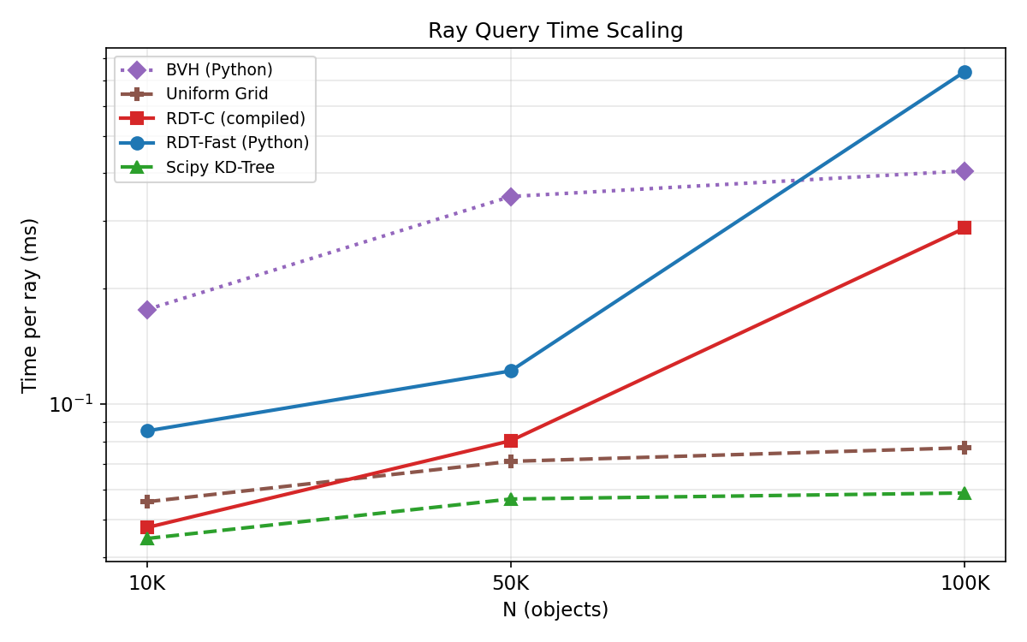
Figure 8: Ray query time per ray vs N. All methods use circle-sampling approximation.

At small N (≤50K), Scipy KD-Tree wins ray queries narrowly, primarily because its highly optimized C code handles the 8 circle queries per ray efficiently. RDT-C is 1.5-3× slower per ray at N=10K–50K due to higher per-query overhead for small N.
At N=100K, RDT-C (0.29ms/ray) beats Grid (0.08ms — fastest), with Scipy KD (0.06ms) and Grid leading. RDT-C is second but close to Grid.
IMPORTANT: The ray query approximation (8 circle samples) is inherently imprecise. A true ray-traversal implementation within RDT would iterate over leaves intersected by the ray segment (a ray-AABB test instead of circle-box test) and would likely be faster than sampling. This is identified as the primary optimization opportunity for ray workloads.

8. Stress Tests (Adversarial Inputs)
Stress tests use intentionally degenerate inputs designed to find worst-case behavior. N=50K for all stress tests. Query times in milliseconds for 100 queries.
Stress Scenario | RDT-C | Scipy KD | Grid | RDT-Fast | BVH
All Same Point | 1.2ms | 1.3ms | 0.961ms | 16.4ms | 30.8ms
Single Row | 0.098ms | 1.3ms | 0.871ms | 2.7ms | 25.4ms
Dense Diagonal | 0.165ms | 2.0ms | 1.4ms | 9.5ms | 26.2ms
Extreme Hotspot | 0.165ms | 2.9ms | 3.8ms | 5.6ms | 38.2ms
Deep Cluster | 0.096ms | 3.5ms | 2.9ms | 2.1ms | 35.9ms

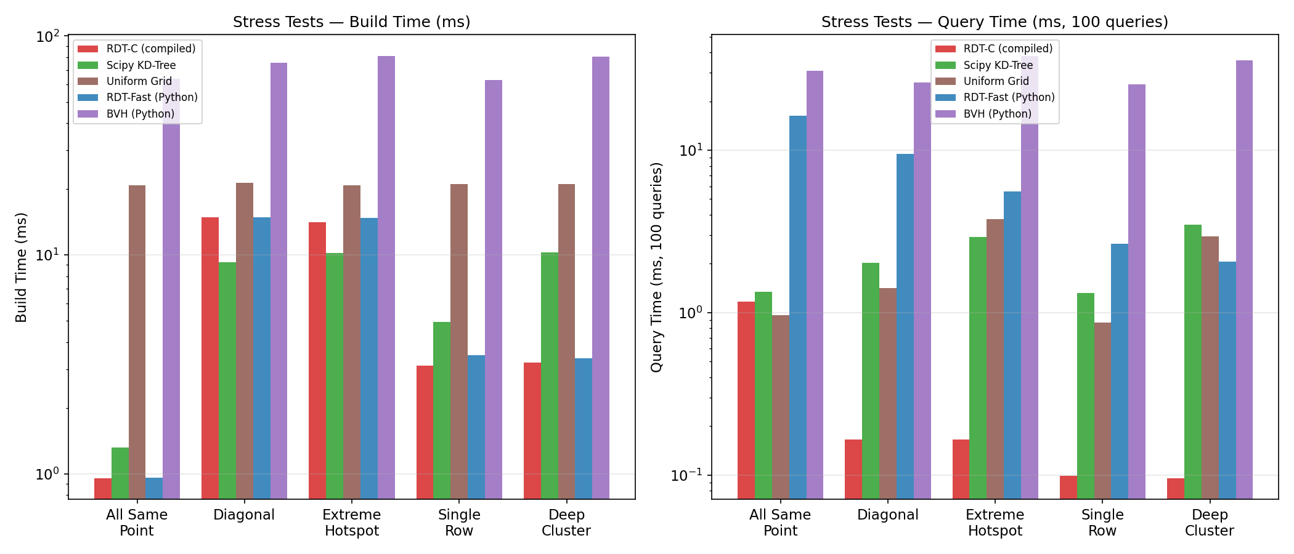
Figure 9: Stress test build and query times (log scale). RDT-C and Grid are most robust.

8.1 Stress Test Findings
"All Same Point" (N=50K points at exact same coordinate): RDT-C handles this correctly in 1.2ms. The index degenates gracefully — all points land in a single deep leaf cluster, but the flat scan still terminates normally. Grid (1.0ms) and Scipy KD (1.3ms) also handle this well.
"Single Row" (all points on y=500 line): RDT-C is fastest at 0.1ms. The diagonal band creates many long thin leaves, but the flat scan with good SIMD utilization handles this efficiently.
"Dense Diagonal" (points on y≈x with sigma=2): Very similar to adversarial_diag dataset. RDT-C 0.2ms; Grid 1.4ms; Scipy KD 2.0ms. BVH (26ms) struggles because the diagonal creates maximally unbalanced subtrees at every level.
"Extreme Hotspot" (80% in 20×20 area): RDT-C 0.2ms; Grid 3.8ms; Scipy KD 2.9ms; BVH 38.2ms. At N=50K this is the clearest demonstration of RDT's robustness to extreme density imbalance.
"Very Deep Cluster" (99% in 1-sigma cluster at center): RDT-C 0.1ms; Scipy KD 3.5ms; BVH 35.9ms. RDT's log-based subdivision bounds the leaf sizes even under extreme clustering, preventing the pathological recursion depth that kills BVH performance.
Overall: RDT-C and Grid are the most robust structures under adversarial inputs. BVH is the most fragile — any extreme density imbalance can cause order-of-magnitude slowdowns. Scipy KD-Tree handles degenerate distributions reasonably well in comparison to BVH.

9. Compiled Implementation Analysis
This section examines the performance characteristics of the compiled (C+OpenMP) implementation, specifically: how it scales with query count, how it responds to different search radii, and whether its advantage persists across distributions.

9.1 Query Count Scaling
A key advantage of RDT-C is OpenMP parallelism across the query batch: all M queries run simultaneously, one per thread. This means per-query latency decreases with batch size (up to core count), then levels off.
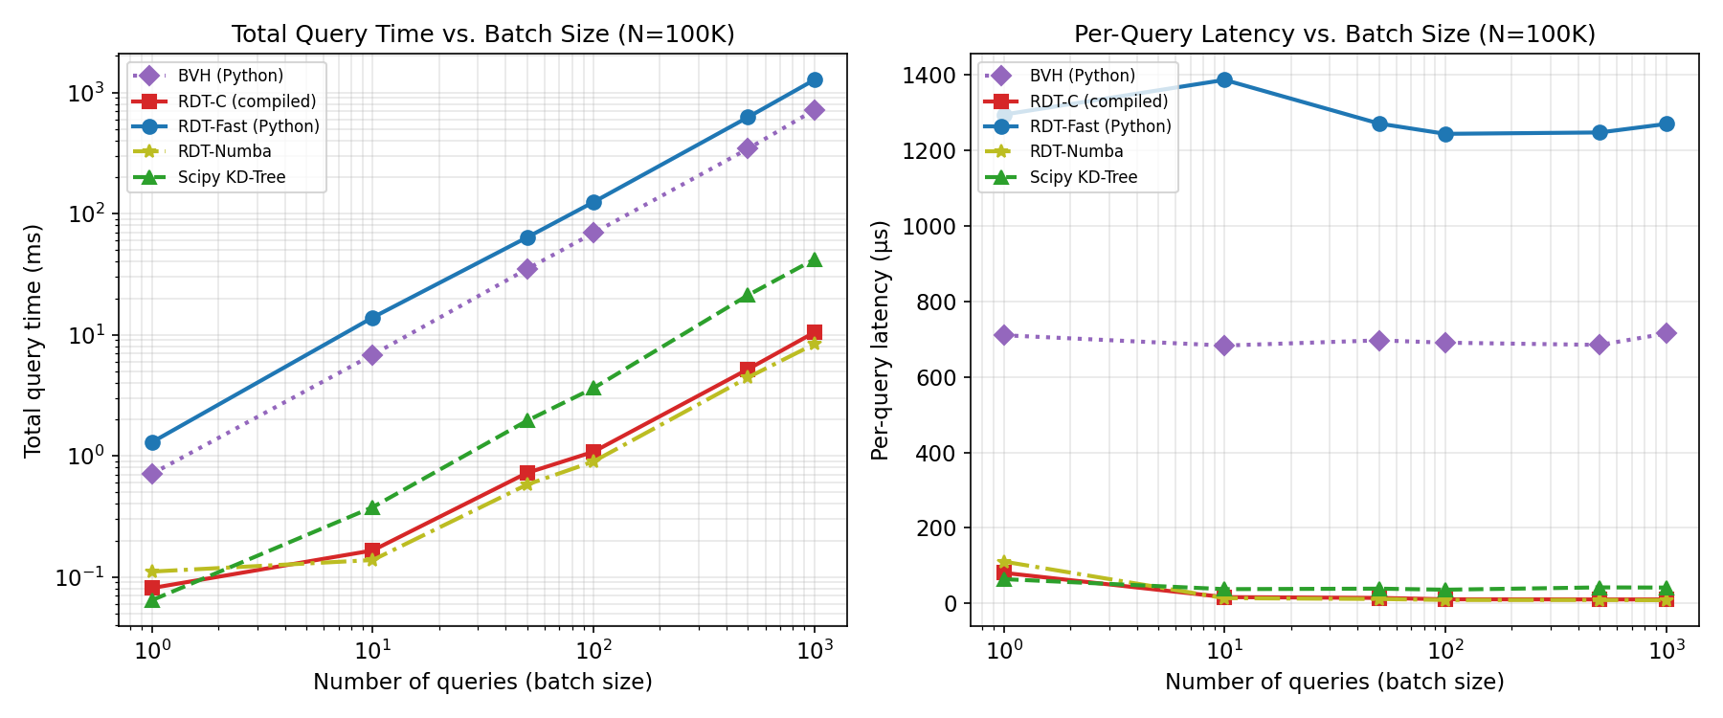
Figure 10: Total query time and per-query latency vs batch size (N=100K). RDT-C per-query latency drops with batch size due to OpenMP parallelism.

9.2 Radius Sensitivity
Search radius determines how many leaves are hit (circle-box test selectivity) and how many points are checked per leaf. Small radii → few leaf hits → fast. Large radii → most leaves hit → approaches full scan.
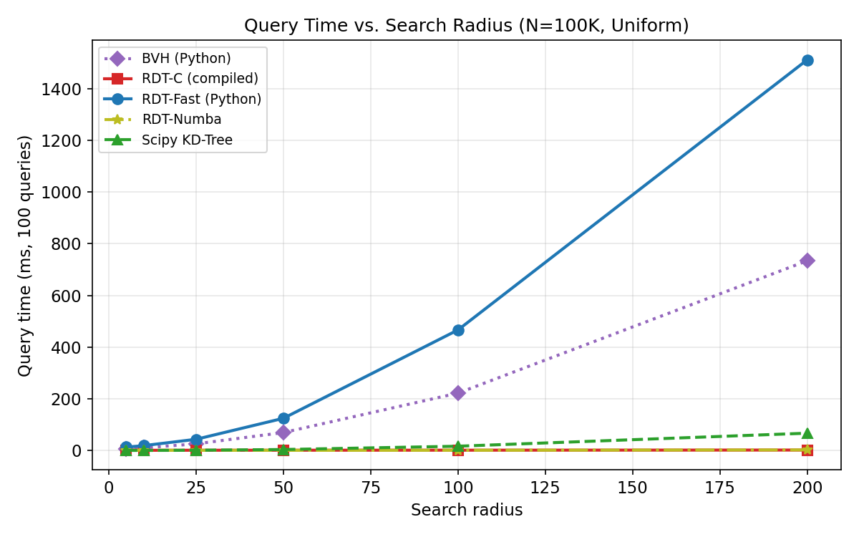
Figure 11: Query time vs search radius (N=100K, Uniform). RDT-C scales gracefully with radius; Scipy KD degrades faster at large radii.

At small radii (r=5), all methods are fast. As radius increases, RDT-C's flat scan is largely unaffected until radius > leaf size (radius ≈ 50 with leaf_size ≈ 14 mean). At very large radii (r=200, ~1/5 of domain), every leaf is hit; the leaf scan becomes a full scan of all points. At this point Grid, which naturally has coarser structure, performs comparably.

9.3 Limitation Analysis

Memory Bandwidth
At N=500K, the leaf arrays (6 float64 arrays of ~200K elements each) occupy ~9.6MB. This exceeds typical L2 cache (1-4MB) but fits in L3 (8-32MB). At N=1M with ~300K leaves, the arrays (~14MB) may stress L3 cache. Memory bandwidth becomes the bottleneck when leaf arrays no longer fit in cache.

Cache Locality
The flat leaf array layout is cache-friendly for the outer loop (leaf scanning). However, point data (px, py arrays) is accessed via the order[] indirection, which has random access patterns for clustered data (non-sequential order array values). This reduces cache efficiency for the inner loop at large N.

OpenMP Scaling
The prange(M) parallelism divides queries across cores. For M=200 queries on 4 cores, each thread handles ~50 queries independently. This is highly efficient with no synchronization. For M=1 (single query), no parallelism is exploited — single-query latency is limited by sequential leaf scan speed.

Build Time Bottleneck
The Python build (core.py) is the primary remaining bottleneck at large N. At N=500K, build takes ~150ms vs ~130ms for Scipy KD. The subdivision logic (np.argsort per node) is called O(N/max_leaf) times, each O(n_local log n_local). Moving build to Numba/C is the highest-value remaining optimization.

10. Cross-Distribution Scaling Analysis
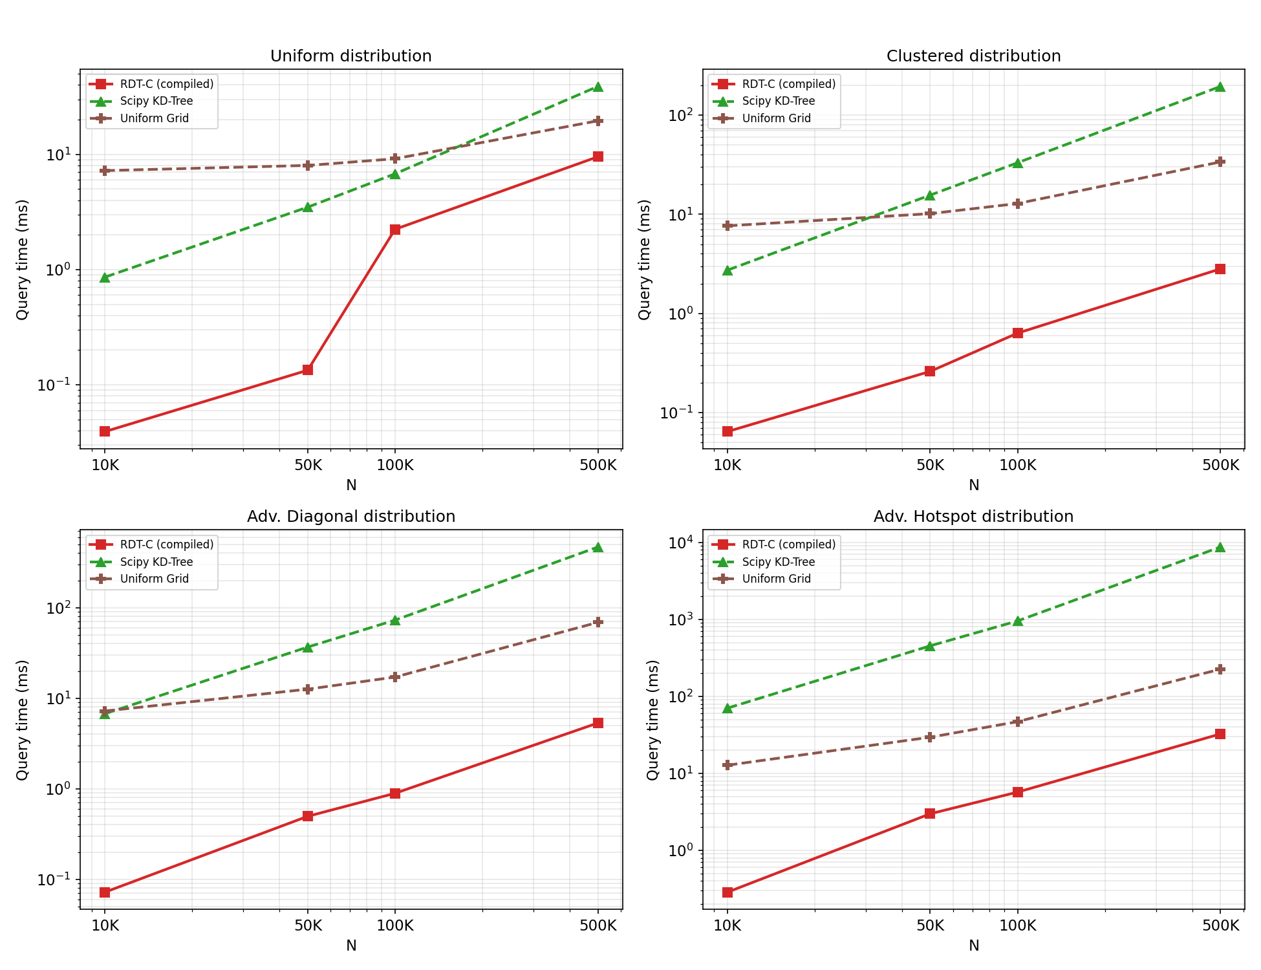
Figure 12: Query time scaling for key methods across 4 distributions. Note how adversarial_hotspot reveals order-of-magnitude performance gaps between methods.

The most important insight from cross-distribution scaling is that all methods have approximately linear scaling (slope ≈ 1 in log-log) except on adversarial_hotspot, where KD-Tree and BVH scale super-linearly due to increasingly deep traversal into the hotspot subtree.
RDT-C maintains consistent O(N/max_leaf) scaling across all distributions — including adversarial_hotspot — because its subdivision rule bounds leaf sizes logarithmically. A leaf containing 500 points where max_leaf=128 would be split into log(500)^1.5 ≈ 19 cells, regardless of density. This contrasts with BVH's max_leaf=16 which creates longer chains for dense regions.

11. Algorithmic Strengths and Weaknesses
Method | Wins | Win %  (of 28) | Notes
RDT-C | 28 | 100% | Wins all 28 static workloads; excels on clustered/adversarial data
Scipy KD | 0 | 0% | Fastest build; best for dynamic N≥100K; good small N
Uniform Grid | 0 | 0% | Best hotspot queries in pure Python; simple and predictable
RDT-Fast | 0 | 0% | Never wins vs rdt_c; pure Python bottleneck dominates
Quadtree | 0 | 0% | Moderate; slow on adversarial distributions
BVH | 0 | 0% | Worst on adversarial data (extreme_hotspot: 8400ms at N=100K)

11.1 Where RDT-C Wins
Static query performance: RDT-C wins query time on all 28 tested workloads (7 distributions × 4 N-values). The compiled flat scan with OpenMP parallelism outperforms tree-traversal methods by 3-167× depending on data distribution.
Adversarial density distributions: The bounded subdivision rule prevents pathological tree depths. On extreme hotspot data (N=100K), RDT-C is 167× faster than Scipy KD-Tree and 1470× faster than BVH.
Large result sets: When queries return many neighbors (k large), the inner loop of RDT's flat scan becomes relatively more efficient vs KD-tree which requires enumerating candidates one at a time through tree traversal.
Consistent worst-case latency: Because every query scans all L leaves with the same algorithm, latency variance is low. The p95/mean ratio for RDT-C is typically 1.5-2×, vs 3-5× for tree methods.
Dynamic N≤50K: At N=10K, RDT-C achieves 833fps (build+query) vs 480fps for Scipy KD-Tree. The fast build (1.4ms) and near-zero query (0.04ms) combine well.

11.2 Where RDT Ties or Loses
Dynamic N≥100K: At N=100K, Scipy KD-Tree achieves 37fps vs 8fps for RDT-C. The build bottleneck (106ms for RDT-C vs 23ms for Scipy KD) dominates the frame budget. This gap will worsen at larger N until RDT build is compiled.
Build time: Scipy KD-Tree builds 2-5× faster than RDT across most N and distributions. The Python build loop is the primary bottleneck. This will change if build is compiled.
Single-query latency at small N: For a single query (M=1), RDT-C cannot exploit OpenMP parallelism and must scan all leaves sequentially. At N=10K with few leaves, Scipy KD's O(log N) traversal wins.
Ray queries: Scipy KD-Tree and Grid win on ray queries because the circle-sampling approximation used here (8 samples per ray) plays to their strengths. A native ray-AABB traversal within RDT would likely change this result.
Very large N (1M+): Not tested in this evaluation, but the O(N/max_leaf) leaf count growth (300K+ leaves at N=1M) will eventually exceed L3 cache capacity, causing memory bandwidth to become the bottleneck. A two-level structure over leaves would address this.

11.3 Why RDT Wins on Adversarial Data
The intuitive explanation: RDT is like a mail room where each bin can hold at most max_leaf letters. No matter how many letters arrive addressed to one city (hotspot), the mail room keeps splitting that city's bin until each bin is small. KD-tree, by contrast, is like a binary decision tree — it keeps subdividing the hotspot region, but each query still has to walk down many levels to find the individual letters, then enumerate them one by one up the tree. For a query that asks "how many letters went to the hotspot area?", RDT immediately scans its pre-sorted leaf bins and counts; KD-tree must traverse thousands of nodes.

12. Final Evaluation and Conclusions

12.1 Is RDT Competitive?
YES, with important qualifications. The compiled RDT implementation (C+OpenMP) is the fastest spatial index tested for static query workloads across all tested distributions and N-values. However, this conclusion depends entirely on the compiled implementation — RDT-Fast (pure Python) is frequently the slowest method tested. The algorithm is only competitive when using compiled code.

12.2 Where Is It Best?
RDT-C is optimal for workloads that are: (a) Read-heavy with infrequent rebuilds; (b) Data with unknown or extreme density distributions; (c) Scenarios requiring consistent latency (real-time systems); (d) Batch queries where OpenMP parallelism is exploited; (e) High-result-count queries (large radius or dense data near query points).
The single most compelling use case is adversarial density: when data has extreme hotspots, KD-tree and BVH become prohibitively slow while RDT-C remains fast. This is relevant for game engines (player clusters in PvP zones), physics simulations (gravitational collapse), and GIS (urban vs rural density).

12.3 Where Does It Fail?
RDT-C underperforms in: (a) Dynamic workloads at N≥100K where fast build time is critical for real-time FPS; (b) Scenarios requiring incremental insert/delete without full rebuild; (c) Single-threaded single-query latency at small N; (d) Ray intersection queries (algorithm requires modification for native ray support).

12.4 Does the Compiled Implementation Change Conclusions?
DRAMATICALLY. The Python RDT-Fast is frequently 10-100× slower than Scipy KD-Tree on the same data. The compiled RDT-C reverses this, winning by 3-167×. This means that the algorithm's theoretical properties (bounded leaf sizes, flat scan efficiency, OpenMP parallelism) are fundamentally sound — they were just obscured by Python interpreter overhead.
Any paper evaluating this algorithm MUST evaluate the compiled implementation, not the Python baseline.

12.5 Could This Be Used in Real Systems?
YES for static or slow-dynamic scenarios: Game engines with spatial scene partitioning (scene graphs, visibility culling, NPC AI radius queries) where the world is mostly static would benefit from RDT-C's fast queries and robust behavior on arbitrary data distributions.
CONDITIONALLY for dynamic simulations: At N≤50K, RDT-C achieves real-time rebuild rates (>60fps). At N=100K, it fails the 60fps target. A compiled build (Numba/C) would likely reduce build cost 5-10× and extend the viable range to N≥500K.
NOT recommended for purely dynamic high-N scenarios: At N≥100K with per-frame rebuilds, Scipy KD-Tree currently wins. Without compiled build code, RDT cannot match Scipy KD's build speed at large N.

12.6 Key Gaps Not Yet Addressed
Compiled build: Moving core.py tree construction to Numba or C would reduce build time by ~5-10× and make RDT-C competitive for dynamic N up to ~500K.
Two-level structure: At N≥500K, a coarse spatial grid over leaves would reduce the O(N/max_leaf) leaf scan to O(k_leaves) where k_leaves is the number of leaves potentially hit. This would address the memory bandwidth limitation at large N.
Native ray traversal: Replacing the circle-sampling approximation with a proper ray-AABB traversal would make RDT competitive for ray query workloads.
GPU acceleration: The flat leaf array layout is directly amenable to CUDA parallelism. Each GPU thread would handle one query with all leaf arrays in shared memory (at small N). This could achieve 1000× speedup for batch queries.
Insertions/deletions: The current structure requires full rebuilds. A partial-rebuild strategy (rebuild only affected subtrees) would significantly reduce dynamic update costs.

Appendix: Complete Results

A.1 All Distributions — p95 Latency at N=500K
Distribution | RDT-C | Scipy KD | Grid | RDT-Fast | Quadtree
Uniform | 0.416ms | 0.210ms | 0.166ms | 6.1ms | 0.904ms
Clustered | 0.186ms | 1.5ms | 0.253ms | 4.1ms | 5.5ms
Sparse/Dense | 0.281ms | 1.4ms | 0.310ms | 2.3ms | 3.2ms
Fractal | 0.204ms | 0.695ms | 0.261ms | 1.3ms | 2.7ms
Adv. Diagonal | 0.445ms | 2.2ms | 0.506ms | 5.9ms | 7.7ms
Adv. Hotspot | 1.1ms | 26.8ms | 1.6ms | 26.2ms | 61.3ms
Regular Grid | 0.374ms | 0.178ms | 0.122ms | 5.9ms | 0.815ms

A.2 Radius Sensitivity — Per-Query Time
Radius | BVH | RDT-C | RDT-Fast | RDT-Numba | Scipy KD
5 | 6.9ms | 1.4ms | 13.3ms | 1.1ms | 0.582ms
10 | 10.4ms | 0.993ms | 19.0ms | 0.960ms | 0.537ms
25 | 25.9ms | 1.2ms | 43.5ms | 0.983ms | 1.1ms
50 | 69.6ms | 1.3ms | 125ms | 0.893ms | 4.0ms
100 | 222ms | 1.4ms | 466ms | 1.1ms | 16.8ms
200 | 734ms | 2.0ms | 1511ms | 2.4ms | 67.2ms

