dontdieretired.com
Revenue & Profit Maximisation Plan
An AI-run content business for the over-50s: how the site earns, in what order, and how it improves itself as traffic grows.
Prepared 27 September 2026 · Companion to the site repository and RUNBOOK.md

1. Summary
The site is built and ready to deploy: nine sourced launch articles, a curated video page, five audience profiles, and every revenue mechanism wired in and switched on by a single config file. It is designed so Claude can run it unattended: a daily job finds a real story, writes and publishes the article, and produces a social pack (posts, image cards, short-video script) for Facebook, Instagram, X, Pinterest, LinkedIn and TikTok/Shorts.
Profit comes from stacking six streams in the order they become available, while the email list and reader-profile data compound underneath. Own digital products and recurring memberships carry ~90% margins and are the main profit engines; display ads and affiliates monetise the long tail of traffic with no extra effort; sponsorship and platform payouts are upside once the audience is proven.
Costs are small: hosting is free (GitHub Pages), a scheduler is £10–25/month, a video tool £20–50/month, domain ~£12/year. Break-even is reached at roughly 3,000 sessions/month; an established site at 100k sessions/month is modelled at ~£9–10k/month across streams.
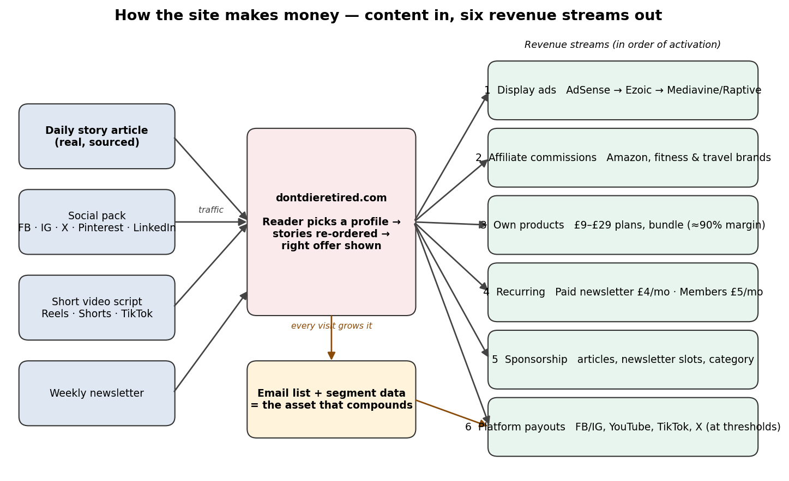
Figure 1 — Content in, six revenue streams out. The email list and segment data are the asset that compounds.

2. Revenue streams — what, when and why
Stream | Mechanism | Typical yield | Why it suits this site | Watch-out
Display ads | AdSense day 1 → Ezoic at 10k sessions/mo → Mediavine at 50k (75% rev share) → Raptive at 100k | £4–8 RPM (AdSense) rising to £20–35 RPM (Mediavine/Raptive, health niche) | Slots, consent banner and non-personalised fallback are built. Zero effort once approved. | Needs traffic; earns least per visitor early on.
Affiliate commissions | Amazon Associates UK/US now; Awin/Impact (Decathlon, Wiggle, Sweaty Betty, Trainline, hotel/travel) once 1k sessions/mo | 1–4% Amazon; 5–12% specialist brands | Category-matched 'kit' boxes on every article; tag appended automatically; clicks tracked by segment. | Amazon closes accounts with <3 sales in 180 days — needs traffic to affiliate-heavy pages.
Own digital products | Gumroad store: 30-Day Restart £9, Strong at 60 £14, Sharp £12, Second Act £19, Bundle £29 | ≈90% margin after fees | Highest margin, no threshold, Claude writes them. Promoted on every article and the shop page. | Needs trust; conversion typically 0.3–1% of sessions.
Recurring: paid newsletter + members | Buttondown/Beehiiv paid tier £4/mo; Ko-fi members £5/mo (0% platform fee) | ≈95% margin | The compounding asset. The free list is captured on every page with the reader's segment as a tag. | Needs content worth paying for: challenge library, live Q&A, community.
Sponsorship | Rate card on /sponsor/: article from £250, newsletter slot £150, category sponsor £600/mo | 100% margin | Over-50 audience with disposable income is attractive to fitness, travel, hearing/vision, finance and insurance brands. | Needs audience proof (media kit at 10k sessions).
Platform payouts | Facebook/Instagram content monetisation, YouTube Partner, TikTok Creator Rewards, X Creator Revenue | Variable; typically £0.5–£4 per 1,000 views | Fed automatically by the social packs and short-video scripts. | Thresholds (below) mean months 6+; treat as upside.
Later: courses & events | Cohort course (£49–£99), online challenge with live sessions, local walking/strength meet-ups with partners | 70–90% | Natural extension once list > 2,000 and product sales prove demand. | Time cost; needs a human host for live elements.

Ad network entry points and rates are drawn from 2026 publisher comparisons (see Sources). RPM = revenue per 1,000 sessions; health & wellness sits in the upper band for all networks, and the site's readership is majority UK/US/AU/CA — the tier-1 geographies networks pay most for.

3. Illustrative revenue model
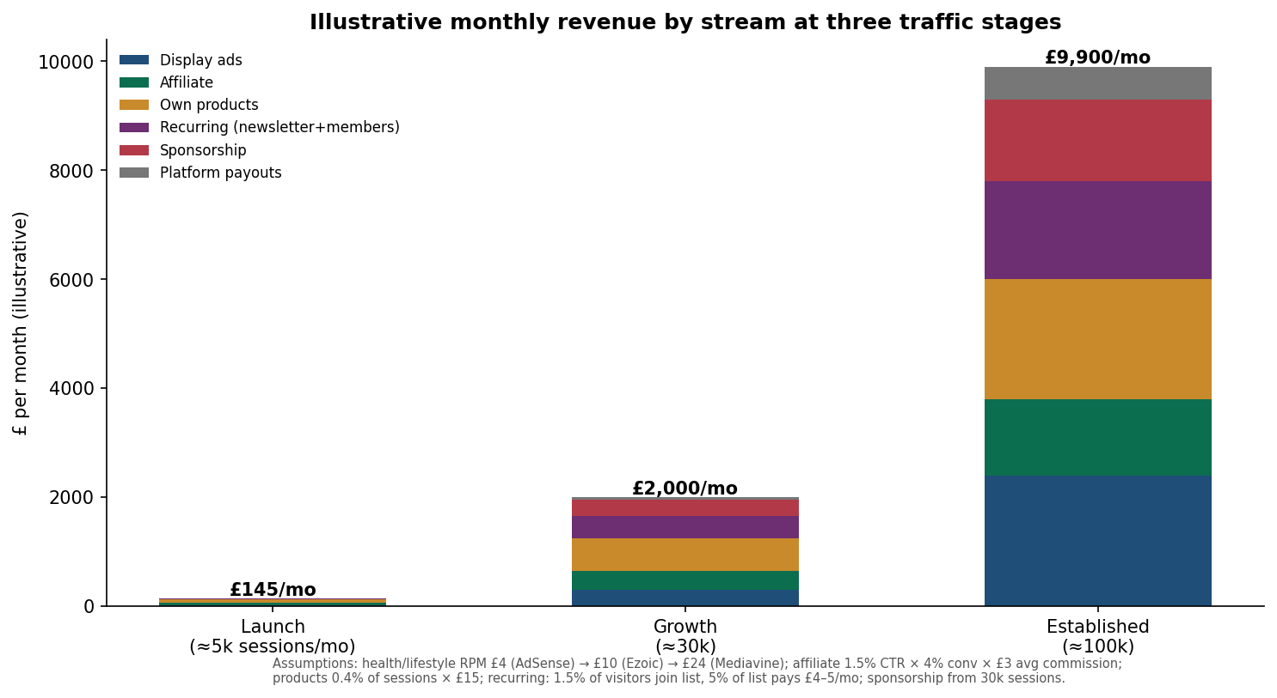
Figure 2 — Monthly revenue by stream at three traffic stages. Figures are illustrative; assumptions shown beneath the chart.
Parameter | Value used | Rationale
Ad RPM | £4 → £10 → £24 | AdSense health-niche typical; Ezoic mid-band; Mediavine/Raptive health £25–45 USD
Affiliate click-through | 1.5% of article views | Category-matched kit boxes in sidebar and shop; conservative
Affiliate conversion / commission | 4% × £3 | Amazon UK blended rate on sub-£60 fitness goods
Product conversion | 0.4% of sessions × £15 avg | Low-ticket PDFs from a trusted, story-led site; bundle lifts average
Newsletter capture | 1.5% of visitors | Form on every page + profile-matched lead magnet
Paid conversion of list | 5% at £4–5/month | Typical for niche newsletters with a real member benefit
Sponsorship | From 30k sessions: 1–2 slots/month | Rate card on /sponsor/; over-50 audience has high advertiser value
Platform payouts | £0.5–4 per 1,000 views | Only after thresholds in §5

Costs (monthly): GitHub Pages £0; domain ~£1; Buffer/Publer £10–25; HeyGen/Pictory £20–50; Buttondown free to 100 subs then ~£9; Gumroad 10% of sales; Ko-fi 0% on memberships. Total fixed ≈ £30–85/month. The AI content cost is the Claude subscription already in use.

4. Social distribution — from site to Facebook, Instagram, X and beyond
Every article automatically produces a social pack in the repository: Facebook post, Instagram caption with hashtags, X post and a four-part thread, Pinterest pin, LinkedIn post, three image cards (square, story, landscape) and a 45-second short-video script. The daily job pushes these to a scheduler (Buffer or Publer) which posts to each network. Every link carries UTM tags so Plausible shows which platform sends readers who subscribe or buy.

How social earns
- Now: Traffic to the site — the primary route; Facebook and Pinterest over-index for 50+ audiences.
- Month 2+: Affiliate links in posts once accounts are approved (allowed on FB/IG/Pinterest with disclosure).
- Month 6+: Platform payouts as each threshold is crossed (table below).
- Month 9+: Sponsored posts once a following exists — typically £50–£300 per post at 10–50k followers in this niche.
Platform | 2026 eligibility threshold | Realistic timing
Facebook Content Monetisation | ≈5,000 followers, 60-day active page, eligible country; In-stream ads: 10k followers, 600k eligible minutes/60 days | Month 6–9
Instagram Subscriptions / Gifts | 10,000 followers (subscriptions); Reels gifts at lower regional thresholds | Month 9+
YouTube Partner (ads) | 1,000 subscribers + 4,000 watch hours/12 mo OR 10M Shorts views/90 days | Month 6–12
YouTube fan funding | 500 subs + 3,000 watch hours OR 3M Shorts views | Month 4–8
TikTok Creator Rewards | 10,000 followers + 100k views/30 days; videos > 1 min | Month 9+
X Creator Revenue Sharing | X Premium subscription + 5M organic impressions/3 months + 500 followers | Month 9+; low priority
Pinterest | No direct payout; strong evergreen traffic source for 'plans' and 'kit' content | Traffic from month 2

Video: Claude cannot render video files, so the pipeline is script → AI video tool (HeyGen, Pictory or InVideo, all with APIs) → scheduler. Until that account exists, the videos page curates verified YouTube films with commentary, which already gives the site a video presence and YouTube-embed dwell time.

5. Audience targeting — built in
Readers choose one of five profiles (Restarter, Mover, Learner, Carer, Career Changer). The choice is stored in the browser, re-orders the homepage, shows a first-week plan on Start Here, tags the newsletter subscription, and is attached to every tracked event (affiliate click, product click, signup, scroll depth). That gives three things advertisers and product decisions need: who the audience is, what each profile buys, and which content formats hold each profile's attention.
Profile | Content emphasis | Best-fit revenue
Restarter | Gentle starts, chair/walk/strength, stories of people who began from zero | 30-Day Restart, resistance bands, walking shoes
Mover | Next challenge, masters sport, endurance, competition | Strong at 60, trackers, event/travel affiliates, sponsors (sportswear)
Learner | Study, languages, instruments, brain health | Sharp course, headphones/books, education sponsors
Carer | 15-minute routines, doing activity with the person cared for, community | Membership (community value), walking poles, insurance/care sponsors
Career Changer | Second acts, ventures, volunteering, purpose | Second Act workbook, business books, finance/insurance sponsors

6. The improvement loop — how we respond when traffic arrives
The site records scroll depth, shares, profile choice and every revenue click. Each Sunday Claude compares the week with the previous four and applies these rules (also in RUNBOOK.md §5):
- Article format — if readers reach 50% but not 90% of an article, shorten it, add sub-heads and move 'Try this' higher; test for two weeks.
- Video — start daily short videos at 1,000 sessions/week; add a weekly 5–8 minute YouTube piece at 5,000/week; apply to Ezoic at the same point.
- Audience — if one profile exceeds 40% of readers, weight two of seven weekly articles to it and build the next product for it.
- Revenue — affiliate CTR above 2% on a category → write a kit-list article; product clicks without sales → lower price or add preview; signups under 1% → change lead magnet or move form.
- Amplify — any article shared 50+ times → make a video of it and a follow-up article.
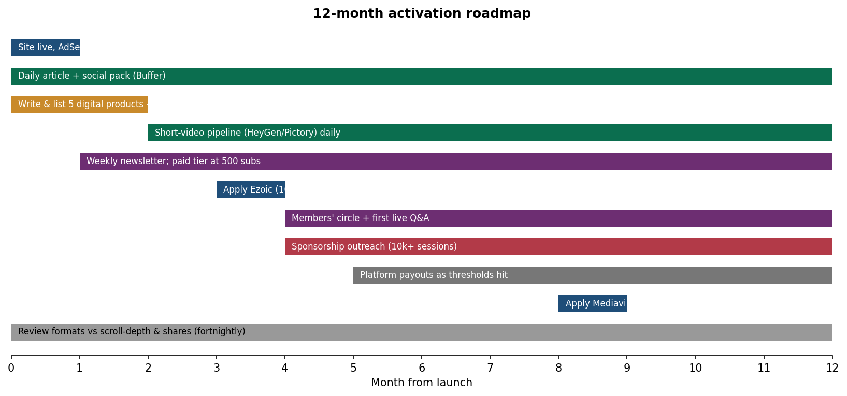
Figure 3 — Twelve-month activation roadmap. Streams switch on as thresholds are met; the daily content job runs throughout.

7. Risk register
Risk | Likelihood | Impact | Mitigation (built in or planned) | Residual
AdSense rejection or slow approval | Medium | High | Publish 20+ articles before applying (done by week 3); privacy/about pages exist; no thin pages. | Medium
Story accuracy — misquoting a real person | Low | High | Runbook rule: fetch and read the source; quote only what's on the page; sources listed on every article; corrections email. | Low
Amazon Associates account closed (no sales in 180 days) | Medium | Medium | Kit-list articles by week 4; drive newsletter clicks to shop; re-apply if closed. | Low
Search engines de-value AI-written content | Medium | High | Every article built on a named real story with links; original 'try this' sections; human founders named on About; E-E-A-T signals. | Medium
Social accounts flagged for automation | Low | Medium | Use an approved scheduler (Buffer/Publer), not scraping; human-looking cadence (1–2 posts/day). | Low
Health-claim liability | Low | High | No medical advice, 'check with your GP' on every page, no supplements affiliate links. | Low
Traffic plateaus — content format wrong for audience | Medium | Medium | Improvement loop (scroll depth, shares, segment split) reviewed fortnightly; test one change at a time. | Low
Founder time for live elements (Q&A, sponsors) | Medium | Medium | Sequence recurring products after the list is > 1,000; Claude drafts all sponsor replies. | Low
Platform policy changes (ad networks, YouTube) | Medium | Medium | Six independent streams; the email list is owned and portable. | Low

Colour key: red = high, amber = medium, green = low.

8. What you need to do (once)
# | Action | Time | Why
1 | Register dontdieretired.com (if not done); create a GitHub account/repo and push the site folder; enable Pages | 30 min | Free hosting; Claude publishes daily by git push
2 | Point DNS at GitHub Pages (records in RUNBOOK §8) | 10 min | Live on your domain with HTTPS
3 | Create Google AdSense account and apply (after ~20 articles, week 3) | 20 min | Display ads
4 | Join Amazon Associates UK and US; put the tags in site.yaml | 20 min | Affiliate commissions
5 | Create Buttondown (or Beehiiv) account; paste the form URL into site.yaml | 15 min | Newsletter — the compounding asset
6 | Create Gumroad store; Claude supplies the five PDFs; paste product URLs into products.yaml | 30 min | Own products, highest margin
7 | Create Facebook page, Instagram, X, Pinterest, TikTok, YouTube accounts; connect to Buffer or Publer; give Claude the scheduler token | 60 min | Automated daily social posting
8 | Plausible Analytics account (~£9/mo) or use free GA4; put the domain/ID in site.yaml | 10 min | The data the improvement loop runs on
9 | Optional: HeyGen/Pictory account for AI short videos | 15 min | Daily Reels/Shorts/TikTok from Claude's scripts
10 | Set up the daily scheduled task for Claude ('run the RUNBOOK daily job') | 5 min | Unattended operation

Sources
- EarnifyHub, 'Mediavine vs Raptive vs Ezoic 2026' — network thresholds (Ezoic 10k, Mediavine 50k, Raptive 100k sessions) and health-niche RPMs. https://earnifyhub.com/blog/blogging/mediavine-vs-raptive-vs-ezoic-rpm
- Later, 'Social Media Monetization Requirements 2026' — Facebook in-stream, Instagram subscriptions, YouTube Partner and TikTok Creator Rewards thresholds. https://later.com/blog/your-guide-to-social-media-network-monetization-requirements/
- Creators Agency, 'Facebook Content Monetization in 2026' — follower and activity requirements for the unified programme. https://creatorsagency.co/blog/facebook-content-monetization-requirements-2026
- Launch-article sources are listed on each article page on the site.

