1 . Base64



2 . Blowfish

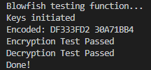

3. RC5

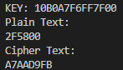

4. RSA

