To whomsoever is concerned,

This is a written declaration that the following project is being run by Aditya Vinod Kumar and Rishi Ravikumar, and the Github repository - https://github.com/adityavinodk/energy_consumption is maintained by Aditya Vinod Kumar with Apache License 2.0

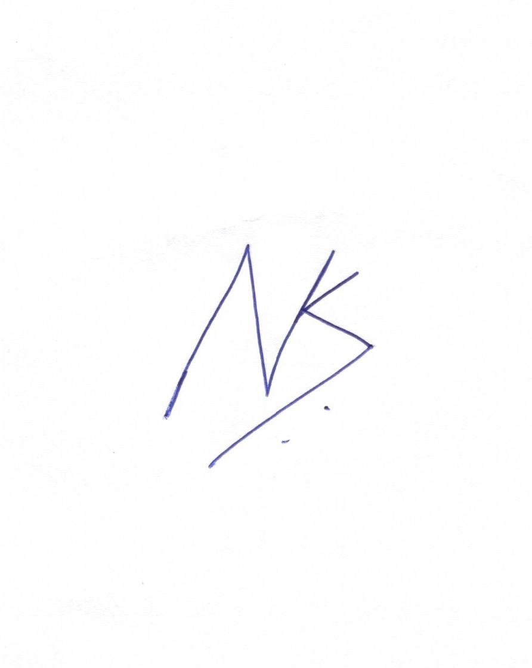 

Aditya Vinod Kumar Rishi Ravikumar

+91 9845920700 +91 9591900867