**Experiment Number** – 1

* Installation of GIMP AND BLENDER.

The Steps are as follows for the installation of the Gimp in windows 10-

Step 1) Open the browser (Chrome, Firefox).

Step 2) Now just type on the browser “Gimp download” or visit a website gimp.org/downloads. From there choose the configuration of the computer you are using and click on the button download Installer.

Step 3) After downloading the Gimp run the installer. You can find this at the location you saved it to, usually your Downloads/My Downloads folder.

Step 4) Follow the prompts to install GIMP. Most users can leave the settings at the defaults.

Step 5) Finish the installation. After selecting the file formats, GIMP will install. This may take a few minutes where it is opening and arranging the packages.

Step 6) Start using GIMP. Once GIMP has finished installing, you can start using it. See this guide for tips on getting started.

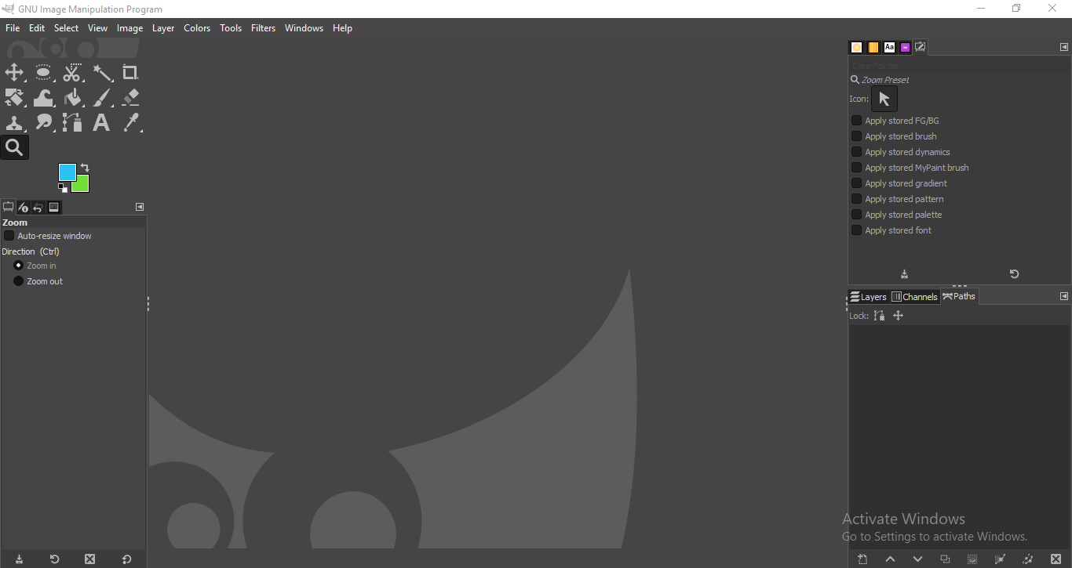

* Installation of BLENDER.

The Steps are as follows for the installation of the Blender in windows 10.

Step 1) Open the browser (Chrome, Firefox).

Step 2) Now just type on the browser “Blender download” or visit a website https://www.blender.org/. From there choose the configuration of the computer you are using and click on the button download Installer or a zip file (unpack the files).

Step 3) Run the installer. It will usually be located in your download folder.

Step 4) Start the installation process. Click Next.

Step 5) Agree to the Terms and Conditions. When prompted, click I Agree.

Step 6) Choose a destination folder. The default location is the Program Files folder of Drive C:\ in your computer.

Step 7) Wait for Blender to install. The status bar indicates the progress of the installation. Depending on your computer processor and speed, it will probably take less than 5 minutes.

Step 8) Finish the installation. Click Finish when the installation is completed. Blender is now installed in your computer. You can start exploring the application when it starts automatically.

