**How to convert Excel sheet to HTML File**

You can convert the excel file to HTML file using the online tool available at the link <https://tableconvert.com/excel-to-html>

Follow the steps below to generate a HTML file for your Excel file.

You can drag and drop the excel file which you want to convert to HTML

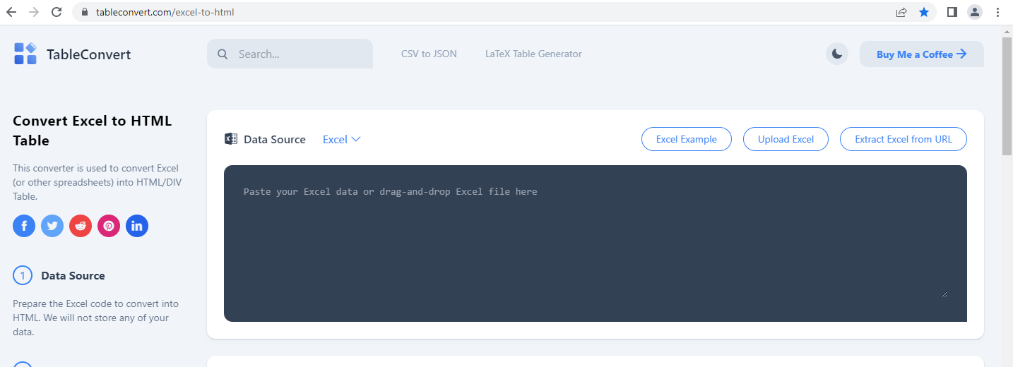

Or, you may also choose to copy the data from your excel sheet and paste it in the space as indicated in the screenshot above.

Once you have uploaded/pasted the excel sheet in the space, the online tool will automatically display the table View and generate the HTML code for the table in the table editor and table generator sections respectively as shown below

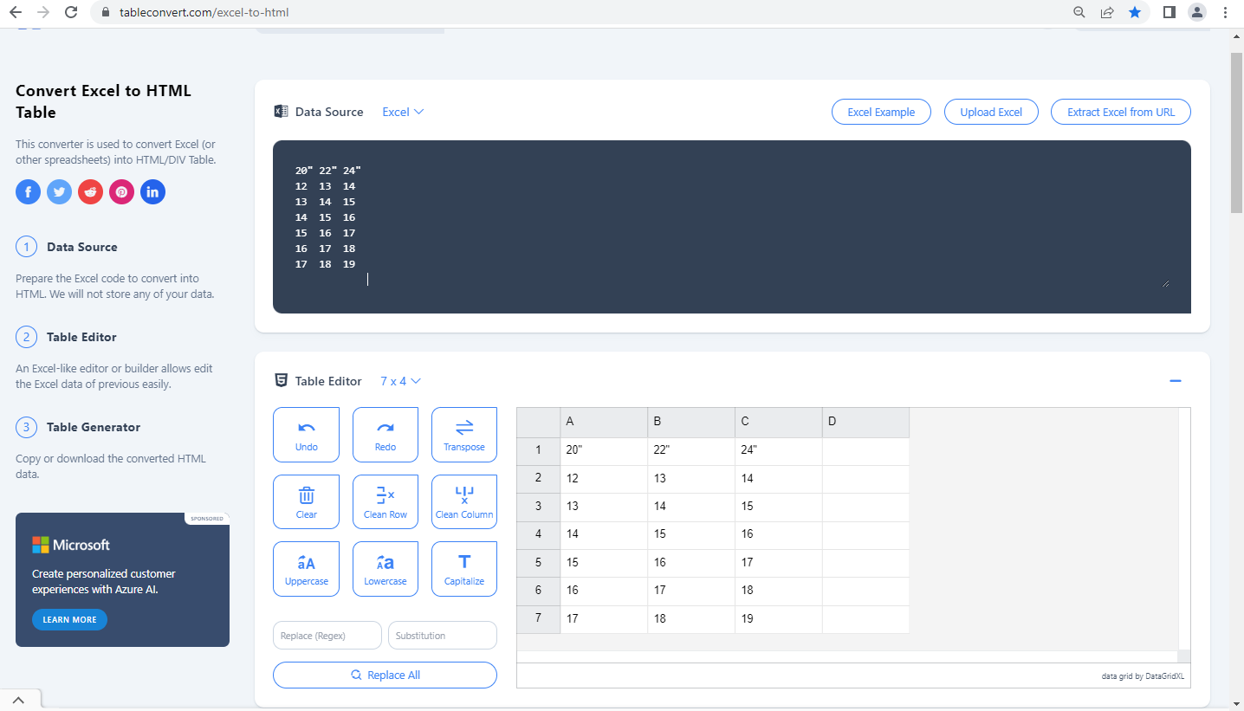

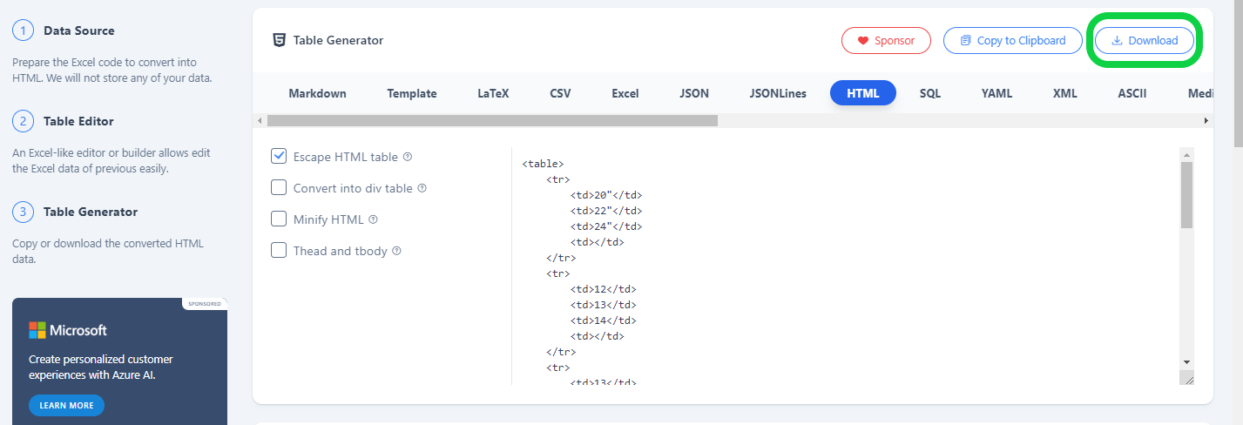

Use the Download button on the top right of the table editor to download the generated HTML file.

You can style the table using the script in your HTML or CSS files.