**Frontend code**

## **Prerequisite**

Make sure that you have set up the Server/backend environment and your server is up and running. Please follow the backend_setup document in order to setup the backend environment.

If the above step is completed, we can now proceed with frontend folder structure as shown in an example below

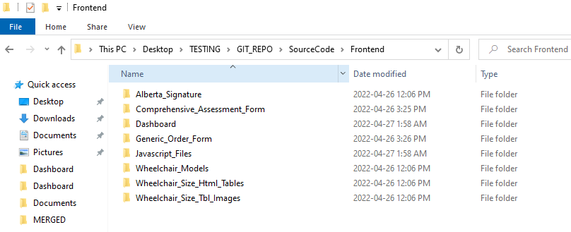

## **Folder Structure**

The Frontend Folder contains 8 sub folders.

1. **Alberta_Signature** – contains AHS and UofA logos
2. **Comprehensive_Assessment_Form** – contains HTML and CSS files (CSAForm.html and CSAFormStyle.css) related to Comprehensive assessment form (CSA Form).
3. **Dashboard** – contains HTML and CSS files (Welcome.html,WelcomeStyle.css, ProcessingScreen.html,ProcessingStyle.css ,faq.html and faq.css) related to Welcome Screen, processing Screen and FAQ Page.
4. **Generic_Order_Form** – contains HTML and CSS files (GOForm.html and GOFormStyle.css) related to Generic Order Form (GO Form).
5. **Javascript_Files** – contains .js files which are responsible for scripts for frontend (functions.js,models.js,faq.js)
6. **Wheelchair_Models** – contains HTML and CSS files (models.html and models.css) related to Available Models Page in the application.
7. **Wheelchair_Size_html_tables** – contains Wheelchair size HTML tables generated from the Wheelchair size excel sheet
8. **Wheelchair_Size_Tbl_Images** – contains Wheelchair size tables screenshots taken from the Wheelchair size excel sheet. Maybe used later but not currently in use.

To run the application UI (launch the web page),Go to the Dashboard folder which contains **Welcome.html** file, Double click to open this file or Right click and open the file in your local browser ( ex. Google Chrome)

Click on “**Enter the Wheelchair App**” button to navigate to the Comprehensive Seating Assessment form page (CSA Form).

Make sure you enter all the input data in the CSA page so that you can proceed with submit.

Print button provides an option to print the page as the Pdf.

On successful submit on CSA Page, you will see a processing screen in between the pages.

Now you will see the Generic Order form (GOF) with values calculated and shown as the response from the first API call. A POSTMAN response to the input is as shown in screenshot below:

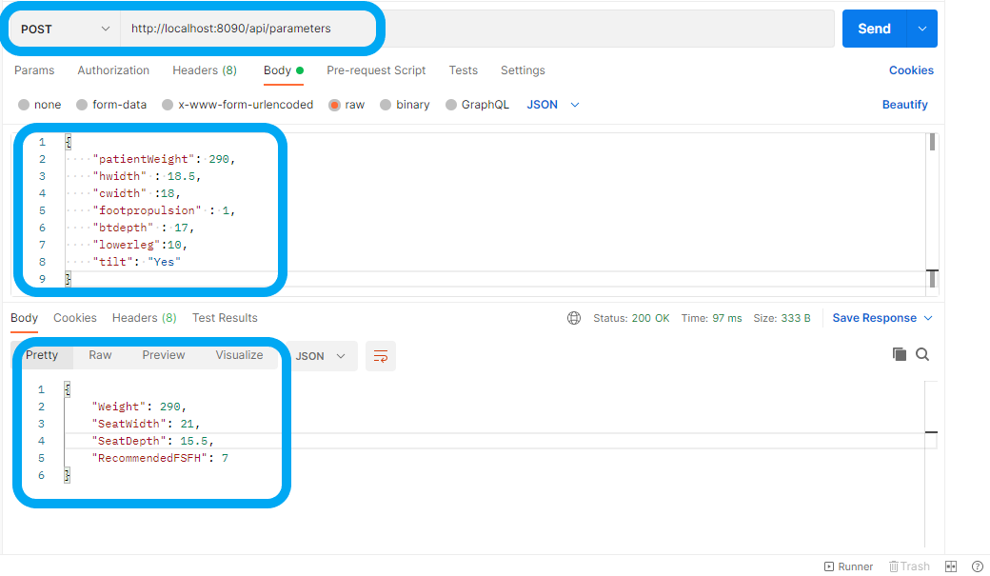

## **Input data for first API call expects following data**

{

    "patientWeight": 290,

    "hwidth" : 18.5,

    "cwidth" :18,

    "footpropulsion" : 1,

    "btdepth" : 17,

    "lowerleg":10,

    "tilt": "Yes"

}

The data above is collected from the CSA and passed to the parameters API which sends response as below

{

    "Weight": 290,

    "SeatWidth": 21,

    "SeatDepth": 15.5,

    "RecommendedFSFH": 7

}

This data is automatically populated on the Generic Order Form page as it loads and one can modify the values on this form and click on submit.

Also here Print button provides an option to print the page as Pdf.

On successful submit from the Generic order form, you will see again see a processing screen in between the pages.

If the previous values entered were valid use case then you should see the list of filtered Wheelchair Models based on the values input on the previous forms.

An example from POSTMAN second API call is as shown below

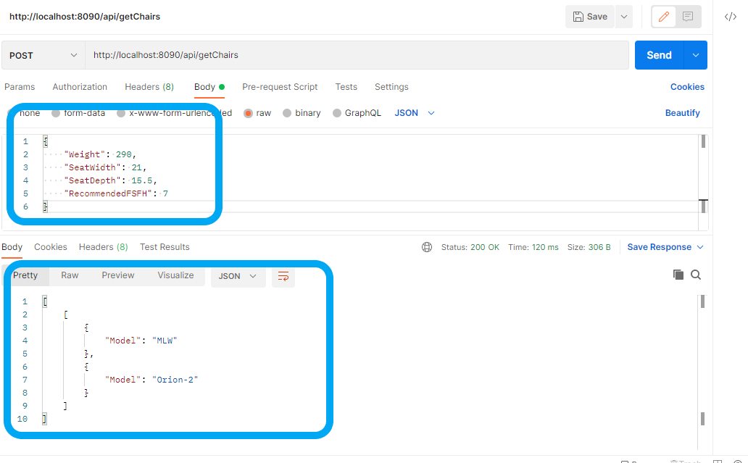

**About the Code**

* **Functions.js** – file which contains all the scripts that are used for CSA and GOF forms.

1. function validateForm() – function which checks if all fields are filled on CSA form
2. submitForm – function called when Submit button is clicked on CSA form
3. updateGOFDataFunction - function called when any of the data in the input fields on Generic order form are changed.
4. processDataFunction - function called when Submit button is clicked on Generic Order Form (GOF) Page.
5. retrieveFormInfo - function called when Generic Order form is loaded

* **Models.js** - file which contains all the scripts that are used for available Models page.

getWheelchairModels() - function called when available models page is loaded