A Voice-Based AI Framework for Medical Pre-Screening of Bangla and Regional Bangladeshi Speech with Intelligent Symptom Capture, Risk Assessment, Clinical Documentation, and EHR Integration

ABSTRACT
Patients in Bangladesh often struggle to describe symptoms to the doctors clearly specially in regional dialects or Banglish, leaving incomplete or rushed consultations. This project proposes a voice-only pre-screening system where the patient speaks naturally in Bangla, Banglish, or in a regional dialect; the system normalizes and transcribes the speech, extracts clinical entities, asks targeted spoken follow-up questions to close information gaps, and compiles an explainable structured pre-screening report before the doctor enters. A rule-based red-flag check inside the risk-assessment module discloses life-threatening symptoms prominently for the doctor. The system shortens consultation time, reduces documentation burden, and improves information completeness.
Method with System Diagram/Design Complexity
The system is a 14-module conversational pipeline (Figure 1). Speech-to-Text (M1) transcribes patient speech; Text Normalization (M2) cleans it without altering meaning; Information Extraction (M3) tags symptoms, duration, severity; a Clinical Summary (M4) is generated. Missing-Information Analysis (M5) and Follow-up Question Generation (M6) form a spoken feedback loop with Response Processing (M7) and Completion Check (M8) until the profile is sufficient. Risk Assessment (M9) applies clinical rules plus an embedded red-flag check to assign a Low-to-Critical tier, explained by an XAI module (M10), compiled into a report (M11), stored in an EHR (M12), and shown on a Doctor Dashboard (M13).

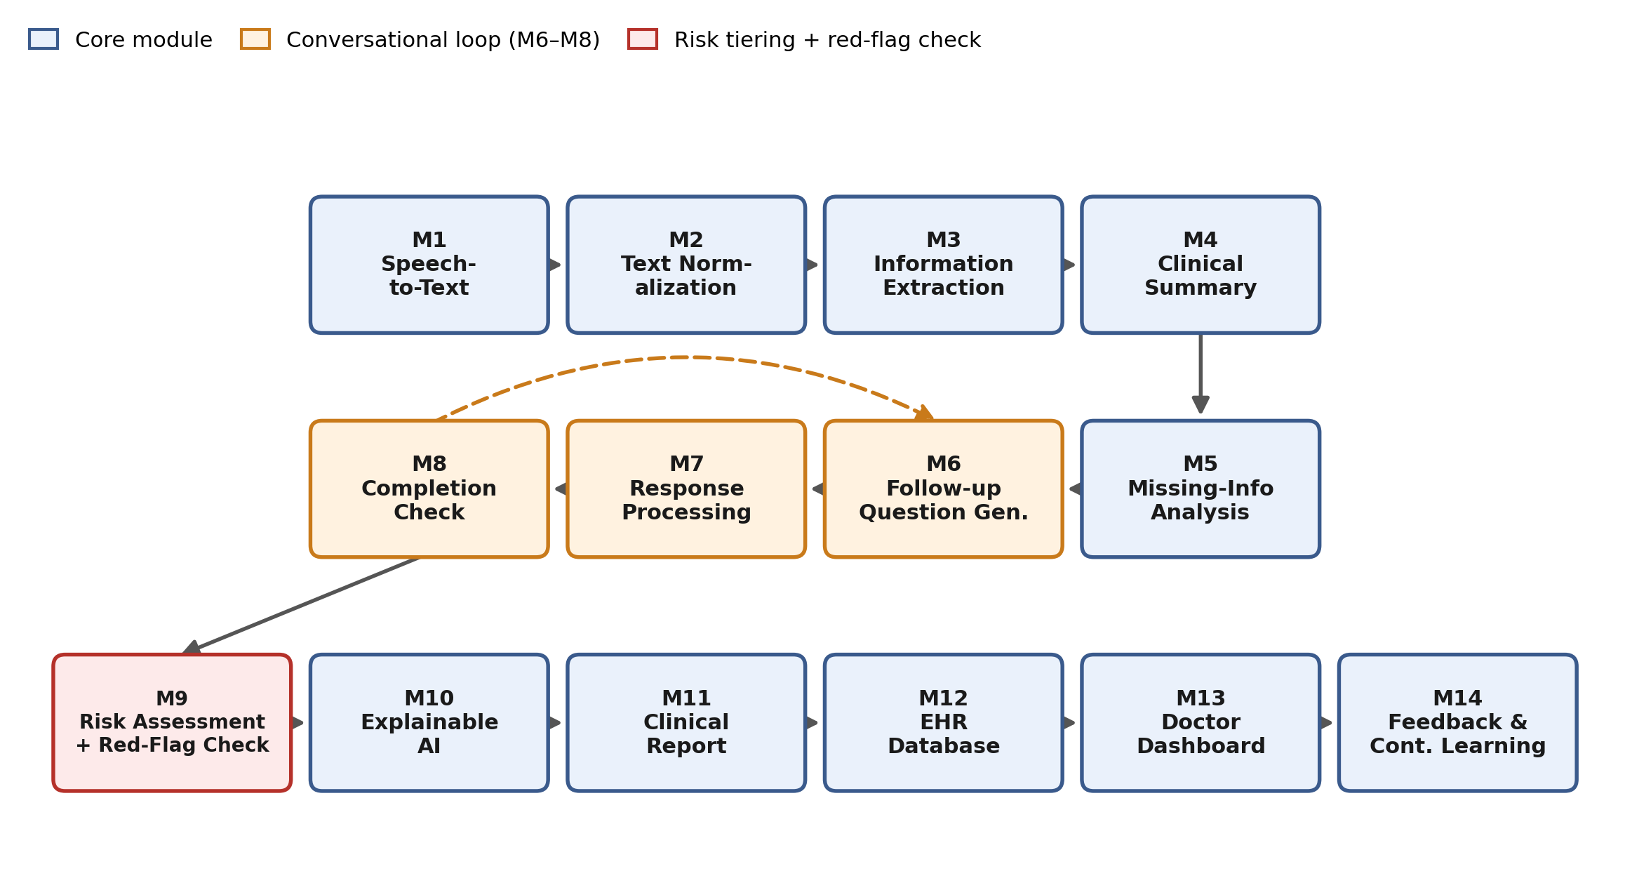
Figure 1: System architecture of the 14-module conversational pre-screening pipeline.

Novelty of Project
Unlike generic dictation or single-pass symptom-checker apps, this system actively closes information gaps through spoken follow-up dialogue instead of accepting one noisy transcript, and pairs Bangla/Banglish/dialect coverage with explainable, rule-audited risk tiering. Existing tools transcribe or triage separately; this pipeline unifies capture, gap-filling, and explainable risk assessment for low-resource clinics.
Impact on society/environment
By capturing symptoms in patients' own dialects, the system reduces miscommunication for rural and elderly patients, shortens doctor consultation time, and lowers documentation burden in overcrowded clinics. Structured records reduce paper use. Consistent red-flag surfacing helps ensure urgent cases are not overlooked, indirectly improving safety without replacing clinical judgement.
Business Model/Feasibility/Financial Scalability plan
The system targets a B2B SaaS model: clinics and diagnostic centers pay a monthly per-kiosk subscription, with tiered pricing by patient volume. A low-cost hardware bundle (Android tablet plus stand) keeps entry cost minimal, and the open-source, CPU-only ASR stack avoids GPU licensing fees, making deployment feasible for small clinics. Revenue scales with clinic count and consultation volume rather than per-patient fees, keeping care free at the point of use. Future scalability includes an EHR-integration add-on, white-labeling for hospital chains, and an anonymized-feedback dataset licensing stream to fund continuous model retraining, without compromising patient data privacy.
Conclusion
This system reframes pre-consultation intake as a guided spoken conversation rather than passive transcription, closing information gaps before the doctor enters the room. Its rule-based red-flag check and explainable risk tiering give clinicians a trustworthy, auditable starting point, reducing documentation load while keeping every diagnostic decision in the doctor's hands.

