Chapter : 4
Fixed-Bias Configuration
1. For the fixed-bias configuration of Fig. 4.118 , determine: a. IBQ. b. ICQ. c. VCEQ. d. V C . e. V B . f. V E . ICQ 510 k

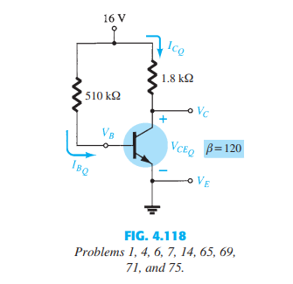

2. Given the information appearing in Fig. 4.119 , determine: a. I C . b. R C . c. R B . d. V CE .
3. Given the information appearing in Fig. 4.120 , determine: a. I C . b. V CC . c. b. d. R B

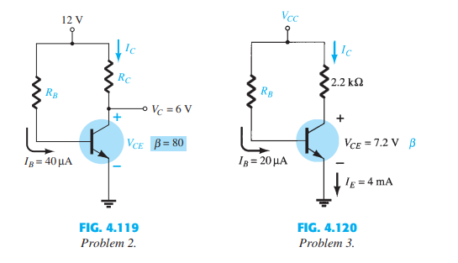
4. Find the saturation current (ICsat) for the fixed-bias configuration of Fig. 4.118 .
Emitter-Bias Configuration :
8. For the emitter-stabilized bias circuit of Fig. 4.122 , determine: a. IBQ. b. ICQ. c. VCEQ. d. V C . e. V B . f. V E .
12. Determine the saturation current (ICsat) for the network of Fig. 4.122
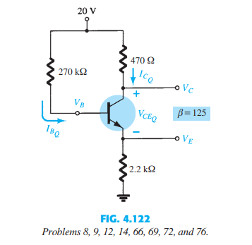
10. Given the information provided in Fig. 4.123 , determine: a. R C . b. R E . c. R B . d. V CE . e. V B .
11. Given the information provided in Fig. 4.124 , determine: a. b. b. V CC . c. R B .
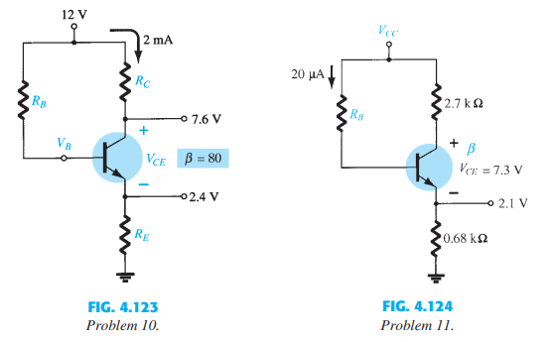

Voltage-Divider Bias Configuration :
15. For the voltage-divider bias configuration of Fig. 4.125 , determine: a. IBQ. b. ICQ. c. VCEQ. d. V C . e. V E . f. V B .
17. Given the information provided in Fig. 4.126 , determine: a. I C . b. V E . c. V B . d. R1 .
19. Determine the saturation current (ICsat) for the network of Fig. 4.125 .

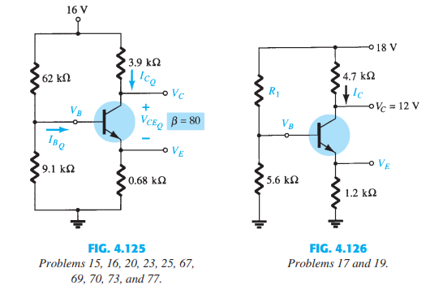
18. Given the information appearing in Fig. 4.127 , determine: a. I C . b. V E . c. V CC . d. V CE . e. V B . f. R1 .
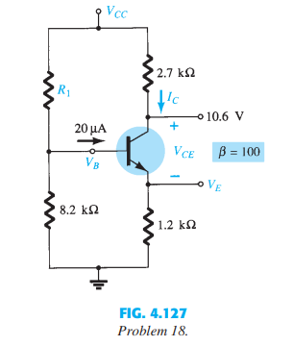
21. Determine the following for the voltage-divider configuration of Fig. 4.128 using the approximate approach if the condition established by Eq. (4.33) is satisfied. a. I C . b. V CE . c. I B . d. V E . e. V B .
22. Repeat Problem 21 using the exact (Thévenin) approach and compare solutions. Based on the results, is the approximate approach a valid analysis technique if Eq. (4.33) is satisfied? 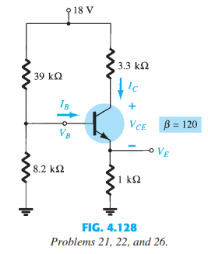
Collector-Feedback Configuration :
27. For the collector-feedback configuration of Fig. 4.129 , determine: a. I B . b. I C . c. V C
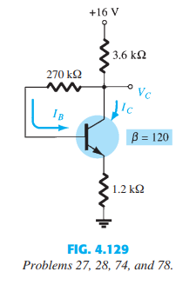

29. For the voltage feedback network of Fig. 4.130 , determine: a. I C . b. V C . c. V E . d. V CE .
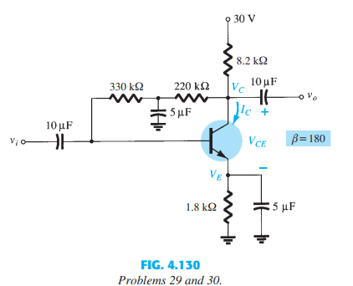

33. Given VB = 4 V for the network of Fig. 4.133 , determine: a. V E . b. I C . c. V C . d. V CE . e. I B . f. b.
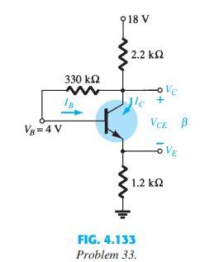

Emitter-Follower Configuration :
34 .Determine the level of V E and I E for the network of Fig. 4.134
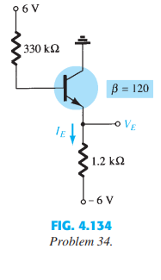
35. For the emitter follower network of Fig. 4.135
a. Find I B , I C , and I E . b. Determine V B , V C , and V E . c. Calculate V BC and V CE .
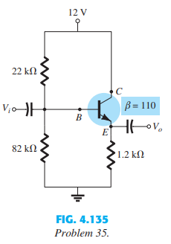
Common-Base Configuration :
36. For the network of Fig. 4.136 , determine: a. I B . b. I C . c. V CE . d. V C .
37. For the network of Fig. 4.137 , determine: a. IE. b. V C . c. V CE .
38. For the common-base network of Fig. 4.138 a. Using the information provided determine the value of R C . b. Find the currents I B and I E . c. Determine the voltages V BC and V CE .
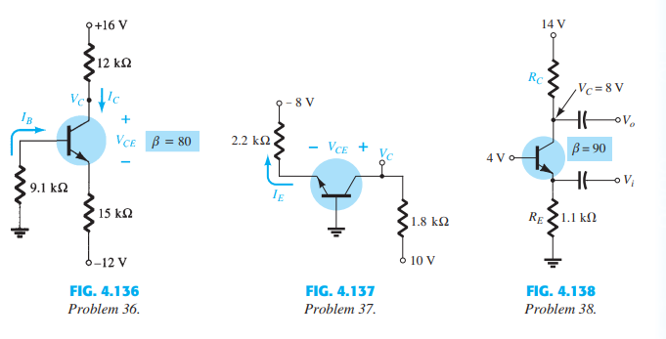
Design Operations :
41. Determine R C and R B for a fixed-bias configuration if VCC = 12 V, b = 80, and ICQ = 2.5 mA with VCEQ = 6 V. Use standard values.
42. Design an emitter-stabilized network at ICQ = 1 2ICsat and VCEQ = 1 2VCC. Use VCC = 20 V, ICsat = 10 mA, b = 120, and RC = 4RE. Use standard values.
43. Design a voltage-divider bias network using a supply of 24 V, a transistor with a beta of 110, and an operating point of ICQ = 4 mA and VCEQ = 8 V. Choose VE = 1 8VCC. Use standard values.

Current Source Circuits :
51. Calculate the current through the 2.2-k load in the circuit of Fig. 4.147 .
52. For the circuit of Fig. 4.148 , calculate the current I.
53. Calculate the current I in the circuit of Fig. 4.149
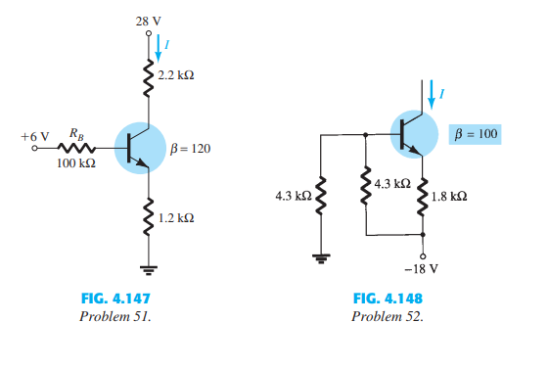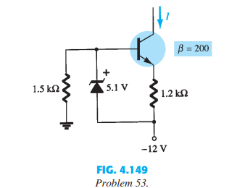

Chapter 1 :

15. a. Determine the thermal voltage for a diode at a temperature of 20°C. b. For the same diode of part (a), find the diode current using Eq. 1.2 if I s 40 nA, n 2 (low value of V D ), and the applied bias voltage is 0.5 V.
16. Repeat Problem 15 for T 100°C (boiling point of water). Assume that I s has increased to 5.0 mA.
17. a. Using Eq. (1.2), determine the diode current at 20°C for a silicon diode with n 2, I s 0.1 mA at a reverse-bias potential of -10 V. b. Is the result expected? Why?
18. Given a diode current of 8 mA and n 1, find I s if the applied voltage is 0.5 V and the temperature is room temperature (25°C).
*19. Given a diode current of 6 mA, V T 26 mV, n 1, and I s 1 nA, find the applied voltage V D .

Chapter 2 :
Series Diode Configurations :
5. Determine the current I for each of the configurations of Fig. 2.155 using the approximate equivalent model for the diode.
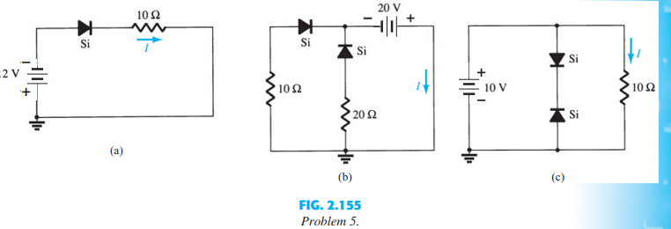
6. Determine V o and I D for the networks of Fig. 2.156 .
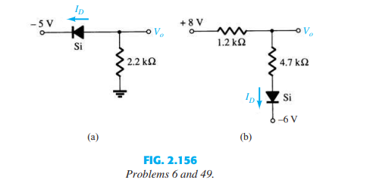
*7. Determine the level of V o for each network of Fig. 2.157 .
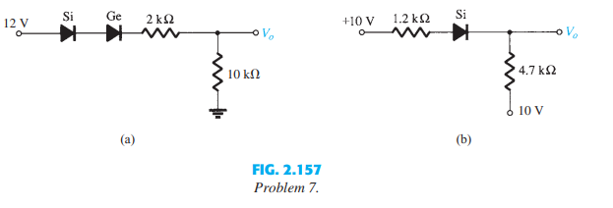
*9. Determine V o1 and V o2 for the networks of Fig. 2.159 .
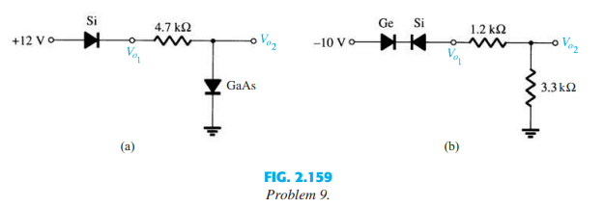
*13. Determine V o and I D for the network of Fig. 2.163 .
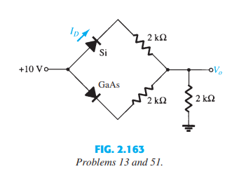
Sinusoidal Inputs; Half-Wave Rectification :

22. Assuming an ideal diode, sketch v i , v d , and i d for the half-wave rectifier of Fig. 2.168 . The input is a sinusoidal waveform with a frequency of 60 Hz. Determine the profit value of v i from the given dc level.
23. Repeat Problem 22 with a silicon diode ( V K 0.7 V).
24. Repeat Problem 22 with a 10 k load applied as shown in Fig. 2.169 . Sketch v L and i L
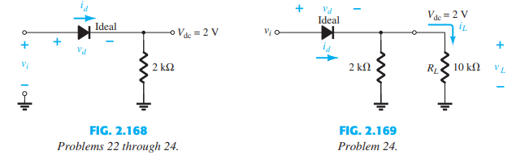

Full-Wave Rectification :

29. Determine v o and the required PIV rating of each diode for the configuration of Fig. 2.173 . In addition, determine the maximum current through each diode.
*30. Sketch v o for the network of Fig. 2.174 and determine the dc voltage available.

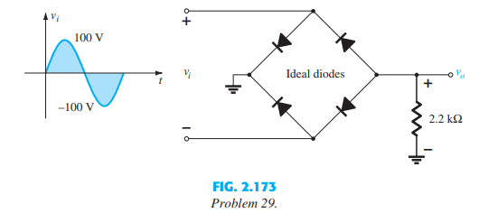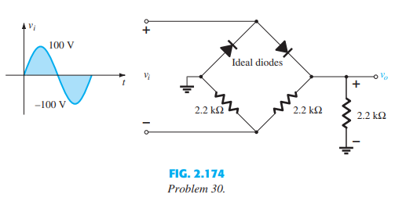

Clippers : ( how understand its clippers circuit )
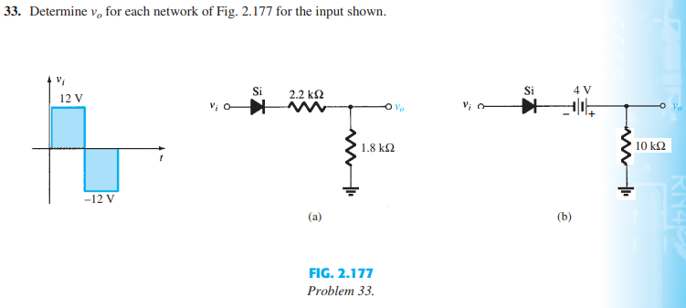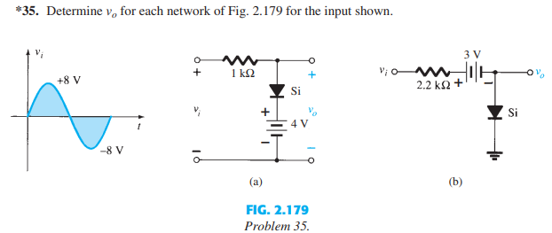
Clampers : ( how understand this clamper circuit)
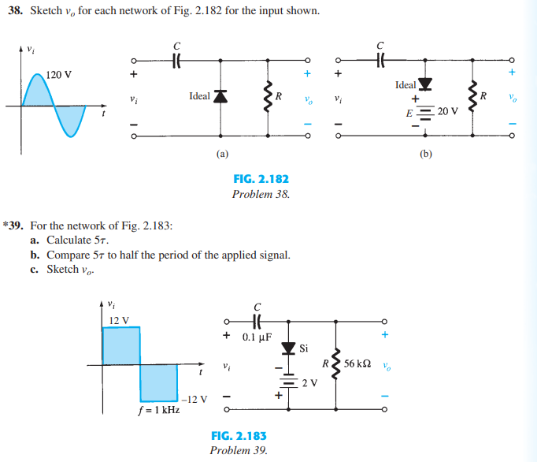

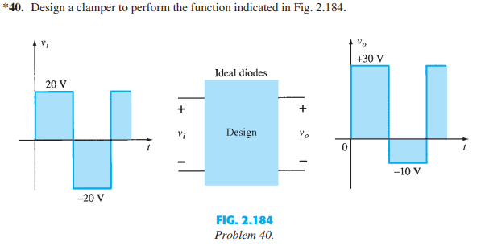

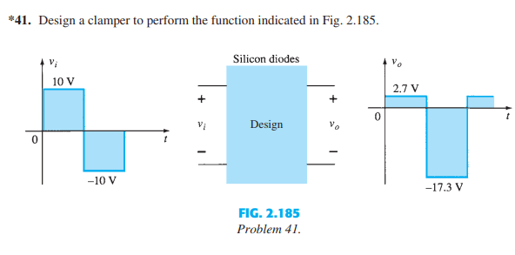

Zener Diodes :

42. a. Determine V L , I L , I Z , and I R for the network of Fig. 2.186 if R L 180 . b. Repeat part (a) if R L 470 . c. Determine the value of R L that will establish maximum power conditions for the Zener diode. d. Determine the minimum value of R L to ensure that the Zener diode is in the “on” state.
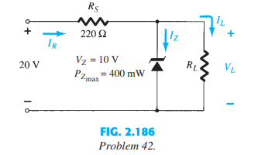
*43. a. Design the network of Fig. 2.187 to maintain V L at 12 V for a load variation ( I L ) from 0 mA to 200 mA. That is, determine R S and V Z . b. Determine P Z max for the Zener diode of part (a).
*44. For the network of Fig. 2.188 , determine the range of V i that will maintain V L at 8 V and not exceed the maximum power rating of the Zener diode.
