Question1

(a) Here is the result of (a), using the same code in homework2, we can get the following picture as showing below.

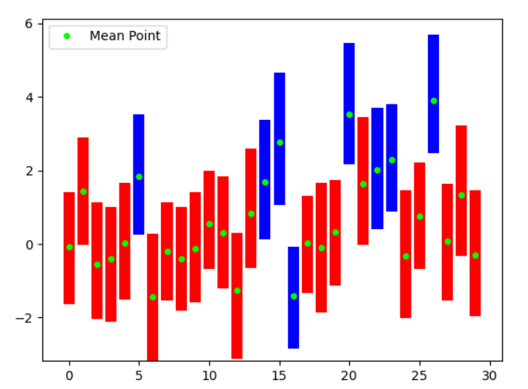

(i) In this question C represent the inverse of regularization strength. This means if the value C takes a small one, the loss function will be smaller. Furthermore, a smaller value of c will increase the penalty of the loss function. In this question the value C takes 1000, this means the loss function is bigger and the penalty of the loss function is not severe.

(ii) In this question, we can reduce the value of C in the training process. By doing this, we can easily find that blue bars which is in the confidence interval will reduce. By decreasing the current C, the loss function will decrease and the penalty will increase. This means the CI result provided by C=1000 is not reliable than those CI which C is small.