

**COMP 9444**

**Neural Networks and Deep Learning**

Assignment 1

|  |  |
| --- | --- |
| **Student Name** | Hongyi Luo |
| **Student Number** | z5241868 |

**Part1**

**Question1**

Based on the question1, we should use the linear function and log softmax function to design the neural network. After running the source code, we can finally get the accuracy, which is 6966/10000. After doing the calculation, the accuracy is around 70%. Here is the picture of the result.

Furthermore, we can also get the confusion matrix as showing below. Here is the result of the confusion matrix.

[[766. 5. 8. 13. 30. 64. 3. 62. 30. 19.]

[ 7. 671. 107. 18. 27. 23. 58. 13. 27. 49.]

[ 5. 58. 691. 27. 28. 21. 47. 37. 46. 40.]

[ 4. 33. 61. 759. 14. 58. 15. 19. 25. 12.]

[ 58. 50. 82. 22. 626. 19. 32. 37. 20. 54.]

[ 8. 28. 128. 17. 20. 722. 26. 8. 33. 10.]

[ 4. 24. 147. 11. 24. 24. 722. 21. 10. 13.]

[ 17. 29. 29. 11. 83. 16. 52. 624. 91. 48.]

[ 9. 35. 95. 41. 8. 31. 46. 7. 707. 21.]

[ 8. 50. 87. 2. 53. 31. 17. 33. 41. 678.]]

**Question2**

Based on the question2, we should use the linear function, tanh function and log softmax function to design a neural network with 2 layers. In this case, we can use a function called nn.sequential to wrap these functions up. This can make the designing process easier. After running the source code, we can easily find the accuracy is 85%, which is 8457/10000. Here is the picture of the result.

Furthermore, we can also get the confusion matrix as showing below. Here is the result of the confusion matrix.

[[847. 7. 3. 6. 31. 34. 4. 39. 24. 5.]

[ 4. 824. 27. 2. 17. 15. 59. 7. 17. 28.]

[ 7. 16. 826. 50. 12. 19. 27. 12. 14. 17.]

[ 5. 12. 25. 919. 2. 18. 7. 2. 4. 6.]

[ 35. 34. 21. 4. 818. 10. 27. 18. 19. 14.]

[ 9. 24. 76. 8. 10. 832. 18. 1. 16. 6.]

[ 3. 16. 42. 9. 13. 7. 891. 8. 1. 10.]

[ 22. 13. 17. 3. 16. 9. 30. 841. 22. 27.]

[ 12. 31. 29. 60. 4. 9. 30. 3. 816. 6.]

[ 4. 21. 44. 3. 32. 5. 19. 20. 9. 843.]]

**Question3**

In question3, we should design a 2-layers neural network by using the convolution function provided by nn. Based on the question2, we can also use the Sequential function to wrap up 2 convolution models. Here is the final accuracy of the question3, which is 9306/10000, which is 93%. Here is the picture of the result.

Also, here is the result of the confusion matrix.

[[957. 2. 2. 0. 16. 8. 0. 12. 1. 2.]

[ 2. 910. 5. 0. 12. 2. 48. 6. 3. 12.]

[ 9. 6. 850. 43. 9. 19. 36. 15. 4. 9.]

[ 2. 1. 17. 954. 3. 12. 3. 4. 1. 3.]

[ 25. 2. 3. 9. 911. 5. 18. 9. 14. 4.]

[ 3. 17. 30. 3. 5. 916. 19. 4. 2. 1.]

[ 5. 4. 11. 1. 7. 3. 964. 1. 2. 2.]

[ 8. 2. 1. 1. 8. 4. 12. 936. 8. 20.]

[ 7. 11. 3. 4. 4. 6. 9. 2. 953. 1.]

[ 5. 9. 2. 4. 12. 4. 0. 4. 5. 955.]]

**Question4**

a. From the previous question, we can get 3 different models, which have their accuracy and confusion matrix. From the first question, we only use the linear function and softmax method. The accuracy is lower, which is around 70%.

In the second question, we still use the linear function. The difference is we increase the layer of the neural network, which is using the 2-layer linear function instead of using only one. Furthermore, we add an activation function which is Tanh in this model. The result is better than the first one, which accuracy is 85% (larger than the first question about 15%). This means we can add more layers and using the activation function to improve the accuracy of the training model.

In question3, we use the convolutional neural network, which is different from the linear function. Furthermore, using the ReLU activation function can help us avoid the appearance of the gradient vanishing problem. This activation function can also avoid the overfitting problem. The result of the third question can easily approve that using the convolutional neural network will give a good performance in image identification than using the linear function. The accuracy is 93% which is larger than the 2-layer linear function, which is larger 8%.

b. From the question1, we can get the information that the rows of the confusion matrix are the target character. Also, the columns indicate the one chosen by the network. The diagonal of the matrix is the number of the correct training samples of each character.

From the confusion matrix given by the question1, we can easily get the number of correct training sample is 624 and 626, which represent the “na” and “ya”. This means the correct number of predictions will affect accuracy. Furthermore, the character “ki” which the number of correct sample is 671, performs a little bit worse but not the worst. Therefore, based on the confusion matrix in question1, character “na” and “ya” are most likely to be mistaken by other characters.

Using the same method, we can also find that character “na” and “re” in the question2(2-layer linear neural network) confusion matrix is most likely to be mistaken.

From the question3 confusion matrix, we can also get that the character “na” is most likely to be mistaken.

c. In the first part questions, I do several changes. In the question2, I changed the number of hidden nodes.

I set the number as 100, and get the following result as the show blew.

I set the number as 10000, and get the following result as the show blew.

The accuracy is 84%, but when I use 1000 hidden nodes the accuracy is 85%. This means the hidden node number can affect the accuracy. Furthermore, this can indicate that the more hidden node we use, we may not get higher accuracy.

The most interesting point is in the question3. When I setting the parameter in the max pool function, I set the parameter as (2,2). After training, accuracy is always lower than 93%. Then changing the parameters to (3,2). The accuracy is 93%. This is because when using CNN to deal with the image. The size would not enough to get the information about the picture. When changing this parameter to (3,2), then doing the convolutional calculation, we can easily find that there is an overlap area. This can help us to improve the efficiency of getting details from the image by using CNN. Therefore, changing the size of the max pool can solve the problem of lower accuracy. In this way, we can get 93% accuracy. Here is the result of MaxPool2d(2,2).

Furthermore, in the part1, we can also get the result that increasing the number of channels can also speed up training and increase accuracy.

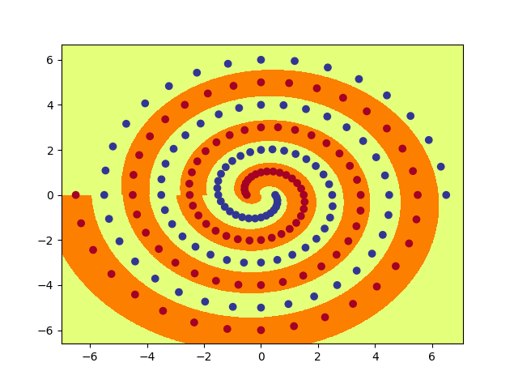**Part2**

**Question2**

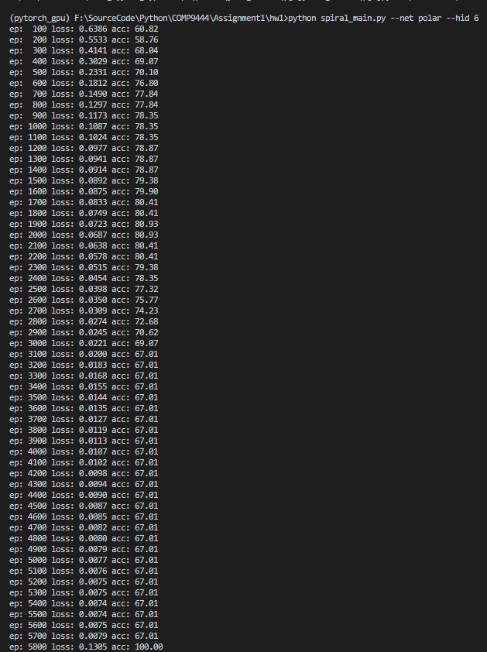Here is the picture result of the question2. From this picture, we can find the process of convergence. The minimum number of hidden nodes 6. Here is the result picture.

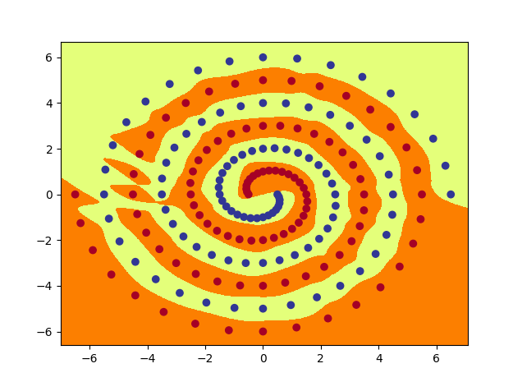**Question4**

Here is the picture result of the question4. This picture is the convergence process of rawNet. Using the hidden node number as 100 can speed up the training. Also, setting the initial weight as 0.2 or larger can speed up training.

**Question5**

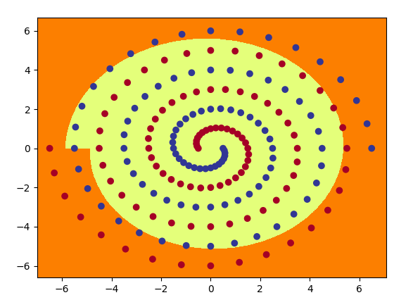PolarNet result has 11 pictures.

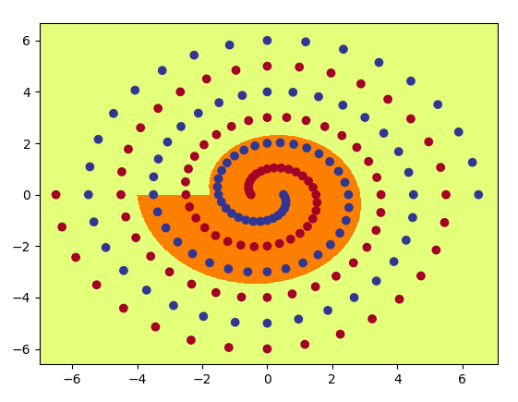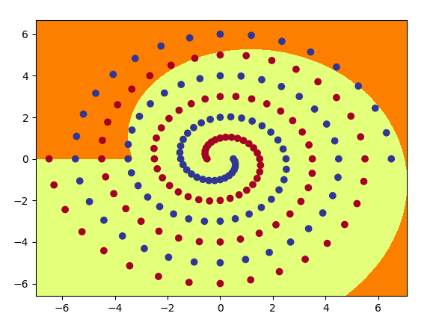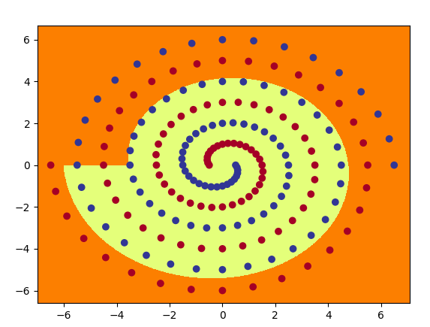

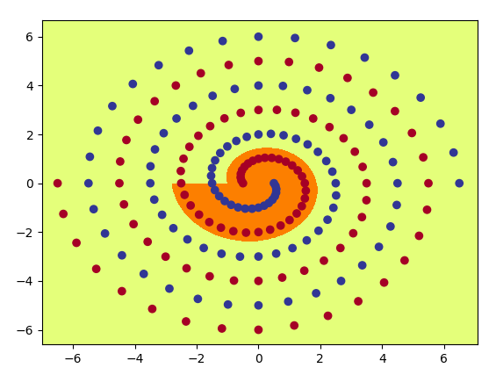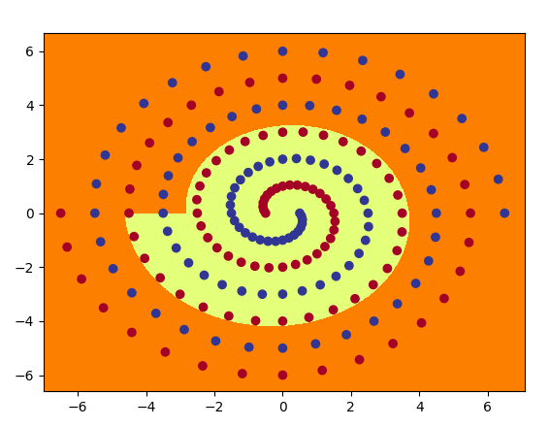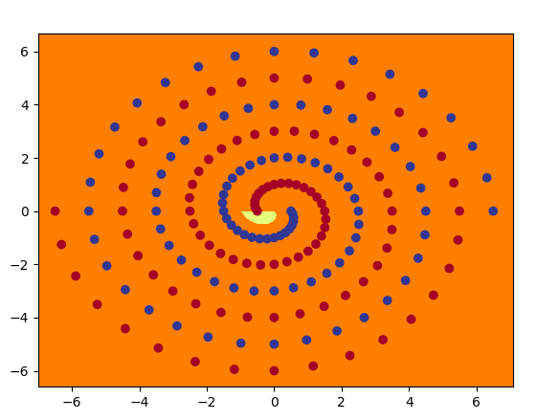

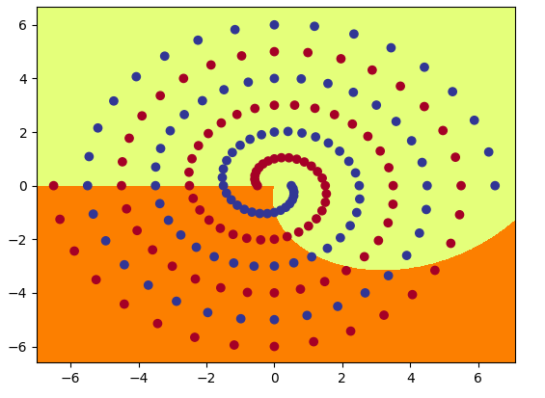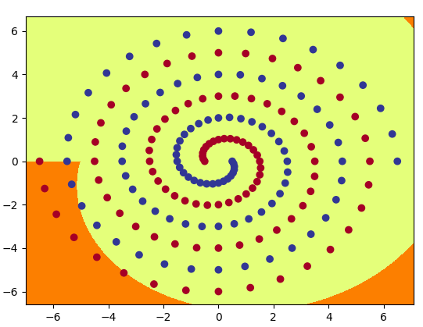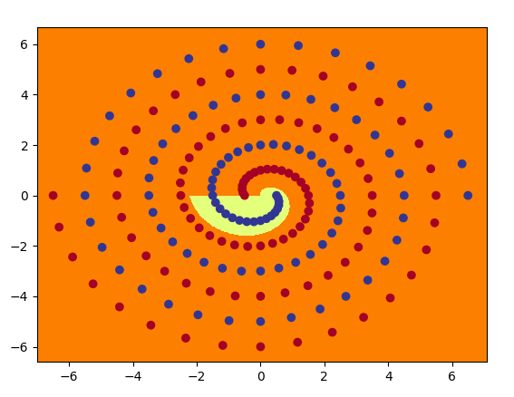

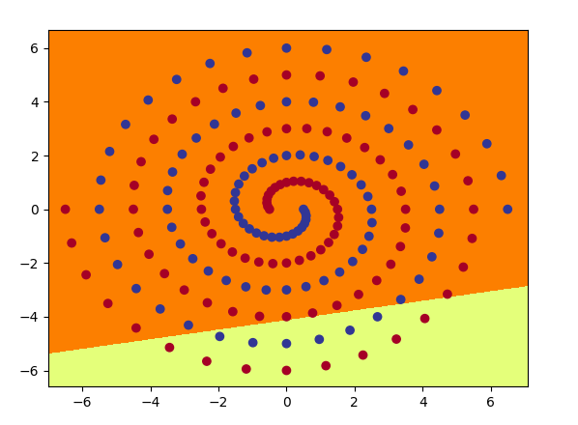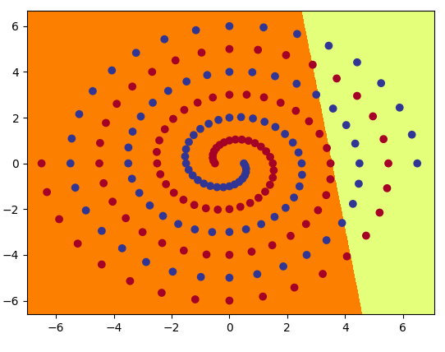RawNet result has 21 pictures.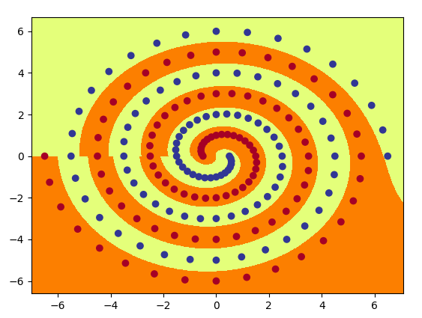

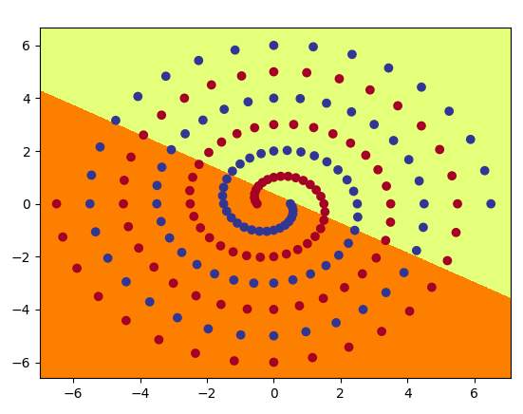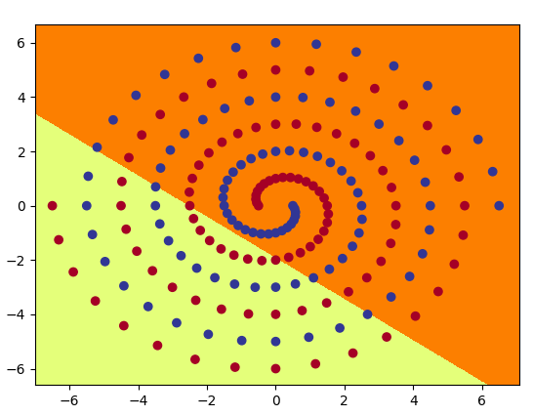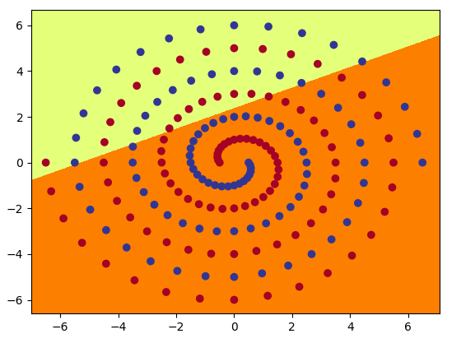

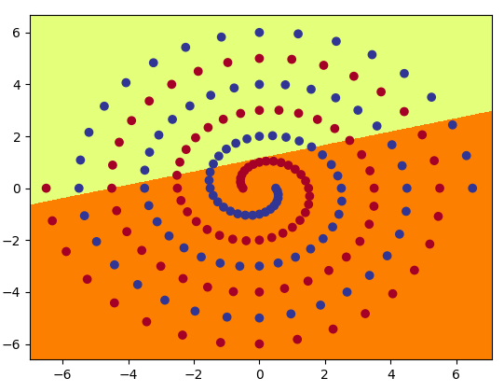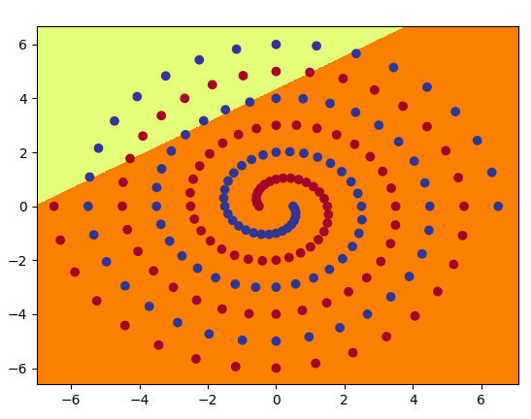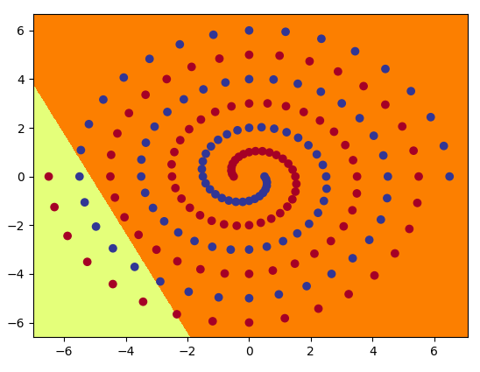

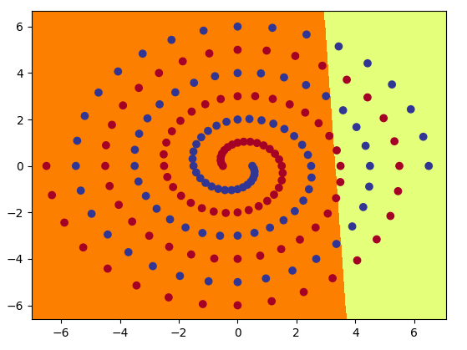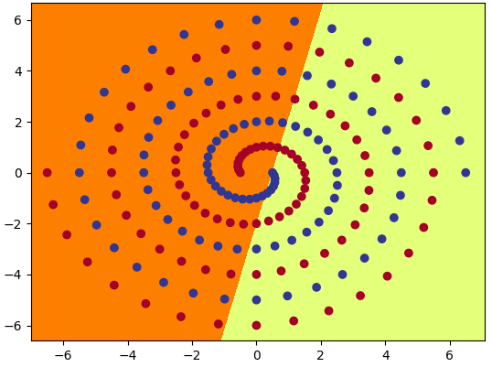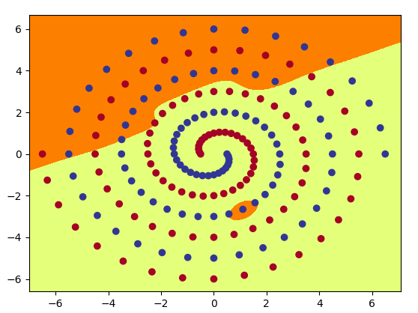

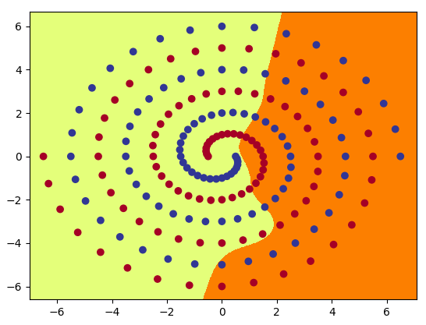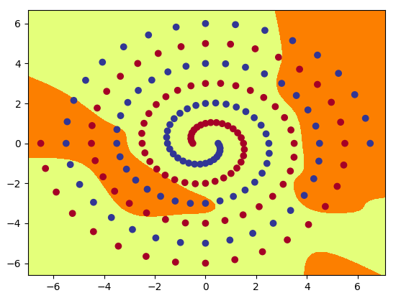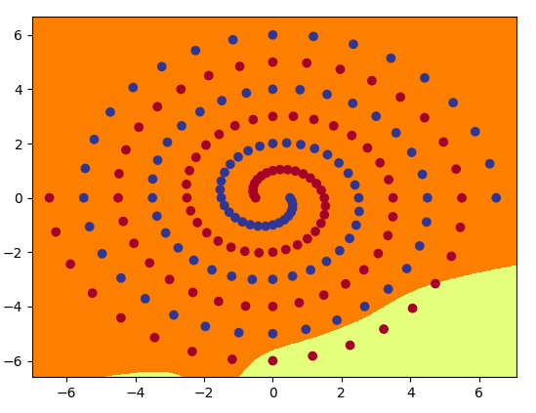

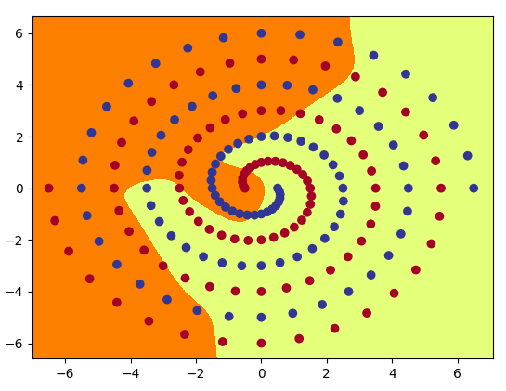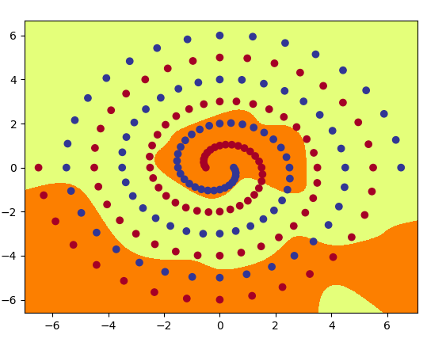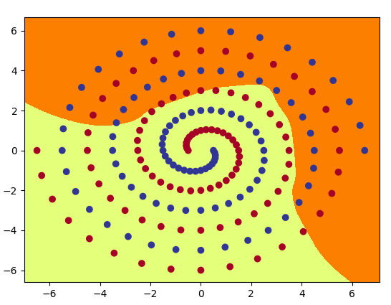

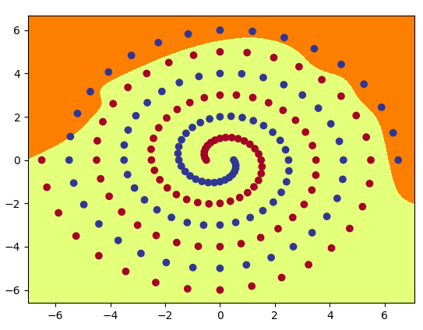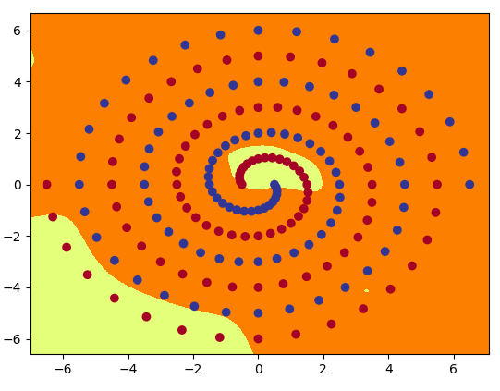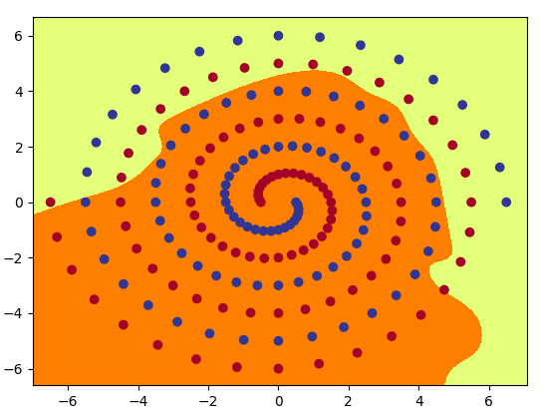

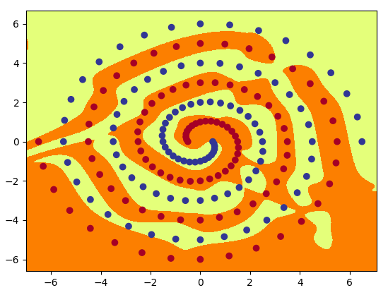

**Question6**

a. From the picture, we can get the differences between polarNet and rawNet. The first difference is the boundary line. From the picture, we can get that polarNet’s boundary is a straight line. The boundary of rawNet is a curve line. The reason why the boundary of rawNet is a curve line is that this method tries to overfitting each point in the graph. In this way, rawNet can finally converge

b. The initial weight will affect the speed of training. For example, in part 2, if we set the hid_num as 10, it may cost a lot of time to convergence. Furthermore, if we set the hid_num as 100 even 1000, it may finish the training process faster than using a small number.

c. In the part2, if I change the activation function to ReLU, the epoch we need has increased. For example, when we change the activation function in polar net to ReLU, the epoch has increased from 1800(the result of using Tanh) to 2000(the result of using ReLU).

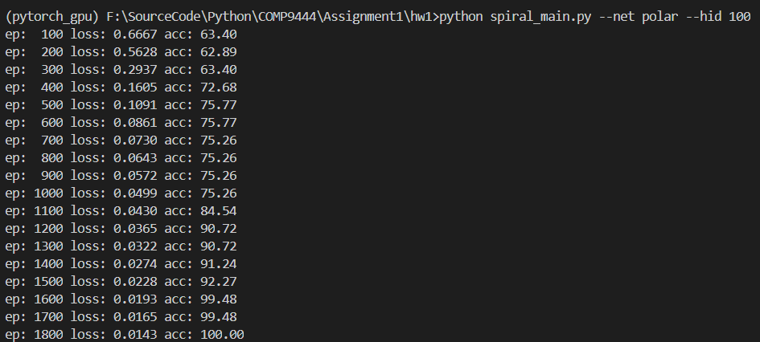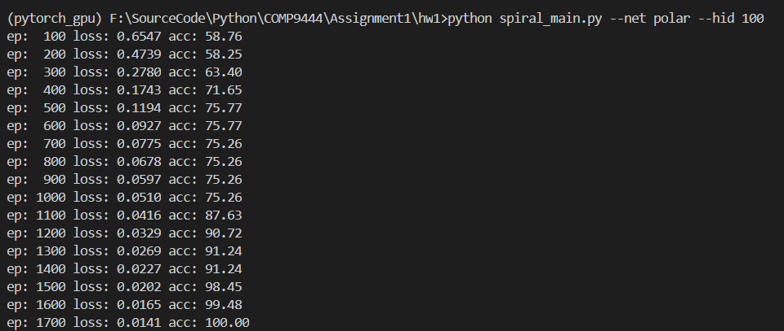This picture is using the Tanh as the activation function.

This picture is using the ReLU as the activation function.

Furthermore, if I change the batch size to 194, the training speed has improved. This process needs 900 epochs. But using the batch size as 97, still needs 1900 epochs. Here is the picture of the result.

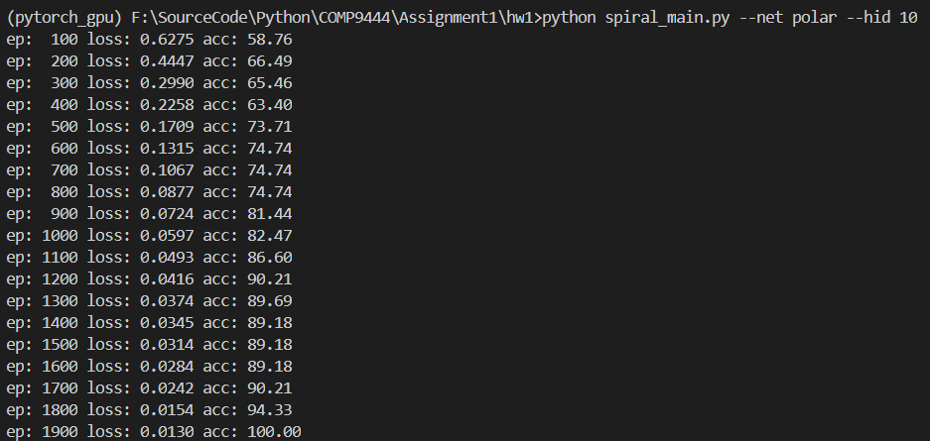This picture is used batch size 97.

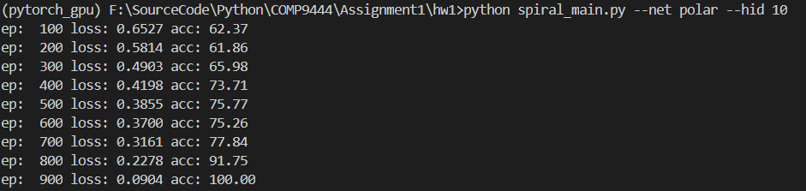This picture is used batch size 194.

**Part3**

**Question1**

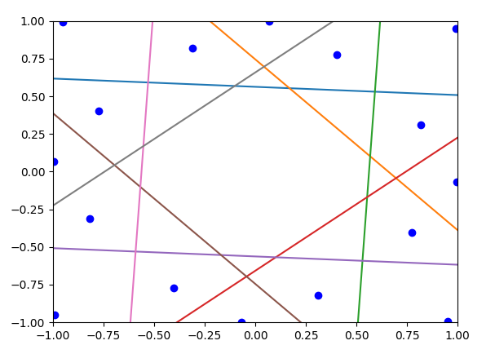Here is the picture result of running the command in the terminal.

**Question2**

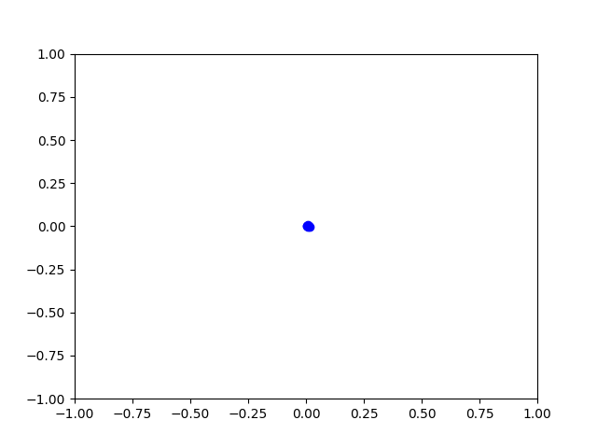Here are the first 11 pictures from epoch 50 to 3000.

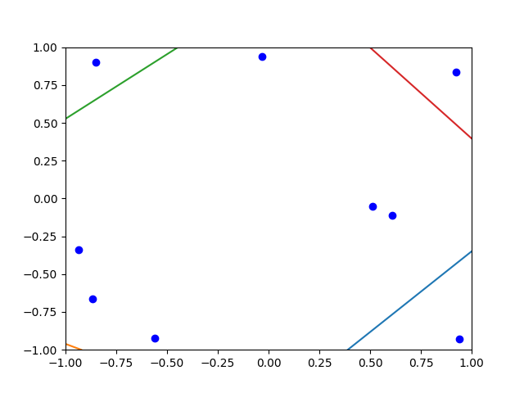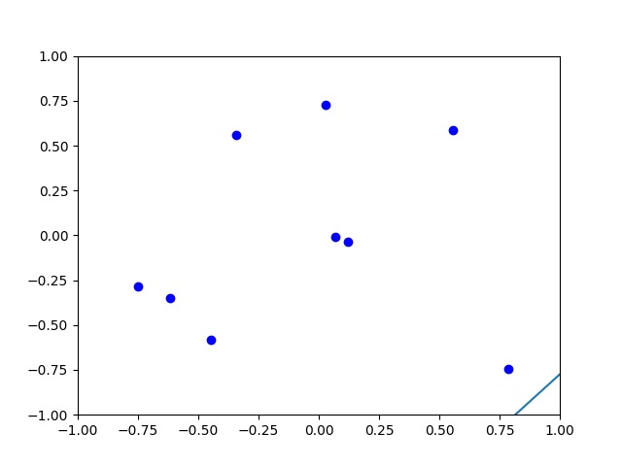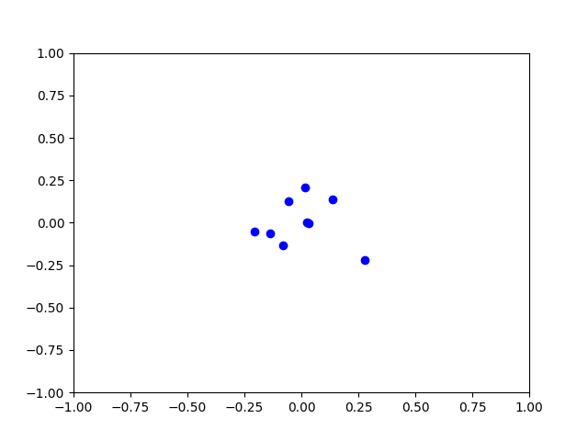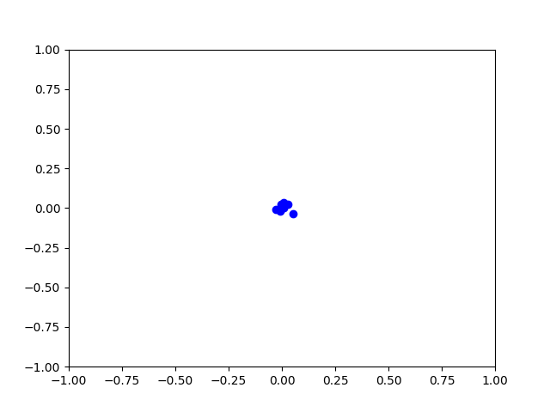

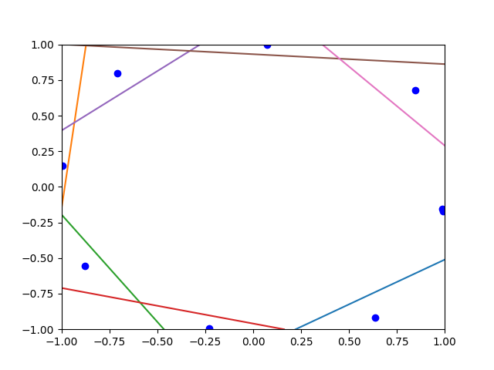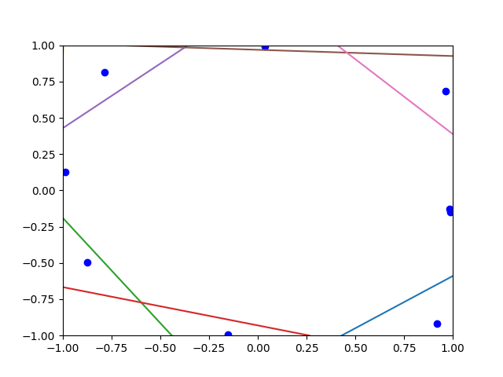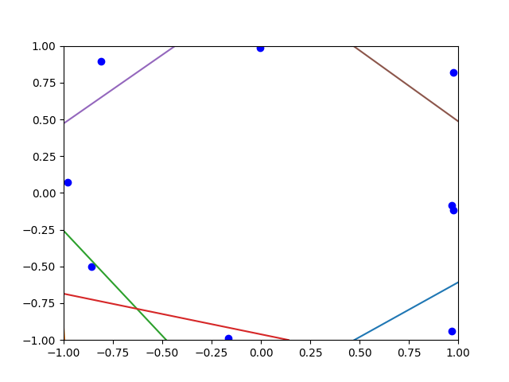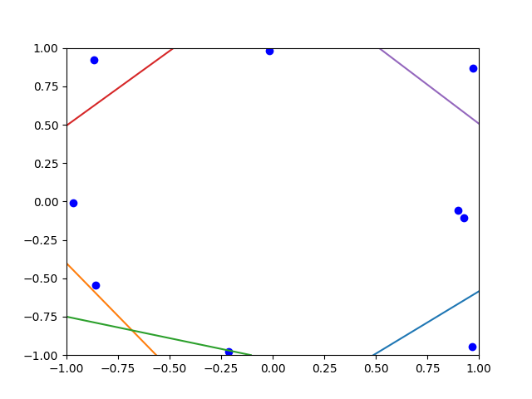

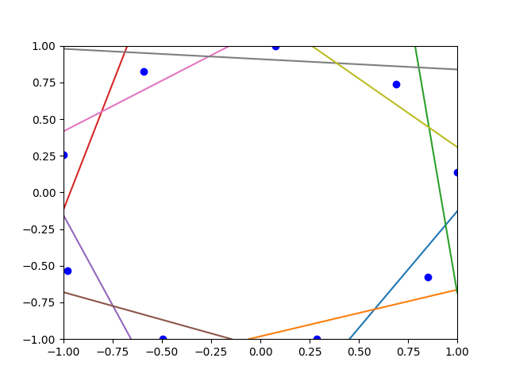This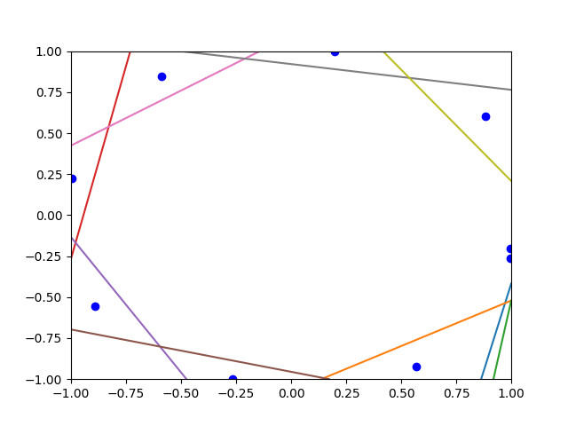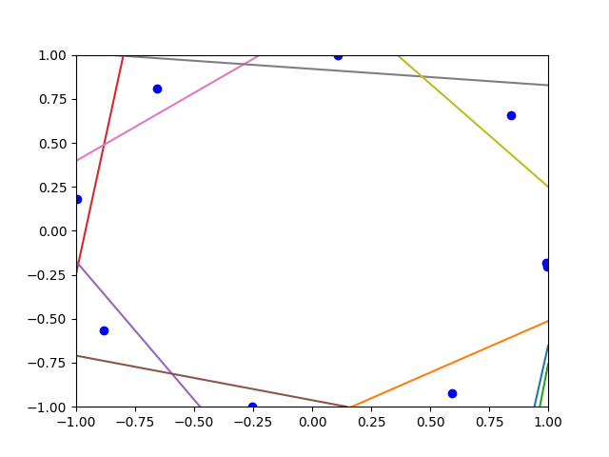 is the last picture of the question2.

When the training start, the dots separate and go in different directions. When they near the boundary, the cut lines appear. These lines start from the boundary and then go to the middle of the graph. When these lines ‘trap’ these dots in different areas, the training process will stop.

**Question3**

First, we should change the graph to a matrix. Also, adding the node index into the table. The size of the table is due to the line in the graph, 9 columns which have 8 lines and 7 rows which have 6 lines. Therefore, we can get this table.

|  |  |  |  |  |  |  |  |  |
| --- | --- | --- | --- | --- | --- | --- | --- | --- |
| 1 |  |  |  |  |  |  |  | 17 |
|  |  | 5 | 7 |  | 11 | 13 |  |  |
|  | 3 |  |  | 9 |  |  | 15 |  |
|  | 4 |  |  |  |  |  | 16 |  |
|  |  | 6 |  |  |  | 14 |  |  |
|  |  |  | 8 |  | 12 |  |  |  |
| 2 |  |  |  | 10 |  |  |  | 18 |

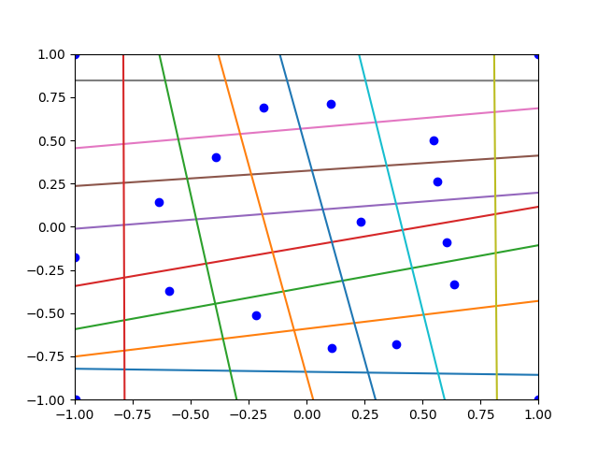Then, change this table to the matrix, based on whether the node is on the left side of the column line or the downside of the row line. Then we can get the picture result as showing below.

From this picture, we can find this heart has rotated left for 90 degree.

**Question4**

Target1

An Abstract Unicorn(Head only)

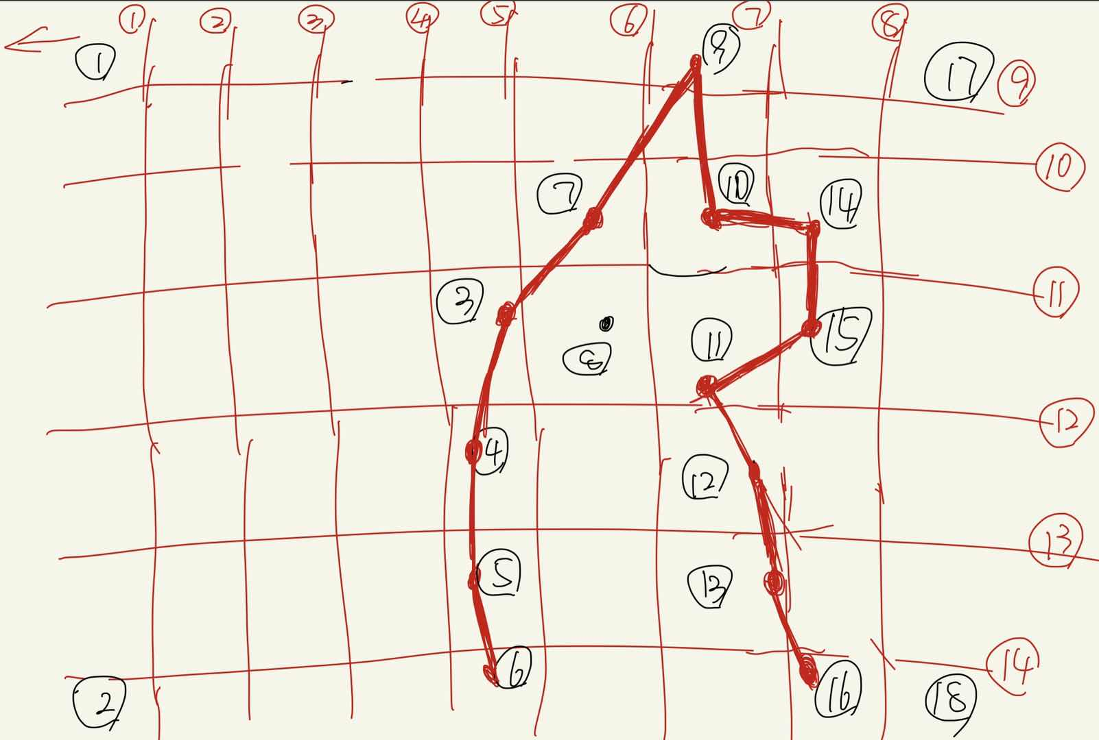Designing Draft

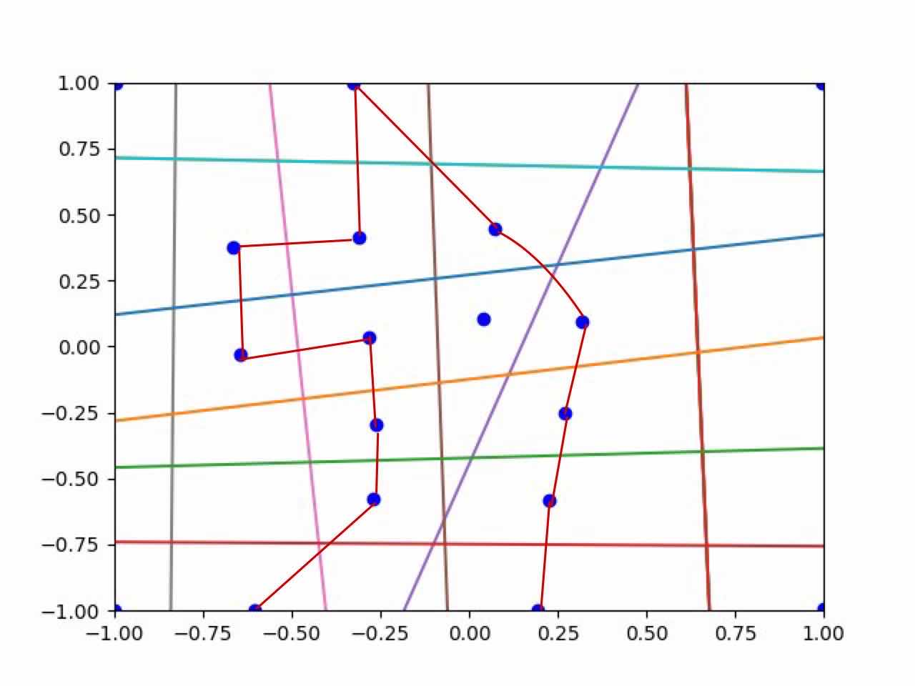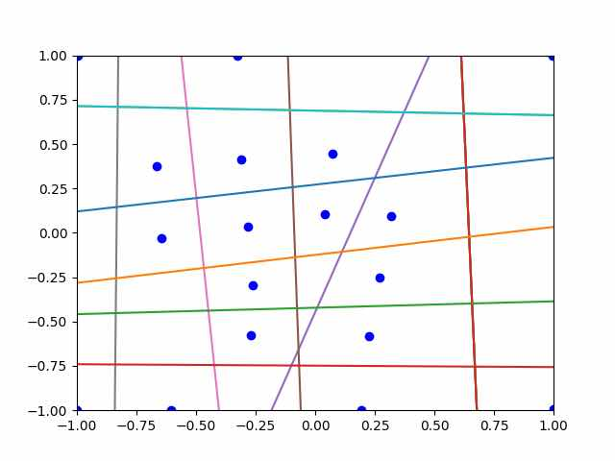The Result

Target2 Roy(My English name)

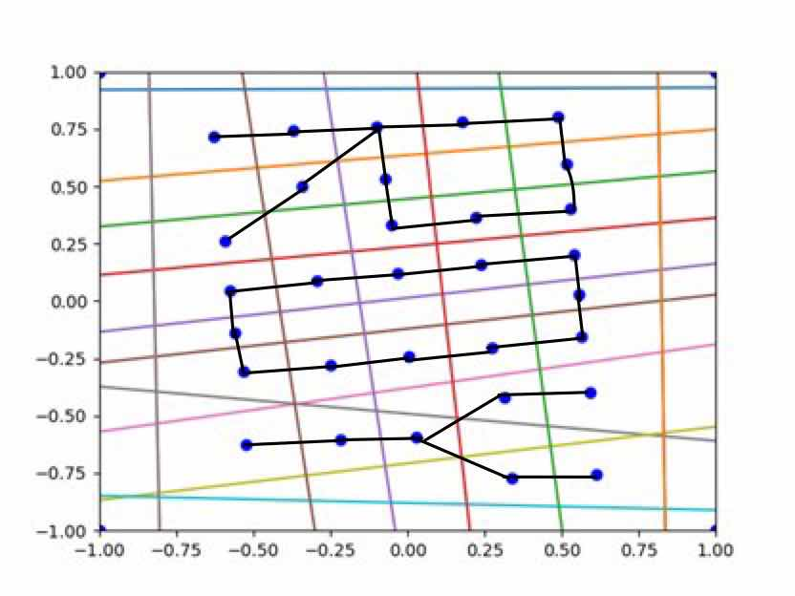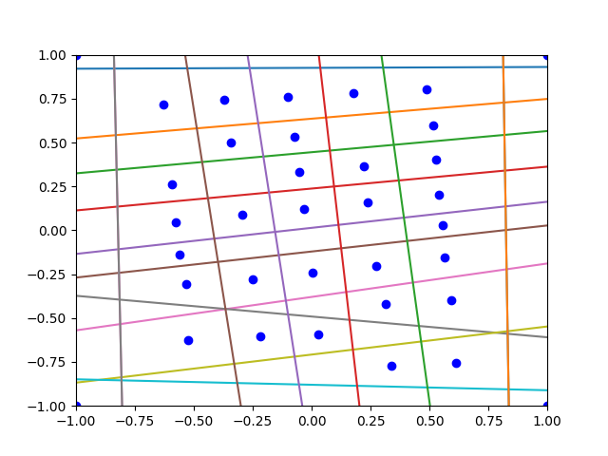The picture result

Target3 nVIDIA

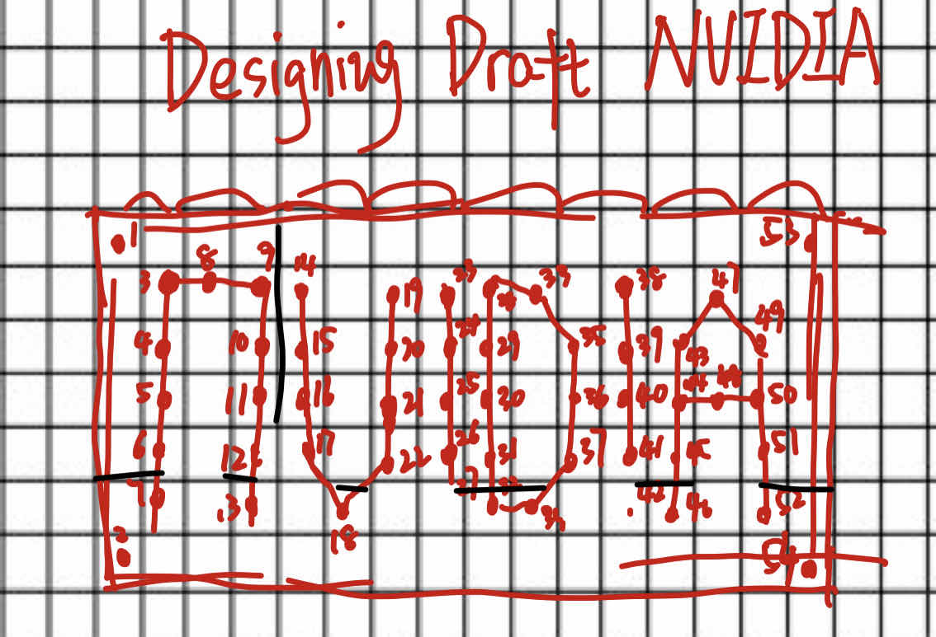Designing Draft

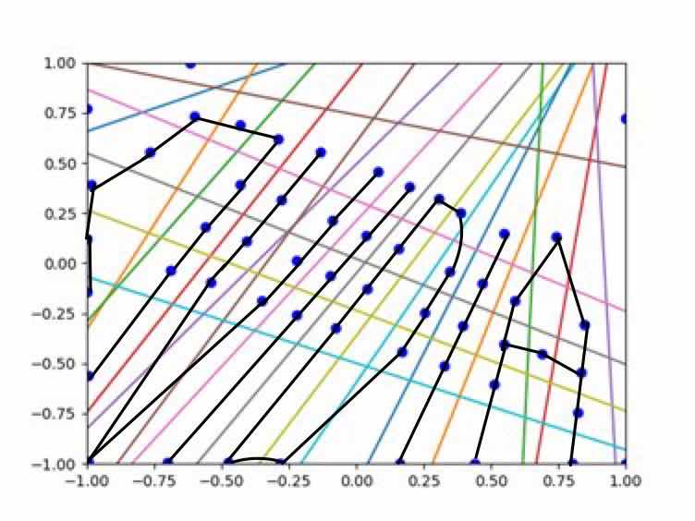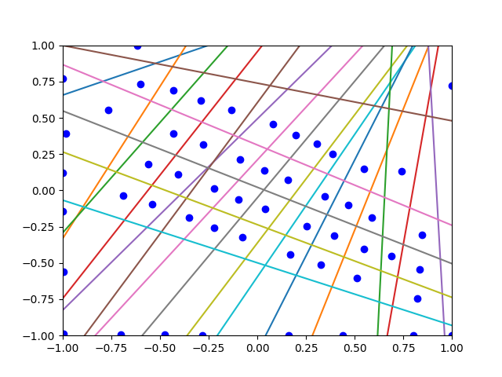Result picture