Lab 1: Linux Programming Laboratory
Code:- IT603 (Introduction to Programming)
Name:- Solanki Ruchit M. Student Id:- 202612085
Date:- 12/08/2026

Exercises
1. Create Your Personal Workspace
Create a directory named StudentLab. Inside it, create the following subdirectories:
• Programs
• Assignments
• Notes
Verify the directory structure and display the current working directory.
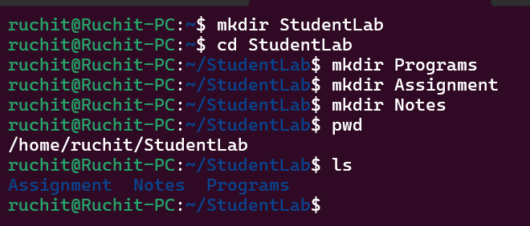v

2. File Management Practice
Inside the Assignments directory:
• Create the files:
– assignment1.txt
– assignment2.txt
– assignment3.txt
• Do all using Command Lines learned in this Lab.
• Rename assignment3.txt to lab3.txt.
• Delete assignment2.txt.
• Display the remaining files.
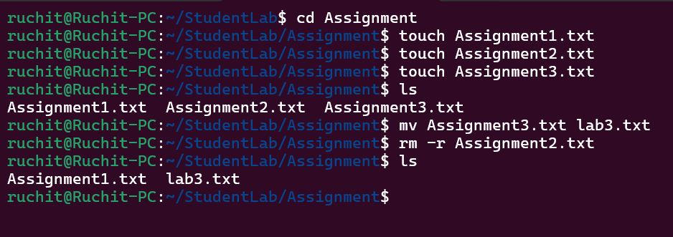

3. Creating and Editing Files
Create a file named profile.txt using the Nano editor.
Enter the following information:
• Name
• Enrollment Number
• Department
• Favourite Programming Language
Save the file and display its contents using the terminal.
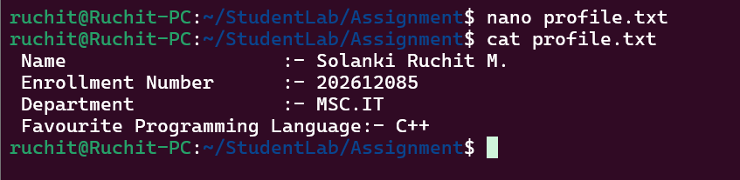

4. File Copy and Backup
Create a file named report.txt.
Copy it to a new file named report backup.txt.
Edit only the backup file and add one additional line.
Finally, display both files and verify that the original file remains unchanged.
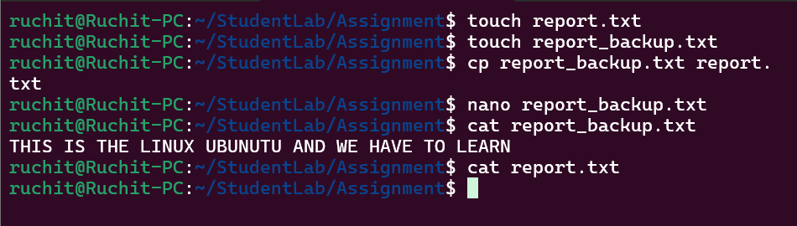

5. Directory Tree Creation
Create the following directory structure:
LinuxLab
C
C++
Python
Java
Inside each directory, create a file named program1.txt.
Display the contents of every directory.
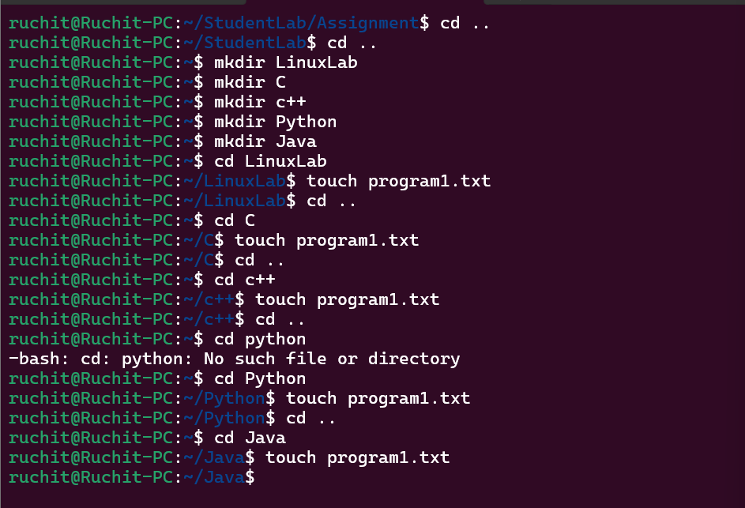

6. Directory Management
Create the following directory structure:
Projects
AI
ML
DL
Perform the following operations:
• Delete the ML directory.
• Rename the DL directory to DeepLearning.
• Verify the final directory structure.
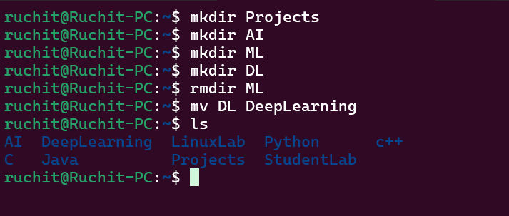

7. Compile and Execute a C++ Program
Write a C++ program that accepts one string and displays is it a palindrome or not.
Compile the program using the GNU C++ compiler and execute it from the terminal.
Record both the compilation command and the program output.
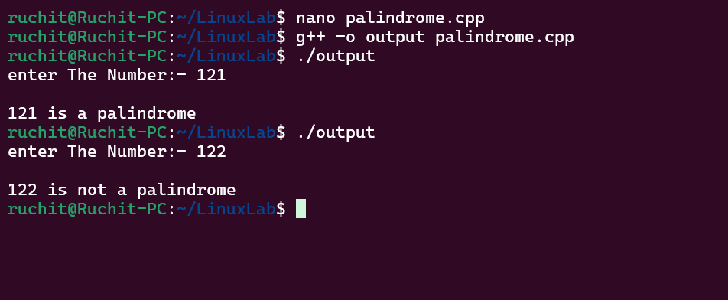

8. Git Repository Basics
Create a directory named GitPractice.
Inside it:
• Initialize a Git repository.
• Create a file named readme.md.
• Stage the file.
• Commit the changes with the message First Commit.
• Display the repository status.
• Display the commit history.
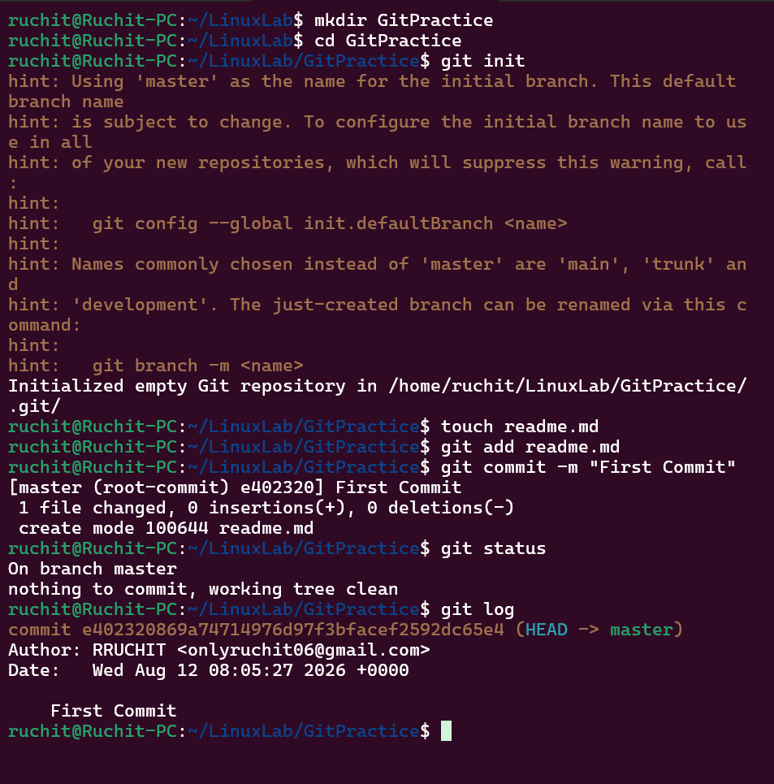

9. Mini Linux Project
Create the following directory structure:
Library
Books
Notes
Assignments
Perform the following tasks:
• Create the files:
– booklist.txt
– notes.txt
– assignment.txt
• Copy booklist.txt into the Notes directory.
• Rename the copied file to library books.txt.
• Delete assignment.txt.
• Display the final directory structure.
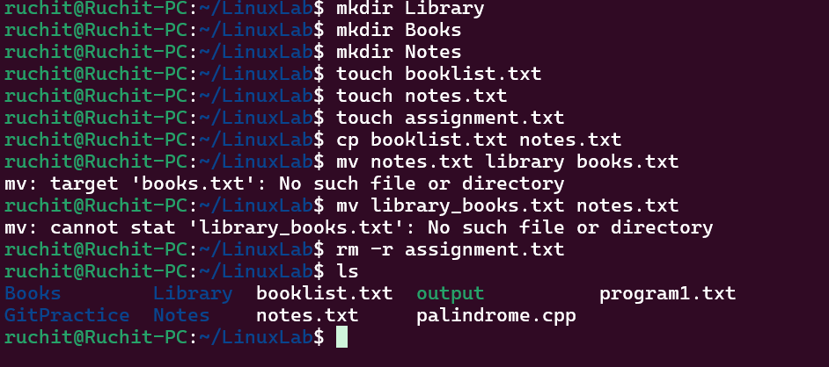

10. Linux Command Challenge
Create the following final directory structure without using any graphical interface:
Student
Programs
cpp.cpp
python.py
Documents
resume.txt
Backup
resume_backup.txt
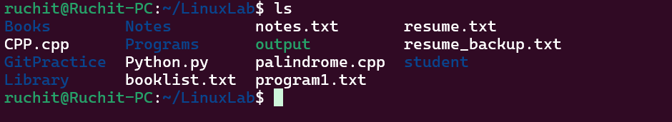

GITHUB SCREEN SHOT:-
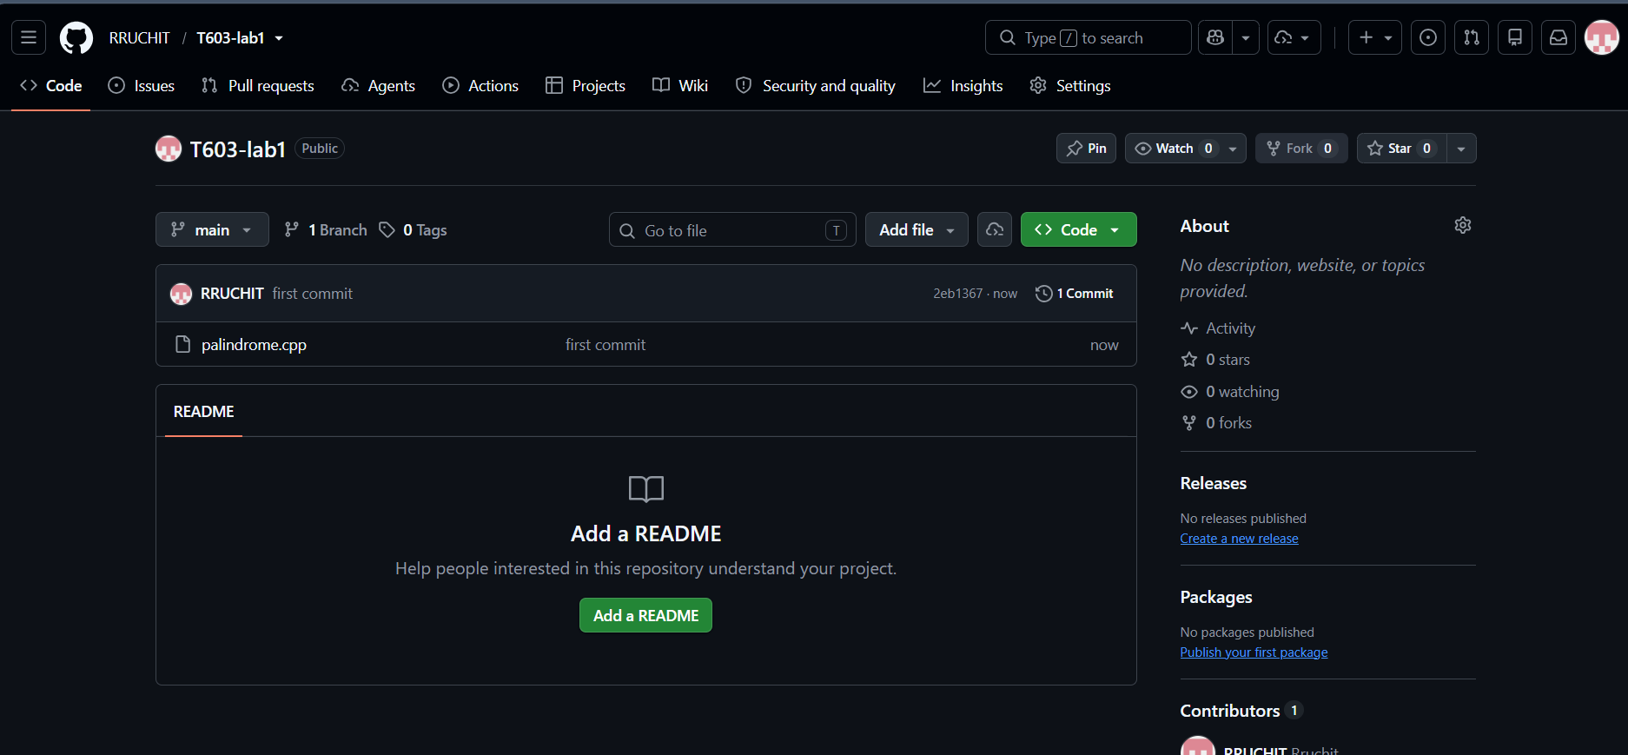

GITHUB Link:- RRUCHIT/T603-lab1

