MTE 544 Autonomous Mobile Robots: Lab 1

Rahul Ramkumar – 20991906
Aly Ahmed – 21003462
Branavan Keethabaskaran – 21015976
Station – MMEPC157
Robot – 11
October 19th, 2026

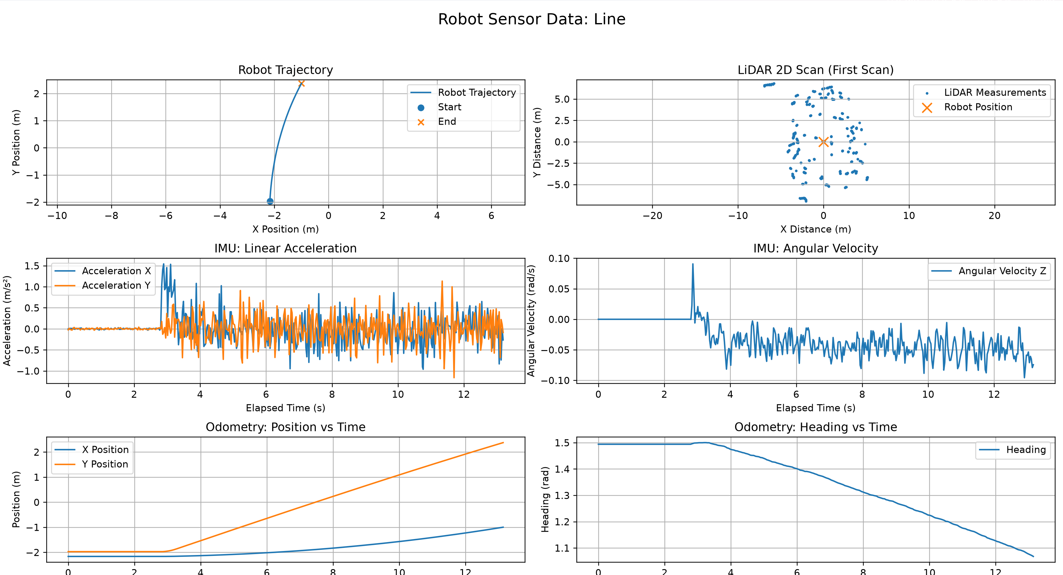
Figure 1: Recorded motion and sensor measurements for traversing in a line at constant velocity. IMU, odometry, and Lidar data graphed
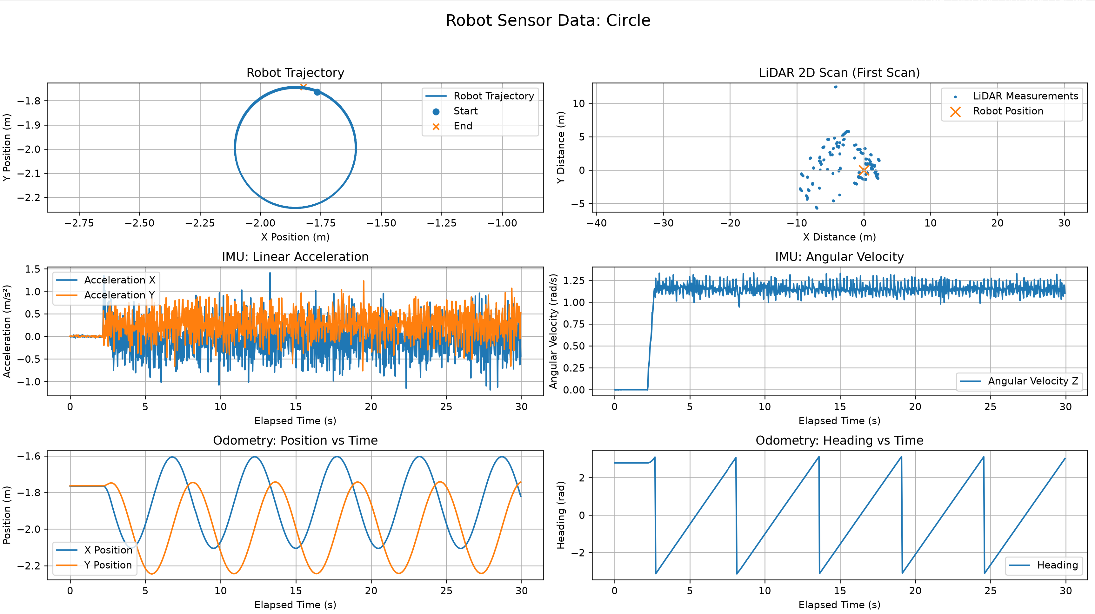
Figure 2:Recorded motion and sensor measurements for traversing in a circle. IMU, odometry, and Lidar data graphed
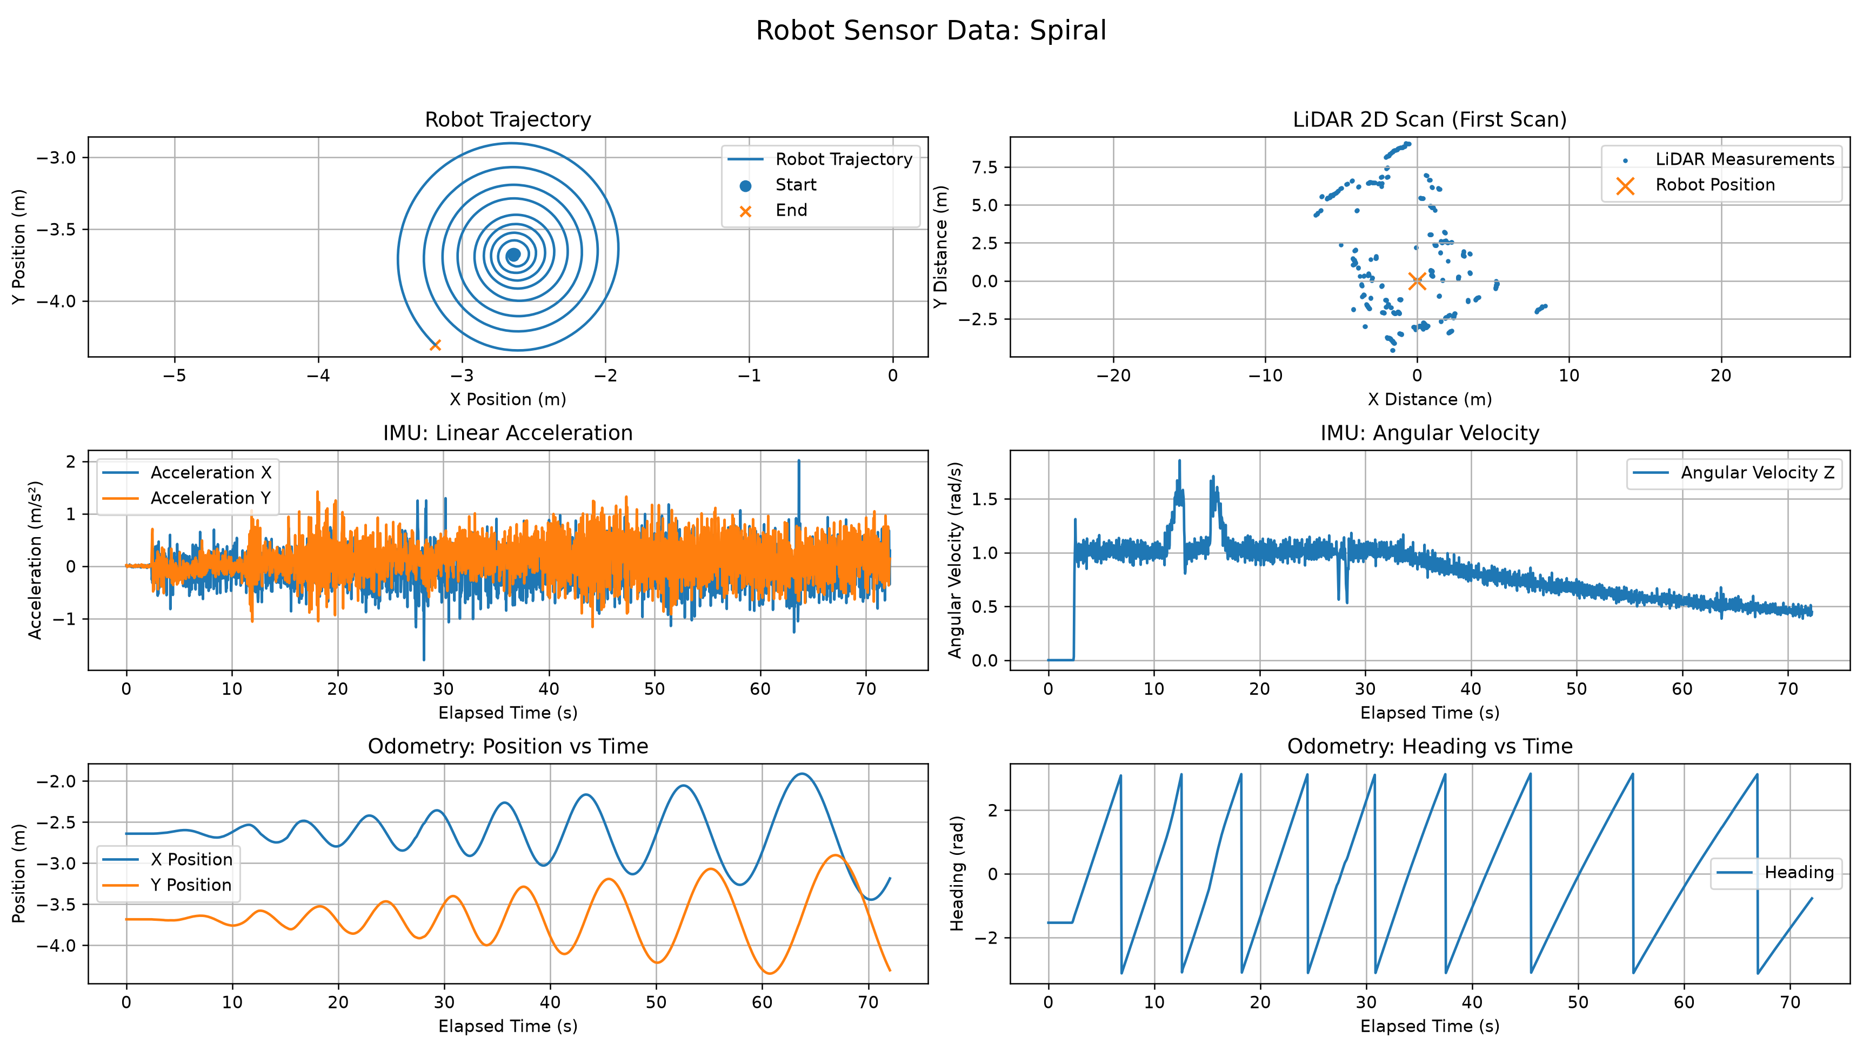
Figure 3:Recorded motion and sensor measurements for traversing in a spiral. IMU, odometry, and Lidar data graphed
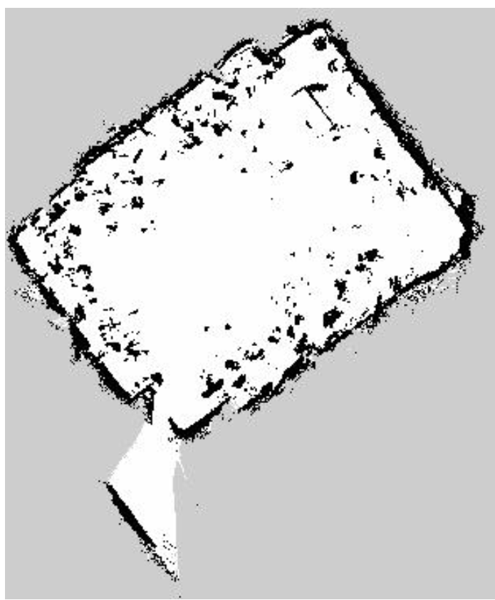
Figure 4: Map of room generated via SLAM. White denotes empty space, black indicates occupied space and grey shows areas out of bounds

Explanation and Discussion for Three Cases

Linear
The first plot for the robot’s trajectory shows the robot move from –2m to about 2.2m in y and motion about –2m in x to –1m in x. This is because the robot’s motion is plotted in the world frame or in a fixed frame, therefore, even though the robot’s velocity was in x in the robot frame, it produced motion in x and y in the fixed frame. Looking at the odometry graph, the y position odometer produces a perfectly linear line. The x position odometer is slightly curved. This could be due to slippage that occurs in the real world or sensor drift which causes discrepancies between the wheel rotation measured by the encoders and the robot's actual displacement. Additionally, small encoder measurement errors can accumulate over time, contributing to odometry drift.

Circle
In the case of a circle, the trajectory produced is a perfect circle as can be seen in the plot of x-position against y-position. The heading changes linearly due to having a constant angular velocity. It produces a saw wave because the angle continuously resets back to 0. X and y position plotted against time is a sine wave which is typical for how position changes for a circle. The IMU measurement shows an average linear acceleration of 0 as well as a constant angular velocity which makes sense for creating a circle and is consistent with input commands given to the robot. The lidar scan shows on the right side what seems to be points clustered in a line which could be a wall. The overall shape obtained by the lidar scan is rectangular which makes out a room approximately, however the number of points on other sides is somewhat sparse. There are also many points in the middle which could be people, other objects, furniture, or other robots that were all over the room. More scans would be needed to obtain a clearer understanding of the robot’s surrounding, but this singular scan does give a general idea of the robot’s surroundings at that point.

Spiral
For the spiral path, we can clearly see the growing radius in the trajectory plot with x-position plotted against y-position. The odometry plots appear similar to the circle path in the sense that x and y plotted against time results in two sinusoids and heading over time results in a linear sawtooth graph. The key difference is that the x and y sinusoids as well as the heading plot grow in amplitude since the path’s radius is growing outwards. The IMU’s average linear acceleration is around 0, and its angular velocity plot displays a slow downward curve due to ω decreasing as the radius increases (ω = v / r). In our implementation, we gradually increment linear speed which causes the rate of change of the radius to increase as the spiral grows which explains the initial flatness in the graph. The 2D Lidar scan of the spiral provides more data points compared to the circle and linear paths since it gradually covers a larger area of the room. Slightly more defined walls and boundaries can be observed in the plot.

