Raagini Rameshwar
Machine Learning – CS 539
Homework 1 Part 2: Visualizing and applying a decision tree

1) Visualization of the Decision Tree Using Graphviz

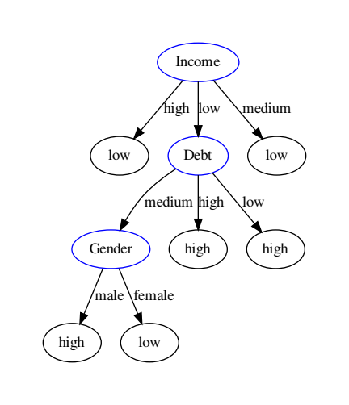

2) Prediction of Two Instances

Tom: Debt = low, Income = low, Married = no, Owns Property = yes, Gender = Male
Prediction: High Risk

Ana: Debt = low, Income = medium, Married = yes, Owns Property = yes, Gender = Female
Prediction: Low Risk

If Sofia’s credit risk were labeled high, the resulting decision tree would not factor Debt or Gender.

